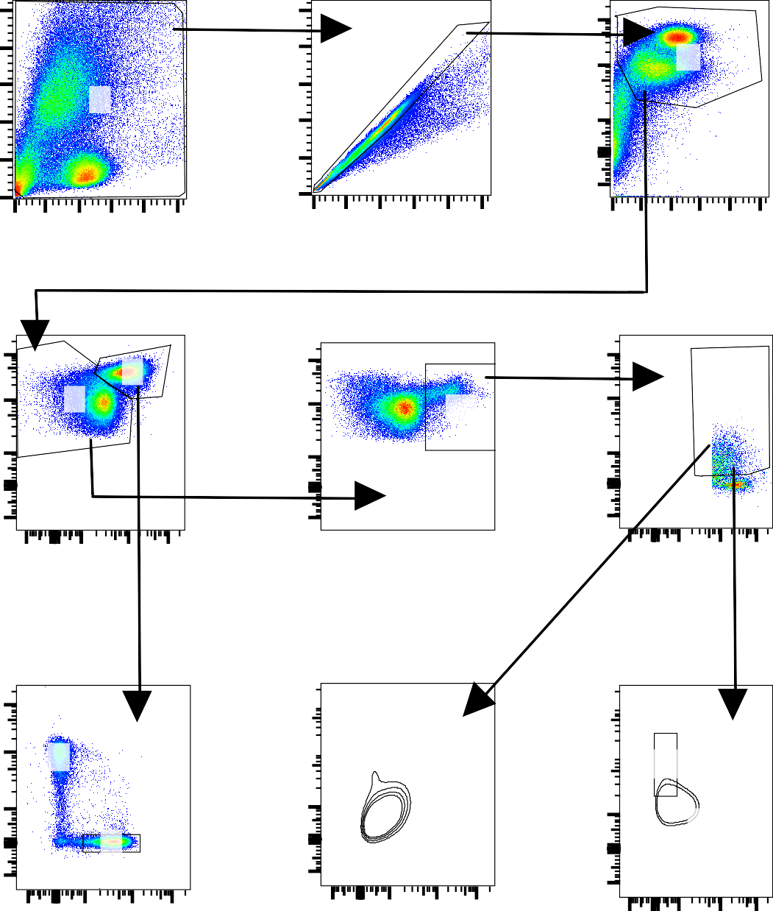
200K
10
5
200K
10
4
CD45+
77.6
Cells
90.9
100K
0
0
0
150K
0
150K
0
150K
FSC-A
FSC-A
FSC-A
5
CD3+
44.9
10
10 5
CD3-
54.9
10
4
HLADR+
10.6
10
4
CD14+
50.1
0
0
0
10
5
0
10
5
0
10
5
CD3
HLADR
CD14
10
5
5
10
10
4
10
4
Non-Classical
11.3
CD4+
70.8
0
0
0
10
5
0
10
5
0
5
10

Classical 34.7

Intermediate 2.98

CD8+ 21.4

MoDCs+ 30.3
Single Cells 91.1

100K
FSC-H
CD45

0

10 5
4
HLADR
10
CD45

0

10 5
4
10
CD11c
CD16

0

CD4
SSC-A
CD8
CD45
CD4+, CD8+, MoDC, nCM, iM, and cM Gating Strategy
CD14
CD14

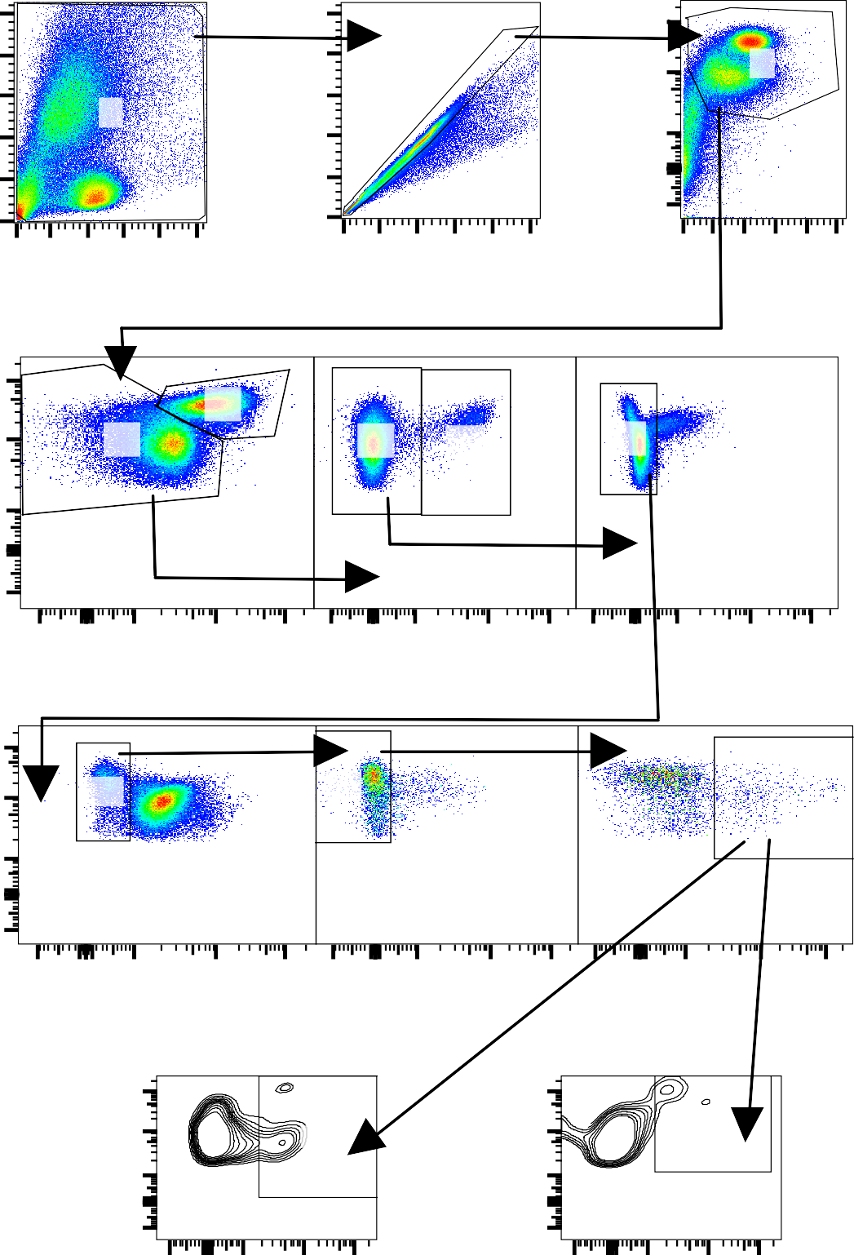
200K
5
10
200K
4
CD45+
77.6
10
Cells
90.9
100K
0
0
0
150K
0
150K
0
150K
FSC-A
FSC-A
FSC-A
CD3+
44.9
CD3-
54.9
CD19-
96.1
CD19+
3.82
CD14-
93.2
0
10
4
0
10
4
0
10
4
CD3
CD19
CD14
CD16-
8.73
CD56-
85.3
0
10
4
0
10
4
0
10
4
CD16
CD56
HLADR
4
CD11c+
25.0
10
4
CD123+
11.5
10
0
0
HLADR+ 12.7
Single Cells 91.1

100K
SSC-A
FSC-H
CD45

0

5
10

4
10
CD45

0

5
10
4
10
CD45

0

4
CD11c
HLADR
0 10
4
0 10

HLADR CD123
CD11c+ and CD123+ Gating Strategy

Figure S1: Flow cytometry gating strategy to identify CD4⁺ T, CD8⁺ T , CD11c⁺, CD123⁺, CD19⁺, moDCs, classical monocytes, intermediate monocytes, and non-classical monocytes. A gate on total cells was set followed by a subgate to exclude doublets. CD45⁺ cells were gated on to identify leukocytes, followed by a CD3⁺ gate for CD4⁺ T and CD8⁺ T cells. CD19⁺ cells were gated through the CD3- subgate. Following the CD19- gate, the CD14- cells were gated, then the CD16- cells, then CD56- cells, and then the HLADR⁺ subgate was made to identify CD11c⁺ and CD123⁺ cells. Using the HLADR⁺ subgate, CD14⁺ cells were gated which allowed for the gating of moDCs and the monocyte subtypes: non-classical, intermediate, and classical.

