Supplementary Materials
Table S1. Aphasic stroke features in the 31 patients.
N | Age | Sex | Lesion side | Lesion site | Lesion Volume (cm³) | Types of Aphasia
Patient01 | 64 | F | Left | Frontal | 16.77 | Fluent
Patient02 | 47 | M | Left | Frontal ,Temporal | 28.67 | Fluent
Patient03 | 86 | M | Left | Frontal, Parietal, Temporal | 62.97 | Fluent
Patient04 | 79 | M | Left | Frontal, Parietal | 107.49 | Non-fluent
Patient05 | 39 | M | Left | Frontal | 19.06 | Fluent
Patient06 | 69 | M | Left | Frontal | 32.81 | Fluent
Patient07 | 76 | M | Left | Frontal | 8.59 | Fluent
Patient08 | 54 | M | Left | Frontal | 30.40 | Non-fluent
Patient09 | 54 | F | Left | Insula | 10.75 | Fluent
Patient10 | 81 | F | Left | Frontal | 5.27 | Fluent
Patient11 | 67 | M | Left | Frontal, Parietal, Temporal | 150.38 | Fluent
Patient12 | 53 | F | Left | Frontal, Parietal | 8.46 | Fluent
Patient13 | 47 | M | Left | Frontal, Parietal | 139.55 | Non-fluent
Patient14 | 58 | M | Left | Frontal | 59.87 | Fluent
Patient15 | 56 | F | Left | Frontal | 28.04 | Fluent
Patient16 | 71 | M | Left | Frontal, Parietal | 171.91 | Fluent
Patient17 | 71 | M | Left | Frontal, Parietal, Temporal | 31.38 | Fluent
Patient18 | 55 | F | Left | Frontal | 13.69 | Fluent
Patient19 | 70 | F | Left | Frontal | 7.69 | Fluent
Patient20 | 54 | M | Left | Frontal, Parietal, Temporal | 119.83 | Non-fluent
Patient21 | 73 | M | Left | Frontal, Parietal | 128.14 | Non-fluent
Patient22 | 49 | M | Left | Frontal, Parietal, | 84.83 | Non-fluent
Patient23 | 61 | F | Left | Frontal | 3.90 | Fluent
Patient24 | 36 | F | Left | Frontal, Parietal, Temporal | 23.99 | Non-fluent
Patient25 | 79 | F | Left | Frontal | 4.75 | Fluent
Patient26 | 52 | M | Left | Frontal, Parietal | 176.78 | Fluent
Patient27 | 49 | F | Left | Parietal | 27.98 | Fluent
Patient28 | 32 | M | Left | Frontal, Parietal | 77.42 | Fluent
Patient29 | 50 | F | Left | Frontal | 6.31 | Fluent
Patient30 | 54 | M | Left | Parietal | 16.53 | Non-fluent
Patient31 | 54 | M | Left | Frontal, Parietal | 13.26 | Fluent

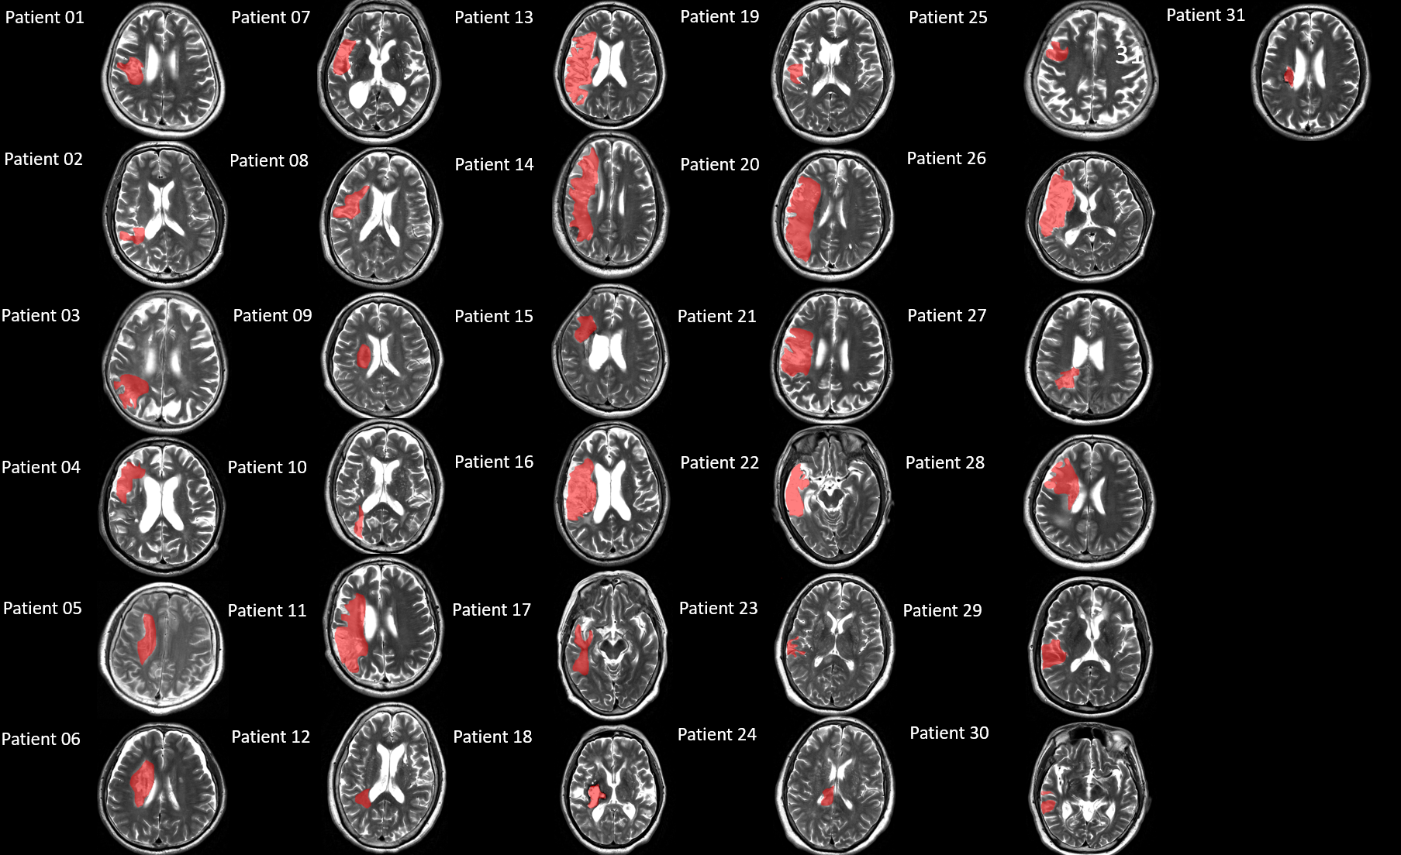
Figure. S1. The display of stroke lesion for each patient.

Table S2: Language assessment results for the patients.
 |  | Western Aphasia Battery
 |  | WAB-0 |  |  |  | WAB-1
Number | AQ-0 | Auditory Comprehension-0 | Spontaneous speech-0 | Naming-0 | repetition-0 | AQ-1 | Auditory Comprehension-1 | Spontaneous speech-1 | Naming-1 | Repetition-1 | ΔAQ | rΔAQ
Patient01 | 46.40 | 7.30 | 9.00 | 4.00 | 2.90 | 47.10 | 8.65 | 9.00 | 4.30 | 1.60 | 0.70 | 1.00
Patient02 | 96.20 | 10.00 | 19.00 | 9.90 | 9.20 | 97.20 | 10.00 | 19.00 | 10.00 | 9.60 | 1.00 | 0.32
Patient03 | 39.30 | 7.35 | 8.00 | 0.80 | 3.50 | 26.60 | 5.80 | 4.00 | 2.10 | 1.40 | -12.70 | 0.60
Patient04 | 0.00 | 0.00 | 0.00 | 0.00 | 0.00 | 0.00 | 0.00 | 0.00 | 0.00 | 0.00 | 0.00 | 0.00
Patient05 | 10.00 | 3.80 | 1.00 | 0.20 | 0.00 | 54.00 | 6.00 | 10.00 | 8.00 | 3.00 | 44.00 | 0.73
Patient06 | 21.00 | 3.30 | 4.00 | 1.30 | 1.90 | 55.90 | 3.45 | 13.00 | 3.00 | 8.50 | 34.90 | -2.40
Patient07 | 6.80 | 1.40 | 2.00 | 0.00 | 0.00 | 6.90 | 1.45 | 2.00 | 0.00 | 0.00 | 0.10 | -0.35
Patient08 | 11.10 | 5.25 | 0.00 | 0.00 | 0.30 | 69.70 | 7.95 | 13.00 | 6.50 | 7.40 | 58.60 | 0.28
Patient09 | 52.60 | 8.20 | 6.00 | 5.60 | 6.50 | 78.60 | 8.30 | 16.00 | 6.90 | 8.10 | 26.00 | 1.45
Patient10 | 73.20 | 7.10 | 14.00 | 6.30 | 9.20 | 78.20 | 7.90 | 17.00 | 8.00 | 6.20 | 5.00 | 0.62
Patient11 | 20.50 | 4.85 | 3.00 | 1.60 | 0.80 | 24.50 | 4.75 | 3.00 | 1.50 | 3.00 | 4.00 | -1.91
Patient12 | 78.10 | 9.15 | 14.00 | 7.70 | 8.20 | 80.70 | 8.95 | 15.00 | 7.50 | 8.90 | 2.60 | 0.24
Patient13 | 4.90 | 2.45 | 0.00 | 0.00 | 0.00 | 5.60 | 2.80 | 0.00 | 0.00 | 0.00 | 0.70 | -0.08
Patient14 | 6.40 | 2.20 | 1.00 | 0.00 | 0.00 | 0.00 | 0.00 | 0.00 | 0.00 | 0.00 | 0.00 | 0.57
Patient15 | 25.10 | 5.75 | 6.00 | 0.10 | 0.70 | 28.00 | 7.30 | 4.00 | 1.70 | 1.00 | 2.90 | -0.71
Patient16 | 14.30 | 1.75 | 1.00 | 0.00 | 4.40 | 5.50 | 0.75 | 2.00 | 0.00 | 0.00 | -8.80 | -4.98
Patient17 | 21.30 | 1.65 | 9.00 | 0.00 | 0.00 | 16.30 | 0.15 | 8.00 | 0.00 | 0.00 | -5.00 | 0.38
Patient18 | 64.20 | 5.80 | 12.00 | 6.70 | 7.60 | 73.30 | 8.05 | 14.00 | 7.20 | 7.40 | 9.10 | 1.23
Patient19 | 71.90 | 6.85 | 14.00 | 6.30 | 8.80 | 75.60 | 8.00 | 16.00 | 7.60 | 6.20 | 3.70 | -0.08
Patient20 | 1.80 | 0.90 | 0.00 | 0.00 | 0.00 | 2.00 | 1.00 | 0.00 | 0.00 | 0.00 | 0.20 | -5.65
Patient21 | 9.10 | 4.35 | 0.00 | 0.00 | 0.20 | 16.00 | 4.50 | 3.00 | 0.00 | 0.50 | 6.90 | -6.64
Patient22 | 6.00 | 3.00 | 0.00 | 0.00 | 0.00 | 9.80 | 4.90 | 0.00 | 0.00 | 0.00 | 3.80 | 0.12
Patient23 | 79.50 | 7.95 | 15.00 | 8.50 | 8.30 | 90.40 | 9.20 | 18.00 | 9.20 | 8.80 | 10.90 | 1.73
Patient24 | 4.60 | 2.30 | 0.00 | 0.00 | 0.00 | 0.00 | 0.00 | 0.00 | 0.00 | 0.00 | 0.00 | -0.08
Patient25 | 41.40 | 5.40 | 9.00 | 3.30 | 3.00 | 69.00 | 8.10 | 12.00 | 7.00 | 7.40 | 27.60 | 0.24
Patient26 | 12.40 | 2.50 | 3.00 | 0.70 | 0.00 | 11.70 | 1.65 | 3.00 | 0.00 | 1.20 | -0.70 | 0.97
Patient27 | 85.00 | 9.00 | 17.00 | 8.90 | 7.60 | 90.10 | 9.05 | 18.00 | 9.00 | 9.00 | 5.10 | 1.90
Patient28 | 40.90 | 5.55 | 7.00 | 4.60 | 3.30 | 0.00 | 0.00 | 0.00 | 0.00 | 0.00 | 0.00 | 3.29
Patient29 | 67.60 | 9.70 | 11.00 | 7.20 | 5.90 | 82.20 | 10.00 | 15.00 | 8.10 | 8.00 | 14.60 | 1.32
Patient30 | 3.90 | 1.65 | 0.00 | 0.30 | 0.00 | 28.30 | 3.95 | 5.00 | 3.40 | 1.80 | 24.40 | 2.81
Patient31 | 88.20 | 17.00 | 9.10 | 9.60 | 8.40 | 87.10 | 9.45 | 17.00 | 9.40 | 7.70 | -1.10 | 2.19
All patients underwent WAB-R testing twice at the baseline (~28 days post-stroke, WAB0) and at three months post-stroke (WAB1). ΔAQ = AQ₁ – AQ_{0,} r ΔAQ= (AQ₁ – AQ₀)/ AQ₀

Table S3: Correlation between all WAB score and FC of the bilateral preSMA.
Pearson Correlation
FC |  | AQ-0 | Auditory Comprehension-0 | Spontaneous speech-0 | Naming-0 | repetition-0 |  | AQ-1 | Auditory Comprehension-1 | Spontaneous speech-1 | Naming-1 | Repetition-1 | ΔAQ | rΔAQ
ROI1-clusters1 | r | -0.01 | -0.03 | 0.07 | -0.04 | -0.09 | 0.04 |  | -0.05 | 0.10 | -0.06 | 0.13 | 0.06 | 0.12
ROI1-clusters1 | p | 0.96 | 0.86 | 0.72 | 0.84 | 0.63 | 0.83 |  | 0.78 | 0.61 | 0.75 | 0.50 | 0.76 | 0.53
ROI1-clusters1 | n | 31.00 | 31.00 | 31.00 | 31.00 | 31.00 | 31.00 |  | 31.00 | 31.00 | 31.00 | 31.00 | 31.00 | 31.00
ROI1-clusters2 | r | 0.19 | 0.12 | 0.20 | 0.17 | 0.21 | 0.06 |  | -0.06 | 0.09 | 0.08 | 0.09 | -0.09 | -0.16
ROI1-clusters2 | p | 0.31 | 0.53 | 0.29 | 0.36 | 0.27 | 0.75 |  | 0.76 | 0.63 | 0.69 | 0.62 | 0.64 | 0.41
ROI1-clusters2 | n | 31.00 | 31.00 | 31.00 | 31.00 | 31.00 | 31.00 |  | 31.00 | 31.00 | 31.00 | 31.00 | 31.00 | 31.00
ROI1-clusters3 | r | 0.02 | 0.09 | -0.04 | 0.06 | -0.01 | -0.04 |  | -0.14 | -0.01 | -0.03 | 0.03 | 0.02 | 0.00
ROI1-clusters3 | p | 0.93 | 0.65 | 0.85 | 0.75 | 0.96 | 0.85 |  | 0.44 | 0.94 | 0.86 | 0.88 | 0.91 | 1.00
ROI1-clusters3 | n | 31.00 | 31.00 | 31.00 | 31.00 | 31.00 | 31.00 |  | 31.00 | 31.00 | 31.00 | 31.00 | 31.00 | 31.00
ROI1-clusters4 | r | -0.16 | -0.29 | -0.10 | -0.14 | -0.07 | -0.39* |  | -0.47** | -0.31 | -0.36* | -0.39* | -0.37* | -0.26
ROI1-clusters4 | p | 0.41 | 0.12 | 0.58 | 0.45 | 0.70 | 0.03 |  | 0.01 | 0.09 | 0.04 | 0.03 | 0.04 | 0.16
ROI1-clusters4 | n | 31.00 | 31.00 | 31.00 | 31.00 | 31.00 | 31.00 |  | 31.00 | 31.00 | 31.00 | 31.00 | 31.00 | 31.00
ROI1-clusters5 | r | -0.31 | -0.35 | -0.26 | -0.27 | -0.29 | -0.35 |  | -0.39* | -0.34 | -0.30 | -0.31 | 0.01 | -0.12
ROI1-clusters5 | p | 0.09 | 0.05 | 0.15 | 0.14 | 0.12 | 0.06 |  | 0.03 | 0.06 | 0.10 | 0.09 | 0.94 | 0.54
ROI1-clusters5 | n | 31.00 | 31.00 | 31.00 | 31.00 | 31.00 | 31.00 |  | 31.00 | 31.00 | 31.00 | 31.00 | 31.00 | 31.00
ROI2-clusters1 | r | -0.04 | -0.11 | -0.04 | -0.02 | 0.03 | -0.01 |  | -0.05 | -0.01 | 0.00 | 0.01 | 0.03 | -0.24
ROI2-clusters1 | p | 0.84 | 0.55 | 0.83 | 0.92 | 0.87 | 0.96 |  | 0.80 | 0.97 | 1.00 | 0.94 | 0.90 | 0.20
ROI2-clusters1 | n | 31.00 | 31.00 | 31.00 | 31.00 | 31.00 | 31.00 |  | 31.00 | 31.00 | 31.00 | 31.00 | 31.00 | 31.00
ROI2-clusters2 | r | 0.11 | 0.21 | 0.06 | 0.13 | 0.05 | 0.08 |  | 0.04 | 0.10 | 0.06 | 0.07 | 0.09 | 0.00
ROI2-clusters2 | p | 0.56 | 0.26 | 0.77 | 0.48 | 0.80 | 0.68 |  | 0.83 | 0.59 | 0.74 | 0.69 | 0.63 | 0.99
ROI2-clusters2 | n | 31.00 | 31.00 | 31.00 | 31.00 | 31.00 | 31.00 |  | 31.00 | 31.00 | 31.00 | 31.00 | 31.00 | 31.00
ROI2-clusters3 | r | -0.23 | -0.30 | -0.21 | -0.20 | -0.18 | -0.33 |  | -0.45* | -0.22 | -0.34 | -0.33 | -0.21 | -0.19
ROI2-clusters3 | p | 0.21 | 0.10 | 0.27 | 0.29 | 0.34 | 0.08 |  | 0.01 | 0.23 | 0.06 | 0.07 | 0.25 | 0.32
ROI2-clusters3 | n | 31.00 | 31.00 | 31.00 | 31.00 | 31.00 | 31.00 |  | 31.00 | 31.00 | 31.00 | 31.00 | 31.00 | 31.00
* p<0.05 ** p<0.01
Abbreviations: r = correlation coefficient, p = probability value, n = number of data points (i.e. patients).ROI1= Ipsilesional preSMA. ROI2= Contralesional preSMA

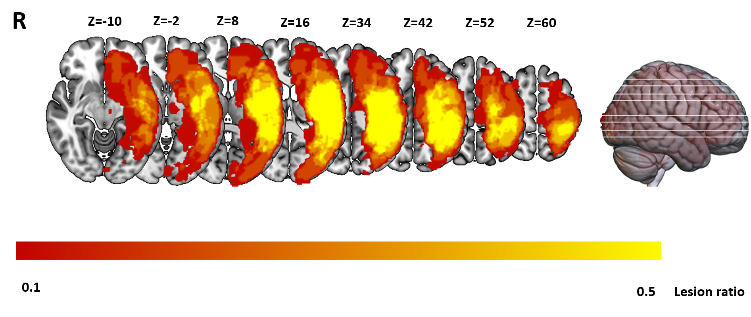

Figure S2: The lesion map represents data from 31 stroke patients, with the color bar indicating the number of subjects with lesions in each voxel. The Z-axis ranges from Z = -10 to Z = 60 in MNI coordinates. R indicates the right hemisphere.
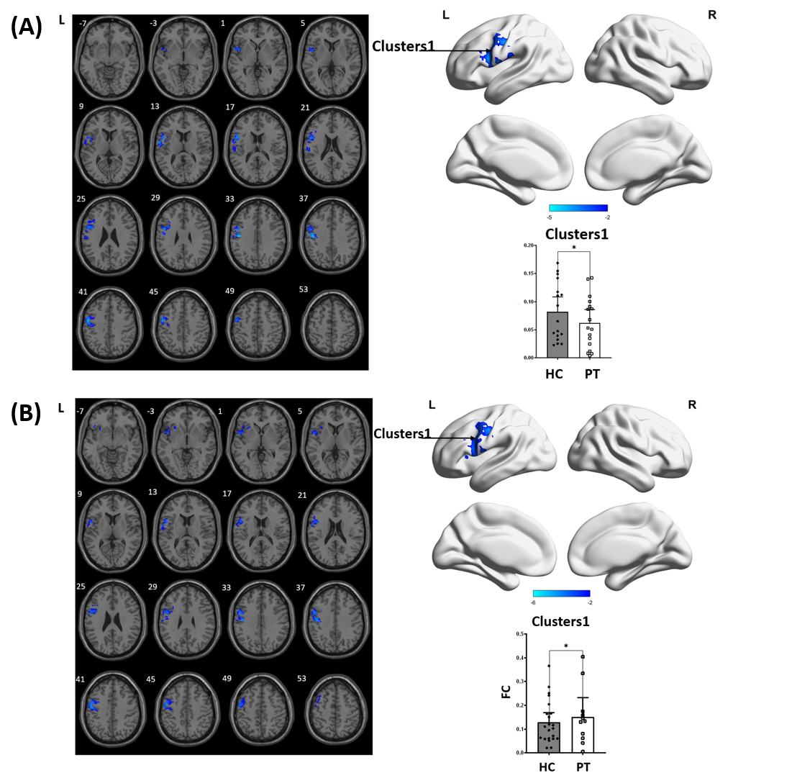
Figure S3: Brain regions demonstrating significant FC differences between stroke patients and healthy controls in ipsilesional (A) and contralesional (B) preSMA. The colored bars represent T values from the two-sample t-test. Cooler colors indicate lower FC values in stroke patients compared to healthy controls. L, left hemisphere; R, right hemisphere.

Table S4: Correlation between all WAB score and FC of the preSMA in an independent group of aphasic stroke patients.
Pearson Correlation
FC |  | AQ-0 | Auditory Comprehension-0 | Spontaneous speech-0 | Naming-0 | repetition-0 | AQ-1 | Auditory Comprehension-1 | Spontaneous speech-1 | Naming-1 | Repetition-1 | ΔAQ | rΔAQ
ROI1-cluster1 | r | -0.33 | -0.23 | -0.44 | 0.10 | -0.33 | -0.39 | -0.28 | -0.42 | -0.09 | -0.55* | -0.40 | -0.31
ROI1-cluster1 | p | 0.20 | 0.38 | 0.08 | 0.71 | 0.19 | 0.12 | 0.28 | 0.09 | 0.73 | 0.02 | 0.12 | 0.23
ROI1-cluster1 | n | 17.00 | 17.00 | 17.00 | 17.00 | 17.00 | 17.00 | 17.00 | 17.00 | 17.00 | 17.00 | 17.00 | 17.00
ROI2-cluster1 | r | 0.01 | -0.02 | 0.00 | 0.32 | -0.14 | -0.01 | 0.14 | -0.12 | 0.26 | -0.26 | -0.04 | -0.36
ROI2-cluster1 | p | 0.96 | 0.94 | 0.99 | 0.21 | 0.58 | 0.98 | 0.60 | 0.66 | 0.32 | 0.32 | 0.87 | 0.15
ROI2-cluster1 | n | 17.00 | 17.00 | 17.00 | 17.00 | 17.00 | 17.00 | 17.00 | 17.00 | 17.00 | 17.00 | 17.00 | 17.00
* p<0.05 ** p<0.01

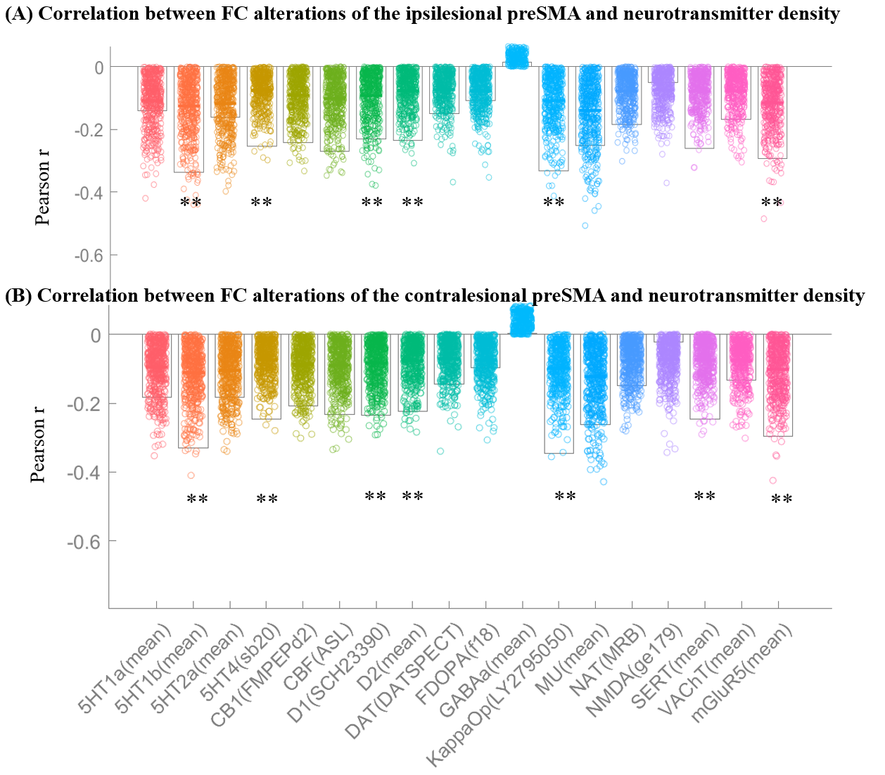
Figure S4: Correlations between FC alterations of the preSMA in PSA and neurotransmitter density. 5HT1a: 5-hydroxytryptamine receptor subtype 1a; 5HT1b: 5-hydroxytryptamine receptor subtype 1b; 5HT2a: 5-hydroxytryptamine receptor subtype 2a; CB1: Cannabinoid Receptor Type 1; CBF: Cerebral Blood Flow; KappaOp: Kappa Opioid Receptor; mGluR5: Metabotropic Glutamate Receptor 5. **: adjusted p < 0.01.

Table S5: Correlation of FC and neurotransmitters.
Ipsilesional preSMA | Neurotransmitters | R-value | p-value | adjusted p-value
 | 5HT4 | -0.25 | 6.99 × 10⁻³ | 4.62 × 10⁻²
 | SERT | -0.25 | 8.99 × 10⁻³ | 4.62 × 10⁻²
 | 5HT1b | -0.32 | 1.50 × 10⁻² | 4.62 × 10⁻²
 | D1 | -0.24 | 1.50 × 10⁻² | 4.62 × 10⁻²
 | D2 | -0.22 | 1.60 × 10⁻² | 4.62 × 10⁻²
 | mGluR5 | -0.30 | 1.80 × 10⁻² | 4.62 × 10⁻²
 | Kappaop | -0.35 | 5.00 × 10⁻³ | 4.62 × 10⁻²
 | CB1 | -0.21 | 4.10 × 10⁻² | 8.99 × 10⁻²
 | CBF | -0.23 | 4.50 × 10⁻² | 8.99 × 10⁻²
 | MU | -0.26 | 8.09 × 10⁻² | 1.46 × 10⁻¹
 | DAT | -0.14 | 1.03 × 10⁻¹ | 1.68 × 10⁻¹
 | NAT | -0.15 | 1.20 × 10⁻¹ | 1.72 × 10⁻¹
 | 5HT1a | -0.18 | 1.24 × 10⁻¹ | 1.72 × 10⁻¹
 | 5HT2a | -0.18 | 1.69 × 10⁻¹ | 2.07 × 10⁻¹
 | VAChT | -0.13 | 1.73 × 10⁻¹ | 2.07 × 10⁻¹
 | FDOPA | -0.10 | 2.96 × 10⁻¹ | 3.33 × 10⁻¹
 | NMDA | -0.02 | 7.75 × 10⁻¹ | 8.21 × 10⁻¹
 | GABAa | 0.01 | 9.62 × 10⁻¹ | 9.62 × 10⁻¹

Contralesional preSMA | Neurotransmitters map | R-value | p-value | adjusted  p-value
 | 5HT1b | -0.33 | 1.50 × 10⁻² | 4.62 × 10⁻²
 | 5HT4 | -0.25 | 6.99 × 10⁻³ | 4.62 × 10⁻²
 | D1 | -0.24 | 1.50 × 10⁻² | 4.62 × 10⁻²
 | D2 | -0.22 | 1.60 × 10⁻² | 4.62 × 10⁻²
 | Kappaop | -0.34 | 5.00 × 10⁻³ | 4.62 × 10⁻²
 | SERT | -0.25 | 8.99 × 10⁻³ | 4.62 × 10⁻²
 | mGluR5 | -0.30 | 1.80 × 10⁻² | 4.62 × 10⁻²
 | CB1 | -0.21 | 4.10 × 10⁻² | 8.99 × 10⁻²
 | CBF | -0.23 | 4.50 × 10⁻² | 8.99 × 10⁻²
 | MU | -0.26 | 8.09 × 10⁻² | 1.46 × 10⁻¹
 | DAT | -0.14 | 1.03 × 10⁻¹ | 1.68 × 10⁻¹
 | 5HT1a | -0.18 | 1.24 × 10⁻¹ | 1.72 × 10⁻¹
 | NAT | -0.15 | 1.20 × 10⁻¹ | 1.72 × 10⁻¹
 | 5HT2a | -0.18 | 1.69 × 10⁻¹ | 2.07 × 10⁻¹
 | VAChT | -0.13 | 1.73 × 10⁻¹ | 2.07 × 10⁻¹
 | FDOPA | -0.09 | 2.96 × 10⁻¹ | 3.33 × 10⁻¹
 | NMDA | -0.02 | 7.75 × 10⁻¹ | 8.21 × 10⁻¹
 | GABAa | 0.01 | 9.62 × 10⁻¹ | 9.62 × 10⁻¹

