Identification and investigation of the intrinsic receptor activation potential and metabolization of the new oxopyridyl synthetic cannabinoid receptor agonist CH-FUBBMPDORA
Marie H. Deventer¹, Maria Carmela Emanuele^{2,3}, Brianna N. Stang⁴, Katleen Van Uytfanghe¹, Jessica Masson⁵, Xavier Bouvot⁵, Catherine Lamoureux⁵, A. Proposito², Fabiano Reniero⁶, Margaret V. Holland⁶, Alex J. Krotulski⁴, Luisa Mannina³, Christophe P. Stove^{1*}, Claude Guillou^{6*}
¹Laboratory of Toxicology, Department of Bioanalysis, Faculty of Pharmaceutical Sciences, Ghent University, Ghent, Belgium.
²Ufficio Laboratori – Agenzia delle Dogane e dei Monopoli, Roma, Italy
³Food Chemistry Lab, Department of Chemistry and Technology of Drugs, Sapienza University of Rome, Rome, Italy
⁴Center for Forensic Science Research and Education, Fredric Rieders Family Foundation, Horsham, PA, 19044, USA.
⁵Service Commun de Laboratoire DGCCRF-DGCCI (SCL), Laboratoire de Paris, Massy, France
⁶European Commission, Joint Research Centre (JRC), Directorate F-Health and Food, Ispra, Italy
*corresponding authors

SCL = Customs Laboratory, France JRC= European Commission, Joint Research Centre, Italy
CONTENT
S1. Additional analytical techniques 2
S2. Gas chromatography – mass spectrometry (GC-MS) (SCL data processed by JRC) 3
S3. Liquid chromatography coupled to time-of-flight mass spectrometry (LC-QTOF-MS)
(SCL data processed by JRC) 4
S4. Fourier-transfer infrared spectroscopy (SCL data processed by JRC) 6
S5. Raman spectroscopy (SCL data processed by JRC) 7
S6. Low Field nuclear magnetic resonance (LF-NMR) correlation spectroscopy (COSY) (SCL data processed by JRC) 8
S7. Low Field nuclear magnetic resonance (LF-NMR) total correlation spectroscopy (TOCSY)
(SCL data processed by JRC) 9
S8. High field nuclear magnetic resonance spectroscopy (HF-NMR) – DMSO-d6 (JRC) 10
S9. High field nuclear magnetic resonance spectroscopy (HF-NMR) – CDCl₃ (JRC) 17
S10. “5CP” product information (SCL and JRC) 25
S11. High performance liquid chromatography coupled to diode-array detection (HPLC-DAD) (Ghent University, Belgium) 26
S12. Gas chromatography – mass spectrometry (GC-MS) (Ghent University, Belgium) 29
S13. Liquid chromatography coupled to time-of-flight mass spectrometry (LC-QTOF-MS) (Ghent University, Belgium) 32
S14. Additional NanoBiT® CB₁ assay results – contamination with a potent SCRA at low concentration (Ghent University, Belgium) 34
S15. Metabolite identification (CFSRE, United States) 35
S16. References 36
S1. Additional analytical techniques (SCL, Customs laboratory, France)
Gas Chromatography - Mass Spectrometry (GC-MS)
For GC-MS analysis, 2 mg of powder placed in a glass vial was dissolved in 1.5 ml of CH₂Cl₂ and methanol (50:50, v:v). The solution was homogenized for 1 minute with a vortex mixer. One µL of sample was injected on an Agilent 6890N GC system coupled to a 5975B mass detector operated by MSD Chemstation software. A 20 m x 0.18 mm i.d. x 0.18 µm Agilent HP-5-MS column was used. Split (20:1) injections were performed automatically at an injection temperature of 280 °C, with helium as a carrier gas at constant flow rate of 0.3 mL/min. The initial temperature was 100 °C, followed by an increase of 40 °C/min up to a maximum of 320 °C, which was held for 5.5 min. Transfer line temperature and ion source temperature were set to 300 and 230 °C, respectively. The MS quadrupole temperature was set to 150 °C and an ionization energy of 70 eV was used. The mass spectrometer operated in SCAN-mode in the range 33 to 550 Da.
Liquid Chromatography Coupled to Time-of-Flight Mass Spectrometry (LC-QTOF-MS)
One mg of powder was dissolved in 1 ml of water and acetonitrile (50:50, v:v) in a 2 ml glass vial to analyze using LC-QTOF-MS and the resulting solution was homogenized with a vortex mixer and then diluted to 1 μg/ml in water. The chromatographic separation was performed using a Bruker Elute LC system equipped with a Thermo Acclaim C18-column (2.2 µm, 2.1 x 100 mm) and a pre-column (Waters Acquity BEH C18), maintained at 30 °C. The solvents used were solvent A (100 ml of methanol and 900 ml of water with 100 µl of formic acid and 315 mg of ammonium formate) and solvent B (1 L of methanol with 100 µl of formic acid and 315 mg of ammonium formate). The solvent program started with 99% of solvent A for 1 min at a flow of 0.2 ml/min, followed by a decrease of the percentage of solvent A to reach 61% at 3 min. The percentage of solvent A was then decreased again to reach 0.1% after 14 min at a flow of 0.4 ml/min. It was held for 2 min and followed by a ramp to return at 99% of solvent A at 16.1 min, held for 2.9 min. The flow was then raised to 0.2 ml/min during 0.1 min and held for 0.9 min. The high-resolution mass spectrometry (HRMS) system used was an Impact II QTOF with an electrospray ionization (ESI positive ionization) source and running with the Compass software, both from Bruker. As a result, a TOF-MS full scan was obtained, combined with a data dependent acquisition of product ion spectra.
Fourier transform infrared spectroscopy (FTIR)
FTIR analysis was performed directly on the powder, using an Alpha-FTIR instrument from Bruker, equipped with an attenuated total reflection (ATR) unit. A series of 24 scans were recorded with a resolution of 2.04 cm⁻¹in the spectral range from 599-3497 cm⁻¹.
Raman spectroscopy
The Raman spectrum was acquired with a handheld RSQ Rigaku with an excitation laser at 1064 nm and a spectral range between 94.1 - 2460.7cm⁻¹.
S2. Gas chromatography - mass spectrometry (GC-MS) (SCL data processed by JRC)

S3. Liquid chromatography coupled to time-of-flight mass spectrometry (LC-QTOF-MS)
(SCL data processed by JRC)

S4. Fourier-transfer infrared spectroscopy (SCL data processed by JRC)

S5. Raman spectroscopy (SCL data processed by JRC)

S6. Low Field nuclear magnetic resonance (LF-NMR) correlation spectroscopy (COSY) (SCL data processed by JRC)

S7. Low Field nuclear magnetic resonance (LF-NMR) total correlation spectroscopy (TOCSY) (SCL data processed by JRC)
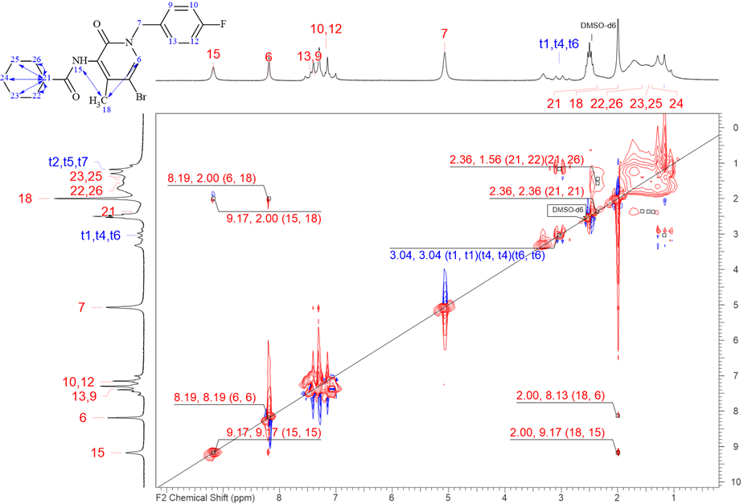

S8. High field nuclear magnetic resonance spectroscopy (HF-NMR) – DMSO-d6 (JRC)
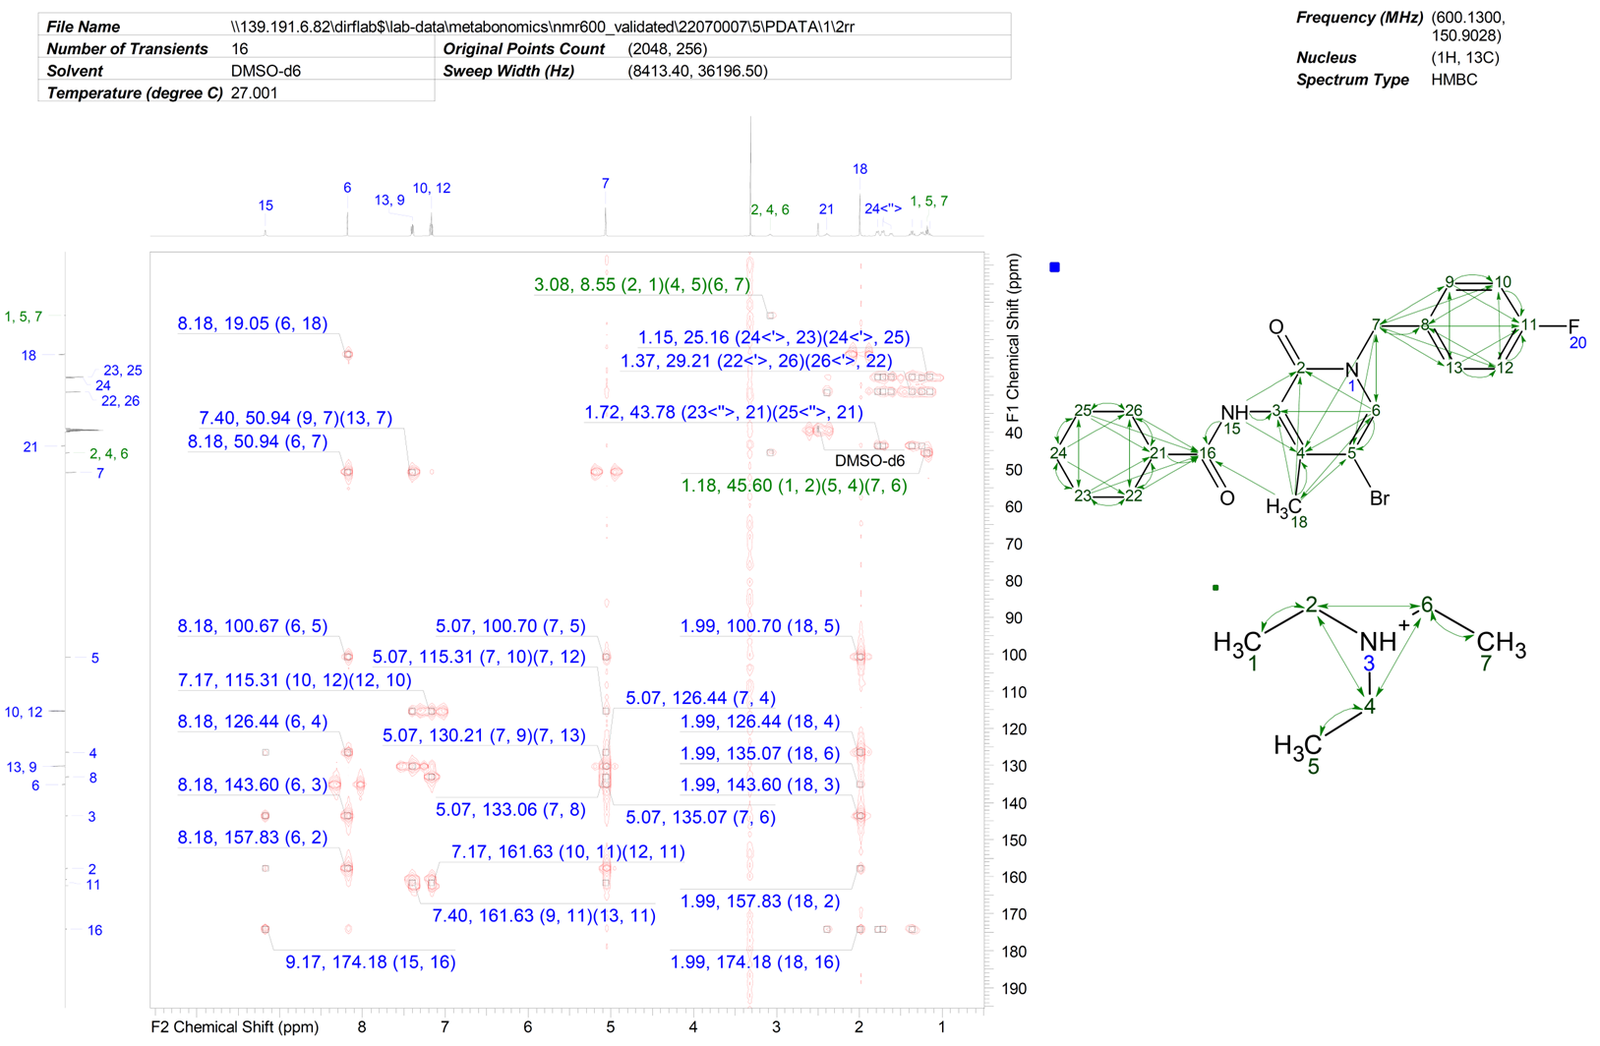

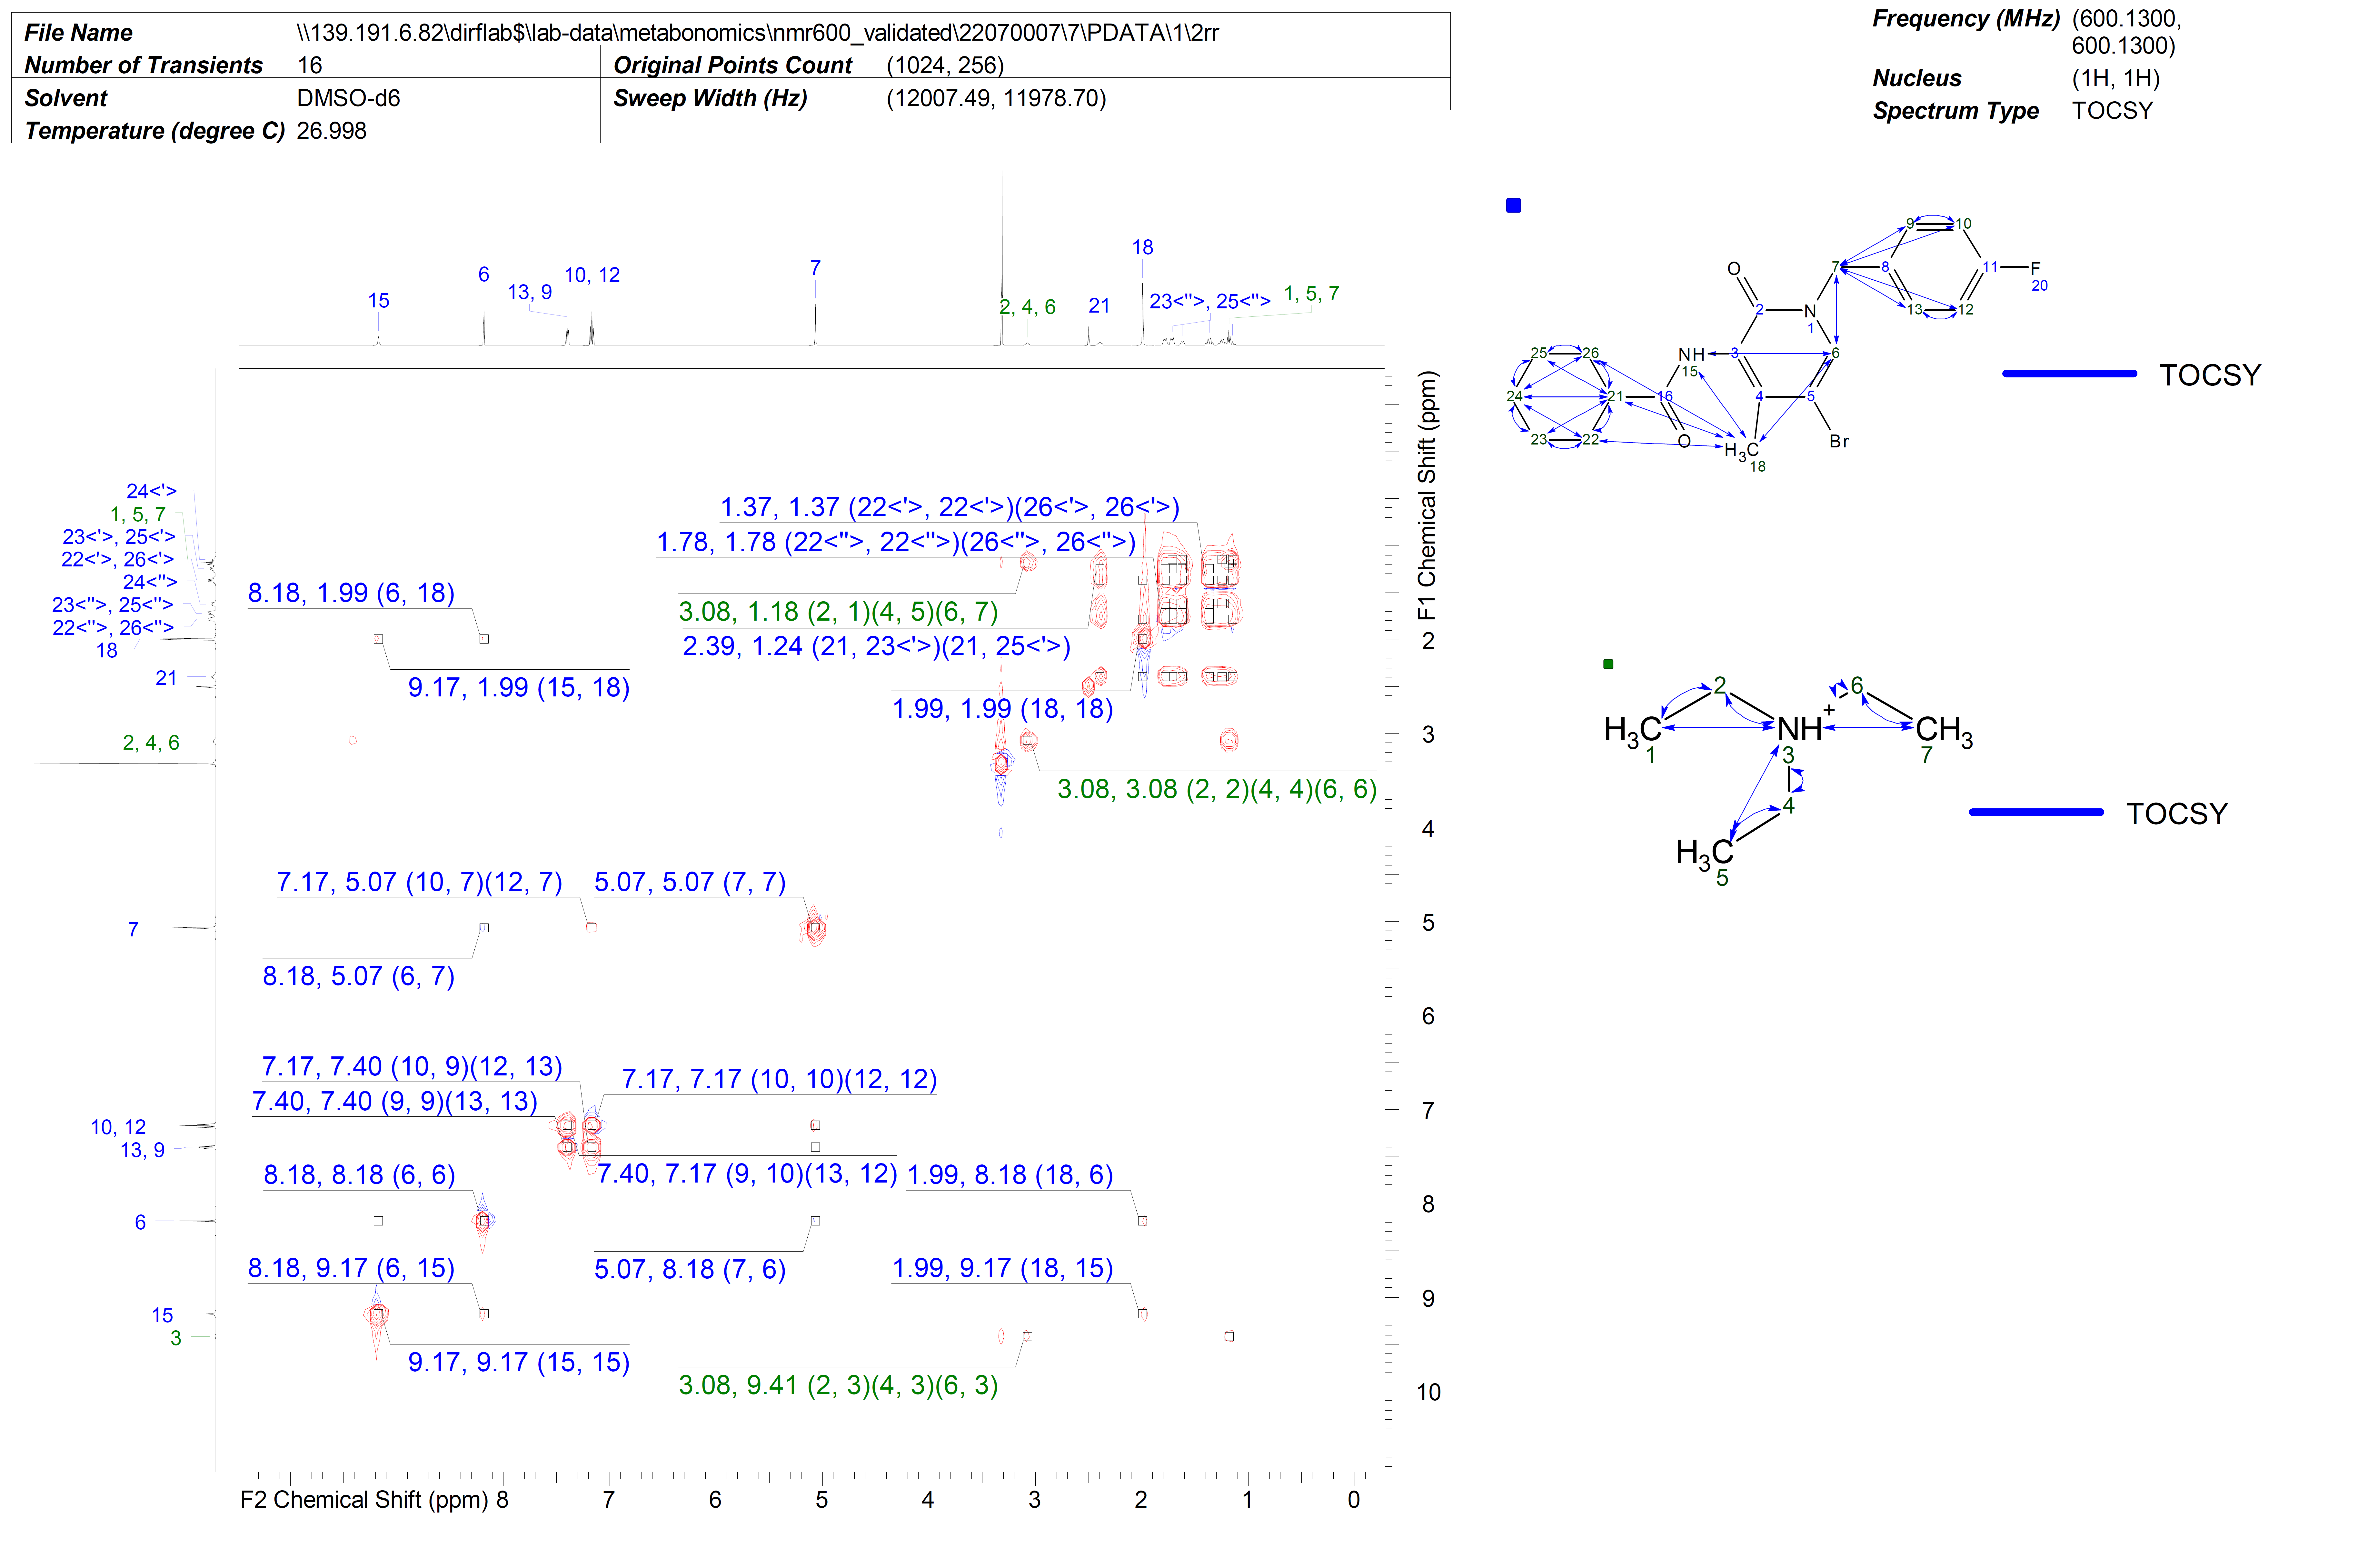
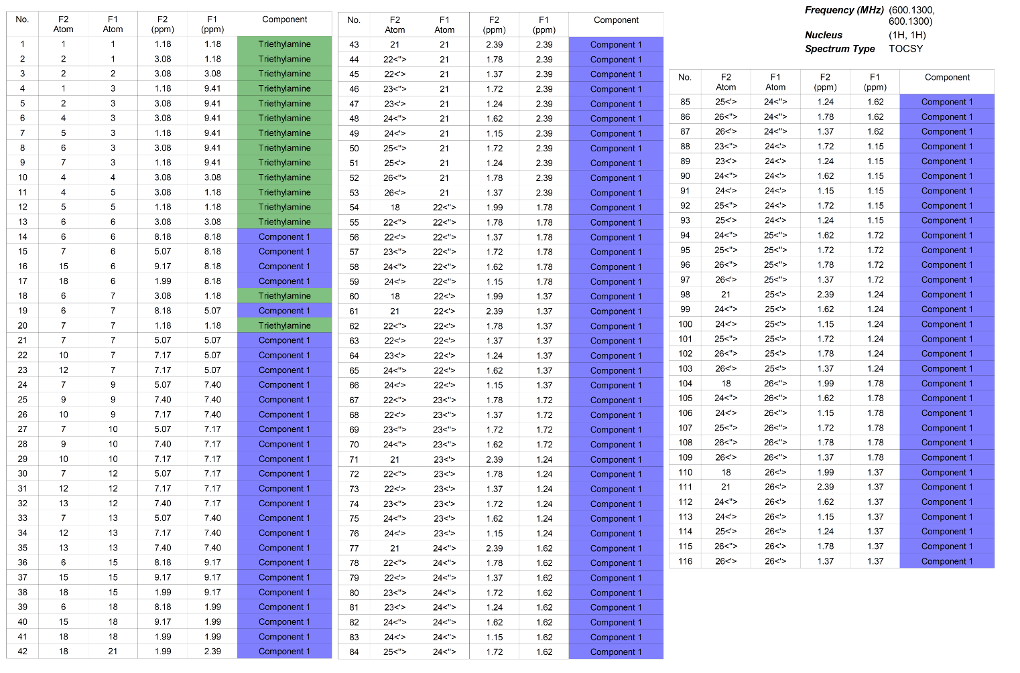

S9. High field nuclear magnetic resonance (HF-NMR) - CDCl₃ (JRC)

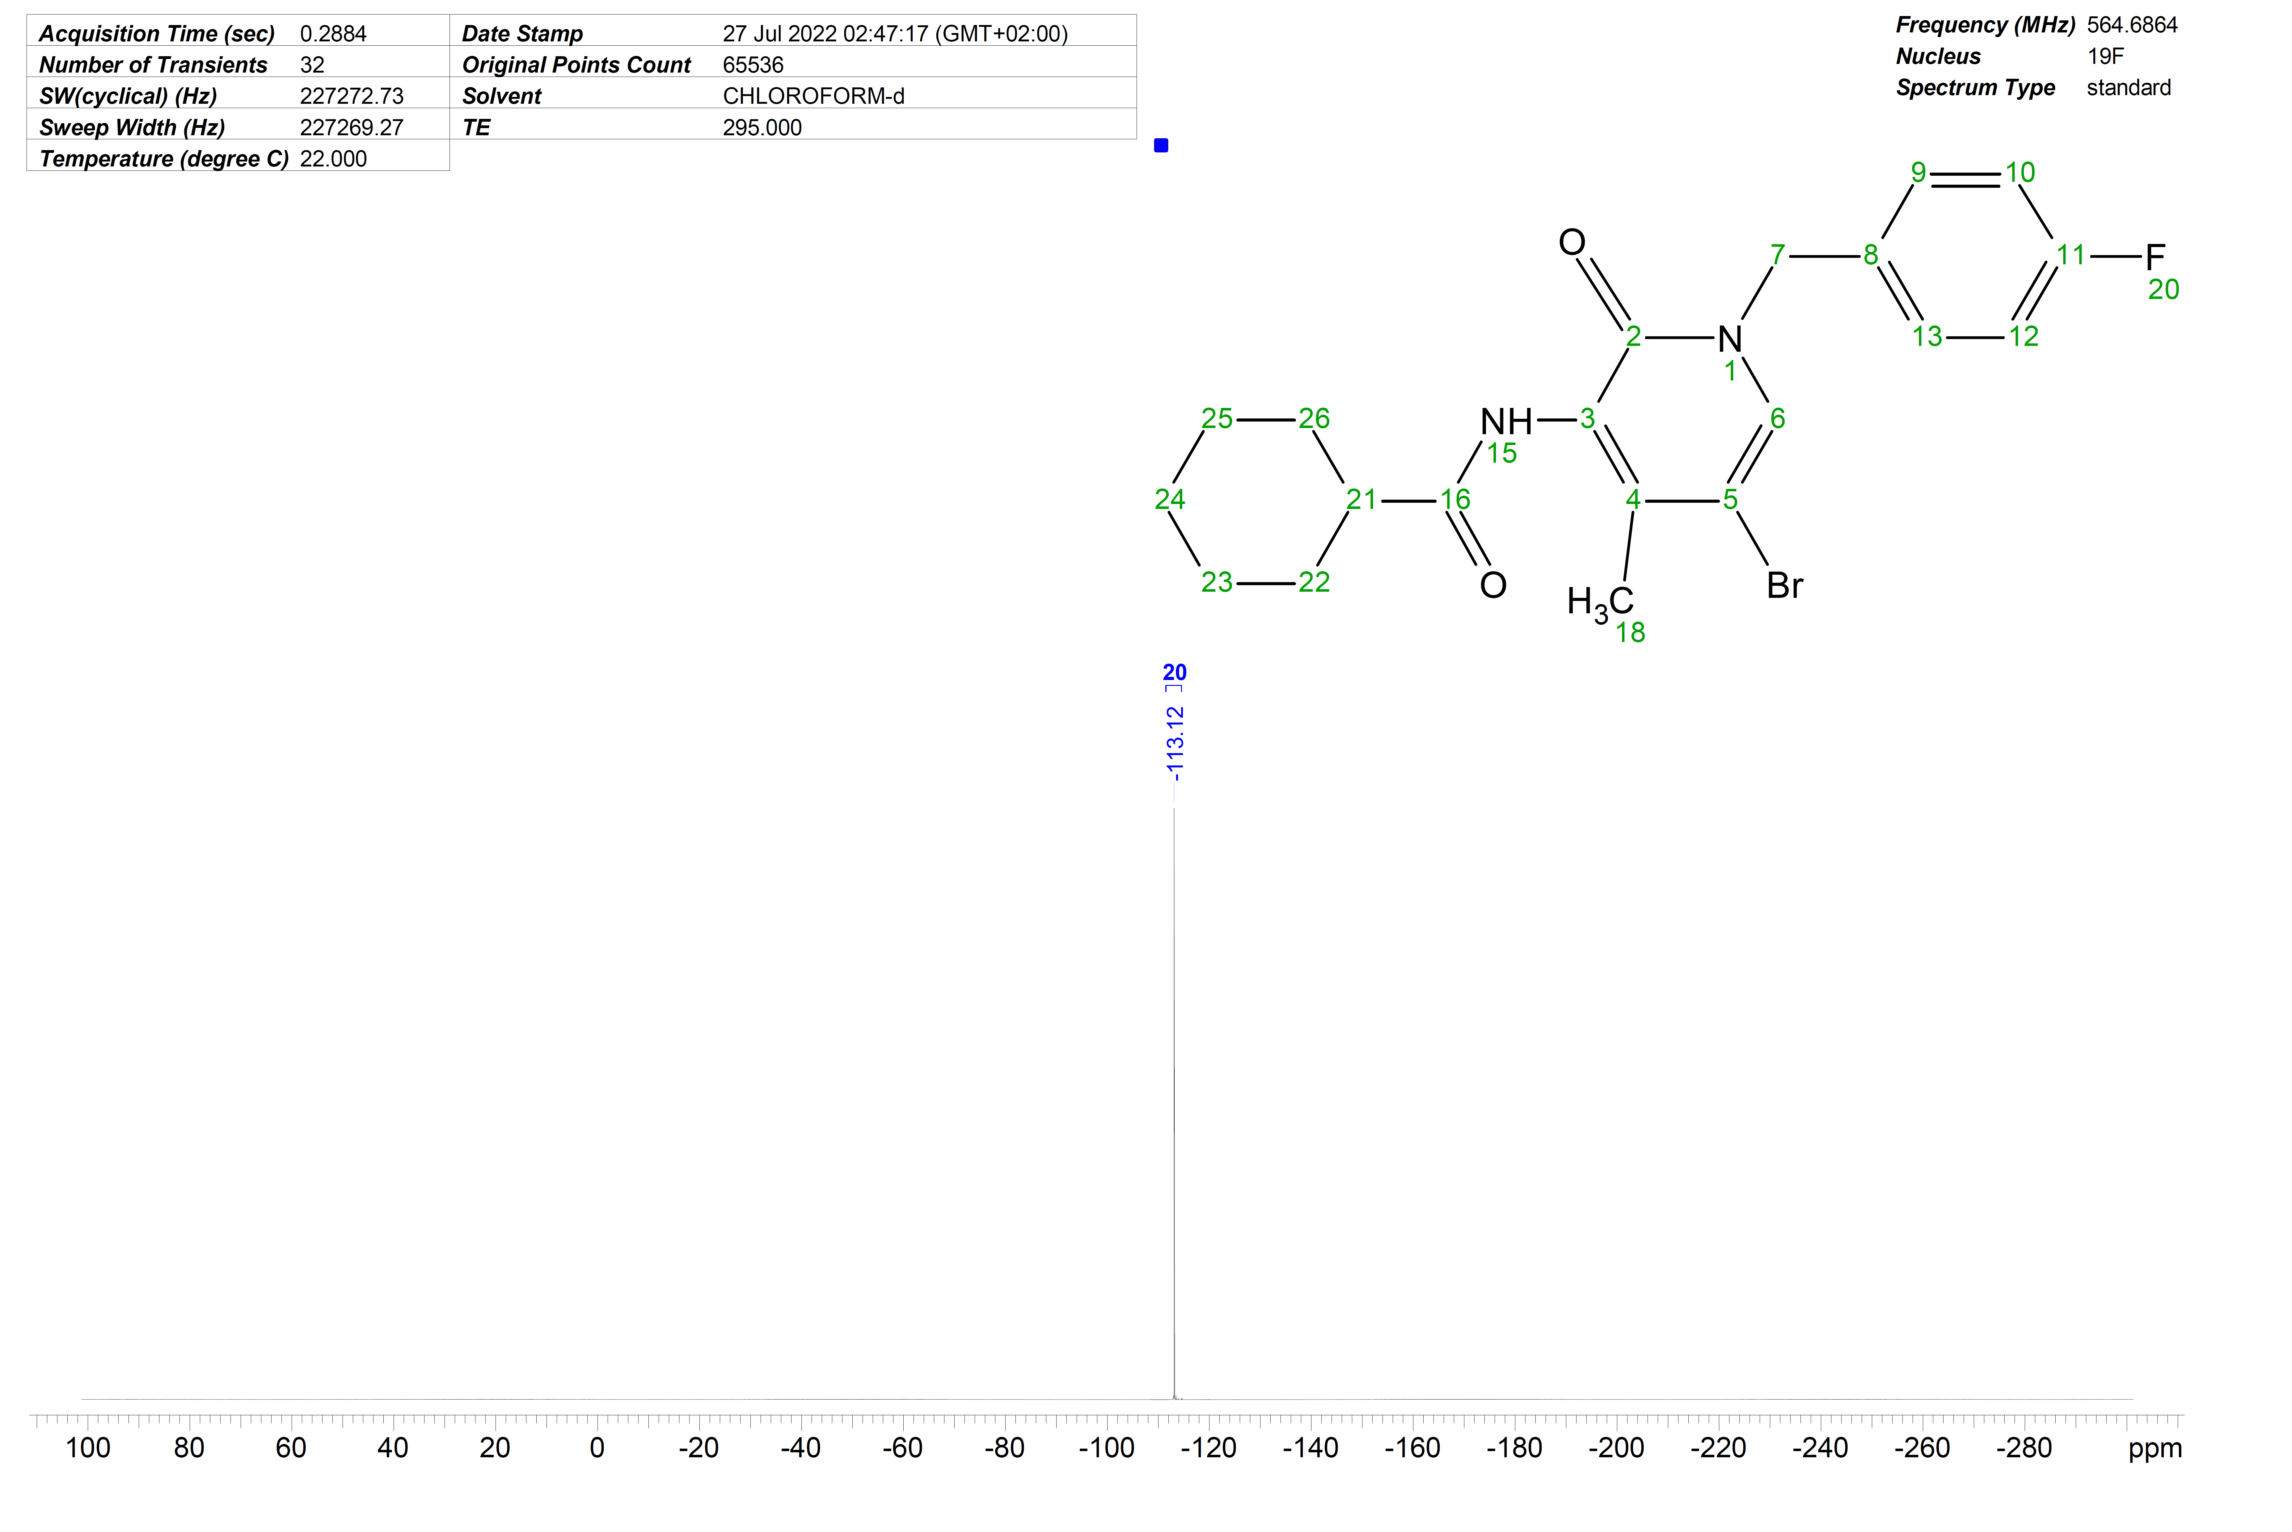
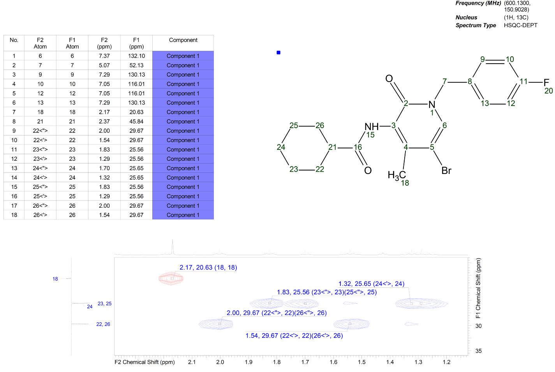

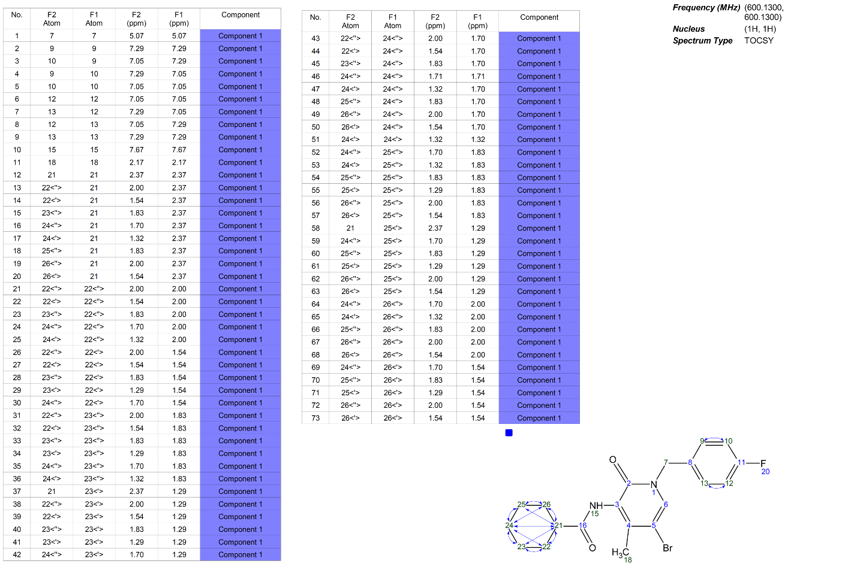

Overall conclusion NMR analyses:
The NMR analyses in CDCl₃ are consistent with the chemical structure previously identified through NMR analyses in DMSO-d6 (S7).
The presence of triethylamine is observable in NMR spectra recorded in both deuterated solvents. The intensities measured in the proton NMR spectra for both DMSO-d6 and CDCl₃ indicate a molar proportion of about 10% of triethylamine in the sample (corresponding to 2.4% w/w).

S10. “5CP” product information
The following information was found on an NPS vendor web site (https://gr8researchchemicals-eu.com/), which has been dismissed in the meantime.

S11. High performance liquid chromatography coupled to diode-array detection (HPLC-DAD) (Ghent University, Belgium)
Method
A total of 1 µg of either CH-FUBBMPDORA or seized sample (volume 50 µL) was injected into the system. Reversed-phase separation was performed on a Nexera XR UHPLC system from Shimadzu (Kyoto, Japan), using a Merck Purospher® Star RP-8 endcapped column (5 µM, 125 mm x 4.6 mm) with a Merck Purospher® Star RP-8 endcapped guard column (5 µM, 4 mm x 4 mm). Settings were as previously published in Blanckaert et al^{[1]}. The mobile phase consisted of methanol-water containing 150 mM phosphate buffer (pH 2.3), following a gradient of 5:95 to 95:5 (v/v) within 30 min. A photodiode array detector (SPD-M40, Shimadzu) was used to monitor a wavelength from 220 to 350 nM with a slit of 1 nm, a spectral bandwidth of 1 nm and a spectral interval of 200 ms. The selected wavelength used to display the chromatographic trace spectrum was 230 nm.

Results
CH-FUBBMPDORA
Chromatogram
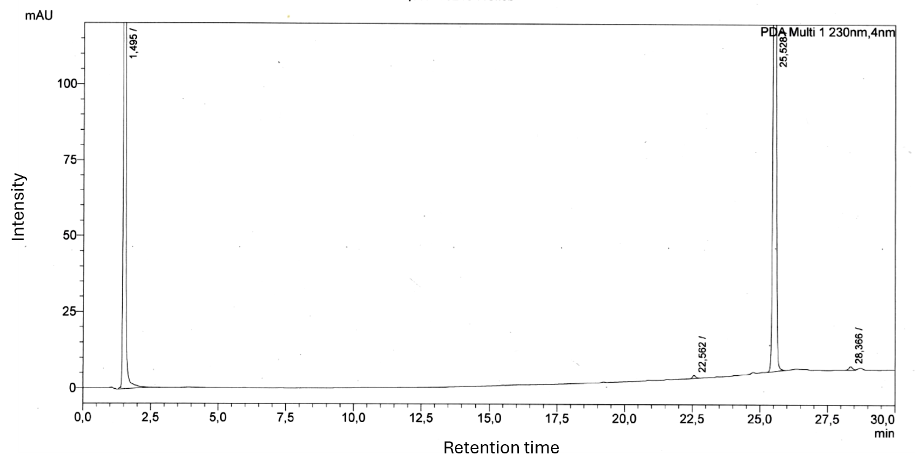

DAD spectrum
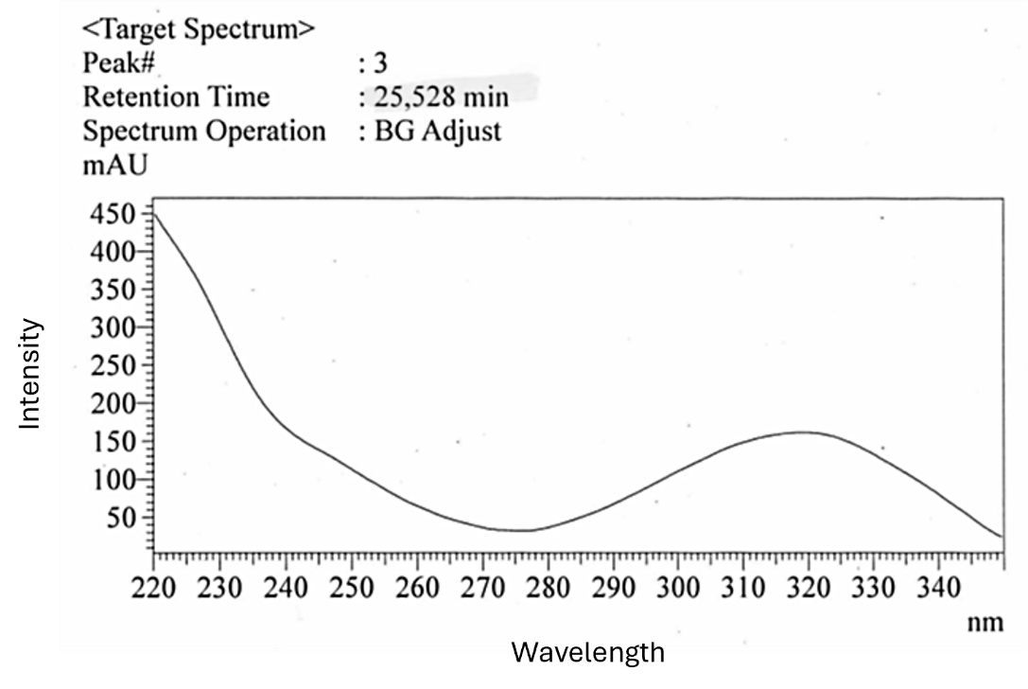

Seized powder
Chromatogram
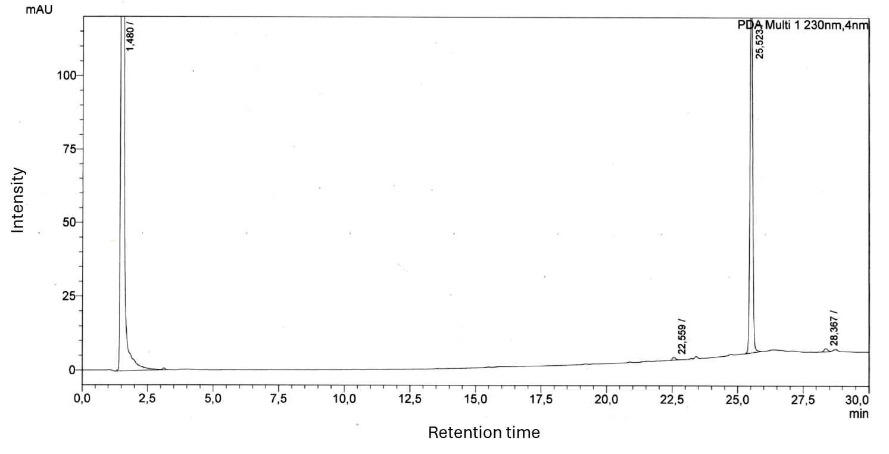

DAD spectrum
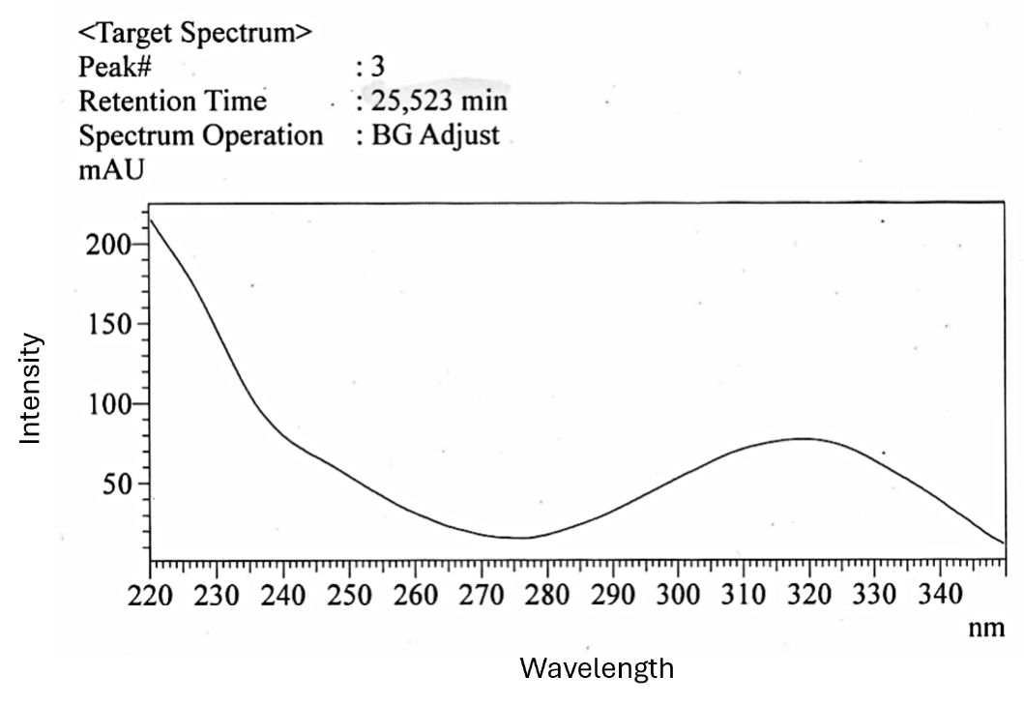

S12. Gas chromatography – mass spectrometry (GC-MS) (Ghent University, Belgium)
Method
GC-MS analyses were performed on both the CH-FUBBMPDORA reference standard and the seized sample, as described before^{[1]}. One µL of sample (1 mg/mL) was injected on an Agilent 7890A GC system (column: 30 m x 0.25 mm i.d. x 0.25 µm Agilent HP-5-MS) coupled to a 5975 XL mass-selective detector operated by MSD Chemstation software. Splitless injections were performed automatically at an injection temperature of 250 °C and purge time of 1 minute, with helium as a carrier gas at constant flow rate of 1 mL/min. The temperature program started at 80 °C for 1 min. The temperature was then raised by 20 °C/min to 200 °C, followed by an increase at 4 °C/min to 260 °C and then by 30 °C/min to 300 °C, which was then held for an additional 8 minutes. The transfer line temperature and the ion source temperature were set at 300 °C and 230 °C, respectively. MS quadrupole temperature was set at 150 °C and an ionization energy of 70 eV was used. The mass spectrometer operated in SCAN-mode (scanning range 50 to 700 Da).

Results
CH-FUBBMPDORA
Chromatogram

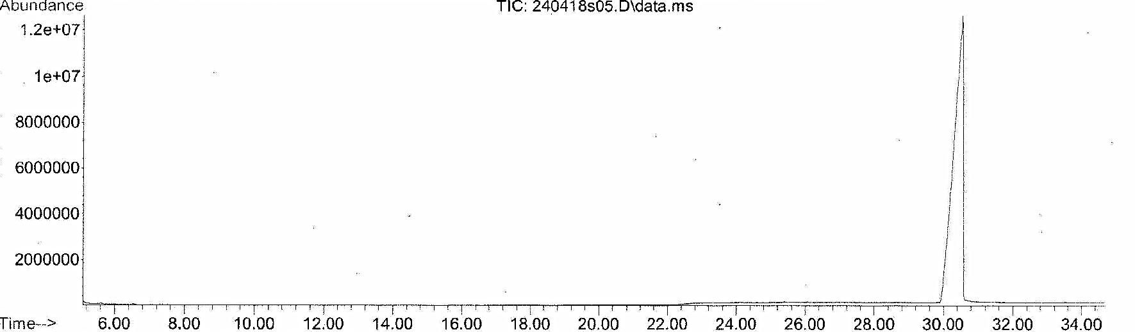

GC-MS spectrum

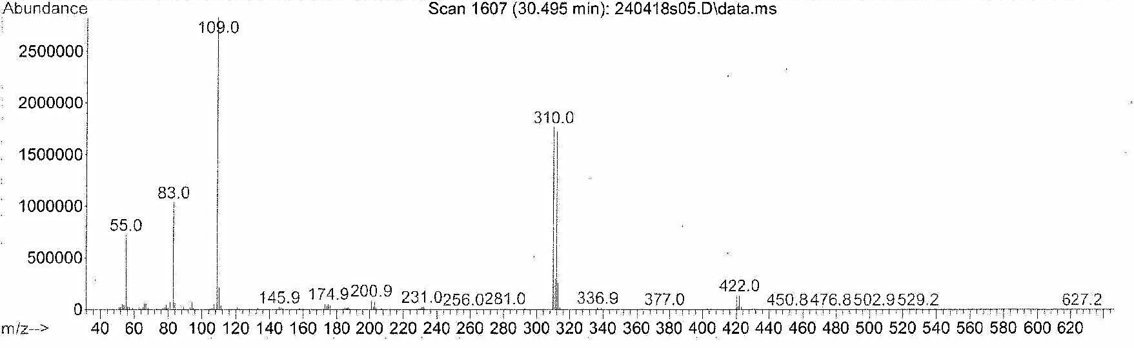
Note: the GC-MS spectrum is in line with data published by the CFSRE^{[2]} and the National Forensic Laboratory of Slovenia^{[3]}.

Seized powder
Chromatogram

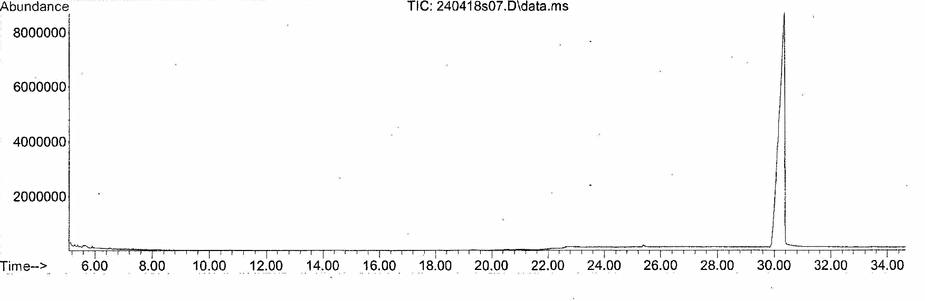
GC-MS spectrum

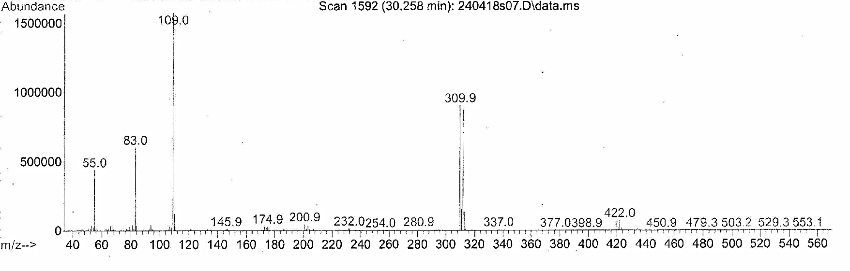

S13. Liquid chromatography coupled to time-of-flight mass spectrometry (LC-QTOF-MS) (Ghent University, Belgium)
Method
LC-QTOF-MS analysis of a sample of a seized powder was performed as published before^{[1,4,5]}.
To prepare the seized powder sample for LC-QTOF-MS analysis, a 1 mg/mL solution was diluted 20-fold in a mixture of 12.5% ACN/MeOH (50:50) in water. The sample was measured with the routine cannabinoid method of the Laboratory of Toxicology. Chromatographic separation was performed using an Agilent 1290 Infinity LC system equipped with a Phenomenex Kinetex C18-column (2.6 µm, 3 x 50 mm) (Woerden, The Netherlands), maintained at 30 °C. The injection volume was 20 µL and the total LC run time was 9 min using the following gradient (flow rate: 0.4 mL/min): mobile phase B starting at 50%, linearly increasing to 98 % in 5 min, further increasing to 100 % in 0.1 min, held for 1.9 min at 100% and then decreased to the starting conditions and held for re-equilibration for 2 min. Mobile phase A consisted of 0.05% (V/V) formic acid and 5 mM ammonium formate in water, whereas mobile phase B was 0.05% (V/V) formic acid in 50/50 MeOH/CAN. The autosampler was kept at 10 °C. The high-resolution mass spectrometry (HRMS) system used was a 5600+ QTOF system with electrospray ionization (ESI) source from SCIEX (Halle, Belgium). . QTOF-MS settings were the same as published before except for the scanning range, which covered 50 – 700 Da. As a result, a TOF-MS full scan was obtained, combined with a data dependent acquisition of product ion spectra. SCIEX Analyst TF 1.8.1 software (Toronto, Canada) was used to steer the system. Analytical data analysis was performed using the SCIEX PeakView 2.2 software (Toronto, Canada).

Results
CH-FUBBMPDORA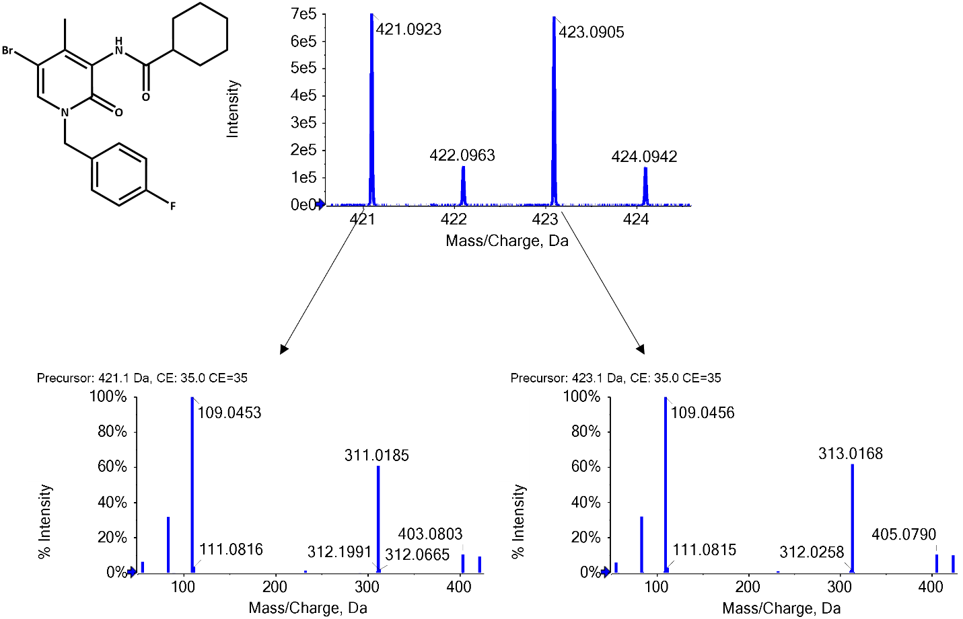
Note: The mass spectrum is in line with data published by the CFSRE for CH-FUBBMPDORA^{[2]}.
Impurity 1 (4.29 %ª)

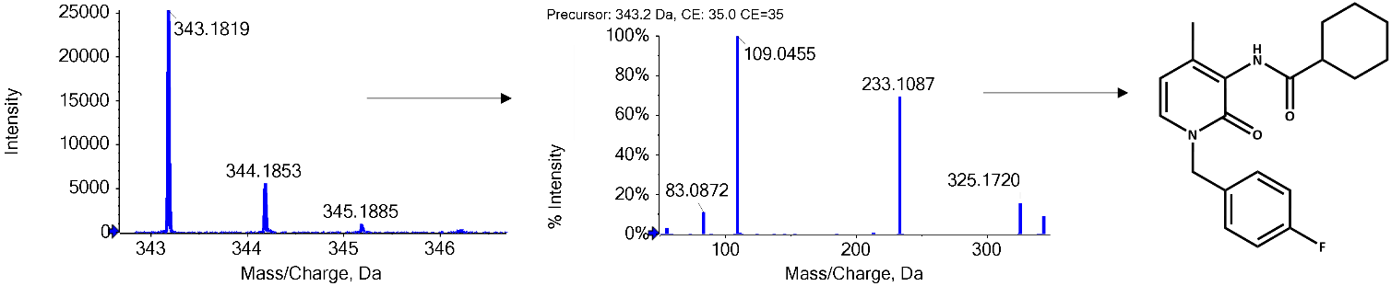

Impurity 2 (0.32 %ª)
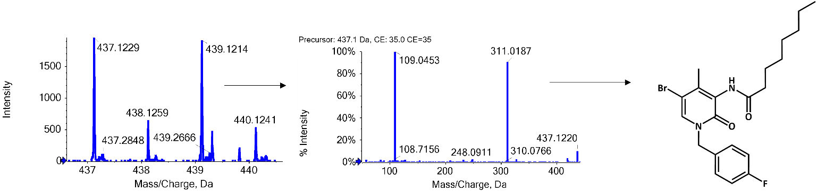
ªValues quantify the amount of impurity present in the sample relative to the amount of main compound CH-FUBBMPDORA (assuming all impurities ionize to the same extent as CH-FUBBMPDORA) and are calculated by comparing the AUC of the impurities and AUC of the peak of CH-FUBBMPDORA.

S14. Additional NanoBiT® CB₁ assay results – contamination with a potent SCRA at low concentration (Ghent University, Belgium)
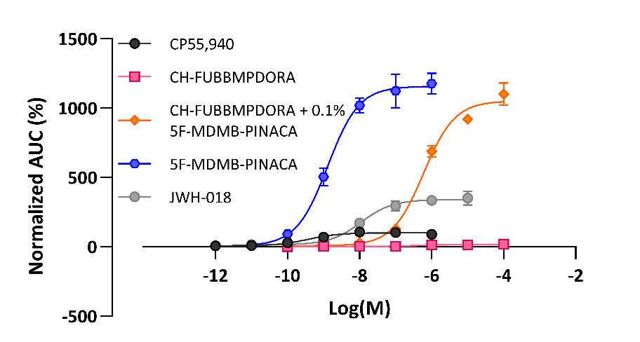
Concentration-response curves of pure CH-FUBBMPDORA (pink), pure 5F-MDMB-PINACA (blue) and a combination of CH-FUBBMPDORA with 5F-MDMB-PINACA, the latter present at 0.1%. Data points represent the AUC ± standard error of the mean (SEM), run in duplicate in minimally three independent experiments.

S15. Metabolite identification of CH-FUBBMPDORA (CFSRE, United States)
Fragmentation (MS/MS) spectrum for CH-FUBBMPDORA (P.0)
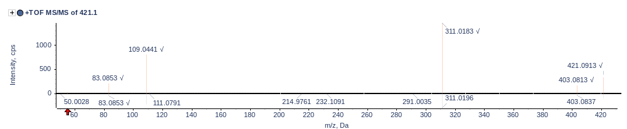
Fragmentation (MS/MS) spectrum for M.1 (Oxidation [Head])
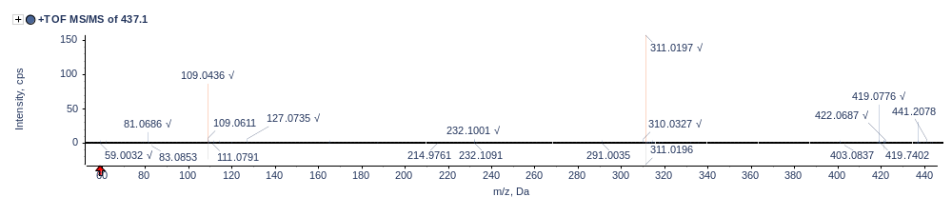
Figure 3: Fragmentation (MS/MS) spectrum for M.2 (Oxidation [Head])
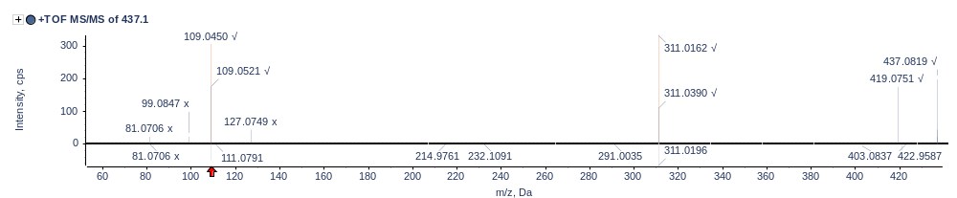
Figure 4: Fragmentation (MS/MS) spectrum for M.3 (Oxidation [Head])
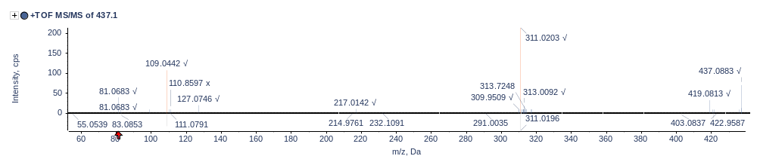

Figure 5: Fragmentation (MS/MS) spectrum for M.4 (Oxidation [Core/Linker])
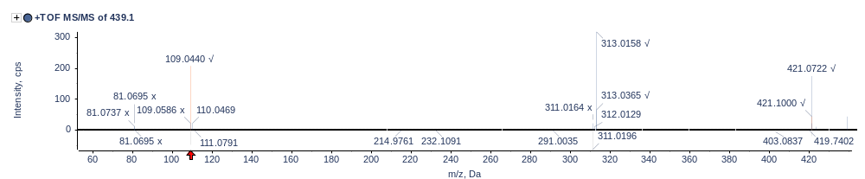
S16. References

[1] P. Blanckaert, A. Cannaert, K. Van Uytfanghe, F. Hulpia, E. Deconinck, S. Van Calenbergh, C. Stove. Report on a novel emerging class of highly potent benzimidazole NPS opioids: Chemical and in vitro functional characterization of isotonitazene. Drug Test Anal, 2020, 12, 422–430.
[2] A. J. Krotulski, R. Newman, M. Gilbert, R. Schelkun, D. M. Iula, S. E. Walton, J. DeBord, M. F. Fogarty, B. K. Logan. CHO-4’Me-5’Br-FUBOXPYRA - NPS Discovery New Drug Monograph, The Center For Forensic Science Research & Education, 2023.
[3] National Forensic Laboratory Slovenia. Analytical Report CH-FUBBMPDORA (C20H22BrFN2O2), Ljubljana, Slovenia, 2023.
[4] K. L. Thoren, J. M. Colby, S. B. Shugarts, A. H. B. Wu, K. L. Lynch. Comparison of Information-Dependent Acquisition on a Tandem Quadrupole TOF vs a Triple Quadrupole Linear Ion Trap Mass Spectrometer for Broad-Spectrum Drug Screening. Clinical Chemistry, 2016, 62, 170–178.
[5] L. K. Janssens, K. Van Uytfanghe, J. B. Williams, K. W. Hering, D. M. Iula, C. P. Stove. Investigation of the intrinsic cannabinoid activity of hemp-derived and semisynthetic cannabinoids with β-arrestin2 recruitment assays—and how this matters for the harm potential of seized drugs. Arch Toxicol, 2024, DOI 10.1007/s00204-024-03769-4.

