Supplementary Table 1:

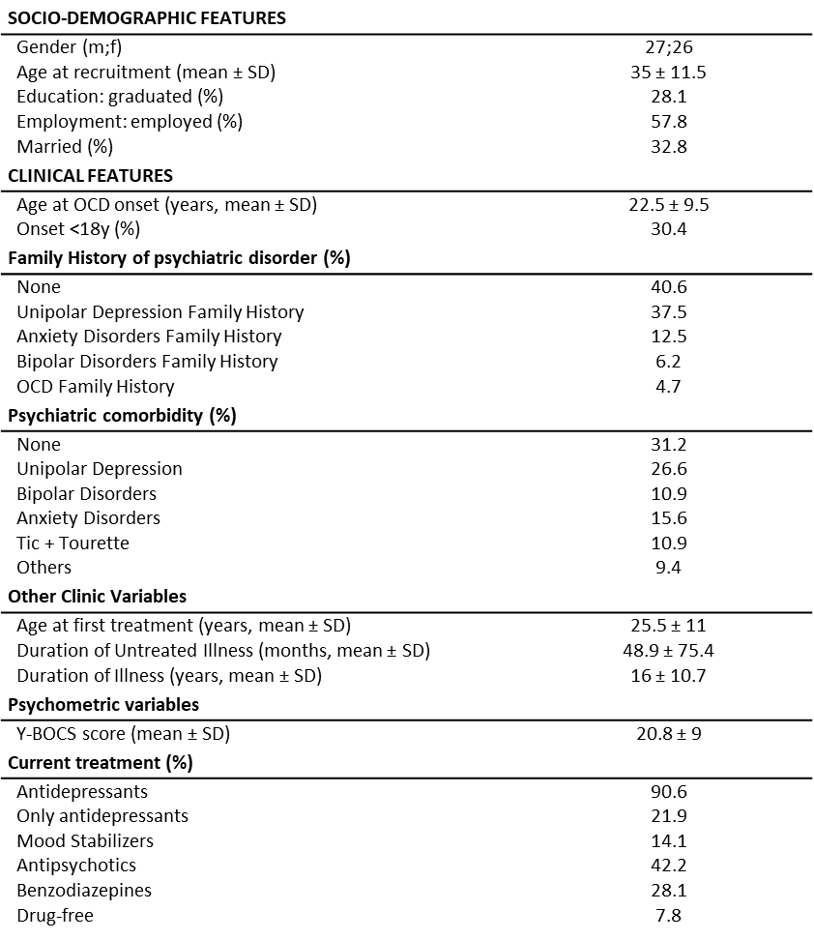

Supplementary Table 2:

Gene | Sequence
Human | Forward | Reverse
GAPDH | CAGCCTCAAGATCATCAGCA | TGTGGTCATGAGTCCTTCCA
β -ACT | GACCCAGATCATCAGCA | CCATCACGATGCCAGTGG
CNR1 | CCTTTTGCTGCCTAAATCCAC | CCACTGCTCAAACATCTGAC
CNR2 | AAGGATGGCTTGGATTCC | ATGCAAAGACCACACTGG
FAAH | CCCAATGGCTTAAAGGACTG | ATGAACCGCAGACACAAC
MAGL | ATGCAGAAAGACTACCCTGGGC | TTATTCCGAGAGAGCACGC
DAGLα | GCCACCAAGAGGAGGCAGCG | CCGCGTGCAGCAGAGGAACA
NAPE-PLD | TTGTGAATCCGTGGCCAACATGG | TACTGCGATGGTGAAGCACG
Rat
Gapdh | AGACAGCCGCATCTTCTTGT | CTTGCCGTGGGTAGAGTCAT
β-Act | AGATCAAGATCATTGCTCCTCCT | ACGCAGCTCAGTAACAGTCC
Cnr1 | TTCCACCGTAAAGACAGCCC | TCCACATCAGGCAAAAGGCC
Cnr2 | TTGACCGATACCTATGTCTGTGC | TGCTTTCCAGAGGACATACCC
Faah | TGACAACTATACCATGCCCAGC | TAAGAAGGGAATCAGCGTGTGG
Magl | ACGTGAACACCGTCCAGAAG | TTGGCAGCAAGGACCTTCAA
Daglα | ATTCTCTCCTTCCTCCTGC | ATTTGGGCTTGGTGCTTCG
Nape-pld | TGTCCCGGGTTCCAAAGAGGAGC | ACCATCAGCGTCGCGTGTCC

Supplementary Table 3:

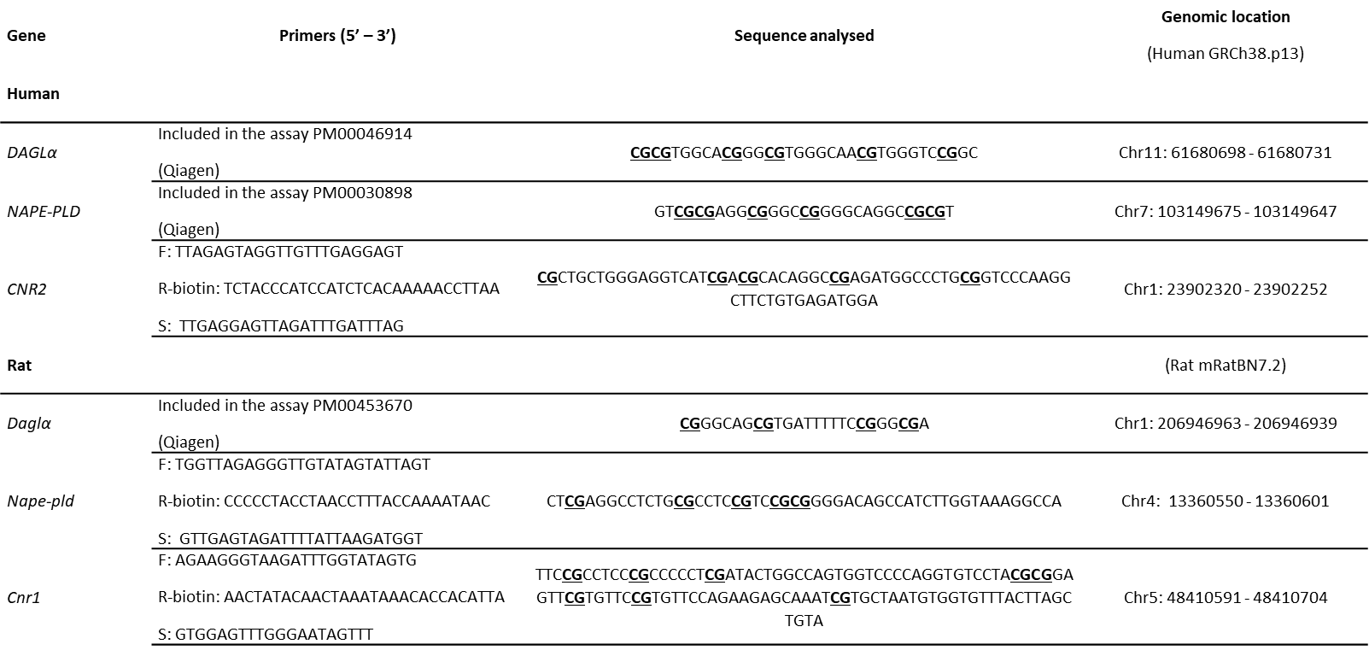

Supplementary Table 4:

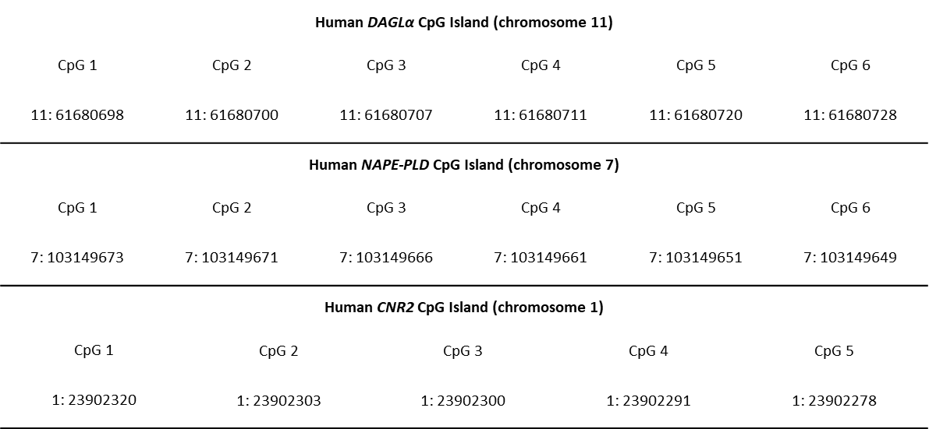

Supplementary Table 5:

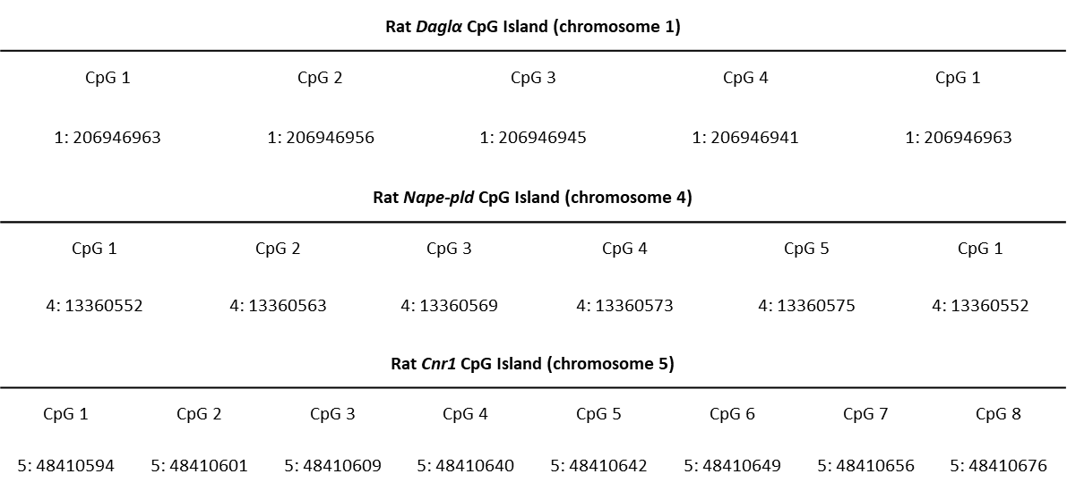

Supplementary Table 6:

Gene | CTRL  (Mean ± SEM) | OCD  (Mean ± SEM) | p value
CNR1 | 1.35 ± 0.21 | 1.47 ± 0.37 | 0.3682
CNR2 | 1.09 ± 0.12 | 0.76 ± 0.07 | 0.0263*
FAAH | 1.27 ± 0.24 | 0.91 ± 0.15 | 0.9102
MAGL | 1.07 ± 0.09 | 1.15 ± 0.12 | 0.7979
DAGLα | 1.07 ± 0.08 | 0.74 ± 0.06 | 0.0056**
NAPE-PLD | 1.37 ± 0.20 | 0.72 ± 0.15 | 0.0253*

Supplementary Table 7:

NAPE-PLD  CpG sites | CTRL  (Mean ± SEM) | OCD  (Mean ± SEM) | p value
1 | 5.22 ± 0.19 | 6.41 ± 0.44 | 0.074
2 | 2.84 ± 0.09 | 3.50 ± 0.28 | 0.135
3 | 6.31 ± 0.22 | 8.06 ± 0.48 | 0.001
4 | 3.91 ± 0.13 | 4.65 ± 0.25 | 0.048
5 | 5.30 ± 0.13 | 6.28 ± 0.34 | 0.088
6 | 1.08 ± 0.04 | 1.26 ± 0.06 | 0.158
Average | 4.11 ± 0.12 | 5.02 ± 0.30 | 0.020

Supplementary Table 8:

DAGLα  CpG sites | CTRL  (Mean ± SEM) | OCD  (Mean ± SEM) | p value
1 | 6.96 ± 0.29 | 6.37 ± 0.19 | 0.267
2 | 6.42 ± 0.35 | 6.34 ± 0.22 | >0.999
3 | 7.88 ± 1.04 | 6.16 ± 0.22 | 0.530
4 | 7.64 ± 0.45 | 8.25 ± 0.29 | 0.944
5 | 7.80 ± 0.27 | 7.65 ± 0.22 | 0.999
6 | 33.66 ± 0.49 | 32.40 ± 0.56 | 0.554
Average | 11.73 ± 0.25 | 11.24 ± 0.24 | 0.762

Supplementary Table 9:

CNR2  CpG sites | CTRL  (Mean ± SEM) | OCD  (Mean ± SEM) | p value
1 | 67.29 ± 6.14 | 61.03 ± 7.46 | 0.995
2 | 76.40 ± 5.67 | 61.58 ± 8.01 | 0.641
3 | 63.91 ± 6.71 | 64.66 ± 6.85 | 0.999
4 | 82.44 ± 5.73 | 79.35 ± 5.33 | 0.957
5 | 55.09 ± 4.52 | 45.96 ± 5.27 | 0.815
Average | 69.03 ± 4.78 | 62.52 ± 5.63 | 0.883

Supplementary Table 10:

Gene | CTRL  (Mean ± SEM) | MAT-HET  (Mean ± SEM) | p value
Prefrontal cortex
Cnr1 | 1.142 ± 0.18 | 1.011 ± 0.09 | 0.6842
Cnr2 | 1.214 ± 0.25 | 1.067 ± 0.22 | 0.7197
Faah | 1.107 ± 0.14 | 1.196 ± 0.34 | 0.7197
Magl | 1.088 ± 0.16 | 1.195 ± 0.31 | 0.4813
Daglα | 1.081 ± 0.14 | 0.589 ± 0.12 | 0.0161*
Nape-pld | 1.025 ± 0.07 | 1.139 ± 0.26 | 0.9682
Amygdala
Cnr1 | 1.148 ± 0.19 | 0.472 ± 0.08 | 0.0041**
Cnr2 | 1.190 ± 0.25 | 1.332 ± 0.28 | 0.8421
Faah | 1.196 ± 0.25 | 0.872 ± 0.14 | 0.6607
Magl | 1.192 ± 0.27 | 1.361 ± 0.27 | 0.4967
Daglα | 1.070 ± 0.17 | 0.360 ± 0.20 | 0.0789
Nape-pld | 1.138 ± 0.20 | 0.616 ± 0.06 | 0.0277*

Supplementary Table 11:

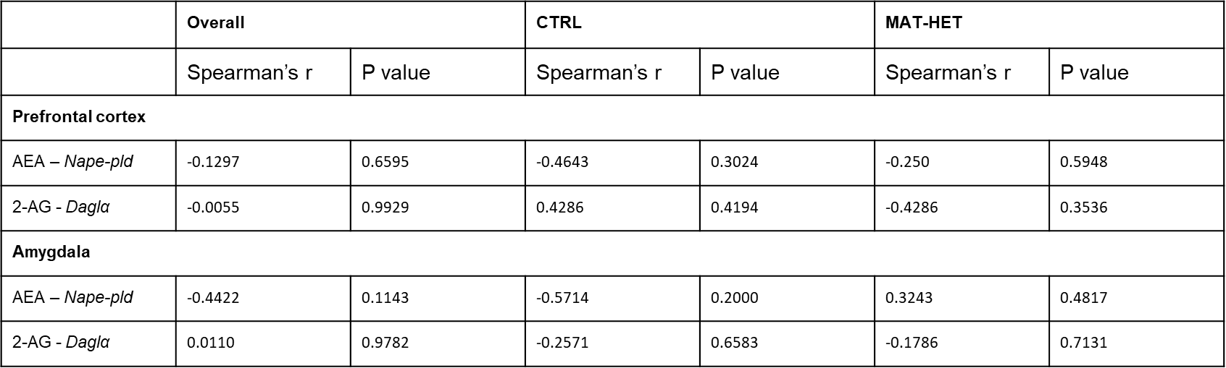

Supplementary Table 12:

 | CTRL  (Mean ± SEM) | MAT-HET  (Mean ± SEM) | p value
Prefrontal cortex
Oxtr | 1.309 ± 0.53 | 2.09 ± 0.67 | 0.3290
Bdnf | 1.048 ± 0.14 | 1.329 ± 0.18 | 0.3290
Amygdala
Oxtr | 1.148 ± 0.19 | 0.472 ± 0.08 | 0.9705
Bdnf | 1.323 ± 0.35 | 1.593 ± 0.31 | 0.4470

