Supplementary Figures

Genetic influences for distinct impulsivity domains are differentially associated with early substance use initiation: Results from the ABCD Study

Ethan Kinstler¹, Aaron J. Gorelik¹, Sarah E. Paul¹, Adamya Aggarwal¹, Emma C. Johnson², Melissa A. Cyders³, Arpana Agrawal², Ryan Bogdan¹, Alex P. Miller⁴

1. Department of Psychological & Brain Sciences, Washington University in Saint Louis, St. Louis, MO
2. Department of Psychiatry, Washington University School of Medicine, St. Louis, MO
3. Department of Psychology, Indiana University Indianapolis, Indianapolis, IN
4. Department of Psychiatry, Indiana University School of Medicine, Indianapolis, IN

Table of Contents

Supplementary Figure 1: Overlap among endorsement of alcohol, nicotine, and cannabis use initiation.
Supplementary Figure 2: Baseline UPPS-P mediating lack of perseverance PGS association with alcohol use initiation.
Supplementary Figure 3: Baseline UPPS-P mediating negative urgency PGS association with nicotine use initiation.
Supplementary Figure 4: Baseline UPPS-P mediating positive urgency PGS association with nicotine use initiation.

Supplementary Figure 1. Overlap among endorsement of alcohol, nicotine, and cannabis use initiation.

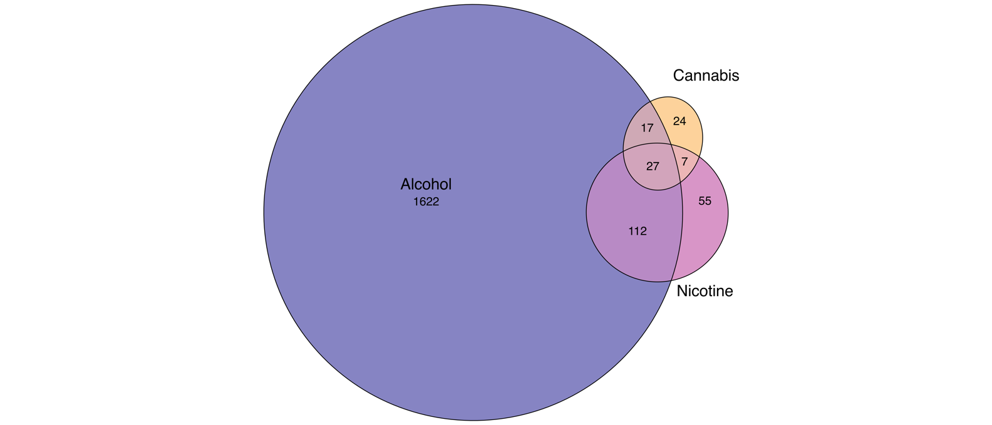

Overlap amongst participants endorsing alcohol (including both ‘sipping’ and ‘full drinks’), nicotine, and cannabis use initiation through follow-up year 3.

Supplementary Figure 2. Baseline UPPS-P mediating lack of perseverance PGS association with alcohol use initiation.

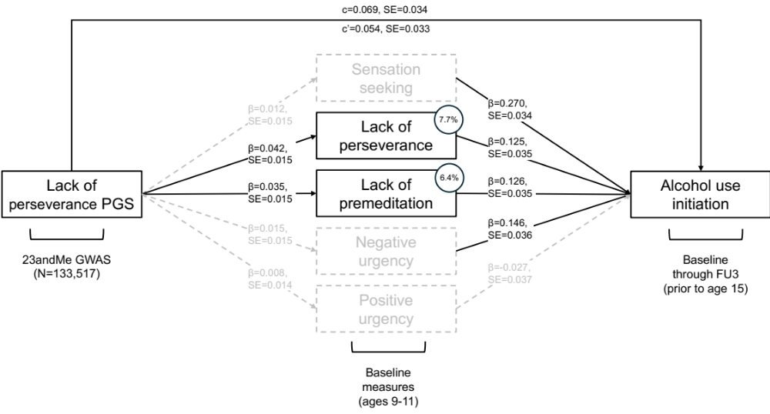

PGS = polygenic score; GWAS = genome-wide association study; c = total effect; c’ = direct effect; FU = follow-up. Standardized regression coefficients (β) and standard errors (SE) are reported along each path. Grey dashed lines indicate individual paths and/or mediation effects with 95% CIs overlapping with 0 (i.e., non-significant). Estimates of proportion of the total effect mediated by baseline UPPS-P measures are included for all significant paths as numbers in circles (i.e., lack of perseverance and lack of premeditation accounted for 7.7 and 6.4% of association between lack of perseverance PGS and alcohol use initiation, respectively).

Supplementary Figure 3. Baseline UPPS-P mediating negative urgency PGS association with nicotine use initiation.

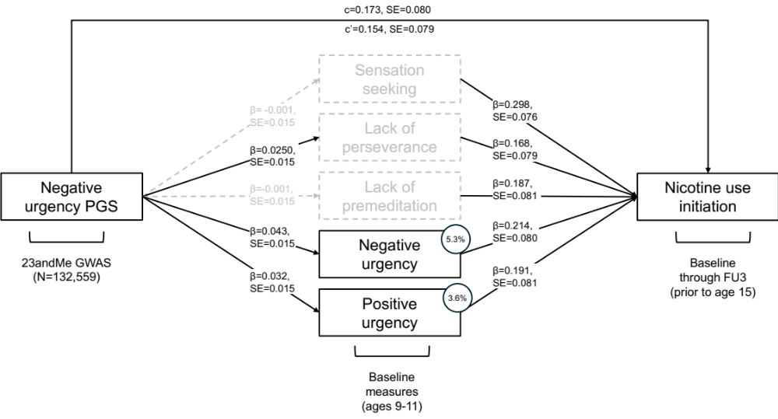

PGS = polygenic score; GWAS = genome-wide association study; c = total effect; c’ = direct effect; FU = follow-up. Standardized regression coefficients (β) and standard errors (SE) are reported along each path. Grey dashed lines indicate individual paths and/or mediation effects with 95% CIs overlapping with 0 (i.e., non-significant). Estimates of proportion of the total effect mediated by baseline UPPS-P measures are included for all significant paths as numbers in circles (i.e., negative urgency accounted for 5.3% of the association between negative urgency PGS and nicotine use initiation).

Supplementary Figure 4. Baseline UPPS-P mediating positive urgency PGS association with nicotine use initiation.

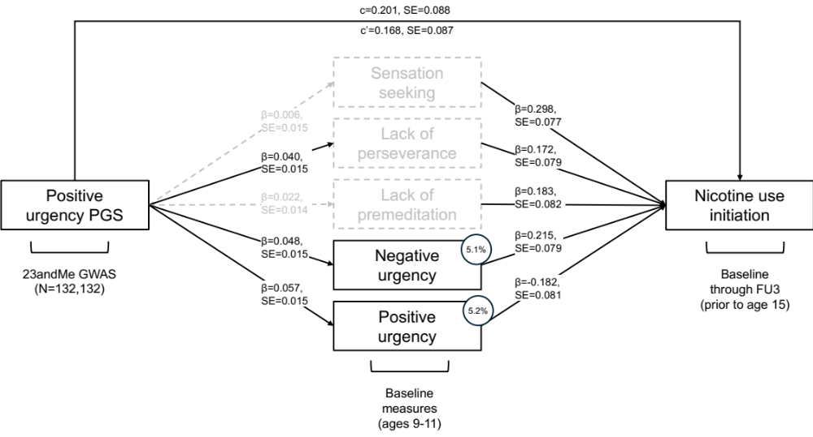

PGS = polygenic score; GWAS = genome-wide association study; c = total effect; c’ = direct effect; FU = follow-up. Standardized regression coefficients (β) and standard errors (SE) are reported along each path. Grey dashed lines indicate individual paths and/or mediation effects with 95% CIs overlapping with 0 (i.e., non-significant). Estimates of proportion of the total effect mediated by baseline UPPS-P measures are included for all significant paths as numbers in circles (i.e., negative urgency and positive urgency accounted for 5.1 and 5.2% of association between positive urgency PGS and nicotine use initiation, respectively).

