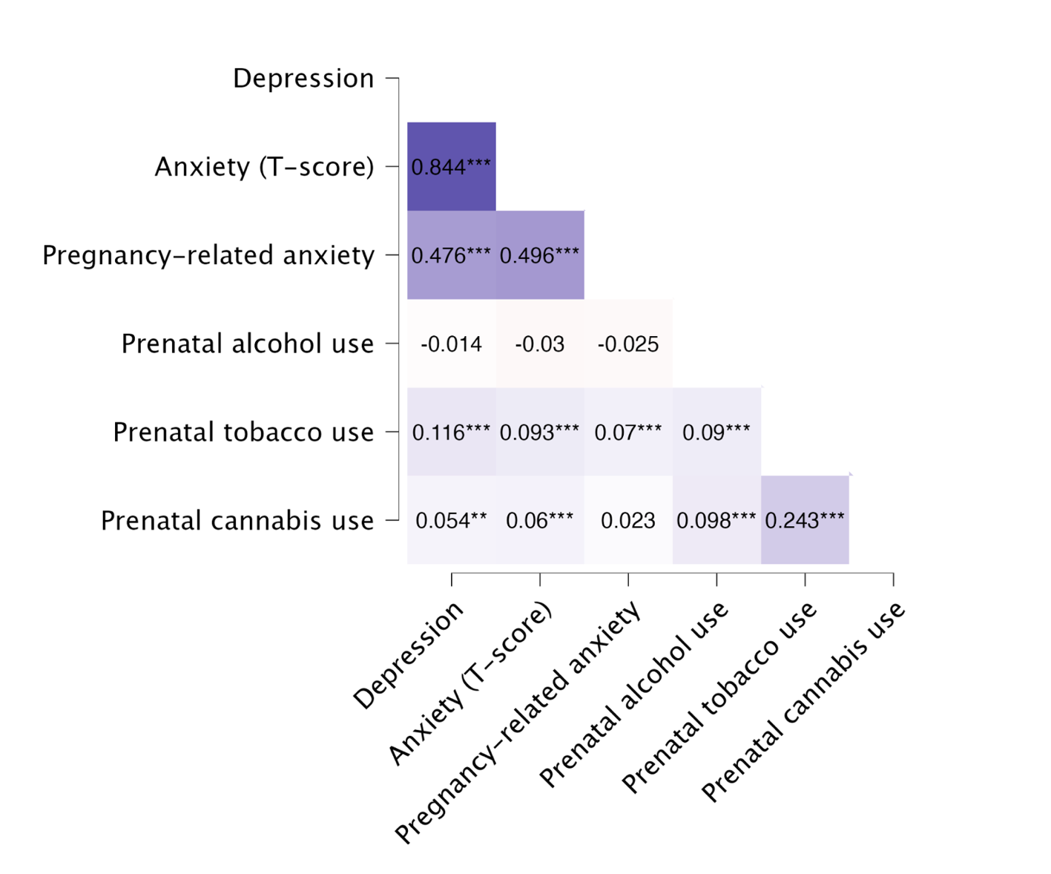

Supplementary Figure S1: Spearman’s rank correlation matrix of maternal mental health variables and substance use after pregnancy recognition.
* p < 0.05, ** p < 0.01, *** p < 0.001.

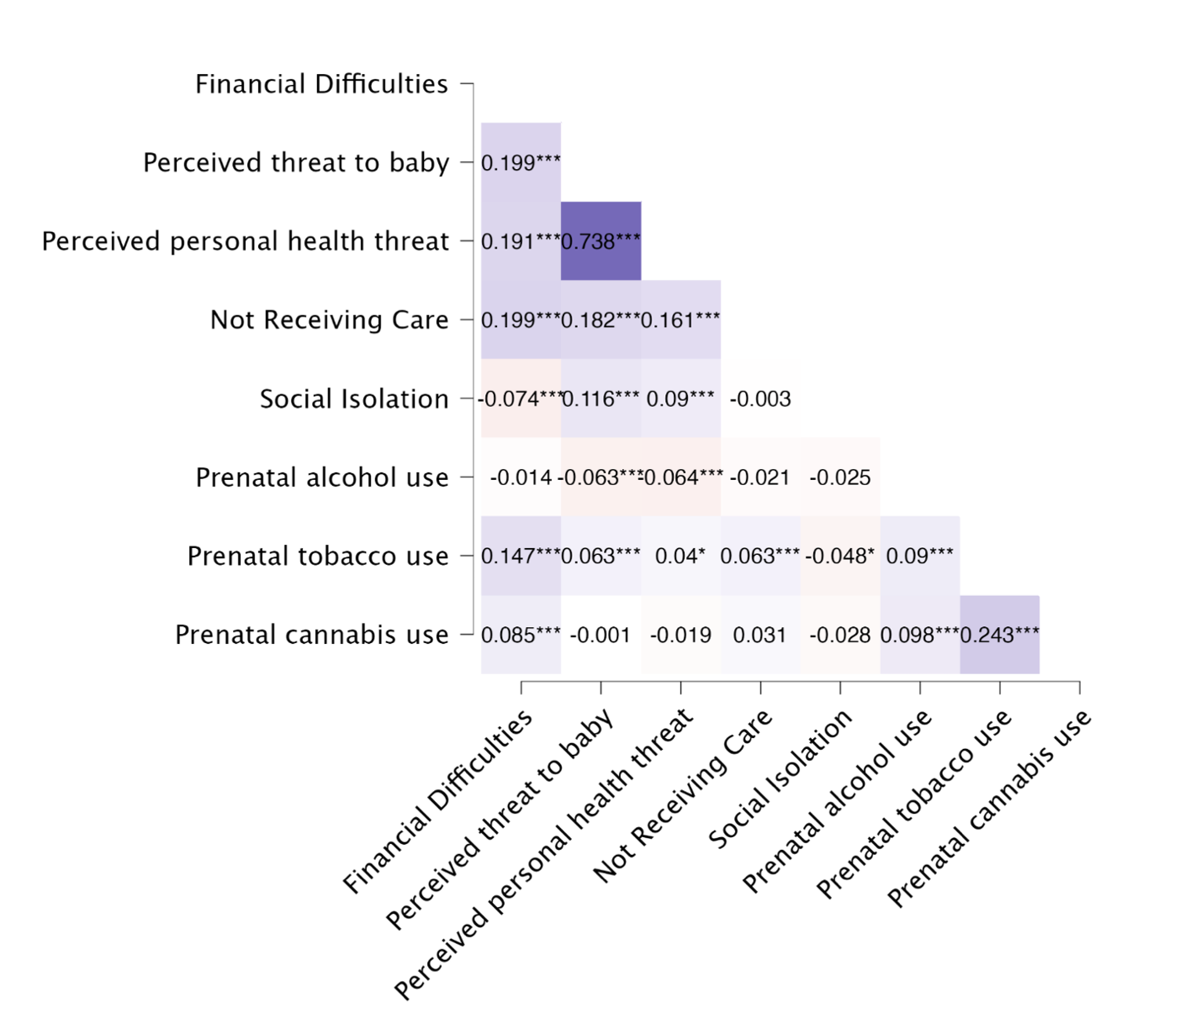

Supplementary Figure S2: Spearman’s rank correlation matrix of pandemic-related stressors and substance use after pregnancy recognition.
* p < 0.05, ** p < 0.01, *** p < 0.001.

