Supplementary Material
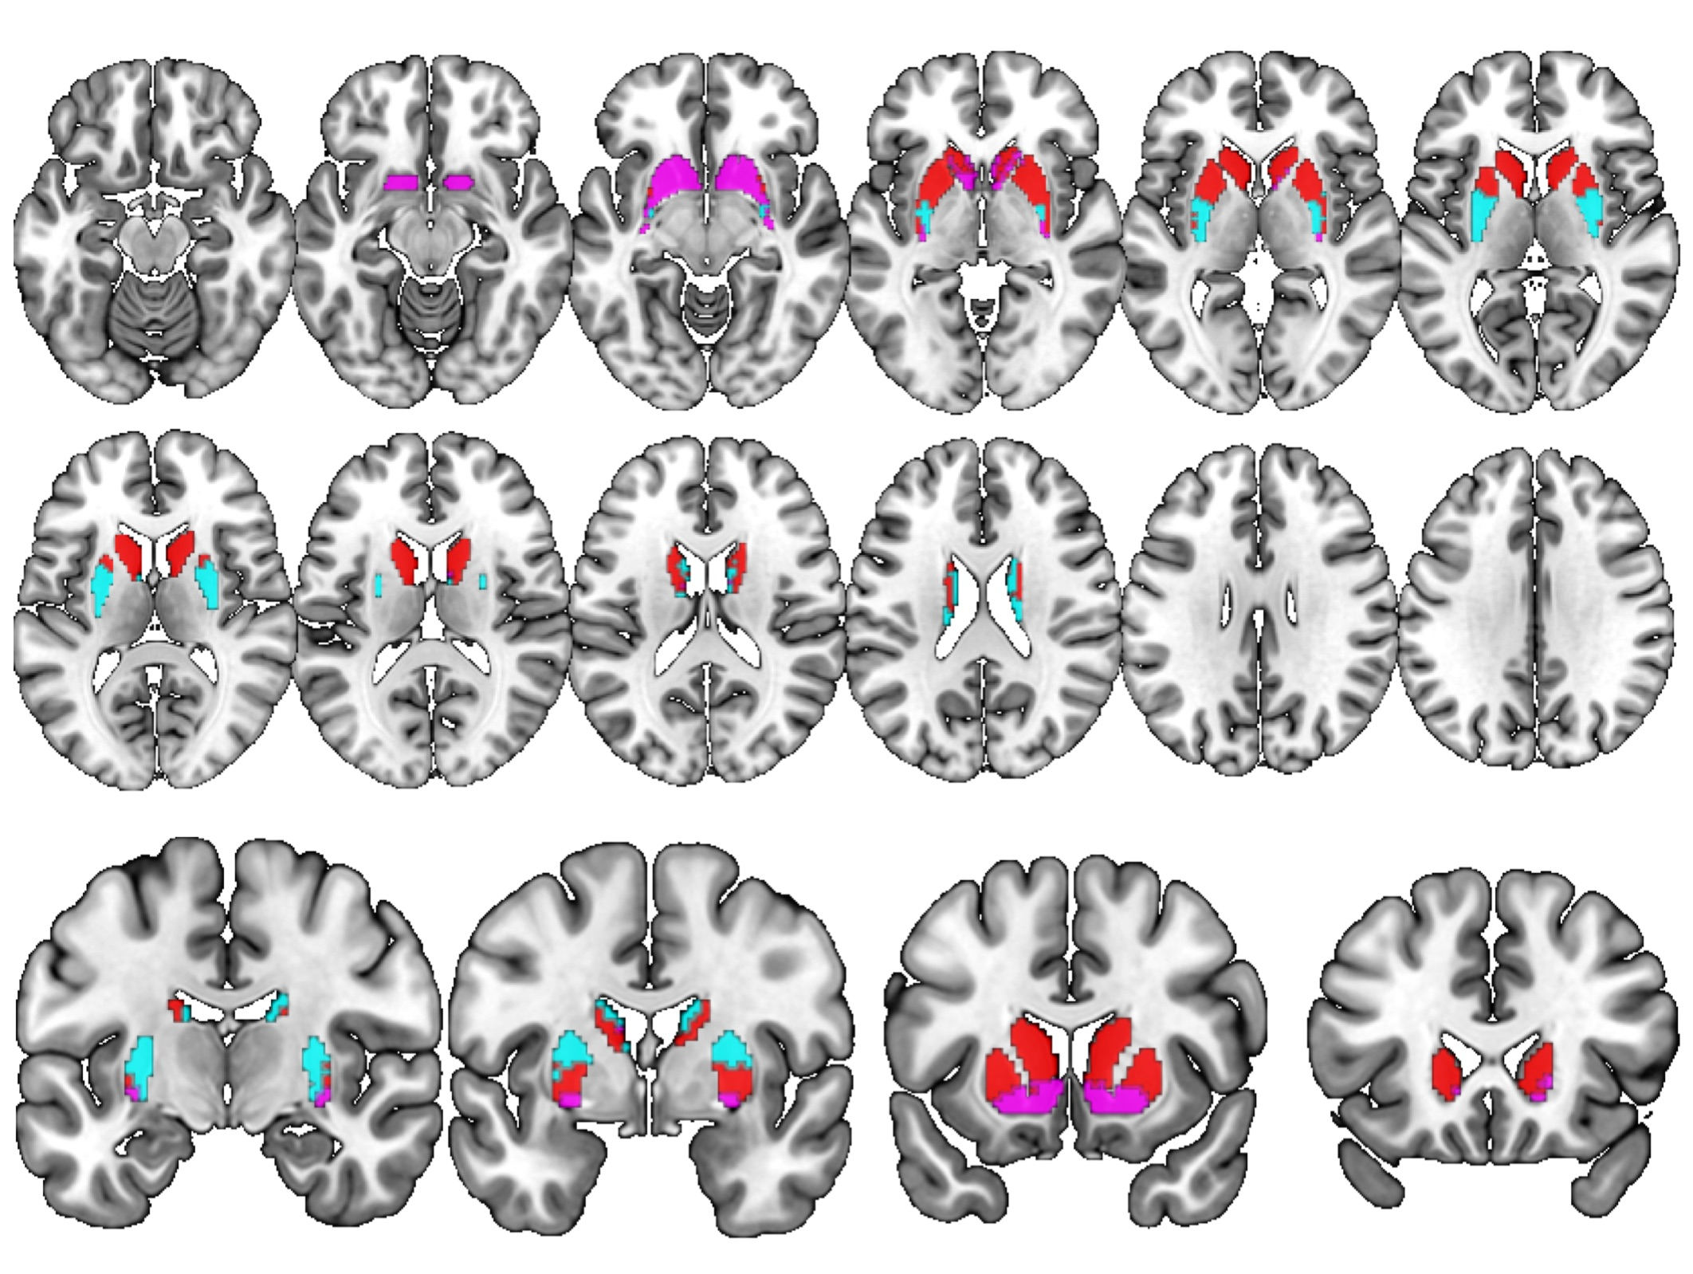
Figure S1. Seed regions used in the functional connectivity analyses, derived from the atlas provided by Tziortzi et al. (2013). Associative striatum in red, limbic striatum in pink, and sensorimotor striatum in cyan.

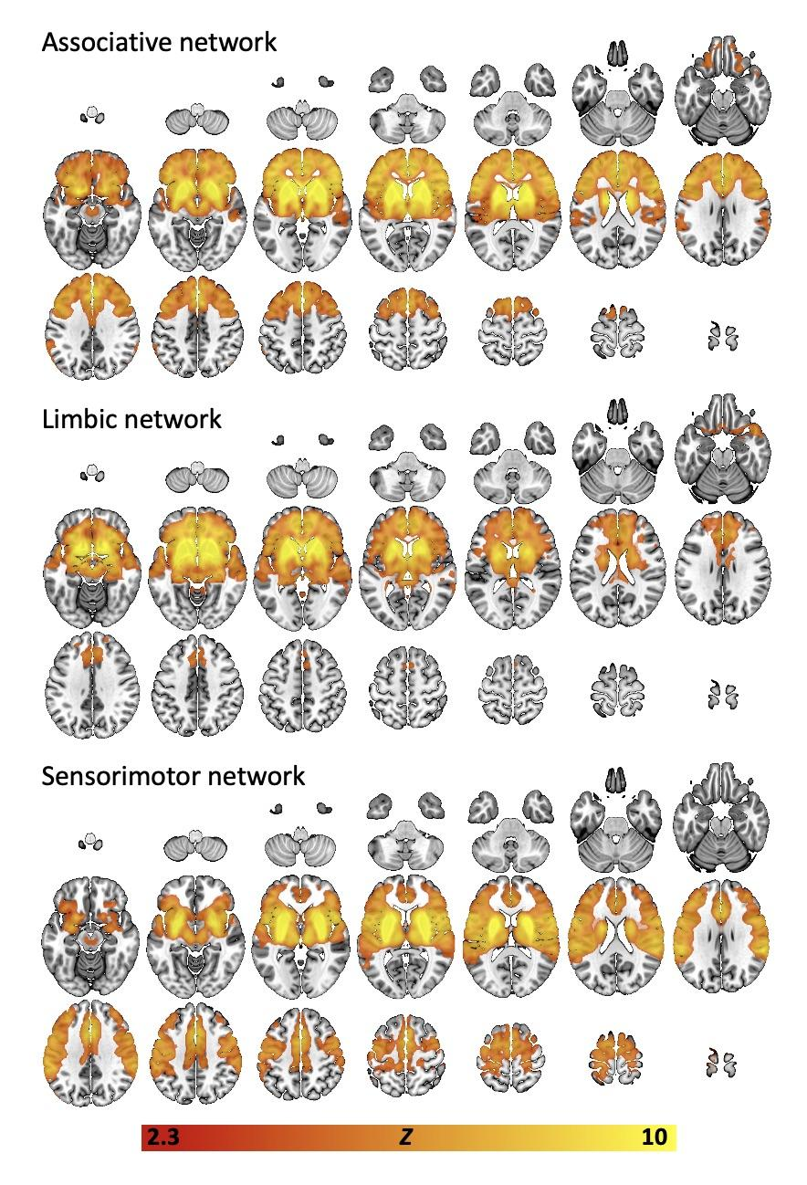
Figure S2. Group-mean (all subjects, all scans) connectivity networks derived using the seed-regions shown in figure S1, and the resting-state fMRI data from study 1 (N=17). Top panel = associative network, middle panel = limbic network, bottom panel = sensorimotor network. Statistical thresholds are Z=2.3, p < 0.05 (cluster-corrected).
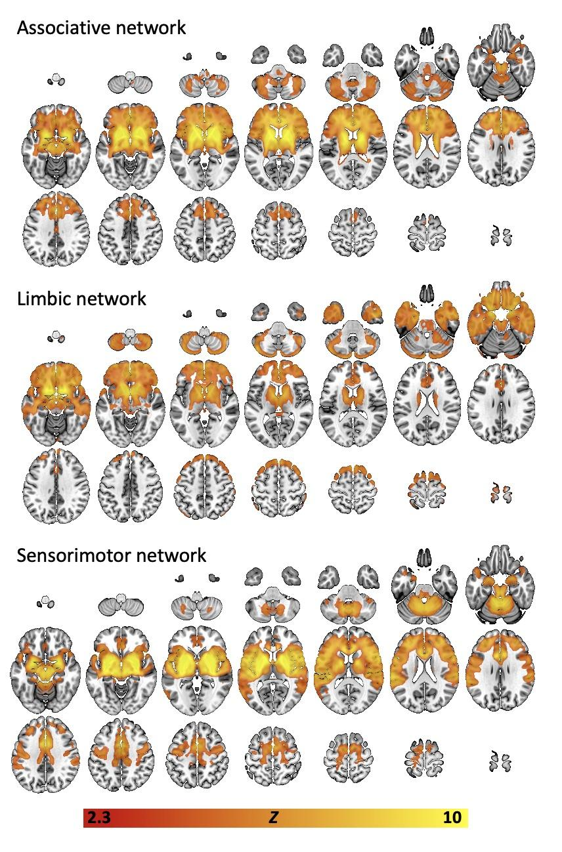
Figure S3. Group-mean (all subjects, all scans) connectivity networks derived using the seed-regions shown in figure S1, and the resting-state fMRI data from study 2 (N=23). Top panel = associative network, middle panel = limbic network, bottom panel = sensorimotor network. Statistical thresholds are Z=2.3, p < 0.05 (cluster-corrected).

Measure | Mean (SD)
Age | 26.18 (7.13)
Gender (m/f) | 8/9
BDI | 3.38 (3.12)
TEPS consummatory | 43.50 (5.61)
TEPS anticipatory | 42.06 (4.85)
TEPS total | 86.56 (9.30)
Cannabis SDS | 1.13 (1.26)
Alcohol ever used (y/n) | 16/0
Alcohol use now (y/n) | 16/0
Alcohol days per month | 10.81 (4.86)
Alcohol units/session | 5.93 (2.08)
Amphetamine ever used (y/n) | 8/8
Amphetamine use now (y/n) | 0/16
Amphetamine days per month | NA
Amphetamine grams/session | NA
Cannabis ever used (y/n) | 16/0
Cannabis use now (y/n) | 16/0
Cannabis days per month | 8.06 (5.48)
Cannabis days to smoke an 8th | 25.88 (33.73)
Cocaine ever used (y/n) | 11/5
Cocaine use now (y/n) | 3/13
Cocaine days per month | 1.0 (0.0)
Cocaine grams/session | 0.5 (0.0)
Heroin ever used (y/n) | 0/16
Heroin use now (y/n) | 0/16
Heroin days per month | NA
Heroin grams/session | NA
Ketamine ever used (y/n) | 10/6
Ketamine use now (y/n) | 2/14
Ketamine days per month | 1.50 (0.71)
Ketamine grams/session | 0.75 (0.35)
Mephedrone ever used (y/n) | 7/9
Mephedrone use now (y/n) | 0/16
Mephedrone days per month | NA
Mephedrone grams/session | NA
MDMA ever used (y/n) | 14/2
MDMA use now (y/n) | 6/10
MDMA days per month | 1.50 (0.84)
MDMA grams/session | 0.31 (0.19)
Tobacco ever used (y/n) | 15/1
Tobacco use now (y/n) | 15/1
Tobacco days per month | 11.30 (10.27)
Tobacco cigs/day (when smoking) | 3.63 (3.62)
Tobacco average cigs/day | 2.16 (3.48)

Table S1. Means (S.D.) and frequencies for demographic data and drug use for participants in study 1. Data was missing for one participant for BDI, TEPS and drugs history.

Measure | Mean (SD)
Age | 23.7 (4.2)
Gender (m/f) | 12/11
BMI | 22.4 (3.5)
FTND | 0 (0)
AUDIT | 2.2 (2.8)
WTAR | 40.5 (4.9)
BAI | 2.6 (3.23)
BDI | 2.2 (4.9)

Table S2. Means (S.D.) and frequencies for demographic data and questionnaire measures for participants in study 2.

 |  |  |  | t |  |  | df |  |  |  |  | p^{Tukey}
Associative Striatum network
Placebo |  | THC+CBD |  |  | 1.260 | 16.0 |  |  |  | 0.437
Placebo |  | THC |  |  | 1.688 | 16.0 |  |  |  | 0.240
THC+CBD |  | THC |  |  | 0.688 | 16.0 |  |  |  | 0.774
Limbic Striatum network
Placebo |  | THC+CBD |  |  | 1.450 | 16.0 |  |  |  | 0.340
Placebo |  | THC |  |  | 2.693 | 16.0 |  |  |  | 0.040
THC+CBD |  | THC |  |  | 1.040 | 16.0 |  |  |  | 0.563
Sensorimotor striatum network
Placebo |  | THC+CBD |  |  | 2.927 | 16.0 |  |  |  | 0.025
Placebo |  | THC |  |  | 3.073 | 16.0 |  |  |  | 0.019
THC+CBD |  | THC |  |  | 0.383 | 16.0 |  |  |  | 0.923

Table S3. Statistical results from the ROI analyses in study 1. Bold text highlights significant (p < 0.05, Tukey-corrected) results.

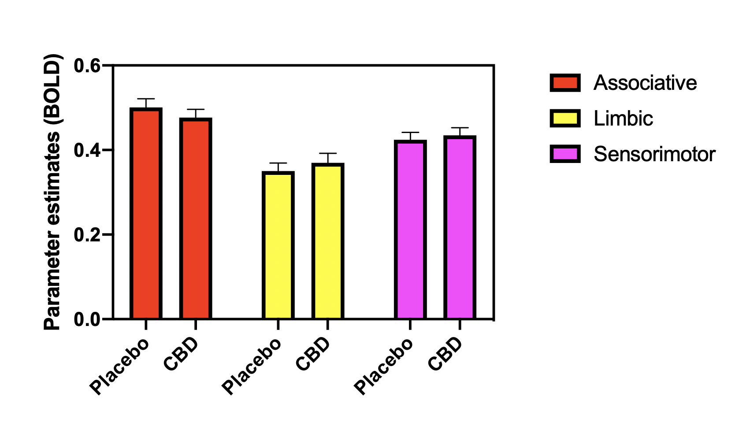

Figure S4. ROI data from study 2. All CBD vs. placebo comparisons are non-significant.

 |  |  |  | t |  | df |  |  |  | p
Associative CBD |  | Associative placebo |  |  | -1.065 |  |  | 22.0 |  |  | 0.298
Limbic CBD |  | Limbic placebo |  |  | 0.934 |  |  | 22.0 |  |  | 0.360
Sensorimotor CBD |  | Sensorimotor placebo |  |  | 0.685 |  |  | 22.0 |  |  | 0.501
Table S4. Statistical results from the ROI analyses in study 2. All results are non-significant.

