Supplementary Information

Rapid LC-QTOF-MS screening method for semi-synthetic cannabinoids in whole blood

Table of contents
- Table Recovery rates and matrix effects SPE, and LLE in glass vials S1
- Recovery rates from the LLE protocol, measured in PP vials S2
- Recovery rates from the LLE protocol, measured in glass vials S3
- Recovery rates from the SPE protocol, measured in PP vials S4
- Δ⁹-THC-COOH interference in a real case sample (Δ⁸-THC-COOH) S5
- Δ⁹-THC and Δ⁸-THC in a real case sample S6
- Δ⁹-THC and Δ⁸-THC in a real case sample S7
- HHC in a real case sample S8

S1: Recovery rates and matrix effects of the analytes from the liquid-liquid extraction protocol (LLE), measured in glass vials (left side) and from the solid-phase extraction protocol (SPE), measured in polypropylene vials (right side). Graphical illustration of the recovery rates from the LLE protocol (analyzed in glass vials) are shown in S3. Graphical illustration of the recovery rates from the SPE protocol are shown in S4.
Analyte | Recovery rates LLE glass vials / % | Matrix effects LLE glass vials / % | Recovery rates SPE / % | Matrix effects SPE / %
Δ⁹-THCO | 79 ± 7.3 | 76 | 69 ± 6.2 | 97
9β-OH-HHC | 55 ± 4.8 | 49 | 82 ± 2.4 | 54
11-OH-Δ⁹-THC | 96 ± 10.5 | 39 | 75 ± 2.0 | 76
11-OH-Δ⁸-THC | 61 ± 7.7 | 45 | 86 ± 12.1 | 46
Δ⁹-THCE | 91 ± 1.3 | 36 | 75 ± 7.3 | 85
11-COOH-9R-HHC | 62 ± 6.4 | 27 | 90 ± 1.1 | 33
11-COOH-Δ⁹-THC | 99 ± 8.3 | 28 | 64 ± 4.4 | 117
9α-OH-HHC | 96 ±8.7 | 48 | 66 ± 4.4 | 95
CBD | 65 ± 10.8 | 18 | 81 ± 5.8 | 79
CBG | 94 ± 16.3 | 15 | 62 ± 6.8 | 126
Δ⁹-THCB | 103 ± 15.3 | 22 | 63 ± 3.6 | 96
CBN | 111 ± 26.5 | 14 | 63 ± 2.2 | 84
Δ⁹-THC | 74 ± 16.0 | 11 | 68 ± 5.7 | 39
Δ⁸-THC | 95 ± 31.8 | 15 | 61 ± 2.4 | 43
9S-HHC | 113 ± 30.5 | 12 | 53 ± 2.3 | 73
9R-HHC | 0 | N/A | 69 ± 2.7 | 54
Δ⁹-THCH | 101 ± 29.9 | 31 | 72 ± 3.4 | 171
9R-HHCH | 0 | N/A | 86 ± 1.8 | 85
Δ⁹-THCP | 0 | N/A | 45 ± 4.6 | 52
Δ⁹-THC-O | 0 | N/A | 57 ± 2.5 | 148
9R-HHCP | 0 | N/A | 44 ± 3.0 | 52
9R-HHC-O | 0 | N/A | 58 ± 1.7 | 74
Δ⁹-THC-C8 | 0 | N/A | 31 ± 4.0 | 97
Δ⁹-THC-OMe | 0 | N/A | 28 ± 2.8 | 120

S2: Recovery rates of the analytes included in the screening panel. Analytes were spiked on blank blood and were extracted with a liquid-liquid-extraction (LLE) protocol. The solutions were measured using polypropylene (PP) vials. Recovery rates and error bars were determined from triplicates.

S3: Recovery rates of the analytes included in the screening panel. Analytes were spiked on blank blood and were extracted with a liquid-liquid-extraction protocol. The solutions were measured using glass vials. The recovery rates were in general lower than from PP vials and the late eluting compounds were not detected. Recovery rates and error bars were determined from triplicates.

S4: Recovery rates of the analytes included in the screening panel. Analytes were spiked on blank blood and were extracted with a solid-phase-extraction (SPE) protocol. The solutions were measured using PP vials. Recovery rates seem to drop with the lipophilicity of the analytes. Recovery rates and error bars were determined from triplicates.

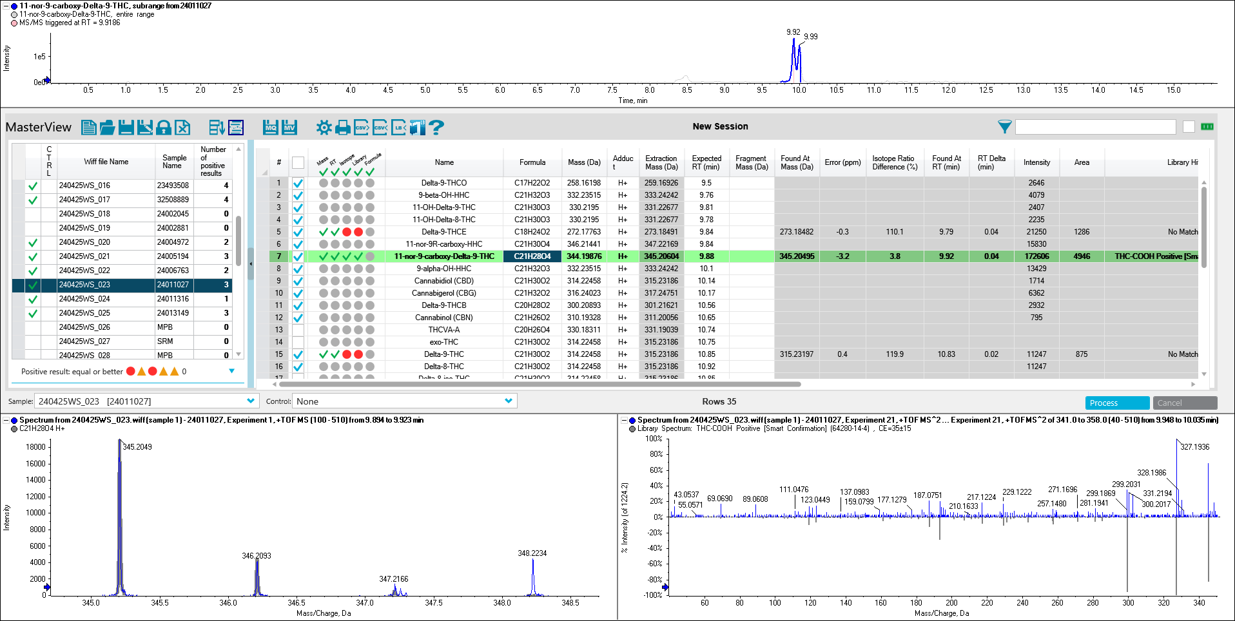
S5: Real case sample, which showed an interference for Δ⁹-THC-COOH at R_{t} = 9.99 min, presumably Δ⁸-THC-COOH. The peaks are not fully resolved.

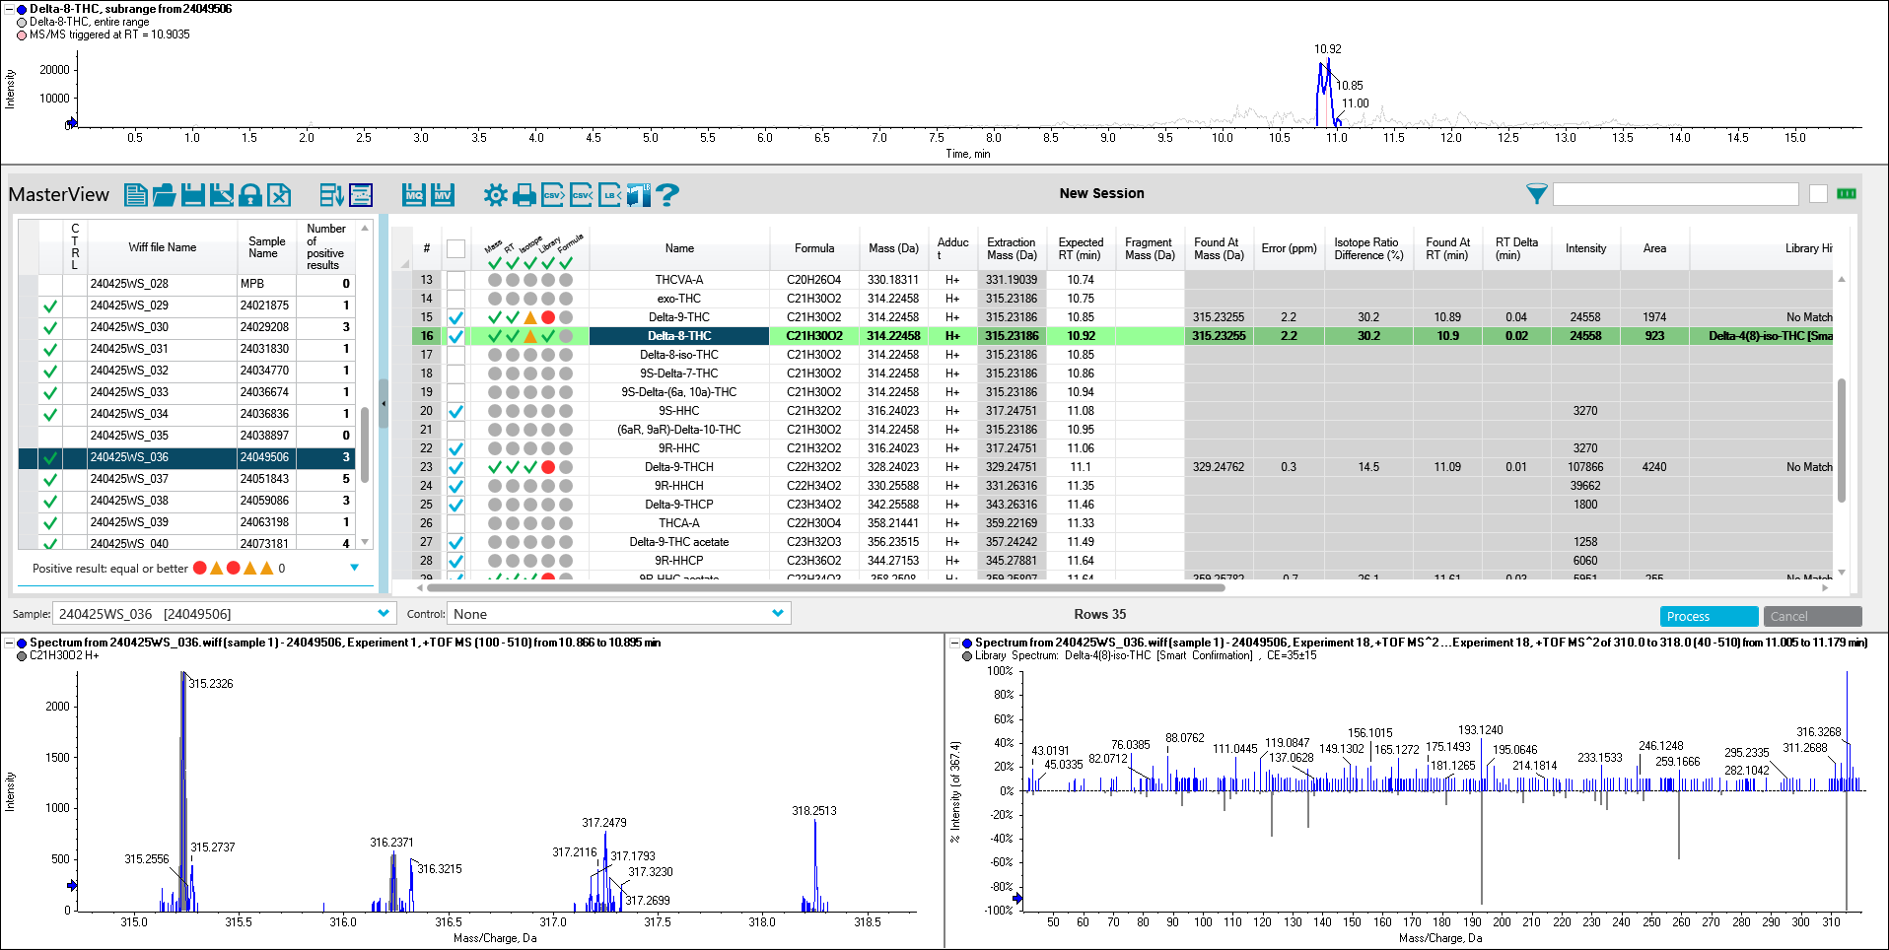
S6: A real case sample with similar amounts of Δ⁸-THC and Δ⁹-THC. The peaks are not fully resolved.

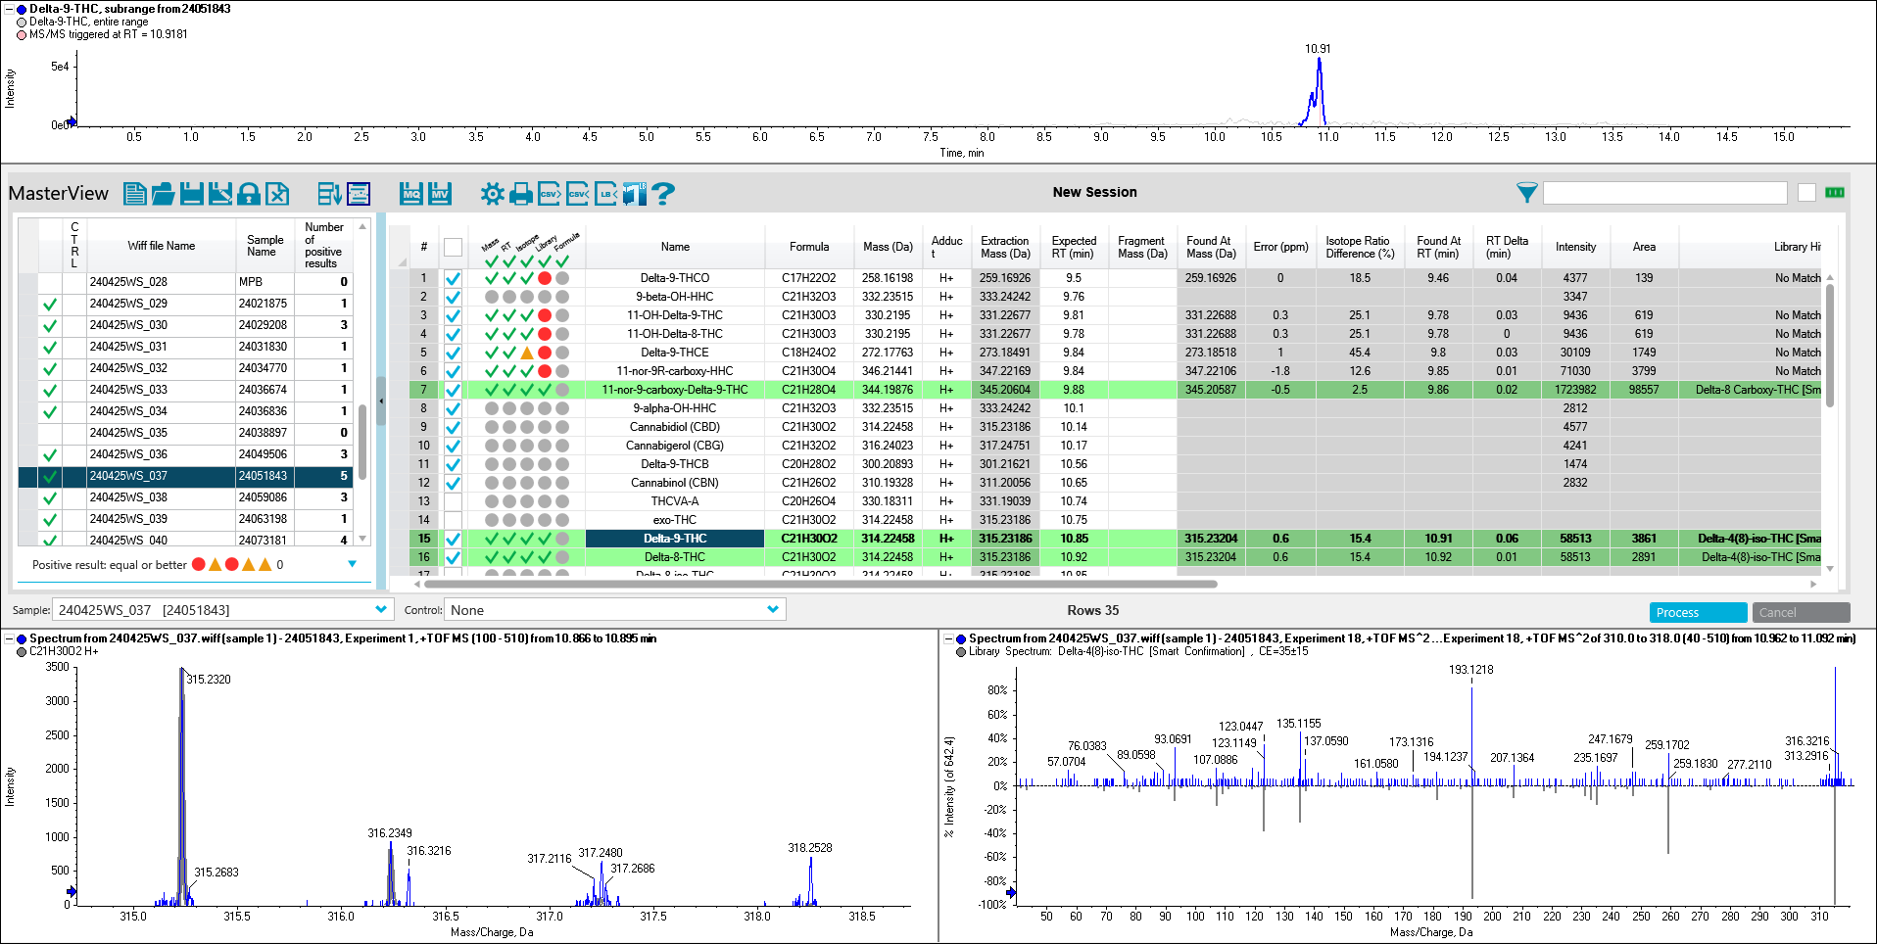
S7: Another real case sample showing more Δ⁸-THC than Δ⁹-THC. The isomers are not fully resolved.

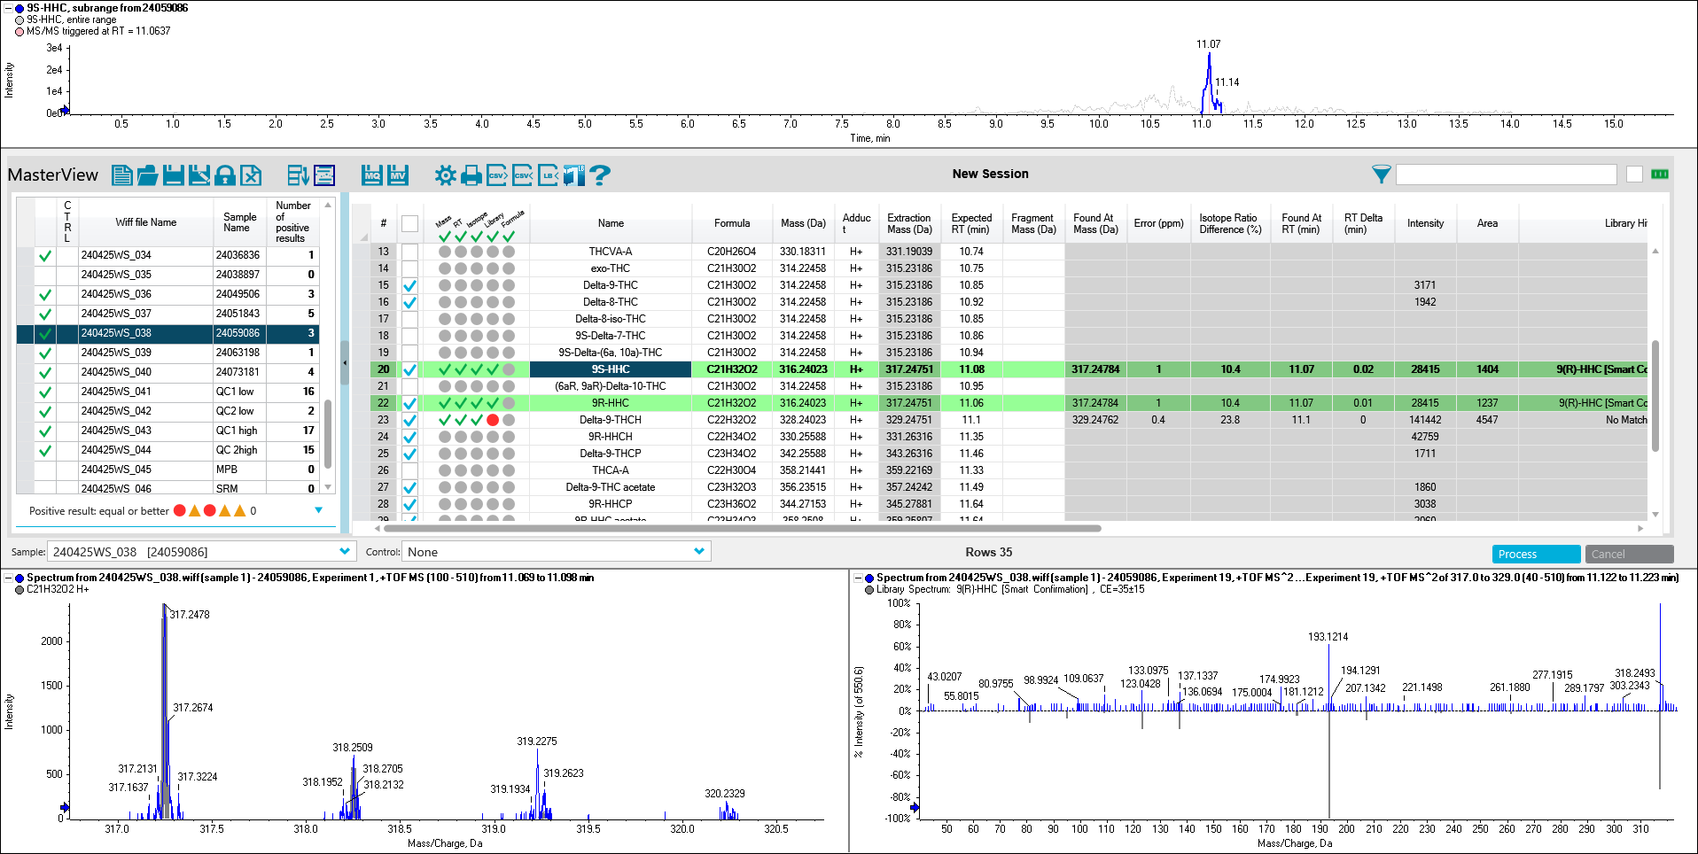
S8: A real case sample containing HHC. Differentiation between the epimers (9R)- and (9S)-HHC is not possible as they are coeluting.

