Fig. S1
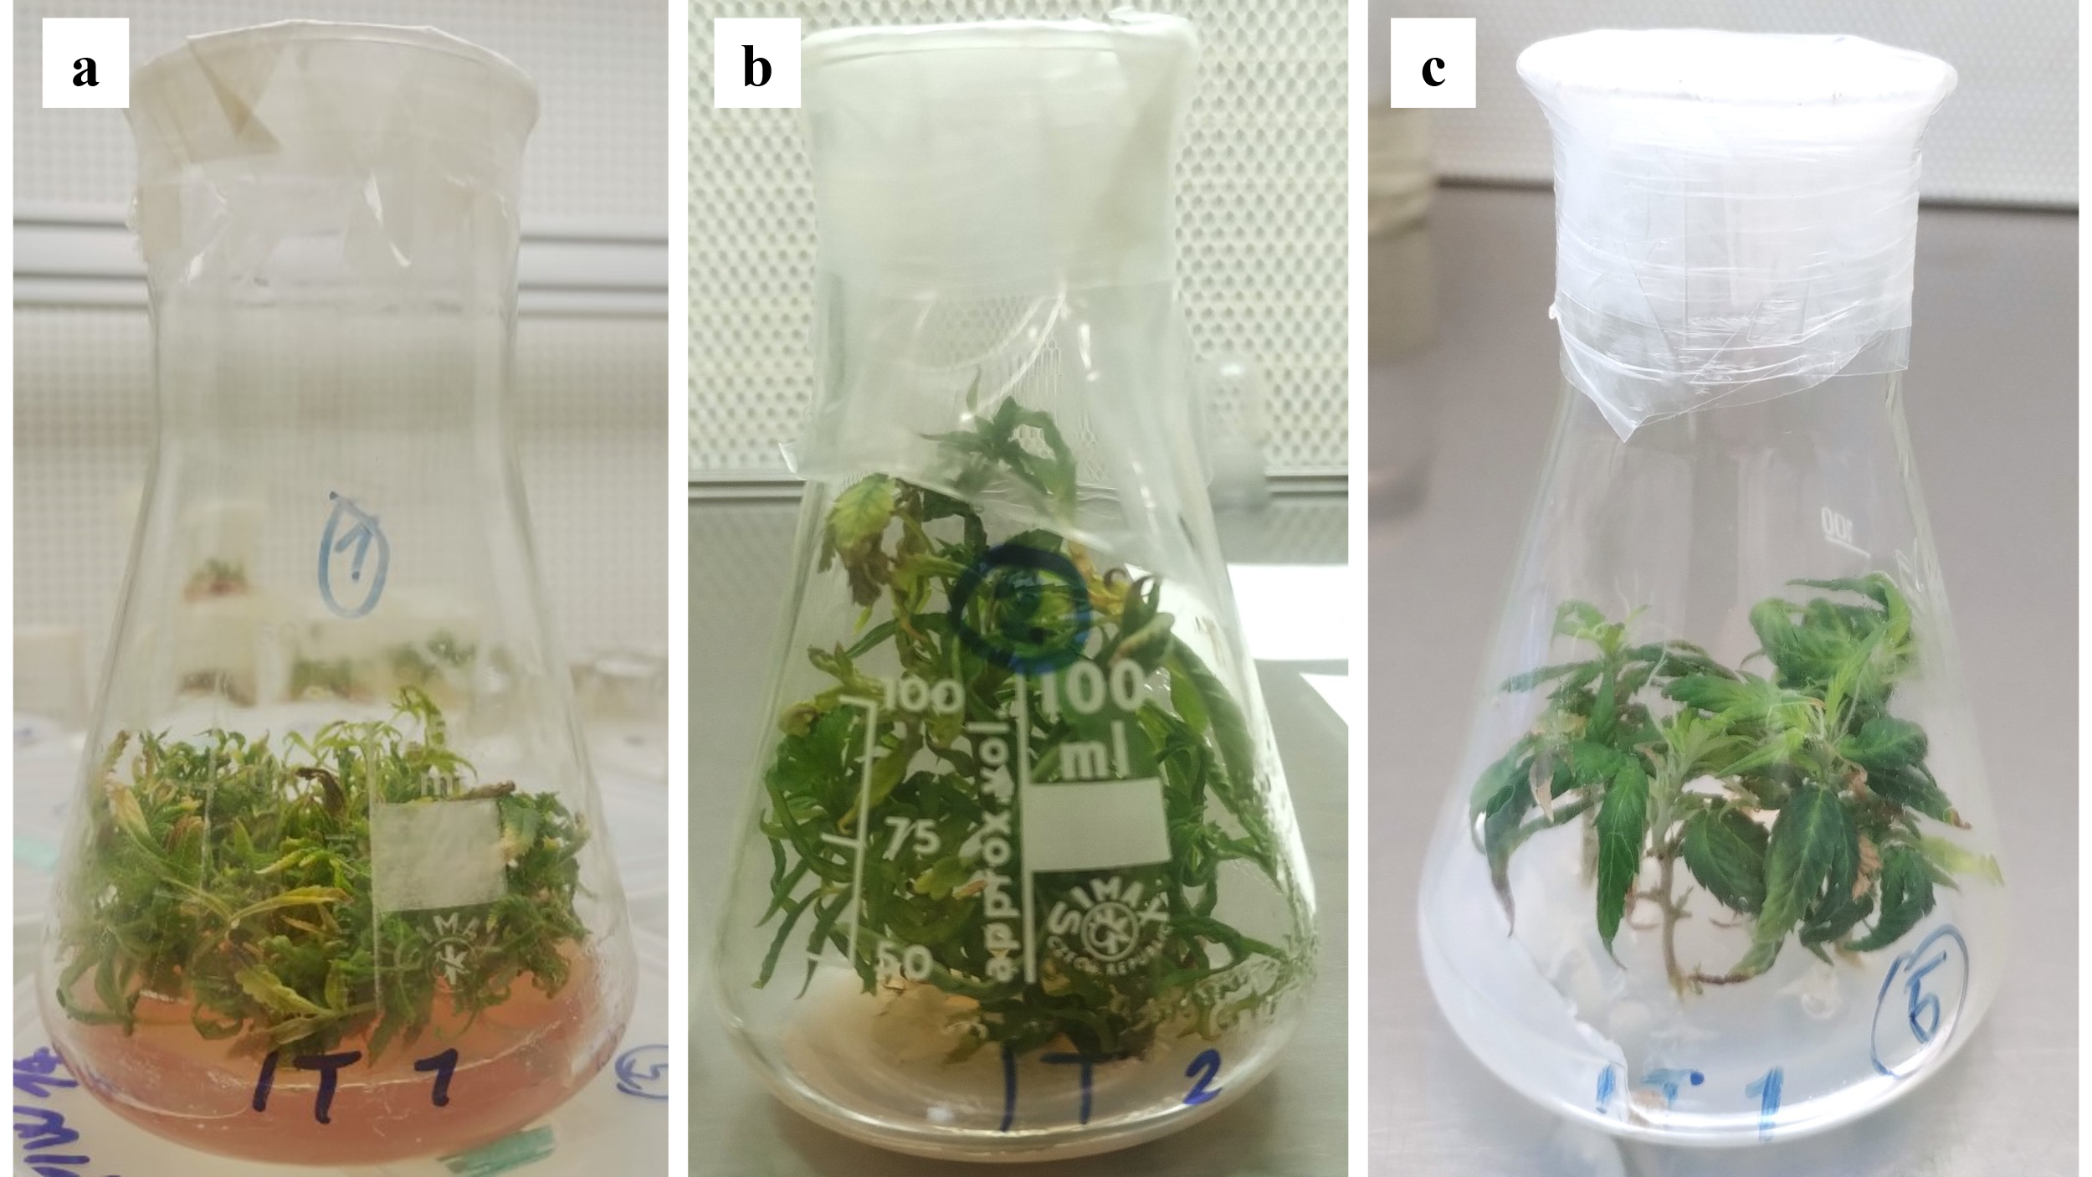
C. sativa in vitro – Effect of culture media. Four-week-old cultures of 'Eletta Campana' derived from nodal explants. (a) Cultured on medium KM1. (b) Cultured on medium KM2. (c) Cultured on medium KM5.

Fig. S2
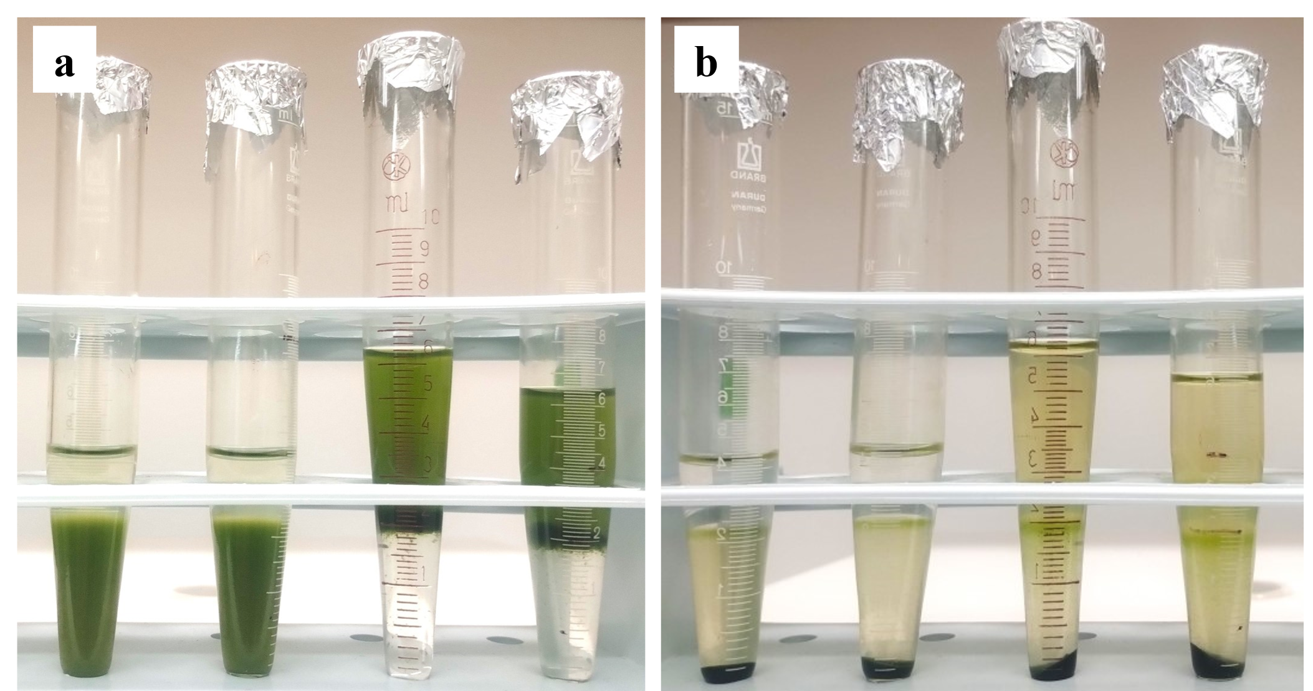
Comparison of Protoplast Purification Efficiency. (a) Protoplast suspensions before centrifugation in a sucrose gradient. (b) Different levels of purification observed after centrifugation, with brown discoloration in the solution above the floating protoplasts.

Fig. S3
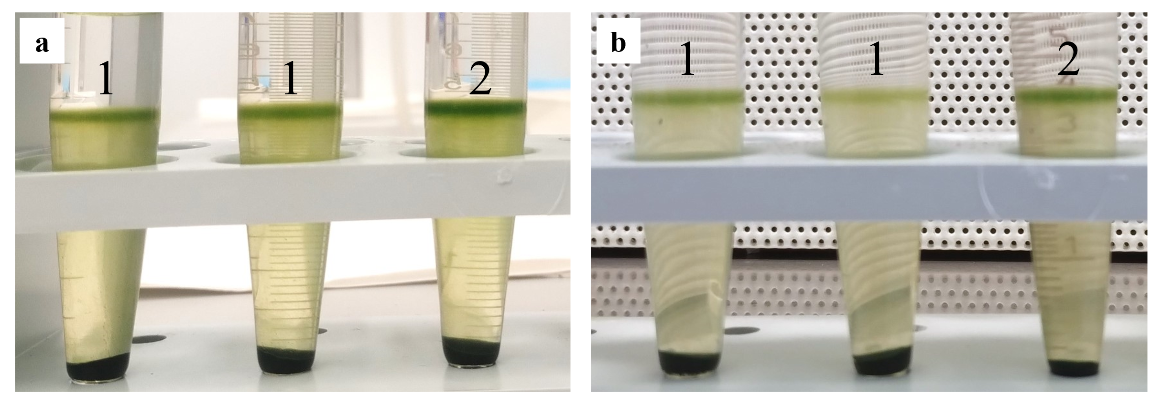
Visual comparison of protoplast yield. (1) Protoplast samples isolated from leaves of 3–4-week-old in vitro USO 31 seedlings. (2) Protoplast samples isolated from 1–2-week-old seedlings. (a) Experiment 1. (b) Experiment 2.

