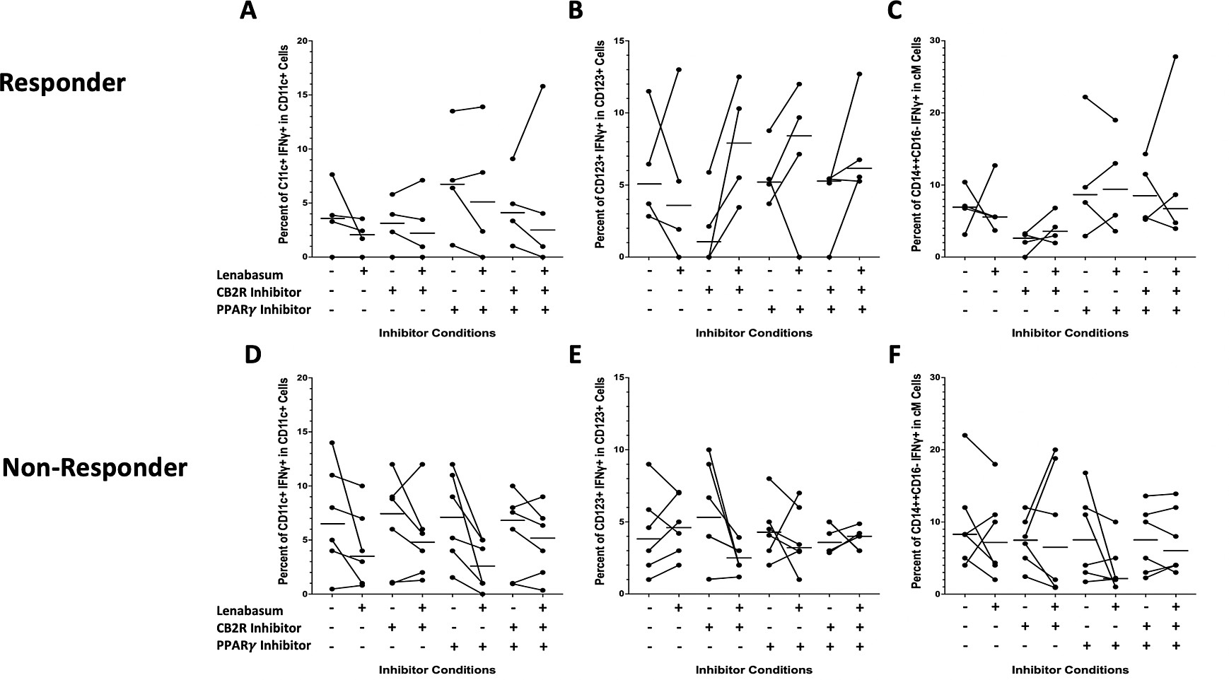

Figure S5: Flow cytometry of DM whole blood leukocytes displaying percent positivity of IFNγ across CD11c⁺, CD123⁺, and cMs in non-responders and responders with various CB2R/PPARγ inhibitions and lenabasum treatment. Black line reflects the median. A) IFNγ positivity in CD11c⁺ cells in responders with lenabasum treatment and CB2R/PPARγ inhibition. B) IFNγ positivity in CD123⁺ cells in responders with lenabasum treatment and CB2R/PPARγ inhibition. C) IFNγ positivity in cMs in responders with lenabasum treatment and CB2R/PPARγ inhibition. D) IFNγ positivity in CD11c⁺ cells in non-responders with lenabasum treatment and CB2R/PPARγ inhibition. E) IFNγ positivity in CD123⁺ cells in non-responders with lenabasum treatment and CB2R/PPARγ inhibition. F) IFNγ positivity in cMs in non-responders with lenabasum treatment and CB2R/PPARγ inhibition.

