State 3 | State 4 | Respiratory Control  Index
Complex I
45.2 | 21.6 | 2.1
Complex II
43.2 | 14.04 | 6.4

Supplementary Figure 1: Respiratory control index (ngAtO/min/mg protein) determined to demonstrate mitochondrial coupling, using the Clark type electrode (Yellow Springs Instruments, Yellow Springs, OH, USA). Substrates for Complex I (5 mM malate plus 3 mM glutamate) and Complex II (10 mM succinate plus 1 μM rotenone as a Complex I inhibitor) were used to activate oxygen consumption in a medium containing 125 mM KCl, 10 mM HEPES and 3 mM inorganic phosphorus (Pi) at pH 7.3. Recordings started by adding 2 mg mitochondrial protein to determine the baseline oxygen consumption (state 4), and mitochondrial respiration was evaluated 1 min later by adding 300 nmol ADP to determine the respiration associated to ATP production (state 3). The respiratory control rate (state 3/state 4) was assessed to demonstrate that mitochondrial respiration is coupled to oxidative phosphorylation with a value greater than 1.

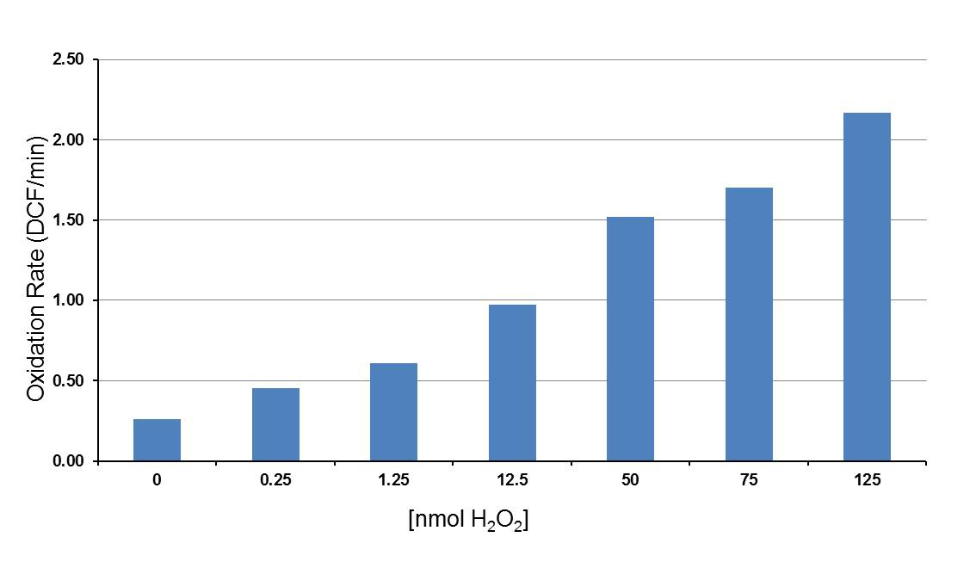

Supplementary Figure 2: H₂O₂ standard curve (nmol/oxidation rate of DCF-H/min). A concentration standard curve of H₂O₂ [0 to 500 μM] was carried out using 100 µg mitochondrial protein. Mitochondria were prepared with horseradish peroxidase (PR: 1 μg) plus protonated dichlorofluorescein (DCF-H: 1 µM). Assessment of fluorescence was recorded in time, where after the first min, H₂O₂ was added and measurements were taken for 15 min. The standard curve (μM) was transformed into nmol to quantify H₂O₂ production in pmol H₂O₂/min/mg protein.

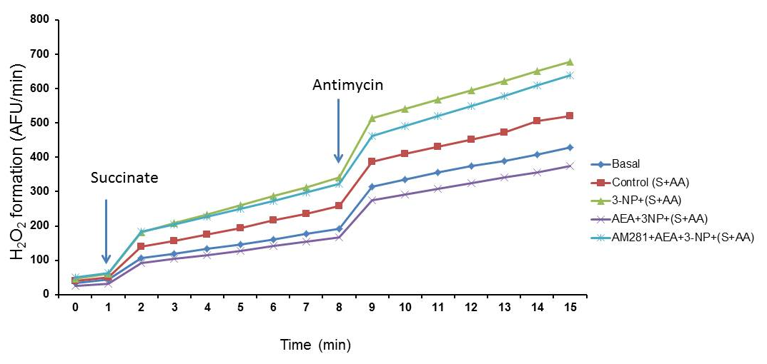
Supplementary Figure 3. Graph represents H₂O₂ formation assessed as fluorescence of protonated dichlorofluorescein as arbitrary fluorescence units (AFU) with respect to time. Mitochondria were added with horseradish peroxidase (HP) and protonated dichlorofluorescein (DCF-H). Once initiated the fluorescence recording, succinate was added during the first min to stimulate H₂O₂ production and detection, and 7 min later, antimycin, a well-known Complex III inhibitor, was added to enhance H₂O₂ formation.

4A
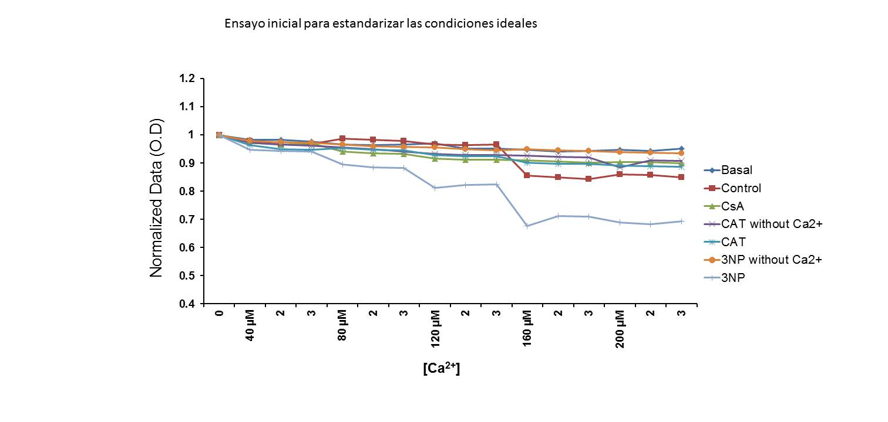

4B
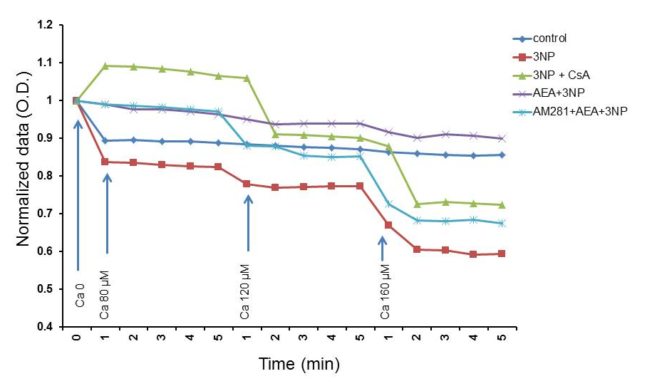

Supplementary Figures 4A and 4B. Both plot graphs represent mitochondrial swelling induced by increased Ca²⁺ concentrations. In A, 3-Nitropropionic acid (3-NP) acts as a mitochondrial swelling inducer in the presence of increased Ca²⁺ concentrations as plot line decreases constantly, whereas 1 μM carboxytractylosyde (CAT), a well-known ADP/ATP translocase (ANT or adenine nucleotide translocator protein, a protein forming part of the structure of mPTP) inhibitor did not induce mitochondrial swelling. In B, the preventive effect of AEA on 3-NP-induced mitochondrial swelling is depicted, where the response induced by AEA is mediated by mitRCB1, evidenced by the effect of the antagonist AM281. Cyclosporin A closed mPTP when interacted with cyclophilin D, which is located in the mitochondrial matrix.

