Appendix A. Supplementary figures
Supplementary figure 1. Prevalence of problem gambling and sex, age group and household economic situationª in a representative sample of 2240 students from the Region of Murcia.

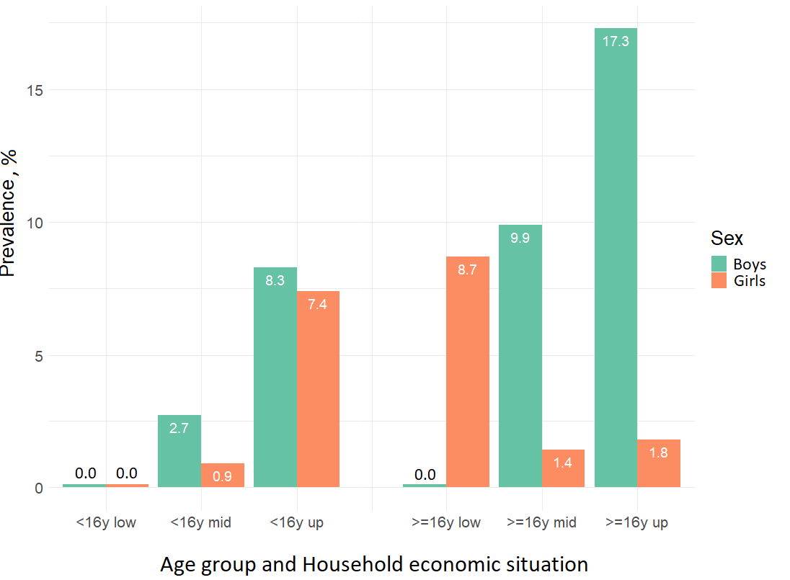
ªThe combination between age group (from 14 to 15 years old,<16y, and over 16 years old, ≥16y) and household economic situation (lower middle, middle standard and upper middle).

Supplementary figure 2. Prevalence, with 95% confidence intervalsª, of problem gambling and sociodemographic characteristics, leisure-time and substance/non-substance use, by sex, in a representative sample of 2240 students from the Region of Murcia.

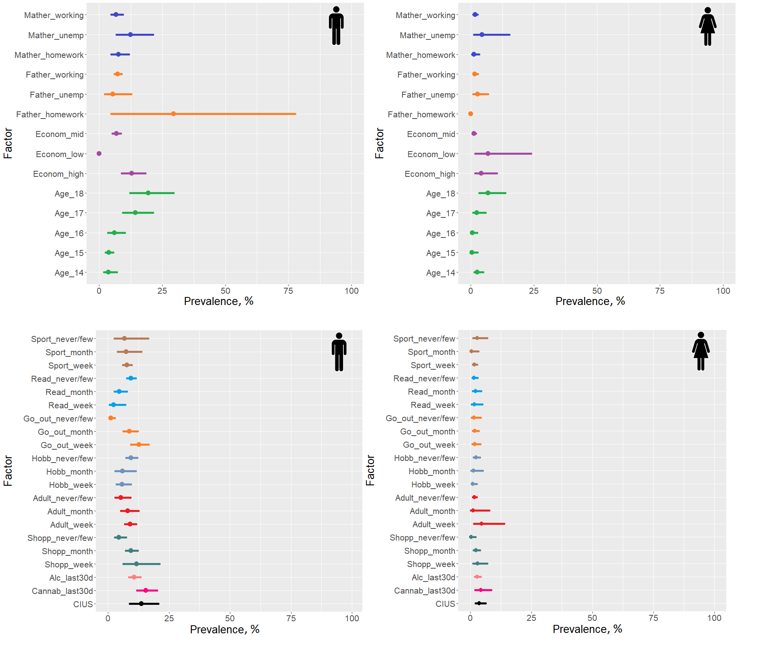
ªThe factor variables are represented according to colour change in each sex.

