Supplementary Materials

Table of Contents:

eMethods 1. Effect size comparison methods.

eTable 1. PCC-related diagnoses.

eTable 2. Diagnosis patterns - test negative cohort.

eTable 3. Top 10 new diagnoses.

eTable 4. Top 10 new diagnoses - test negative cohort.

eTable 5. Full model results for top hits.

eTable 6. Effect size comparison full results.

eFigure 1. Flow diagram.

eFigure 2. Venn diagram comparing cohorts.

eFigure 3. 1:4 Matched 90-day analysis - test negative Manhattan plots.

eFigure 4. Venn diagram comparing COVID-19-positive and COVID-19-negative.

eFigure 5. 1:2 Matched 180-day analysis Manhattan plots.

eFigure 6. 2:4 Matched 90-day analysis Manhattan plots.

eFigure 7. Fixed 90-day analysis Manhattan plots.

eFigure 8. 1:4 Matched 90 day analysis - 2020 vs 2021+ Manhattan plots.

eFigure 9. Effect size comparison.

eFigure 10. Effect size comparison – Severe vs matched negative.

eReferences

eMethods 1. Effect size comparison methods.

To compare effect sizes of a given PheCode across two mutually exclusive groups (say severe versus mild/moderate), we tested if $β_{1}^{k}$ for group A is different from $β_{1}^{k}$ for group B using the hypothesis test H₀: $β_{1A}^{k}$ = $β_{1B}^{k}$. We computed the Z statistic, Z_{k} = $\frac{{\hat{β}}_{1A}^{k}- {\hat{β}}_{1B}^{k}. }{\sqrt{[std err({{\hat{β}}_{1A}^{k})]}^{2}+[std errr({{\hat{β}}_{1B}^{k})]}^{2}}}$ and the corresponding p-value for these comparisons. All PheCodes with p<0.05 in each group were eligible for comparison.

Diagnosis | PheCode(s)
Dyspnea or increased respiratory effort | 512.9, 512.7
Fatigue | 798.1, 798
Post-exertional malaise and/or poor endurance | 798
“Brain fog,” or cognitive impairment | 292, 292.2
Cough | 512.8
Chest pain | 418, 512.2
Headache | 339, 306.9, 340
Palpitations and/or tachycardia | 427.9, 427.7, 427.1, 427.11, 427.12
Arthralgia | 526.42, 745
Myalgia | 770
Paresthesia | 687.4
Abdominal pain | 785
Diarrhea | 564, 561.1
Insomnia and other sleep difficulties | 327.4, 327.41
Fever | 783
Lightheadedness | 386.9
Impaired daily function and mobility | 350.2, 1010.7
Pain | 338.1, 338.2
Rash (e.g., urticaria) | 687.1
Mood changes | 296
Anosmia or dysgeusia | 350.6
Menstrual cycle irregularities | 626.1, 626.13
Anxiety* | 300, 300.1, 300.11
Depression* | 296.22
* Not included in the CDC’s characterization, but often cited as a common symptom in other literature

eTable 1. PCC-related diagnoses. The list of diagnoses associated with the “post-COVID-19 period” was derived from a list provided by the CDC¹. This table provides the diagnoses and the corresponding PheCode(s)².

COVID-19-negative (n=141,615)ª
Outcome | Pre-test | Post-test
Follow-up Time (Weeks) | 85.86 (47.43, 98.57) | 35.57 (20.29, 44.86)
Encounters Per Month | 0.42 (0.17, 0.98) | 0.54 (0.18, 1.26)
1+ New Diagnoses^{b} |  | 113,772 (82%)
1+ New PCC-Related Diagnosis^{b} |  | 49,595 (60%)
New Diagnoses Per Month |  | 0.36 (0.09, 0.9)
New PCC-Related Diagnoses Per Month |  | 0.09 (0, 0.18)
ª Median (IQR) or Frequency (%)
^{b} In the ~11 month-long “post-COVID-19 period”

eTable 2. Diagnosis patterns - test negative cohort. This table includes six outcomes: follow-up time in weeks, encounters per month, individuals with at least one new diagnosis in the “post-COVID-19 period,” individuals with at least one new PCC-related diagnosis in the “post-COVID-19 period,” the number of new diagnoses per month in the “post-COVID-19 period,” and the number of new PCC-related diagnoses per month in the “post-COVID-19 period.” Each outcome is stratified by both COVID-19 severity, “pre-“/”post-COVID-19 period,” and year. Statistics are presented as median (IQR) for continuous variables and n (%) for categorical variables, and sample sizes for cohorts are provided.

Overall (n=36,856) |  | Mild/Moderate (n=34,568) |  | Severe (n=2,288)
Diagnosis | n (%) | Diagnosis | n (%) | Diagnosis | n (%)
Hypertension | 10,556 (29%) | Hypertension | 9,264 (27%) | Hypertension | 1,292 (56%)
Essential hypertension | 10,380 (28%) | Essential hypertension | 9,117 (26%) | Essential hypertension | 1,263 (55%)
Anxiety disorders | 9,614 (26%) | Anxiety disorders | 8,940 (26%) | Disorders of lipoid metabolism | 902 (39%)
Anxiety disorder | 9,177 (25%) | Anxiety disorder | 8,537 (25%) | Hyperlipidemia | 901 (39%)
Mood disorders | 8,701 (24%) | Mood disorders | 8,039 (23%) | Diseases of esophagus | 821 (36%)
Depression | 8,267 (22%) | Depression | 7,638 (22%) | Cardiac dysrhythmias | 809 (35%)
Diseases of esophagus | 7,842 (21%) | Diseases of esophagus | 7,021 (20%) | Other anemias | 781 (34%)
Esophagitis, GERD and related diseases | 7,646 (21%) | Esophagitis, GERD and related diseases | 6,871 (20%) | Esophagitis, GERD and related diseases | 775 (34%)
GERD | 7,493 (20%) | GERD | 6,741 (20%) | GERD | 752 (33%)
Disorders of lipoid metabolism | 7,466 (20%) | Disorders of lipoid metabolism | 6,564 (19%) | Renal failure | 736 (32%)

eTable 3. Top 10 new diagnoses. Shown are the top 10 most prevalent new diagnoses in the overall cohort, the mild/moderate cohort, and the severe cohort. Total number of individuals receiving each diagnosis is also shown.

COVID-19-negative (n=141,615)
Diagnosis | n (%)
Hypertension | 37,979 (27%)
Essential hypertension | 37,520 (26%)
Anxiety disorders | 35,994 (25%)
Anxiety disorder | 34,164 (24%)
Mood disorders | 33,270 (23%)
Depression | 31,572 (22%)
Diseases of esophagus | 29,335 (21%)
Esophagitis, GERD and related diseases | 28,566 (20%)
GERD | 27,785 (20%)
Disorders of lipoid metabolism | 27,742 (20%)

eTable 4. Top 10 new diagnoses - test negative cohort. Shown are the top 10 most prevalent new diagnoses in the test negative cohort and the number of individuals receiving each diagnosis.

eTable 5. Full model results for top hits. This information is available in supplemental file “Full_Model_Results.xlsx.” This table presents the p-value and odds ratio (95% CI) for the union of every phenome-wide significant hit in the overall, mild/moderate, severe, vaccinated, unvaccinated, and test negative analyses.

eTable 6. Effect size comparison full results. This information is available in supplemental file “Effect_Size_Comparisons.xlsx.” This table presents the measured effect sizes (regression coefficients), the difference in effect sizes between groups, and the Z statistic and p-value for the hypothesis test formally testing for a difference in effect sizes between groups. Each tab is a different group comparison.

Tested
Tested/Diagnosed for COVID-19 at Michigan Medicine (3/10/20-5/1/22)
(n = 332,579)

Complete Info
Complete testing info and follow-up in both periods
(n = 217,573)

COVID-19-negative - severe
Matched only to severe cohort
(n = 9,152)

COVID-19-positive
Positive test or diagnosis
(n = 36,856)

COVID-19-negative
Age- and sex-matched negative controls
(n = 141,615)

Unvaccinated
No vaccination at date of first COVID-19 infection
(n = 24,280)

2020
First COVID-19 infection
in 2020
(n = 10,782)

2021+
First COVID-19 infection in 2021+
(n = 14,154)

Fully Vaccinated
First COVID-19 infection after being fully vaccinated
(n = 10,834)

Severe
COVID-19-related
hospitalization or death
(n = 2,288)

Mild/Moderate
No COVID-19-related hospitalization or death
(n = 34,568)

COVID-19-related hospitalization
Hospitalization within 30 days of infection (no ICU admission)
(n = 1,703)

COVID-19-related ICU admission
ICU admission within 30 days of infection
(n = 522)

COVID-19-related death
Death within 60 days
of infection
(n = 115)

Stratified Analyses

Breakthrough Infections

COVID-19-Negative Controls

COVID-19-Positive
(Cohort of interest)

eFigure 1. Flow diagram. Here we present the flow of COVID-19-tested patients in the creation of our primary study cohort and several subgroups. The green box represents our cohort of interest (COVID-19-positive patients), the red boxes are cohorts of negative controls, orange boxes are cohorts used in stratified analyses, and the purple box is a cohort of patients whose first COVID-19 infection fell after they became fully vaccinated (breakthrough infections). Sample sizes are shown in parenthesis.

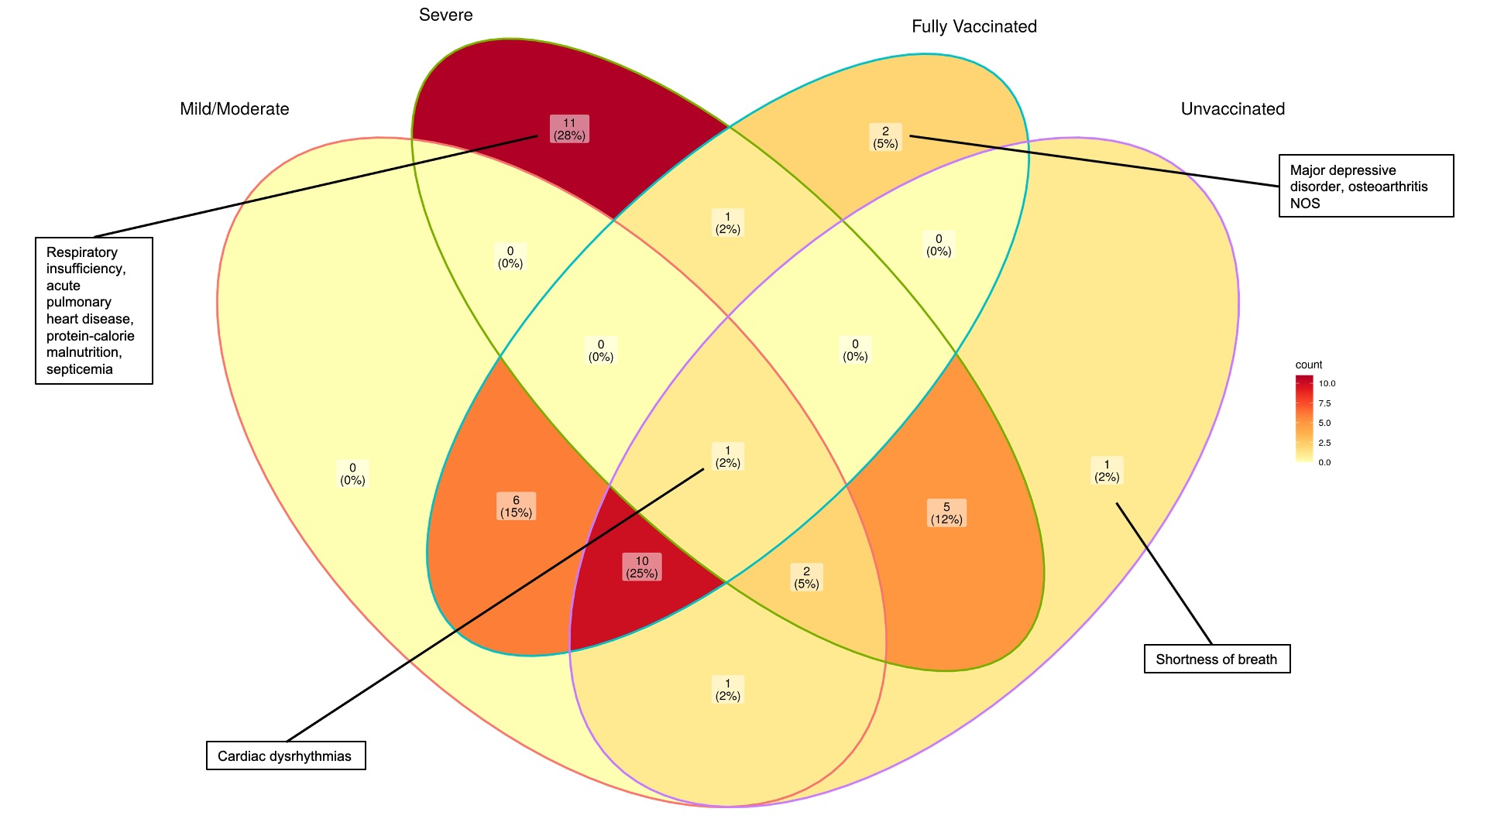

eFigure 2. Venn diagram comparing cohorts. In this figure, we took the top 20 hits from the following analyses: Mild/Moderate, Severe, Fully Vaccinated, Unvaccinated. Then, we plotted them on a Venn diagram to visualize the intersections between the cohorts. The number of hits (and percentage of the total) lying in each section of the diagram are shown. For a selection of sections, some of the included hits are noted in text box .

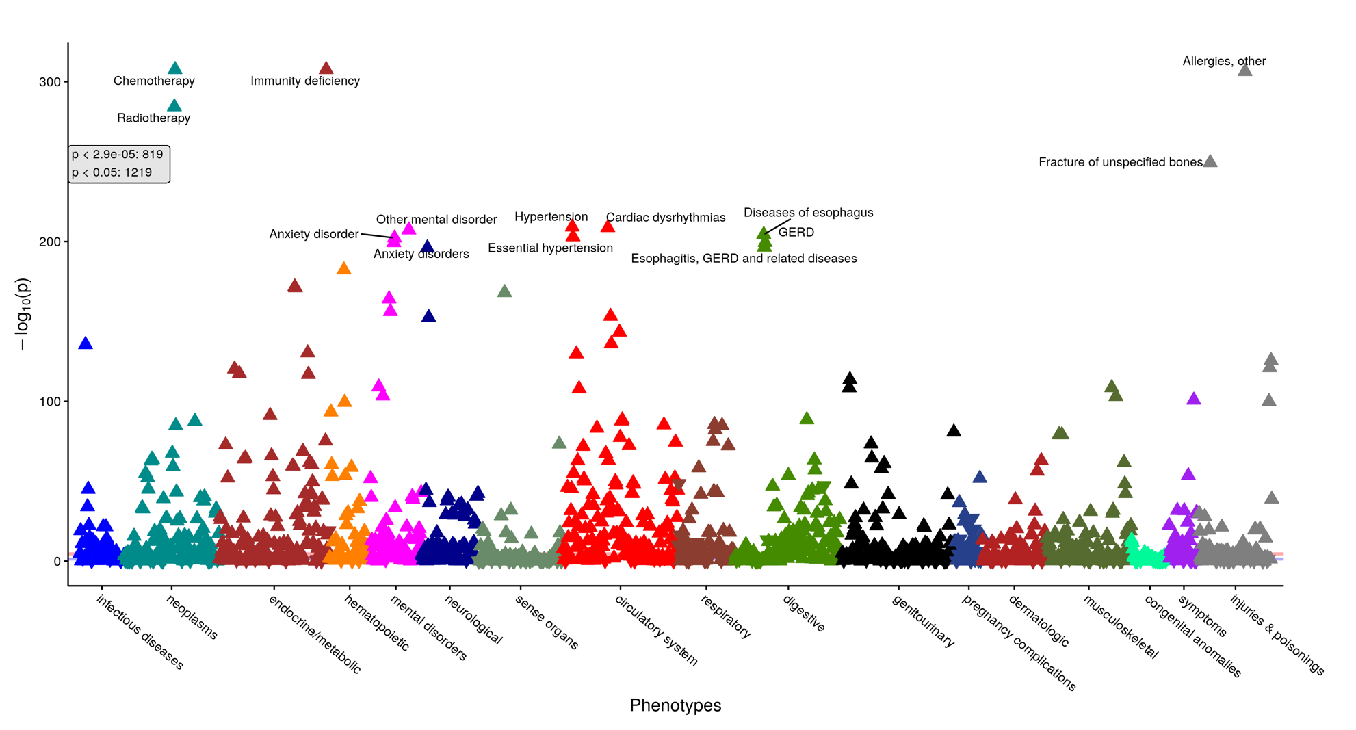eFigure 3. 1:4 Matched 90-day analysis - test negative Manhattan plots. PheCodes (grouped by category) are on the x-axis and the -log₁₀(p-value) is on the y-axis. Points above the Bonferroni-adjusted p-value threshold line (in red) are considered statistically significant. The nominal p-value threshold (0.05) is also shown in blue. The number of hits at the Bonferroni and nominal p-value threshold are provided. Some of the top hits for each plot are annotated. For each hit, an upward pointing triangle represents a positive association (OR>1), and a downward facing triangle represents a negative association (OR<1). Two PheCodes were removed from the plot (“Other infectious and parasitic diseases” and “Other headache syndromes”) for better visualization.

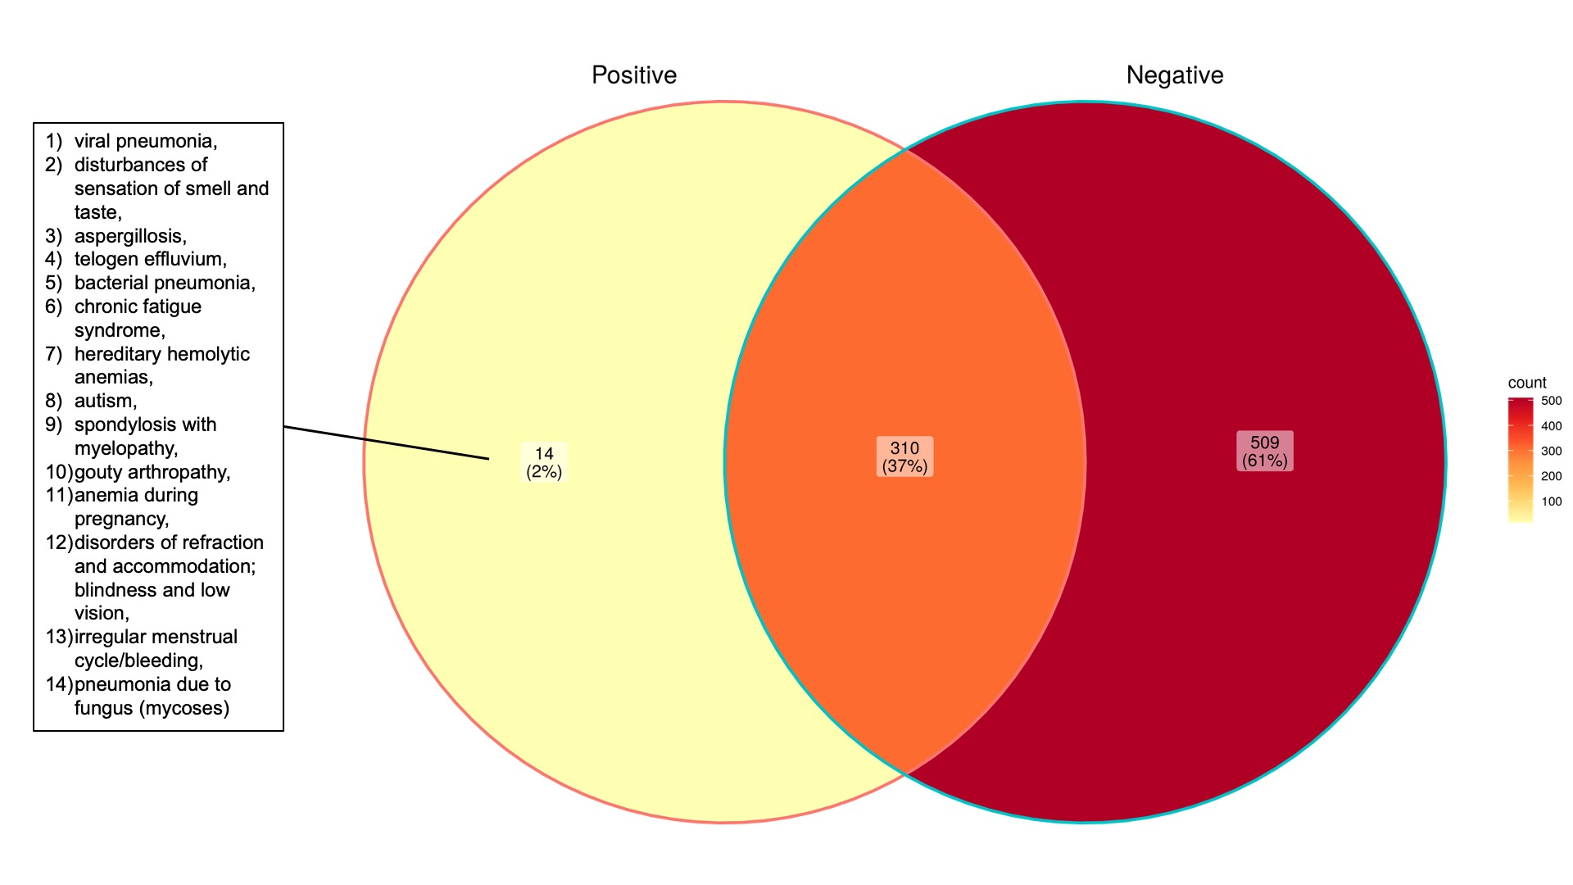

eFigure 4. Venn diagram comparing COVID-19-positive and COVID-19-negative. Here we compare all phenome-wide significant diagnoses in the 1:4 matched 90 day COVID-19-positive and COVID-19-negative analyses. The number of hits (and percentage of the total) lying in each section of the diagram are shown. Unique hits for the positive cohort are shown

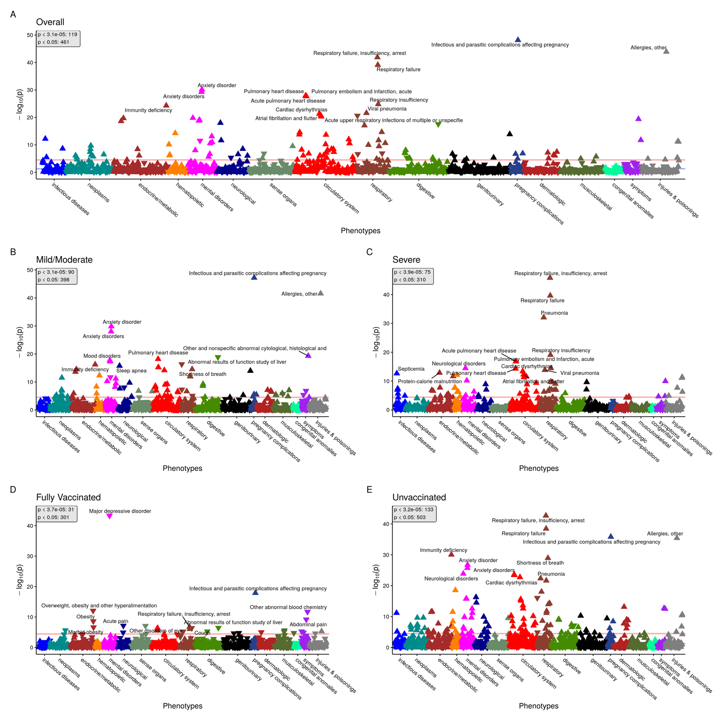eFigure 5. 1:2 Matched 180-day analysis Manhattan plots. Panel of PheWAS Manhattan plots showing overall (panel A) and stratified by COVID-19 severity (panels B and C) and vaccination status (panels D and E). PheCodes (grouped by category) are on the x-axis and the -log₁₀(p-value) is on the y-axis. Points above the Bonferroni-adjusted p-value threshold line (in red) are considered statistically significant. The nominal p-value threshold (0.05) is also shown in blue. For each panel, the number of hits at the Bonferroni and nominal p-value threshold are provided. Some of the top hits for each plot are annotated. For each hit, an upward pointing triangle represents a positive association (OR>1), and a downward facing triangle represents a negative association (OR<1). Two PheCodes were removed from plots (“Other infectious and parasitic diseases” and “Other headache syndromes”) for better visualization.

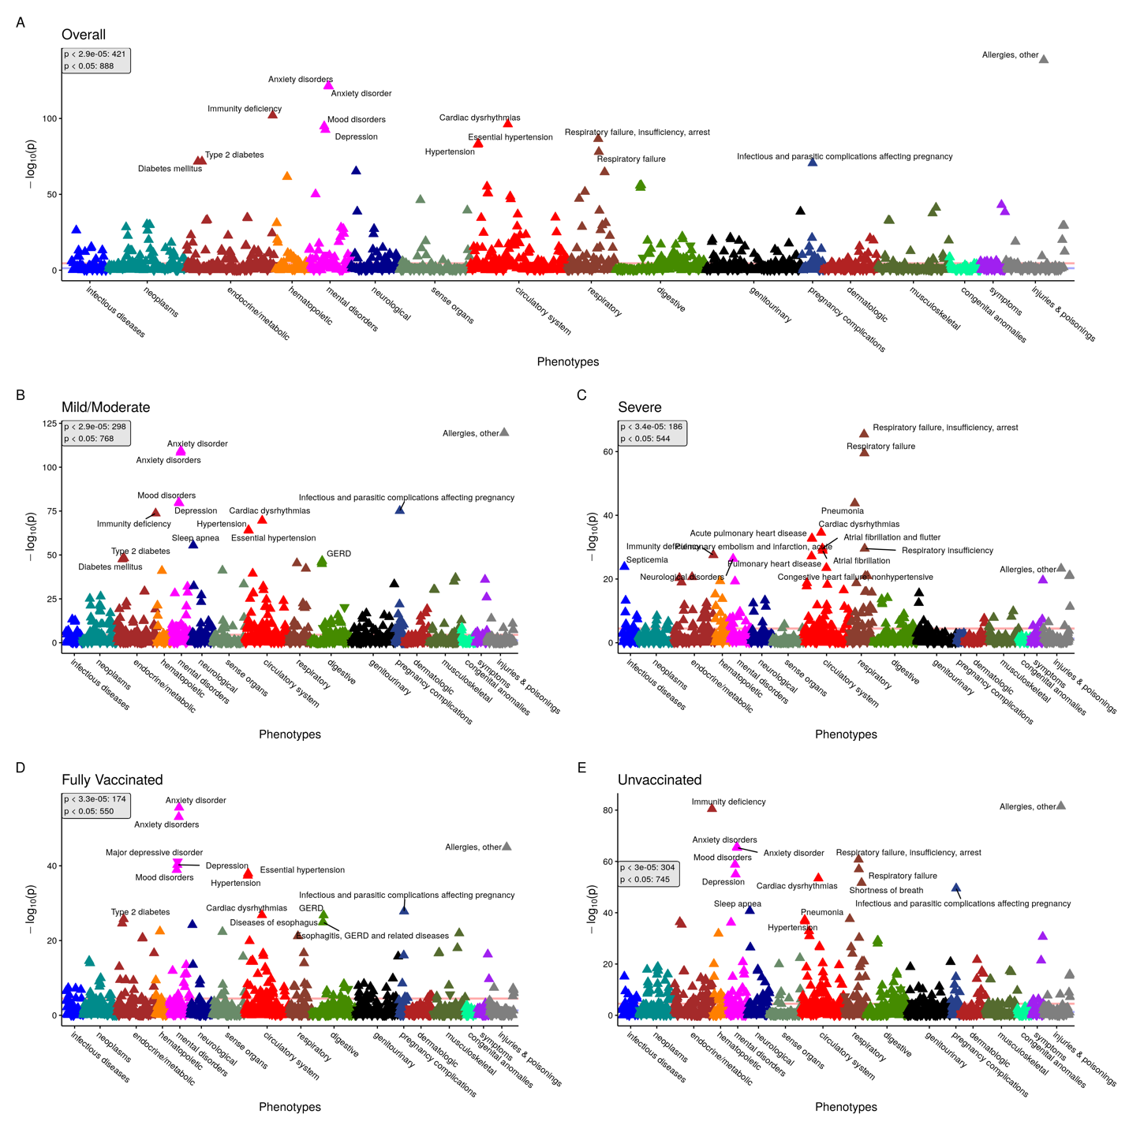eFigure 6. 2:4 Matched 90-day analysis Manhattan plots. Panel of PheWAS Manhattan plots showing overall (panel A) and stratified by COVID-19 severity (panels B and C) and vaccination status (panels D and E). PheCodes (grouped by category) are on the x-axis and the -log₁₀(p-value) is on the y-axis. Points above the Bonferroni-adjusted p-value threshold line (in red) are considered statistically significant. The nominal p-value threshold (0.05) is also shown in blue. For each panel, the number of hits at the Bonferroni and nominal p-value threshold are provided. Some of the top hits for each plot are annotated. For each hit, an upward pointing triangle represents a positive association (OR>1), and a downward facing triangle represents a negative association (OR<1). Two PheCodes were removed from plots (“Other infectious and parasitic diseases” and “Other headache syndromes”) for better visualization.

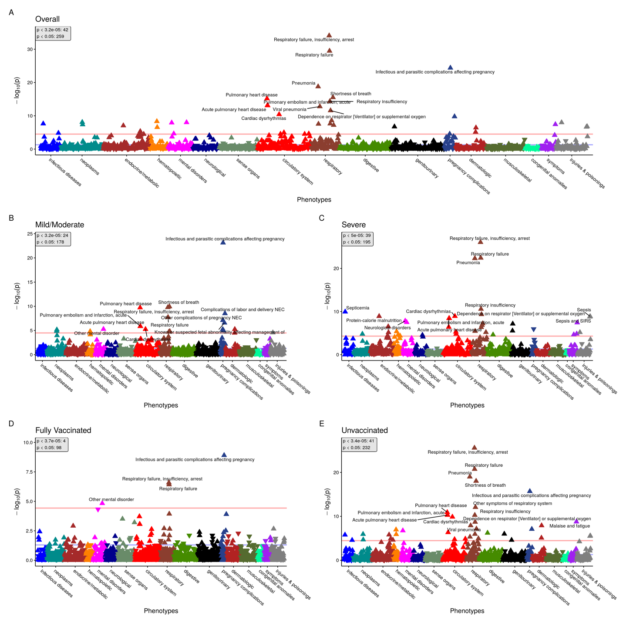eFigure 7. Fixed 90-day analysis Manhattan plots. Panel of PheWAS Manhattan plots showing overall (panel A) and stratified by COVID-19 severity (panels B and C) and vaccination status (panels D and E). PheCodes (grouped by category) are on the x-axis and the -log₁₀(p-value) is on the y-axis. Points above the Bonferroni-adjusted p-value threshold line (in red) are considered statistically significant. The nominal p-value threshold (0.05) is also shown in blue. For each panel, the number of hits at the Bonferroni and nominal p-value threshold are provided. Some of the top hits for each plot are annotated. For each hit, an upward pointing triangle represents a positive association (OR>1), and a downward facing triangle represents a negative association (OR<1). Two PheCodes were removed from plots (“Other infectious and parasitic diseases” and “Other headache syndromes”) for better visualization.

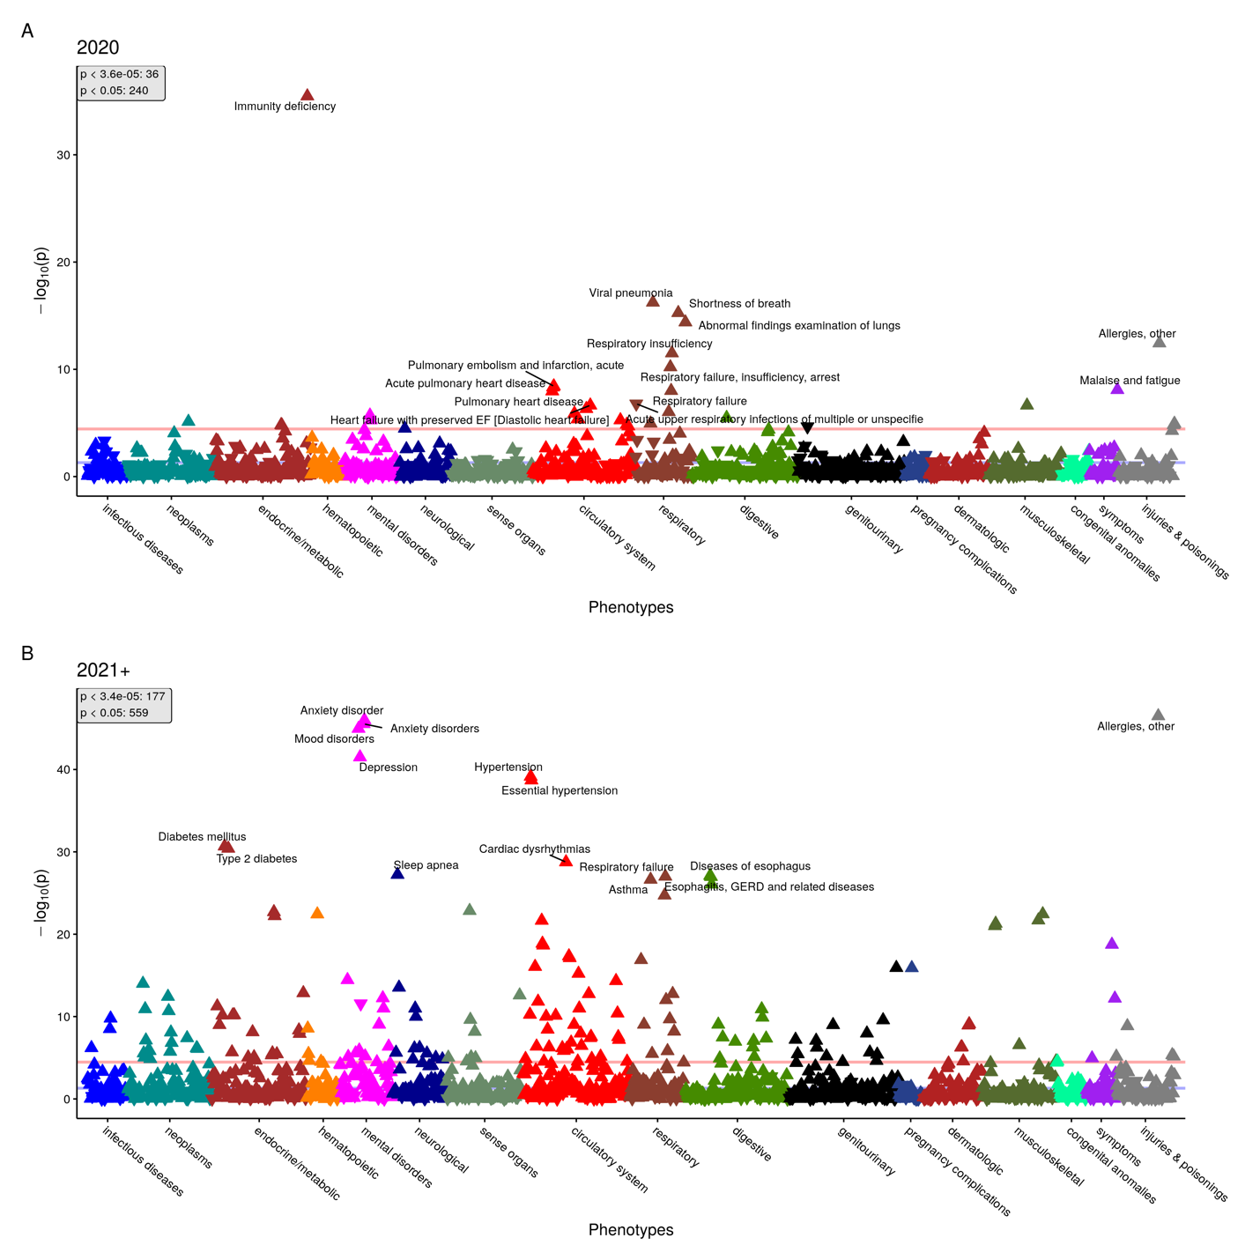eFigure 8. 1:4 Matched 90-day analysis - 2020 vs 2021+ Manhattan plots. PheWAS Manhattan plots for patients diagnosed in 2020 (panel A) vs 2021 and beyond (panel B). PheCodes (grouped by category) are on the x-axis and the -log₁₀(p-value) is on the y-axis. Points above the Bonferroni-adjusted p-value threshold line (in red) are considered statistically significant. The nominal p-value threshold (0.05) is also shown in blue. For each panel, the number of hits at the Bonferroni and nominal p-value threshold are provided. Some of the top hits for each plot are annotated. For each hit, an upward pointing triangle represents a positive association (OR>1), and a downward facing triangle represents a negative association (OR<1). Two PheCodes were removed from plots (“Other infectious and parasitic diseases” and “Other headache syndromes”) for better visualization.
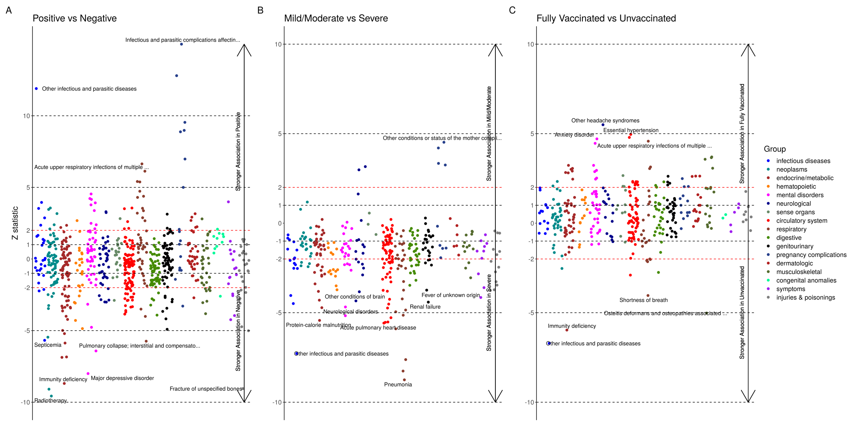
eFigure 9. Effect size comparison. This figure shows results of comparing effect sizes between the overall positive and negative groups (panel A), mild/moderate and severe groups (panel B), and fully vaccinated and unvaccinated groups (panel C). We plot the Z statistic (y axis) for the hypothesis test comparing the regression coefficients between the two groups for a specific PheCode (as described in eMethods 1) against each PheCode (x axis), colored by group. A Z statistic greater than 2 or less than -2 indicates a significant difference (shown as red lines). A highly positive Z statistic indicates that the first group had a stronger association between a PheCode and the “post-COVID-19 period” than the second group, and the converse if true for a highly negative Z statistic. Arrows are drawn to depict which PheCodes correspond to stronger associations with which groups. Some of the most significant PheCodes are labeled.

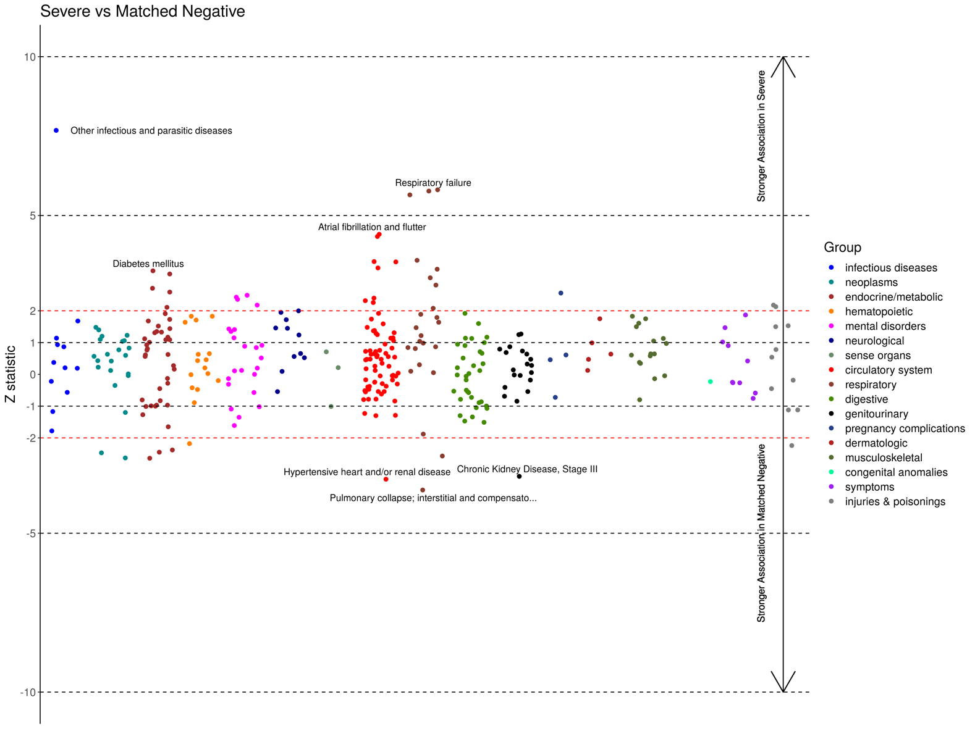
eFigure 10. Effect size comparison – Severe vs matched negative. This figure shows results of comparing effect sizes between the severe group and a cohort of test negative patients matched to only the severe group. We plot the Z statistic (y axis) for the hypothesis test comparing the regression coefficients between the two groups for a specific PheCode (as described in eMethods 1) against each PheCode (x axis), colored by group. A Z statistic greater than 2 or less than -2 indicates a significant difference (shown as red lines). A highly positive Z statistic indicates that the first group had a stronger association between a PheCode and the “post-COVID-19 period” than the second group, and the converse if true for a highly negative Z statistic. Arrows are drawn to depict which PheCodes correspond to stronger associations with which groups. Some of the most significant PheCodes are labeled.

eReferences

1. COVID-19 and Your Health. Centers for Disease Control and Prevention. Published February 11, 2020. Accessed February 21, 2022. https://www.cdc.gov/coronavirus/2019-ncov/long-term-effects/index.html
2. Wu P, Gifford A, Meng X, et al. Mapping ICD-10 and ICD-10-CM Codes to Phecodes: Workflow Development and Initial Evaluation. JMIR Med Inform. 2019;7(4):e14325. doi:10.2196/14325

