Supplementary Materials for

Establishment of a Human Organoid-based Evaluation System for Assessing Interspecies Infection Risk of Animal-borne Coronaviruses

Qianchun Gong^{1,*}, Rendi Jiang^{1,*,†}, Lina Ji³, Haofeng Lin², Meiqin Liu⁴, Yong Yang², Jing Chen², Zishuo Guo², Qi Wang², Qian Li⁴, Xi Wang², Tingting Jiang², Shizhe Xie², Xinglou Yang⁵, Peng Zhou^{4,6}, Zhengli Shi^{2,†} and Xinhua Lin^{1,3,†}

Correspondence to: xlin@fudan.edu.cn (X.H.L.), zlshi@wh.iov.cn (Z.L.S.) or Jiang_rendi@fudan.edu.cn (R.D.J.)

This PDF file includes:

Materials and Methods
Supplementary Text
Figures. S1 to S8
Table S1

Materials and Methods

Biosafety and Ethical Statement
All the viruses utilized in this experiment were from the Wuhan Institute of Virology, Chinese Academy of Sciences. The storage, propagation, and infection experiments with these viral strains were strictly conducted following the biosafety regulation of the institute. Experiments with the viruses in this study was permitted by the Biosafety Committee of the Wuhan Institute of Virology, Chinese Academy of Sciences. Bat SARS-related coronaviruses WIV1 and rRsSHC014S, pangolin coronavirus MpCoV-GX, as well as HCoV-229E (IVCAS 6.7565) and HCoV-OC43 (IVCAS 6.7567) were managed within a BSL-2 laboratory. SARS-CoV-2 (IVCAS 6.7512), MERS-CoV (IVCAS 6.6.7609), Omicron BA.1 (IVCAS 6.7600), and Omicron BA.5 (IVCAS 6.8981) were handled within a BSL-3 laboratory.
All experiments in this project employed well-established organoid models to completely eliminate the need for human sample collection while ensuring absolute safety for donors. Given that researchers had no access to personal information about donors and research outcomes did not impact personal privacy rights or expose any personal information risks whatsoever. The use of human organoid samples obtained from human tissues had previously undergone meticulous ethical scrutiny and approval by Ethics Committee of Fudan University (FE22018R).

Cell Lines and Culture
The Vero E6, Huh7-G, and HCT-8 cell lines were cultured in DMEM (Gibco, C11995500BT) supplemented with 10% FBS (Gibco, C22400500BT) and maintained at 37°C in a humidified incubator with 5% CO₂. During the process of viral amplification, the culture medium was modified to DMEM supplemented with 2% FBS and 1% Antibiotic-Antimycotic (Gibco, 15240062). In the plaque assays, cell culture was conducted using a semi-solid medium containing 0.9% methylcellulose (Sigma, M0512). All cell lines utilized in this study underwent rigorous testing to ensure they were free from mycoplasma contamination. Furthermore, none of the cell lines appeared on the list of commonly misidentified cell lines (by ICLAC).

Virus Propagation
For virus propagation, sensitive cells were cultured for 2-3 consecutive passages to ensure a robust cell population. Once the cell density reached 90%-100%, the original culture medium was removed and the cells were washed with PBS (Gibco, C10010500BT). Subsequently, the virus was added to the cells at a multiplicity of infection (MOI) of 0.01 and cells were incubated at 37°C. After approximately 50% cytopathic effect (CPE), the virus was collected by centrifugation at 6000g for 15 minutes at 4°C, followed by resuspension and division into aliquots for freezing and storage. WIV1, rRsSHC014S, MpCoV-GX, SARS-CoV-2, and MERS-CoV were propagated and titrated in Vero E6 cells, HCoV-229E in Huh7-G cells and HCoV-OC43 virus in HCT-8 cells.

Plaque Assay for Virus Titration
To determine the viral titer, a plaque assay was conducted. First, the virus samples were diluted using DMEM in a gradient manner. Next, after washed with PBS, cells were exposed to the diluted virus solution and incubated on a shaker at 37°C for 1 hour. The medium was then substituted with a semi-solid medium containing 0.9% methylcellulose and the cells were placed in a 5% CO₂ humidified incubator at 37°C for 3-5 days until visible plaques appeared on the cell plate surface. Once visible plaques emerged, the cells were washed with PBS, fixed with 4% paraformaldehyde (BOSTER, AR1069) for 15 minutes at room temperature, stained with a 0.5% crystal violet solution for 5 minutes at room temperature, and washed with PBS again. Plaques clearly visible on the cell plate surface were counted accurately to calculate the virus titer.

Establishment and Maintenance of Human Organoids
The human adult nasal mucosa, distal lung, small intestine, and colon tissues were obtained from patients who underwent surgical resection due to various diseases. The adjacent normal tissues were utilized for the derivation of organoids.
A modified version of the protocol described by Sachs et al.[1] and Rajan et al.[2] was used to prepare hNOs and hLOs. In brief, the nasal or lung biopsies were washed with cold PBS and then minced into approximately 2-mm-thick sections. These sections were incubated with 400 U/mL collagenase I (Gibco, 17100017) and 10U/mL DNase I (Sigma, DN25) at 37°C for 1-2 hours. Subsequently, the suspension was filtered through a 100-μm cell strainer (Falcon, 352360) to eliminate larger debris. 2% FBS was added to the suspension to halt the digestion process. Following centrifugation at 250g for 3 minutes, the pelleted cells were resuspended in cold Matrigel (Corning, 356231) and seeded in 24-well plates. After solidification of Matrigel, 500 μL organoid medium was added to each well and cells were cultured in a humidified 5% CO₂ incubator at 37°C. The medium was refreshed every three days and organoids were passaged every two weeks to sustain their growth and functionality.
The hIOs and hCOs were prepared following a modified protocol described by Sato et al.[3] First, the intestinal tissue was thoroughly washed with cold PBS until the supernatant became clear. Next, the tissue was cut into small fragments and incubated with 5 mM EDTA in PBS at 4°C for 30-40 minutes. After the EDTA buffer removed, the tissue fragments were resuspended in cold PBS and gently pipetted up and down several times to isolate the crypts. Then, the suspension was filtered through a 70-μm cell strainer (Falcon, 352350) to remove larger debris. Following centrifugation at 250g for 3 minutes, the pelleted cells were embedded in Matrigel and seeded in 24-well plates. After solidification of Matrigel, 500 μL organoid medium was added to each well and cells were cultured in a humidified 5% CO₂ incubator at 37°C. The medium was refreshed every three days and organoids were passaged every two weeks to sustain their growth and functionality.

Viral Infection of Organoids
The Matrigel was dissolved using cell recovery solution (Corning, 354253). Subsequently, the organoids were gently dissociated either through 1× TrypLE Select (Gibco, A1217701) digestion or mechanical disruption to expose their lumens and thereby to facilitate virus entry and infection. Next, the organoids were infected with the virus at a MOI ranging from 0.1 to 1. The organoid-virus mixture was then incubated in a humidified 5% CO₂ incubator at 37°C for 3 hours. After incubation, the organoids were washed twice with PBS and finally resuspended in Matrigel. The resuspended organoids were seeded and cultured with their respective medium in a humidified 5% CO₂ incubator at 37°C. Depending on experimental requirements, virus-infected organoid samples were collected at different time points.
To investigate the impact of TMPRSS2 and CTSB/L on viral growth, pretreatment using either 100 μM camostat mesylate (MCE, HY-13512) /100 μM E64-D (MCE, HY-100229) (inhibitors) or DMSO (control) for 1 hour were conducted. Subsequently, the organoids were inoculated with viruses at an MOI of 1 for 3 hours at 37°C. The organoids were then seeded into Matrigel and cultured back in medium containing inhibitors or control.

Immunofluorescence Staining, Confocal Imaging and Flow Cytometry.
For immunofluorescence staining, organoids were extracted from Matrigel using cell recovery solution, fixed with 4% PFA at 4°C for 1 hour, permeabilized with 0.25% Triton X-100 (Sigma, T9284) in PBS for 15 minutes, and blocked with 5% BSA (BBI, A600332) for 1 hour to prevent nonspecific binding. For primary antibody staining, the organoids were incubated with the specified primary antibodies at 4°C overnight and subsequently washed three times with PBST (PBS containing 0.1% Tween-20). Afterwards, the organoids were incubated with appropriate secondary antibodies and DAPI (Roche, 10236276001) at room temperature for 1 hour, followed by washes with PBST. Finally, visualization of the organoids was performed using a confocal microscope (Leika, STELLARIS 8 WILL). The following primary antibodies were utilized: recombinant Anti-Cytokeratin 5 antibody [EP1601Y] (1:500, abcam, ab224984), recombinant Anti-Mucin 5AC antibody [EPR16904] (1:500, abcam, ab198294), acetylated alpha Tubulin antibody [6-11B-1] (1:100, Santa cruz, sc-23950), CC10 antibody [E-11] (1:100, Santa cruz, sc-365992), WIV1/rRsSHC014S-NP antibody (1:1000, made in house), Anti-MpCoV-NP antibody (1:1000, made in house), Anti-HCoV-229E-NP antibody (1:1000, made in house), Anti-HCoV-OC43-NP antibody (1:1000, made in house), Anti-SARS-CoV-2/Omicron BA.1-NP antibody (1:1000, made in house), Anti-MERS-CoV antibody (1:1000, made in house). The following secondary antibodies were used: fluorescein (FITC)-conjugated Affinipure Goat Anti-Mouse IgG(H+L) (1:200, Proteintech, SA00003-1), goat Anti-Rabbit IgG H&L (Cy3) (1:200, Abcam, ab6939).
For flow cytometry analysis, the organoids were dissociated into single cells using TrypLE Express at 37°C for 15 minutes after removal of Matrigel. The cells were then incubated with Apoptracker (Biolegend, 427403) or Zombie (Biolegend, 423101) probes in the dark at room temperature for 20 minutes. Subsequently, Cyto-FastTM Fix/Perm Buffer (Biolegend, 426803) was used to fix and permeabilize the cells followed by 2 washes with 1x Cyto-FastTM Perm Wash Solution (Biolegend, 426803). After incubation in PBS containing 5% BSA at room temperature for 30 minutes, cells were stained with primary and secondary antibodies sequentially. Flow cytometric analysis was performed using a BD LSRFortessa flow cytometer and data processing was done using FlowJo software. Primary antibodies used included WIV1/rRsSHC014S-NP antibody (1:1000), Anti-MpCoV-NP antibody (1:1000), Anti-HCoV-229E-NP antibody (1:1000), Anti- HCoV-OC43-NP antibody (1:1000), Anti-SARS-CoV-2/Omicron BA.1-NP antibody (1:1000), and Anti-MERS-CoV antibody(1:1000); all made in house. Secondary antibodies used included Goat Anti-Rabbit IgG H&L (Cy3®) (1:200, Abcam, ab6939) and Donkey Anti-Mouse IgG H&L (Alexa Fluor® 647) (1:200, Abcam, ab150107).

RNA Extraction and qRT-PCR
To extract RNA from cell culture supernatants, the Purifier™ Modesty automated nucleic acid extraction system (Genfine Biotech) in conjunction with the FineQuick Viral DNA/RNA Kit (Genfine Biotech) were used following the manufacturers’ instructions. To extract RNA from organoids, the RNAprep pure Cell/Bacteria Kit (TIANGEN, DP430) was used following the manufacturer’s instructions.
Individual viral N gene plasmids were constructed as standards for qRT-PCR. Quantification of viral N gene was performed using the HiScript® II One Step qRT-PCR SYBR® Green Kit (Vazmye, Q221-01) and the StepOne Plus system (ABI) in a reaction system consisting of 5 μL of 2 × One Step SYBR® Green Mix, 0.5 μL of One Step SYBR® Green Enzyme Mix, 0.2 μL of 50 × ROX Reference Dye 1, 0.2 μL of the forward primer, 0.2 μL of the reverse primer, 2 μL of the template, and ddH2O to a final volume of 10 μL. The reaction program was set as follows: 50°C for 3 minutes, 95°C for 5 minutes, 40 cycles at 95°C for 10 seconds, 60°C for 30 seconds, and a melt curve analysis.
For reverse transcription and qRT-PCR of organoid RNA, HiScript III All-in-one RT SuperMix Perfect for qPCR (Vazmye, R333-01) and Taq Pro Universal SYBR qPCR Master Mix (Vazmye, Q712) kits were used to quantify the expression of various cell-specific markers and host response genes. The reverse transcription reaction consisted of 10 μL of 5× All-in-one qRT SuperMix, 10 μL of RNA, 2.5 μL of Enzyme Mix, and nuclease-free water to a final volume of 50 μL. The reaction was incubated at 50°C for 15 minutes, followed by heat inactivation of the reverse transcriptase at 85°C for 5 seconds. The qPCR reaction system consisted of 10 μL of 2× Taq Pro Universal SYBR qPCR Master Mix, 0.4 μL of forward primer, 0.4 μL of reverse primer, 2 μL of cDNA template, and nuclease-free water to reach a final volume of 20 μL. The reaction program was set as follows: 95°C for 30 seconds, 40 cycles at 95°C for 15 seconds, 60°C for 30 seconds, and a melt curve analysis. Relative expression was calculated using comparative Ct method (2^{-ΔΔCt}) and statistical significance was determined by 2-tailed unpaired Student’s t test. A semi-quantitative approach by calculating 2^{-ΔCt} was used to analyze sgRNA replication activity.

Primers used in this work are listed as follows:
SARS-CoV-2-NP-F: GAGCTACCAGACGAATTCGTGGT
SARS-CoV-2-NP-R: AGCATTGTTAGCAGGATTGCGG
SARS-CoV-2-sgRNA-F: CCAGGTAACAAACCAACCAACT
SARS-CoV-2-sgRNA-R: TGAATCTGAGGGTCCACCAAAC
Omicron BA.1-NP-F: GAGCTACCAGACGAATTCGTGGT
Omicron BA.1-NP-R: AGCATTGTTAGCAGGATTGCGG
Omicron BA.1-sgRNA-F: CCAACCAACTTTCGATCTCTTG
Omicron BA.1-sgRNA-R: TGAATCTGAGGGTCCACCAAAC
Omicron BA.5-NP-F: GAGCTACCAGACGAATTCGTGGT
Omicron BA.5-NP-R: AGCATTGTTAGCAGGATTGCGG
MERS-CoV-NP-F: GGGTGTACCTCTTAATGCCAATTC
MERS-CoV-NP-R: TCTGTCCTGTCTCCGCCAAT
MERS-CoV-sgRNA-F: CTTGGCTATCTCACTTCCCCTC
MERS-CoV-sgRNA-R: TATCGGCAAAGGAAACAGCACG
HCoV-229E-NP-F: GGGTTGCTGTTGATGGTG
HCoV-229E-NP-R: GTGTGGTATCTCTGGTTCTG
HCoV-229E-sgRNA-F: TGCTTTTTAGACTTTGTGTCTAC
HCoV-229E-sgRNA-R: AAATCCACCCGTTTGCCCT
HCoV-OC43-NP-F: ATGCTAAAGACCAGTACGGC
HCoV-OC43-NP-R: GCGGAAACCTAGTCGGAATAG
HCoV-OC43-sgRNA-F: ATTGTGAGCGATTTGCGTGCGT
HCoV-OC43-sgRNA-R: CGCTCTACTACTGGATTGCTTA
WIV1-NP-F: TCGTATGGGTCGCAACTGAG
WIV1-NP-R: GCGAGAAGAGGCTTGACTGC
WIV1-sgRNA-F: CAACCAACCCCGATCTCTTG
WIV1-sgRNA-R: CTGTGGGTCCACCAAATGTAAT
rRsSHC014S-NP-F: TCGTATGGGTCGCAACTGAG
rRsSHC014S-NP-R: GCGAGAAGAGGCTTGACTGC
rRsSHC014S-sgRNA-F: CAACCAACCCCGATCTCTTG
rRsSHC014S-sgRNA-R: CTGTGGGTCCACCAAATGTAAT
MpCoV-GX-NP-F: TACCAGACGAGTTCGTGGTGGT
MpCoV-GX-NP-R: ATTGCGGGTGCCAATGTGATC
MpCoV-GX-sgRNA-F: AGGTAGCAAAACCAACCAACTC
MpCoV-GX-sgRNA-R: GTCCACCAAATGTAATGCGGGG
IFNA1-F: GCCTCGCCCTTTGCTTTACT
IFNA1-R: CTGTGGGTCTCAGGGAGATCA
IFNB-F: GCTTGGATTCCTACAAAGAAGCA
IFNB-R: ATAGATGGTCAATGCGGCGTC
IFNλ1-F: GGACGCCTTGGAAGAGTCACT
IFNλ1-R: AGAAGCCTCAGGTCCCAATTC
IL1-β-F: ATGATGGCTTATTACAGTGGCAA
IL1-β-R: GTCGGAGATTCGTAGCTGGA
IL6-F: ACTCACCTCTTCAGAACGAATTG
IL6-R: CCATCTTTGGAAGGTTCAGGTTG
IL7-F: TTCCTCCCCTGATCCTTGTTC
IL7-R: CTTGCGAGCAGCACGGAATA
IL33-F: GTGACGGTGTTGATGGTAAGAT
IL33-R: AGCTCCACAGAGTGTTCCTTG
TNFα-F: GAGGCCAAGCCCTGGTATG
TNFα-R: CGGGCCGATTGATCTCAGC
CXCL10-F: GTGGCATTCAAGGAGTACCTC
CXCL10-R: TGATGGCCTTCGATTCTGGATT
CCL5-F: CCAGCAGTCGTCTTTGTCAC
CCL5-R: CTCTGGGTTGGCACACACTT
MCP1-F: CAGCCAGATGCAATCAATGCC
MCP1-R: TGGAATCCTGAACCCACTTCT
MX2-F: ATGAATGTGGTGCGGAACCT
MX2-R: AAGTCTTTCTGCCAGTCGGG
ACE2-F: CATTGGAGCAAGTGTTGGATCTT
ACE2-R: GAGCTAATGCATGCCATTCTCA
DPP4-F: GGAACAGACGATGCAACTG
DPP4-R: GACTATACAGTTTCAGTCTG
APN-F: GTTCTCCTTCTCCAACCTCATC
APN-R: CTGTTTCCTCGTTGTCCTTCT
TMPRSS2-F: CAG GTC ATA TTG AAC ATT CCA G
TMPRSS2-R: CTG AGT TCA AAG CCA TCT TG
CTSB-F: ACAACGTGGACATGAGCTACT
CTSB-R: TCGGTAAACATAACTCTCTGGGG
CTSL-F: AAACTGGGAGGCTTATCTCACT
CTSL-R: GCATAATCCATTAGGCCACCAT
IFIT3-F: CCTGGAATGCTTACGGCAAGCT
IFIT3-R: GAGCATCTGAGAGTCTGCCCAA
ISG15-F: CTCTGAGCATCCTGGTGAGGAA
ISG15-R: AAGGTCAGCCAGAACAGGTCGT
TNFα-F: GAGGCCAAGCCCTGGTATG
TNFα-R: CGGGCCGATTGATCTCAGC
IL6-F: ACTCACCTCTTCAGAACGAATTG
IL6-R: CCATCTTTGGAAGGTTCAGGTTG
IRE1α-F: CCGAACGTGATCCGCTACTTCT
IRE1α-R: CGCAAAGTCCTTCTGCTCCACA
PERK-F: GTCCCAAGGCTTTGGAATCTGTC
PERK-R: CCTACCAAGACAGGAGTTCTGG
ATF6-F: CAGACAGTACCAACGCTTATGCC
ATF6-R: GCAGAACTCCAGGTGCTTGAAG
SOCS1-F: TTCGCCCTTAGCGTGAAGATGG
SOCS1-R: TAGTGCTCCAGCAGCTCGAAGA
Alt. spliced XBP1-F: GCTGAGTCCGCAGCAGGT
Alt. spliced XBP1-R: CTGGGTCCAAGTTGTCCAGAAT
Total XBP1-F: TGAAAACAGAGTAGCAGCTCAGA
Total XBP1-R: CCCAAGCGCTGTCTTAACTC
GAPDH-F: GGAGCGAGATCCCTCCAAAAT
GAPDH-R: GGCTGTTGTCATACTTCTCATGG

Organoid Colony Formation Assay
The hLOs were cultured for approximately 10 days to reach a density of 60–70%. After dissociation into small cell clusters using 1× TrypLE Select, a total of 1000 cells were plated per well in a 24-well plate. The number of organoid colonies were counted 1-2 days later. Each experimental group consisted of three samples each with two biological replicates.

CBD treatment
We set the CBD concentration in our experiment to 10uM based on prior studies of its efficacy in A549-ACE2 cells[4]. Mature hLOs were cultured in medium containing 10uM CBD (Sigma, PHL85705) or DMSO for 12 hours prior to viral infection. After infection, hLOs were maintained in the same culture medium containing 10uM CBD or DMSO for 24 hours before subsequent analysis.

XBP1 splicing assay
qRT-PCR was employed to quantify the expression of spliced XBP1 (XBP1s) and total XBP1, as previously described[5]. The level of alternative splicing of XBP1(%XBP1s) was determined by the ratio of XBP1s expression to that of total XBP1.

Statistical Analysis
The statistical analyses were performed using GraphPad Prism, version 8.0 software. Data are presented as the mean ± standard error of the mean (SEM). Statistical significance (p-value) is determined by two-tailed Student's t-test. P-values less than 0.05 were considered statistically significant. Symbols or sample numbers (n) are provided in each figure or figure legend.

Data Availability Statement
The data presented in this study can be obtained upon request from the corresponding authors. Due to limitations in the material transfer agreement, the data are not publicly accessible.

Informed Consent Statement
Informed consent was obtained from all subjects involved in the study.

Supplementary Text

Criteria for the Coronavirus Comprehensive Evaluation System
1. Virus cell tropism. The infectivity of 7 different cell types was evaluated, comprising 3 from hNO and 4 from hLO. Each successfully infected cell type was assigned a score of 1.43 points, resulting in a total score of 10 points.
2. Virus invasion preference. The total score is 10 points, consisting of two components.
(1) Virus tissue tropism: The virus transmission ability is assessed by its release in hNO supernatant, while its pathogenicity is indicated by replication in hLO cells. A virus with an amplification exceeding 10-fold in organoid cells is considered to have effective infection capability and awarded 2.5 points, whereas a virus with an amplification exceeding 100-fold in supernatant is regarded as having effective release and awarded 2.5 points. The total score for this criterion amounts to 5 points.
(2) Virus invasion mechanism preference. In hNOs, a virus that primarily utilizes endocytic pathways is assigned 2.5 points, while a virus that uses both membrane fusion and endocytic pathways receives 1.875 points. A virus mainly utilizing membrane fusion pathways is awarded 1.25 points, and a virus that does not utilize either pathway receives 0.625 points. In hLOs, a virus mainly utilizing membrane fusion pathways is awarded 2.5 points, while a virus using both membrane fusion and endocytic pathways scores 1.875 points. A virus primarily utilizing endocytic pathways receives 1.25 points, and a virus that does not use either pathway receives 0.625 points. The total score for this criterion is five.
3. Virus replication activity. The total score is 10 points, assessed by employing sgRNA as a surrogate for measuring replication activity in organoid cells and PFU as an indicator of viral titer in the supernatant of organoids.
(1) In hLO cells, the viruses are ranked based on the relative expression level of sgRNA, and they are classified into segments according to their strength from highest to lowest, as follows: >MERS-CoV, MERS-CoV~HCoV-OC43, HCoV-OC43~SARS-CoV-2, SARS-CoV-2~HCoV-229E, HCoV-229E~Omicron BA.1, <Omicron BA.1. The respective scores are 2.5, 2.0, 1.5, 1.0, 0.5, and 0 points.
(2) In hNO cells, the viruses are ranked based on the relative expression level of sgRNA, and they are classified into segments according to their strength from highest to lowest, as follows: >HCoV-229E, HCoV-229E~HCoV-OC43, HCoV-OC43~SARS-CoV-2, SARS-CoV-2~MERS-CoV, MERS-CoV~Omicron BA.1, <Omicron BA.1. The respective scores are 2.5, 2.0, 1.5, 1.0, 0.5, and 0 points.
(3) In hLO supernatant, the viruses are ranked in descending order based on their PFU values, as follows: >SARS-CoV-2, SARS-CoV-2~MERS-CoV, MERS-CoV~HCoV-229E, HCoV-229E~HCoV-OC43, HCoV-OC43~Omicron BA.1, <Omicron BA.1. The corresponding scores assigned to them are 2.5, 2.0, 1.5, 1.0, 0.5, and 0 points.
(4) In hNO supernatant, the viruses are ranked in descending order based on their PFU values, as follows: >HCoV-OC43, HCoV-OC43~HCoV-229E, HCoV-229E~Omicron BA.1, Omicron BA.1~SARS-CoV-2, SARS-CoV-2~MERS-CoV, <MERS-CoV. The corresponding scores assigned to them are 2.5, 2.0, 1.5, 1.0, 0.5, and 0 points.
4. Host response to virus infection. This evaluation consists of two components. Firstly, the interferon response (measured by IFNA1, IFNB, IFNλ1, MX2) was analyzed based on its trend at 24hpi, 48hpi and 72hpi. The ranking was determined as follows: sustained increase, initial increase followed by decrease, initial decrease followed by increase and sustained decrease. Secondly, the expression of inflammatory factors (IL1β, IL6, IL7, IL33, TNFα, CXCL10, CCL5, MCP1) was assessed through curve plotting and AUC calculation. Viruses were ranked and scored based on their AUC values. The total score is out of 10 points.
5. Virus-induced host cell apoptosis & death. The assessment was predicated on the proportion of cells undergoing apoptosis or death among the entire single cell population, resulting in a total score of 10 points.
(1) At 24 hpi, the severity of cell death was ranked as follows: >HCoV-229E, HCoV-229E~SARS-CoV-2, SARS-CoV-2~Omicron BA.1, Omicron BA.1~HCoV-OC43, HCoV-OC43~MERS-CoV, <MERS-CoV, with scores of 2.5, 2.0, 1.5, 1.0, 0.5, and 0 points, respectively.
(2) At 72 hpi, the severity of cell death was ranked as follows: >MERS-CoV, MERS-CoV~HCoV-OC43, HCoV-OC43~SARS-CoV-2, SARS-CoV-2~Omicron BA.1, Omicron BA.1~HCoV-229E, <HCoV-229E, with scores of 2.5, 2.0, 1.5, 1.0, 0.5, and 0 points, respectively.
(3) At 24 hpi, the severity of cell apoptosis was ranked as follows: >HCoV-OC43, HCoV-OC43~HCoV-229E, HCoV-229E~SARS-CoV-2, SARS-CoV-2~Omicron BA.1, Omicron BA.1~MERS-CoV, <MERS-CoV, with scores of 0, 0.5, 1.0, 1.5, 2.0, and 2.5 points, respectively.
(4) At 72 hpi, the severity of cell apoptosis was ranked as follows: >HCoV-229E, HCoV-229E~HCoV-OC43, HCoV-OC43~MERS-CoV, MERS-CoV~SARS-CoV-2, SARS-CoV-2~Omicron BA.1, <Omicron BA.1, with scores of 0, 0.5, 1.0, 1.5, 2.0, and 2.5 points, respectively.

References
1. Sachs N, Papaspyropoulos A, Zomer-van Ommen DD, et al. Long-term expanding human airway organoids for disease modeling. EMBO J. 2019 Feb 15;38(4).
2. Rajan A, Weaver AM, Aloisio GM, et al. The Human Nose Organoid Respiratory Virus Model: an Ex Vivo Human Challenge Model To Study Respiratory Syncytial Virus (RSV) and Severe Acute Respiratory Syndrome Coronavirus 2 (SARS-CoV-2) Pathogenesis and Evaluate Therapeutics. mBio. 2022 Feb 15:e0351121.
3. Sato T, Stange DE, Ferrante M, et al. Long-term Expansion of Epithelial Organoids From Human Colon, Adenoma, Adenocarcinoma, and Barrett's Epithelium. Gastroenterology. 2011 Nov;141(5):1762-1772.
4. Nguyen LC, Yang D, Nicolaescu V, et al. Cannabidiol inhibits SARS-CoV-2 replication through induction of the host ER stress and innate immune responses. Sci Adv. 2022 Feb 25;8(8):eabi6110.
5. Zhou Y, Zhou B, Pache L, et al. Metascape provides a biologist-oriented resource for the analysis of systems-level datasets. Nat Commun. 2019 Apr 3;10(1):1523.

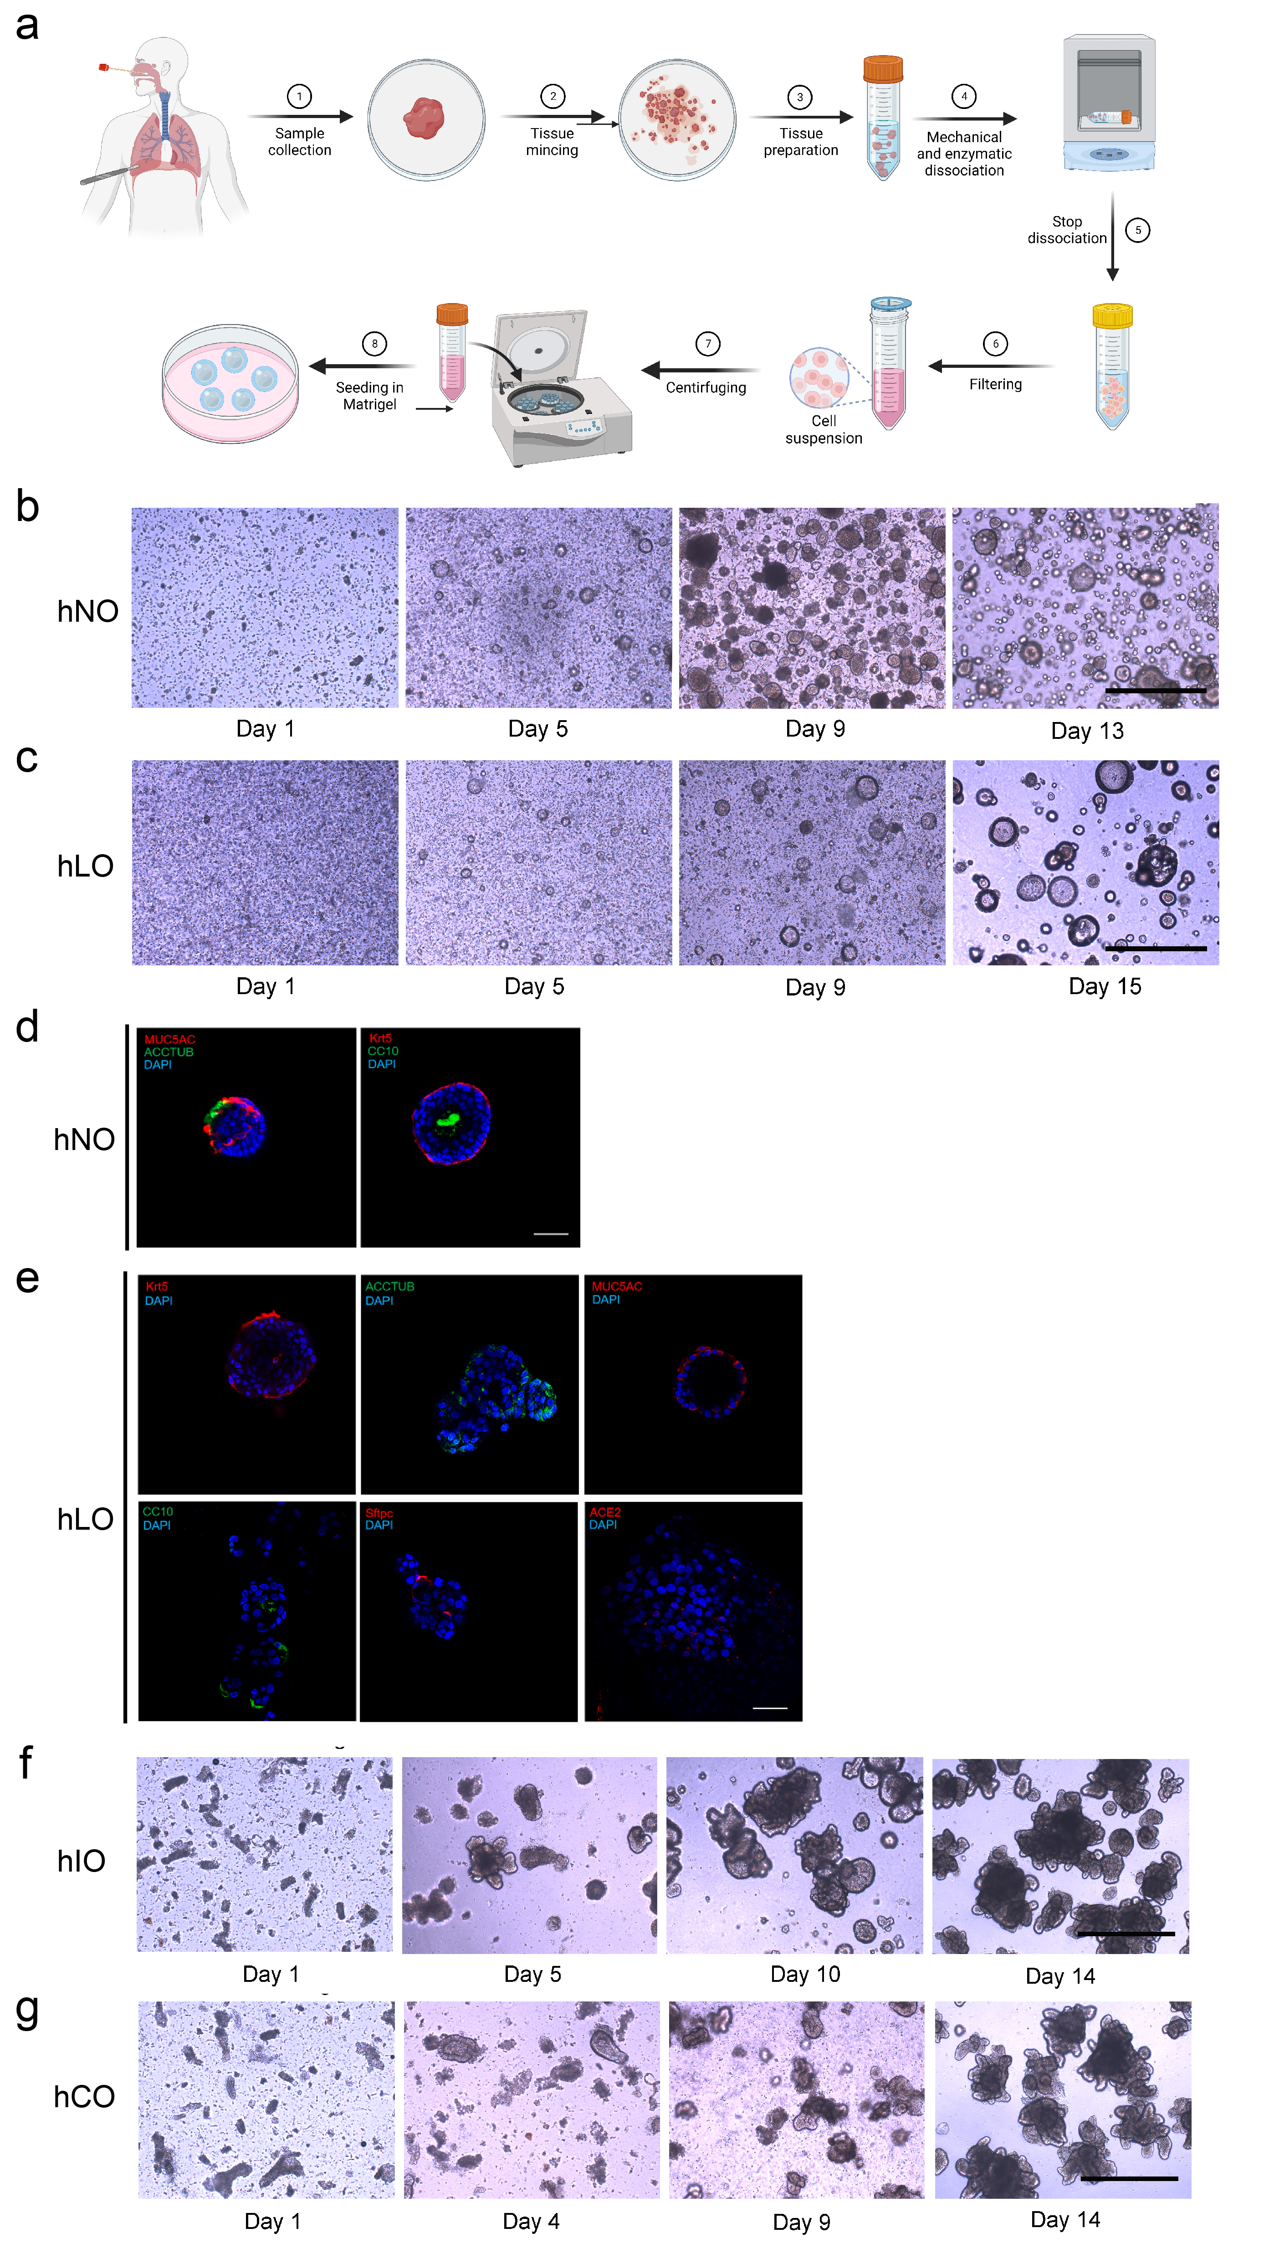
Figure S1. Culturing and Characterization of Human Respiratory and Intestinal Organoids. (a) Generation of hNOs and hLOs. (b) Growth of hNOs in culture, scale bar = 500μm. (c) Growth of hLOs in culture, scale bar = 500μm. (d) Immunofluorescence staining of hNOs with antibodies against specific cell markers, scale bar = 50μm. (e) Immunofluorescence staining of hLOs with antibodies against specific cell markers, scale bar = 50μm. Cell nuclei (DAPI, blue), ciliated cells (ACCTUB, green), club cells (CC10, green), goblet cells (MUC5AC, red), basal cells (KRT5, red), AT2 cells (SFTPC, red) and ACE2 receptor (ACE2, red) were stained. Scale bar = 50μm. (f) Growth of hIOs in culture, scale bar = 500μm. hIOs, human small intestinal organoids. (g) Growth of hCOs in culture, scale bar = 500μm. hCOs, human colonic organoids.

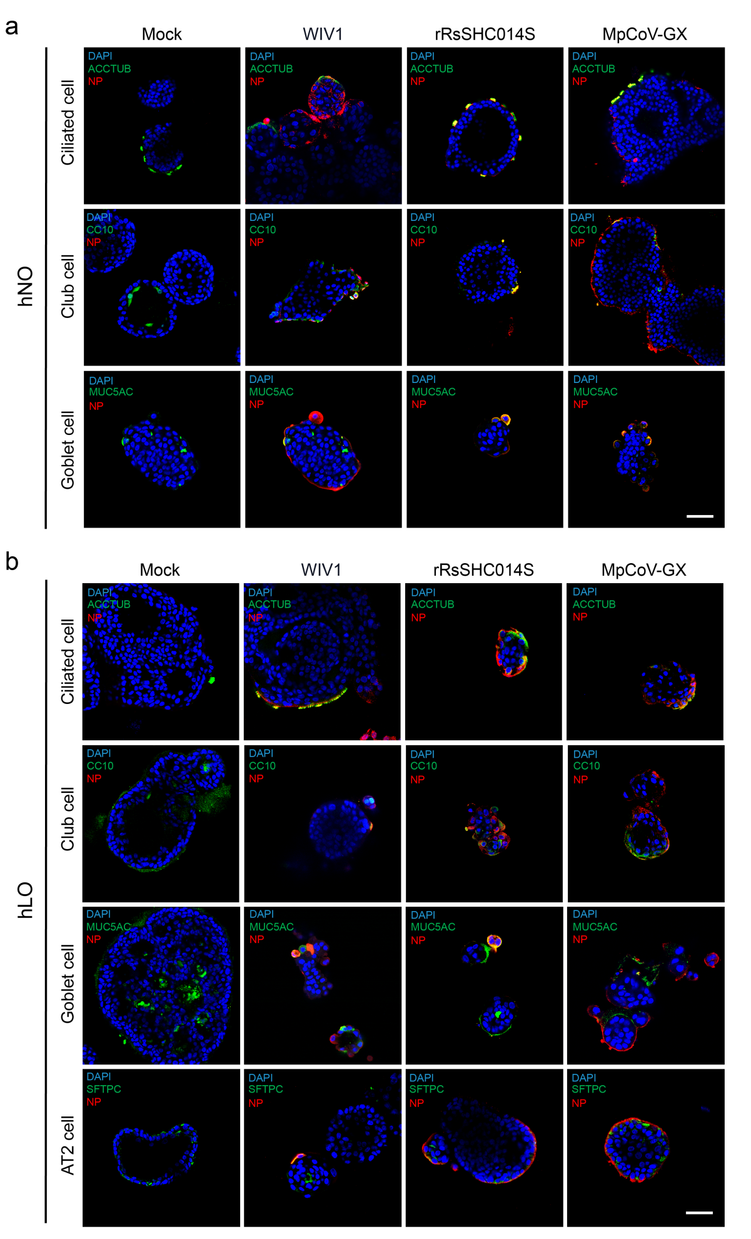
Figure S2. Cell Tropism of Three Animal-borne Coronaviruses in Human Respiratory Organoids. (a) Cell tropism of three animal-borne coronaviruses in hNOs. (b) Cell tropism of three animal-borne coronaviruses in hLOs. hNOs and hLOs were infected with three animal-borne coronaviruses respectively (MOI=1) and harvested at 48 hpi (n=3). Immunofluorescence staining was performed with indicated antibodies. Cell nuclei (DAPI, blue), virus (NP, red), and epithelial cell markers (ciliated cells: ACCTUB, club cells: CC10, goblet cells: MUC5AC, alveolar type II cells: SFTPC, green) were stained. Scale bar = 50μm.

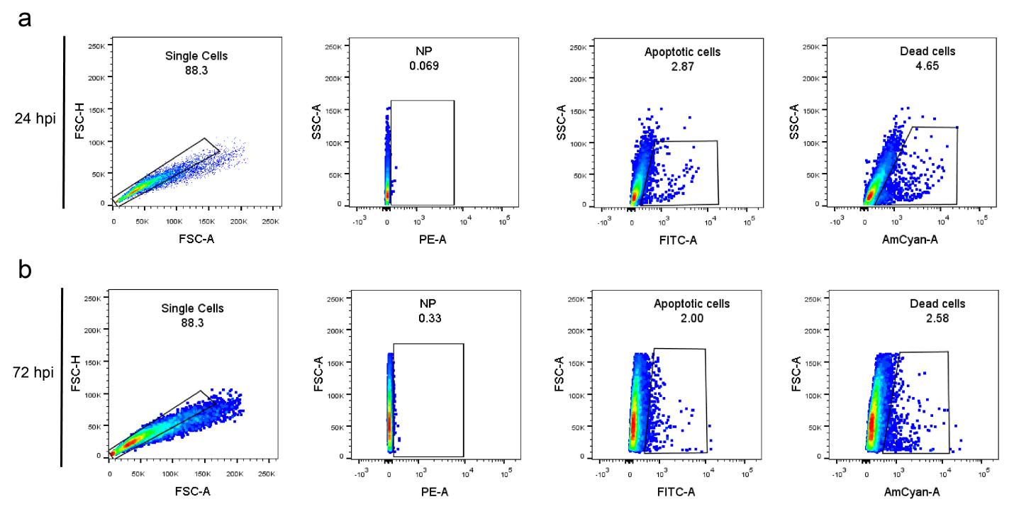
Figure S3. Virus Infection-Induced Host Cell Apoptosis and Death. (a) Cell apoptosis and death induced by SARS-CoV-2 at 24 hpi. (b) Cell apoptosis and death induced by SARS-CoV-2 at 72 hpi. After virus infection, organoid samples were digested into single cells, stained with apoptosis and death probe, fixed, and labeled with virus NP antibodies for flow cytometry analysis. The gating strategy during flow cytometry analysis is shown and the same approach was followed by all virus infections.
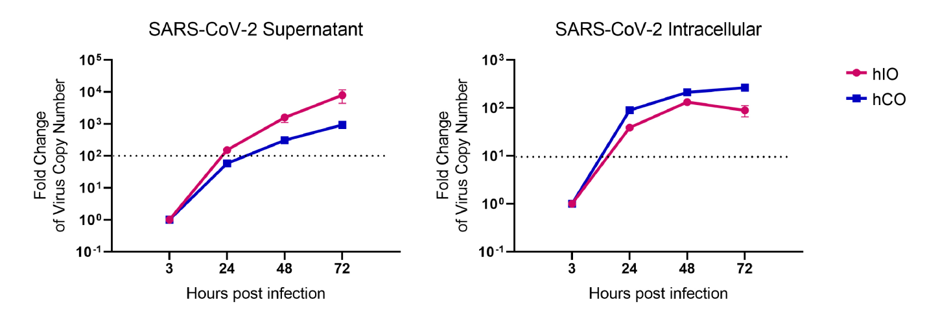
Figure S4. Replication Levels of SARS-CoV-2 in hIOs and hCOs. The replication levels of SARS-CoV-2 in hIOs and hCOs are shown (MOI=0.1, n=3). The dashed line in supernatant plot indicates effective release with virus amplification more than 100-fold; the dashed line in intracellular plot indicates effective replication with virus amplification more than 10-fold.

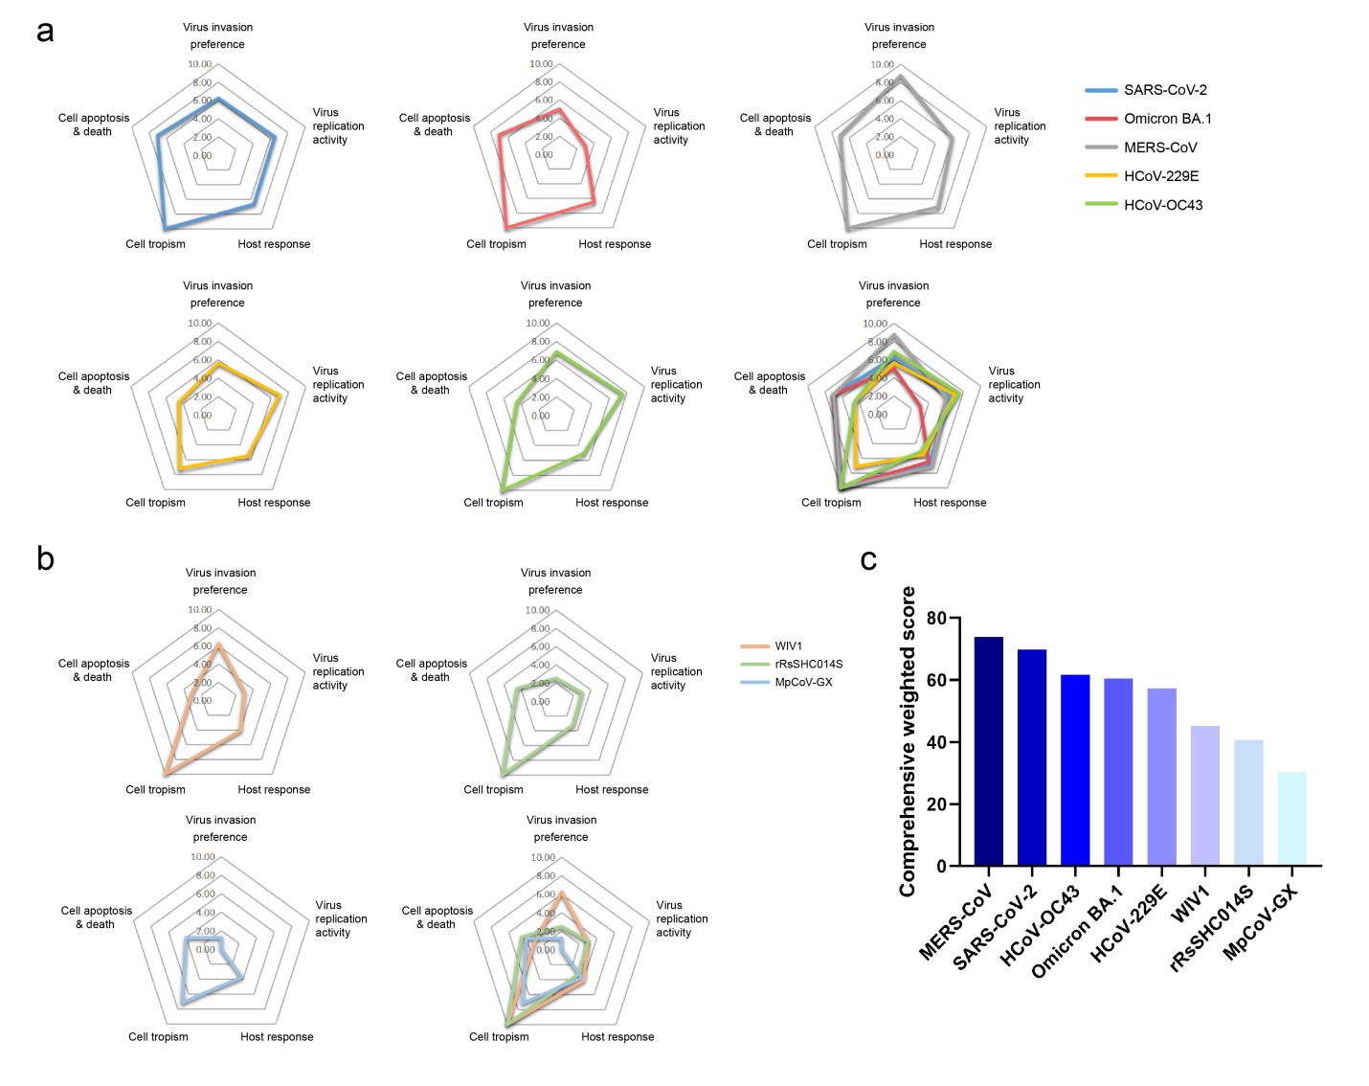
Figure S5. Comprehensive Evaluation Scoring of Coronaviruses. (a) Radar chart displaying the scores of the five HCoVs. (b) Radar chart showing the scores of the three animal-borne coronaviruses. The five vertices of the radar chart represent the five evaluation indicators. (c) Ranking of the comprehensive weighted scores.

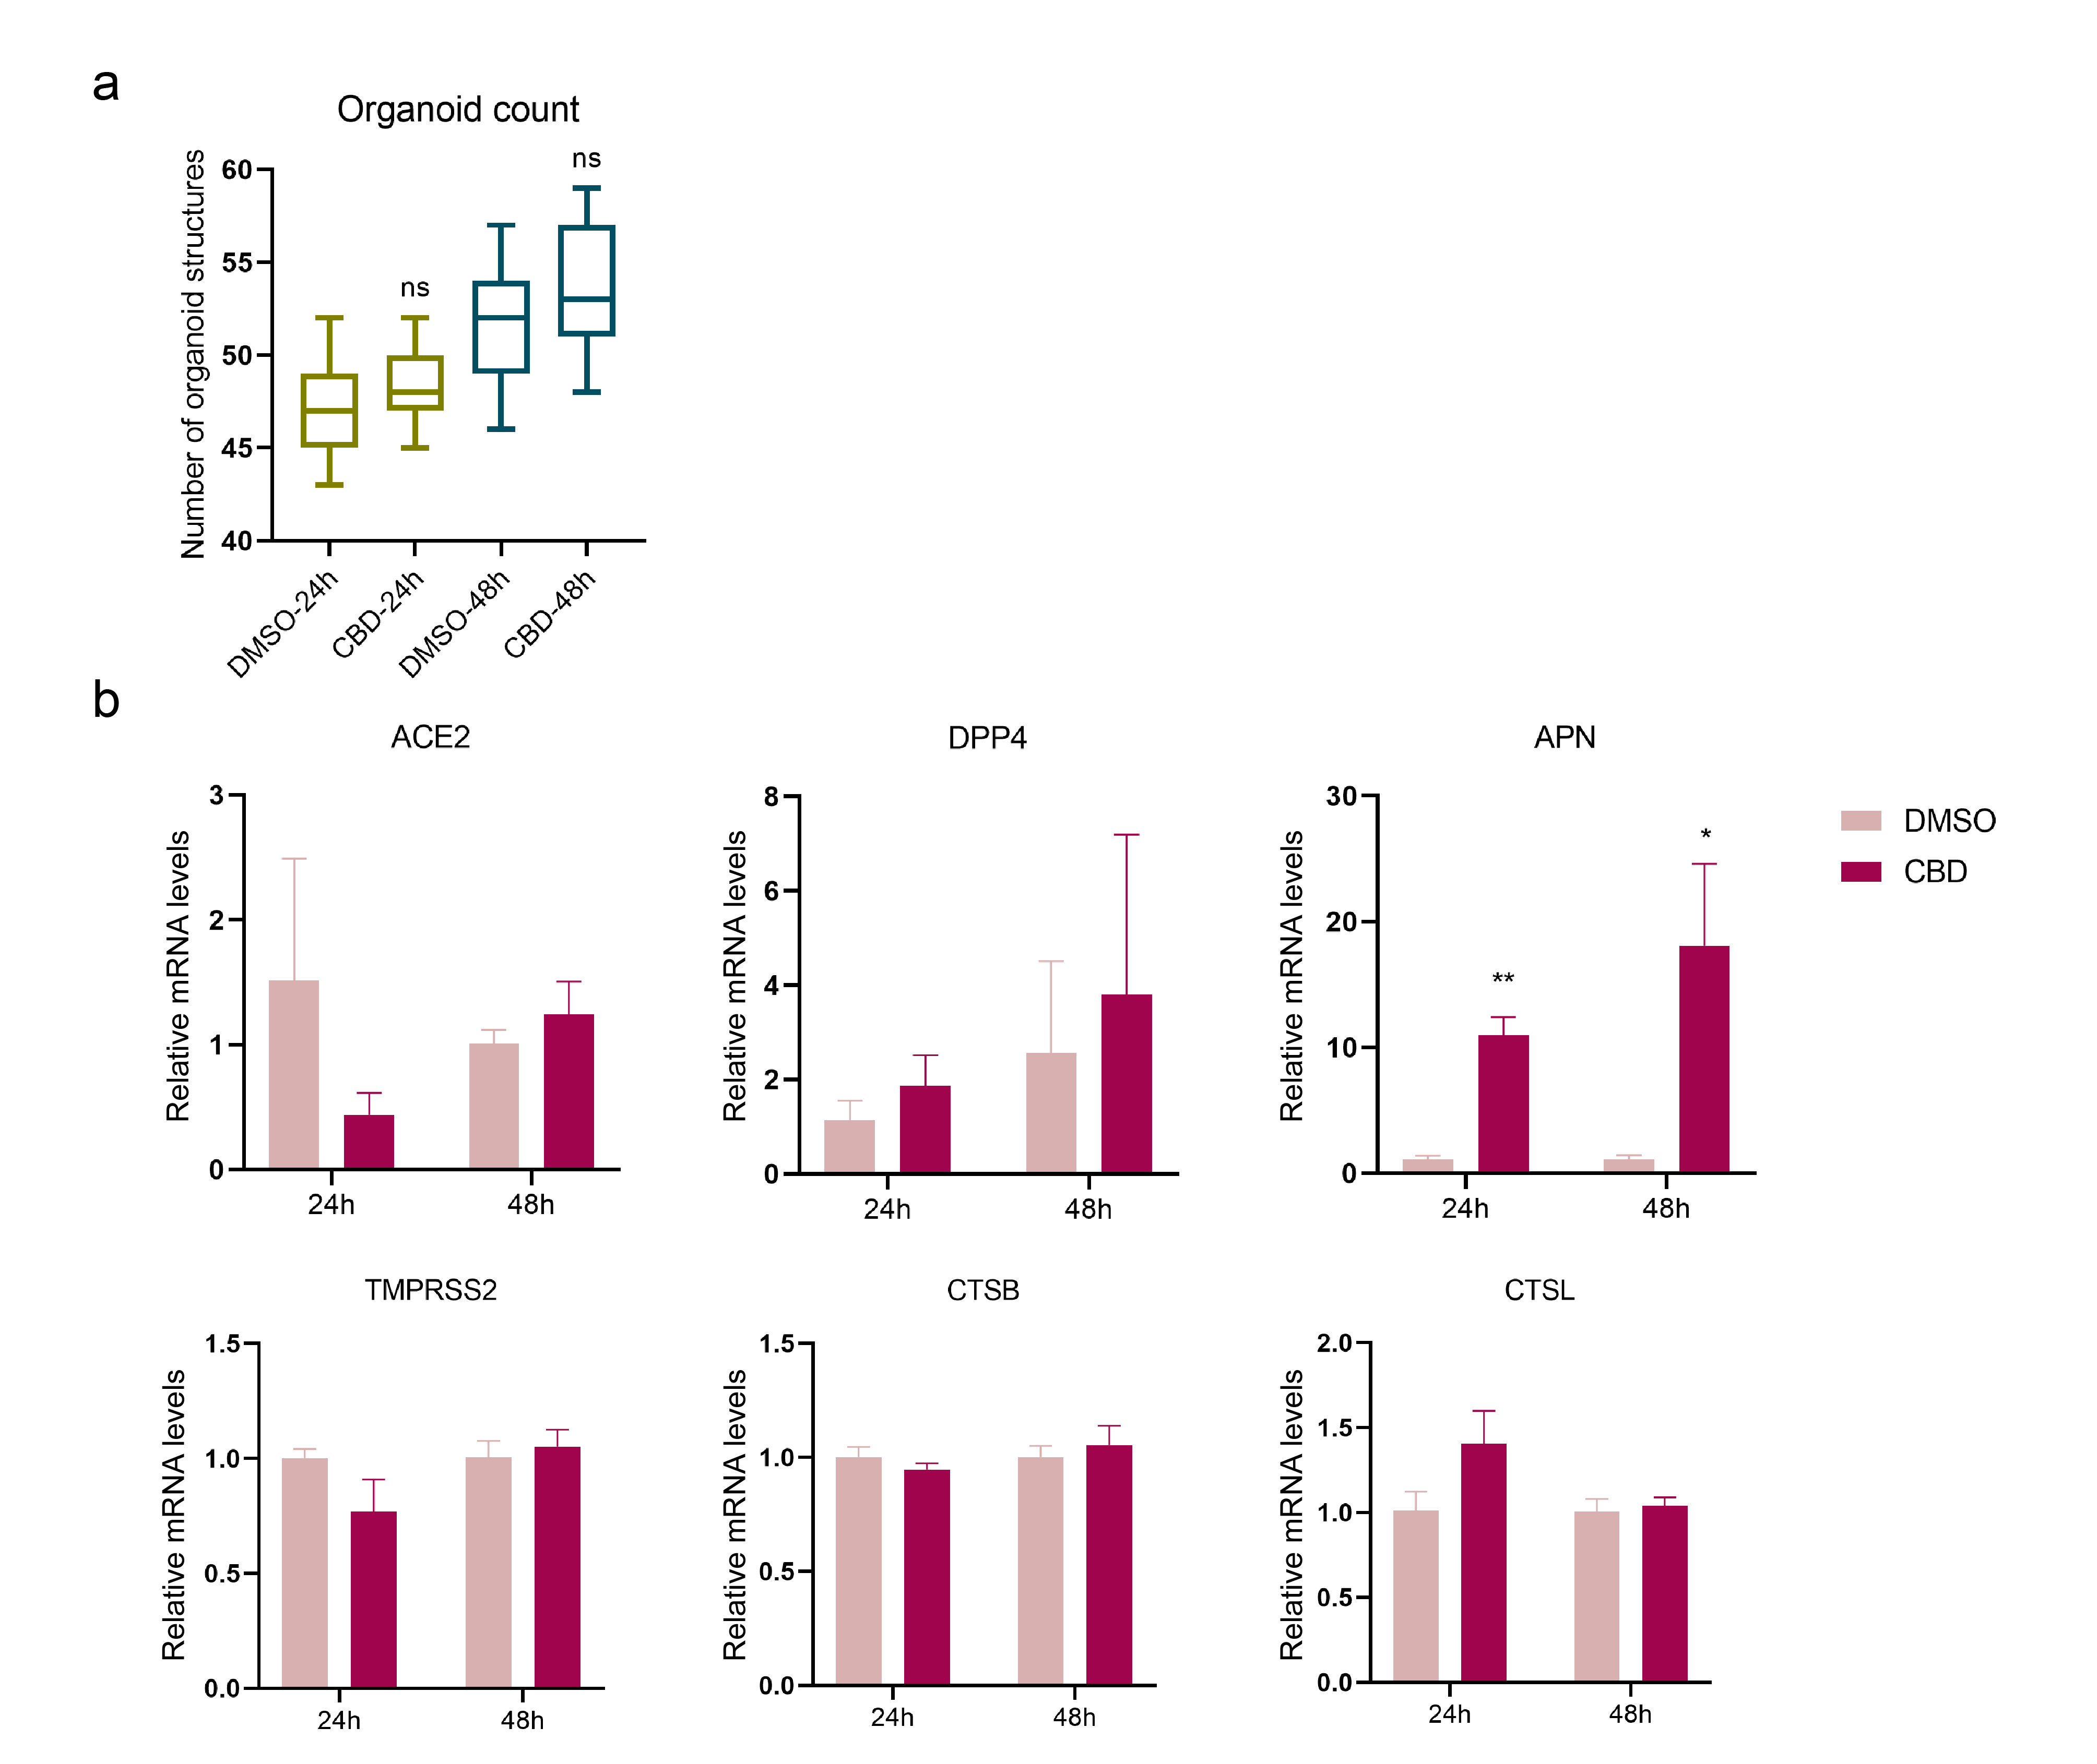Figure S6. Effects of CBD on hLOs. (a) The formation rate of organoid structures derived from single cells after CBD or DMSO treatment (n=2). (b) Expression of coronavirus invasion-related genes in hLOs after CBD treatment. Data are the mean ± SEM, n=3 and statistical significance is analyzed by Student’s t-test (*p < 0.05; **p < 0.01; ns, not significant).

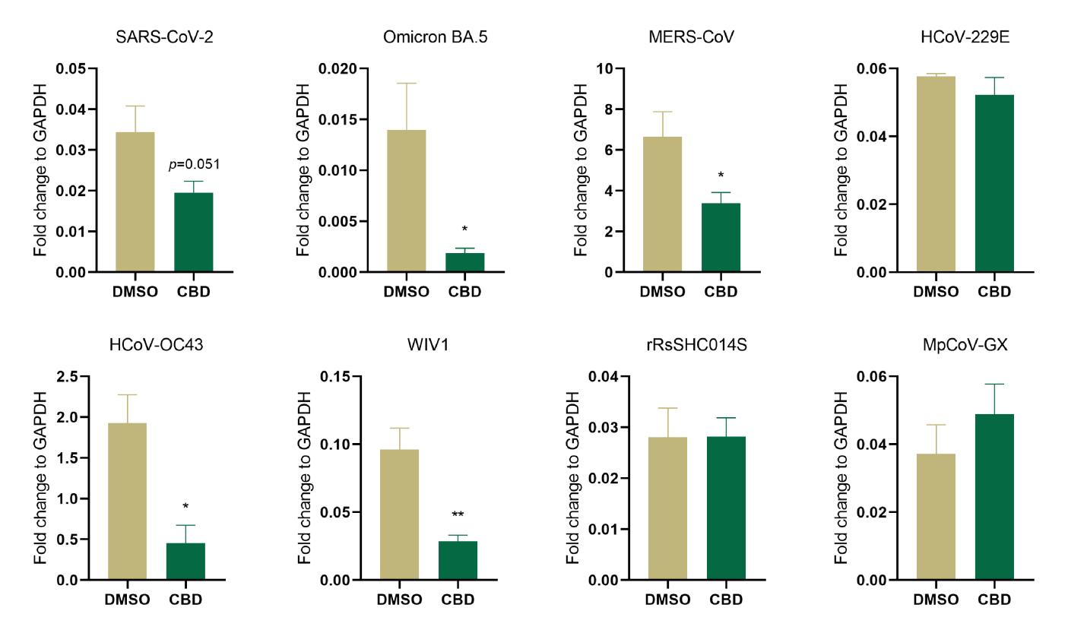
Figure S7. Changes of sgRNA levels in hLO cells after CBD treatment. HLOs were treated with 10 μM CBD for 12 hours before and 24 hours after virus infection (MOI=1) (n=3). SgRNA expression was quantified by qPCR and normalized to levels of GAPDH. Data are the mean ± SEM. Statistical significance is analyzed by Student’s t-test (*p < 0.05; **p < 0.01).

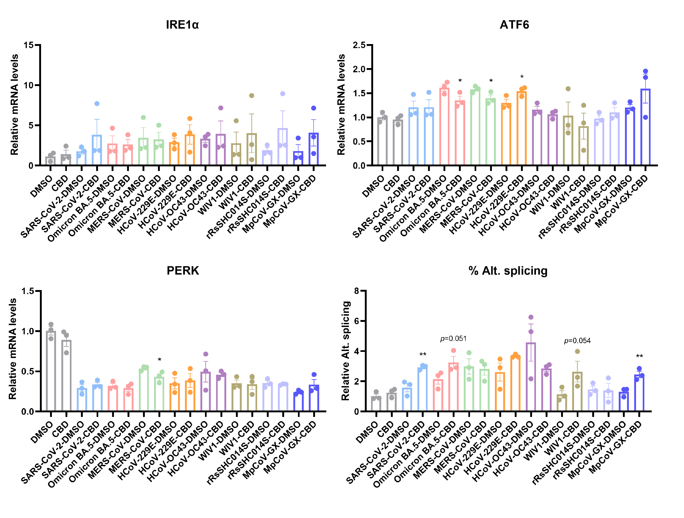
Figure S8. Changes in ER Stress-Related Gene Expression in hLO after CBD Treatment. The expression of ER stress-related genes in hLOs treated with CBD or DMSO. Data are the mean ± SEM. Statistical significance is analyzed by Student’s t-test using pairwise comparisons between the CBD- and DMSO-treated groups for each set of experiments (*p < 0.05; **p < 0.01).

Table S1. Cell Tropism of Eight Viruses on Human Respiratory Organoid
 | hLO |  |  |  |  | hNO
 | Ciliated cell | Goblet cell | Club  cell | AT2  cell |  | Ciliated cell | Goblet cell | Club  cell
SARS-CoV-2 | √ | √ | √ | √ |  | √ | √ | √
Omicron BA.1 | √ | √ | √ | √ |  | √ | √ | √
MERS-CoV | √ | √ | √ | √ |  | √ | √ | √
HCoV-229E |  | √ | √ | √ |  |  | √ | √
HCoV-OC43 | √ | √ | √ | √ |  | √ | √ | √
WIV1 | √ | √ | √ | √ |  | √ | √ | √
rRsSHC014S | √ | √ | √ | √ |  | √ | √ | √
MpCoV-GX | √ |  | √ |  |  | √ | √ | √

