Supplementary Information to Maradonna et al.,

Optimization of the optimal cell number for transplantation
Preliminary experiments were performed to identify the optimal number of HCT116 cells to be used in the transplantation experiment. Following previous studies, embryos were injected with 200-400 or 500-1000 cells (1–3).
Results showed that only in fish transplanted with 200-400 cell, AEA concentration significantly reduced tumor cell proliferation, thus experiments were performed using this cell number.

Supplementary Figure 1. HCT116 tumor size (3 dpi) in WT xenografts injected with 200-400 cells and 500-1000 cells measured as total Dil Vibrant Red fluorescence. Each trial consisted of a Ctrl and a AEA exposed group. The mean value of the tumor size in the Ctrl was settled as 100%. Error bar indicates SEM (200-400 cells, Ctrl N = 17 AEA N = 12; 500-1000 cells, Ctrl N= 11 AEA N=15). Statistical analysis was performed using T-test analysis . *, P < 0.05.

Macrophage quantification

Supplementary Figure 2. Macrophage analysis in mpeg1:EGFP larvae (3 dpi) injected with HCT116 cells. Quantification of the number of macrophages (GFP-positive cells) in a similar region of interest (ROI) size. The fluorescence of each individual was normalized for their tumour volume. The mean number of macrophages in Ctrl was set as 100%. Error bar indicates SEM (Ctrl N = 10; AEA N=9; AM251 N=8; AEA + AM251 N=11). Sample size derived from three independent experiments.

RNA-seq validation by RT-PCR
DEGs of interest were quantified by Real Time PCR to validate RNA seq results. csf3b, il11, socs3, mhcluba, and pcnp mRNA expression resulted significant downregulated in xenografts exposed to AEA. Both AM251 and AEA+AM251 groups presented mRNA levels similar to those measured in Ctrl fish. Among selected genes, only mep1b expression resulted significantly upregulated in AEA exposed fish (Supplementary Figure 3 a-f). Lack of significant change was observed concerning casp3 (Supplementary Figure 4a), vegfaa, vegfab and vegfc mRNA levels, according the RNA seq analysis. Nevertheless, although not statistically significant, vegfs mRNA resulted downregulated by AEA treatment (Supplementary Figure 4 b-d).
Supplementary Figure 3. Real time PCR analysis on selected DEGs. Soc3 (a), csf3b (b), mhcIuba (c), mep1b (d), pcnp (e), il11a (f) mRNA levels xenograft, normalized against rplp0 and rpl13a. Data are shown as mean ± SD (N = 5). Asterisk * above each column denote significant differences among the experimental groups (P < 0.05), which have been analyzed by one-way ANOVA followed by Tukey’s multiple comparison test.

Supplementary Figure 4. casp3 (a), vegfaa (b), vegfab (c), vegfd (d) mRNA levels in xenograft, normalized against rplp0 and rpl13a. Data are shown as mean ± SD (N = 5). Asterisk * above each column denote significant differences among the experimental groups (P < 0.05), which have been analyzed by one-way ANOVA followed by Tukey’s multiple comparison test.

In vitro viability of cell exposed to grade concentration of AEA
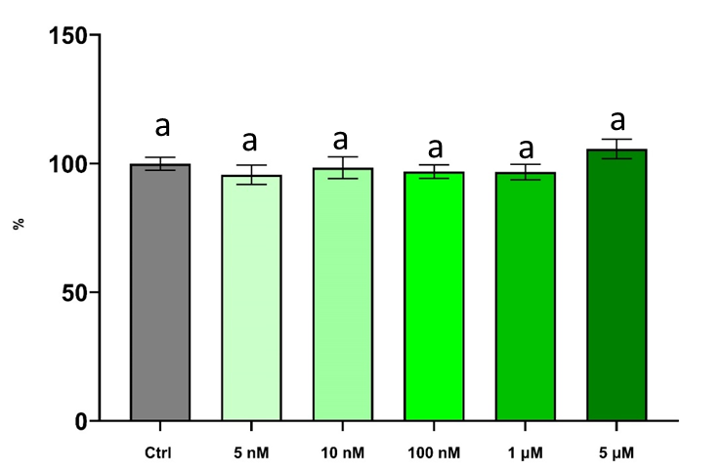
Supplementary Figure 5. AEA does not affect HTC116 cell viability in vitro. Bar plot showing cell proliferation in HCT116 cells exposed to different AEA concentration. The same letter (a) above each column denotes any significant difference among experimental groups (P>0.05)

Gene name | geneid | description | Kegg pathway
pcnp | ENSDARG00000116774 | PEST proteolytic signal-containing nuclear protein-like [Source:NCBI gene;Acc:110437793] | NF-kappa B signaling pathway
socs3a | ENSDARG00000025428 | suppressor of cytokine signaling 3a [Source:ZFIN;Acc:ZDB-GENE-030131-7349] | TNF signaling pathway
mep1b | ENSDARG00000037533 | meprin A, beta [Source:ZFIN;Acc:ZDB-GENE-041014-209] | Protein digestion and absorption
il11a | ENSDARG00000037859 | interleukin 11a [Source:ZFIN;Acc:ZDB-GENE-051019-1] | Cytokine-cytokine receptor interaction
mhc1uba | ENSDARG00000075963 | major histocompatibility complex class I UBA [Source:ZFIN;Acc:ZDB-GENE-990415-145] | Natural killer cell mediated cytotoxicity
csf3b | ENSDARG00000098752 | colony stimulating factor 3 (granulocyte) b [Source:ZFIN;Acc:ZDB-GENE-141212-221] | IL-17 signaling pathway
vegfaa | ENSDARG00000103542 | vascular endothelial growth factor Aa [Source:NCBI gene;Acc:30682] | VEGF signaling pathway
vegfab | ENSDARG00000034700 | vascular endothelial growth factor Ab [Source:ZFIN;Acc:ZDB-GENE-030131-4605] | VEGF signaling pathway
vegfd | ENSDARG00000056624 | vascular endothelial growth factor D [Source:ZFIN;Acc:ZDB-GENE-070810-6] | VEGF signaling pathway
casp3a | ENSDARG00000017905 | caspase 3, apoptosis-related cysteine peptidase a [Source:ZFIN;Acc:ZDB-GENE-011210-1] | apoptosis

Supplementary Table 1. Gene identification, description and related Kegg pathway

Gene Acronym | NCBI gene accession no. | Forward | Reverse
rpl13a | NM_212784.1 | TCTGGAGGACTGTAAGAGGTATGC | AGACGCACAATCTTGAGAGCAG
rplp0 | NM_131580.2 | CTGAACATCTCGCCCTTCTC | TAGCCGATCTGCAGACACAC
csf3b | NM_001143754.2 | ACACGCGGTGCAGTGTTTTT | GCCTGATTGTTCAACTGGGG
pcnp | NM_001326716.1 | TAGACTCAACAGCGTCTCTCTG | TGAGCGACTGATGCCTTGG
mhcIuba | NM_131471.1 | ACCTGGACTGCTGCTAATTCT | TAGCCCACATACTTCTGCACC
il11a | XM_693882.9 | GGGAGATGGTTCAGACCTCT | GATGTCCCGGTGCTTCCTA
mep1b | NM_001076621.2 | ACTTGATCTGGTGGAAGGAGACATT | AAGAAGTACGGCACAGTGGTAGG
socs3a | NM_199950.1 | GGAAGACAAGAGCCGAGACT | GCGATACACACCAAACCCTG
casp3a | NM_131877.3 | ACAGCAGTAACGCCACATTT | AGTTTGGGCTTTCCCACCAG
vegfaa | NM_001110349.2 | GACGTTTCGTGTCTCTGTCG | AAAAGAGTGCGTGCAAGACC
vegfab | NM_001328597.1 | GGACCTGCAGATGTGACAAA | ATCAAATCCTGTGCTCCGAG
vegfd | NM_001040178.1 | CTCAGTTCCTGCTCCCACTT | GGCCTCAACAGAGCTTCAAC

Supplementary Table 2. Primer list

References
1. Cornet C, Dyballa S, Terriente J, Di Giacomo V. ZeOncoTest: Refining and automating the zebrafish xenograft model for drug discovery in cancer. Pharmaceuticals. 2020;13(1):1.
2. Ye S, Liu Y, Fuller AM, Katti R, Ciotti GE, Chor S, et al. TGFβ and hippo pathways cooperate to enhance sarcomagenesis and metastasis through the hyaluronan-mediated motility receptor (HMMR). Mol Cancer Res. 2020;18(4):560–73.
3. Fior R, Póvoa V, Mendes R V, Carvalho T, Gomes A, Figueiredo N, et al. Single-cell functional and chemosensitive profiling of combinatorial colorectal therapy in zebrafish xenografts. Proc Natl Acad Sci U S A. 2017;114(39):E8234–43.

