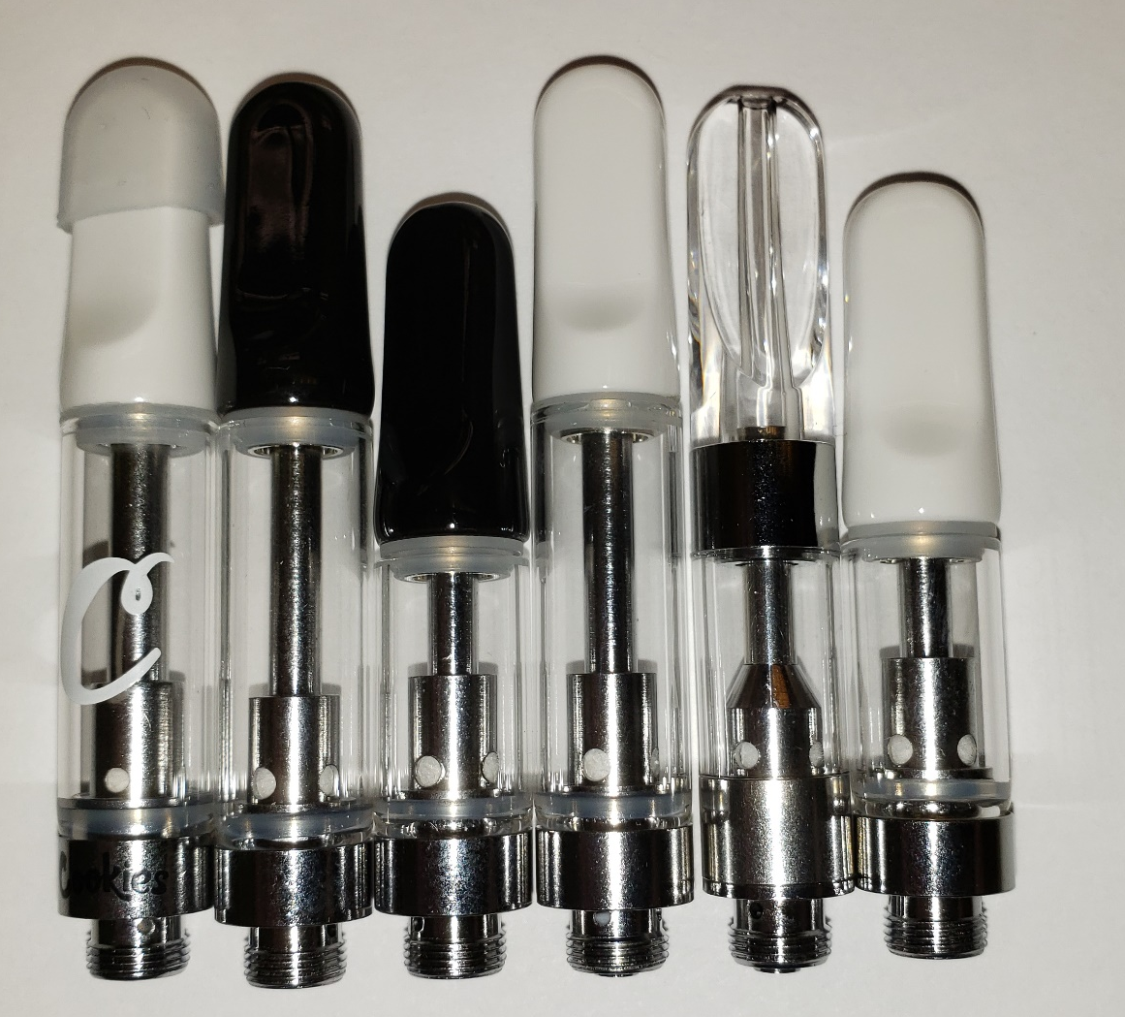
Supplementary Figure 1. Image of empty ceramic coil cartridges used in this work. Identified C1-C6 from left to right. Measured resistances of cartridges C1 through C6 prior to use were 1.6, 1.4, 1.6, 1.4, 1.8, and 1.5 Ω, respectively.

Supplementary Figure 2. Mass spectrum of the peak at 19.79 min in the suspect total ion chromatogram of unvaped material (A), library spectrum of a Δ⁹-THC standard (B), mass spectrum of the peak at 27.07 min in the suspect total ion chromatogram of unvaped material (C) and library spectrum of VEA (D).

Supplementary Figure 3. GC/FT-IR/MS mass spectra of the TIC peaks at 6.86 and 6.92 min from cartridge C5 (A and C) and corresponding IR spectra of the AC peaks at 6.93 and 7.05 min (B and D), respectively.

Supplementary Figure 4. LC-MS extracted ion chromatograms of m/z 207.1016 (±5 ppm). Top: vaped liquid (C5); feature at t_{R} = 15.06 minutes is putatively assigned as 4-acetoxy-2,3,5-trimethyl-6-methylene-2,4-cyclohexadienone (ATMMC). Bottom: unvaped liquid (B).

Supplementary Figure 5. LC-MS spectra from vaped liquid (C5) feature at t_{R} = 15.06 minutes putatively assigned as 4-acetoxy-2,3,5-trimethyl-6-methylene-2,4-cyclohexadienone (ATMMC). Top: full scan mass spectrum. Note that m/z 214.0900 is also present in the unvaped liquid at this retention time. The other labeled ions are present only in the vaped liquid at this retention time. Bottom: full scan MS/MS spectrum with precursor m/z 207.1 ± 0.5.

Supplementary Figure 6. LC-MS extracted ion chromatograms of m/z 149.0962 (±5 ppm; assigned as an in-source fragment of m/z 209.1209). Top: vaped liquid (C5); feature at t_{R} = 14.90 minutes is putatively assigned as durohydroquinone monoacetate (DHQMA). Bottom: unvaped liquid (B).

Supplementary Figure 7. LC-MS spectra from vaped liquid (C5) feature at t_{R} = 14.90 minutes putatively assigned as durohydroquinone monoacetate (DHQMA). A) Full scan mass spectrum. Ions assigned as follows: 226.1437, [M+NH₄]⁺; 209.1209, [M+H]⁺; 191.1072, [M+H-H₂O]⁺; 149.0962, [M+H-C₂H₄O₂]⁺. B) Full scan MS/MS spectrum with precursor m/z 209.1 ± 0.5. C) Full scan MS/MS spectrum with precursor m/z 191.1 ± 0.5. D) Full scan MS/MS spectrum with precursor m/z 149.1 ± 0.5.

Supplementary Figure 8. LC-MS extracted ion chromatograms, m/z 165.0910 (±5 ppm). Top: ~2 ppm duroquinone standard. Middle: vaped liquid (C5); feature at t_{R} = 17.03 minutes is identified as duroquinone (DQ). Bottom: unvaped liquid (B).

Supplementary Figure 9. LC-MS spectra from vaped liquid (C5) feature at t_{R} = 17.03 minutes identified as duroquinone. Top: full scan mass spectrum. Bottom: full scan MS/MS spectrum with precursor m/z 165.1 ± 0.5, which is consistent with the MS/MS spectrum of duroquinone reference standard obtained at this retention time.

Supplementary Figure 10. LC-MS chromatograms of vaped liquid from cartridge C1 obtained by the method used for quantitative analysis. The peak at t_{R} = 8.60 minutes corresponds to duroquinone. A) Total ion chromatogram. B) Extracted ion chromatogram of product ion m/z 122.0728 (±5 ppm). C) Extracted ion chromatogram of product ion m/z 107.0495 (±5 ppm).

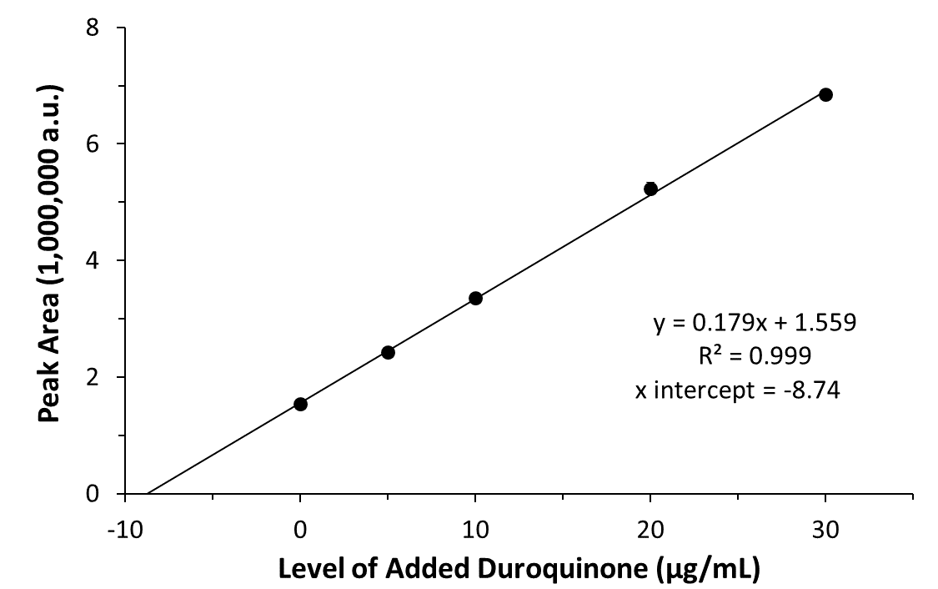

Supplementary Figure 11. Standard additions calibration curve generated by plotting peak areas obtained using extracted ion chromatograms of the product ion m/z 107.0495 (±5 ppm) vs the level of added duroquinone. Error bars representing two standard deviations are smaller than the data markers.

Supplementary Table 1 Band assignments for the infrared spectrum corresponding to the AC peak at 6.93 min.

Peak (cm⁻¹) | Assignment
3075 | C=C-H stretching
2955 | CH₃ anti-symmetric stretching
2928 | CH₂ anti-symmetric stretching
2869 | CH₃ symmetric stretching
2847 | CH₂ symmetric stretching
1651 | C=C stretching in a cis configuration
1462 | CH₂ scissoring
1385(shoulder)/ 1375/1366 split peak | CH₃ umbrella deformation characteristic of branching
886 | Out of plane C-H bending characteristic of a vinylidene moiety
736 | CH₂ in-phase rocking

