Supplementary information: Characterization of new psychoactive substances by integrating benchtop NMR to multi-technique databases
Thomas Castaing-Cordierª, Alejandra Benavides Restrepoª, Damien Dubois^{b}, Virginie Ladroue^{b}, Fabrice Besacier^{c}, Audrey Bulete^{b}, Céline Charvoz^{b}, Anais Goupilleª, Denis Jacqueminª, Patrick Giraudeauª and Jonathan Farjon^{a,*}
ªNantes Université, CNRS, CEISAM UMR 6230, F-44000 Nantes, France
^{b}Service National de police scientifique, Laboratoire de police scientifique de Lyon, 69134 Ecully, France
^{c}Service National de police scientifique, Sous-direction de la stratégie de l’innovation et du pilotage, 69134 Ecully, France
*Corresponding author: jonathan.farjon@univ-nantes.fr

S1: Database entries 4
S2: ¹H-¹³C HSQC spectral comparison 16
S2: SNR comparison of different ¹H-¹³C HSQC 17
S3: PH HSQC ME pulse program 18
S4: LF, HQI optimization 25
S5: 1D ¹H 3-MMC peak search 27
S5: 1D ¹H 4-MMC peak search 28
S5: 1D ¹H 3-MMC absolute algorithm 29
S5: 1D ¹H 3-MMC euclidian algorithm 30
S5: 1D ¹H 4-MMC absolute algorithm 31
S5: 1D ¹H 4-MMC euclidian algorithm 32
S5: 1D ¹⁹F AB-FUBINACA similarity search 33
S5: 1D ¹⁹F AB-FUBINACA peak search 34
S5: HSQC 3-MMC identification 35
S5: HSQC 4-MMC identification 36
S5: HSQC 4-MMC spectral homology 37
S5: IR 3-MMC peak search 38
S5: IR 3-MMC absolute algorithm 39
S5: IR 3-MMC euclidian algorithm 40
S5: IR 4-MMC peak search 41
S5: IR 4-MMC absolute algorithm 42
S5: IR 4-MMC euclidian algorithm 43
S6: 1D ¹⁹F substance n°1 44
S6: 2D HSQC substance n°1 45
S6: IR substance n°1 46
S6 : Identification substance 1 at 700MHz 47
S7: 2D HSQC substance n°2 50
S7: IR substance n°2 51
S7: Identification substance 2 at 700MHz 52
S8: 2D HSQC substance n°3 55
S8: 1D ¹H substance n°3 56
S8: Identification substance 3 at 700MHz 57
S9: 2D HSQC identification substance n°4 58
S9: 2D HSQC elucidation substance n°4 59
S9: 1D ¹H substance n°4 60
S9: IR substance n°4 61
S9: Elucidation substance n°4 at 700MHz 62
S10: 2D HSQC identification substance n°5 65
S10: 2D HSQC elucidation substance n°5 66
S10: 1D ¹H substance n°5 67
S10: IR substance n°5 68
S10: HSQC prediction for MPHP 69
S10A: 700 MHz and predicted HSQC comparison 70
S10: Elucidation substance n°5 at 700MHz 71
S11: 2D HSQC identification substance n°6 74
S11: 2D HSQC elucidation substance n°6 75
S11: 1D ¹H substance n°6 76
S11: Elucidation substance 6 at 700MHz 77
S12: Integrations area for the determination of purity 80

S1: Database entries
Name | Structure | NMR concentration (mM) | NMR | IR
2-AI | 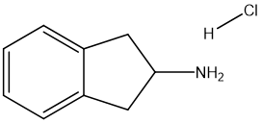 | 295 | Yes | Yes
2-BMMP | 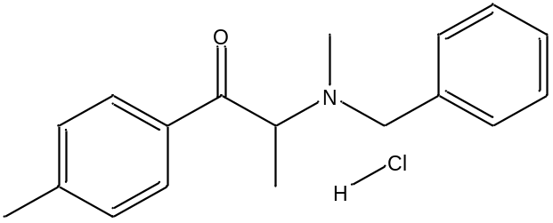 | 306 | Yes | Yes
2C-E | 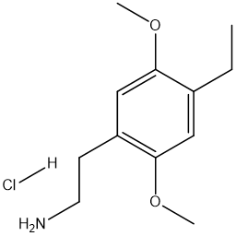 | 298 | Yes | Yes
2C-I | 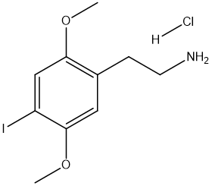 | 258 | Yes | Yes
2-FDCK | 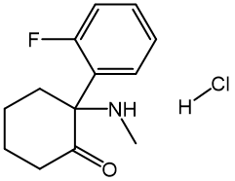 | 288 | Yes | Yes
2C-B | 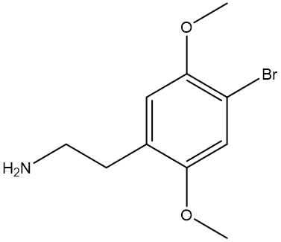 | x | No | Yes
3-CMC | 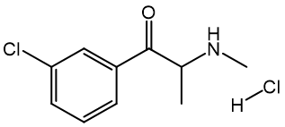 | 291 | Yes | Yes
3-FPM | 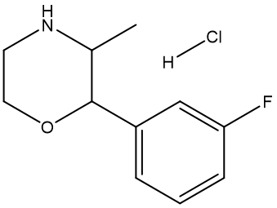 | 307 | Yes | Yes
3-MMC | 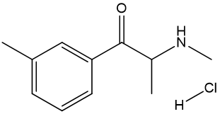 | 299 | Yes | Yes
4-CEC | 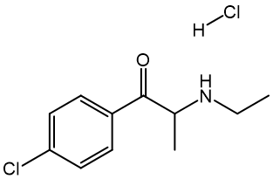 | 150 | Yes | Yes
4-EPD | 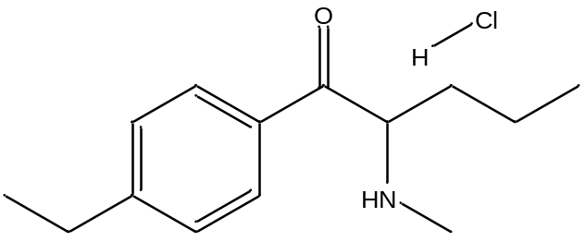 | 315 | Yes | Yes
4F-MPH | 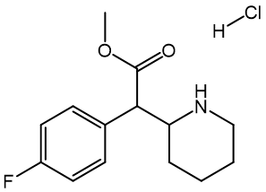 | 317 | Yes | Yes
4F-A | 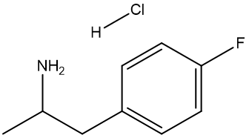 | 273 | Yes | Yes
4-MEC | 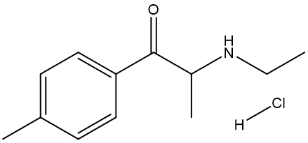 | 258 | Yes | Yes
4-MeO-PCP | 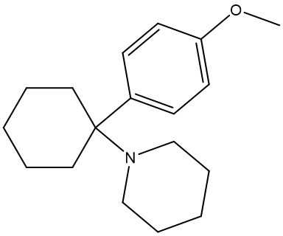 | 305 | Yes | Yes
4-MMC | 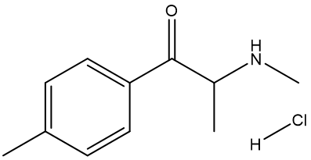 | 243 | Yes | Yes
5-APB | 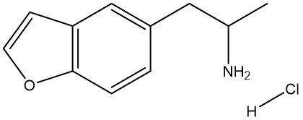 | 298 | Yes | Yes
5F-ADB | 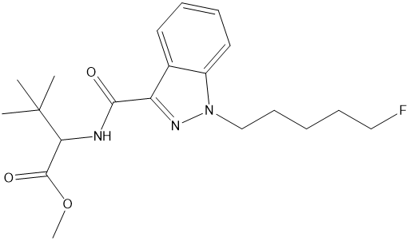 | 273 | Yes | Yes
5-MeO-DALT | 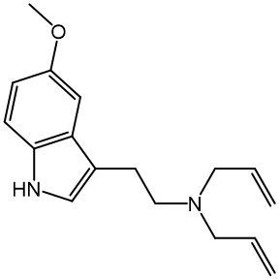 | X | No | Yes
5F-MDMB-PICA | 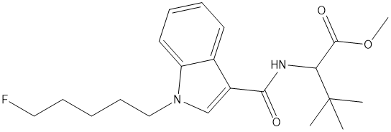 | 330 | Yes | Yes
5F-PB-22 | 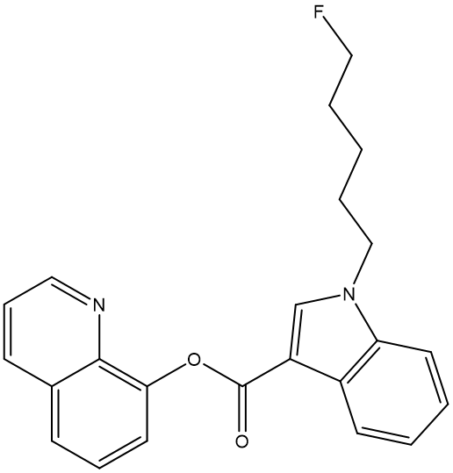 | 147 | Yes | Yes
AMT | 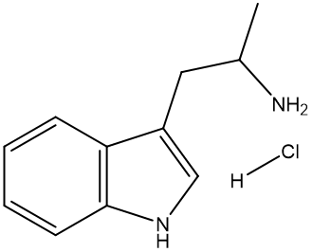 | 277 | Yes | Yes
α-PVP | 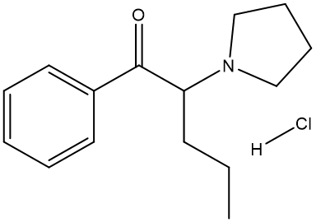 | 265 | Yes | Yes
AB-CHMINACA | 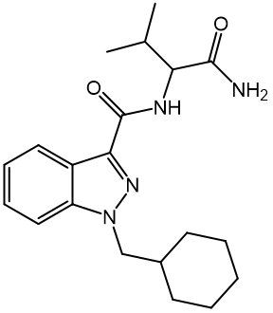 | 312 | Yes | Yes
AB-FUBINACA | 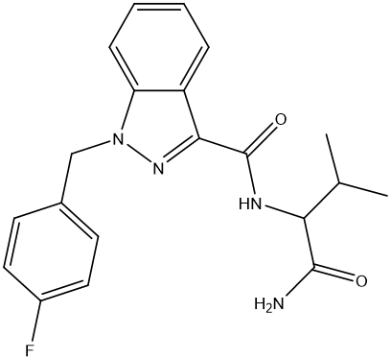 | 291 | Yes | Yes
ADB-CHMINACA | 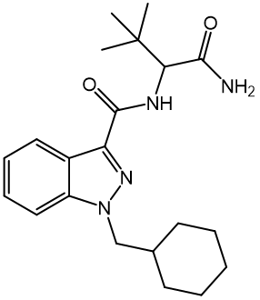 | 279 | Yes | Yes
AF | 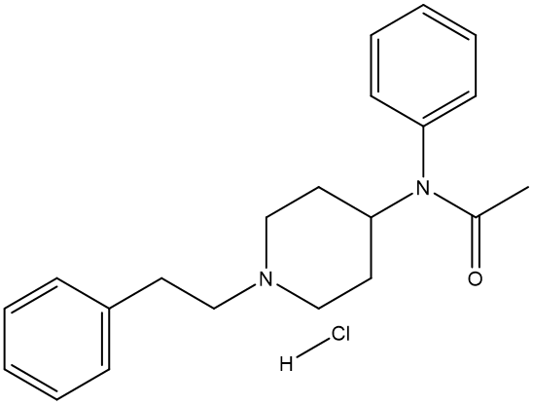 | 276 | Yes | Yes
AMB-CHMICA | 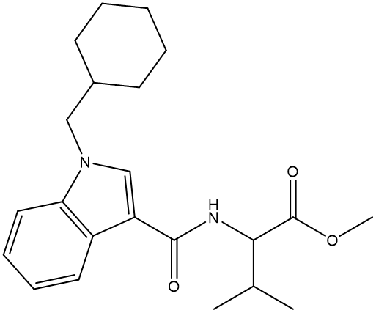 | 275 | Yes | Yes
AMB-FUBINACA | 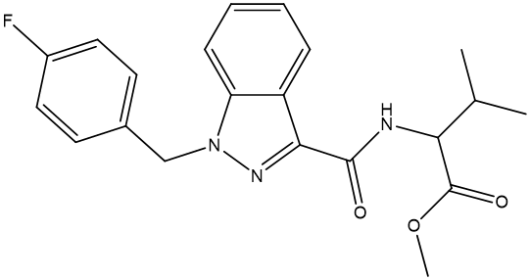 | 248 | Yes | Yes
AMF | 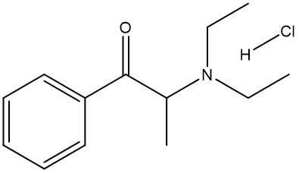 | 236 | Yes | Yes
AMP | 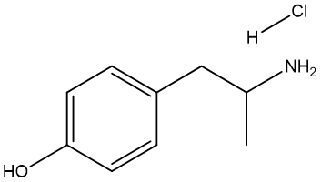 | 300 | Yes | Yes
APINACA | 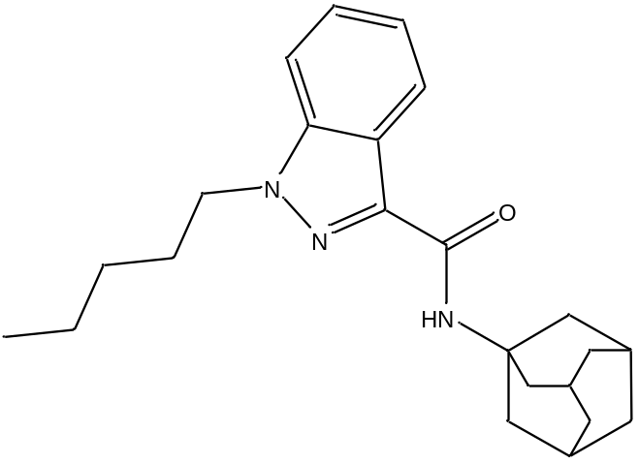 | 301 | Yes | Yes
bk-MBDB | 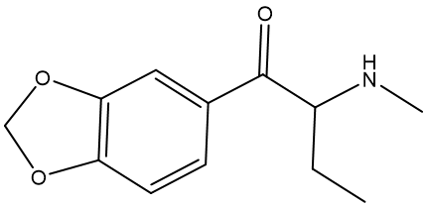 | X | No | Yes
bk-MPA | 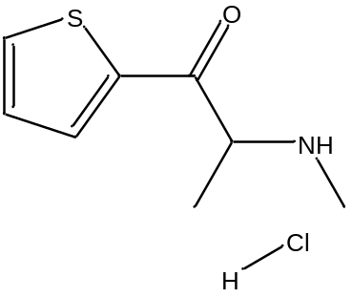 | 286 | Yes | Yes
BPR | 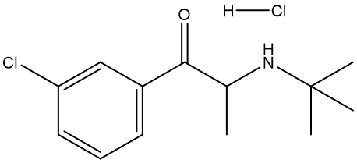 | 319 | Yes | Yes
DMPEA-NBTOMe | 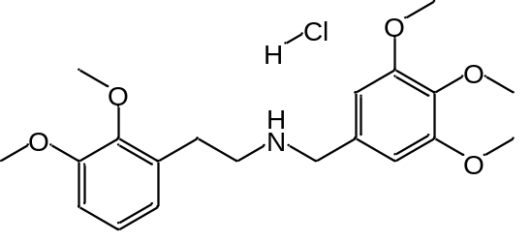 | 268 | Yes | Yes
DPD | 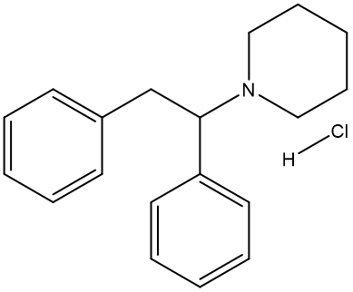 | 297 | Yes | Yes
ETH-CAT | 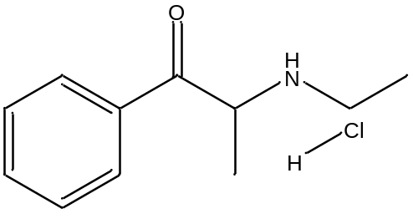 | 310 | Yes | Yes
FIBF | 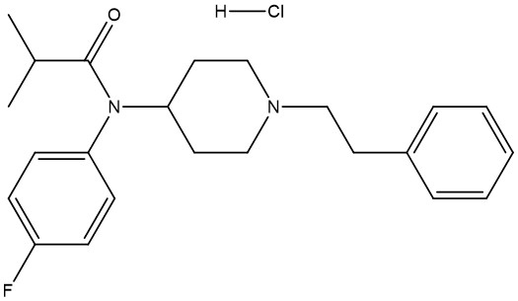 | 206 | Yes | Yes
HEXEN | 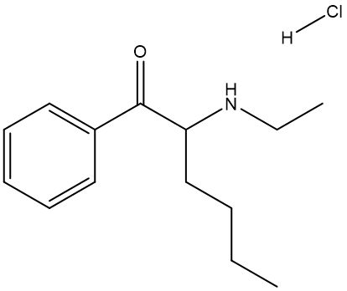 | 310 | Yes | Yes
JWH210 | 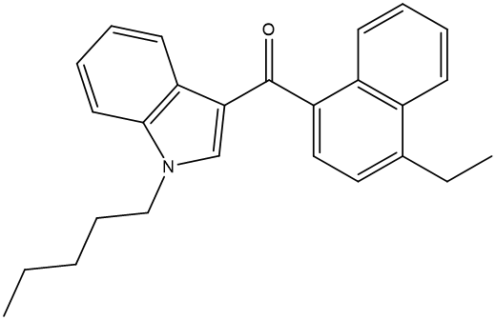 | 265 | Yes | Yes
MDAI | 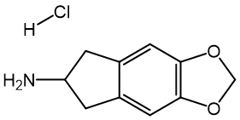 | 275 | Yes | Yes
MDEC | 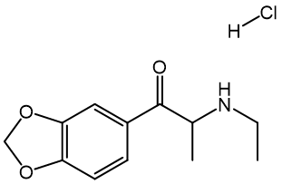 | 295 | Yes | Yes
MDMB-FUBINACA | 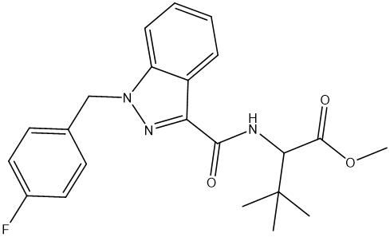 | 290 | Yes | Yes
MDMB-CHMCZCA | 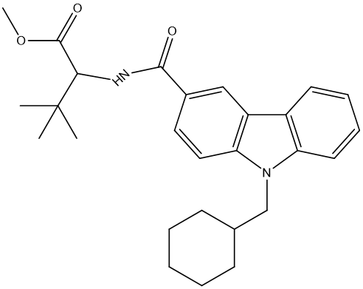 | 300 | Yes | Yes
MDMB-CHMICA | 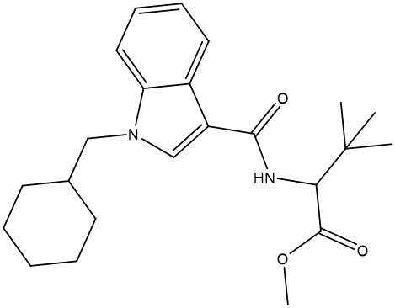 | 260 | Yes | Yes
MDMC | 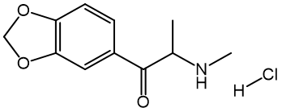 | 310 | Yes | Yes
MDPV | 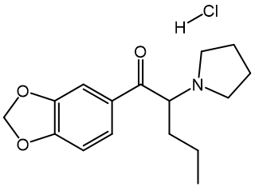 | 110 | Yes | Yes
MPHP | 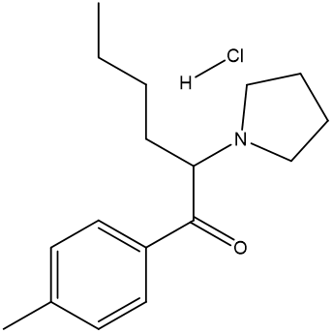 | 200 | Yes | Yes
MXE | 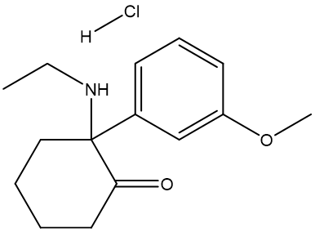 | 144 | Yes | Yes
NEK | 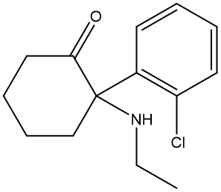 | 203 | Yes | Yes
O-PCE | 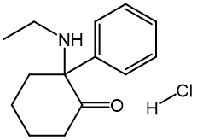 | 150 | Yes | Yes
PHENF | 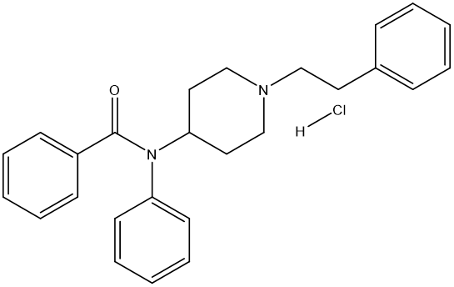 | 217 | Yes | Yes
PV9 | 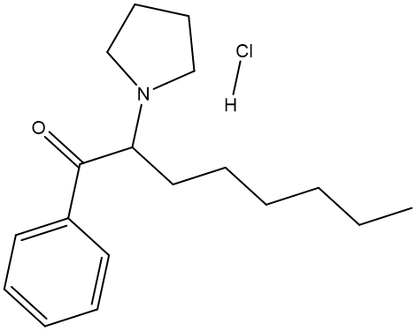 | 250 | Yes | Yes
TFMPP | 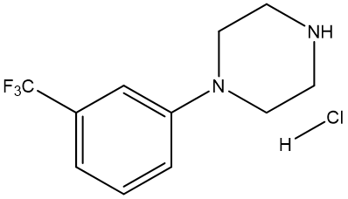 | 295 | Yes | Yes
U-47700 | 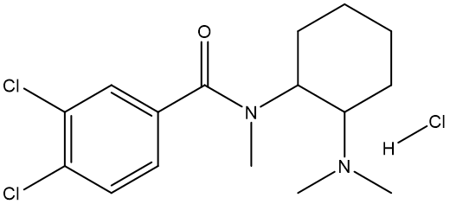 | 300 | Yes | Yes
UR-144 | 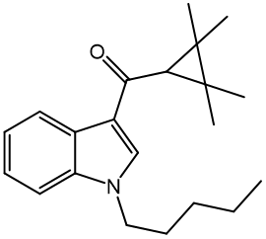 | 306 | Yes | Yes

S2: ¹H-¹³C HSQC spectral comparison
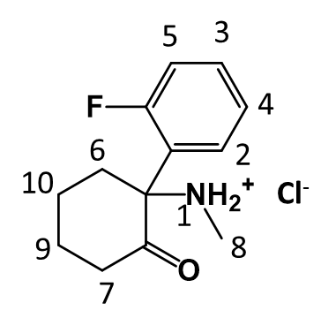
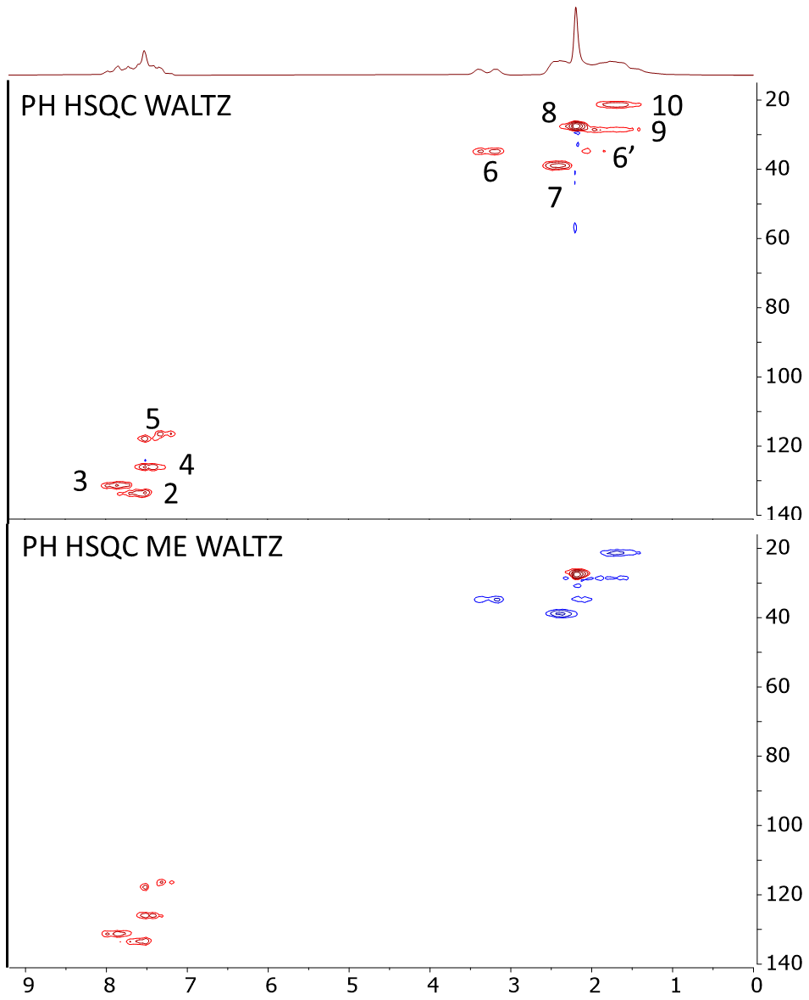

S2: SNR comparison of different ¹H-¹³C HSQC

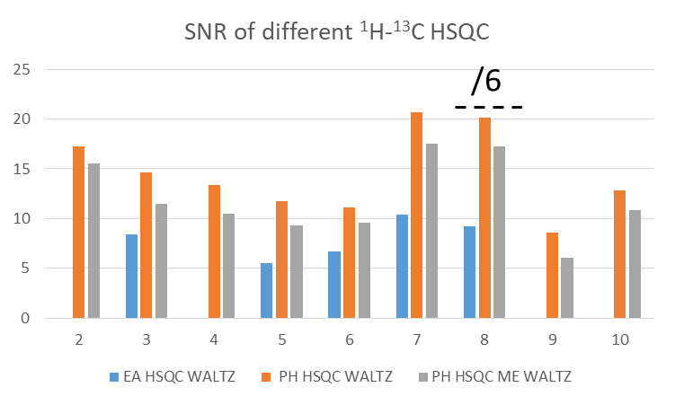

S3: PH HSQC ME pulse program
Procedure (pulse_program,dir,mode)
# Interface description (name, label, x, y, ctrl, vartype)
interface = ["nucleus", "Nuclei","0","0", "tb", "readonly_string",
"b1Freq1H", "Proton Frequency (MHz)","0","0", "tbw","freq",
"offFreq", "Offset Frequency (Hz)","0","1", "tbw","float",
"pulseLength13C", "Pulse length for all(us)", "0","2", "tbw","pulselength",
"90AmplitudeHC", "90 Pulse amplitude (dB)", "0","3", "tbw","pulseamp",
"180AmplitudeHC", "180 Pulse amplitude (dB)", "0","4", "tbw","pulseamp",
"b1Freq13C", "Carbon Frequency (MHz)", "1","0", "tbw","freq",
"90Amplitude13C", "90 Pulse amplitude (dB)", "1","1", "tbw","pulseamp",
"spoilAmp", "Homospoil amplitude", "1","2", "tbw","float,[1,1e4]",
"spoilDur", "Homospoil duration (us)", "1","3", "tbw","sdelay",
"gradStab", "Grad ringdown time (us)", "1","4", "tb", "sdelay",
"aCDec", "Decouple amplitude (dB)", "1","5", "tbw","pulseamp",
"pulseLengthC180", "Decouple length 180 (us)", "1","6", "tbw","pulselength",
"jch", "J(C,H) (Hz)", "2","2", "tbw","float",
"bandwidth2", "Bandwidth2 (kHz)", "2","3", "tbw","float,[1,1e5]",
"nrSteps","Number of steps","2","4", "tbw","integer,[1,1024]",
"repTime","Repetition time (ms)", "3","1", "tbw","reptime",
"dummyCycles", "Number of dummy cycles", "3","2", "tb", "integer,[0,16]",
"gradStabEnd", "Grad ringdown time (us)", "4","4", "tb", "sdelay"
# Relationships to determine remaining variable values
relationships = ["b1Freq = b1Freq1H",
"d9 = 1",
"d4 = 1",
"n1 = nrPnts",
"n3 = nrEchoes",
"n4 = xshim",
"n5 = yshim",
"n6 = zshim",
"n7 = xshim-(spoilAmp*xshim/(abs(xshim)+0.1))",
"n8 = yshim-(spoilAmp*yshim/(abs(yshim)+0.1))",
"n9 = zshim-(spoilAmp*zshim/(abs(zshim)+0.1))",
"n10 = xshim-(0.75*spoilAmp*xshim/(abs(xshim)+0.1))",
"n11 = yshim-(0.0*spoilAmp*yshim/(abs(yshim)+0.1))",
"n12 = zshim-(0.0*spoilAmp*zshim/(abs(zshim)+0.1))",
"n13 = xshim+(spoilAmp*xshim/(abs(xshim)+0.1))",
"n14 = yshim+(spoilAmp*yshim/(abs(yshim)+0.1))",
"n15 = zshim+(spoilAmp*zshim/(abs(zshim)+0.1))",
"a1 = 90AmplitudeHC",
"a2 = 180AmplitudeHC",
"a3 = 90Amplitude13C",
"a4 = 0",
"a5 = -85",
"a6 = aCDec",
"d1 = pulseLength13C",
"d12 = pulseLengthC180/2",
"d13 = 3*pulseLengthC180/2",
"d14 = 2*pulseLengthC180",
"d6 = pulseLengthC180",
"d7 = spoilDur",
"d8 = gradStab", # gradient settle delay
"d2 = 1e6/4/jch-2*pulseLength13C/3.14",
"d3 = 1e6/3/jch-pgo-pulseLength13C/2",
"d10 = 1e6/2/jch-pgo-2*pulseLength13C/3.14",
"d20 = 3.976/4*d7",
"w1 = 1e3/2/bandwidth2",
"d5 = acqDelay",
"O1 = offFreq",
"f1 = double(b1Freq1H)+double(offFreq/1e6d)",
"f2 = 10d*f1",
"f3 = double(b1Freq13C)",
"a111 = -80",
"totPnts = nrPnts",
"totTime = acqTime"]

# Define the tabs and their order
tabs = ["Pulse_sequence","Progress","Acquisition2d",
"Processing_Std","Display_2D","File_Settings"]

# These parameters will be changed between experiments
variables = ["w1"]

# x and y spacing between controls
dim = [190,26]

# Pulse sequence
initpp(dir) # Reset internal parameter list
cleardata(n1)
settxfreqs(f1,f3)
delay(5000) # allow time to finish lock scan
#BIRD module
pulse(1,a1,p1,d1) # 90 H RF pulse, phase 0
delay(d10) # 1/2J
pulse(1,a1,p3,f1,2,a3,p3,f3,d1) # 90 HC pulse
delay(1) # rf delay
pulse(1,a2,p1,f1,2,a4,p1,f3,d1) # 180 HC pulse
delay(1) # rf delay
pulse(1,a1,p3,f1,2,a3,p3,f3,d1) # 90 HC pulse
delay(d10) # 1/2J
pulse(1,a1,p13,d1) # 90 H RF pulse, phase 2
#350 ms delay hardcoded for now
delay(175000) #nulling delay
delay(175000) #nulling delay
pulse(1,a1,p1,d1) # 90 H RF pulse
delay(d2) # coupling delay
pulse(1,a1,p2,f1,2,a3,p5,f3,d1) # 90 HC pulse
delay(1) # rf delay
pulse(1,a2,p3,f1,2,a4,p7,f3,d1) # 180 HC pulse
delay(1) # rf delay
pulse(1,a1,p2,f1,2,a3,p5,f3,d1) # 90 HC pulse
delay(d2) # coupling delay
#Split HC pulse into separate H and C pulses - Z filter between two
pulse(1,a1,p3,d1) # 90 H RF pulse
delay(10)
shim16(1,n7) # x
shim16(2,n8) # y
shim16(0,n9) # z
delay(d7) # homospoil delay
delay(d7) # homospoil delay
delay(d7) # homospoil delay
delay(d7) # homospoil delay
delay(d7) # homospoil delay
shim16(1,n4) # x
shim16(2,n5) # y
shim16(0,n6) # z
delay(d8) # settle delay
pulse(2,a3,p8,d1) # 90 C RF pulse
wait(w1) # evolution delay
pulse(1,a1,p5,d1) # 90 H pulse
delay(1) # rf delay
pulse(1,a2,p4,d1) # 180 H pulse
delay(1) # rf delay
pulse(1,a1,p5,d1) # 90 H pulse
wait(w1) # evolution delay

#Mutiplicity-editing
delay(d10) # 1/2J
pulse(1,a1,p3,f1,2,a3,p3,f3,d1) # 90 HC pulse
delay(1) # rf delay
pulse(1,a2,p1,f1,2,a4,p1,f3,d1) # 180 HC pulse
delay(1) # rf delay
pulse(1,a1,p3,f1,2,a3,p3,f3,d1) # 90 HC pulse
delay(d10) # 1/2J
#End of ME
#Split HC pulses and use Z filter again
pulse(2,a3,p9,d1) # 90 C RF pulse
delay(10)
shim16(1,n7) # x
shim16(2,n8) # y
shim16(0,n9) # z
delay(d7) # homospoil delay
delay(d7) # homospoil delay
delay(d7) # homospoil delay
delay(d7) # homospoil delay
shim16(1,n4) # x
shim16(2,n5) # y
shim16(0,n6) # z
delay(d8) # settle delay
pulse(1,a1,p5,d1) # 90 H RF pulse
delay(d2) # coupling delay

pulse(1,a1,p3,f1,2,a3,p5,f3,d1) # 90 HC pulse
delay(1) # rf delay
pulse(1,a2,p6,f1,2,a4,p10,f3,d1) # 180 HC pulse
delay(1) # rf delay
pulse(1,a1,p3,f1,2,a3,p5,f3,d1) # 90 HC pulse
delay(d2) # coupling delay
#Acquisition and decoupling
acquireon(n1)
loop(l1,n2)
pulse(2,a6,p12,d13); delay(d9); pulse(2,a6,p11,d14); delay(d9); pulse(2,a6,p12,d6); delay(d9); pulse(2,a6,p11,d13); delay(d9); pulse(2,a6,p12,d12); delay(d9); pulse(2,a6,p11,d6); delay(d9); pulse(2,a6,p12,d14); delay(d9); pulse(2,a6,p11,d6); delay(d9); pulse(2,a6,p12,d13);
delay(d4);
pulse(2,a6,p11,d13); delay(d9); pulse(2,a6,p12,d14); delay(d9); pulse(2,a6,p11,d6); delay(d9); pulse(2,a6,p12,d13); delay(d9); pulse(2,a6,p11,d12); delay(d9); pulse(2,a6,p12,d6); delay(d9); pulse(2,a6,p11,d14); delay(d9); pulse(2,a6,p12,d6); delay(d9); pulse(2,a6,p11,d13);
delay(d4);
pulse(2,a6,p11,d13); delay(d9); pulse(2,a6,p12,d14); delay(d9); pulse(2,a6,p11,d6); delay(d9); pulse(2,a6,p12,d13); delay(d9); pulse(2,a6,p11,d12); delay(d9); pulse(2,a6,p12,d6); delay(d9); pulse(2,a6,p11,d14); delay(d9); pulse(2,a6,p12,d6); delay(d9); pulse(2,a6,p11,d13);
delay(d4);
pulse(2,a6,p12,d13); delay(d9); pulse(2,a6,p11,d14); delay(d9); pulse(2,a6,p12,d6); delay(d9); pulse(2,a6,p11,d13); delay(d9); pulse(2,a6,p12,d12); delay(d9); pulse(2,a6,p11,d6); delay(d9); pulse(2,a6,p12,d14); delay(d9); pulse(2,a6,p11,d6); delay(d9); pulse(2,a6,p12,d13);
delay(d4);
delay(10);
endloop(l1)
acquireoff("overwrite",n1)
shim16(1,n7) # x
shim16(2,n8) # y
shim16(0,n9) # z
delay(100000) # homospoil delay
shim16(1,n4) # x
shim16(2,n5) # y
shim16(0,n6) # z
delay(50000)
lst = endpp(mode) # Return parameter list

# Phase cycle list
phaseList = [0,0,0,0; # phase 1
0,0,0,0; # phase 2
1,1,1,1; # phase 3
0,0,0,0; # phase 4
1,1,1,1; # phase 5
0,0,0,0; # phase 6
0,0,0,0; # phase 7
0,2,0,2; # phase 8
0,0,2,2; # phase 9
0,0,0,0; # phase 10
0,0,0,0; # Decouple phase 1
2,2,2,2; # Decouple phase 2
2,2,2,2; # BIRD
0,2,2,0] # Acquire phase
endproc(lst,tabs,interface,relationships,variables,dim,phaseList)

S4: LF, HQI optimization
For 1D ¹H, we evaluated both types of search comparison on 3-MMC and 4-MMC but the best results were obtained with the similarity search applied to a spectral width between -1 and 12 ppm. This is due to the fact that 60 MHz ¹H NMR spectra are overcrowded and highly hampered by overlapping, which makes the peak searching method inefficient. In most cases, a large part of the database is returned by the software with an HQI between 0 and 100, therefore only the first four results will be presented. For the identification of 3-MMC, the following results were obtained with an absolute similarity search (HQI values are indicated in brackets for each hit): 3-MMC (96.45), 4-MMC (94.94), 3-CMC (91.79) and 4-MEC (90.13). The following results were obtained with a Euclidian search: 4-MMC (74.81), 3-CMC (69.99), 4-MEC (67.85) and 3-MMC (66.76). While the first four results were from the cathinone family in both cases, only the absolute search provided the correct molecule as a first hit. For 4-MMC, the absolute similarity search provided as match 4-MMC (100), 3-MMC (95.41), bk-MPA (91.23), 4-MEC (90.64) while the Euclidian similarity search returned 4-MMC (81.89), 4-MEC (68.02), 3-MMC (65.98), 3-CMC (65.73). While the first four results were from the cathinone family again, only the absolute search was able to provide 4-MMC with an HQI of 100 and 3-MMC as a second match. Therefore, absolute search was chosen as a default approach for all 1D ¹H spectra. With this pre-validation, 1D ¹H NMR can be used to identify but also to find substances close to the unknown one.
For AB-FUBINACA, the 1D ¹⁹F spectrum was compared with similarity and peak search. For similarity search with absolute algorithm, the first four matches were AB-FUBINACA (92.21), MDMB-FUBINACA (92.20), AMB-FUBINACA (91.87) and 3-FPM (91.46), while for the peak search only 3 molecules were returned with a LF fixed at 0.3 ppm: MDMB-FUBINACA (100), AMB-FUBINACA (100) and AB-FUBINACA (100). Therefore, peak search was found more efficient, probably because it also considers the multiplicity of the NMR signal.
For HSQC comparison, peak search was chosen by default because it is the only approach available in the software to compare HSQC maps. A first LF value needs to be set for NPS identification. In the 3-MMC / 4-MMC example, a single match should ideally be obtained. Such results were obtained with a LF of 0.1 ppm for ¹H and 1 ppm for ¹³C. The next LF that must be chosen is the one for spectral homology comparison. This one must allow to obtain at least one another match for the 4-MMC. 3-MMC was found with an HQI of 100 if LF of 0.2 for ¹H and 2 ppm for ¹³C.
Finally, for IR spectroscopy, comparison by peak for 3-MMC was tested but gave disappointing results. In fact, HQI was not calculated and the 4 first results were 3-MMC, APINACA, ADB-CHMINACA, 4-MMC. The second and the last matches were from cannabinoids family, so this type of comparison was excluded. Then absolute and Euclidian algorithm with similarity search were compared for the two pre validated molecules. For absolute classification of 3-MMC, the first matches were 3-MMC (87.36), 4-MMC (62.23), 4-MEC (60.02) and bk-MPA (52.91) while with Euclidian, 3-MMC (88.98), 4-MMC (60.54), 4-MEC (56.70) and bk-MPA (55.35) were obtained. For identification of 3-MMC, the largest difference between the two isomers was obtained with the Euclidian algorithm. The IR comparison of 4-MMC with absolute algorithm gave 4-MMC (100.00), 4-MEC (70.79), 4-EPD (62.56) and bk-MPA (60.76) as match while the Euclidian algorithm returned 4-MMC (100.00), 4-MEC (67.57) a homologous lateral chain of 4-MMC, 3-MMC (57.94) a positional isomer and 5F-ADB (57.10).To find NPS close to the unknown one, it seems that the Euclidian search is more correct since the found hits are very close to 4-MMC most of them have a substituent in para of their aromatic ring.
The pre validation step allowed to find the best parameters for comparison. Thus, for the next steps the database comparison was performed with similarity search with Absolute algorithm for 1D ¹H spectra, peak search for 1D ¹⁹F spectra, and similarity search with Euclidian algorithm for IR spectroscopy. In the case of HSQC, peak search with LF 0.1/1 ppm was chosen for identification and at least 0.2/2 ppm for elucidation.

S5: 1D ¹H 3-MMC peak search
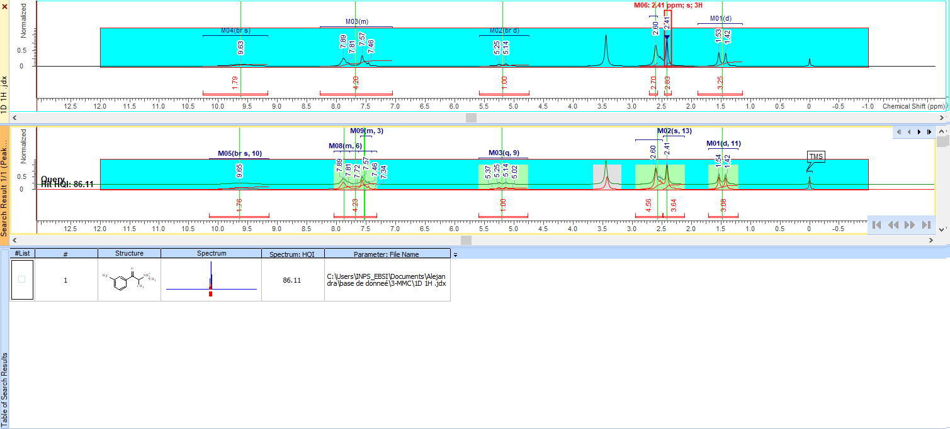
S5: 1D ¹H 4-MMC peak search
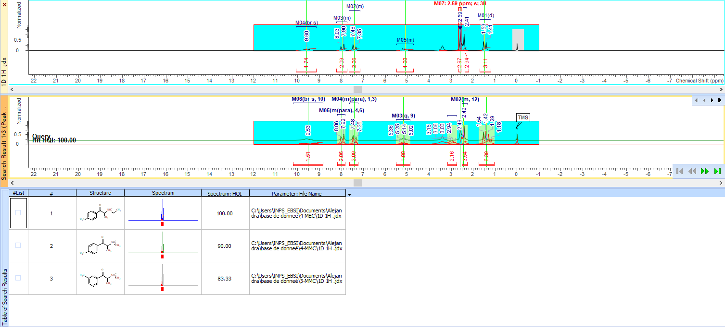
S5: 1D ¹H 3-MMC absolute algorithm
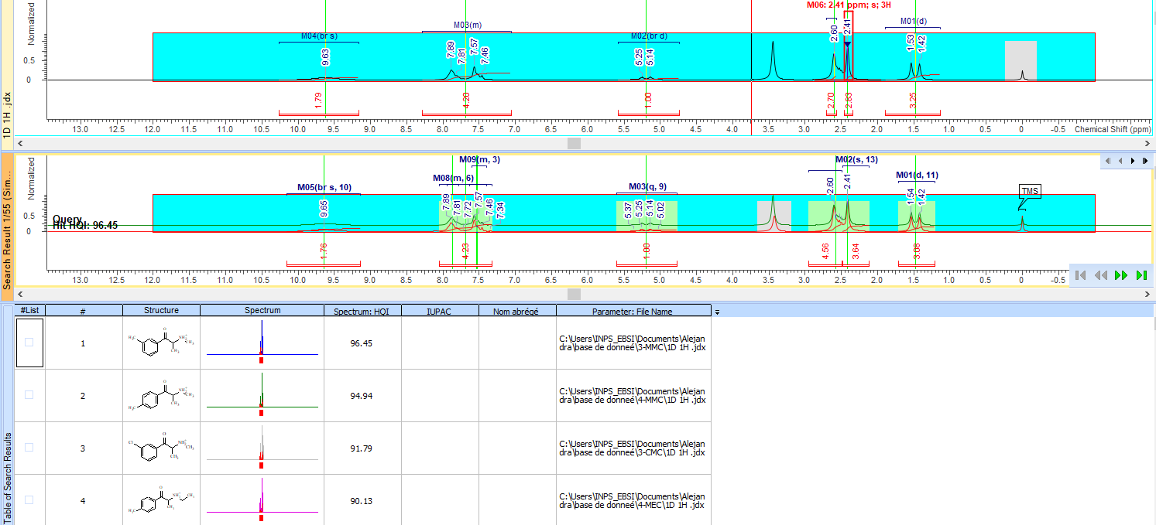
S5: 1D ¹H 3-MMC euclidian algorithm
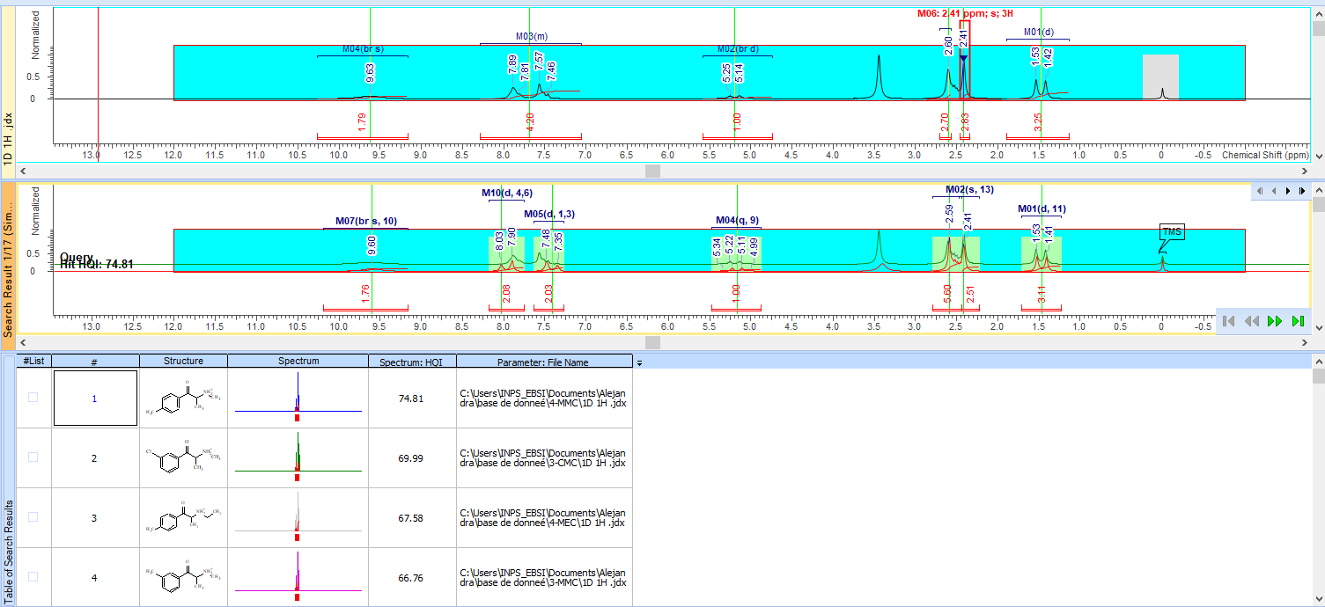
S5: 1D ¹H 4-MMC absolute algorithm
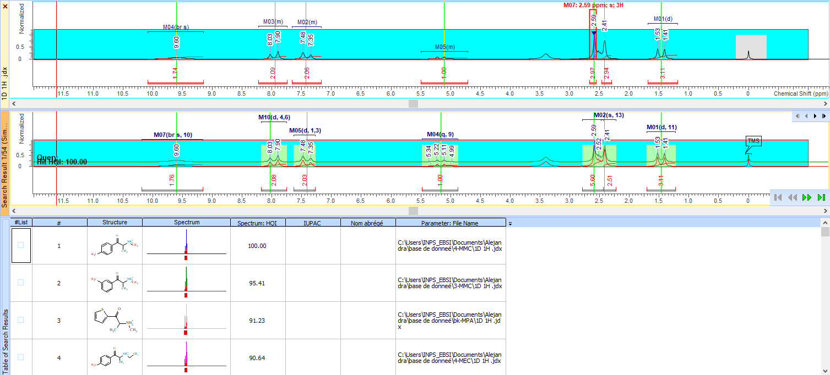
S5: 1D ¹H 4-MMC euclidian algorithm
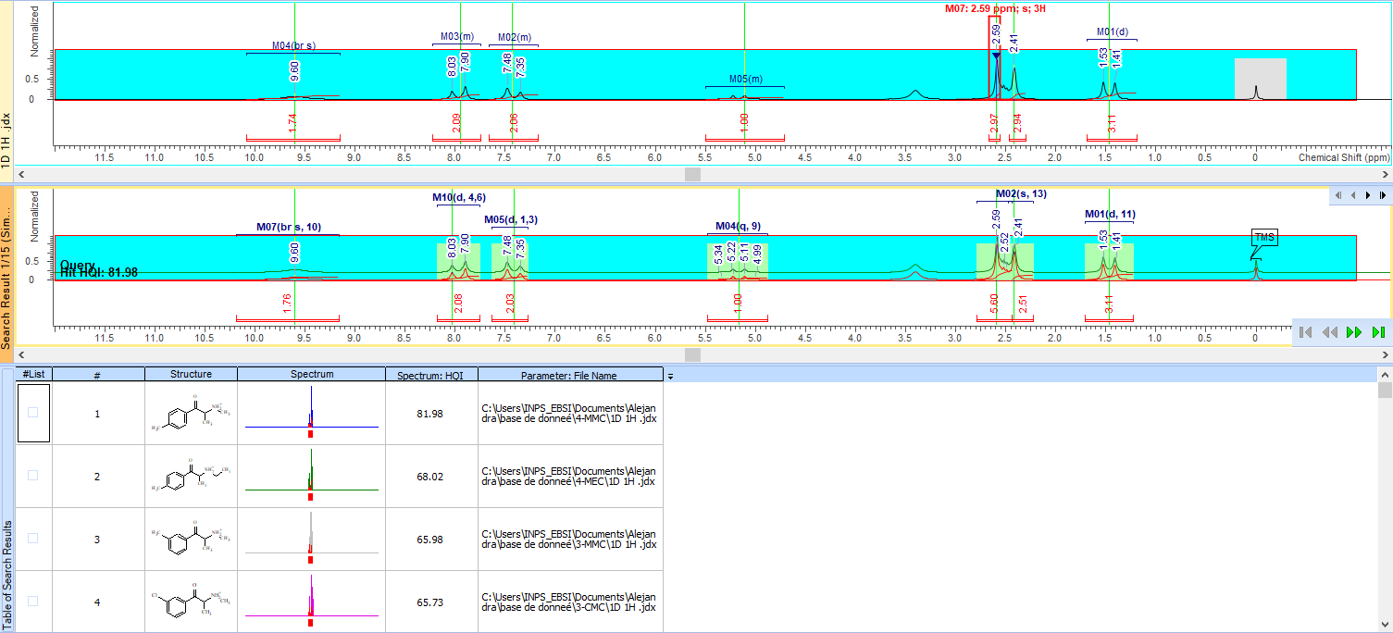
S5: 1D ¹⁹F AB-FUBINACA similarity search
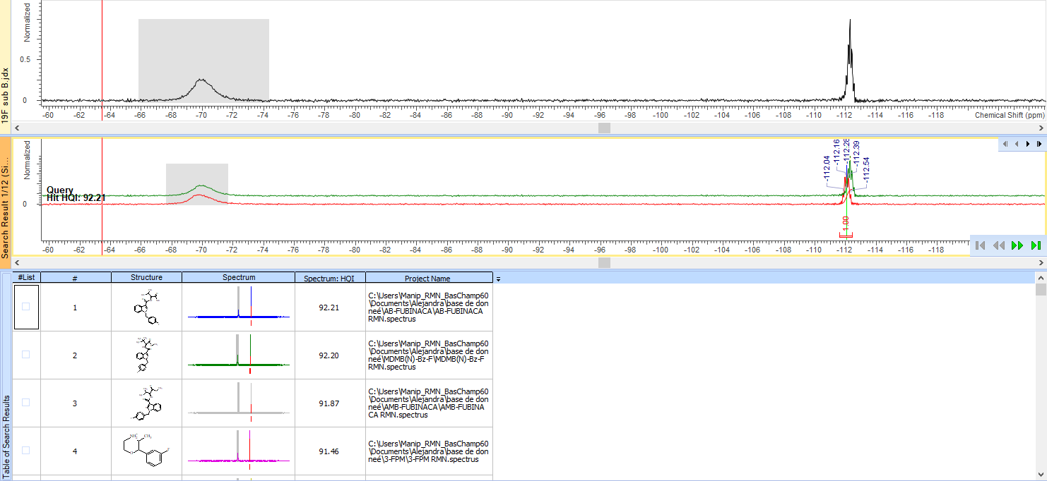
S5: 1D ¹⁹F AB-FUBINACA peak search
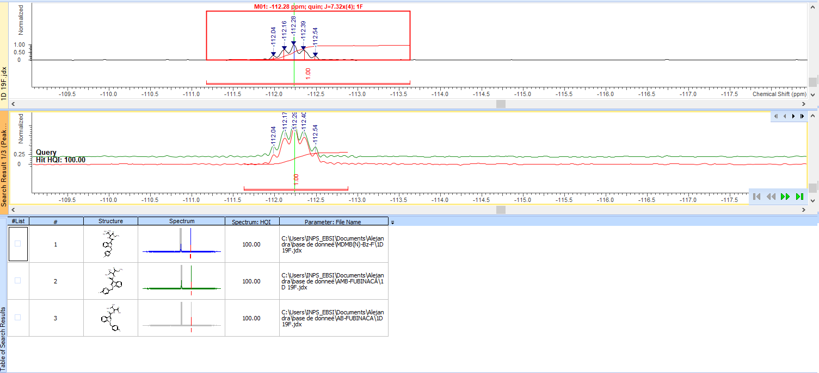
S5: HSQC 3-MMC identification
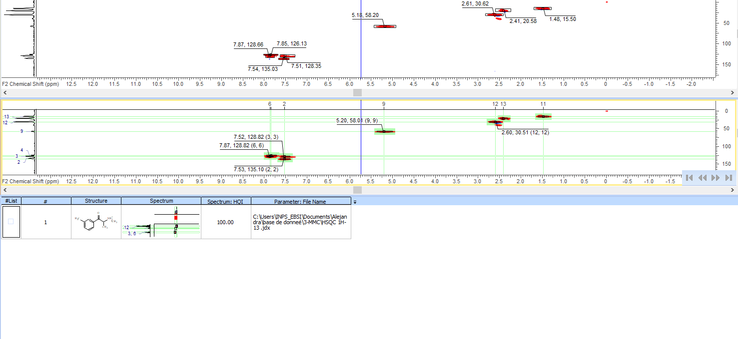
S5: HSQC 4-MMC identification
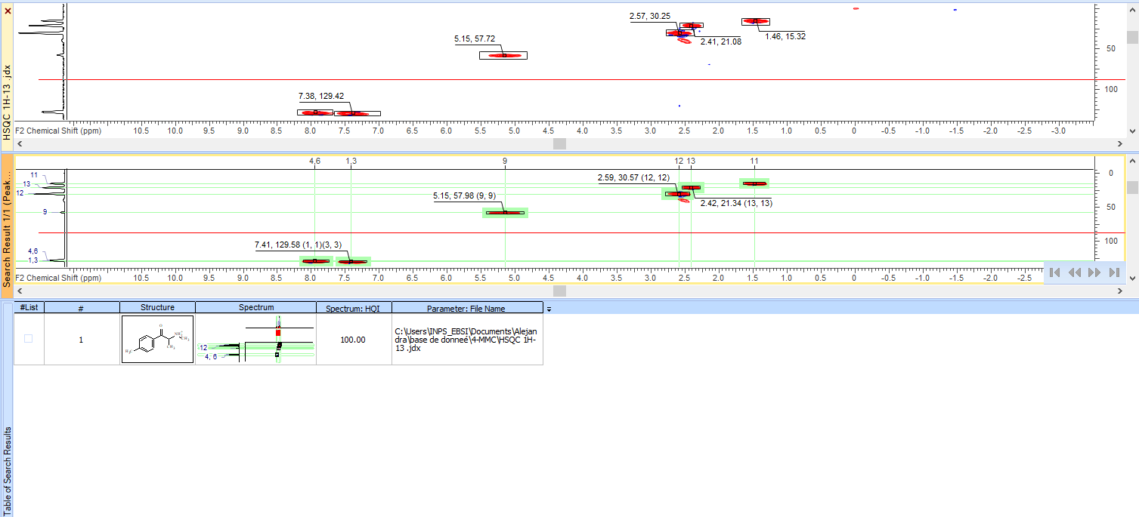
S5: HSQC 4-MMC spectral homology
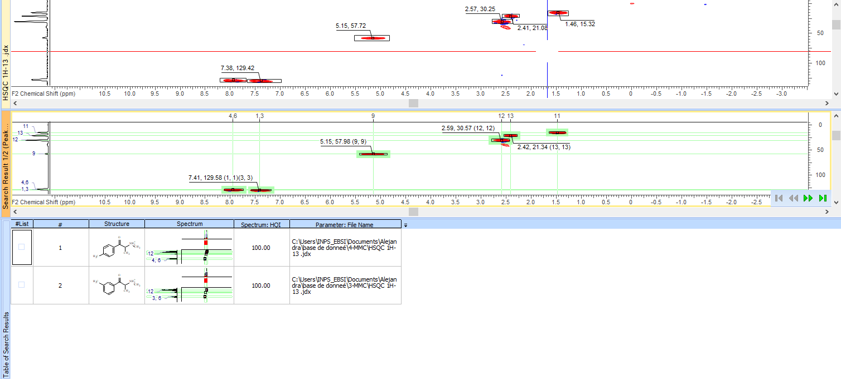
S5: IR 3-MMC peak search
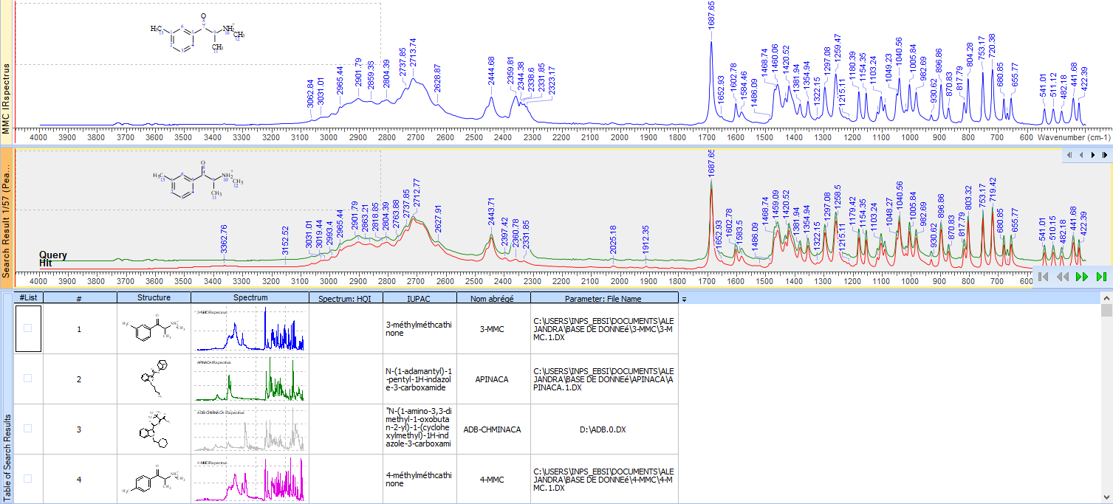
S5: IR 3-MMC absolute algorithm
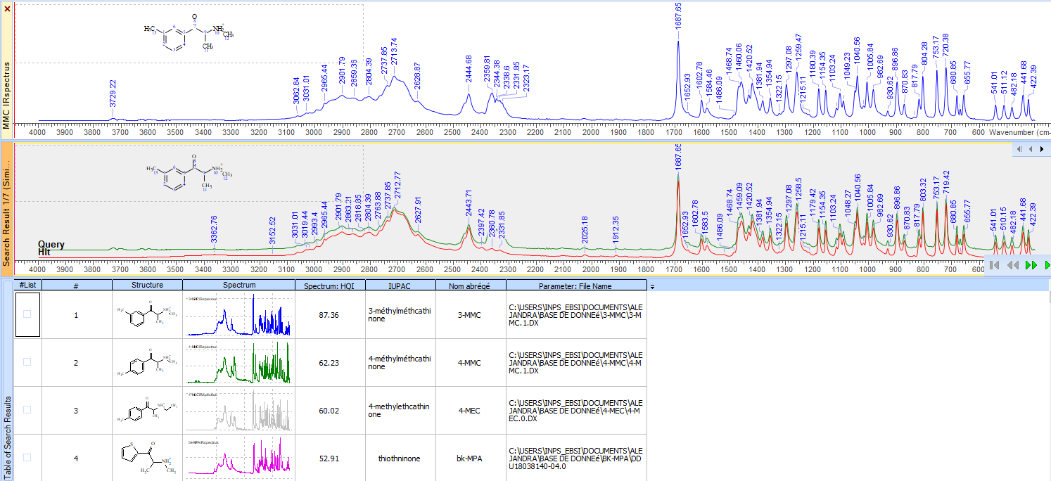
S5: IR 3-MMC euclidian algorithm
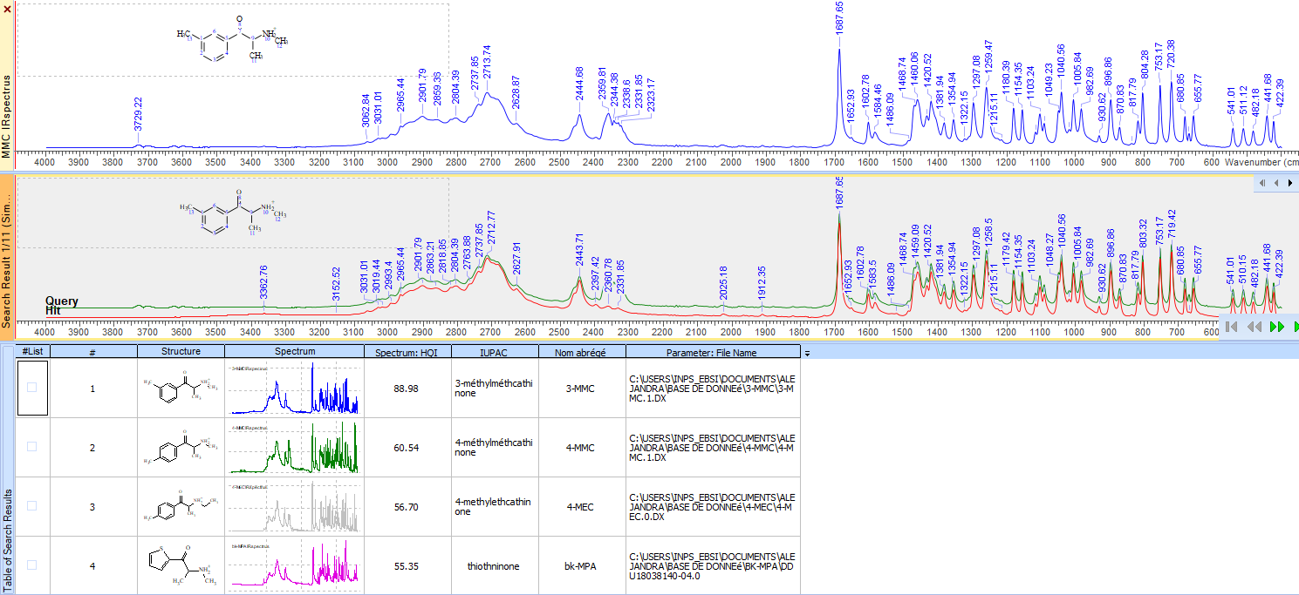
S5: IR 4-MMC peak search
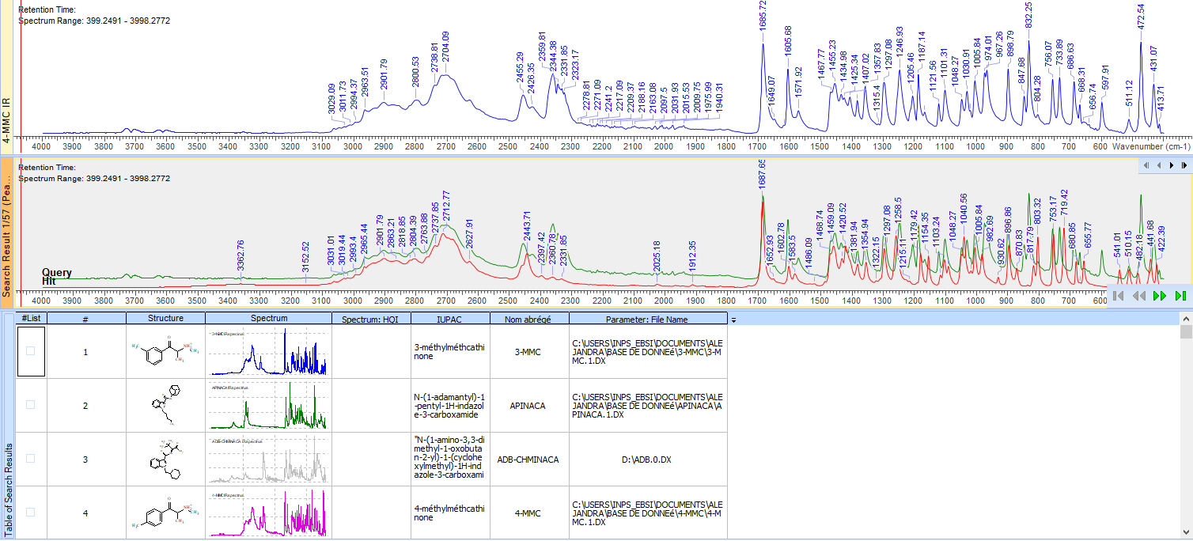
S5: IR 4-MMC absolute algorithm
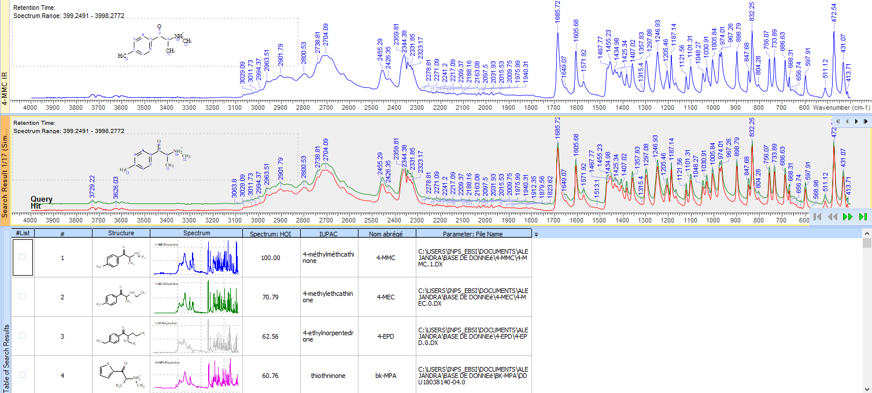
S5: IR 4-MMC euclidian algorithm
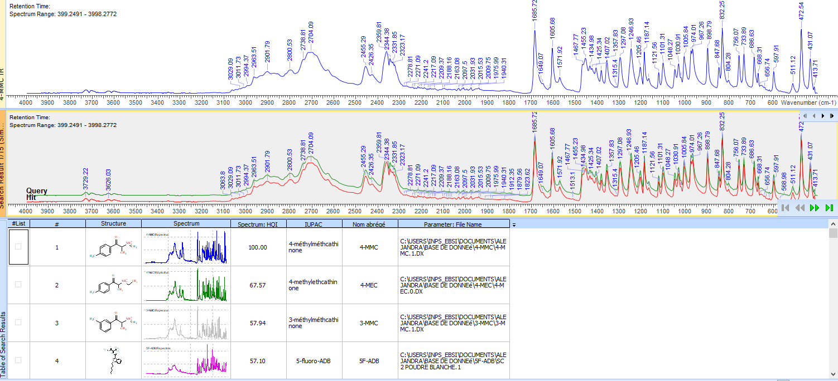
S6: 1D ¹⁹F substance n°1
S6: 2D HSQC substance n°1
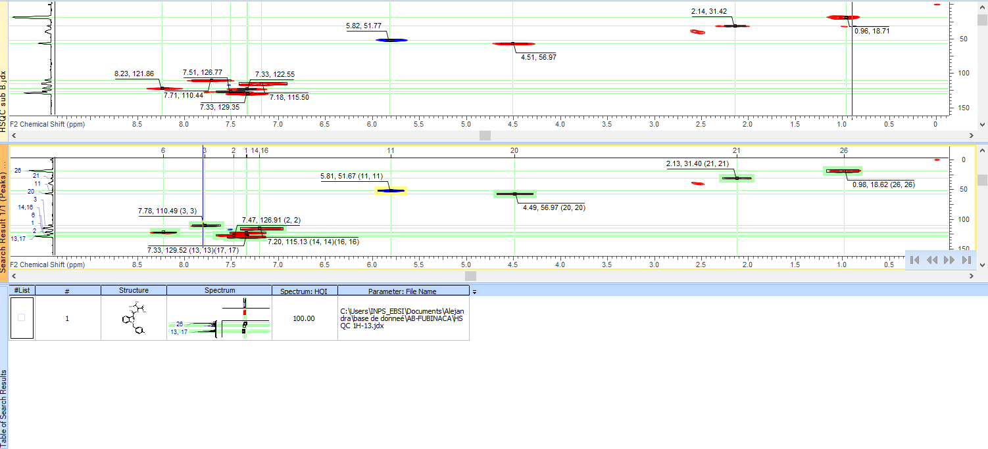
S6: IR substance n°1
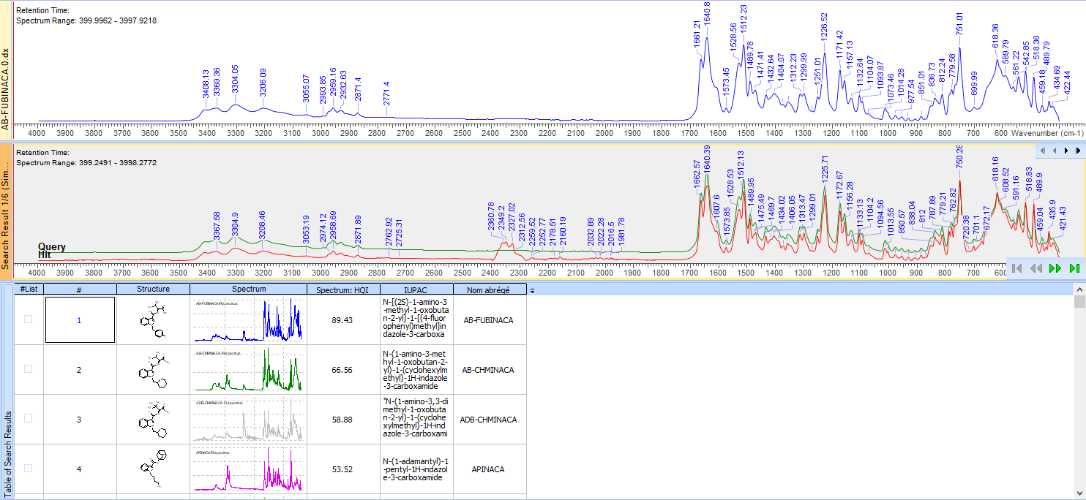
S6 : Identification substance 1 at 700MHz
1D ¹H
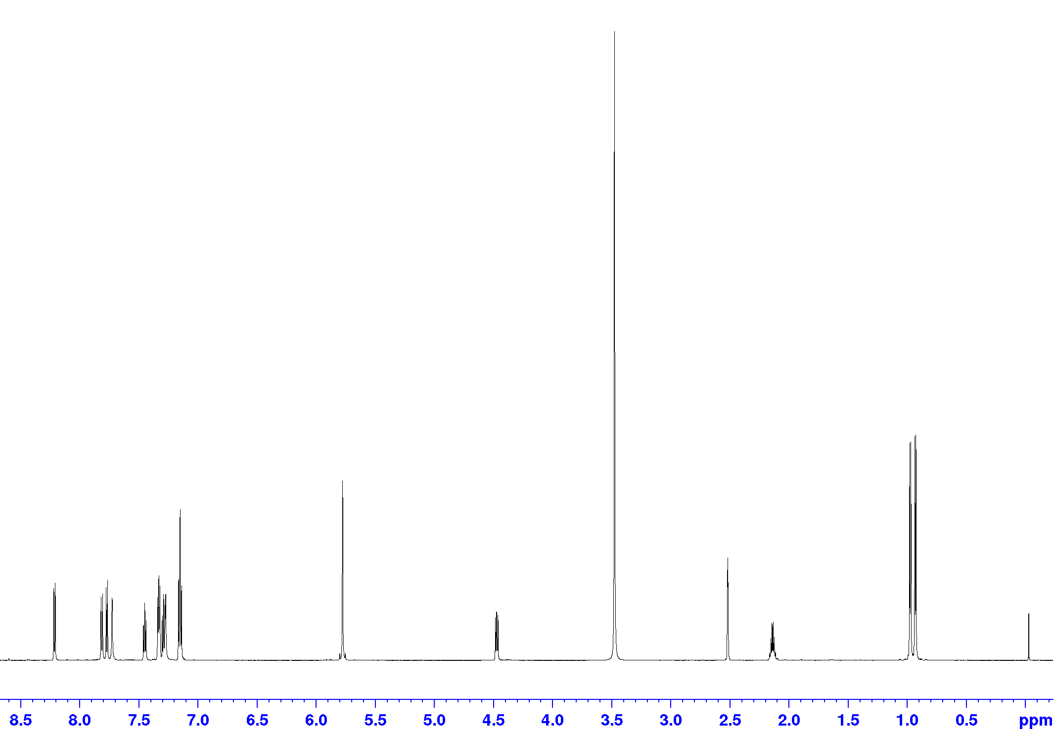
¹H-¹H COSY
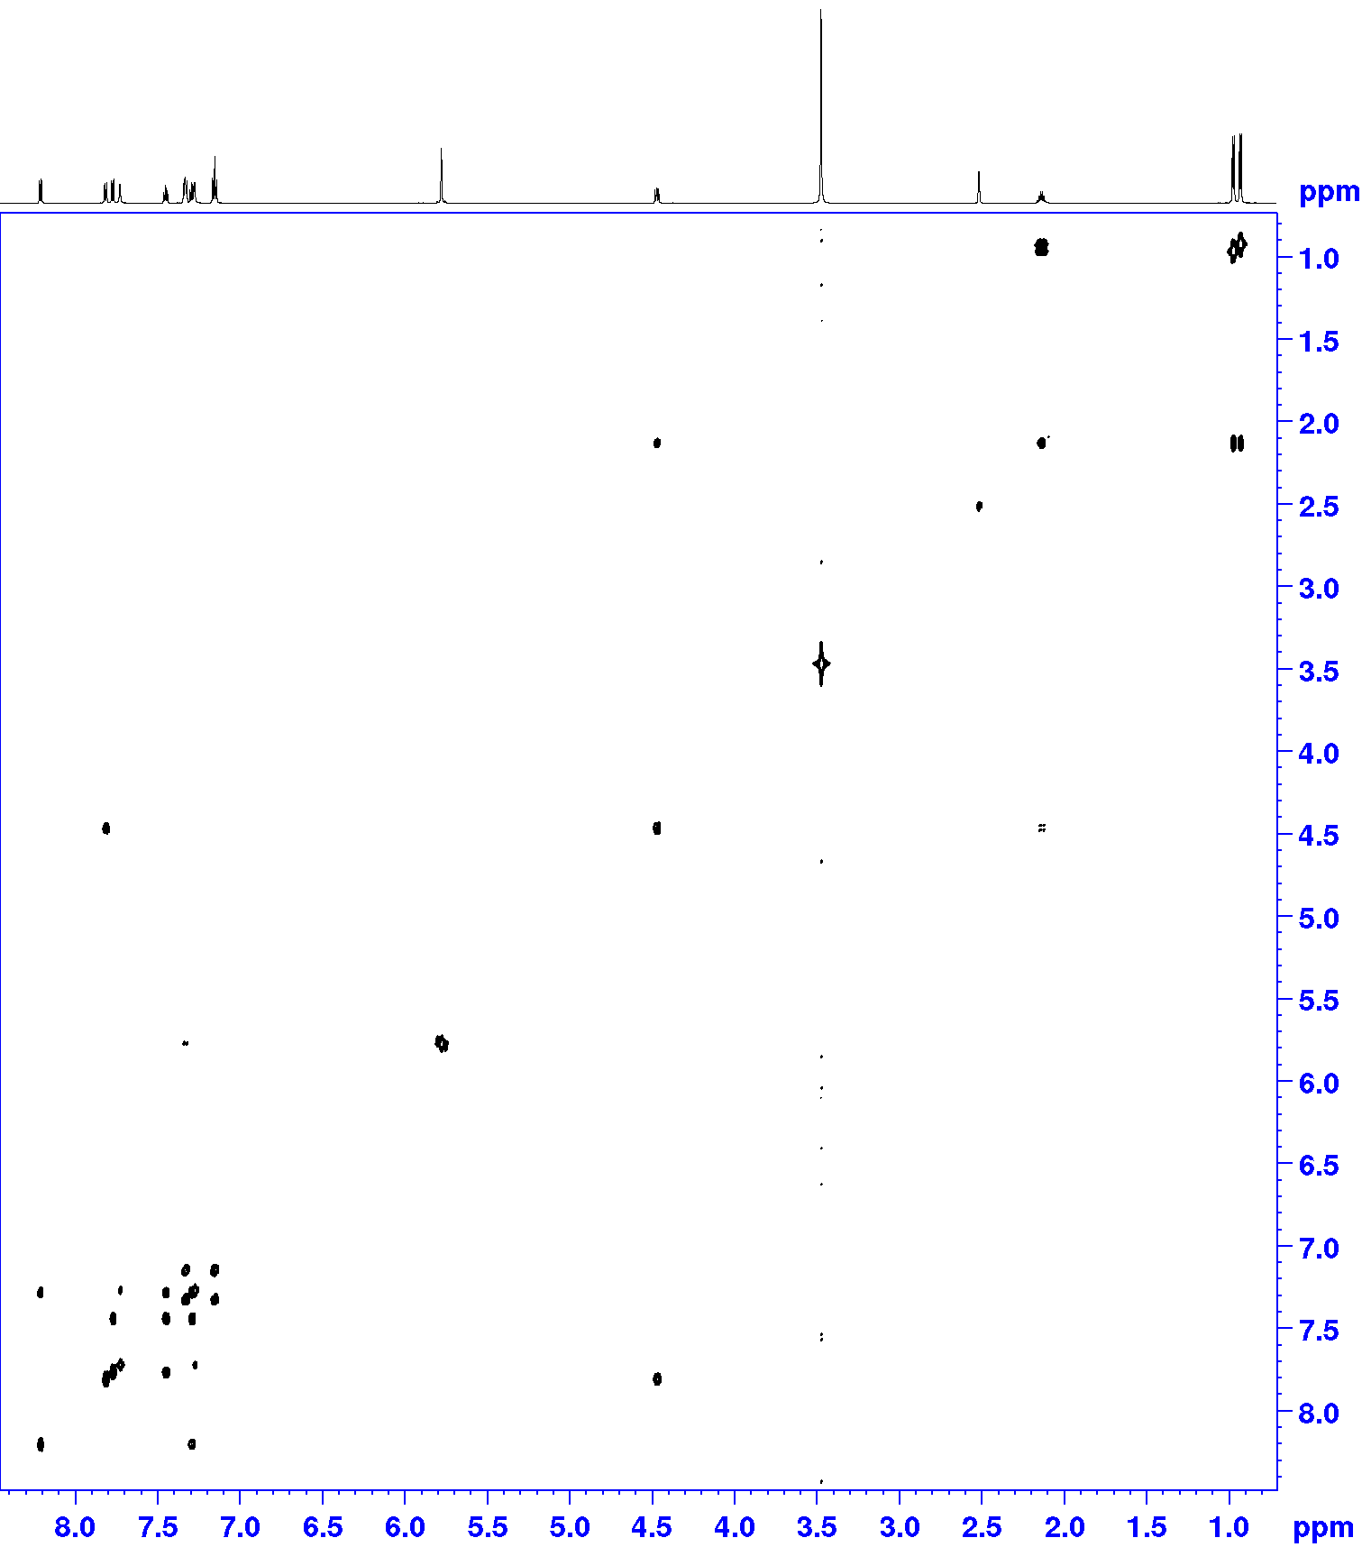
¹H-¹³C HSQC
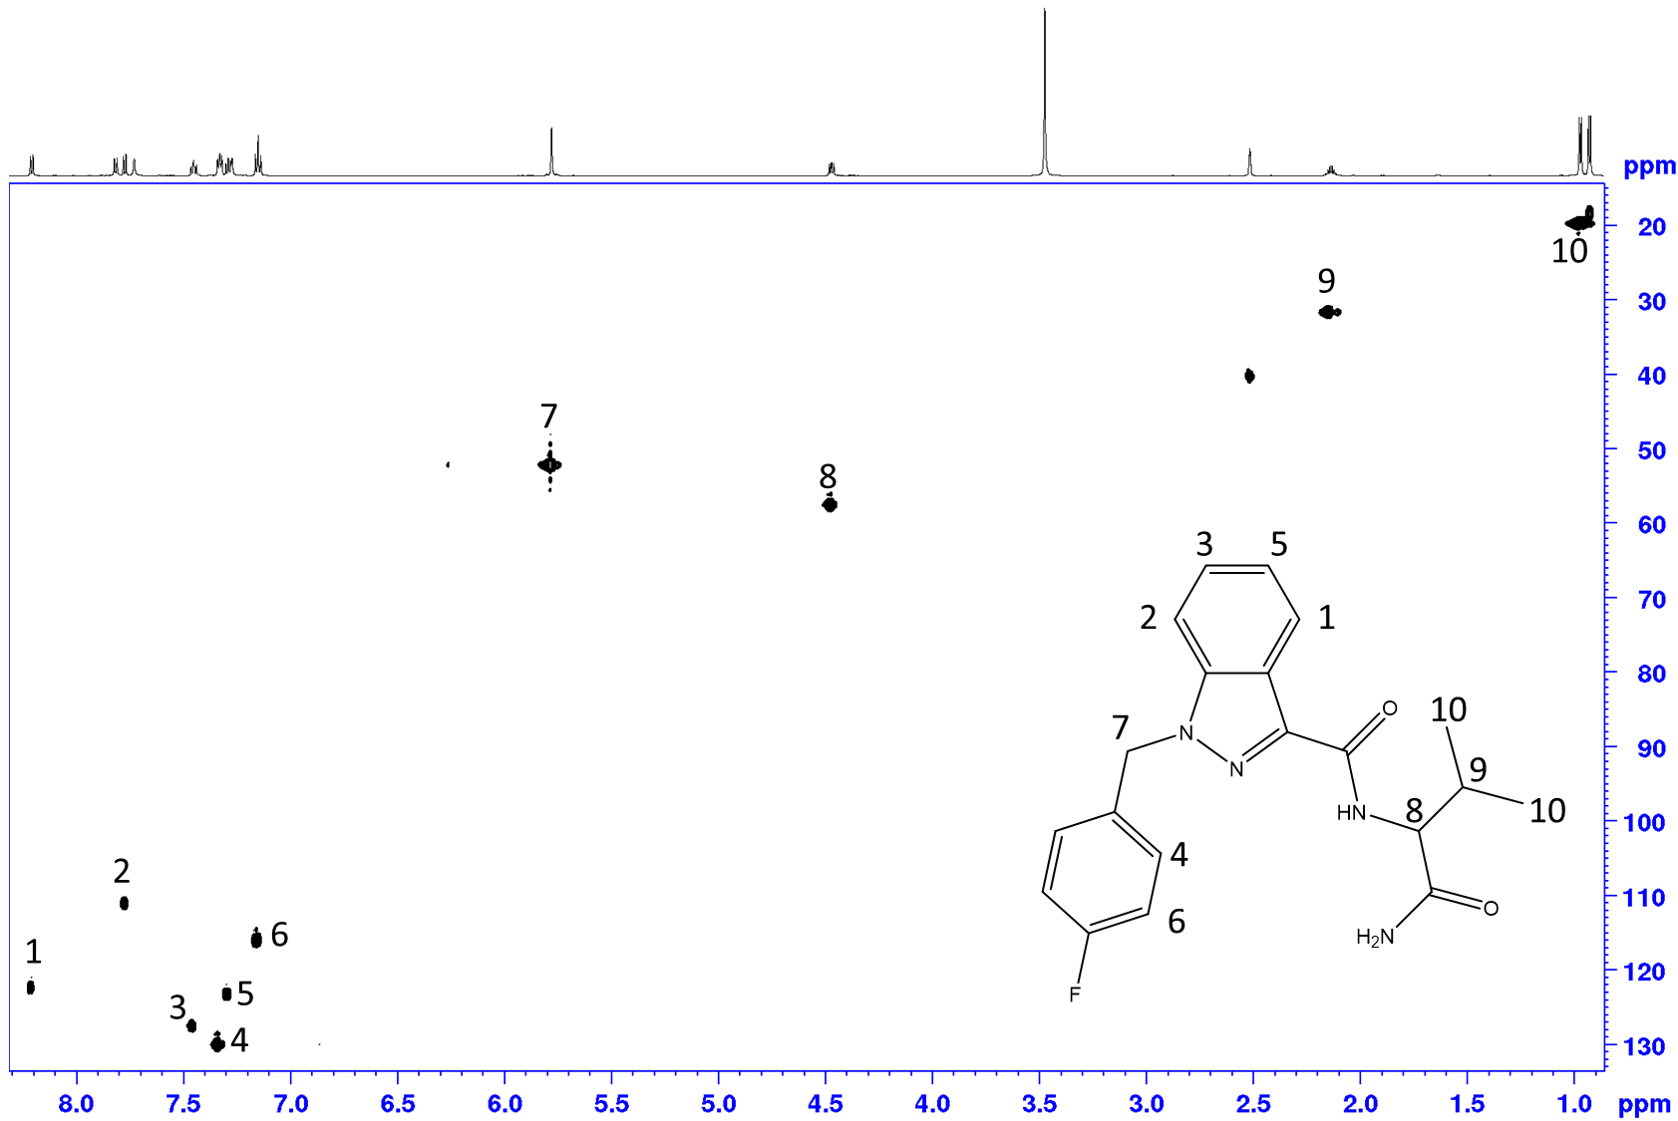
S7: 2D HSQC substance n°2
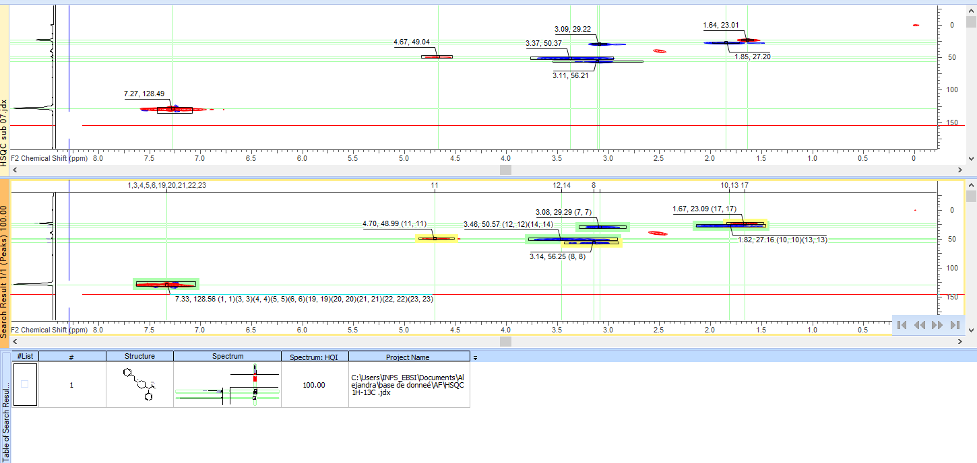
S7: IR substance n°2
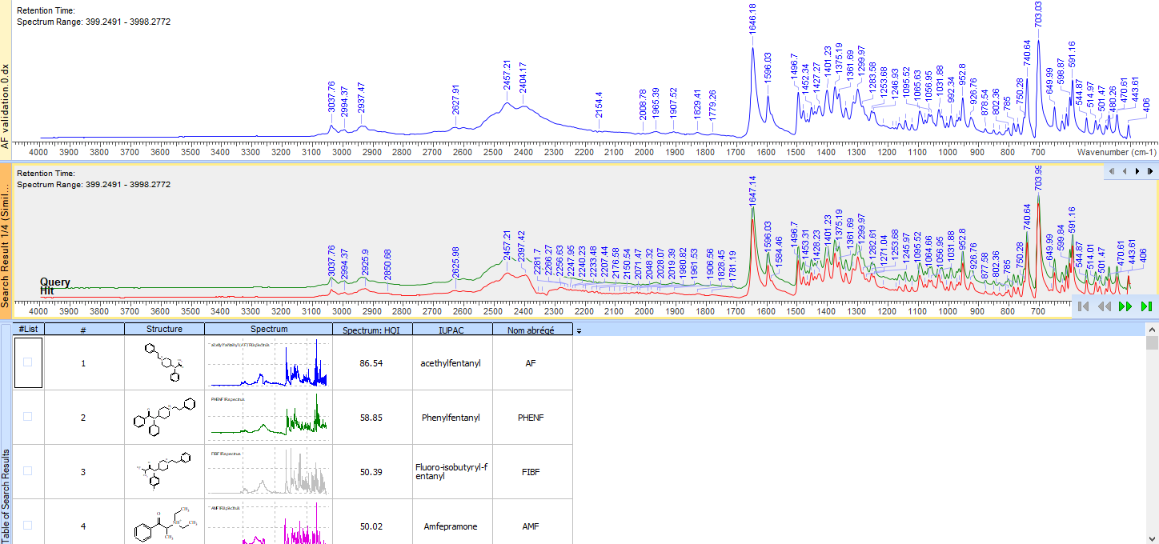
S7: Identification substance 2 at 700MHz
1D ¹H
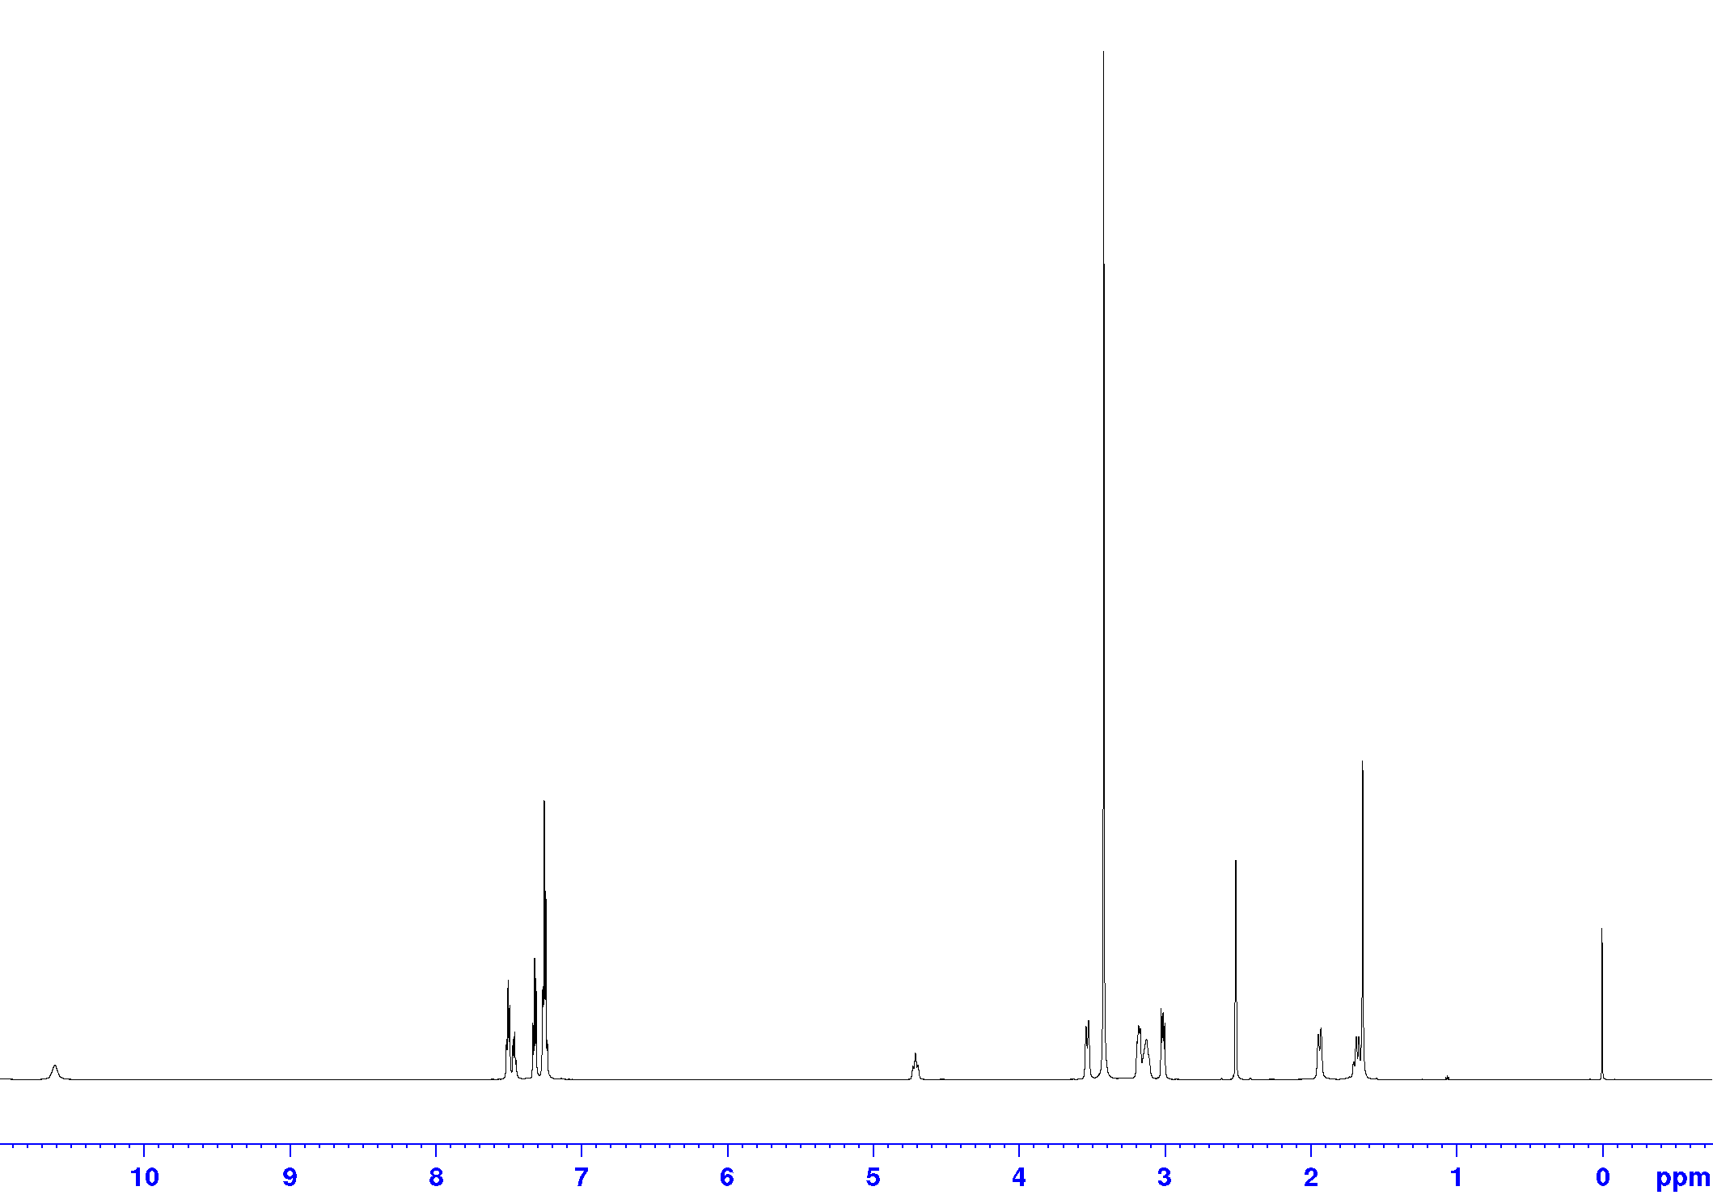
¹H-¹H COSY
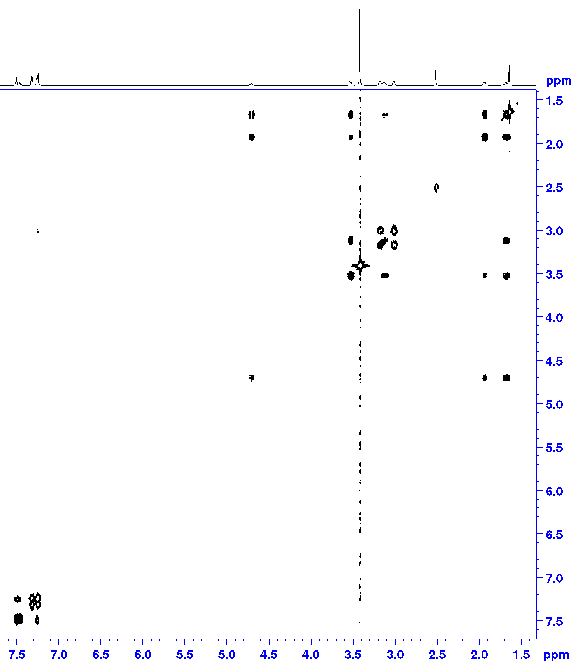
¹H-¹³C HSQC
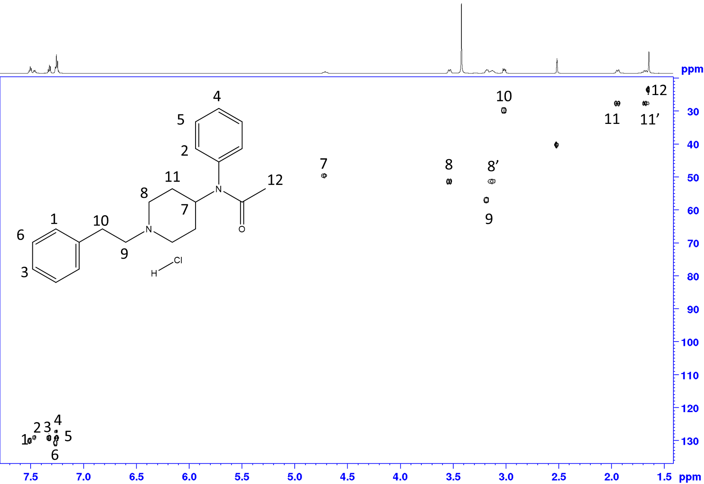
S8: 2D HSQC substance n°3
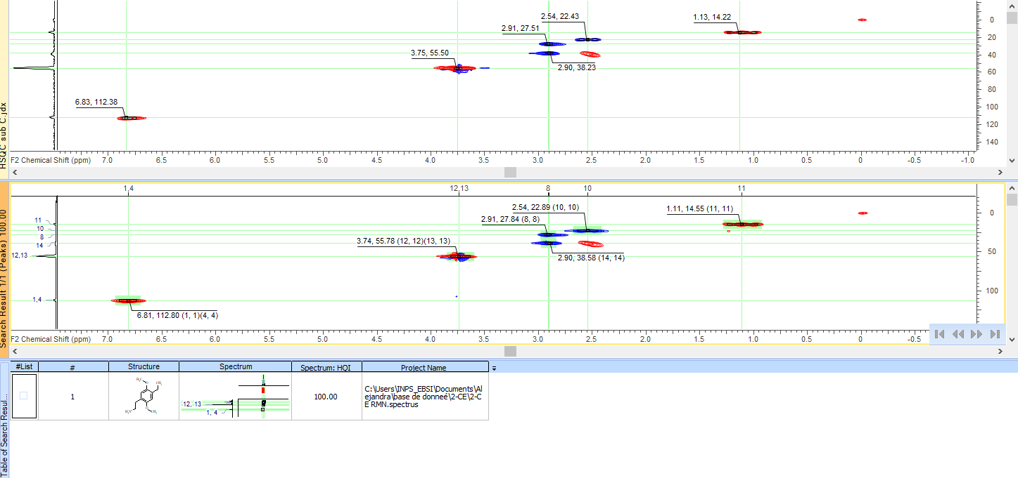
S8: 1D ¹H substance n°3
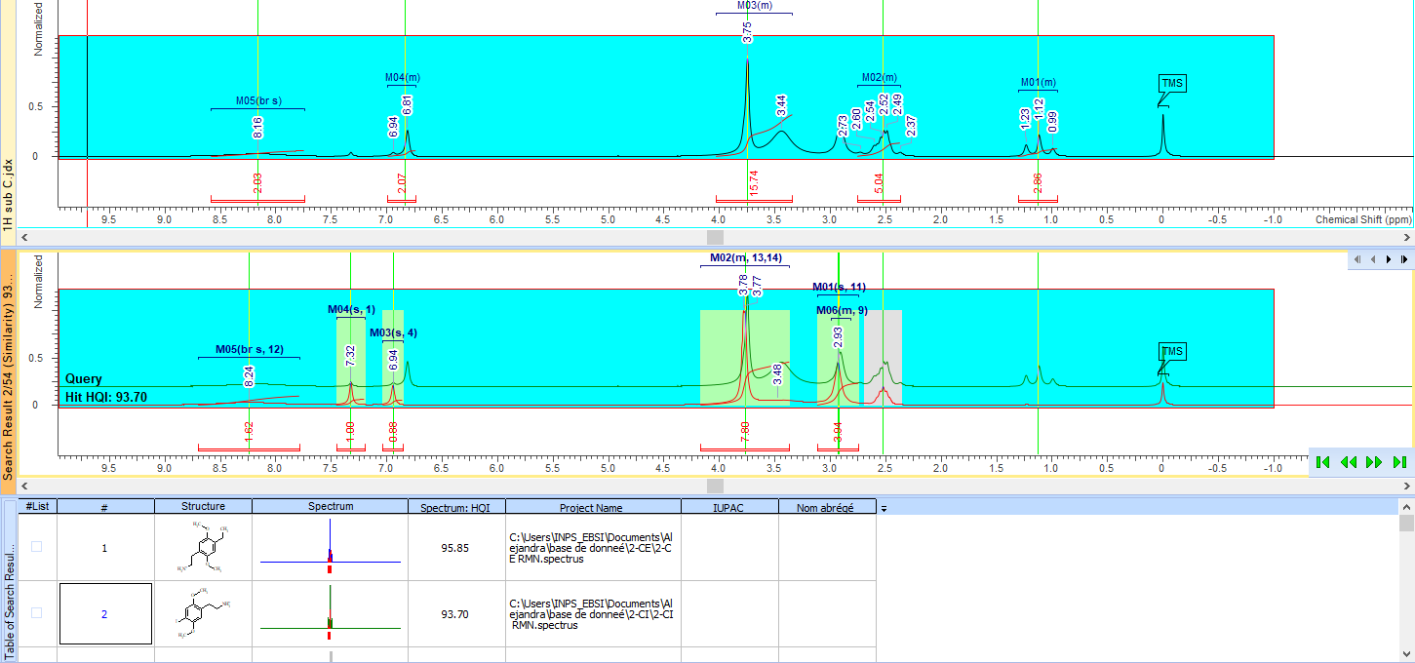
S8: Identification substance 3 at 700MHz
1D ¹H NMR comparison with pure samples
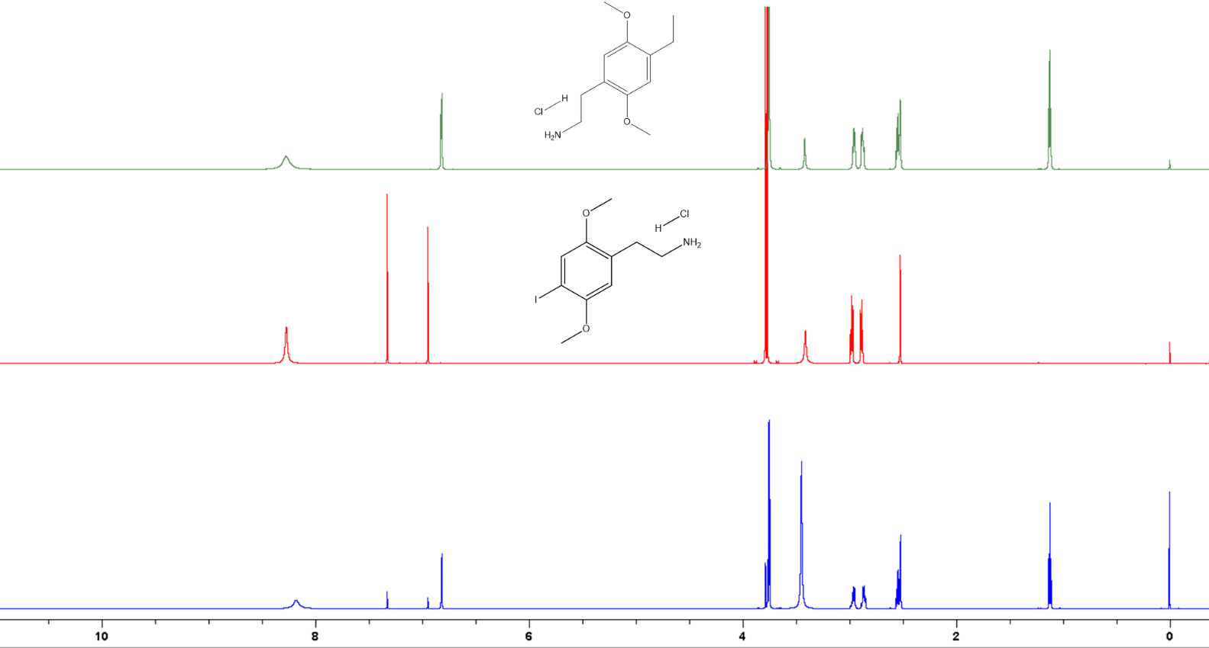

S9: 2D HSQC identification substance n°4
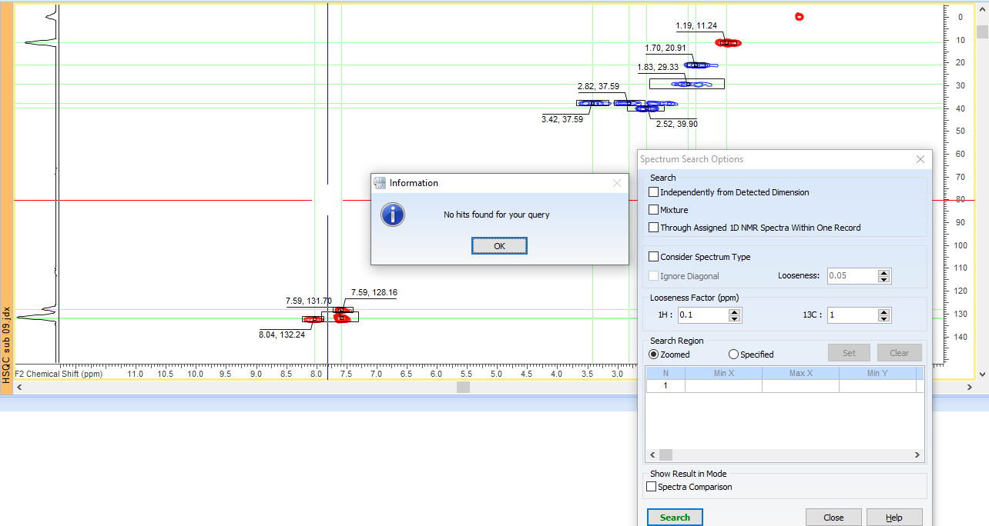
S9: 2D HSQC elucidation substance n°4
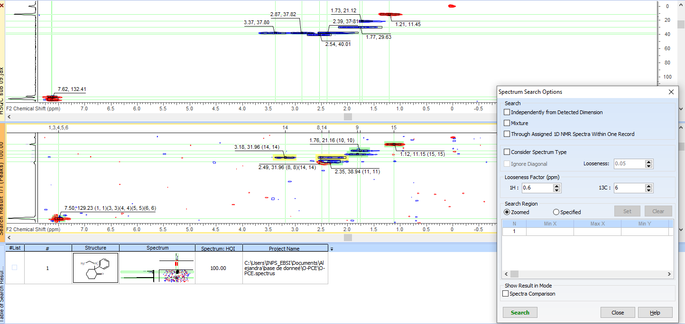
S9: 1D ¹H substance n°4
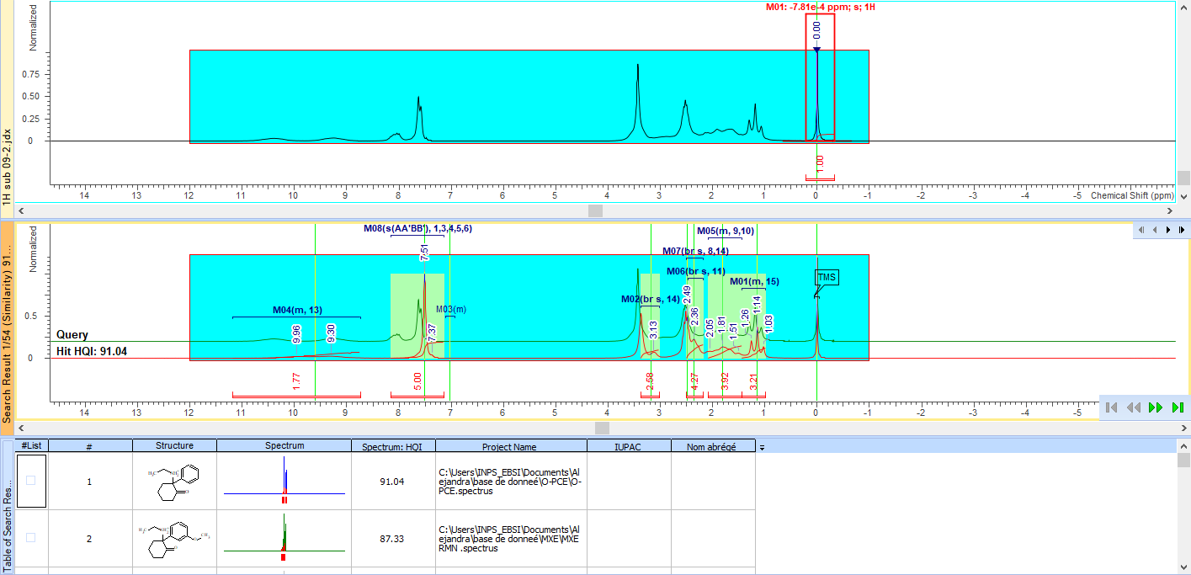
S9: IR substance n°4
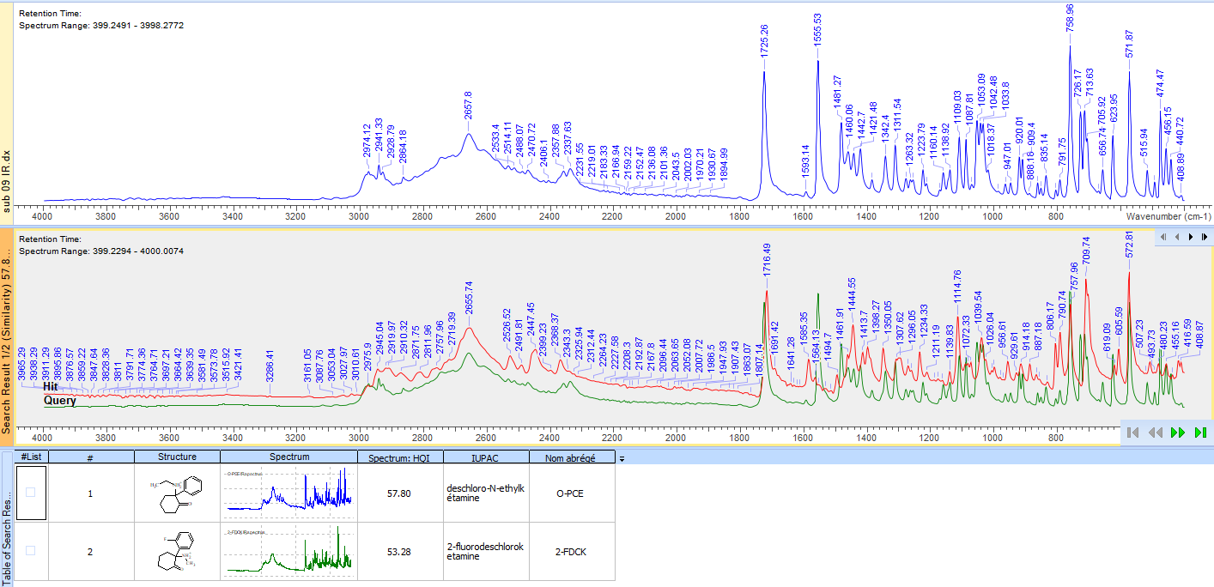
S9: Elucidation substance n°4 at 700MHz
1D ¹H
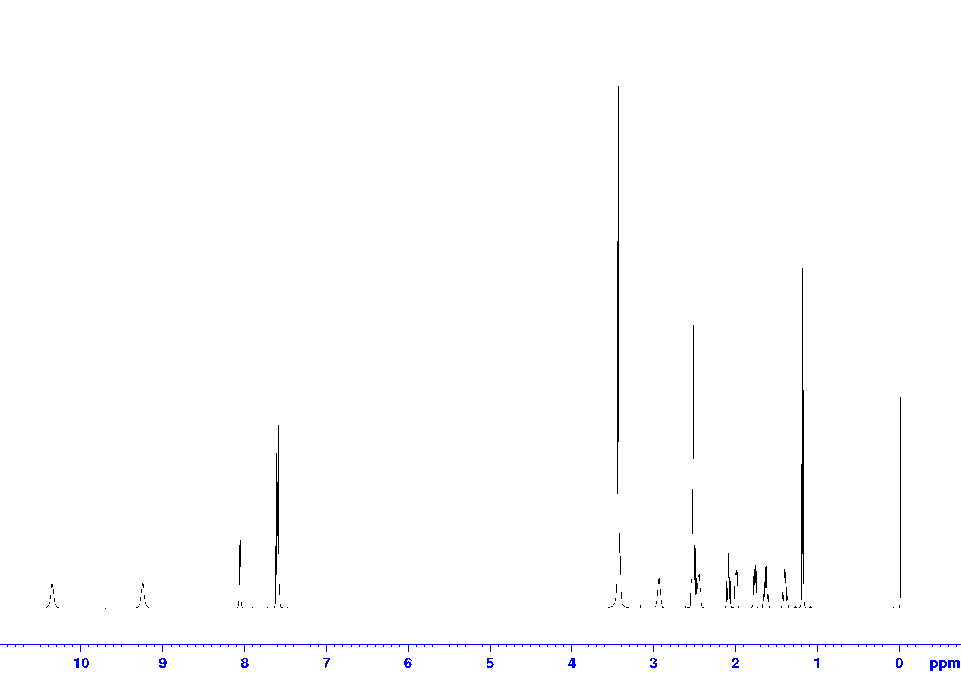
¹H-¹H COSY
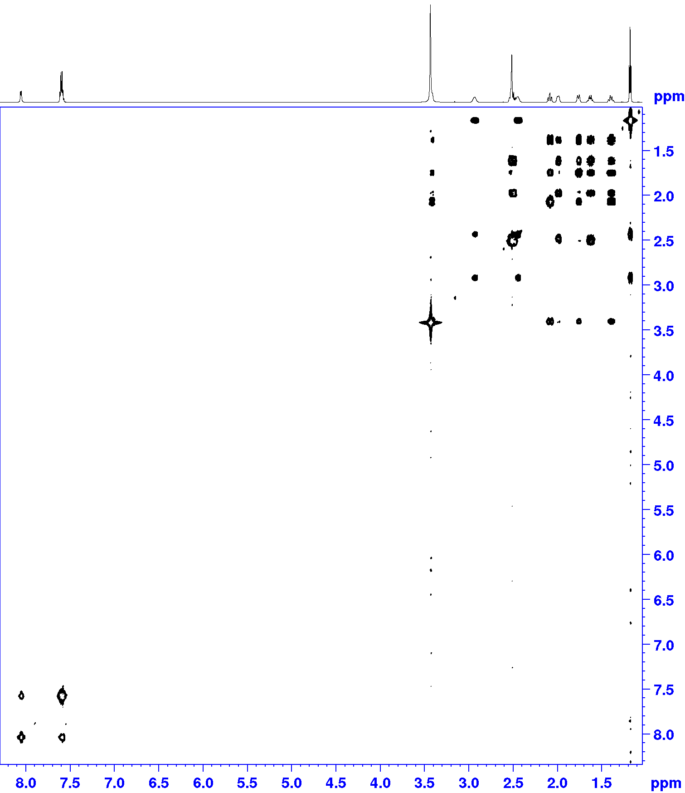

¹H-¹³C HSQC
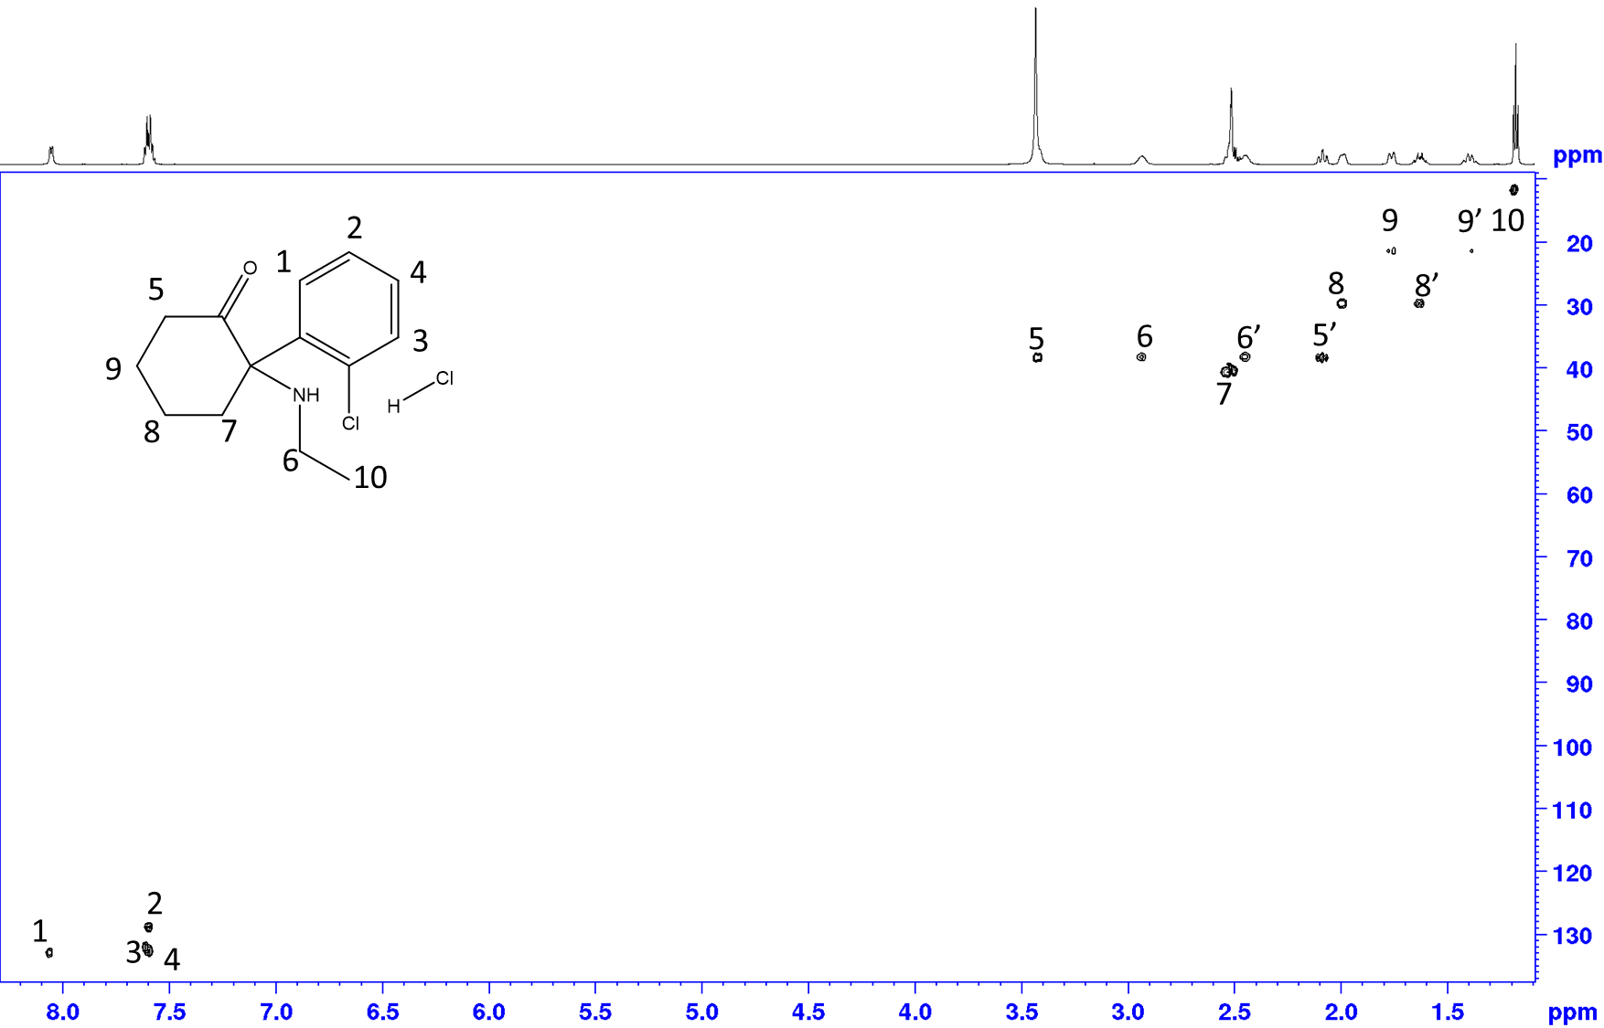
S10: 2D HSQC identification substance n°5
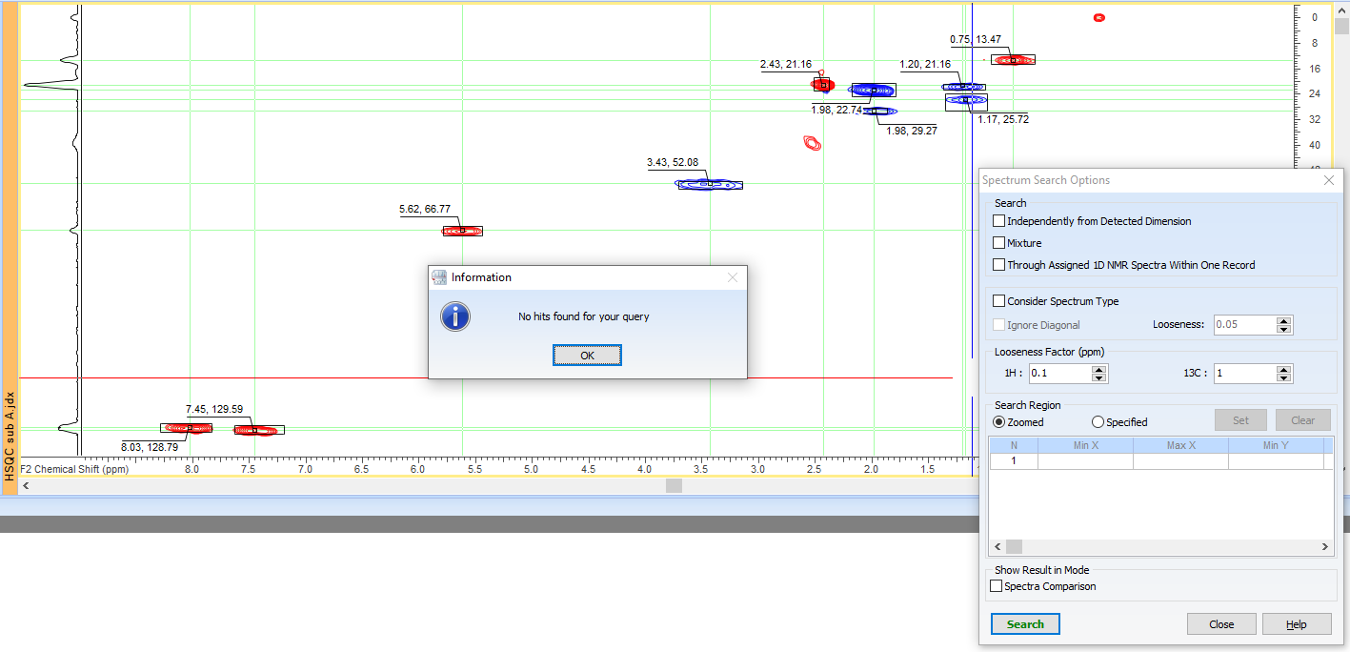
S10: 2D HSQC elucidation substance n°5
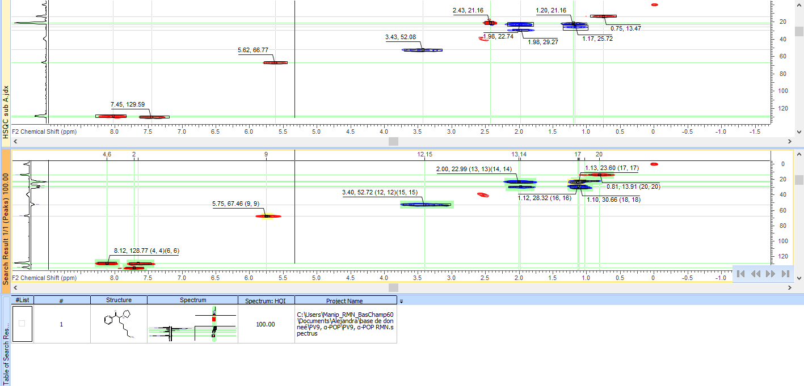
S10: 1D ¹H substance n°5
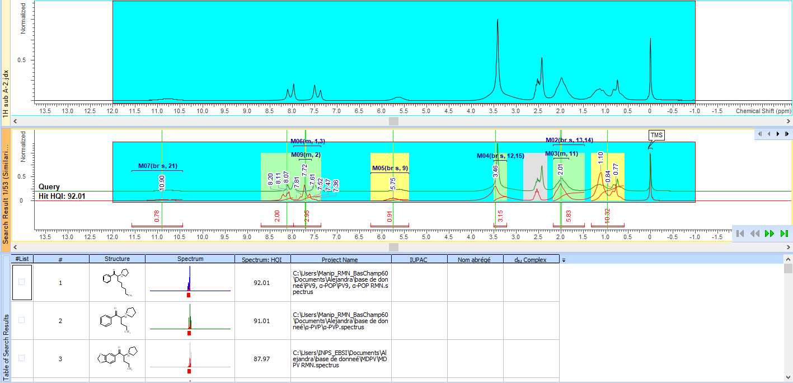
S10: IR substance n°5
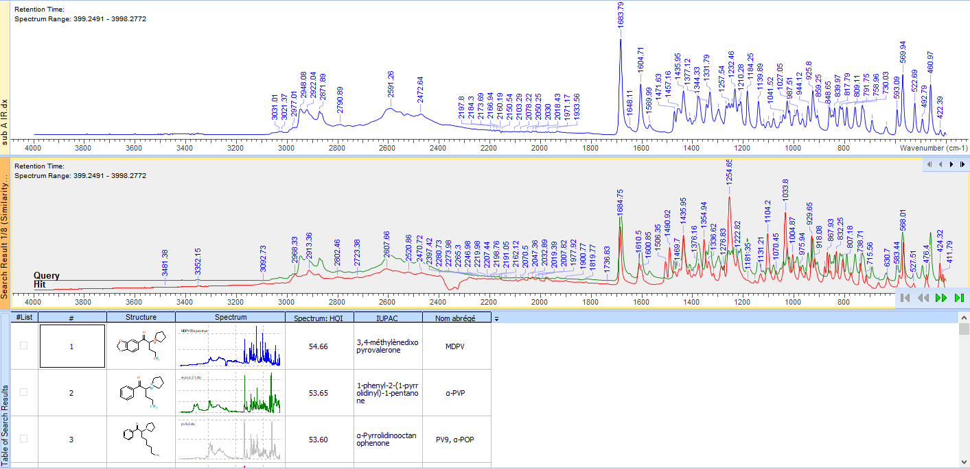
S10: HSQC prediction for MPHP
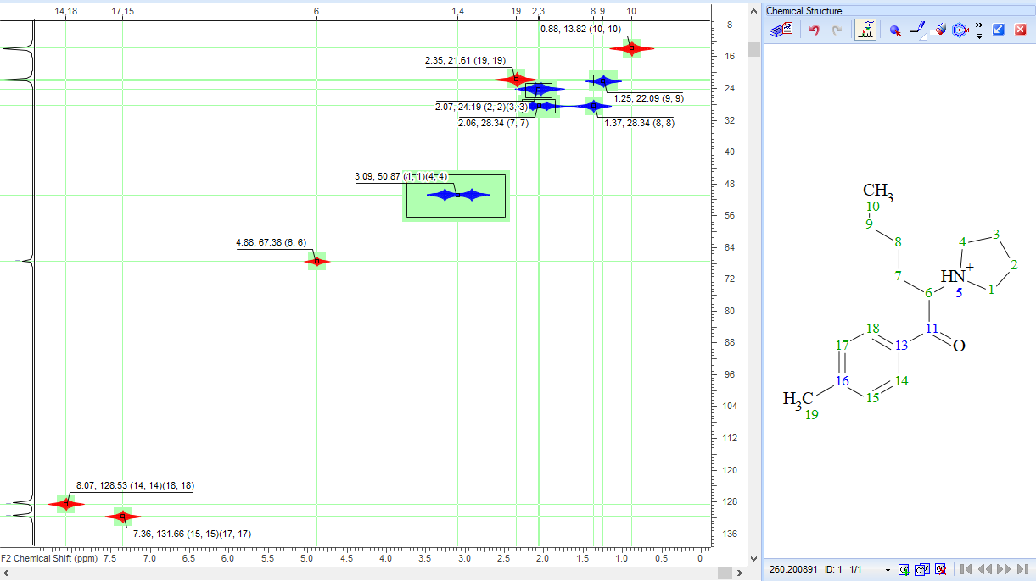
S10A: 700 MHz and predicted HSQC comparison

S10: Elucidation substance n°5 at 700MHz
1D ¹H
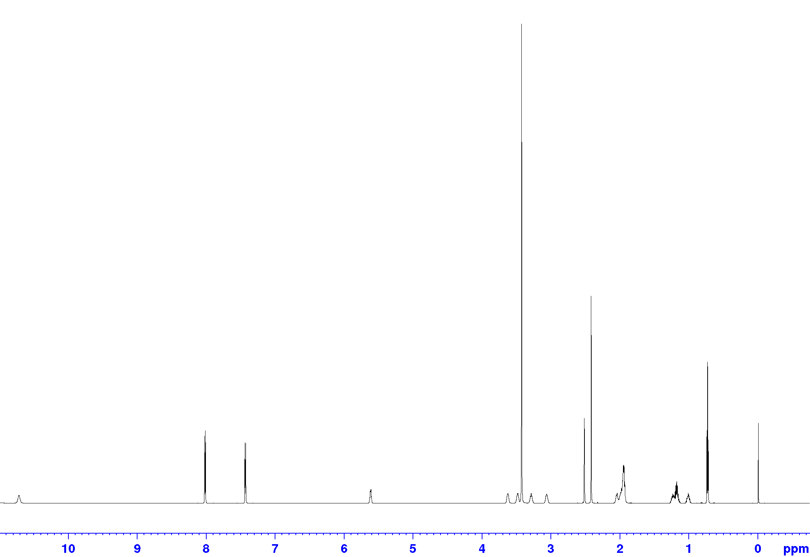
¹H-¹H COSY
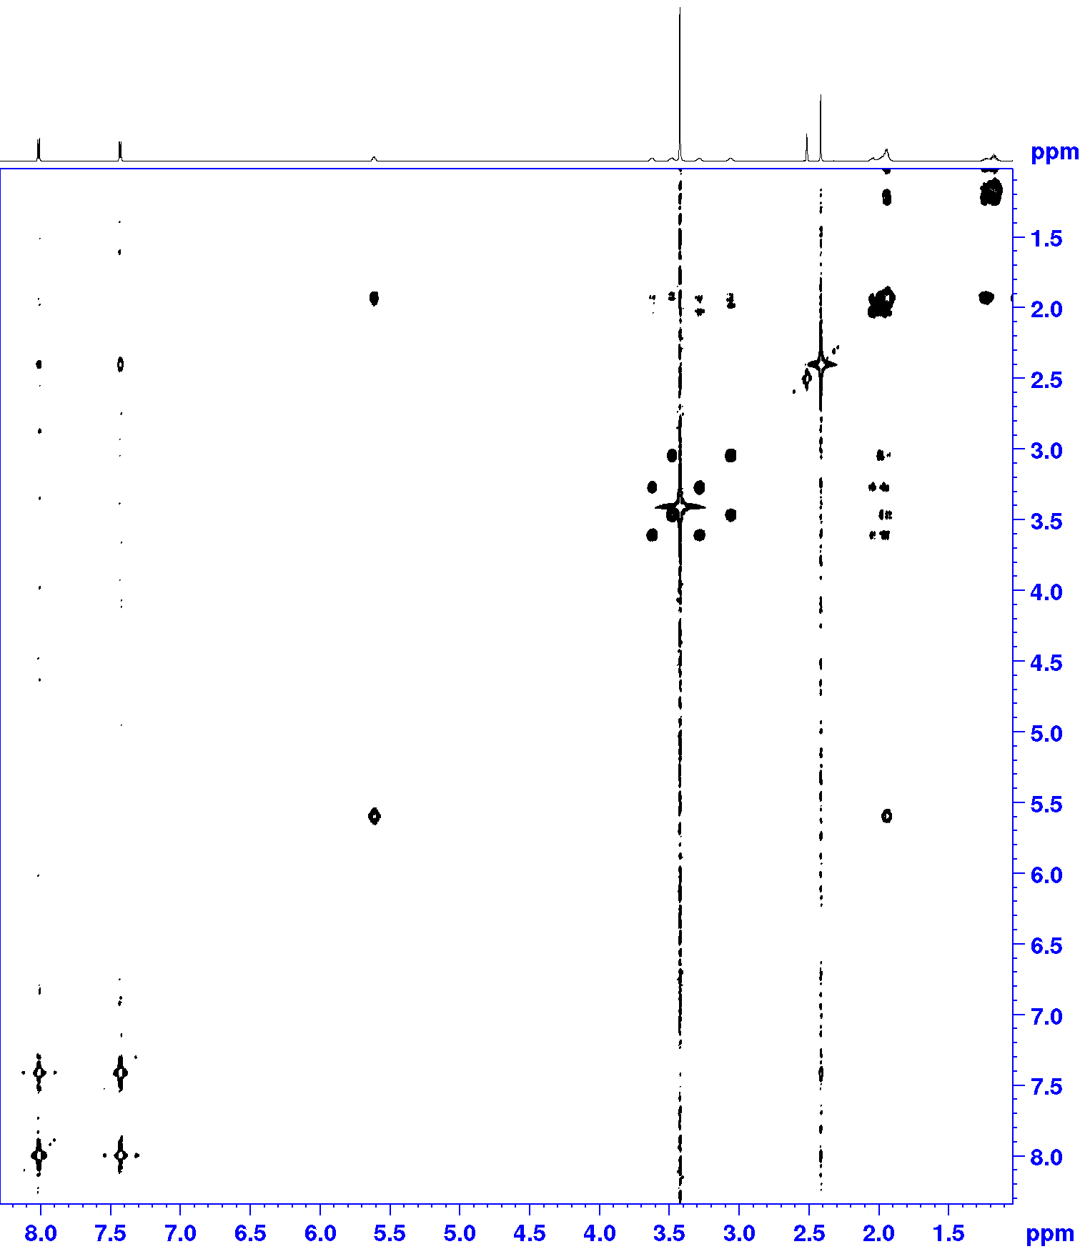

¹H-¹³C HSQC
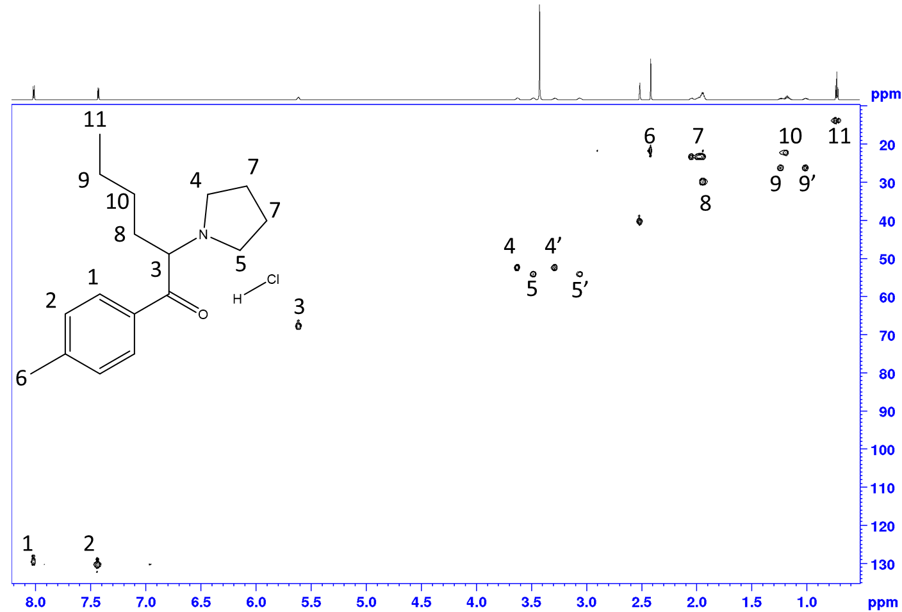
S11: 2D HSQC identification substance n°6
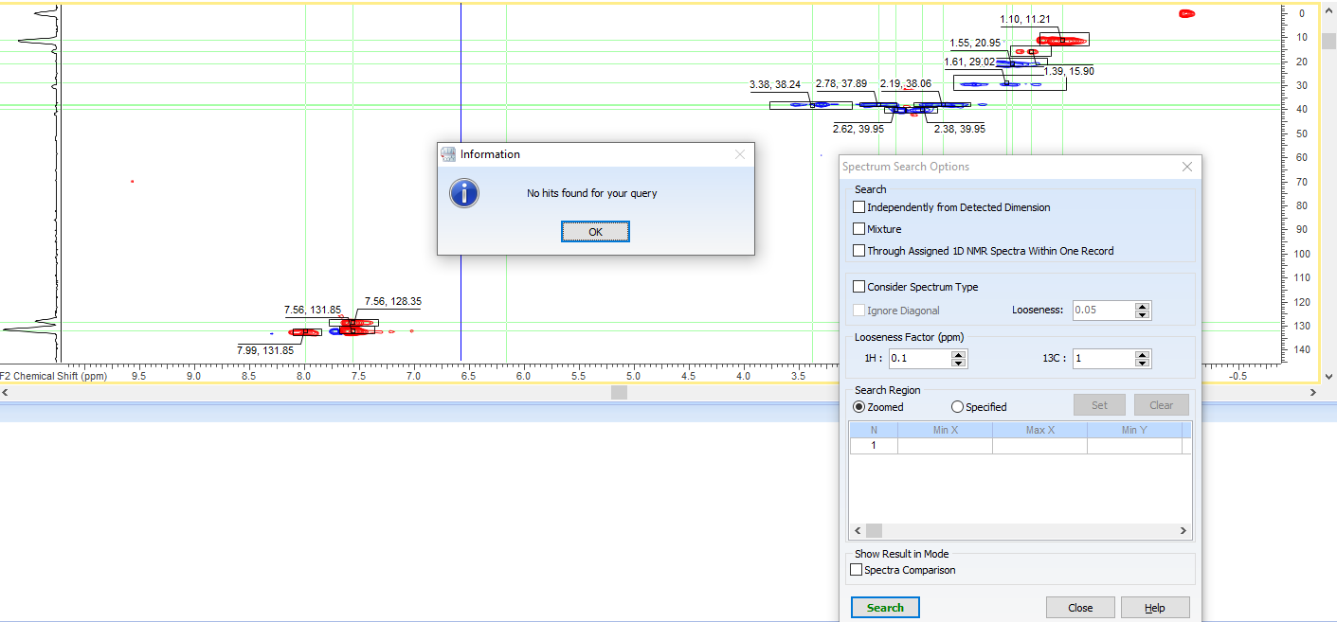
S11: 2D HSQC elucidation substance n°6
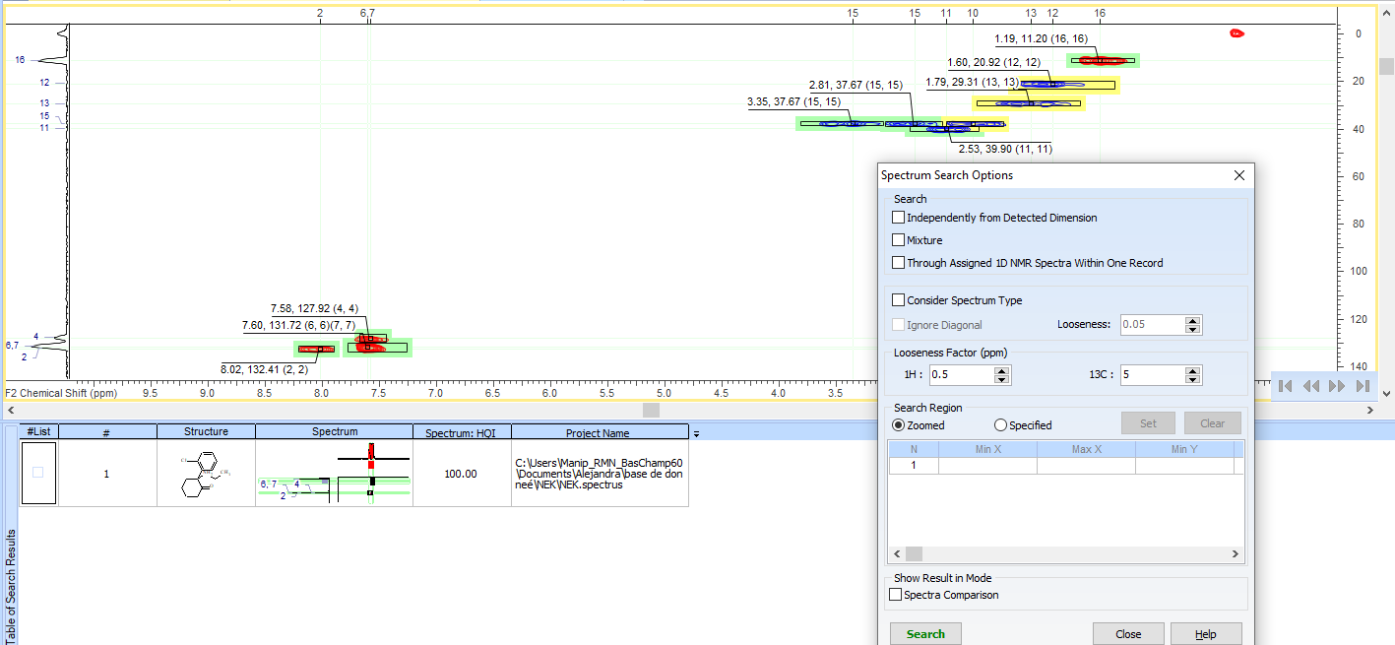
S11: 1D ¹H substance n°6
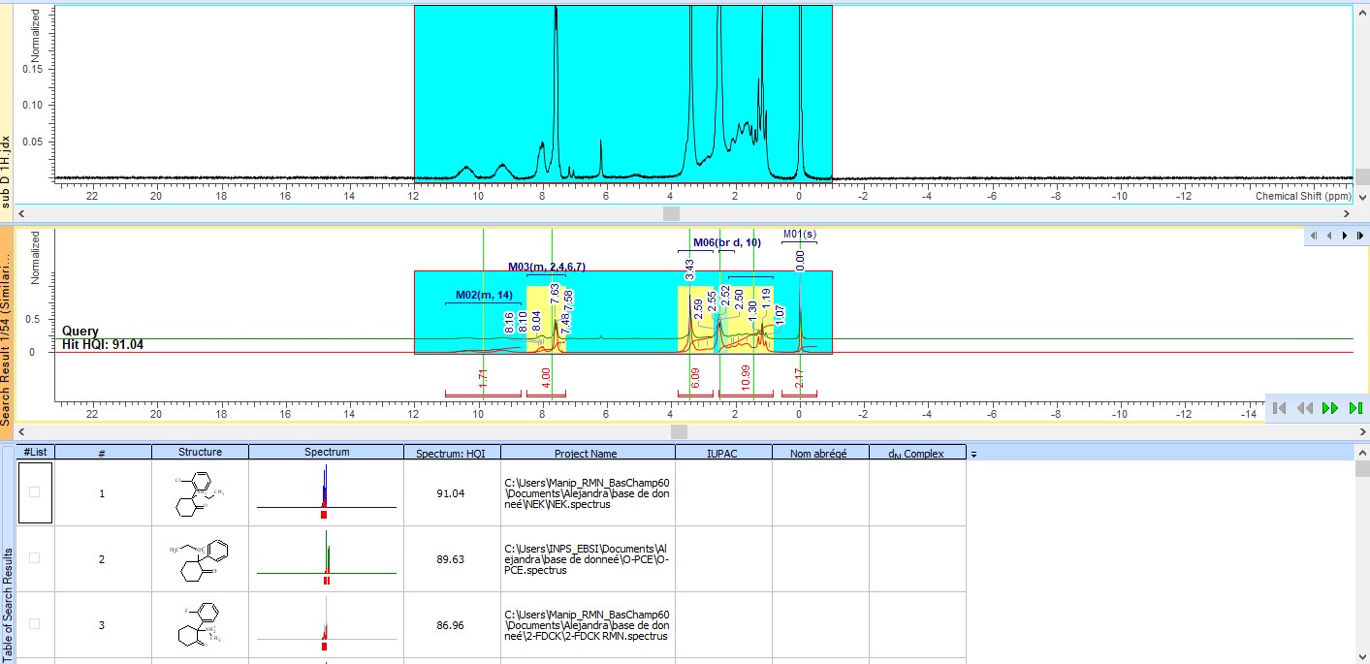
S11: Elucidation substance 6 at 700MHz
1D ¹H
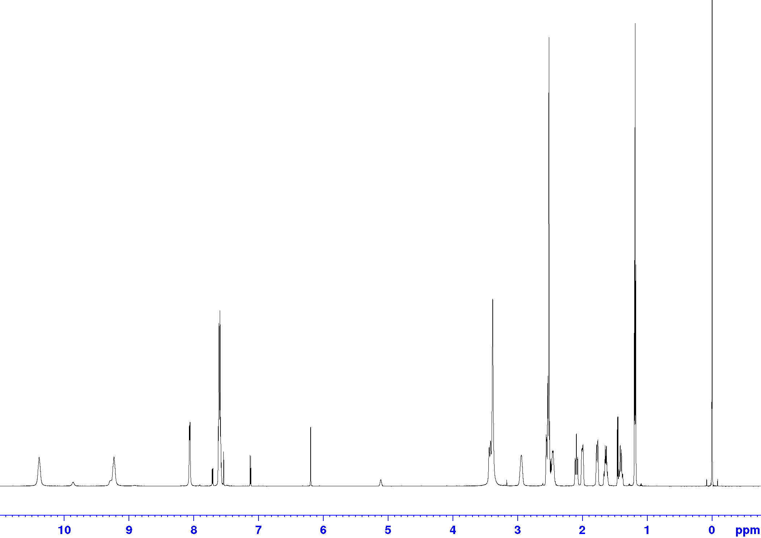
¹H-¹H COSY
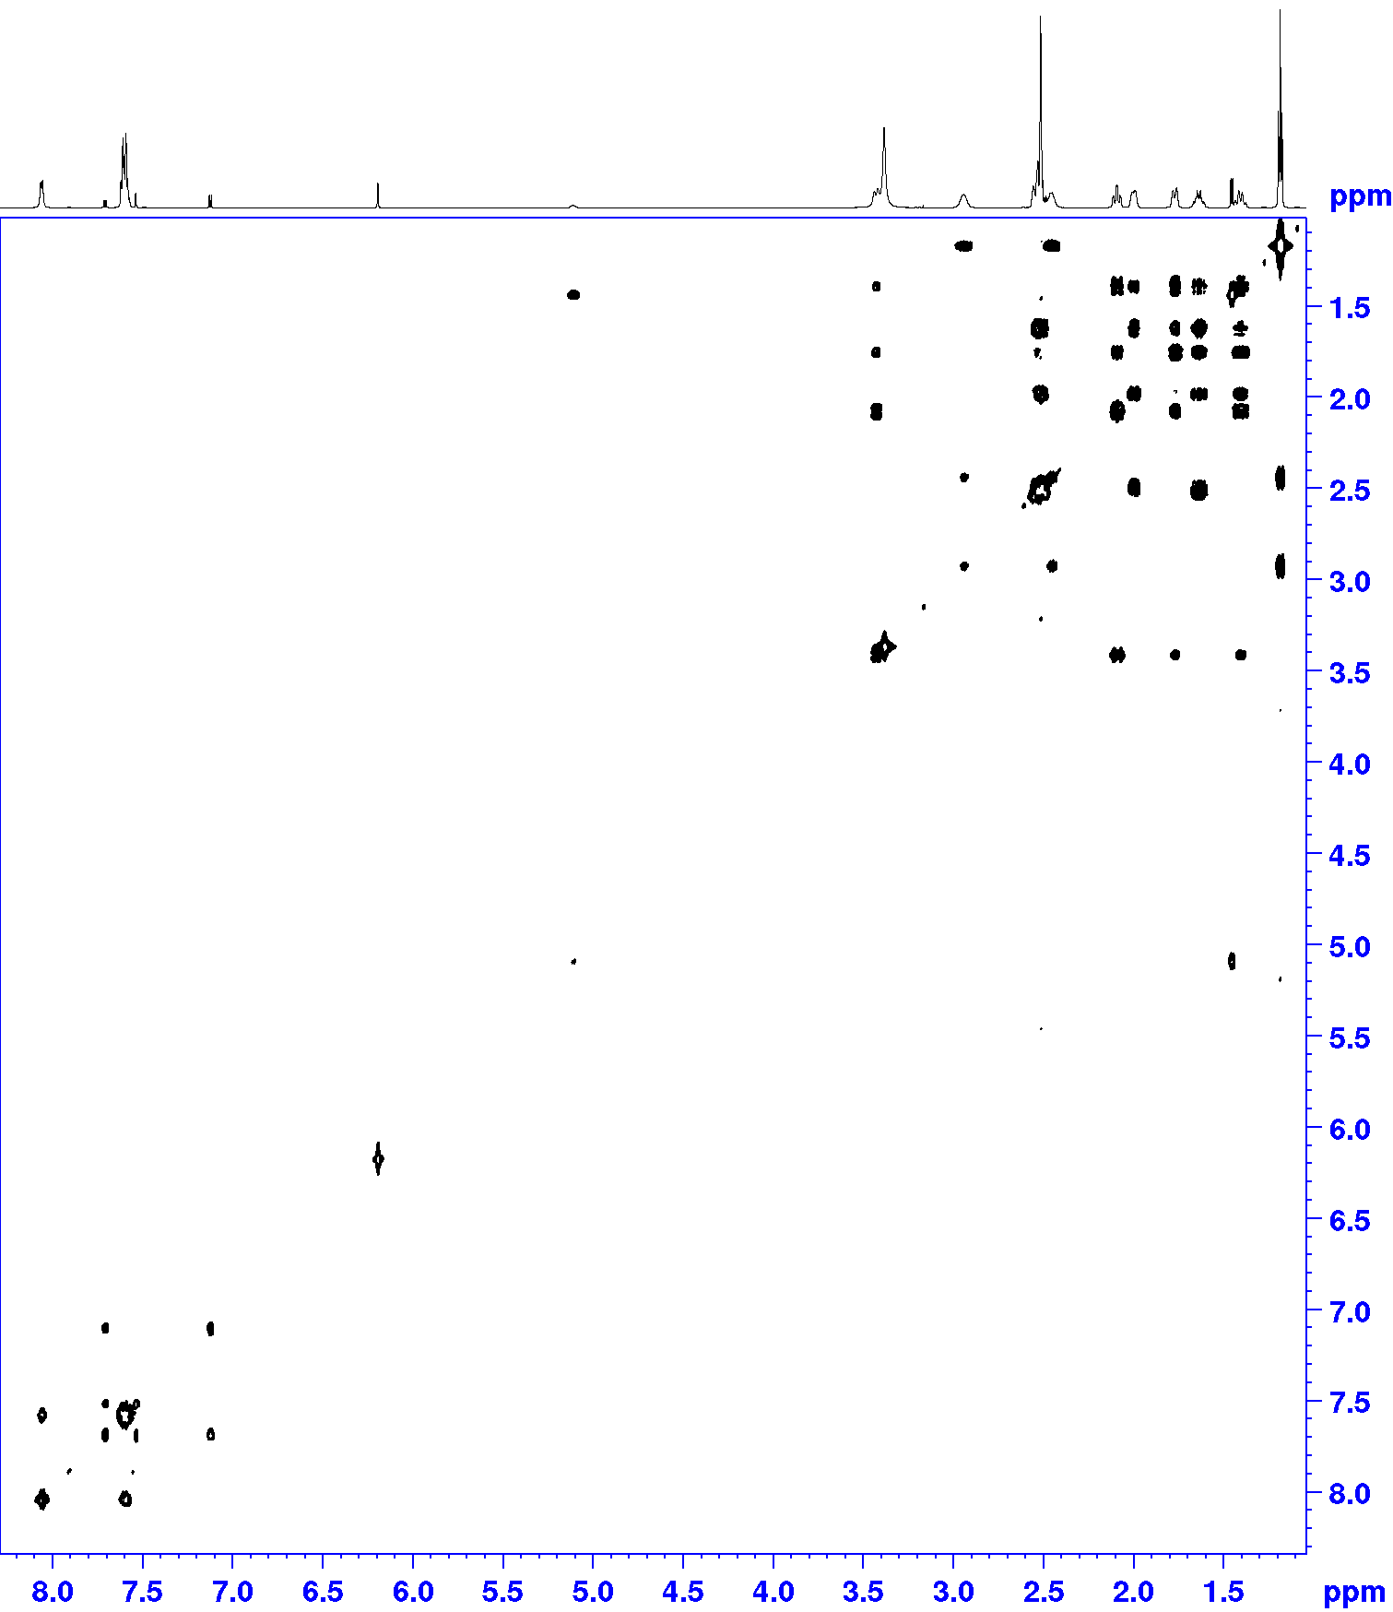

¹H-¹³C HSQC
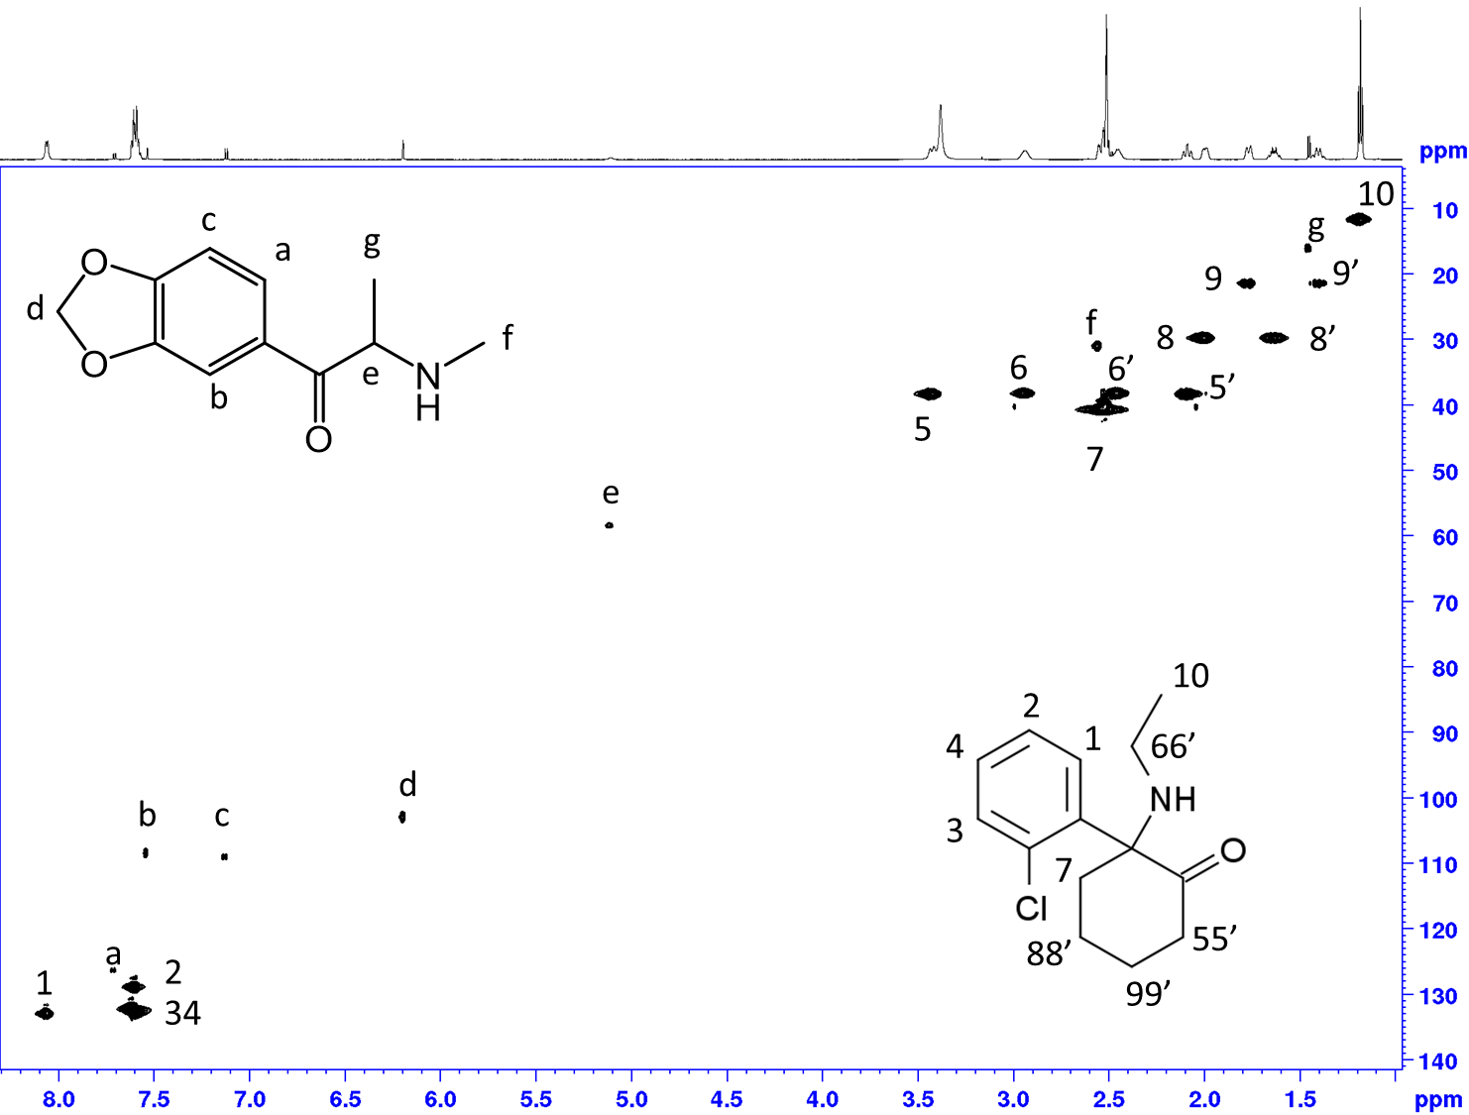

S12: Integrations area for the determination of purity
