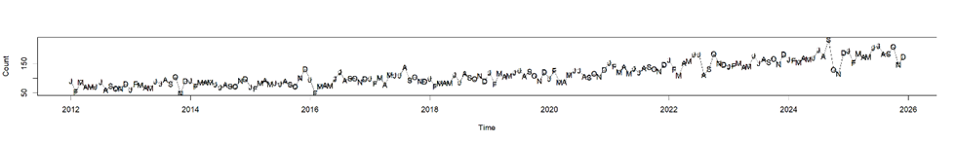
Figure S1. Observed NPS poisoning incidence rate between 2012 and 2025 with monthly plotting symbols. All January values are plotted with the character J, all Februarys with F, all Marches with M, and so forth. Distinguishing between Januarys, Junes, and Julys, between Marches and Mays, and Aprils and Augusts is easily done by looking at neighboring characters.

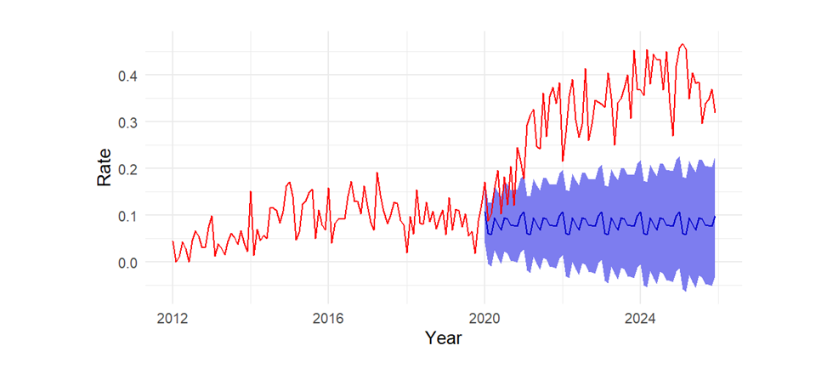

Figure S2. Observed monthly NPS poisoning incidence rate from 2012 to 2025 (in red), and TBATS model forecast with 95% confidence intervals from 2020 to 2025 (in blue). TBATS stands for Trigonometric, Box-Cox transform, ARMA errors, Trend, and Seasonality.

