SUPPORTING INFORMATION

Anderson et. al.

SI Materials and Methods

Animals. Scn1a^{+/-} mice were purchased from The Jackson Laboratory (stock 37107-JAX; Bar Harbor, MA, USA) and maintained as a congenic line on the 129S6/SvEvTac background (129.Scn1a^{+/-}). For experiments, F1 mice were generated by breeding heterozygous 129.Scn1a^{+/-} mice with wildtype C57BL/6J (Jackson Laboratory stock 000664; Animal Resources Centre; Canning Vale, Australia). The Scn1a genotype was determined as previously described¹. Mice were group-housed under a 12 h light/12 h dark cycle with ad libitum access to food and water.

Drugs. Clobazam (Sigma-Aldrich Co.; St. Louis, MO, USA), N-desmethylclobazam (Novachem; Heidelberg West, Australia) and cannabidiol (THC Pharm; Frankfurt, Germany) were used. For acute administration, drugs were prepared fresh on the day of the experiment. Clobazam was prepared as a solution in vegetable oil (0.1 – 10 mg/kg). CBD was prepared in ethanol:Tween-80:saline (1:1:18). CBD was a solution at the 12 mg/kg dose and a suspension for the 100 mg/kg dose. Drugs were administered as an ip injection in a volume of 10 mL/kg.

CYP450 reactions. CYP3A4 metabolism of clobazam was performed in 40 µL reaction mixtures consisting of clobazam (0.5 – 100 µM), 100 mM Tris buffer, pH 7.4, CBD (0 – 3 µM) and 50 nM Supersomes™ containing CYP3A4 and NADPH-P450 reductase (Corning Incorporated, Corning, NY, USA). Mixtures were preincubated at 37 °C for 5 min and the reaction was initiated by the addition of 4 mM NADPH. Reactions were then incubated at 37 °C for 10 minutes, terminated by the addition of ice-cold acetonitrile (40 µL) and spiked with internal standard (2 µg/mL diazepam, 5 µL). Proteins were removed by centrifugation (14,000 g for 30 min) and supernatants were analyzed by LC-MS/MS as described below. CYP2C19 metabolism was performed as above except with N-CLB (0.5 – 100 µM) and CYP2C19 instead of clobazam and CYP3A4, respectively, with an incubation time of 30 min. Clobazam and N-CLB stocks were made in DMSO and CBD stocks in methanol. Final concentration of solvents was less than 0.1% (v/v). Kinetic parameters, K_{M} and k_{cat}, were calculated using nonlinear regression of the Michaelis-Menten equation in GraphPad Prism 7.0 (La Jolla, CA, USA) to a plot of substrate concentration against velocity. K_{i} values were calculated from substrate-velocity curves in the presence of several concentrations of CBD using GraphPad Prism.

Pharmacokinetic analysis. Wildtype mice (postnatal day 21-28, P21-28) received an ip injection of 12 mg/kg CBD and were returned to home cage for 45 minutes. Mice then received an ip injection of 5 mg/kg clobazam. At selected time points following the clobazam injection (5 min – 24 h), mice were anesthetized with isoflurane, whole blood was collected by cardiac puncture and brains were harvested. Plasma was isolated by centrifugation (9000 g for 10 min, 4 °C) and stored at -80 °C until assayed by LC-MS/MS described below. Clobazam and N-CLB concentrations at each time point were averaged and pharmacokinetic parameters were calculated in plasma and brain by a two-compartment model (peritoneum and blood). Two exponential decay functions, each with a separate time constant, were used to model diffusion from peritoneum into blood and diffusion from blood. The pharmacokinetic measurements were fit to:

Concentration = C_{max} (1-e^{-λot})(e^{-λ1t})

Where C_{max} is the maximum concentration, t is time from injection, and λ₀ and λ₁ are decay constants for diffusion from the peritoneum and blood, respectively. The curve was fit using the Python Scipy² library ‘curve_fit’ function, with maximum iterations limited to 2000, initial guesses for C_{max} as the maximum measured concentration, λ₀ = 0.002 and λ₁ ₌ 0.01. Total drug exposure (area under concentration-time curve, AUC) was calculated from the curve fit. Elimination rate constant (k_{e}) used to calculate t_{1/2} was determined by linear regression of the terminal component of the concentration-time curve using GraphPad Prism.

Hyperthermia-induced seizures. Hyperthermia-induced seizure experiments were conducted on male and female Scn1a^{+/-} mice at P14-16 as previously described^{3,4}. Briefly, mice were injected ip with vehicle or CBD (12 mg/kg or 100 mg/kg) and returned to home cage for 30 minutes. Pretreatment time was based on time to peak CBD brain concentration⁵. Mice then received an ip injection of vehicle or clobazam (0.1 – 10 mg/kg) and returned to the home cage for 15 minutes before acclimation to the temperature probe and initiation of hyperthermia protocol. Mouse core body temperature was elevated 0.5 °C every 2 min until the onset of first clonic convulsion with loss of posture or until 42.5 °C was reached. Mice that reached 42.5 °C were held at temperature for 3 minutes and were considered seizure-free if no seizure occurred during the hold. Following the hyperthermia-induced seizure protocol, plasma and brain samples were isolated and stored at -80 °C until assayed. Seizure threshold temperatures were compared using Mantel-Cox logrank test and p < 0.05 was considered statistically significant.

Spontaneous seizures and survival. Male and female Scn1a^{+/-} mice were exposed to a single hyperthermia-induced seizure event at P18 as described previously⁴. Following the thermally-induced seizure, mice were randomly assigned to drug treatment groups (untreated, clobazam, CBD or clobazam plus CBD). Drugs were administered orally through supplementation in chow. Drugs were formulated in house using R&M Standard Diet (Specialty Feeds; Glen Forrest, Australia) irradiated powder with the following formulations: 80 mg clobazam/kg chow, 3500 mg CBD/kg chow and 80 mg clobazam plus 3500 mg CBD/kg chow. Continuous video recording from 12:00 on P19 through 24:00 on P21 was captured using a day/night camera with an infrared lens (Samsung SCB5003, Tamron 13F604IRSQ). The number of spontaneous generalized tonic-clonic seizures (GTCS) in this 60 h recording session were quantified offline by an observer blinded to treatment. Mice continued drug treatment to P30 to monitor survival. Statistical comparisons were made using Fisher’s exact test (proportion or mice seizure-free) and Mantel-Cox logrank test (survival) and p < 0.05 was considered statistically significant.

Analytical. Clobazam, N-CLB and CBD in plasma and brain were assayed by LC-MS/MS. Plasma samples (50 µL) were spiked with internal standard (2 µg/mL diazepam, 5 µL) and extraction was achieved by vortex-mixing with 4x volume of acetonitrile. The organic layer was isolated by centrifugation (4000 g for 10 min, 4 °C) and evaporated to dryness with N_{2(g)}. Samples were reconstituted in methanol and 0.1% formic acid in water (150:250, v/v) for solid-liquid extraction with methyl tert-butyl ether using Biotage Isolute SLE+ columns (Uppsala, Sweden). Samples were evaporated to dryness with N_{2(g)} and reconstituted in acetonitrile and 0.1% formic acid in water (1:1.5, v/v) for analysis. Brain samples were prepared as above with minor modifications. Briefly, ½ brain was homogenized in phosphate buffered saline (15x, w/v). Homogenates were centrifuged (20,000 g for 30 min, 4 °C) and supernatant (67 mg brain/mL) was spiked with diazepam (10 µg/mL, 10 µL). Extraction was achieved by vortex-mixing with 3x volume of acetonitrile. The organic layer was isolated by centrifugation (20,000 g for 15 min, 4 °C) and evaporated to dryness. Samples were reconstituted in ice-cold acetonitrile (2 mL) and centrifuged (14,000 g for 30 min, 4 °C). The supernatant was evaporated to dryness and reconstituted for solid-liquid extraction as above. Samples were evaporated to dryness and reconstituted in acetonitrile and 0.1% formic acid in water (1:1, v/v) for analysis. Samples were assayed by LC-MS/MS using a Shimadzu Nexera ultra-high performance liquid chromatograph coupled to a Shimadzu 8030 triple quadrupole mass spectrometer (Shimadzu Corp.; Kyoto, Japan). The mass spectrometer was operated in positive electrospray ionization mode with multiple reaction monitoring with the following mass transition pairs: m/z 301.0 > 259.05 (clobazam), 287.2 > 245.1 (N-CLB), 315.3 > 193.15 (CBD) and 284.6 > 257.0 (diazepam). Quantification was achieved by comparing experimental samples to standards prepared with known amounts of drug.

Two-electrode voltage-clamp recording. Cell currents were recorded from Xenopus leavis oocytes expressing the concatenated γ2-β2-α1-β2-α1 GABA receptor using two-electrode voltage-clamp. The concatenated construct was generated as previously described and 2 ng of cRNA was injected per oocyte⁶. Cells were incubated for 2-4 days on an oscillator at 18 °C in ND96 solution (mM: NaCl, 96; KCl, 2; MgCl₂, 1; CaCl₂, 1.8; HEPES, 5; pH 7.4) supplemented with 2.5 mM pyruvate, 0.5 mM theophylline and 50 µg/mL gentamycin. Cell currents were recorded using the two-electrode voltage-clamp method as previously described⁷. For modulation experiments, GABA (15 µM) was applied three times as a reference and currents were normalized to the mean current of the last two GABA applications. A washout period of 7-12 min was performed between GABA applications to prevent effects from desensitization. Where CBD was co-applied with GABA, CBD was pre-incubated for 60 s. GABA applications wee performed in the order shown in the representative data figure (Fig. 4). All experiments were performed over a minimum of two different batches of oocytes. Data was acquired at 1 kHz and converted to 10 Hz offline to display representative traces. For concentration-response curves, the percent modulation by clobazam or CBD was derived by the equation:

Percent modulation = 100 * (I_{drug} – I_{15 µM GABA}) / (I_{GABA})

This data was then fit to the Hill equation using GraphPad Prism to determine I_{max} and EC₅₀ values. Statistical comparisons were made using a paired one-way ANOVA followed by Dunnett’s post-hoc test.

Supporting Table 1. Kinetic characteristics for CYP450 metabolism
 | Clobazam | NCLB
CYP450 | CYP3A4 | CYP2C19
Metabolite | N-CLB | 4-OH-N-CLB
K_{M} (µM) | 25 ± 4 | 28 ± 7
V_{max} (pmol/min/pmol CYP450) | 4.9 ± 0.2 | 0.30 ± 0.04
Apparent K_{i} CBD (µM) | 0.14 ± 0.02 | 2.6 ± 0.6

A B

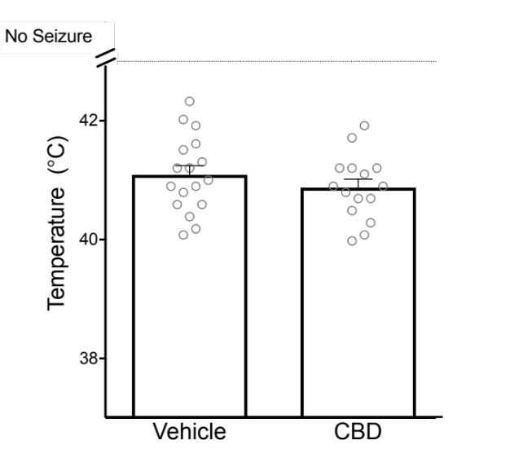
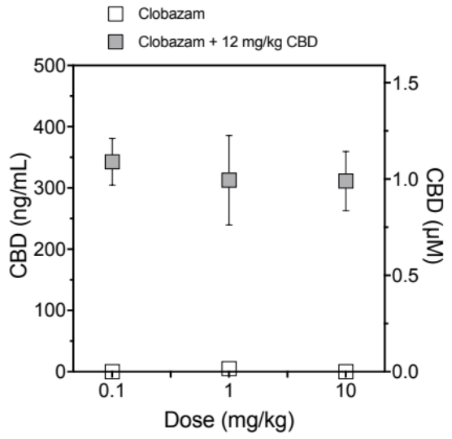
Supporting Figure 1. CBD had no effect on hyperthermia-induced seizures in Scn1a^{+/-} mice. (A) Average CBD plasma concentrations in Scn1a^{+/-} mice treated with clobazam only (white symbols) or clobazam and CBD (12 mg/kg)(grey symbols). Error bars represent SEM, with n=5-6 per treatment group. (B) Temperature threshold of individual mice for GTCS induced following acute treatment of vehicle or 12 mg/kg CBD. The average temperatures of seizure induction are depicted by the bars and error bars represent SEM, with n = 15-17 per treatment group.

A B

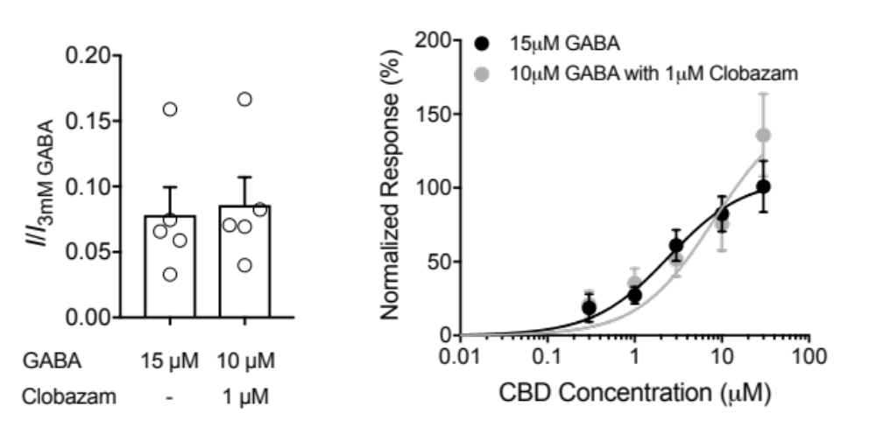

Supporting Figure 2. (A) Estimated open probability of receptors. Currents have been normalized to 3 mM GABA. Data are shown as mean ± SEM, with n = 5 per group. (B) Concentration-response curves for CBD of currents evoked by 15 µM GABA (black) or 10 µM GABA with 1 µM clobazam (grey) at GABA_{A} receptor. Data are shown as mean ± SEM fit to the Hill equation, with n = 4 per group.

REFERENCES
1. Miller AR, Hawkins NA, Mccollom CE, Kearney JA. Mapping genetic modifiers of survival in a mouse model of Dravet syndrome. Genes, Brain Behav. 2014. doi:10.1111/gbb.12099
2. Jones E, Oliphant T, Peterson P, Others. SciPy.org. SciPy: Open source scientific tools for Python2.2001.
3. Hawkins NA, Zachwieja NJ, Miller AR, Anderson LL, Kearney JA. Fine Mapping of a Dravet Syndrome Modifier Locus on Mouse Chromosome 5 and Candidate Gene Analysis by RNA-Seq. PLoS Genet. 2016. doi:10.1371/journal.pgen.1006398
4. Hawkins NA, Anderson LL, Gertler TS, Laux L, George AL, Kearney JA. Screening of conventional anticonvulsants in a genetic mouse model of epilepsy. Ann Clin Transl Neurol. 2017. doi:10.1002/acn3.413
5. Deiana S, Watanabe A, Yamasaki Y, et al. Plasma and brain pharmacokinetic profile of cannabidiol (CBD), cannabidivarine (CBDV), Δ 9-tetrahydrocannabivarin (THCV) and cannabigerol (CBG) in rats and mice following oral and intraperitoneal administration and CBD action on obsessive-compulsive behav. Psychopharmacology (Berl). 2012. doi:10.1007/s00213-011-2415-0
6. Liao VWY, Chua HC, Kowal NM, Chebib M, Balle T, Ahring PK. Concatenated γ-aminobutyric acid type A receptors revisited: Finding order in chaos. J Gen Physiol. April 2019:jgp.201812133. doi:10.1085/jgp.201812133
7. Chua HC, Absalom NL, Hanrahan JR, Viswas R, Chebib M. The Direct Actions of GABA, 2’-Methoxy-6-Methylflavone and General Anaesthetics at β3γ2L GABAA Receptors: Evidence for Receptors with Different Subunit Stoichiometries. Rudolph U, ed. PLoS One. 2015;10(10):e0141359. doi:10.1371/journal.pone.0141359

