Supporting Information

Enhanced Phytocannabinoid Production in Medical Cannabis Cultivars using Microbial Consortia

Bulbul Ahmed^{1,2}, František Beneš³, Jana Hajšlová³, Lenka Fišarová⁴, Miroslav Vosátka⁴ and Mohamed Hijri^{1,5}*

This article has the following supporting information:

Supplementary Tables

Tables S1, S3-S11 are provided in Excel Format.

Table S2. Taxonomic assignation and taxa distributions across cultivars.

Cultivar | No. of  ASVs | Taxa type & ASVs | ASV ID | Kingdom | Phylum | Class | Order | Family | Genus | Species
ECC - EUS - THE | 1 | shared | BASV30 | Bacteria | Verrucomicrobiota | Verrucomicrobiae | Chthoniobacterales | Terrimicrobiaceae | Terrimicrobium | Terrimicrobium sp.
CCL- ECC | 1 | shared | BASV164 | Bacteria | Actinobacteriota | Actinobacteria | Micromonosporales | Micromonosporaceae | Actinoplanes | Actinoplanes sp.
EUS - THE | 1 | shared | FASV155 | Fungi | Ascomycota | Sordariomycetes | Hypocreales | Hypocreaceae | Trichoderma | Trichoderma reesei
CCL | 10 | Hub taxa (7) | BASV299 | Bacteria | Patescibacteria | Parcubacteria | Candidatus Kaiserbacteria | NA | Candidatus Kaiserbacteria | Candidatus Kaiserbacteria
CCL | 10 | Hub taxa (7) | FASV86 | Fungi | NA | NA | NA | NA | Unclassified fungi | Unclassified fungi
CCL | 10 | Hub taxa (7) | FASV204 | Fungi | Ascomycota | Sordariomycetes | Savoryellales | Savoryellaceae | Savoryella | Savoryella aquatica
CCL | 10 | Hub taxa (7) | FASV290 | Fungi | Basidiomycota | Tremellomycetes | Filobasidiales | Piskurozymaceae | Solicoccozyma | Solicoccozyma terricola
CCL | 10 | Hub taxa (7) | BASV113 | Bacteria | Patescibacteria | Parcubacteria | Candidatus Kaiserbacteria | NA | Candidatus Kaiserbacteria | Candidatus Kaiserbacteria
CCL | 10 | Hub taxa (7) | BASV164 | Bacteria | Actinobacteriota | Actinobacteria | Micromonosporales | Micromonosporaceae | Actinoplanes | Actinoplanes sp.
CCL | 10 | Hub taxa (7) | BASV48 | Bacteria | Proteobacteria | Alphaproteobacteria | Rhizobiales | Rhizobiaceae | Rhizobium | Rhizobium sp.
CCL | 10 | Connector (6) | FASV96 | Fungi | Ascomycota | Sordariomycetes | NA | NA | Unclassified Sordariomycetes | Unclassified Sordariomycetes
CCL | 10 | Connector (6) | BASV180 | Bacteria | Planctobacteria | Phycisphaerae | Tepidisphaerales | WD2101 soil group | Unclassified Tepidisphaerales | Unclassified Tepidisphaerales
CCL | 10 | Connector (6) | BASV3 | Bacteria | Patescibacteria | Parcubacteria | Candidatus Adlerbacteria | NA | Candidatus Adlerbacteria | Candidatus Adlerbacteria
CCL | 10 | Connector (6) | BASV265 | Bacteria | Planctobacteria | Phycisphaerae | Phycisphaerales | Phycisphaeraceae | Unclassified Phycisphaerales | Unclassified Phycisphaerales
ECC | 15 | Hub taxa (7) | BASV127 | Bacteria | Armatimonadota | Fimbriimonadia | Fimbriimonadales | Fimbriimonadaceae | Unclassified Fimbriimonadales | Unclassified Fimbriimonadales
ECC | 15 | Hub taxa (7) | FASV112 | Fungi | Ascomycota | Sordariomycetes | Hypocreales | Nectriaceae | Fusarium | Fusarium oxysporum
ECC | 15 | Hub taxa (7) | BASV112 | Bacteria | Patescibacteria | Saccharimonadia | Saccharimonadales | LWQ8 | Unclassified Saccharimonadales | Unclassified Saccharimonadales
ECC | 15 | Hub taxa (7) | FASV324 | Fungi | Basidiomycota | Agaricomycetes | NA | NA | Unclassified Agaricomycetes | Unclassified Agaricomycetes
ECC | 15 | Hub taxa (7) | BASV15 | Bacteria | Planctobacteria | Planctomycetes | Planctomycetales | Rubinisphaeraceae | Unclassified Rubinisphaeraceae | Unclassified Rubinisphaeraceae
ECC | 15 | Hub taxa (7) | FASV11 | Fungi | Ascomycota | Sordariomycetes | Hypocreales | Nectriaceae | Fusarium | Fusarium oxysporum
ECC | 15 | Hub taxa (7) | FASV67 | Fungi | Ascomycota | Sordariomycetes | Sordariales | Sordariales_fam_Incertae_sedis | Conlarium | Conlarium sp.
ECC | 15 | Connector (8) | BASV44 | Bacteria | Patescibacteria | Saccharimonadia | Saccharimonadales | Saccharimonadaceae | Unclassified Saccharimonadales | Unclassified Saccharimonadales
ECC | 15 | Connector (8) | FASV83 | Fungi | Ascomycota | Pezizomycotina_cls_Incertae_sedis | Pezizomycotina_ord_Incertae_sedis | Pezizomycotina_fam_Incertae_sedis | Ciliophora | Ciliophora sp.
ECC | 15 | Connector (8) | BASV201 | Bacteria | Proteobacteria | Alphaproteobacteria | Rhizobiales | Rhizobiaceae | Shinella | Shinella fusca
ECC | 15 | Connector (8) | FASV82 | Fungi | Ascomycota | Dothideomycetes | Botryosphaeriales | Botryosphaeriaceae | Neodeightonia | Neodeightonia phoenicum
ECC | 15 | Connector (8) | FASV89 | Fungi | Ascomycota | Sordariomycetes | Sordariales | Chaetomiaceae | Zopfiella | Zopfiella marina
ECC | 15 | Connector (8) | FASV329 | Fungi | Ascomycota | Sordariomycetes | Sordariales | Chaetomiaceae | Trichocladium | Trichocladium pyriforme
ECC | 15 | Connector (8) | FASV54 | Fungi | Ascomycota | Eurotiomycetes | Eurotiales | Aspergillaceae | Penicillium | Penicillium sp.
ECC | 15 | Connector (8) | FASV51 | Fungi | Ascomycota | Eurotiomycetes | Eurotiales | Aspergillaceae | Penicillium | Penicillium pimiteouiense
EEA | 12 | Hub taxa (5) | BASV744 | Bacteria | Gemmatimonadota | Gemmatimonadetes | Gemmatimonadales | Gemmatimonadaceae | Unclassified Gemmatimonadales | Unclassified Gemmatimonadales
EEA | 12 | Hub taxa (5) | BASV80 | Bacteria | Planctobacteria | Planctomycetes | Gemmatales | Gemmataceae | Fimbriiglobus | Fimbriiglobus sp.
EEA | 12 | Hub taxa (5) | BASV698 | Bacteria | Planctobacteria | Planctomycetes | Gemmatales | Gemmataceae | Unclassified Gemmatales | Unclassified Gemmatales
EEA | 12 | Hub taxa (5) | BASV476 | Bacteria | Planctobacteria | Phycisphaerae | Tepidisphaerales | Tepidisphaeraceae | Unclassified Tepidisphaerales | Unclassified Tepidisphaerales
EEA | 12 | Hub taxa (5) | FASV753 | Fungi | Basidiomycota | Agaricomycetes | Sebacinales | NA | Unclassified Sebacinales | Unclassified Sebacinales
EEA | 12 | Connector (7) | BASV452 | Bacteria | Proteobacteria | Alphaproteobacteria | Rhizobiales | Hyphomicrobiaceae | Hyphomicrobium | Hyphomicrobium sp.
EEA | 12 | Connector (7) | FASV175 | Fungi | Basidiomycota | Agaricomycetes | Sebacinales | NA | Unclassified Sebacinales | Unclassified Sebacinales
EEA | 12 | Connector (7) | BASV279 | Bacteria | Proteobacteria | Alphaproteobacteria | Rhizobiales | Xanthobacteraceae | Pseudolabrys | Pseudolabrys sp.
EEA | 12 | Connector (7) | BASV37 | Bacteria | Patescibacteria | Parcubacteria | Candidatus Kaiserbacteria | NA | Candidatus Kaiserbacteria | Candidatus Kaiserbacteria
EEA | 12 | Connector (7) | FASV36 | Fungi | Ascomycota | Sordariomycetes | Sordariales | Chaetomiaceae | Zopfiella | Zopfiella marina
EEA | 12 | Connector (7) | FASV85 | Fungi | Ascomycota | Dothideomycetes | Botryosphaeriales | Botryosphaeriaceae | Lasiodiplodia | Lasiodiplodia sp.
EEA | 12 | Connector (7) | FASV911 | Fungi | Basidiomycota | Agaricomycetes | Agaricomycetes_ord_Incertae_sedis | Agaricomycetes_fam_Incertae_sedis | Xenasmatella | Xenasmatella sp.
EUS | 10 | Hub taxa (5) | BASV410 | Bacteria | Actinobacteriota | Actinobacteria | Micrococcales | Microbacteriaceae | Leifsonia | Leifsonia sp.
EUS | 10 | Hub taxa (5) | BASV98 | Bacteria | Proteobacteria | Alphaproteobacteria | Caulobacterales | Caulobacteraceae | Asticcacaulis | Asticcacaulis sp.
EUS | 10 | Hub taxa (5) | FASV132 | Fungi | Ascomycota | Sordariomycetes | Glomerellales | Plectosphaerellaceae | Plectosphaerella | Plectosphaerella sp.
EUS | 10 | Hub taxa (5) | FASV155 | Fungi | Ascomycota | Sordariomycetes | Hypocreales | Hypocreaceae | Trichoderma | Trichoderma reesei
EUS | 10 | Hub taxa (5) | BASV30 | Bacteria | Verrucomicrobiota | Verrucomicrobiae | Chthoniobacterales | Terrimicrobiaceae | Terrimicrobium | Terrimicrobium sp.
EUS | 10 | Connector (5) | BASV759 | Bacteria | Chloroflexi | Chloroflexia | Kallotenuales | AKIW781 | Unclassified Kallotenuales | Unclassified Kallotenuales
EUS | 10 | Connector (5) | FASV53 | Fungi | Ascomycota | Sordariomycetes | Myrmecridiales | Myrmecridiales_fam_Incertae_sedis | Atractospora | Atractospora sp.
EUS | 10 | Connector (5) | FASV62 | Fungi | Ascomycota | Sordariomycetes | Sordariales | Chaetomiaceae | Humicola | Humicola sp.
EUS | 10 | Connector (5) | BASV208 | Bacteria | Proteobacteria | Alphaproteobacteria | Sphingomonadales | Sphingomonadaceae | Unclassified Sphingomonadales | Unclassified Sphingomonadales
EUS | 10 | Connector (5) | FASV516 | Fungi | Ascomycota | Eurotiomycetes | Eurotiales | Aspergillaceae | Penicillium | Penicillium sp.
THE | 19 | Hub taxa (5) | BASV662 | Bacteria | Planctobacteria | Planctomycetes | Gemmatales | Gemmataceae | Unclassified Gemmatales | Unclassified Gemmatales
THE | 19 | Hub taxa (5) | FASV373 | Fungi | Basidiomycota | Cystobasidiomycetes | Erythrobasidiales | Erythrobasidiales_fam_Incertae_sedis | Sakaguchia | Sakaguchia sp.
THE | 19 | Hub taxa (5) | FASV712 | Fungi | Ascomycota | Leotiomycetes | Helotiales | Helotiaceae | Meliniomyces | Meliniomyces sp.
THE | 19 | Hub taxa (5) | BASV629 | Bacteria | Patescibacteria | Parcubacteria | Candidatus Kaiserbacteria | NA | Candidatus Kaiserbacteria | Candidatus Kaiserbacteria
THE | 19 | Hub taxa (5) | BASV652 | Bacteria | Chloroflexi | Anaerolineae | Caldilineales | Caldilineaceae | Unclassified Caldilineales | Unclassified Caldilineales
THE | 19 | Connector (14) | FASV220 | Fungi | Ascomycota | Dothideomycetes | Capnodiales | Mycosphaerellaceae | Acrodontium | Acrodontium hydnicola
THE | 19 | Connector (14) | FASV832 | Fungi | NA | NA | NA | NA | Unclassified fungi | Unclassified fungi
THE | 19 | Connector (14) | FASV179 | Fungi | Ascomycota | Sordariomycetes | Sordariales | Chaetomiaceae | Unclassified Sordariomycetes | Unclassified Sordariomycetes
THE | 19 | Connector (14) | BASV280 | Bacteria | Patescibacteria | Parcubacteria | NA | NA | Unclassified Parcubacteria | Unclassified Parcubacteria
THE | 19 | Connector (14) | FASV917 | Fungi | Ascomycota | Eurotiomycetes | Chaetothyriales | Herpotrichiellaceae | Exophiala | Exophiala xenobiotica
THE | 19 | Connector (14) | BASV458 | Bacteria | Patescibacteria | Parcubacteria | Candidatus Kaiserbacteria | NA | Candidatus Kaiserbacteria | Candidatus Kaiserbacteria
THE | 19 | Connector (14) | FASV527 | Fungi | Ascomycota | Sordariomycetes | Sordariales | Chaetomiaceae | Unclassified Sordariomycetes | Unclassified Sordariomycetes
THE | 19 | Connector (14) | BASV1048 | Bacteria | Proteobacteria | Alphaproteobacteria | Micropepsales | Micropepsaceae | Unclassified Micropepsales | Unclassified Micropepsales
THE | 19 | Connector (14) | BASV166 | Bacteria | Proteobacteria | Alphaproteobacteria | Rhizobiales | Xanthobacteraceae | Afipia | Afipia felis
THE | 19 | Connector (14) | FASV485 | Fungi | NA | NA | NA | NA | Unclassified fungi | Unclassified fungi
THE | 19 | Connector (14) | BASV129 | Fungi | Ascomycota | Eurotiomycetes | Eurotiales | Aspergillaceae | Penicillium | Penicillium riverlandense
THE | 19 | Connector (14) | BASV604 | Bacteria | Chloroflexi | Anaerolineae | Caldilineales | Caldilineaceae | Unclassified Caldilineales | Unclassified Caldilineales
THE | 19 | Connector (14) | FASV139 | Fungi | Basidiomycota | Microbotryomycetes | Sporidiobolales | Sporidiobolaceae | Rhodotorula | Rhodotorula toruloides
THE | 19 | Connector (14) | FASV243 | Fungi | Ascomycota | Dothideomycetes | Pleosporales | NA | Unclassified Pleosporales | Unclassified Pleosporales

Supplementary Figures:

Supplementary Figure 1. Cannabis flower biomass. Fresh weight (in green) and dry weight (in grey) of the flower blossom in five cannabis cultivars: (A) THE; (B) CCL; (C) ECC; (D) EEA and (E) EUS. Cannabis plants were inoculated with Ferticann (F) containing beneficial bacteria, Trichoderma, and R. irregularis plus microalgae; forest microbial suspension plus R. irregularis (K2) and forest microbial suspension (K1). With each treatment group, means with the same letter are not significantly different (P> 0.05) by a Tukey's range test. THE = CBD Therapy; CCL = Critical; ECC = CBD Sweet and Sour Widow; EEA = Euforia and EUS = CBD US.

Supplementary Figure 2. Cannabis biomass and mycorrhizal colonization of roots, in response to microbial inoculation. (A) Cannabis height (cm) after 90 days growth, with no inoculation (KO) or inoculation with Ferticann (F) containing beneficial bacteria, Trichoderma, and R. irregularis plus microalgae; forest microbial suspension plus R. irregularis (K2) and forest microbial suspension (K1). CCL = Critical, ECC = CBD Sweet and Sour Widow, EEA = Euforia, EUS = CBD US and THE = CBD Therapy. (B) Mycorrhizal colonization of cannabis roots showing typical AMF vesicles and intraradical hyphae stained with Cotton blue. (C) Estimation of mycorrhizal colonization in the root system. Presence of mycorrhizal fungi, average number of arbuscules and vesicles, and % of root colonization are presented in different colours.

Supplementary Figure 3. Principle coordinates analysis (PCoA) of bacterial diversity in root (A) and rhizosphere soil (B); fungal diversity in root (C) and rhizosphere soil (D). Community composition assignments of cannabis cultivars and treatments are done with PCoA. The percentage of the total variance explained by each axis is shown in parentheses. Each color represents cannabis cultivar, CCL = Critical, ECC = CBD Sweet and Sour Widow, EEA = Euforia, EUS = CBD US and THE = CBD Therapy. Each shape represents treatments, F = Ferticann, K1 = microbial suspension, K2 = R. irregularis mixed with microbial suspension and KO = control.

Supplementary Figure 4. Bacterial eco-microbiota in root. Relative abundance of the bacterial eco-microbiota at the species level in root of cannabis cultivars. CCL = Critical, ECC = CBD Sweet and Sour Widow, EEA = Euforia, EUS = CBD US and THE = CBD Therapy.

Supplementary Figure 5. Bacterial eco-microbiota in rhizosphere soil. Relative abundance of the bacterial eco-microbiota composition at the species level in rhizosphere soil of cannabis cultivars. CCL = Critical, ECC = CBD Sweet and Sour Widow, EEA = Euforia, EUS = CBD US and THE = CBD Therapy.

Supplementary Figure 6. Fungal eco-mycobiota in root. Pie chart showing fungal, eco-mycobiota composition (relative abundance) at species level in root in different cannabis cultivars: THE (A), CCL (B), ECC (C), EEA (D) and EUS (E). CCL = Critical, ECC = CBD Sweet and Sour Widow, EEA = Euforia, EUS = CBD US and THE = CBD Therapy.

Supplementary Figure 7. Fungal eco-mycobiota in rhizosphere soil. Pie chart showing fungal, eco-mycobiota composition (relative abundance) at species level in rhizosphere soil in different cannabis cultivars: THE (A), CCL (B), ECC (C), EEA (D) and EUS (E). CCL = Critical, ECC = CBD Sweet and Sour Widow, EEA = Euforia, EUS = CBD US and THE = CBD Therapy.

Supplementary Figure 8. Amplicon Sequence Variant (ASV) shared by biotopes in each cannabis cultivar. The Venn diagram shows the number of ASVs found unique or shared in root: (A) THE = CBD Therapy; (B) CCL = Critical; (C) ECC = CBD Sweet and Sour Widow; (D) EEA = Euforia and (E) EUS = CBD US. The number of ASVs found unique or shared in rhizosphere soil in (A) THE = CBD Therapy; (B) CCL = Critical; (C) ECC = CBD Sweet and Sour Widow; (D) EEA = Euforia and (E) EUS = CBD US.

Supplementary Figure 9. Network cooccurrence in THE and CCL cultivar. (A) Interkingdom network patterns in CBD Therapy (THE). Three bacterial and two fungal ASVs were identified as hub taxa, 14 connector ASVs, total 19 ASVs were identified as network hub in THE cultivar. (B) network cooccurrence patterns in Critical (CCL). Ten hub taxa included four hub taxa and six connector taxa. Bacterial (circular) and fungal (rhombus) ASVs are shown by the different node shape. The relative abundance of the corresponding ASVs determines how nodes are coloured. The ribbon depicts the relative complexity of the inter-kingdom network. Betweenness centrality and node degree of ASVs and their inter-connection were considered in identifying hub taxa.

Supplementary Figure 10. Network cooccurrence in ECC and EEA cultivar. (A) Interkingdom network patterns in CBD Sweet and Sour Widow (ECC). Three bacterial and four fungal ASVs were identified as hub taxa, and eight connector ASVs were identified as network hub in ECC cultivar. (B) network cooccurrence patterns in Euforia (EEA). Twelve ASVs were identified as network hub included four bacterial and one fungal ASVs as hub taxa and three bacterial and four fungal ASVs as connector taxa. Bacterial (circular) and fungal (rhombus) ASVs are shown by the different node shape. The relative abundance of the corresponding ASVs determines how nodes are coloured. The ribbon depicts the relative complexity of the inter-kingdom network. Betweenness centrality and node degree of ASVs and their inter-connection were considered in identifying hub taxa.

Supplementary Figure 11. Network cooccurrence in EUS cultivar and network taxa shared across cultivars. (A) Interkingdom network patterns in CBD US (EUS). Five ASVs were found as hub taxa (three bacterial ASVs and two fungal ASVs) with five connector taxa in the EUS cultivar. Bacterial (circular) and fungal (rhombus) ASVs are shown by the different node shape. The relative abundance of the corresponding ASVs determines how nodes are coloured. The ribbon depicts the relative complexity of the inter-kingdom network. Betweenness centrality and node degree of ASVs and their inter-connection were considered in identifying hub taxa. (B) ASVs shared between cultivars in the network cooccurrence pattern. 26 hub ASVs and 40 connector ASVs, total 66 ASVs were identified as network taxa across Cannabis cultivars (details in Table 4).

Fig. S1
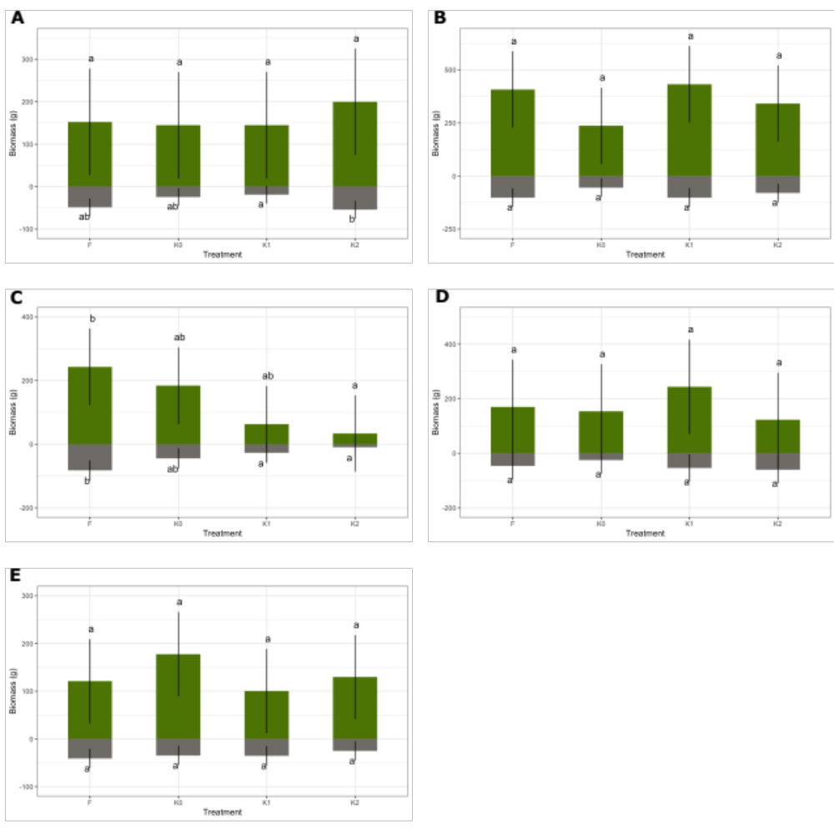

Fig. S2.
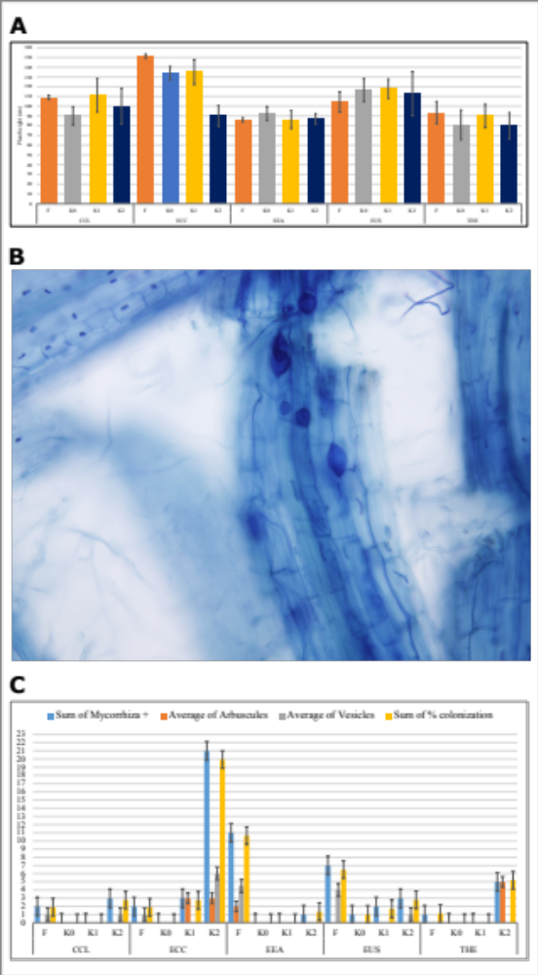

Fig. S3.
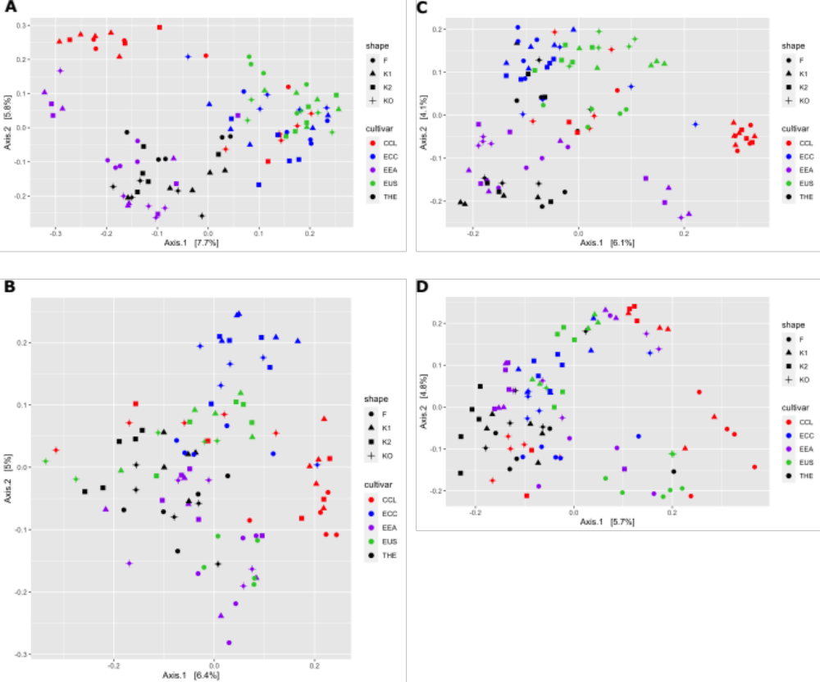

Fig. S4.
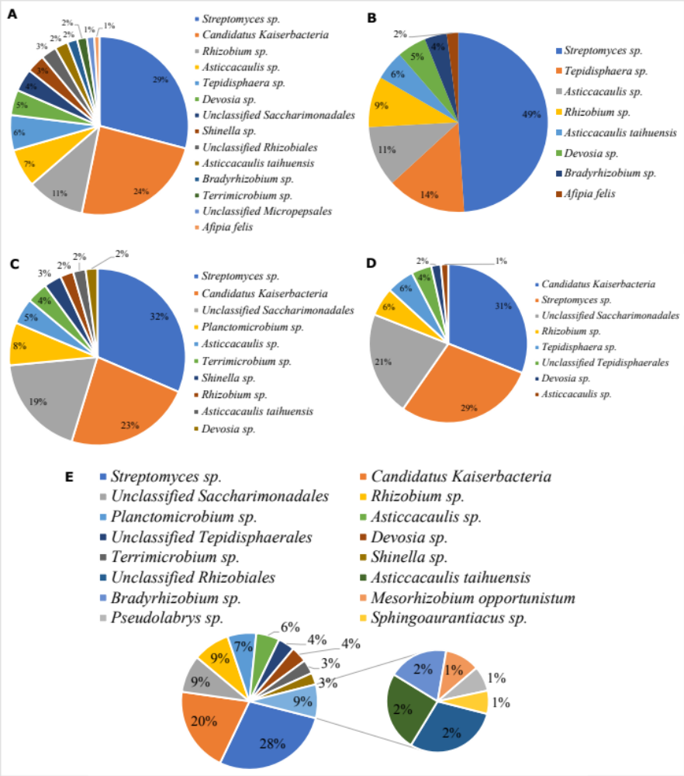

Fig. S5.
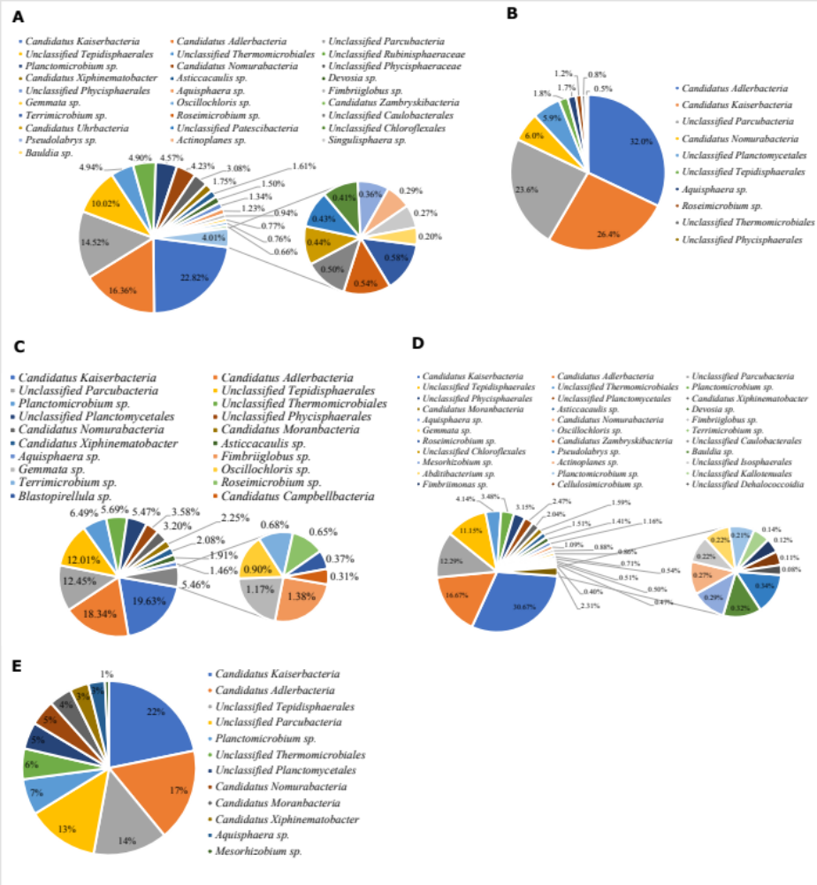

Fig. S6.
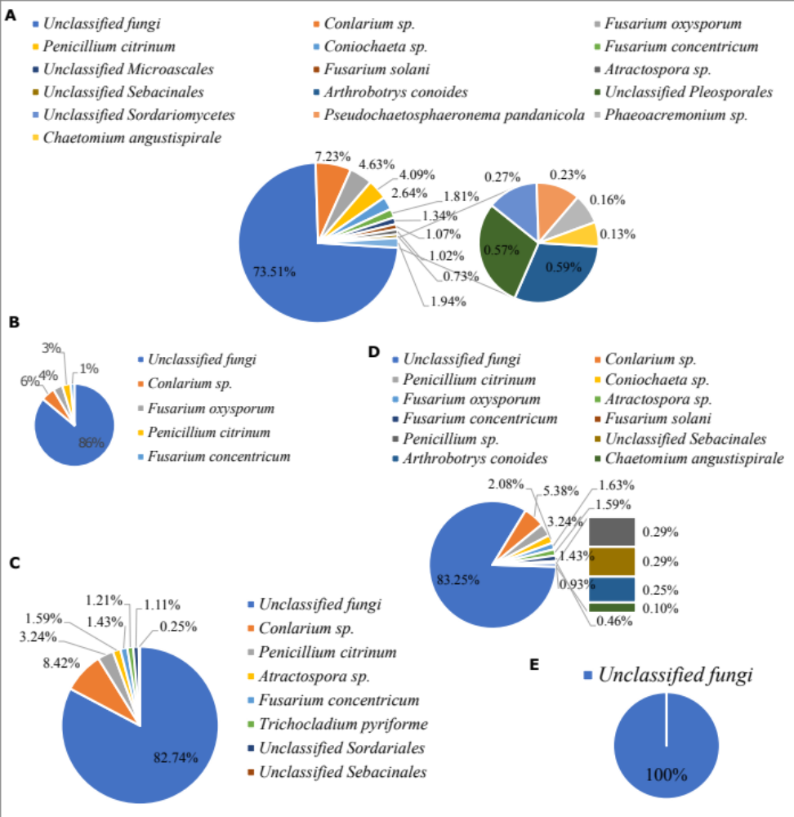

Fig. S7.
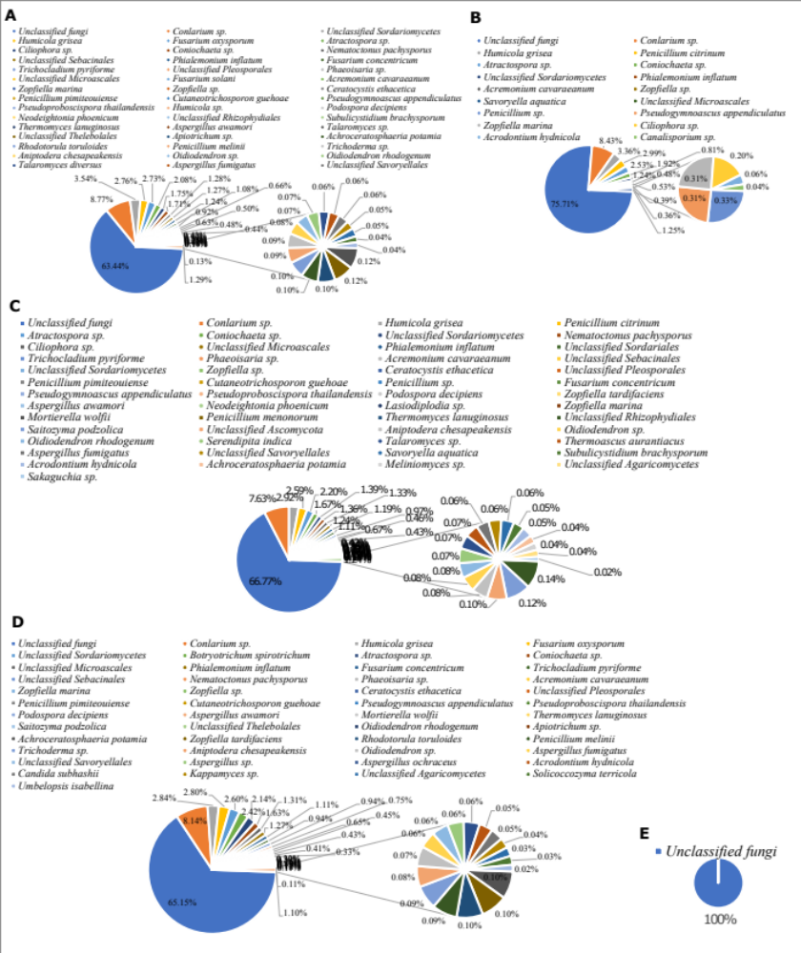

Fig. S8.
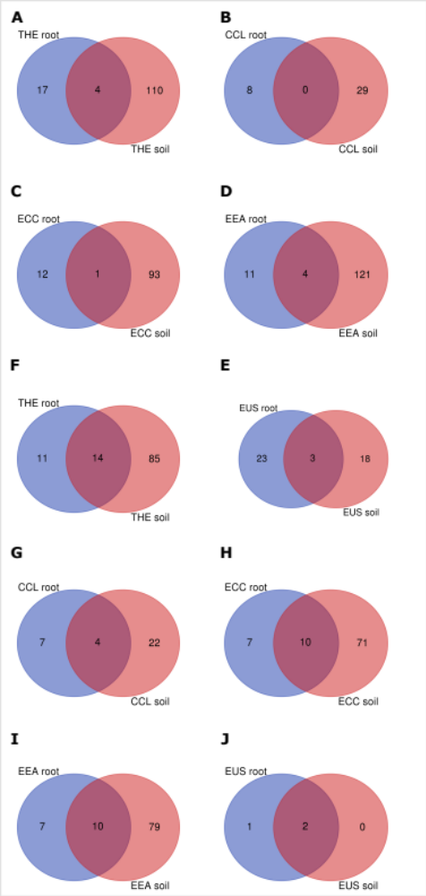
Fig. S9.
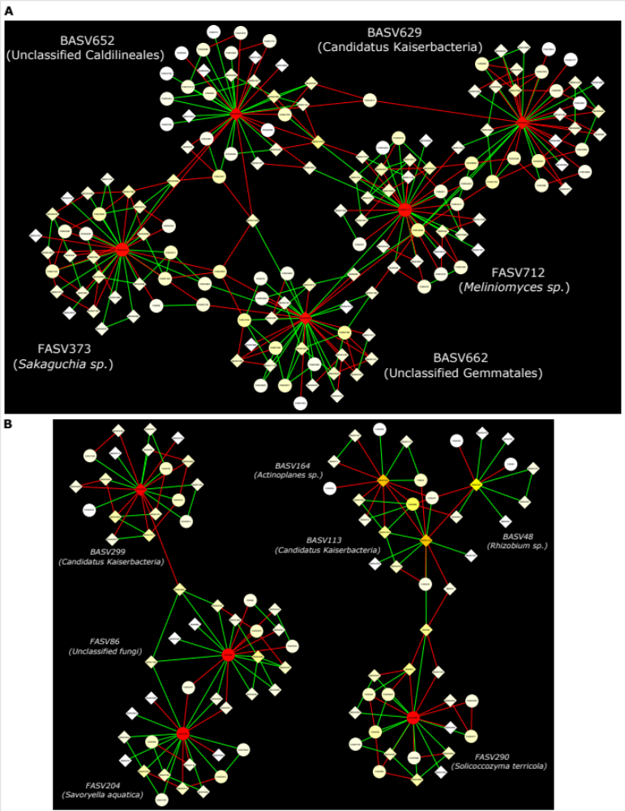
Fig. S10.
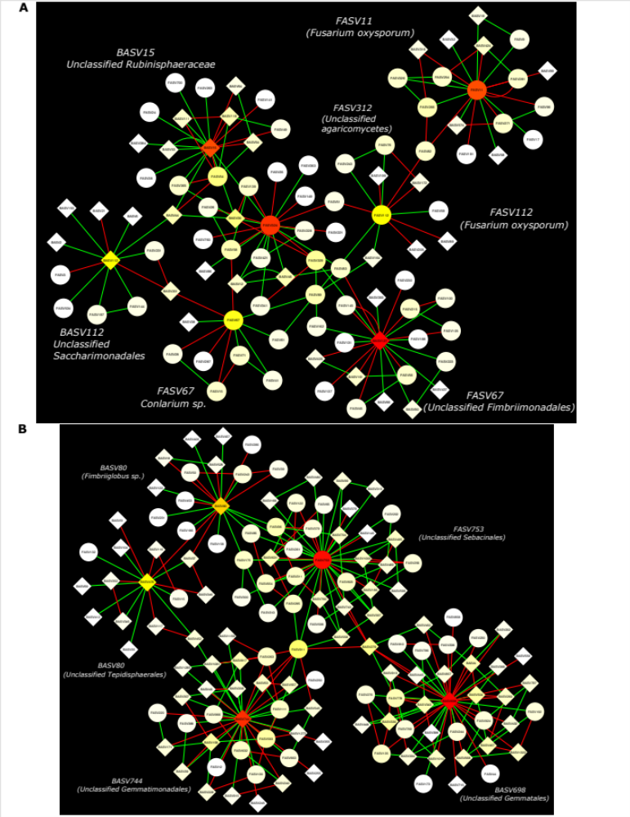
Fig. S11.
