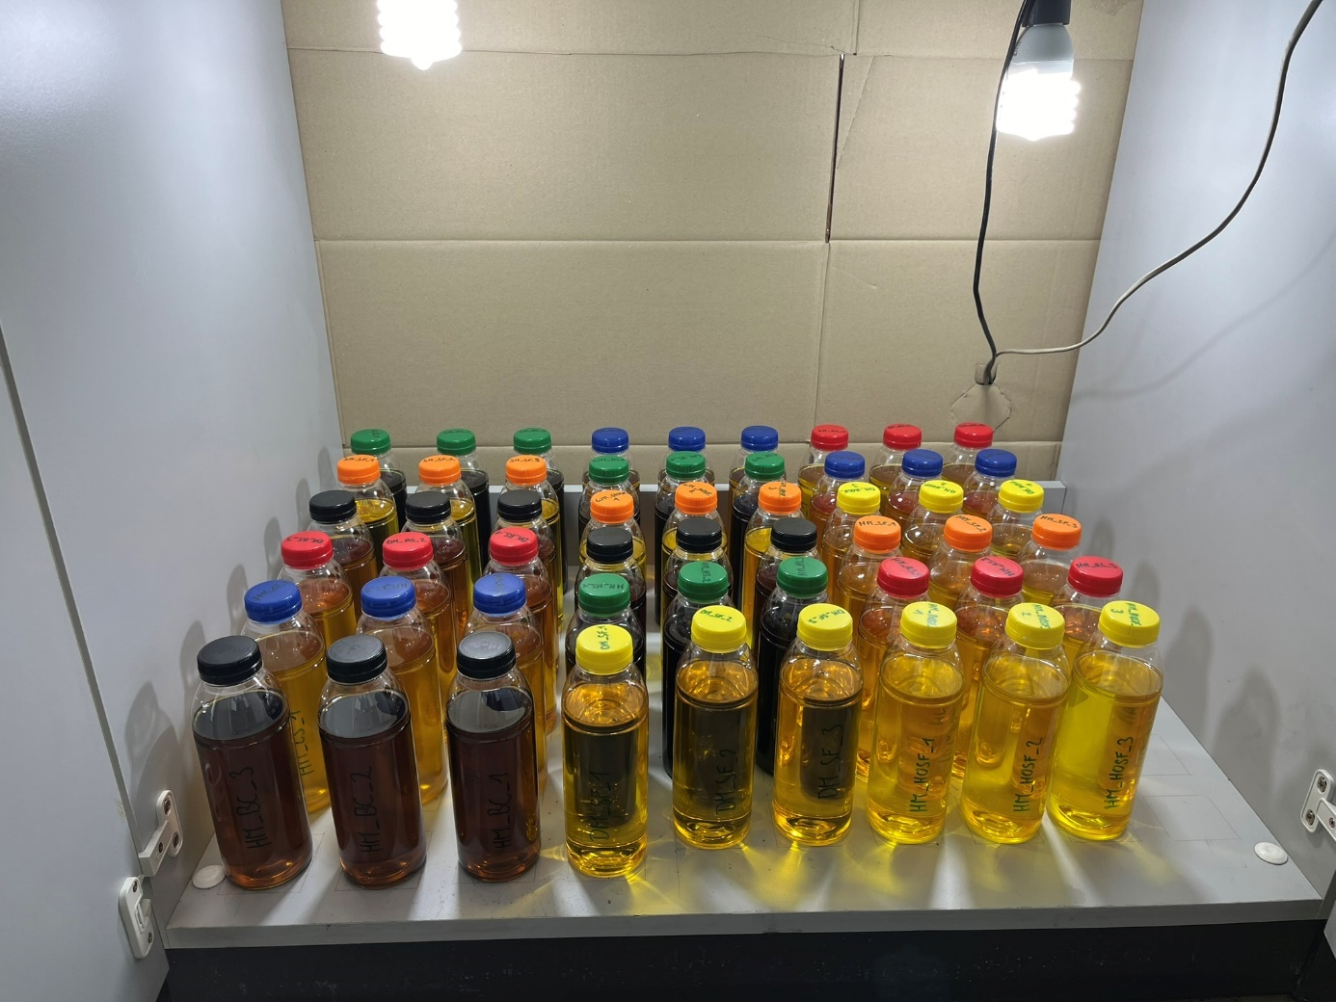
Fig. S1: Setup of storage study with 54 oil samples (black cumin, canola, sunflower, high-oleic sunflower, linseed and hempseed oil from three different suppliers in triplicates) in PET bottles stored at room temperature for 12 h under cold fluorescent light per day for six months.
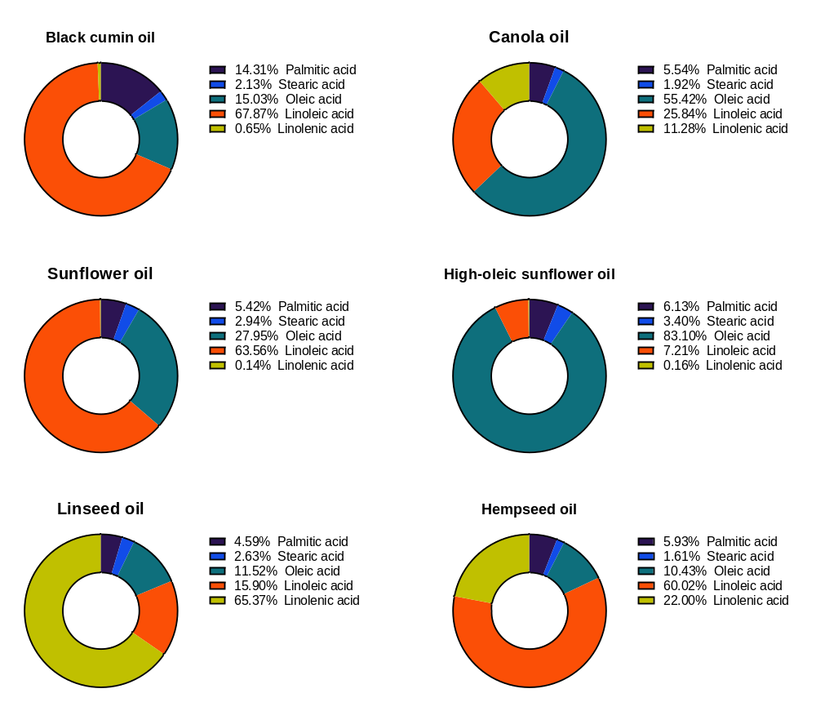
Fig S2: Initial relative fatty acid composition [%] (at day 0) of each oil: (A) black cumin, (B) canola, (C) sunflower, (D) high-oleic sunflower, (E) linseed and (F) hempseed oil. Values are shown as mean, n ≥ 9.
(B)
(F)
(D)
(E)
(C)
(A)
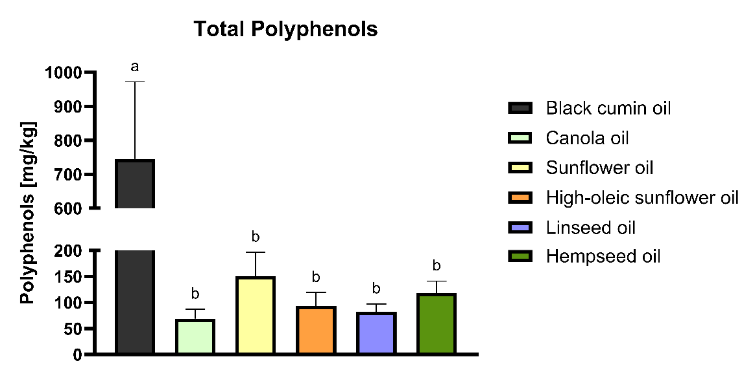
Fig. S3: Total polyphenol content in mg/kg oil in six cold-pressed oils at day 0 (T0) determined by LC-MS/MS. One-way ANOVA was conducted. Different lowercase letters indicate significant differences (p < 0.05, ANOVA with Tukey’s post hoc test). Values are shown as mean + SD, n ≥ 9

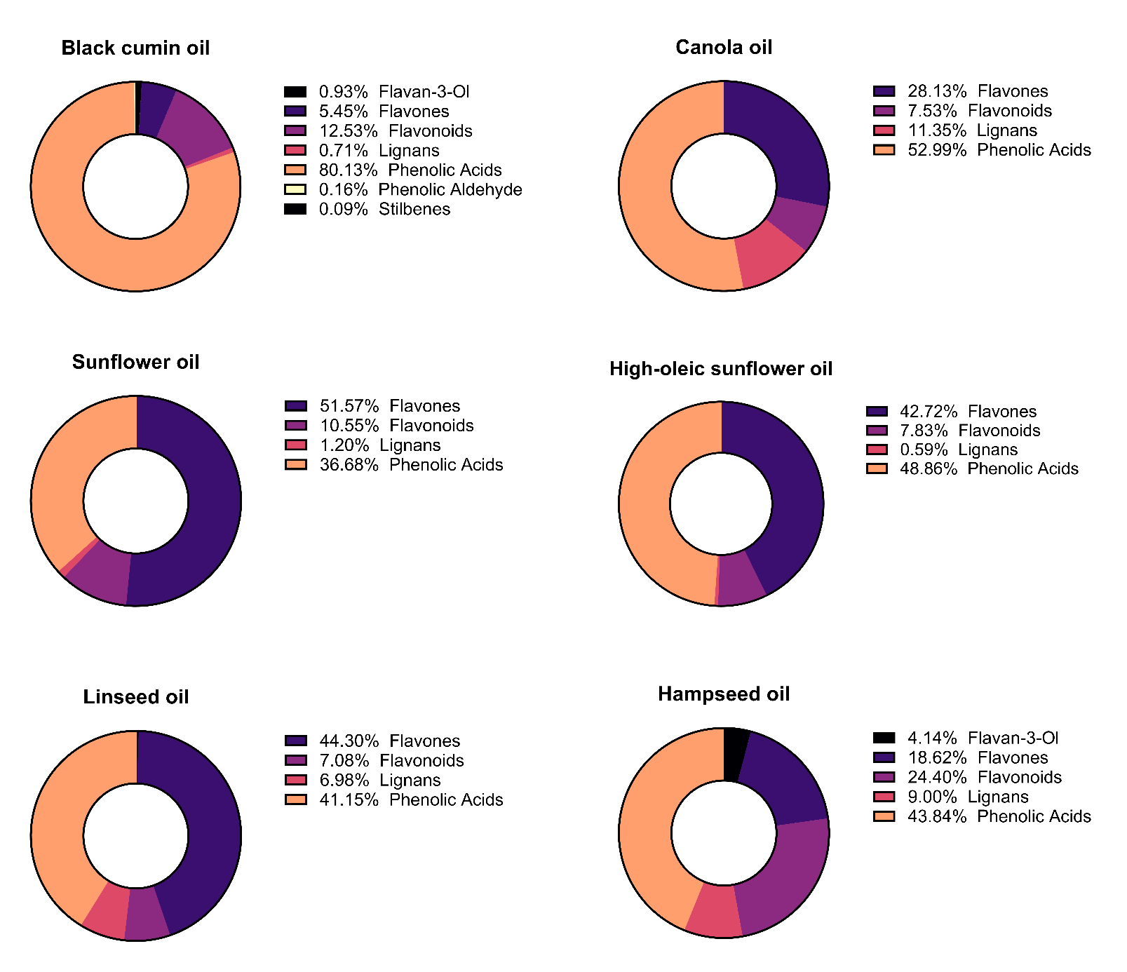
(F)
(B)
(D)
(E)
(C)
(A)
Fig. S4: Relative composition of polyphenol classes [%] in six cold-pressed oils at T0 (day 0), averaged across three suppliers. Data obtained via LC-MS/MS classification into phenolic acids, flavonoids, stilbenes, and lignans. Values are shown as relative mean of total polyphenol content, n ≥ 9.
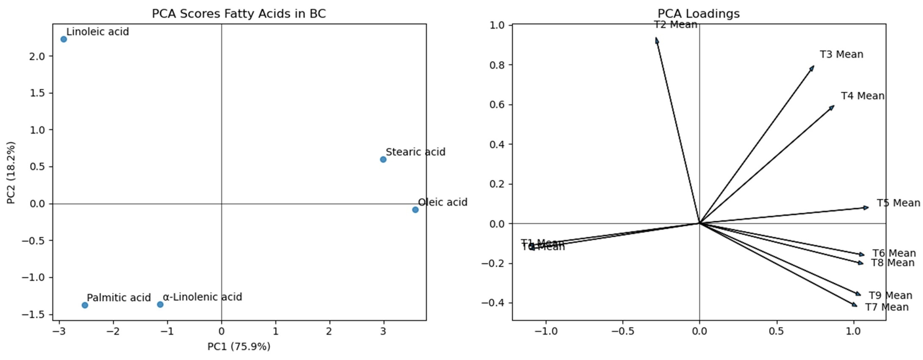
b)
a)
α-
Figure S5: a) Principal Component Analysis (PCA) of fatty acid profiles in black cumin oil (BC). Scores plot showing separation of fatty acids along the first two principal components. b) loadings plot illustrating the contribution of sampling time points (T0–T9, day 0 to 168) to the variance structure. PC1 and PC2 explain 75.9% and 18.2% of the total variance, respectively (cumulative 94.1%).

Table S1: Standard curves used for the fatty acid analysis by GC-FID. x = concentration [g/kg oil] and y = area under the curve (AuC) and coefficient of determination (R²).
Standard | Formula | R² | LOD [µg/g oil] | LOQ [µg/g oil]
Methyl palmytate | y = 1.7026x - 0.1025 | 99.86 | 14 | 43
Methyl stearate | y = 1.2663x - 0.0452 | 98.67 | 1.82 | 54
Methyl oleate | y = 1.654x - 0.4769 | 99.63 | 84 | 255
Methyl linoleate | y = 1.7386x - 0.0844 | 99.91 | 13 | 39
Methyl linolenate | y = 1.3398x - 0.0057 | 99.90 | 1 | 4

Table S2: Standard curves from each of the representative standards used for quantification of polyphenolic substances identified with x = concentration [µg/g oil] and y = area under the curve (AuC) by LC-MS/MS with limit of detection (LOD) (signal-to-noise ratio of 3) and a limit of quantification (LOQ) (signal-to-noise ratio of 10) and coefficient of determination (R²).
Standard | Formula | R² | LOD [µg/g] | LOQ [µg/g]
Kaempferol | y = 6976x - 7692 | 97.56 | 2.17 | 7.23
Quercetin-3-glucoside | y = 44641x - 95622 | 98.27 | 1.82 | 6.07
Naringenin | y = 131240x - 122238 | 98.73 | 1.56 | 5.20
Apigenin | y = 185771x - 124518 | 99.87 | 0.46 | 1.54
Epicatechin | y = 2059x + 32561 | 99.04 | 1.61 | 5.37
Secoisolariciresinol | y = 771x + 545 | 99.58 | 0.52 | 1.73
Caffeic acid | y = 96713x + 349596 | 99.83 | 1.31 | 4.39
Ferulic acid | y = 190086x - 121795 | 98.16 | 1.88 | 6.27
p-Coumaric acid | y = 123484x - 305192 | 99.13 | 1.29 | 4.29
Gallic acid | y = 28929x + 61422 | 99.64 | 0.82 | 2.74
Vanillic acid | y = 3721x - 1749 | 99.65 | 0.99 | 3.28
4-Hydroxybenzoic acid | y = 23581x + 116242 | 99.72 | 0.91 | 3.04
Resveratrol | y = 1252x - 870 | 99.36 | 0.96 | 3.19

Table S3: Secondary lipid oxidation products used for quantification. Calibration curve equations are shown with coefficient of determination (R²).
Standard | Formula | R²
Hexanal | y = 835429x + 5432321 | 95.81
2-pentanone | y = 3145202x - 4562391 | 98.41
2-heptanone | y = 1337482x + 2163811 | 98.32
1-hexanol | y = 1377884x + 2764936 | 91.56

Table S4: Transition list of all analyzed polyphenolic substances, grouped by class, including their precursor and product ion m/z values used for LC-MS/MS data acquisition in MRM mode.
Polyphenol Class | Molecule Name | Precursor [m/z] | Product [m/z]
Phenolic Acids | 1,3-Dicaffeoylquinic acid | 515.0 | 353.0, 191.0, 171.0
Phenolic Acids | 3,4-Dimethoxycinnamic acid | 207.1 | 207.1, 119.0, 103.0
Phenolic Acids | 4-Hydroxybenzoic acid | 137.0 | 119.1, 108.0, 93.0, 59.2
Phenolic Acids | 4-O-Caffeoylquinic acid | 353.1 | 191.0, 179.0, 173.0
Flavones | Amentoflavone | 539.1 | 403.0, 377.1
Flavonoids | Apigenin | 269.0 | 151.0, 117.0, 107.0
Flavonoids | Astragalin | 447.4 | 284.0, 255.0, 227.0
Phenolic Acids | Caffeic acid | 179.0 | 135.0, 107.0, 97.0
Phenolic Acids | Caffeic acid hexoside | 341.1 | 179.0, 135.0, 103.0
Flavonoids | Chalcone | 209.1 | 131.0, 103.0
Phenolic Acids | Chlorogenic acid | 353.1 | 191.2, 179.0
Phenolic Acids | cis Cinnamic acid | 149.1 | 131.0, 103.0
Phenolic Acids | Coniferyl aldehyde | 177.1 | 162.0, 81.0
Phenolic Acids | Coumaric acid hexoside | 325.1 | 205.0, 145.0, 117.0
Phenolic Acids | Ellagic acid | 303.0 | 257.0, 229.0
Flavan-3-Ol | Epicatechin | 289.1 | 245.1, 125.0, 109.0
Flavonoids | Eriodictyol | 287.1 | 255.0, 151.0, 135.0
Phenolic Acids | Ferulic acid | 195.0 | 177.0, 117.0, 89.0
Phenolic Acids | Gallic acid | 169.0 | 125.0, 96.6, 79.1
Flavan-3-Ol | Gallocatechol | 305.1 | 137.0, 125.0
Flavones | Herbacetin | 303.0 | 169.0, 133.0, 121.0
Flavonoids | Hesperetin | 303.3 | 177.0, 153.0
Flavonoids | Hesperidin | 609.2 | 301.1
Phenolic Acids | Hydroxyferulic acid | 209.0 | 165.0, 121.0
Phenolic Acids | Isoferulic acid | 193.0 | 178.3, 133.8
Flavonoids | Isorhamnetin | 315.0 | 151.0, 107.0
Flavonoids | Isorhamnetin 3-rutinoside | 625.2 | 302.0
Flavonoids | Isorhamnetin-3-O-glucoside | 477.1 | 314.0, 271.0, 243.0
Flavonoids | Kaempferol | 285.1 | 257.0, 229.0
Flavonoids | Kaempferol-3-O-arabinoside | 417.0 | 284.0, 255.0, 227.0
Flavonoids | Kaempferol-3-O-glucoside | 447.1 | 285.0, 247.1
Flavonoids | Kaempferol-3-O-glucuronic acid | 461.1 | 285.0, 229.0
Flavonoids | Kaempferol-3-O-hexoxyl-hexoside | 609.1 | 284.0
Lignans | Lariciresinol | 359.1 | 330.0, 160.1
Flavonoids | Luteolin | 285.0 | 151.0, 133.0, 107.0
Flavonoids | Luteolin-7-O-glucoside | 447.1 | 285.0, 151.0
Lignans | Matairesinol | 357.1 | 137.0, 122.0, 83.0
Flavonoids | Naringenin | 271.2 | 151.0, 119.0
Flavonoids | Naringin | 579.2 | 459.0, 271.1, 151.0
Phenolic Acids | p-Coumaric acid | 165.0 | 147.0, 119.0, 91.0
Lignans | Pinoresinol | 357.1 | 151.0, 136.0
Phenolic Acids | Protocatechuic acid | 153.0 | 109.0, 81.0
Stilbenes | Pterostilbene | 255.1 | 195.0, 169.0
Flavonoids | Quercetin | 301.0 | 151.0, 121.0, 93.0
Flavonoids | Quercetin-3-(sinapoyl-diglucoside)-7-glucoside | 625.1 | 463.0, 301.0
Flavonoids | Quercetin-3-O-glucoronic acid | 477.1 | 301.0, 151.0, 107.0
Flavonoids | Quercetin-3-O-glucoside | 463.0 | 301.0, 271.0
Phenolic Acids | Quinic acid | 191.0 | 93.0, 85.0
Stilbenes | Resveratrol | 227.0 | 185.0, 143.0
Flavonoids | Rutin | 609.0 | 300.0, 271.0
Lignans | Secoisolariciresinol | 363.2 | 327.2, 137.1
Lignans | Secoisolariciresinol diglucoside | 685.0 | 523.0, 361.0
Phenolic Acids | Sinapic acid | 223.0 | 163.0, 149.0
Phenolic Acids | Syringic acid | 197.0 | 120.9, 105.8
Phenolic Acids | Syringic aldehyde | 181.0 | 151.0, 123.0
Phenolic Acids | Vanillic acid | 167.0 | 152.0, 108.0
Phenolic Aldehyde | Vanillin | 151.0 | 136.0, 92.0

Table S5: GC-FID analysis of fatty acids in six cold-pressed oils during storage. Data given as mean ± standard deviation (SD) in mg/g oil, n=9.
Black Cumin Oil
Substance | Day 0 | Day 3 | Day 7 | Day 14 | Day 28 | Day 42 | Day 56 | Day 84 | Day 112 | Day 168
Palmitic acid | 112.64 ± 7.85 | 109.36 ± 4.53 | 78.95 ± 1.54 | 59.81 ± 1.01 | 48.48 ± 1.01 | 44.51 ± 0.94 | 44.31 ± 1.04 | 46.38 ± 0.41 | 44.51 ± 0.91 | 41.88 ± 0.35
Stearic acid | 16.78 ± 1.01 | 16.29 ± 4.33 | 23.94 ± 0.18 | 19.02 ± 0.29 | 15.67 ± 0.29 | 14.46 ± 0.30 | 13.82 ± 0.30 | 15.06 ± 0.17 | 14.54 ± 0.31 | 13.61 ± 0.11
Oleic acid | 118.26 ± 6.03 | 114.82 ± 28.99 | 147.19 ± 1.05 | 136.70 ± 2.06 | 112.53 ± 2.05 | 103.97 ± 1.76 | 101.12 ± 1.52 | 104.65 ± 1.00 | 97.87 ± 1.98 | 95.03 ± 0.68
Linoleic acid | 534.15 ± 33.58 | 514.97 ± 27.16 | 424.14 ± 11.96 | 320.15 ± 5.25 | 257.21 ± 5.22 | 216.76 ± 3.99 | 196.61 ± 3.25 | 197.91 ± 2.30 | 199.23 ± 4.63 | 178.92 ± 1.67
α-Linolenic acid | 5.14 ± 0.34 | 4.80 ± 0.93 | 3.71 ± 0.08 | 2.99 ± 0.05 | 2.56 ± 0.08 | 2.34 ± 0.07 | 2.14 ± 0.07 | 2.41 ± 0.08 | 2.25 ± 0.04 | 2.13 ± 0.06
Canola Oil
Palmitic acid | 35.24 ± 0.90 | 44.99 ± 1.56 | 33.29 ± 0.18 | 30.82 ± 0.35 | 27.37 ± 1.15 | 26.89 ± 0.55 | 21.91 ± 0.76 | 24.37 ± 0.37 | 22.15 ± 0.77 | 19.55 ± 0.14
Stearic acid | 12.22 ± 0.44 | 11.44 ± 0.28 | 18.18 ± 0.11 | 17.02 ± 0.17 | 16.59 ± 0.91 | 14.00 ± 0.26 | 11.62 ± 0.43 | 13.27 ± 0.28 | 12.20 ± 0.48 | 10.48 ± 0.06
Oleic acid | 352.43 ± 14.69 | 325.08 ± 8.70 | 349.89 ± 14.12 | 352.38 ± 5.17 | 318.84 ± 15.62 | 310.51 ± 8.26 | 287.82 ± 11.49 | 297.92 ± 6.88 | 292.16 ± 13.11 | 252.86 ± 2.10
Linoleic acid | 164.31 ± 6.58 | 151.14 ± 6.54 | 126.67 ± 4.75 | 113.04 ± 6.19 | 100.01 ± 6.08 | 77.72 ± 2.61 | 70.74 ± 2.96 | 68.38 ± 1.79 | 73.88 ± 3.27 | 63.29 ± 0.56
α-Linolenic acid | 71.73 ± 3.27 | 67.98 ± 2.11 | 59.63 ± 3.06 | 55.63 ± 1.02 | 50.57 ± 1.38 | 40.11 ± 2.12 | 34.91 ± 1.98 | 33.04 ± 1.12 | 37.12 ± 1.26 | 31.59 ± 0.33
Sunflower Oil
Palmitic acid | 37.47 ± 2.43 | 44.10 ± 1.82 | 41.99 ± 0.30 | 31.93 ± 0.36 | 28.76 ± 6.96 | 28.63 ± 0.25 | 29.81 ± 0.56 | 26.87 ± 0.18 | 25.95 ± 0.59 | 23.95 ± 0.29
Stearic acid | 20.32 ± 0.68 | 20.17 ± 0.58 | 28.08 ± 0.31 | 27.97 ± 0.29 | 24.92 ± 0.19 | 22.45 ± 0.42 | 19.22 ± 0.46 | 20.89 ± 0.55 | 21.17 ± 0.47 | 18.71 ± 0.29
Oleic acid | 193.32 ± 8.27 | 177.96 ± 4.78 | 168.47 ± 3.68 | 164.67 ± 6.84 | 176.10 ± 6.39 | 155.23 ± 5.06 | 166.39 ± 9.52 | 161.59 ± 3.75 | 159.52 ± 3.93 | 146.91 ± 1.90
Linoleic acid | 439.66 ± 16.27 | 419.57 ± 14.41 | 385.22 ± 5.99 | 348.76 ± 6.18 | 295.52 ± 7.94 | 262.23 ± 6.86 | 224.52 ± 7.13 | 202.68 ± 3.79 | 206.41 ± 4.82 | 185.77 ± 2.85
α-Linolenic acid | 0.95 ± 0.04 | 0.92 ± 0.04 | 0.87 ± 0.06 | 0.80 ± 0.05 | 0.71 ± 0.03 | 0.69 ± 0.06 | 0.70 ± 0.04 | 0.70 ± 0.04 | 0.58 ± 0.05 | 0.59 ± 0.06
High-Oleic Sunflower Oil
Palmitic acid | 42.87 ± 2.13 | 38.59 ± 3.54 | 26.40 ± 0.13 | 24.22 ± 0.58 | 21.91 ± 1.16 | 21.06 ± 1.34 | 19.87 ± 2.81 | 17.80 ± 0.18 | 17.76 ± 0.24 | 15.34 ± 0.22
Stearic acid | 23.78 ± 1.17 | 19.83 ± 1.75 | 31.01 ± 0.15 | 26.52 ± 4.68 | 23.51 ± 1.48 | 21.20 ± 1.65 | 18.42 ± 0.25 | 18.83 ± 2.90 | 19.97 ± 0.34 | 17.10 ± 0.28
Oleic acid | 580.86 ± 27.08 | 545.72 ± 39.13 | 537.85 ± 13.86 | 489.56 ± 11.07 | 428.21 ± 27.33 | 419.46 ± 24.83 | 355.11 ± 15.28 | 323.77 ± 5.21 | 391.68 ± 6.56 | 344.08 ± 6.55
Linoleic acid | 50.39 ± 2.87 | 48.42 ± 4.55 | 35.39 ± 1.38 | 33.05 ± 1.51 | 27.38 ± 1.49 | 24.63 ± 3.34 | 21.13 ± 0.77 | 18.19 ± 0.25 | 22.04 ± 0.34 | 18.82 ± 0.30
α-Linolenic acid | 1.13 ± 0.11 | 0.99 ± 0.10 | 0.90 ± 0.04 | 0.88 ± 0.05 | 0.75 ± 0.03 | 0.79 ± 0.07 | 0.65 ± 0.04 | 0.70 ± 0.11 | 0.67 ± 0.04 | 0.60 ± 0.03
Linseed Oil
Palmitic acid | 37.53 ± 3.01 | 34.21 ± 3.64 | 38.86 ± 0.18 | 37.44 ± 0.25 | 32.06 ± 1.51 | 27.16 ± 0.03 | 25.42 ± 0.08 | 27.22 ± 0.15 | 24.60 ± 1.12 | 22.38 ± 0.19
Stearic acid | 21.51 ± 1.05 | 21.82 ± 1.36 | 27.85 ± 0.20 | 30.50 ± 0.24 | 28.92 ± 1.29 | 24.64 ± 0.03 | 21.09 ± 0.09 | 23.08 ± 0.24 | 21.58 ± 1.11 | 19.19 ± 0.20
Oleic acid | 94.30 ± 4.15 | 95.59 ± 5.69 | 114.17 ± 3.27 | 111.97 ± 4.24 | 119.95 ± 5.31 | 108.30 ± 3.42 | 97.20 ± 4.67 | 102.85 ± 3.15 | 91.72 ± 3.81 | 83.70 ± 0.77
Linoleic acid | 130.10 ± 10.80 | 132.50 ± 11.43 | 120.39 ± 8.91 | 111.01 ± 7.32 | 93.66 ± 6.34 | 76.38 ± 4.58 | 68.07 ± 2.36 | 72.82 ± 3.16 | 67.65 ± 3.57 | 60.35 ± 0.71
α-Linolenic acid | 535.02 ± 32.93 | 530.08 ± 39.22 | 494.73 ± 23.09 | 449.47 ± 16.57 | 369.01 ± 23.22 | 347.66 ± 8.32 | 279.03 ± 8.67 | 281.46 ± 6.76 | 264.78 ± 15.00 | 236.66 ± 3.19
Hempseed Oil
Palmitic acid | 41.16 ± 1.85 | 49.04 ± 3.13 | 43.91 ± 0.56 | 36.48 ± 1.18 | 34.54 ± 0.24 | 33.81 ± 0.02 | 28.50 ± 0.22 | 31.63 ± 0.59 | 27.91 ± 1.07 | 24.78 ± 0.36
Stearic acid | 11.17 ± 0.51 | 13.16 ± 0.58 | 21.44 ± 0.29 | 20.71 ± 0.67 | 16.38 ± 0.16 | 14.19 ± 0.25 | 15.43 ± 0.33 | 17.68 ± 0.43 | 15.94 ± 0.71 | 13.74 ± 0.27
Oleic acid | 72.40 ± 1.51 | 69.77 ± 1.91 | 73.67 ± 1.98 | 73.63 ± 3.30 | 76.97 ± 1.92 | 73.85 ± 0.65 | 69.35 ± 2.76 | 73.86 ± 1.35 | 67.75 ± 2.14 | 58.23 ± 0.80
Linoleic acid | 416.47 ± 18.07 | 402.87 ± 24.67 | 376.82 ± 9.30 | 331.96 ± 13.31 | 297.54 ± 6.22 | 264.84 ± 7.43 | 213.02 ± 3.29 | 214.80 ± 5.74 | 209.86 ± 9.73 | 181.57 ± 3.20
α-Linolenic acid | 152.68 ± 8.08 | 151.08 ± 8.73 | 142.51 ± 5.63 | 120.89 ± 7.22 | 110.84 ± 3.33 | 91.21 ± 2.90 | 81.41 ± 2.16 | 83.71 ± 2.64 | 82.77 ± 3.94 | 71.34 ± 1.33

Table S6: Targeted LC-MS/MS analysis of polyphenols in six cold-pressed oils. Data given as mean ± standard deviation (SD) in ppm, n=9.
Black Cumin Oil
Polyphenol Class | Substance | Day 0 | Day 3 | Day 7 | Day 14 | Day 28 | Day 42 | Day 56 | Day 84 | Day 112 | Day 168
Flavan-3-Ol | Epicatechin | 5.64 ± 1.74 | 1.23 ± 0.36 | 0.80 ± 0.19 | 1.90 ± 0.63 | 1.47 ± 0.38 | 1.37 ± 0.32 | 1.72 ± 0.57 | 0.70 ± 0.04 | 1.94 ± 0.15 | 2.55 ± 1.00
Flavan-3-Ol | Gallocatechol | 1.31 ± 0.28 | 0.20 ± 0.02 | LOQ | 0.28 ± 0.02 | 0.29 ± 0.02 | 0.29 ± 0.01 | 0.34 ± 0.13 | 0.38 ± 0.02 | 0.31 ± 0.04 | LOQ
Flavones | Amentoflavone | 0.11 ± 0.03 | 0.22 ± 0.08 | LOQ | LOQ | LOQ | LOQ | LOQ | LOD | LOD | LOD
Flavones | Herbacetin | 40.63 ± 8.12 | 13.22 ± 3.84 | 11.32 ± 1.54 | 5.19 ± 1.87 | 4.38 ± 0.67 | 6.08 ± 1.42 | 6.53 ± 1.15 | 3.73 ± 1.07 | 0.58 ± 0.29 | 0.54 ± 0.22
Flavonoids | Apigenin | 2.48 ± 1.04 | 0.22 ± 0.11 | 0.11 ± 0.05 | 0.29 ± 0.13 | LOQ | LOD | LOD | LOD | 0.34 ± 0.06 | LOQ
Flavonoids | Chalcone | 0.29 ± 0.10 | LOQ | LOQ | LOD | LOD | LOD | LOD | LOD | LOD | LOD
Flavonoids | Eriodictyol | 1.47 ± 0.39 | 0.28 ± 0.07 | 0.30 ± 0.04 | 0.26 ± 0.01 | 0.24 ± 0.08 | LOQ | LOQ | LOQ | LOD | LOD
Flavonoids | Hesperetin | 7.52 ± 2.01 | 0.93 ± 0.21 | 1.13 ± 0.62 | 1.85 ± 1.02 | 0.63 ± 0.18 | LOD | LOQ | LOQ | LOD | LOD
Flavonoids | Hesperidin | 0.28 ± 0.06 | LOQ | LOQ | LOQ | LOD | LOD | LOD | LOD | LOD | LOD
Flavonoids | Isorhamnetin | 10.92 ± 3.24 | 1.46 ± 0.54 | 1.22 ± 0.34 | 0.96 ± 0.53 | 0.58 ± 0.24 | 0.48 ± 0.11 | 0.42 ± 0.07 | 0.41 ± 0.20 | LOD | LOD
Flavonoids | Isorhamnetin 3-rutinoside | 4.63 ± 1.34 | 1.13 ± 0.43 | 0.92 ± 0.34 | 0.29 ± 0.03 | 0.27 ± 0.05 | 0.34 ± 0.09 | LOQ | LQO | LOD | LOD
Flavonoids | Isorhamnetin-3-O-glucoside | 3.38 ± 0.46 | 0.47 ± 0.16 | 0.23 ± 0.02 | 0.89 ± 0.16 | 0.44 ± 0.15 | LOQ | LOQ | 0.50 ± 0.27 | 0.34 ± 0.01 | 0.32 ± 0.11
Flavonoids | Kaempferol | 9.71 ± 1.33 | 0.63 ± 0.14 | 0.74 ± 0.20 | 2.01 ± 1.37 | 0.53 ± 0.18 | 0.58 ± 0.15 | LOQ | 0.74 ± 0.22 | 0.48 ± 0.11 | 0.40 ± 0.07
Flavonoids | Kaempferol-3-O-arabinoside | 0.89 ± 0.18 | 0.38 ± 0.14 | 0.23 ± 0.07 | 2.23 ± 0.06 | 0.53 ± 0.22 | 0.54 ± 0.22 | 1.13 ± 0.38 | 0.82 ± 0.39 | 0.46 ± 0.09 | 0.43 ± 0.19
Flavonoids | Kaempferol-3-O-glucoside (Astragalin) | 22.60 ± 3.60 | 6.65 ± 1.82 | 6.90 ± 1.58 | 12.40 ± 6.24 | 3.12 ± 1.07 | 2.67 ± 0.86 | 2.62 ± 0.68 | 2.93 ± 1.37 | 0.46 ± 0.17 | 0.41 ± 0.24
Flavonoids | Kaempferol-3-O-glucuronic acid | 13.76 ± 3.68 | 2.74 ± 0.88 | 2.25 ± 0.60 | 1.81 ± 0.79 | 1.48 ± 0.60 | 1.05 ± 0.36 | 0.19 ± 0.07 | 0.46 ± 0.04 | 0.51 ± 0.19 | 0.46 ± 0.15
Flavonoids | Kaempferol-3-O-hexoxyl-hexoside | 1.01 ± 0.27 | 0.37 ± 0.11 | 0.17 ± 0.04 | 0.42 ± 0.16 | 0.20 ± 0.03 | 0.17 ± 0.02 | 0.46 ± 0.01 | LOQ | 0.38 ± 0.02 | 0.46 ± 0.19
Flavonoids | Luteolin | 0.65 ± 0.37 | 0.18 ± 0.03 | LOQ | LOQ | LOD | LOD | LOD | LOD | LOD | LOD
Flavonoids | Luteolin-7-O-glucoside | 0.88 ± 0.28 | LOD | LOD | LOD | LOD | LOD | LOD | LOD | LOD | LOD
Flavonoids | Naringenin | 1.74 ± 0.26 | 0.34 ± 0.08 | 0.16 ± 0.03 | 0.20 ± 0.02 | 0.15 ± 0.03 | 0.16 ± 0.06 | LOD | LOD | LOD | LOD
Flavonoids | Naringin | 1.61 ± 0.45 | 0.20 ± 0.10 | 0.06 ± 0.02 | 0.23 ± 0.09 | 0.16 ± 0.01 | 0.17 ± 0.02 | 0.19 ± 0.06 | LOD | LOD | LOD
Flavonoids | Quercetin | 2.51 ± 0.35 | 0.51 ± 0.10 | 0.42 ± 0.10 | 0.70 ± 0.30 | 0.65 ± 0.20 | 0.43 ± 0.05 | 0.44 ± 0.11 | 0.44 ± 0.08 | 0.24 ± 0.09 | LOD
Flavonoids | quercetin-3-(sinapoyl-diglucoside)-7-glucoside | 0.63 ± 0.18 | 0.32 ± 0.05 | 0.33 ± 0.05 | 0.32 ± 0.03 | 0.35 ± 0.09 | 0.23 ± 0.04 | 0.32 ± 0.10 | 0.26 ± 0.03 | 0.22 ± 0.02 | 0.29 ± 0.04
Flavonoids | Quercetin-3-O-glucoronic acid | 3.28 ± 0.96 | 0.58 ± 0.17 | 0.48 ± 0.05 | 4.34 ± 0.82 | 0.48 ± 0.13 | 0.28 ± 0.03 | LOQ | 0.25 ± 0.03 | 0.28 ± 0.11 | LOQ
Flavonoids | Quercetin-3-O-glucoside | 2.22 ± 0.45 | 0.32 ± 0.05 | 0.21 ± 0.07 | 0.44 ± 0.11 | 0.31 ± 0.11 | LOQ | 0.27 ± 0.07 | LOD | 0.32 ± 0.07 | LOD
Lignans | Lariciresinol | 0.27 ± 0.09 | 0.18 ± 0.01 | 0.08 ± 0.03 | LOD | LOD | LOD | LOD | LOD | LOD | LOD
Lignans | Matairesinol | 1.51 ± 0.19 | 0.72 ± 0.28 | 0.28 ± 0.06 | 0.35 ± 0.13 | 0.39 ± 0.13 | 0.30 ± 0.08 | 0.20 ± 0.07 | 0.23 ± 0.07 | LOD | LOD
Lignans | Pinoresinol | 1.85 ± 0.14 | 1.43 ± 0.41 | 1.07 ± 0.56 | 1.09 ± 0.60 | 1.01 ± 0.39 | 1.12 ± 0.52 | 0.64 ± 0.18 | 0.68 ± 0.38 | 0.29 ± 0.08 | 0.18 ± 0.08
Lignans | Secoisolariciresinol | 1.59 ± 0.46 | 0.66 ± 0.28 | 0.29 ± 0.10 | 0.35 ± 0.03 | LOD | LOD | LOD | LOD | LOD | LOD
Lignans | Secoisolariciresinol diglucoside | LOQ | LOQ | LOD | LOD | LOD | LOD | LOD | LOD | LOD | LOD
Phenolic Acids | 3,4-Dimethoxycinnamic acid | LOQ | LOQ | 0.26 ± 0.05 | 0.32 ± 0.04 | 1.09 ± 0.26 | 0.76 ± 0.06 | 0.64 ± 0.03 | 0.49 ± 0.06 | LOD | LOD
Phenolic Acids | 4-Hydroxybenzoic acid | 13.07 ± 1.18 | 2.29 ± 0.58 | 1.73 ± 0.37 | 1.26 ± 0.59 | 0.75 ± 0.16 | 0.79 ± 0.17 | 0.64 ± 0.19 | 0.58 ± 0.12 | 2.30 ± 0.18 | 1.07 ± 0.63
Phenolic Acids | 4-O-Caffeoylquinic acid | LOQ | LOQ | LOQ | LOQ | LOD | LOQ | LOD | LOD | LOD | LOD
Phenolic Acids | Caffeic acid | 2.74 ± 0.58 | 1.88 ± 1.05 | LOQ | LOQ | LOQ | LOQ | LOQ | LOQ | LOD | LOD
Phenolic Acids | Caffeic acid hexoside | 2.73 ± 0.13 | 1.03 ± 0.26 | 0.41 ± 0.07 | 0.67 ± 0.34 | 0.70 ± 0.26 | 0.45 ± 0.13 | 0.78 ± 0.30 | 0.49 ± 0.16 | LOD | LOD
Phenolic Acids | Chlorogenic acid | LOQ | LOQ | LOQ | LOQ | LOQ | LOQ | LOD | LOQ | LOQ | LOD
Phenolic Acids | cis Cinnamic acid | 11.31 ± 1.95 | 6.30 ± 2.21 | 1.96 ± 0.47 | 1.61 ± 0.80 | 0.94 ± 0.26 | 0.88 ± 0.22 | 0.87 ± 0.19 | 0.73 ± 0.23 | LOD | LOD
Phenolic Acids | Coniferyl aldehyde | 0.04 ± 0.00 | 0.02 ± 0.00 | 0.07 ± 0.04 | 0.10 ± 0.06 | 0.15 ± 0.05 | 0.24 ± 0.11 | 0.28 ± 0.13 | LOQ | LOQ | LOQ
Phenolic Acids | Ferulic acid | 2.53 ± 0.49 | 0.83 ± 0.15 | 0.24 ± 0.05 | LOQ | LOQ | LOQ | LOQ | LOQ | LOD | LOD
Phenolic Acids | Gallic acid | 0.86 ± 0.19 | 0.37 ± 0.15 | 0.38 ± 0.08 | 0.63 ± 0.31 | 0.24 ± 0.08 | 0.54 ± 0.19 | 0.46 ± 0.21 | 0.43 ± 0.12 | 1.77 ± 0.44 | LOQ
Phenolic Acids | Hydroxyferulic acid | 1.46 ± 0.72 | 0.80 ± 0.22 | 0.26 ± 0.07 | LOQ | LOQ | LOQ | LOQ | LOD | LOD | LOD
Phenolic Acids | p-Coumaric acid | 538.20 ± 68.93 | 248.12 ± 66.03 | 63.40 ± 9.22 | 46.57 ± 19.22 | 29.86 ± 7.15 | 34.08 ± 7.72 | 41.69 ± 10.37 | 33.64 ± 8.24 | 22.02 ± 8.52 | 13.22 ± 8.78
Phenolic Acids | Quinic acid | 25.32 ± 1.23 | 23.84 ± 1.33 | 23.55 ± 1.07 | 21.08 ± 7.08 | 20.20 ± 1.49 | 19.21 ± 1.52 | 16.64 ± 0.89 | 14.12 ± 0.91 | 15.71 ± 5.49 | 2.42 ± 1.77
Phenolic Acids | Sinapic acid | 0.48 ± 0.10 | 0.11 ± 0.01 | 0.07 ± 0.02 | 2.85 ± 1.93 | 0.31 ± 0.10 | 0.39 ± 0.22 | 0.62 ± 0.28 | 0.86 ± 0.45 | 2.65 ± 0.18 | 2.41 ± 1.77
Phenolic Acids | Syringic aldehyde | 0.08 ± 0.01 | 0.04 ± 0.01 | 0.01 ± 0.00 | 0.04 ± 0.00 | LOD | LOD | LOD | LOD | 0.13 ± 0.07 | LOD
Phenolic Aldehyde | Vanillin | 12.25 ± 1.33 | 2.18 ± 1.09 | 0.43 ± 0.11 | 0.38 ± 0.14 | 0.83 ± 0.02 | 0.76 ± 0.07 | 0.34 ± 0.05 | 0.45 ± 0.07 | 0.31 ± 0.12 | 1.50 ± 0.81
Stilbenes | Pterostilbene | 3.81 ± 0.91 | 2.50 ± 0.79 | 2.16 ± 0.23 | 3.07 ± 0.45 | 2.46 ± 0.41 | 3.06 ± 0.39 | 3.08 ± 0.84 | 1.19 ± 0.06 | 3.12 ± 0.95 | 3.00 ± 0.59
Stilbenes | Resveratrol | 2.63 ± 0.70 | 1.96 ± 0.74 | 1.79 ± 0.65 | 2.29 ± 0.35 | 1.41 ± 0.52 | 1.83 ± 0.67 | 1.54 ± 0.09 | 1.85 ± 0.21 | 1.31 ± 0.23 | 1.99 ± 0.43
 | 5-Ethyl-2(5)-furanone | 0.30 ± 0.09 | 5.08 ± 1.68 | 0.03 ± 0.01
Canola Oil
Flavones | Amentoflavone | 0.41± 0.04 | 0.60± 0.23 | 0.31± 0.12 | 0.39± 0.14 | 0.20± 0.02 | 0.44± 0.08 | 0.47± 0.14 | 0.42± 0.08 | LOD | LOQ
Flavones | Herbacetin | 19.11± 7.09 | 6.32± 2.27 | 4.69± 1.21 | 3.60± 1.06 | 2.85± 1.73 | 2.61± 0.42 | 3.17± 0.66 | 2.56± 0.21 | 1.57± 0.30 | 1.41± 0.51
Flavonoids | Apigenin | LOQ | LOQ | LOQ | LOQ | LOD | LOD | LOD | LOD | LOD | LOD
Flavonoids | Chalcone | 0.06± 0.01 | 0.05± 0.01 | LOD | LOD | LOD | LOD | LOD | LOD | LOD | LOD
Flavonoids | Eriodictyol | 0.57± 0.16 | LOQ | 0.45± 0.05 | 0.49± 0.17 | LOQ | LOQ | LOQ | 0.53± 0.10 | LOD | LOD
Flavonoids | Hesperetin | 1.43± 0.39 | 0.18± 0.07 | 0.22± 0.05 | 0.63± 0.18 | 0.46± 0.28 | 0.17± 0.00 | 0.09± 0.03 | 0.18± 0.00 | 0.18± 0.02 | LOD
Flavonoids | Hesperidin | LOQ | 0.17± 0.02 | 0.18± 0.02 | LOQ | 0.26± 0.13 | LOQ | LOQ | LOQ | LOQ | LOQ
Flavonoids | Isorhamnetin | LOQ | 0.14± 0.05 | 0.17± 0.05 | 0.18± 0.02 | 0.25± 0.14 | LOQ | LOQ | LOQ | LOD | LOD
Flavonoids | Isorhamnetin 3-Rutinoside | 1.08± 0.13 | 0.29± 0.03 | 0.38± 0.04 | 0.29± 0.09 | 0.62± 0.05 | LOQ | 0.29± 0.05 | LOQ | LOD | LOQ
Flavonoids | Kaempferol | 1.14± 0.25 | 0.48± 0.05 | 0.36± 0.10 | 0.57± 0.19 | 0.58± 0.33 | LOQ | LOQ | 0.33± 0.08 | 0.43± 0.13 | LOQ
Flavonoids | Naringenin | 0.22± 0.04 | LOQ | LOQ | 0.42± 0.05 | LOQ | LOQ | LOQ | LOQ | LOD | LOD
Flavonoids | Naringin | LOQ | LOQ | LOQ | LOQ | LOQ | LOQ | LOD | LOD | LOD | LOD
Flavonoids | Quercetin | 0.52± 0.10 | 0.26± 0.09 | 0.48± 0.11 | LOQ | 0.76± 0.34 | LOQ | LOQ | LOQ | LOQ | LOQ
Lignans | Lariciresinol | 4.97± 1.93 | 3.45± 1.59 | LOQ | LOQ | 1.02± 0.98 | 0.99± 0.47 | 0.56± 0.32 | 1.05± 0.59 | LOQ | LOQ
Lignans | Matairesinol | 1.59± 0.33 | 0.53± 0.17 | 0.43± 0.14 | 0.83± 0.26 | 0.94± 0.60 | LOQ | LOQ | LOQ | LOD | LOD
Lignans | Pinoresinol | 1.05± 0.14 | 0.33± 0.07 | LOQ | 0.84± 0.34 | LOQ | LOQ | LOQ | LOQ | LOD | LOD
Lignans | Secoisolariciresinol | LOQ | LOQ | LOQ | LOD | LOD | LOD | LOD | LOD | LOD | LOD
Phenolic Acids | 3,4-Dimethoxycinnamic acid | 0.21± 0.05 | 0.25± 0.03 | 0.31± 0.03 | 0.67± 0.18 | 1.51± 0.94 | 0.73± 0.08 | 0.66± 0.03 | 0.69± 0.04 | LOQ | LOD
Phenolic Acids | 4-Hydroxybenzoic acid | 0.74± 0.17 | LOQ | LOQ | 0.69± 0.18 | 0.51± 0.27 | LOQ | 0.24± 0.07 | LOQ | LOQ | LOD
Phenolic Acids | 4-O-Caffeoylquinic acid | 0.34± 0.02 | 0.38± 0.05 | 0.39± 0.05 | 0.49± 0.15 | 1.01± 0.23 | 0.30± 0.09 | 0.40± 0.14 | 0.39± 0.11 | LOQ | LOQ
Phenolic Acids | Caffeic acid | 0.24± 0.01 | 0.25± 0.02 | 0.18± 0.05 | 0.63± 0.15 | 0.53± 0.11 | LOQ | LOQ | 0.48± 0.08 | 0.39± 0.13 | 0.38± 0.17
Phenolic Acids | Caffeic acid hexoside | 0.77± 0.12 | 0.37± 0.06 | 0.22± 0.03 | 0.54± 0.20 | 0.51± 0.30 | 0.03± 0.01 | 0.10± 0.03 | 0.12± 0.03 | LOD | LOD
Phenolic Acids | Chlorogenic acid | 0.22± 0.11 | 0.03± 0.00 | 0.05± 0.01 | 0.08± 0.03 | 0.23± 0.02 | LOD | LOD | LOD | LOD | LOD
Phenolic Acids | cis Cinnamic acid | 0.53± 0.16 | 0.08± 0.03 | 0.03± 0.00 | 0.37± 0.14 | 0.10± 0.08 | LOD | LOD | LOD | LOD | LOD
Phenolic Acids | Coumaric acid hexoside | LOQ | LOQ | LOQ | LOD | LOD | LOD | LOD | LOD | LOD | LOD
Phenolic Acids | Ellagic acid | 0.94± 0.45 | 0.14± 0.03 | 0.37± 0.05 | 0.42± 0.12 | 0.33± 0.12 | 0.19± 0.07 | 0.22± 0.04 | 0.19± 0.02 | 0.15± 0.04 | 0.47± 0.17
Phenolic Acids | Ferulic acid | 2.07± 0.66 | 0.53± 0.17 | 0.42± 0.09 | 1.48± 0.52 | 0.56± 0.34 | LOQ | LOQ | 0.18± 0.01 | 0.14± 0.03 | LOD
Phenolic Acids | p-Coumaric acid | 3.42± 1.00 | 1.25± 0.21 | 1.43± 0.11 | 1.30± 0.48 | 1.26± 0.59 | 0.61± 0.16 | 0.50± 0.18 | 0.79± 0.19 | 0.34± 0.08 | 0.28± 0.15
Phenolic Acids | Quinic acid | 25.64± 4.74 | 23.85± 0.91 | 23.93± 1.32 | 18.27± 6.86 | 12.54± 1.79 | 16.11± 0.87 | 15.13± 0.58 | 14.34± 0.72 | 13.24± 1.08 | 10.75± 4.61
Phenolic Acids | Sinapic acid | 0.39± 0.04 | 0.13± 0.05 | 0.09± 0.03 | 0.87± 0.07 | 0.17± 0.16 | LOD | LOD | LOD | LOD | LOD
Phenolic Acids | Syringic aldehyde | 1.07± 0.12 | 0.32± 0.03 | 0.30± 0.05 | 0.31± 0.08 | 0.91± 0.68 | 0.22± 0.02 | 0.26± 0.07 | 0.25± 0.04 | 0.12± 0.00 | 0.37± 0.09
Sunflower Oil
Flavones | Amentoflavone | LOQ | LOQ | LOQ | LOQ | LOD | LOD | LOD | LOD | LOD | LOD
Flavones | Herbacetin | 77.61± 27.74 | 18.44± 3.86 | 9.41± 3.69 | 6.65± 2.54 | 4.10± 1.16 | 4.12± 0.88 | 3.01± 0.94 | 3.32± 0.70 | 2.88± 1.23 | 1.42± 0.73
Flavonoids | Apigenin | LOQ | LOQ | LOQ | LOQ | LOD | LOD | LOD | LOD | LOD | LOD
Flavonoids | Chalcone | LOQ | LOQ | LOQ | LOQ | LOD | LOD | LOD | LOD | LOD | LOD
Flavonoids | Eriodictyol | 0.99± 0.21 | LOQ | 0.35± 0.06 | LOQ | LOQ | LOQ | LOQ | LOD | LOQ | 0.20± 0.13
Flavonoids | Hesperetin | 3.83± 1.24 | 0.43± 0.08 | 0.31± 0.08 | LOQ | 0.23± 0.06 | LOQ | 0.33± 0.09 | 0.40± 0.08 | LOQ | 0.81± 0.29
Flavonoids | Isorhamnetin | 0.59± 0.16 | 0.27± 0.01 | 0.35± 0.01 | 0.19± 0.05 | 0.22± 0.05 | 0.29± 0.07 | LOQ | LOQ | LOQ | LOQ
Flavonoids | Isorhamnetin 3-rutinoside | 1.17± 0.23 | 0.29± 0.10 | 0.21± 0.08 | 0.26± 0.05 | 0.38± 0.08 | LOQ | 0.25± 0.04 | 0.32± 0.07 | LOQ | LOQ
Flavonoids | Isorhamnetin-3-O-glucoside | 1.43± 0.22 | 0.13± 0.01 | 0.36± 0.05 | 0.25± 0.07 | 0.34± 0.10 | 0.22± 0.02 | 0.30± 0.10 | 0.20± 0.05 | 0.35± 0.03 | 0.14± 0.02
Flavonoids | Kaempferol | 1.35± 0.31 | 0.23± 0.01 | 0.35± 0.08 | LOQ | 0.44± 0.12 | 0.32± 0.03 | 0.36± 0.08 | 0.32± 0.08 | 0.27± 0.08 | LOQ
Flavonoids | Kaempferol-3-O-glucoside (Astragalin) | 1.78± 0.20 | 0.41± 0.02 | 0.34± 0.08 | LOQ | 0.41± 0.06 | 0.31± 0.11 | 0.28± 0.05 | 0.28± 0.02 | LOQ | LOQ
Flavonoids | Kaempferol-3-O-glucuronic acid | 0.65± 0.14 | 0.44± 0.12 | 0.48± 0.17 | 0.48± 0.14 | 0.26± 0.09 | 0.31± 0.08 | 0.18± 0.07 | 0.48± 0.12 | 0.37± 0.02 | 0.50± 0.21
Flavonoids | Luteolin | 0.16± 0.04 | 0.06± 0.01 | 0.05± 0.01 | 0.06± 0.01 | LOD | LOD | LOD | LOD | LOD | LOD
Flavonoids | Luteolin-7-O-glucoside | 0.26± 0.09 | LOD | LOD | LOD | LOD | LOD | LOD | LOD | LOD | LOD
Flavonoids | Naringenin | LOQ | LOQ | LOQ | LOQ | LOQ | LOQ | LOQ | LOQ | LOQ | LOQ
Flavonoids | Quercetin | 1.04± 0.28 | 0.15± 0.02 | 0.23± 0.03 | 0.18± 0.04 | 0.33± 0.04 | 0.42± 0.05 | LOQ | LOQ | LOD | LOQ
Flavonoids | Quercetin-3-O-glucoronic acid | 0.79± 0.25 | 0.13± 0.01 | 0.16± 0.02 | 0.18± 0.05 | 0.17± 0.04 | 0.17± 0.02 | 0.33± 0.01 | 0.24± 0.03 | 0.32± 0.08 | 0.27± 0.03
Flavonoids | Quercetin-3-O-glucoside | 1.39± 0.15 | 0.22± 0.02 | 0.31± 0.02 | 0.30± 0.06 | 0.19± 0.05 | 0.27± 0.11 | 0.37± 0.12 | 0.14± 0.00 | 0.24± 0.02 | 0.13± 0.05
Flavones | Amentoflavone | LOQ | LOQ | LOQ | LOQ | LOQ | LOD | LOD | LOD | LOD | LOD
Flavones | Herbacetin | 77.61± 27.74 | 18.44± 3.86 | 9.41± 3.69 | 6.65± 2.54 | 4.10± 1.16 | 4.12± 0.88 | 3.01± 0.94 | 3.32± 0.70 | 2.88± 1.23 | 1.42± 0.73
Flavonoids | Apigenin | 0.18± 0.05 | LOQ | LOQ | LOQ | LOD | LOD | LOD | LOD | LOD | LOD
Flavonoids | Chalcone | 0.11± 0.03 | LOD | LOD | LOD | LOD | LOD | LOD | LOD | LOD | LOD
Lignans | Matairesinol | 0.75±0.18 | 0.59±0.33 | LOD | 0.18±0.07 | 0.34±0.15 | 0.29±0.08 | 0.47±0.22 | 0.33±0.18 | LOQ | LOD
Lignans | Pinoresinol | 0.62±0.16 | 0.13±0.05 | LOD | LOQ | LOD | LOD | LOD | LOD | LOD | LOD
Lignans | Secoisolariciresinol | 0.44±0.16 | LOQ | LOQ | LOQ | LOQ | LOQ | LOD | LOD | LOD | LOD
Phenolic Acids | 1,3-Dicaffeoylquinic acid | 0.29±0.03 | LOQ | LOQ | LOQ | LOQ | LOQ | LOD | LOD | LOD | LOD
Phenolic Acids | 3,4-Dimethoxycinnamic acid | 0.11±0.02 | 0.23±0.03 | 0.31±0.04 | 0.25±0.03 | 0.86±0.04 | 0.76±0.05 | 0.56±0.05 | 0.59±0.07 | 0.21±0.02 | LOD
Phenolic Acids | 4-Hydroxybenzoic acid | 0.54±0.12 | 0.31±0.11 | 0.27±0.01 | 0.26±0.02 | 0.24±0.07 | 0.23±0.09 | 0.33±0.07 | 0.29±0.02 | 0.39±0.09 | 0.26±0.03
Phenolic Acids | 4-O-Caffeoylquinic acid | 0.04±0.00 | 0.02±0.00 | 0.03±0.00 | LOD | LOD | LOD | LOD | LOD | LOD | LOD
Phenolic Acids | Caffeic acid | 1.05±0.21 | 0.17±0.05 | 0.12±0.04 | 0.13±0.02 | 0.18±0.05 | LOQ | LOQ | LOQ | LOD | LOD
Phenolic Acids | Caffeic acid hexoside | 2.60±0.86 | 0.58±0.16 | 0.41±0.16 | 0.19±0.08 | 0.42±0.09 | 0.01±0.00 | 0.42±0.13 | 0.39±0.11 | 0.18±0.09 | 0.13±0.07
Phenolic Acids | Chlorogenic acid | 2.92±1.14 | 0.26±0.15 | 0.23±0.13 | LOQ | LOQ | LOQ | LOQ | LOQ | LOD | LOD
Phenolic Acids | cis Cinnamic acid | 2.15±0.76 | 0.20±0.08 | 0.21±0.13 | 0.11±0.05 | 0.17±0.04 | 0.11±0.05 | LOQ | LOQ | LOQ | LOQ
Phenolic Acids | Ellagic acid | 16.65±6.51 | 3.13±0.44 | 1.69±0.73 | 0.69±0.29 | 0.94±0.17 | 0.71±0.34 | 0.30±0.09 | 0.55±0.08 | 0.49±0.10 | 0.45±0.28
Phenolic Acids | Ferulic acid | 0.80±0.06 | 0.12±0.02 | 0.13±0.02 | 0.14±0.03 | LOQ | LOQ | LOQ | LOQ | LOQ | LOD
Phenolic Acids | p-Coumaric acid | 7.50±2.17 | 1.35±0.37 | 1.48±0.54 | 1.17±0.24 | 0.71±0.20 | 0.72±0.14 | 0.51±0.21 | 1.46±0.41 | 0.48±0.12 | 0.36±0.25
Phenolic Acids | Quinic acid | 20.63±1.98 | 23.88±1.07 | 23.15±1.20 | 32.03±1.96 | 15.30±0.86 | 13.59±0.77 | 12.59±0.79 | 10.51±0.47 | 9.47±0.42 | 4.54±3.11
HO Sunflower Oil
Flavones | Herbacetin | 39.76± 14.50 | 3.92± 0.88 | 7.56± 2.77 | 1.32± 0.29 | 2.59± 0.70 | 2.62± 0.75 | 2.60± 0.92 | 2.22± 1.15 | 1.83± 0.36 | 1.36± 0.78
Flavonoids | Apigenin | LOQ | LOQ | LOQ | LOQ | LOQ | LOQ | LOD | LOD | LOD | LOD
Flavonoids | Chalcone | LOD | LOD | LOD | LOD | LOD | LOD | LOD | LOD | LOD | LOD
Flavonoids | Eriodictyol | 0.69± 0.15 | 0.20± 0.04 | 0.35± 0.09 | 0.18± 0.01 | 0.20± 0.07 | LOQ | LOD | 0.49± 0.08 | LOQ | LOQ
Flavonoids | Hesperetin | 2.35± 0.62 | 0.32± 0.13 | 0.37± 0.12 | LOQ | LOQ | LOQ | LOQ | 0.38± 0.21 | LOQ | LOD
Flavonoids | Hesperidin | 0.33± 0.03 | LOQ | LOQ | LOQ | LOQ | LOQ | LOQ | LOD | LOD | LOD
Flavonoids | Isorhamnetin 3-rutinoside | 0.79± 0.31 | 0.25± 0.02 | 0.38± 0.14 | 0.38± 0.03 | LOQ | LOQ | LOQ | LOQ | LOQ | LOQ
Flavonoids | Isorhamnetin-3-O-glucoside | 0.39± 0.18 | 0.36± 0.03 | 0.21± 0.02 | 0.37± 0.08 | LOQ | 0.36± 0.02 | LOQ | LOQ | LOQ | LOQ
Flavonoids | Kaempferol | 1.15± 0.29 | LOQ | 0.46± 0.05 | 0.42± 0.04 | 0.29± 0.04 | LOQ | 0.30± 0.02 | 0.45± 0.16 | 0.48± 0.03 | LOQ
Flavonoids | Kaempferol-3-O-glucoside (Astragalin) | LOQ | LOD | LOQ | LOQ | LOQ | LOQ | LOQ | 0.82± 0.42 | 0.29± 0.09 | LOD
Flavonoids | Kaempferol-3-O-glucuronic acid | LOQ | LOQ | 0.38± 0.02 | LOQ | 0.37± 0.04 | LOQ | 0.44± 0.08 | 0.64± 0.33 | LOQ | 0.32± 0.10
Flavonoids | Luteolin | LOQ | LOD | LOD | LOD | LOD | LOD | LOD | LOD | LOD | LOD
Flavonoids | Quercetin | 0.56± 0.10 | LOD | LOD | LOD | LOD | LOD | LOD | LOD | LOD | LOD
Flavonoids | Quercetin-3-O-glucoside | 0.75± 0.05 | LOQ | 0.27± 0.00 | 0.23± 0.07 | 0.38± 0.08 | LOQ | 0.30± 0.07 | 0.17± 0.07 | 0.26± 0.01 | 0.15± 0.04
Lignans | Matairesinol | 0.22± 0.07 | LOQ | LOQ | LOQ | LOQ | LOD | LOQ | LOQ | LOD | LOD
Lignans | Pinoresinol | LOQ | LOQ | LOQ | LOQ | LOQ | LOQ | LOQ | 0.24± 0.14 | LOD | LOD
Lignans | Secoisolariciresinol | LOQ | LOD | LOD | LOD | LOD | LOD | LOD | LOD | LOD | LOD
Phenolic Acids | 1,3-Dicaffeoylquinic acid | 0.20±0.03 | 0.30±0.04 | LOQ | LOQ | LOQ | LOD | LOD | LOD | LOD | LOD
Phenolic Acids | 3,4-Dimethoxycinnamic acid | 0.41±0.10 | 0.31±0.02 | 0.29±0.03 | 0.42±0.07 | 0.86±0.05 | 0.76±0.07 | 0.61±0.04 | 0.65±0.02 | 0.40±0.07 | LOD
Phenolic Acids | 4-Hydroxybenzoic acid | LOQ | LOQ | 0.20±0.03 | 0.17±0.04 | 0.36±0.08 | 0.31±0.11 | 0.17±0.05 | 0.25±0.08 | 0.31±0.11 | 0.29±0.11
Phenolic Acids | 4-O-Caffeoylquinic acid | 0.51±0.14 | 0.13±0.06 | LOQ | LOD | LOD | LOD | LOD | LOD | LOD | LOD
Phenolic Acids | Caffeic acid | 0.25±0.08 | 0.12±0.06 | LOQ | LOQ | 0.11±0.01 | LOQ | LOD | 0.10±0.03 | LOD | LOD
Phenolic Acids | Caffeic acid hexoside | 4.62±2.26 | 0.85±0.21 | LOQ | LOQ | LOQ | LOQ | LOQ | LOQ | LOD | LOD
Phenolic Acids | Chlorogenic acid | 0.54±0.09 | LOQ | 0.76±0.19 | LOQ | LOQ | LOQ | LOQ | LOQ | LOD | LOD
Phenolic Acids | cis Cinnamic acid | 10.39±3.37 | 2.44±1.19 | LOQ | LOQ | LOQ | LOQ | LOQ | LOQ | LOD | LOD
Phenolic Acids | Ellagic acid | 1.51±0.69 | 0.20±0.08 | 1.77±0.66 | 0.26±0.01 | 0.37±0.06 | LOQ | 0.29±0.09 | 1.06±0.70 | 0.24±0.03 | 0.25±0.14
Phenolic Acids | Ferulic acid | 2.81±0.69 | 0.90±0.31 | LOQ | LOQ | LOQ | LOQ | LOQ | LOD | LOD | LOD
Phenolic Acids | p-Coumaric acid | 0.67±0.18 | 0.04±0.01 | 1.19±0.27 | 0.83±0.10 | 0.38±0.18 | 0.56±0.12 | 0.57±0.14 | 0.33±0.27 | 0.38±0.10 | 0.33±0.20
Phenolic Acids | Protocatechuic acid | 23.17±1.43 | 23.73±3.72 | 24.45±1.44 | 30.93±2.76 | 15.59±0.68 | 14.14±1.23 | 15.29±1.02 | 14.69±1.01 | 11.31±1.03 | 7.48±5.38
Phenolic Acids | Quinic acid | 0.20±0.03 | 0.30±0.04 | LOD | LOD | LOD | LOD | LOD | LOD | LOD | LOD
Linseed Oil
Flavan-3-Ol | Gallocatechol | 0.40± 0.11 | LOQ | LOQ | LOQ | LOQ | LOQ | LOQ | LOQ | LOD | LOD
Flavones | Amentoflavone | LOQ | LOD | LOD | LOD | LOD | LOD | LOD | LOD | LOD | LOD
Flavones | Herbacetin | 36.21± 4.84 | 11.70± 2.15 | 5.39± 0.82 | 1.21± 0.22 | 2.40± 0.36 | 1.81± 0.26 | 1.99± 0.26 | 1.75± 0.33 | 1.67± 0.31 | 1.29± 0.37
Flavonoids | Apigenin | LOQ | LOD | LOD | LOD | LOD | LOD | LOD | LOD | LOD | LOD
Flavonoids | Chalcone | LOQ | LOD | LOD | LOD | LOD | LOD | LOD | LOD | LOD | LOD
Flavonoids | Eriodictyol | 0.34± 0.07 | LOQ | 0.35± 0.07 | LOQ | 0.19± 0.07 | LOQ | LOQ | 0.49± 0.08 | LOQ | LOQ
Flavonoids | Hesperetin | 3.22± 1.22 | 1.36± 0.25 | 0.33± 0.08 | LOQ | LOQ | LOQ | LOD | LOQ | LOD | LOQ
Flavonoids | Isorhamnetin 3-rutinoside | 0.55± 0.19 | 0.21± 0.08 | LOQ | 0.30± 0.04 | LOQ | 0.37± 0.12 | 0.31± 0.06 | LOQ | LOQ | LOQ
Flavonoids | Kaempferol | 0.52± 0.07 | 0.39± 0.14 | 0.46± 0.17 | 0.40± 0.00 | 0.35± 0.05 | 0.31± 0.04 | 0.34± 0.02 | LOQ | LOQ | LOQ
Flavonoids | Luteolin | 0.25± 0.09 | LOD | LOD | LOD | LOD | LOD | LOD | LOD | LOD | LOD
Flavonoids | Luteolin-7-O-glucoside | 0.17± 0.05 | LOD | LOD | LOD | LOD | LOD | LOD | LOD | LOD | LOD
Flavonoids | Naringin | 0.20± 0.09 | LOQ | LOQ | LOQ | LOQ | LOQ | LOD | LOQ | LOQ | LOQ
Flavonoids | Quercetin-3-O-glucoronic acid | 0.40± 0.11 | 0.27± 0.08 | LOQ | 0.35± 0.09 | LOQ | 0.28± 0.09 | 0.26± 0.00 | 0.37± 0.13 | LOQ | LOQ
Lignans | Matairesinol | 0.29± 0.09 | 0.47± 0.12 | 0.46± 0.10 | LOQ | 0.24± 0.07 | 0.31± 0.12 | 0.52± 0.24 | 0.62± 0.37 | LOQ | LOQ
Lignans | Pinoresinol | 0.28± 0.07 | LOQ | LOQ | LOD | LOD | LOD | LOD | LOD | LOD | LOD
Lignans | Secoisolariciresinol | 5.24± 1.88 | 1.44± 0.24 | 0.45± 0.07 | 0.11± 0.02 | LOD | LOD | LOD | LOD | LOD | LOD
Phenolic Acids | 1,3-Dicaffeoylquinic acid | LOQ | LOD | LOD | LOD | LOD | LOD | LOD | LOD | LOD | LOD
Phenolic Acids | 3,4-Dimethoxycinnamic acid | LOQ | 0.22± 0.02 | LOQ | 0.34± 0.08 | 0.49± 0.04 | 0.53± 0.08 | 0.44± 0.06 | 0.34± 0.03 | LOQ | LOD
Phenolic Acids | 4-Hydroxybenzoic acid | 0.95± 0.30 | 0.35± 0.05 | LOQ | 0.31± 0.07 | LOQ | LOQ | 0.37± 0.07 | LOQ | 0.38± 0.12 | 0.41± 0.06
Phenolic Acids | Caffeic acid | 0.36± 0.07 | LOQ | 0.38± 0.12 | 0.35± 0.12 | 0.60± 0.09 | 0.39± 0.08 | 0.38± 0.02 | 0.49± 0.09 | 0.36± 0.10 | LOQ
Phenolic Acids | Caffeic acid hexoside | 0.34± 0.07 | LOQ | LOQ | LOQ | LOQ | LOQ | LOQ | LOQ | LOD | LOD
Phenolic Acids | Chlorogenic acid | 0.37± 0.07 | LOQ | LOQ | LOQ | LOQ | LOQ | LOQ | LOQ | LOD | LOD
Phenolic Acids | cis Cinnamic acid | 0.71± 0.24 | LOQ | LOQ | LOQ | LOD | LOD | LOD | LOD | LOD | LOD
Phenolic Acids | Coumaric acid hexoside | 0.11± 0.01 | 0.03± 0.01 | LOD | LOD | LOD | LOD | LOD | LOD | LOD | LOD
Phenolic Acids | Ellagic acid | 1.07± 0.25 | LOQ | LOQ | 0.32± 0.08 | LOQ | LOQ | LOQ | LOD | 0.32± 0.01 | LOQ
Phenolic Acids | Ferulic acid | 1.24± 0.26 | 0.23± 0.07 | LOQ | LOQ | LOQ | LOQ | LOQ | LOQ | LOQ | LOD
Phenolic Acids | p-Coumaric acid | 6.07± 2.55 | 1.09± 0.23 | 1.57± 0.18 | 0.82± 0.11 | 0.44± 0.15 | 0.51± 0.11 | 0.48± 0.11 | 0.58± 0.18 | 0.41± 0.07 | LOQ
Phenolic Acids | Quinic acid | 22.74± 1.86 | 26.48± 1.35 | 23.36± 1.39 | 22.92± 1.31 | 15.37± 1.17 | 13.43± 1.17 | 15.40± 0.80 | 15.15± 1.04 | 12.28± 0.76 | 5.23± 3.01
Hempseed Oil
Flavan-3-Ol | Epicatechin | 3.0 ± 1.2 | 1.9 ± 0.6 | 1.78 ± 0.46 | 0.74 ± 0.29 | 1.95 ± 0.17 | 0.99 ± 0.14 | 0.71 ± 0.28 | 0.94 ± 0.03 | 1.88 ± 0.02 | 2.34 ± 0.63
Flavan-3-Ol | Gallocatechol | 1.3 ± 0.3 | 0.3 ± 0.1 | LOQ | LOQ | LOQ | LOQ | LOD | LOQ | LOD | LOD
Flavones | Amentoflavone | 0.3 ± 0.1 | LOD | LOD | LOD | LOD | LOD | LOD | LOD | LOD | LOD
Flavones | Herbacetin | 19.0 ± 4.3 | 13.6 ± 2.9 | 1.72 ± 0.44 | 0.19 ± 0.04 | 0.41 ± 0.11 | 0.4 ± 0.06 | 0.48 ± 0.17 | 0.35 ± 0.01 | 0.37 ± 0.13 | 0.25 ± 0.07
Flavonoids | Apigenin | 0.1 ± 0.0 | 0.0 ± 0.0 | LOD | LOD | LOD | LOD | LOD | LOD | LOD | LOD
Flavonoids | Chalcone | 0.1 ± 0.0 | 0.1 ± 0.0 | 0.14 ± 0.03 | LOD | LOD | LOD | LOD | LOD | LOD | LOD
Flavonoids | Eriodictyol | 0.3 ± 0.1 | LOQ | 0.37 ± 0.09 | LOQ | LOQ | LOQ | LOQ | LOD | LOD | LOD
Flavonoids | Hesperetin | 7.1 ± 1.7 | 2.2 ± 0.9 | 0.98 ± 0.47 | 0.75 ± 0.43 | 0.85 ± 0.39 | LOQ | LOQ | LOQ | LOQ | LOD
Flavonoids | Hesperidin | 2.0 ± 0.8 | 0.3 ± 0.1 | 0.42 ± 0.08 | LOQ | LOQ | LOQ | LOQ | LOD | LOD | LOQ
Flavonoids | Isorhamnetin 3-rutinoside | 4.1 ± 0.8 | 0.5 ± 0.1 | LOQ | LOQ | 2.4 ± 1.25 | LOQ | 0.48 ± 0.22 | 0.36 ± 0.07 | 0.27 ± 0.09 | 0.19 ± 0.14
Flavonoids | Isorhamnetin-3-O-glucoside | 1.0 ± 0.4 | LOQ | LOQ | LOQ | LOQ | LOQ | LOQ | LOQ | LOQ | LOD
Flavonoids | Kaempferol | 1.4 ± 0.2 | 0.4 ± 0.1 | 0.42 ± 0.09 | 0.59 ± 0.24 | 0.78 ± 0.35 | LOQ | LOQ | LOQ | LOQ | LOQ
Flavonoids | Kaempferol-3-O-arabinoside | 4.9 ± 0.3 | 1.8 ± 0.5 | LOQ | LOQ | LOQ | LOQ | LOQ | 0.44 ± 0.04 | LOQ | LOQ
Flavonoids | Kaempferol-3-O-glucoside (Astragalin) | 0.7 ± 0.2 | 0.3 ± 0.0 | LOQ | 0.29 ± 0.0 | 0.49 ± 0.06 | 0.42 ± 0.15 | 0.34 ± 0.07 | 0.36 ± 0.13 | LOQ | LOQ
Flavonoids | Kaempferol-3-O-glucuronic acid | 0.5 ± 0.2 | 0.2 ± 0.0 | LOQ | LOQ | LOQ | LOQ | LOD | LOQ | LOD | LOQ
Flavonoids | Luteolin | LOQ | LOD | LOD | LOD | LOD | LOD | LOD | LOD | LOD | LOD
Flavonoids | Luteolin-7-O-glucoside | 0.3 ± 0.2 | LOQ | LOD | LOD | LOD | LOD | LOD | LOD | LOD | LOD
Flavonoids | Naringenin | 0.2 ± 0.0 | LOQ | LOQ | LOQ | LOQ | LOQ | LOQ | LOQ | LOQ | LOQ
Flavonoids | Naringin | 1.7 ± 0.0 | LOQ | LOQ | LOQ | LOQ | LOQ | LOQ | LOQ | LOQ | LOD
Flavonoids | Quercetin | LOQ | LOQ | LOQ | LOQ | LOQ | LOQ | LOQ | LOQ | LOD | LOD
Flavonoids | Quercetin-3-O-glucoronic acid | 0.8 ± 0.3 | 0.3 ± 0.1 | LOQ | 0.25 ± 0.03 | 0.36 ± 0.13 | LOQ | LOQ | 0.41 ± 0.11 | 0.23 ± 0.08 | 0.29 ± 0.12
Lignans | Lariciresinol | 0.1 ± 0.0 | 0.0 ± 0.0 | 0.07 ± 0.0 | LOD | LOD | LOD | LOD | LOD | LOD | LOD
Lignans | Matairesinol | 2.1 ± 0.2 | 1.3 ± 0.4 | 1.13 ± 0.39 | 1.16 ± 0.43 | 3.11 ± 0.65 | 0.54 ± 0.17 | 2.24 ± 1.01 | 0.73 ± 0.22 | LOQ | LOD
Lignans | Pinoresinol | 1.6 ± 0.1 | 0.6 ± 0.2 | 0.4 ± 0.15 | 0.7 ± 0.32 | LOQ | LOQ | LOQ | LOQ | LOD | LOD
Lignans | Secoisolariciresinol | 5.5 ± 2.6 | 1.1 ± 0.4 | 0.38 ± 0.19 | LOQ | LOQ | LOQ | LOD | LOD | LOQ | LOQ
Phenolic Acids | 3,4-Dimethoxycinnamic acid | LOQ | LOQ | 0.27 ± 0.08 | 0.36 ± 0.1 | 0.82 ± 0.13 | 0.84 ± 0.05 | 0.68 ± 0.06 | 0.65 ± 0.06 | LOD | LOD
Phenolic Acids | 4-O-Caffeoylquinic acid | 0.2 ± 0.1 | LOD | LOD | LOD | LOD | LOD | LOD | LOD | LOD | LOD
Phenolic Acids | 4-Hydroxybenzoic acid | 2.0 ± 0.4 | 0.3 ± 0.1 | LOQ | 0.98 ± 0.51 | 1.36 ± 0.86 | 0.31 ± 0.06 | LOQ | 0.36 ± 0.05 | LOQ | LOQ
Phenolic Acids | Caffeic acid | LOQ | LOQ | LOQ | LOQ | LOD | LOD | LOD | LOD | 0.19 ± 0.1 | LOD
Phenolic Acids | Caffeic acid hexoside | 1.6 ± 0.3 | 0.6 ± 0.2 | 0.48 ± 0.15 | 0.6 ± 0.28 | 1.07 ± 0.46 | LOQ | 0.46 ± 0.2 | 0.38 ± 0.13 | LOQ | LOD
Phenolic Acids | Chlorogenic acid | 3.5 ± 2.4 | 0.7 ± 0.3 | 0.46 ± 0.19 | LOQ | LOQ | LOQ | 0.44 ± 0.08 | LOQ | LOD | LOD
Phenolic Acids | Coumaric acid hexoside | 0.1 ± 0.0 | LOD | LOD | LOD | LOD | LOD | LOD | LOD | LOD | LOD
Phenolic Acids | Ellagic acid | 2.4 ± 1.1 | 0.7 ± 0.1 | 0.17 ± 0.02 | 0.75 ± 0.24 | 0.46 ± 0.23 | LOQ | 0.18 ± 0.01 | 0.34 ± 0.09 | 1.52 ± 0.32 | 0.23 ± 0.05
Phenolic Acids | Ferulic acid | 1.1 ± 0.2 | LOQ | LOQ | LOQ | LOQ | LOQ | LOD | LOD | LOD | LOD
Phenolic Acids | Gallic acid | 0.6 ± 0.2 | LOQ | LOQ | LOQ | LOQ | LOQ | LOQ | LOQ | 0.92 ± 0.43 | 0.82 ± 0.25
Phenolic Acids | Quinic acid | 25.3 ± 1.1 | 22.1 ± 1.5 | 20.93 ± 1.12 | 21.15 ± 5.01 | 12.51 ± 1.38 | 12.0 ± 0.83 | 12.66 ± 1.39 | 12.21 ± 1.23 | 8.91 ± 2.36 | 4.23 ± 3.08
Phenolic Acids | cis Cinnamic acid | 1.3 ± 0.3 | LOQ | LOQ | LOQ | LOQ | LOD | LOD | LOD | LOD | LOD
Phenolic Acids | p-Coumaric acid | 7.2 ± 2.7 | 1.8 ± 0.8 | 4.03 ± 1.7 | 2.84 ± 0.98 | 1.37 ± 0.72 | 0.8 ± 0.23 | 0.85 ± 0.21 | 1.25 ± 0.47 | 0.91 ± 0.04 | 0.39 ± 0.32
<LOD: below limit of detection (determined with S/N<3), <LOQ: below limit of quantification (S/N<10)

Table S7: Quantitative results of the GC-MS measurements. Data given as mean ± standard deviation (SD) in ppm, n=9.
Oil Type | 1-Hexanol [ppm] | Hexanal [ppm] | 2-Heptanone [ppm] | 2-Pentanone [ppm]
Black cumin Oil
Day 0 | 0.00 ± 0.00 | 0.02 ± 0.00
3 | 0.01 ± 0.00 | 0.08 ± 0.01
7 | 0.01 ± 0.00 | 0.12 ± 0.02
14 | 0.02 ± 0.01 | 0.28 ± 0.11
28 | 0.06 ± 0.01 | 0.33 ± 0.12
42 | 0.06 ± 0.02 | 0.66 ± 0.11
56 | 0.06 ± 0.01 | 0.63 ± 0.06
84 | 0.15 ± 0.04 | 1.37 ± 0.30
112 | 0.17 ± 0.03 | 1.45 ± 0.21
168 | 0.06 ± 0.01 | 1.17 ± 0.14
Canola Oil
Day 0 | 0.00 ± 0.00 | 0.02 ± 0.01
3 | 0.01 ± 0.00 | 0.06 ± 0.01
7 | 0.01 ± 0.00 | 0.10 ± 0.02
14 | 0.02 ± 0.01 | 0.31 ± 0.06
28 | 0.06 ± 0.02 | 0.45 ± 0.11
42 | 0.06 ± 0.00 | 0.65 ± 0.19
56 | 0.04 ± 0.02 | 0.58 ± 0.04
84 | 0.08 ± 0.00 | 0.76 ± 0.17
112 | 0.10 ± 0.02 | 0.84 ± 0.25
168 | 0.08 ± 0.02 | 0.96 ± 0.18
Sunflower Oil
Day 0 | 0.02 ± 0.01 | 0.02 ± 0.00
3 | 0.01 ± 0.01 | 0.04 ± 0.01
7 | 0.01 ± 0.01 | 0.06 ± 0.01
14 | 0.02 ± 0.00 | 0.47 ± 0.17
28 | 0.06 ± 0.03 | 0.69 ± 0.21
42 | 0.10 ± 0.02 | 0.85 ± 0.38
56 | 0.15 ± 0.02 | 1.24 ± 0.29
84 | 0.11 ± 0.02 | 1.61 ± 0.37
112 | 0.22 ± 0.05 | 1.81 ± 0.51
168 | 0.13 ± 0.01 | 2.13 ± 0.12
HO Sunflower Oil
Day 0 | 0.02 ± 0.01 | 0.02 ± 0.00
3 | 0.02 ± 0.01 | 0.04 ± 0.01
7 | 0.01 ± 0.00 | 0.06 ± 0.01
14 | 0.02 ± 0.00 | 0.47 ± 0.07
28 | 0.06 ± 0.01 | 0.83 ± 0.13
42 | 0.10 ± 0.03 | 0.97 ± 0.26
56 | 0.15 ± 0.03 | 1.55 ± 0.33
84 | 0.11 ± 0.02 | 3.87 ± 0.89
112 | 0.22 ± 0.08 | 2.17 ± 1.09
168 | 0.13 ± 0.03 | 1.28 ± 0.58
Linseed Oil
Day 0 | 0.04 ± 0.02 | 0.03 ± 0.01 | 0.00 ± 0.00
3 | 0.05 ± 0.02 | 0.05 ± 0.02 | 0.01 ± 0.00
7 | 0.06 ± 0.01 | 0.08 ± 0.03 | 0.02 ± 0.01
14 | 0.12 ± 0.03 | 0.71 ± 0.27 | 0.02 ± 0.01
28 | 0.30 ± 0.09 | 5.08 ± 1.68 | 0.03 ± 0.01
42 | 0.46 ± 0.12 | 18.32 ± 6.83 | 0.06 ± 0.02
56 | 0.64 ± 0.22 | 10.51 ± 2.61 | 0.04 ± 0.02
84 | 0.58 ± 0.07 | 18.50 ± 3.08 | 0.03 ± 0.01
112 | 0.60 ± 0.27 | 13.33 ± 2.57 | 0.05 ± 0.01
168 | 0.37 ± 0.03 | 5.72 ± 1.18 | 0.02 ± 0.00
Hempseed Oil
Day 0 | 0.07 ± 0.01 | 0.07 ± 0.01 | 0.01 ± 0.00 | 0.01 ± 0.00
3 | 0.09 ± 0.01 | 0.10 ± 0.02 | 0.02 ± 0.00 | 0.01 ± 0.00
7 | 0.09 ± 0.00 | 0.12 ± 0.03 | 0.02 ± 0.01 | 0.01 ± 0.00
14 | 0.18 ± 0.03 | 0.66 ± 0.20 | 0.02 ± 0.00 | 0.01 ± 0.00
28 | 0.36 ± 0.07 | 6.73 ± 1.66 | 0.03 ± 0.00 | 0.02 ± 0.00
42 | 0.51 ± 0.05 | 28.87 ± 2.86 | 0.07 ± 0.01 | 0.02 ± 0.00
56 | 0.78 ± 0.16 | 24.38 ± 0.54 | 0.05 ± 0.01 | 0.03 ± 0.00
84 | 0.81 ± 0.20 | 27.86 ± 3.61 | 0.06 ± 0.00 | 0.04 ± 0.00
112 | 0.76 ± 0.06 | 29.61 ± 7.38 | 0.08 ± 0.01 | 0.05 ± 0.01
168 | 0.73 ± 0.01 | 25.77 ± 8.12 | 0.11 ± 0.01 | 0.06 ± 0.01

Table S8: Results of volatiles analyzed via GC-MS. Data are given as mean ± standard deviation (SD) in area under the curve (AuC), n=9.
Oil Type | Day 0 | Day 3 | Day 7 | Day 14 | Day 28 | Day 42 | Day 56 | Day 84 | Day 112 | Day 168
Black cumin Oil
(E)-2-Octenal | 1814032 ± 238846 | 1819626 ± 351657 | 3406733 ± 34603 | 376867 ± 33912 | 308100 ± 56062 | 610851 ± 115310 | 985905 ± 843218 | 1858718 ± 140982 | 3283767 ± 194190 | 6286856 ± 249311
1-Octen-3-ol | 1744145 ± 542885 | 1261519 ± 318186 | 207415 ± 21670 | 21198 ± 10710 | 20002 ± 4552 | 140156 ± 59396 | 71717 ± 17997 | 174247 ± 47269 | 353721 ± 70634 | 81831 ± 16019
2-Decen-1-ol | 1467131 ± 205479 | 2492981 ± 127244 | 110971 ± 1521 | 71377 ± 7421 | 98568 ± 9616 | 133927 ± 18467 | 224148 ± 14972 | 51126 ± 14503 | 56216 ± 18655 | 76477 ± 5706
2-Octen-1-ol | 324867 ± 90511 | 233405 ± 174651 | 15085 ± 5162 | 10438 ± 3011 | 19677 ± 2017 | 33918 ± 6143 | 39828 ± 8209 | 83266 ± 2794 | 103792 ± 13487 | 103937 ± 26483
6-Oxabicyclo [3.1.0]hexan-3-ol | 176555 ± 12098 | 150664 ± 7361 | 90996 ± 21127 | 137189 ± 11021 | 168276 ± 44423 | 151689 ± 31013 | 188640 ± 25270 | 197573 ± 43705 | 236859 ± 4290 | 868122 ± 396428
(E)-2-Decenal | 12698 ± 3669 | 13464 ± 4345 | 1914710 ± 414185 | 173154 ± 15780 | 145823 ± 25496 | 3398167 ± 530742 | 6554391 ± 404072 | 800696 ± 295421 | 1520851 ± 255892 | 869496 ± 152583
(E)-2-Nonenal | 134810 ± 86201 | 185971 ± 54526 | 945660 ± 111820 | 1314165 ± 147815 | 1163775 ± 52574 | 5487132 ± 817286 | 6956830 ± 865767 | 5146693 ± 1047062 | 4321810 ± 949947 | 2539703 ± 518056
4,5-Epoxy-(E)-2-decenal | 319978 ± 25265 | 168363 ± 17967 | 189464 ± 35918 | 188188 ± 138084 | 132703 ± 21500 | 283722 ± 89344 | 440474 ± 11713 | 734743 ± 127673 | 940997 ± 42384 | 2007405 ± 907617
Heptanal | 79854 ± 20965 | 81923 ± 23740 | 1366942 ± 90819 | 2018176 ± 354175 | 715476 ± 492624 | 4339881 ± 814078 | 4165367 ± 451962 | 4960221 ± 1514536 | 7584147 ± 1760053 | 6161253 ± 346332
Nonanal | 822840 ± 28635 | 1233942 ± 68030 | 1778205 ± 341746 | 71781448 ± 39776234 | 274953 ± 102615 | 106930668 ± 50760127 | 195928107 ± 140972936 | 494157945 ± 84525833 | 12474410 ± 1146555 | 1877601 ± 1346242
5-Ethyl-2(5)-furanone | 43877740 ± 19955546 | 25886921 ± 10879349 | 46825 ± 13750 | 153904 ± 63349 | 72914 ± 19212 | 705269 ± 182465 | 508809 ± 46103 | 679853 ± 12182 | 1069533 ± 552839 | 513528 ± 81374
Canola Oil
(E)-2-Decenal | 1080101 ± 96764 | 1139515 ± 207639 | 1039928 ± 347859 | 113827 ± 35086 | 158089 ± 58538 | 2463322 ± 349052 | 3009709 ± 429363 | 742837 ± 2553 | 809419 ± 376572 | 476198 ± 106725
(E)-2-Nonenal | 444296 ± 77083 | 519612 ± 91645 | 580579 ± 96322 | 1200185 ± 259314 | 872553 ± 145985 | 2530206 ± 250338 | 1463128 ± 362301 | 2244442 ± 478786 | 2078247 ± 323404 | 1464372 ± 103559
2,4-Decadienal | 54698 ± 11141 | 84045 ± 10177 | 143056 ± 10240 | 76369 ± 13985 | 142923 ± 5714 | 233211 ± 58694 | 256621 ± 62592 | 618702 ± 183001 | 773629 ± 4537 | 772176 ± 23228
2,4-Heptadienal | 58649 ± 11155 | 136129 ± 9504 | 188185 ± 7929 | 208381 ± 23751 | 294508 ± 56076 | 328809 ± 41857 | 170354 ± 28311 | 304372 ± 75256 | 100409 ± 13480 | 64129 ± 9273
Heptanal | 1174405 ± 217990 | 918220 ± 224253 | 946195 ± 286515 | 900617 ± 213011 | 880076 ± 199901 | 1505704 ± 320353 | 939369 ± 305482 | 1757077 ± 430067 | 4163854 ± 1106735 | 3298991 ± 977316
Sunflower Oil
Heptanal | 1080101 ± 326490 | 1070614 ± 329099 | 946195 ± 355624 | 900617 ± 171960 | 880076 ± 168038 | 1505704 ± 489519 | 939369 ± 270417 | 1757077 ± 338874 | 4163854 ± 1747447 | 3298991 ± 1543662
(E)-2-Decenal | 444296 ± 201411 | 547796 ± 208946 | 1039928 ± 339028 | 113827 ± 19458 | 158089 ± 27025 | 2463322 ± 499575 | 3009709 ± 259663 | 742837 ± 257779 | 809419 ± 127689 | 476198 ± 36950
(E)-2-Nonenal | 54698 ± 29378 | 102931 ± 22965 | 580579 ± 286210 | 1200185 ± 246690. | 872553 ± 179348 | 2530206 ± 886492 | 1463128 ± 614595 | 2244442 ± 335940 | 2078247 ± 893332 | 1464372 ± 148958
2,4-Decadienal | 58649 ± 36185 | 131809 ± 34984 | 143056 ± 14742 | 76369 ± 14015 | 142923 ± 26229 | 233211 ± 54175 | 256621 ± 37289 | 618702 ± 35328 | 773629 ± 147835 | 772176 ± 114263
2,4-Heptadienal | 1174405 ± 497757 | 1124978 ± 479173 | 188185 ± 26510 | 208381 ± 65830 | 294508 ± 93038 | 328809 ± 70241 | 170354 ± 10028 | 304372 ± 102852 | 100409 ± 26009 | 64129 ± 4128
HO Sunflower Oil
(E)-2-Decenal | 984690 ± 236674 | 1194980 ± 246860 | 1097157 ± 260025 | 136694 ± 14305 | 282243 ± 114608 | 3753913 ± 749236 | 4029623 ± 758437 | 864155 ± 277365 | 1004374 ± 326433 | 577736 ± 162073
(E)-2-Octenal | 194032 ± 30670 | 228689 ± 35261 | 306929 ± 42714 | 46180 ± 14474 | 163454 ± 44685 | 250053 ± 48113 | 310181 ± 98274 | 252199 ± 4030 | 327286 ± 44112 | 207102 ± 34775
Decanal | 21774 ± 618 | 20534 ± 3858 | 25215 ± 6246 | 27408 ± 9746 | 58171 ± 12996 | 98474 ± 30375 | 168206 ± 15173 | 184658 ± 6896 | 141952 ± 26101 | 127798 ± 20971
Nonanal | 33516467 ± 2210001 | 20091557 ± 1194482 | 1980983 ± 143659 | 91444984 ± 5021449 | 55036585 ± 6233288 | 198352014 ± 34889347 | 127927303 ± 46111942 | 212563941 ± 57604708 | 38844367 ± 13791054 | 1166752 ± 231386
Linseed Oil
Nonanoic acid | 99774 ± 14474 | 87449 ± 15666 | 53914 ± 17960 | 6928 ± 4641 | 18380 ± 8046 | 96436 ± 39258 | 64525 ± 11102 | 35203 ± 4371 | 81182 ± 9584 | 40426 ± 1254
1-Octen-3-ol | 133082 ± 17322 | 133453 ± 18208 | 130138 ± 17930 | 53714 ± 12078 | 89476 ± 12244 | 149369 ± 35314 | 290474 ± 32510 | 781601 ± 26922 | 971075 ± 170854 | 970923 ± 32799
2-Octen-1-ol | 146866 ± 5929 | 159203 ± 32134 | 154656 ± 67436 | 141493 ± 31595 | 1412236 ± 271360 | 1074984 ± 244886 | 342412 ± 91487 | 478300 ± 52793 | 224861 ± 66097 | 256518 ± 3265
2.4-Decadienal | 10268 ± 1801 | 13589 ± 2488 | 14712 ± 3978 | 13572 ± 5102 | 21594 ± 8512 | 21362 ± 5555 | 26474 ± 6709 | 59432 ± 8585 | 62852 ± 13855 | 64040 ± 2507
2.4-Heptadienal | 144562 ± 21778 | 84591 ± 14606 | 18900 ± 5938 | 75255 ± 21836 | 68277 ± 27648 | 582421 ± 187700 | 158296 ± 38491 | 116072 ± 14259 | 191526 ± 53826 | 101324 ± 11529
Heptanal | 961528 ± 371743 | 935317 ± 540021 | 1147416 ± 643333 | 611530 ± 239966 | 565895 ± 116835 | 1452434 ± 624628 | 1406460 ± 637511 | 1426213 ± 445918 | 4249249 ± 1195684 | 415021 ± 20078
2-Pentyl-furan | 17422 ± 4251 | 21618 ± 5302 | 28427 ± 6737 | 68745 ± 4606 | 184641 ± 51884 | 247764 ± 51783 | 240170 ± 35545 | 242470 ± 56011 | 130693 ± 27576 | 156757 ± 49402
5-Ethyl-2(5)-furanone | 1689324 ± 445540 | 1752438 ± 601283 | 2275468 ± 661795 | 1708367 ± 626282 | 1407020 ± 562441 | 6542291 ± 2072709 | 19729256 ± 8675076 | 36163819 ± 6134901 | 50346973 ± 14605288 | 39397082 ± 4223269
Hemseed Oil
Nonanoic acid | 1223218 ± 397619 | 1096914 ± 333127 | 817554 ± 201530 | 127040 ± 27794 | 136284 ± 36238 | 2149909 ± 230040 | 3848733 ± 592128 | 933212 ± 72923 | 1020706 ± 378182 | 642643 ± 55333
1-Octen-3-ol | 314657 ± 70980 | 395655 ± 69797 | 507056 ± 58995 | 754834 ± 306365 | 1111533 ± 77373 | 2728044 ± 141858 | 1859121 ± 259785 | 2631234 ± 334258 | 1968038 ± 926422 | 2185631 ± 67820
(E)-2-Decenal | 371708 ± 80150 | 426626 ± 61046 | 448727 ± 49458 | 70076 ± 8204 | 193896 ± 151669 | 488384 ± 48838 | 709795 ± 57153 | 356213 ± 39430 | 681846 ± 19126 | 1101604 ± 37214
(E)-2-Heptenal | 9183307 ± 1402293 | 5474476 ± 871949 | 1943676 ± 431459 | 53952709 ± 15757553 | 195677798 ± 43002544 | 436919646 ± 65101027 | 281337879 ± 5309877 | 400937516 ± 43054078 | 407503742 ± 53609309 | 38834800 ± 494247
(E)-2-Nonenal | 150262 ± 72968 | 93692 ± 44320 | 53860 ± 16387 | 6114 ± 1597 | 14622 ± 5013 | 91697 ± 9628 | 51744 ± 16181 | 41077 ± 2120 | 65154 ± 7202 | 46628 ± 1826
(E)-2-Octenal | 170400 ± 30246 | 154604 ± 41157 | 189982 ± 43578 | 121801 ± 36965 | 238603 ± 443 | 548294 ± 59764 | 1092007 ± 260655 | 1566335 ± 506221 | 1794963 ± 734016 | 3258130 ± 926954
2,4-Decadienal | 484706 ± 110807 | 399039 ± 107078 | 419121 ± 118975 | 857535 ± 41610 | 1402420 ± 455836 | 1797753 ± 348764 | 1703540 ± 254131 | 1672378 ± 637558 | 1414218 ± 212876 | 1886161 ± 214613
2,4-Heptadienal | 894444 ± 199295 | 826920 ± 147307 | 651201 ± 67323 | 926561 ± 160663 | 918660 ± 66048 | 1584736 ± 337549 | 1037978 ± 161514 | 2055061 ± 253698 | 3415795 ± 90325 | 4234906 ± 871328
Heptanal | 1535749 ± 331038 | 1668719 ± 363260 | 1791707 ± 355006 | 1842899 ± 390552 | 1433366 ± 333272 | 4607247 ± 552451 | 10238327 ± 1462851 | 14333658 ± 2202213 | 17917072 ± 3475795 | 20476654 ± 2195046
2-Pentyl-furan | 285695 ± 70022 | 164655 ± 36489 | 36841 ± 7696 | 282912 ± 64017 | 159900 ± 34937 | 1946269 ± 275559 | 1615270 ± 229313 | 2368826 ± 395471 | 2151979 ± 414126 | 2302817 ± 213080
5-Ethyl-2(5)-furanone | 20164 ± 4214 | 27614 ± 4064 | 29367 ± 5292 | 87909 ± 14309 | 83738 ± 22107 | 121564 ± 18127 | 187780 ± 32032 | 157448 ± 21776 | 188319 ± 35786 | 244933 ± 39209

