Supplementary Materials for Peer victimization in childhood and timing of substance use initiation:
Evidence from a twin study

Supplementary Material S1 – Substance Use Initiation Data from RFAB Team
Table S1: Proportion of Early Initiators (by age 14-16 years at Wave 3)
 | Cigarette | Alcohol | Marijuana
% | 0.150 | 0.181 | 0.105
N | 173 | 155 | 119

Table S2: Substance Use Initiation Categories
 | Cigarette  (N) % | Alcohol  (N) % | Marijuana  (N) %
Never | (410) 54.59% | (209) 40.12% | (369) 53.32%
Early (W3) | (173) 23.04% | (155) 29.75% | (119) 17.20%
Mid (W4) | (120) 15.98% | (80) 15.36% | (145) 20.95%
Late (W5) | (48) 6.39% | (77) 14.78% | (59) 8.53%

Table S3: Age at Censoring and Initiation Age
Ages in Years | Age at Censoring  (N) Mean ± SD | Age at Substance Use  (N) Mean ± SD
Cigarette | (1104) 15.4 ± 3.8 | (458) 14.7 ± 3.1
Alcohol | (808) 14.2 ± 3.8 | (662) 15.6 ± 2.4
Marijuana | (1082) 15.2 ± 3.8 | (480) 15.1 ± 2.0

Supplementary Material S2 – Bar Chart of Timing of Substance Initiation of Children Who Experienced Victimization or Not
Figure S2.1. Percentage of adolescents in categories of timing of alcohol initiation
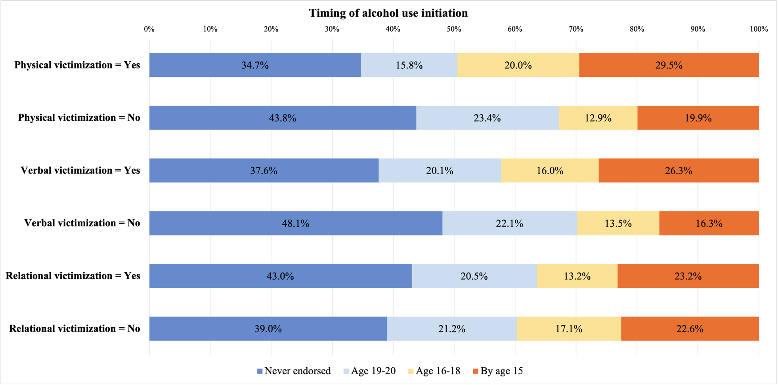
Note: This bar chart is only for displaying the tendency of timing of substance use initiation in participants experienced/not experienced victimization to readers, and not for any steps in analytic plans.
Figure S2.2. Percentage of adolescents in categories of timing of cigarette initiation
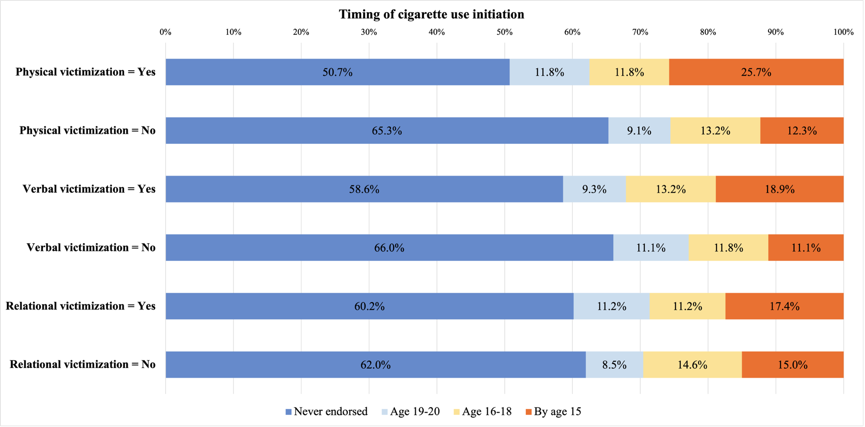

Figure S2.3. Percentage of adolescents in categories of timing of marijuana initiation
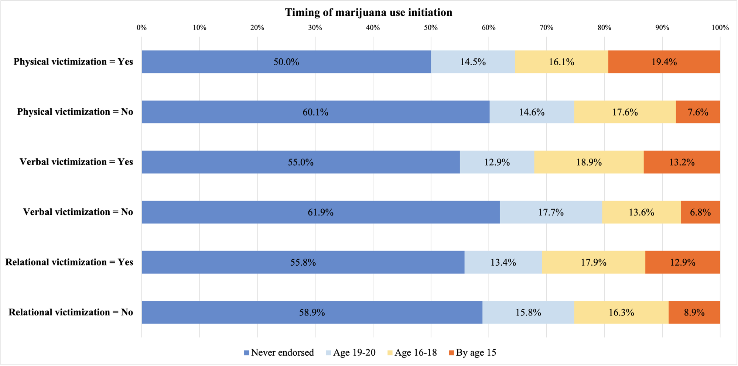

Supplementary Material S3 – Results of Sensitivity Analysis Using the Sample of 237 Twin Pairs
Table S3.1. Sociodemographic Characteristics of Twins in Sensitivity Analysis
Characteristic | N | %
Sex
Female | 271 | 57.2
Male | 203 | 42.8
Race/Ethnicity
Caucasian | 148 | 31.2
Hispanic | 158 | 33.3
Black | 60 | 12.7
Asian | 26 | 5.5
Multiracial | 82 | 17.3
Zygosity
MZ males | 47 (pairs) | 19.8
MZ females | 66 (pairs) | 27.8
DZ males | 29 (pairs) | 12.2
DZ females | 44 (pairs) | 18.6
DZ opposite sex | 51 (pairs) | 21.5

Table S3.2. Descriptive Results for Peer Victimization and Timing of Substance Initiation in Sensitivity Analysis
Variable | N (Individuals) | M | SD |  | Level
 |  |  |  | Skewness | 1 |  | 2 |  |  | 3 |  | 4
 |  |  |  |  | N | % |  | N | % | N | % |  | N | %
Physical victimization | 472 | 1.63 | 1.15 | 1.87 | / | / |  | / | / | / | / |  | / | /
Verbal victimization | 474 | 2.10 | 1.18 | .98 | / | / |  | / | / | / | / |  | / | /
Relational victimization | 473 | 2.11 | 1.31 | .94 | / | / |  | / | / | / | / |  | / | /
Timing of cigarette use initiation | 455 | / | / | .93 | 278 | 61.1 |  | 45 | 9.9 | 58 | 12.7 |  | 74 | 16.3
Timing of alcohol use initiation | 298 | / | / | .42 | 123 | 41.3 |  | 62 | 20.8 | 45 | 15.1 |  | 68 | 22.8
Timing of marijuana use initiation | 427 | / | / | .91 | 245 | 57.4 |  | 62 | 14.5 | 73 | 17.1 |  | 47 | 11.0
Note: Due to data skewness, physical victimization was Box-Cox transformed, with the skewness after transformation being .68. For timing of substance use initiation variables, Level 1 = Never endorsed by the final assessment: if the child/adolescent never reported ever use in any wave; Level 2 = Late initiation: if the child/adolescent reported the first ever use at age 19-20 (wave 5); Level 3 = Mid initiation: if the child/adolescent reported the first ever use at age 16-18 (wave 4); Level 4 = Early initiation: if the child/adolescent reported the first ever use at or before age 15 (wave 1-3).

Table S3.3. Mixed-Effect Model Results for Sex Differences in Peer Victimization and Timing of Substance Use Initiation
 |  | N | Mean | SD | F | p
Physical Victimization | Male | 203 | 1.77 | 1.25 | 1.51 | .22
Physical Victimization | Female | 269 | 1.62 | 1.11 | 1.51 | .22
Verbal victimization | Male | 203 | 2.14 | 1.18 | .00 | .98
Verbal victimization | Female | 271 | 2.12 | 1.16 | .00 | .98
Relational victimization | Male | 203 | 2.27 | 1.38 | .75 | .39
Relational victimization | Female | 270 | 2.10 | 1.32 | .75 | .39
Timing of cigarette use initiation | Male | 193 | 2.02 | 1.24 | 1.42 | .24
Timing of cigarette use initiation | Female | 262 | 1.97 | 1.25 | 1.42 | .24
Timing of alcohol use initiation | Male | 134 | 2.36 | 1.23 | .82 | .37
Timing of alcohol use initiation | Female | 164 | 2.39 | 1.25 | .82 | .37
Timing of marijuana use initiation | Male | 186 | 2.01 | 1.15 | 1.17 | .28
Timing of marijuana use initiation | Female | 241 | 1.97 | 1.16 | 1.17 | .28

Table S3.4. Mixed-Effect Model Results for Racial/Ethnic Differences in Peer Victimization and Timing of Substance Use Initiation
Variable | F (df1, df2) | p-value | Post Hoc Comparisons
Physical victimization | .89 (4, 237) | .47 | /
Verbal Victimization | 1.18 (4, 237) | .32 | /
Relational Victimization | 1.74 (4, 237) | .14 | /
Timing of cigarette use initiation | .31 (4, 237) | .87 | /
Timing of alcohol use initiation | 1.38 (4, 237) | .24 | /
Timing of marijuana use initiation | 1.55 (4, 237) | .19 | /
Note: M diff = difference between means. Higher score on victimization represents more victimization experiences at age 9-10. Higher score on timing of substance use initiation represents earlier initiation.

Table S3.5. Multinomial Logistic Regressions Between Childhood Victimization and Timing of Substance Use Initiation
(Reference Group = Never Endorsed by the Final Assessment)
 |  | Physical Victimization | Verbal Victimization | Relational Victimization
RRR (95% CI)
Timing of cigarette use initiation | 19-20yo | 4.13 (.53, 32.03) | .74 (.48, 1.14) | 1.37 (1.03, 1.82)
Timing of cigarette use initiation | 16-18yo | .85 (.13, 5.59) | 1.14 (.85, 1.53) | 1.08 (.82, 1.43)
Timing of cigarette use initiation | <15yo | 6.18 (1.16, 32.96) | 1.28 (.93, 1.75) | .93 (.70, 1.22)
Timing of alcohol use initiation | 19-20yo | .77 (.10, 5.79) | 1.07 (.73, 1.57) | .89 (.68, 1.17)
Timing of alcohol use initiation | 16-18yo | 6.62 (.79, 55.38) | 1.24 (.81, 1.88) | .60 (.40, .89)
Timing of alcohol use initiation | <15yo | 1.64 (.23, 11.52) | 1.32 (.90, 1.93) | .89 (.64, 1.23)
Timing of marijuana use initiation | 19-20yo | 2.10 (.37, 11.95) | 1.02 (.72, 1.45) | .93 (.70, 1.23)
Timing of marijuana use initiation | 16-18yo | .56 (.09, 3.56) | 1.24 (.91, 1.67) | 1.08 (.84, 1.40)
Timing of marijuana use initiation | <15yo | 5.24 (.66, 41.39) | 1.33 (.92, 1.92) | 1.01 (.76, 1.35)
Note: For timing of substance use initiation variables, Level 1 = Never endorsed by the final assessment: if the child/adolescent never reported ever use in any wave; Level 2 = Late initiation: if the child/adolescent reported the first ever use at age 19-20 (wave 5); Level 3 = Mid initiation: if the child/adolescent reported the first ever use at age 16-18 (wave 4); Level 4 = Early initiation: if the child/adolescent reported the first ever use at or before age 15 (wave 1-3). Bold values represent significant results (i.e., 95%CI does not include 1.0). The number of observations is 453 for cigarette initiation models, 296 for alcohol initiation models, and 425 for marijuana initiation models.
(Reference Group = Initiated at age 19-20)
 |  | Physical Victimization | Verbal Victimization | Relational Victimization
RRR (95% CI)
Timing of cigarette use initiation | Never endorsed | .24 (.03, 1.88) | 1.35 (.88, 2.08) | .73 (.55, .97)
Timing of cigarette use initiation | 16-18yo | .21 (.02, 2.53) | 1.54 (.96, 2.48) | .79 (.56, 1.11)
Timing of cigarette use initiation | <15yo | 1.50 (.14, 15.68) | 1.73 (1.06, 2.80) | .68 (.47, .98)
Timing of alcohol use initiation | No use by 21yo | 1.30 (.17, 9.74) | .93 (.64, 1.36) | 1.12 (.85, 1.48)
Timing of alcohol use initiation | 16-18yo | 8.59 (.78, 95.16) | 1.15 (.74, 1.78) | .67 (.44, 1.01)
Timing of alcohol use initiation | <15yo | 2.13 (.24, 19.20) | 1.23 (.83, 1.82) | 1.00 (.72, 1.39)
Timing of marijuana use initiation | No use by 21yo | .48 (.08, 2.70) | .98 (.69, 1.40) | 1.08 (.82, 1.42)
Timing of marijuana use initiation | 16-18yo | .27 (.03, 2.22) | 1.21 (.81, 1.81) | 1.17 (.84, 1.62)
Timing of marijuana use initiation | <15yo | 2.49 (.26, 24.14) | 1.30 (.83, 2.04) | 1.09 (.76, 1.56)

(Reference Group = Initiated at age 16-18)
 |  | Physical Victimization | Verbal Victimization | Relational Victimization
RRR (95% CI)
Timing of cigarette use initiation | No use by 21yo | 1.17 (.18, 7.66) | .88 (.65, 1.18) | .93 (.70, 1.23)
Timing of cigarette use initiation | 19-20yo | 4.84 (.40, 59.14) | .65 (.40, 1.04) | 1.27 (.90, 1.77)
Timing of cigarette use initiation | <15yo | 7.23 (.80, 65.06) | 1.12 (.78, 1.62) | .86 (.60, 1.22)
Timing of alcohol use initiation | No use by 21yo | .15 (.02, 1.26) | .81 (.53, 1.23) | 1.68 (1.13, 2.50)
Timing of alcohol use initiation | 19-20yo | .12 (.01, 1.29) | .87 (.56, 1.34) | 1.49 (.99, 2.26)
Timing of alcohol use initiation | <15yo | .25 (.03, 2.37) | 1.07 (.70, 1.62) | 1.49 (.99, 2.23)
Timing of marijuana use initiation | No use by 21yo | 1.78 (.28, 11.24) | .81 (.60, 1.09) | .92 (.72, 1.19)
Timing of marijuana use initiation | 19-20yo | 3.74 (.45, 31.06) | .83 (.55, 1.23) | .86 (.62, 1.19)
Timing of marijuana use initiation | <15yo | 9.31 (.92, 94.61) | 1.08 (.72, 1.60) | .93 (.66, 1.31)

Table S3.6. Phenotypic Correlation Matrix for Peer Victimization and Substance Initiation Variables
Variable | 1 | 2 | 3 | 4 | 5 | 6
1 Physical Victimization | 1
2 Verbal Victimization | .55*** | 1
3 Relational Victimization | .38*** | .55*** | 1
4 Timing of Cigarette Use Initiation | .17*** | .16*** | .06 | 1
5 Timing of Alcohol Use Initiation | .13* | .10 | -.01 | .72*** | 1
6 Timing of Marijuana Use Initiation | .14** | .14** | .09 | .77*** | .74*** | 1
Note: .08< ⁺p <.05, *p < .05, **p < .01, ***p < .001

Table S3.7. Twin Correlation Matrix for Peer Victimization and Timing of Substance Use Initiation Variables
 | 1 Physical Victimization | 2 Verbal Victimization | 3 Relational Victimization | 4 Timing of Cigarette Use Initiation | 5 Timing of Alcohol Use Initiation | 6 Timing of Marijuana Use Initiation
MZ vs. DZ
MZ | .31 | .47 | .21 | .80 | .88 | .81
DZ | .18 | .08 | .12 | .53 | .62 | .63
MZF vs. DZF
MZF | .39 | .44 | .26 | .82 | .88 | .82
DZF | .13 | .03 | -.04 | .66 | .84 | .76
MZM vs. DZM
MZM | .20 | .53 | .15 | .78 | .89 | .80
DZM | .32 | .23 | .33 | .37 | .74 | .56
DZOS
DZOS | .15 | .09 | .19 | .51 | .45 | .58
Note: MZF = MZ female twin pairs, DZF = DZ female twin pairs, MZM = MZ male twin pairs, DZM = DZ male twin pairs, DZOS = DZ opposite-sex pairs.

Table S3.8. Cross-twin Cross-trait Correlation Matrix of Main Variables for MZ and DZ Twin Pairs (DZ Correlations Below the Diagonal)
 | T1 VV | T1 PV | T1 RV | T1 ToC | T1 ToA | T1 ToM | T2 VV | T2 PV | T2 RV | T2 ToC | T2 ToA | T2 ToM
T1 VV | 1.00 | .50 | .49 | .21 | .07 | .22 | .47 | .32 | .36 | .22 | .26 | .25
T1 PV | .48 | 1.00 | .36 | .17 | .15 | .13 | .32 | .31 | .32 | .21 | .44 | .18
T1 RV | .50 | .31 | 1.00 | -.06 | -.27 | -.13 | .15 | .27 | .21 | -.06 | .01 | -.13
T1 ToC | .03 | .12 | -.02 | 1.00 | .68 | .83 | .34 | .23 | .11 | .80 | .67 | .70
T1 ToA | -.08 | -.03 | -.15 | .72 | 1.00 | .77 | .27 | .20 | .09 | .72 | .88 | .71
T1 ToM | .04 | .10 | .00 | .73 | .64 | 1.00 | .33 | .21 | .17 | .78 | .70 | .81
T2 VV | .08 | .57 | .07 | -.01 | -.10 | -.05 | 1.00 | .59 | .60 | .38 | .38 | .40
T2 PV | .10 | .18 | .10 | .11 | .08 | -.04 | .65 | 1.00 | .33 | .23 | .24 | .26
T2 RV | .08 | .14 | .12 | .07 | -.09 | .02 | .60 | .51 | 1.00 | .15 | .21 | .28
T2 ToC | -.01 | .01 | -.03 | .53 | .48 | .38 | .01 | .14 | .12 | 1.00 | .80 | .82
T2 ToA | -.03 | .08 | -.10 | .50 | .62 | .49 | .04 | .15 | .07 | .69 | 1.00 | .78
T2 ToM | .04 | .12 | -.03 | .52 | .40 | .63 | -.02 | .09 | .17 | .74 | .78 | 1.00
Note: T1 = Twin 1; T2 = Twin 2; VV = Verbal Victimization; PV = Physical Victimization; RV = Relational Victimization; ToC = Timing of cigarette use initiation; ToA = Timing of alcohol use initiation; ToM = Timing of marijuana use initiation
Table S3.9. Within-twin Concordance for Timing of Substance Use Initiation Variables
(Timing of cigarette use initiation)
 |  | MZ Twin 1
 |  | Level 1 | Level 2 | Level 3 | Level 4
MZ Twin 2 | Level 1 | 66 (61.11%) | 2 (1.85%) | 3 (2.78%) | 1 (.93%)
MZ Twin 2 | Level 2 | 2 (1.85%) | 3 (2.78%) | 1 (.93%) | 0 (.00%)
MZ Twin 2 | Level 3 | 2 (1.85%) | 0 (.00%) | 9 (8.33%) | 3 (2.78%)
MZ Twin 2 | Level 4 | 0 (.00%) | 4 (3.70%) | 2 (1.85%) | 10 (9.26%)
Note: For timing of substance use initiation variables, Level 1 = Never endorsed by the final assessment: if the child/adolescent never reported ever use in any wave; Level 2 = Late initiation: if the child/adolescent reported the first ever use at age 19-20 (wave 5); Level 3 = Mid initiation: if the child/adolescent reported the first ever use at age 16-18 (wave 4); Level 4 = Early initiation: if the child/adolescent reported the first ever use at or before age 15 (wave 1-3).
 |  | DZ Twin 1
 |  | Level 1 | Level 2 | Level 3 | Level 4
DZ Twin 2 | Level 1 | 49 (43.36%) | 8 (7.08%) | 5 (4.42%) | 4 (3.54%)
DZ Twin 2 | Level 2 | 4 (3.54%) | 5 (4.42%) | 0 (.00%) | 0 (.00%)
DZ Twin 2 | Level 3 | 5 (4.42%) | 6 (5.31%) | 3 (2.65%) | 1 (.88%)
DZ Twin 2 | Level 4 | 5 (4.42%) | 1 (.88%) | 5 (4.42%) | 12 (10.62%)

(Timing of alcohol use initiation)
 |  | MZ Twin 1
 |  | Level 1 | Level 2 | Level 3 | Level 4
MZ Twin 2 | Level 1 | 24 (42.11%) | 4 (7.02%) | 1 (1.75%) | 0 (.00%)
MZ Twin 2 | Level 2 | 2 (3.51%) | 4 (7.02%) | 3 (5.26%) | 0 (.00%)
MZ Twin 2 | Level 3 | 0 (.00%) | 1 (1.75%) | 4 (7.02%) | 1 (1.75%)
MZ Twin 2 | Level 4 | 0 (.00%) | 1 (1.75%) | 2 (3.51%) | 10 (17.54%)

 |  | DZ Twin 1
 |  | Level 1 | Level 2 | Level 3 | Level 4
DZ Twin 2 | Level 1 | 10 (20.41%) | 2 (4.08%) | 4 (8.16%) | 1 (2.04%)
DZ Twin 2 | Level 2 | 5 (10.20%) | 4 (8.16%) | 1 (2.04%) | 0 (.00%)
DZ Twin 2 | Level 3 | 0 (.00%) | 0 (.00%) | 6 (12.24%) | 2 (4.08%)
DZ Twin 2 | Level 4 | 1 (2.04%) | 2 (4.08%) | 2 (4.08%) | 9 (18.37%)

(Timing of marijuana use initiation)
 |  | MZ Twin 1
 |  | Level 1 | Level 2 | Level 3 | Level 4
MZ Twin 2 | Level 1 | 53 (56.38%) | 3 (3.19%) | 0 (.00%) | 0 (.00%)
MZ Twin 2 | Level 2 | 3 (3.19%) | 5 (5.32%) | 1 (1.06%) | 0 (.00%)
MZ Twin 2 | Level 3 | 6 (6.38%) | 3 (3.19%) | 10 (10.64%) | 1 (1.06%)
MZ Twin 2 | Level 4 | 0 (.00%) | 1 (1.06%) | 2 (2.13%) | 6 (6.38%)

 |  | DZ Twin 1
 |  | Level 1 | Level 2 | Level 3 | Level 4
DZ Twin 2 | Level 1 | 39 (37.50%) | 6 (5.77%) | 6 (5.77%) | 0 (.00%)
DZ Twin 2 | Level 2 | 7 (6.73%) | 9 (8.65%) | 2 (1.92%) | 1 (.96%)
DZ Twin 2 | Level 3 | 5 (4.81%) | 4 (3.85%) | 7 (6.73%) | 2 (1.92%)
DZ Twin 2 | Level 4 | 1 (.96%) | 3 (2.88%) | 3 (2.88%) | 9 (8.65%)

Table S3.10. Univariate Twin Model Parameter Estimates and Fit Statistics
Model | A | C (D) | E | AIC | BIC | -2LL | p
Verbal Victimization
ADE | .00 [.00, .49] | .43 [.00, .55] | .57 [.45, .72] | 1487.04 | 1489.05 | 1466.06 | -
AE | .40 [.25, .53] | - | .60 [.47, .75] | 1486.70 | 1488.59 | 1467.91 | .17
E | - | - | 1.00 [1.00, 1.00] | 1510.47 | 1512.22 | 1493.84 | <.001
Physical Victimization
ACE | .28 [.00, .44] | .02 [.00, .32] | .70 [.56, .87] | -197.46 | -195.45 | -218.43 | -
AE | .31 [.15, .44] | - | .69 [.56, .85] | -199.63 | -197.74 | -218.42 | .92
CE | - | .23 [.10, .35] | .77 [.65, .90] | -198.27 | -196.38 | -217.06 | .24
E | - | - | 1.00 [1.00, 1.00] | -187.77 | -186.02 | -204.40 | <.001
Relational Victimization
ACE | .18 [.00, .34] | .02 [.00, .26] | .81 [.66, .97] | 1607.87 | 1609.88 | 1586.90 | -
AE | .20 [.04, .34] | - | .80 [.66, .96] | 1605.70 | 1607.59 | 1586.90 | .93
CE | - | .15 [.02, .27] | .85 [.73, .98] | 1606.17 | 1608.06 | 1587.37 | .49
E | - | - | 1.00 [1.00, 1.00] | 1609.41 | 1611.16 | 1592.77 | .05
Timing of cigarette use initiation
ACE | .62 [.37, .84] | .17 [.00, .40] | .21 [.15, .28] | 1274.61 | 1276.62 | 1253.64 | -
AE | .80 [.73, .85] | - | .20 [.15, .27] | 1273.80 | 1275.69 | 1255.01 | .24
CE | - | .62 [.54, .70] | .38 [.30, .46] | 1295.40 | 1297.30 | 1276.61 | <.001
E | - | - | 1.00 [1.00, 1.00] | 1399.47 | 1401.22 | 1382.83 | <.001
Timing of alcohol use initiation
ACE | .54 [.25, .88] | .31 [.00, .57] | .15 [.10, .23] | 831.11 | 833.12 | 810.14 | -
AE | .85 [.78, .90] | - | .15 [.10, .22] | 831.61 | 833.50 | 812.82 | .10
CE | - | .72 [.62, .79] | .28 [.21, .38] | 843.06 | 844.95 | 824.27 | <.001
E | - | - | 1.00 [1.00, 1.00] | 922.21 | 923.97 | 905.58 | <.001
Timing of marijuana use initiation
ACE | .43 [.18, .71] | .36 [.09, .57] | .22 [.16, .30] | 1108.79 | 1110.80 | 1087.82 | -
AE | .79 [.72, .84] | - | .21 [.16, .28] | 1112.96 | 1114.86 | 1094.17 | .01
CE | - | .66 [.58, .73] | .34 [.27, .42] | 1118.18 | 1120.07 | 1099.39 | <.001
E | - | - | 1.00 [1.00, 1.00] | 1232.54 | 1234.30 | 1215.91 | <.001
Note: AE and CE sub-model fitted equally for physical victimization, thus variance components for both sub-models were reported. For timing of alcohol and marijuana use initiation, variance components were estimated separately for males and females, with M = male, F = female, in subscripts of model names. Models in bold texts are best fitting models.

Table S3.11. Frequency of Participants Reporting Different Levels of Victimization
Form of victimization | Response = 1 (“Never”) |  | Response = 2 or higher
Form of victimization | Frequency | % | Frequency | %
Physical victimization | 330 | 69.9 | 142 | 30.0
Verbal victimization | 161 | 34.0 | 313 | 66.0
Relational victimization | 222 | 46.9 | 251 | 53.0
Note: For each item of child self-reported victimization, 1 = Never, 2 = Rarely, 3 = Sometimes, 4 = Often, 5 = Always.

