Additional file 3

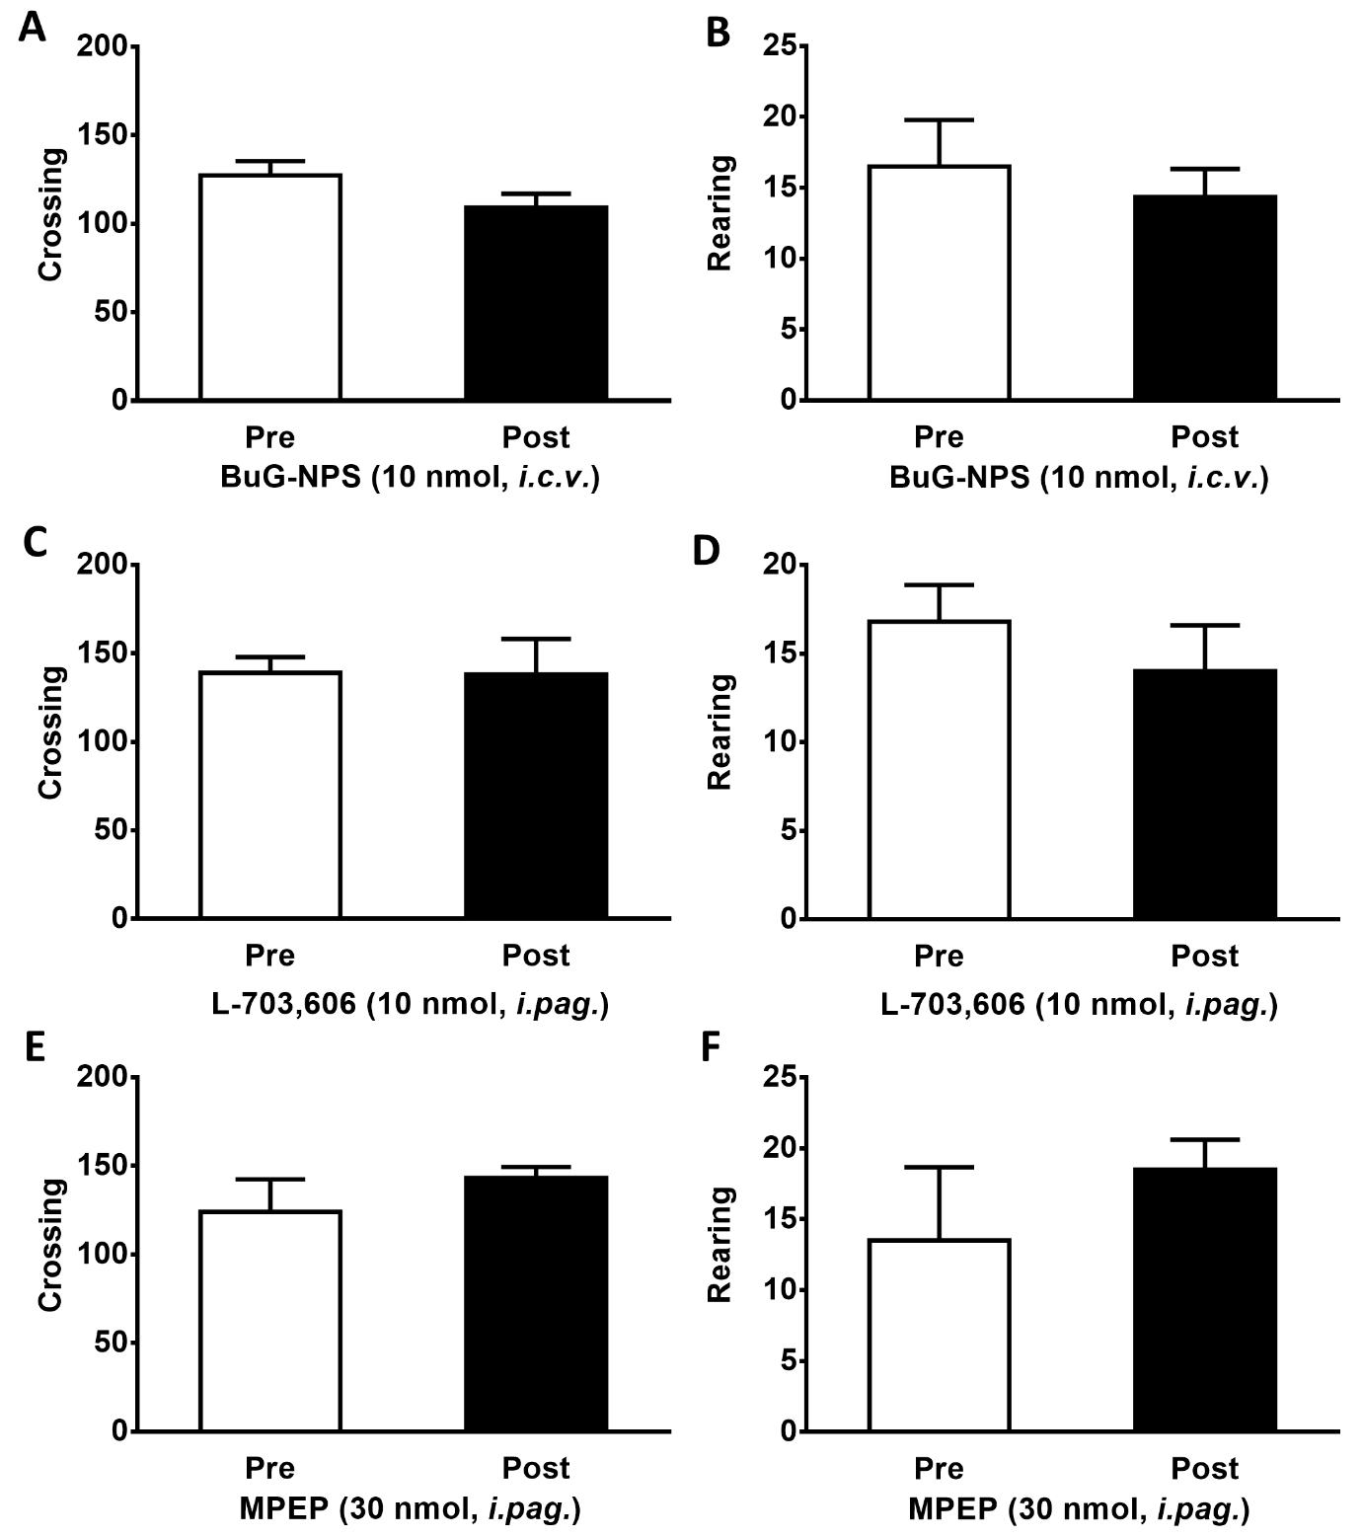
Figure S3. Effects of [tBu-D-Gly⁵]NPS, L-703,606 or MPEP on locomotor activity. Locomotor activity in the open field test was measured before and 10 min after administration of [tBu-D-Gly⁵]NPS (10 nmol, i.c.v.) (A-B), L-703,606 (10 nmol, i.pag.) (C-D), or MPEP (30 nmol, i.pag.) (E-F). Locomotor activity was assessed by the number of crossing (A, C & E) and rearing (B, D & F) in the open field test for 5 min. Data are expressed as the mean ± S.E.M. (Unpaired t-test)

