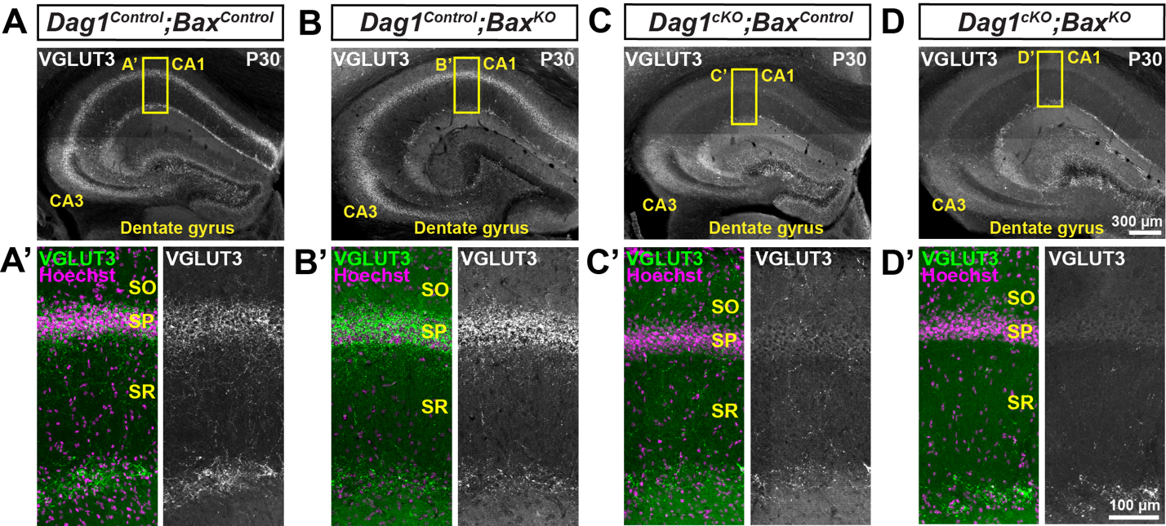
Figure S4. Constitutive deletion of Bax in Dag1^{cKO} mice does not rescue VGLUT3+ terminals. (A-D) Coronal sections of the hippocampus stained for VGLUT3 (gray) from P30 (A) Dag1^{Control};Bax^{Control}, (B) Dag1^{Control};Bax^{KO}, (C) Dag1^{cKO};Bax^{Control} and (D) Dag1^{cKO};Bax^{KO} mice. (A’-D’) Magnified images of the CA1 (yellow boxed regions) stained for VGLUT3 (green; Right, gray single channel images) and Hoechst (magenta) to stain the pyramidal cell layer (SP). SO, stratum oriens; SP, stratum pyramidale; SR, stratum radiatum.

