Supporting Information
Figure S1. Experimental design evaluating therapeutic efficacy. GL261 tumor-bearing mice were divided into four groups: control (CTRL), RT, BCP, and combination (COMB), and received treatments when the tumor volume reached 80–100 mm³. On day 4, 4 Gy X-ray irradiation was applied after the first vehicle or BCP dose. The vehicle and BCP were administered intraperitoneally daily for 14 days. Tumor volumes and body weights were monitored until the tumor sizes reached 1500 mm³, which served as the experimental endpoint.

Figure S2. The 1-year survival curve of patients with GBM with different CNR2 (CB2) levels extracted from the Xena database. The CB2 level is inversely related to the overall survival, with patients with GBM expressing higher CB2 levels having a poorer prognosis.

Figure S3. Radiation survival curves of U87MG and GL261 cells. Radiation survival curves depicting the response of U87MG and GL261 cells to radiation based on the colony formation assay results. Error bars represent the standard error of the mean (SEM) and range based on three biological replicates.

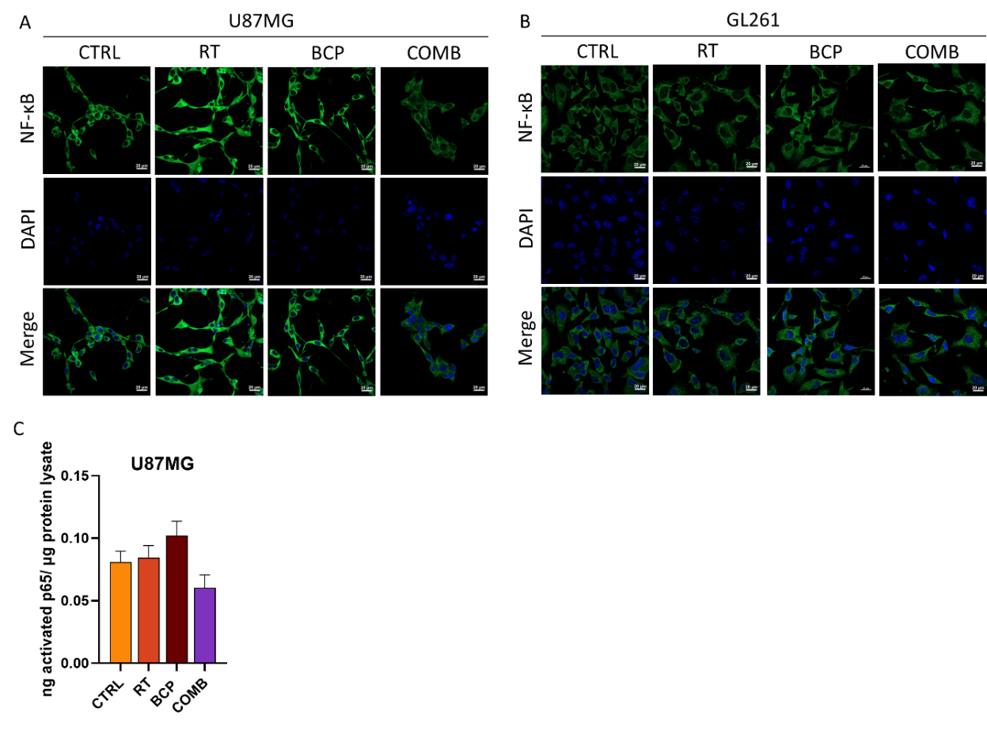
Figure S4. The combined effect of BCP and RT on NF-κB levels in GBM cells. (A) Fluorescence staining of NF-κB (green) and nucleus (DAPI, blue) in U87MG and (B) GL261 cells post-treatment. The scale bar represents 20 µm. (C) Quantification of NF-κB p65 activity in U87MG cells under various treatment conditions, expressed in ng p65 per µg protein lysate. Error bars represent SEM and range across four biological replicates.
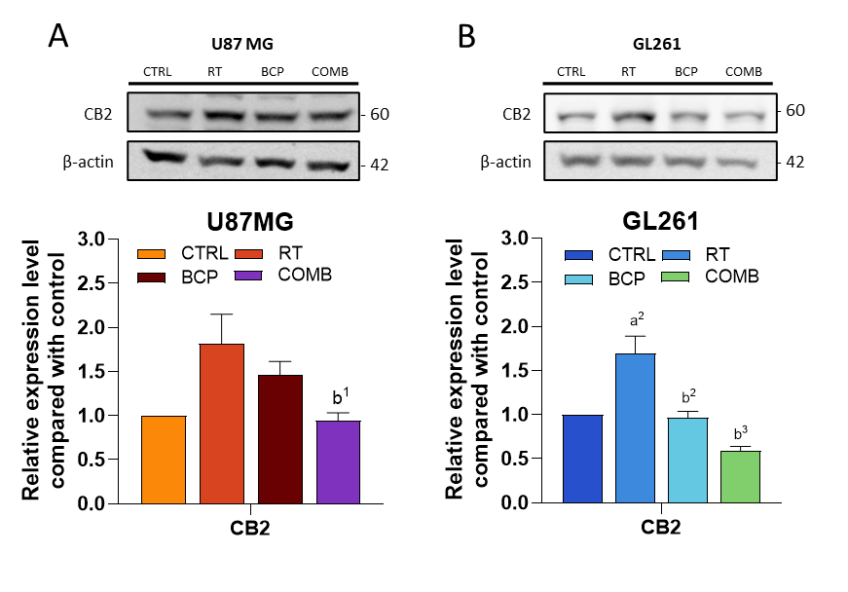
Figure S5. BCP combined with RT decreased RT-induced elevation of CB2. (A) Representative images and quantification of CB2 expression in U87MG and (B) GL261 cells after various treatments. “a” compares to CTRL; “b” compares to RT. Statistical significance: 1, P < 0.05; 2, P < 0.01; 3, P < 0.001. Error bars indicate SEM and range of three biological replicates; One-way ANOVA was used for the analysis.

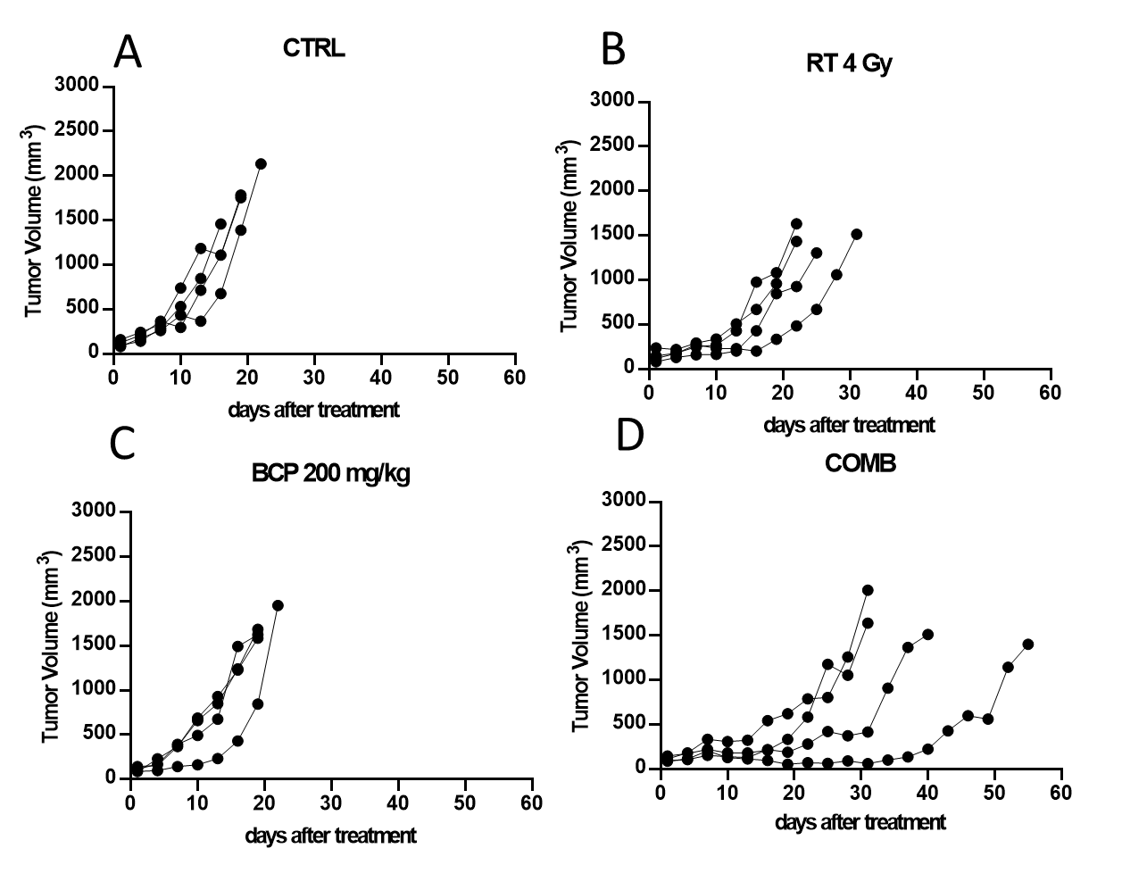
Figure S6. Tumor growth curves of subcutaneous GL261-bearing mice under various treatment conditions. Individual tumor growth curves are illustrated for (A) CTRL, (B) RT 4 Gy, (C) BCP 200 mg/kg, and (D) COMB groups. Each group comprised four mice for the assessment of long-term survival outcomes after the combined treatment with BCP and RT.

