Supplementary material
Figure S1. The correlation between the level of free fatty acids in sea buckthorn seeds oil and changes in the level of free fatty acids in keratinocytes and fibroblasts after exposure to UVA [30 J/cm² and 20 J/cm²] and UVB radiation [60 mJ/cm² and 200 mJ/cm², respectively] and sea buckthorn seeds oil [500 ng/mL] treatment.
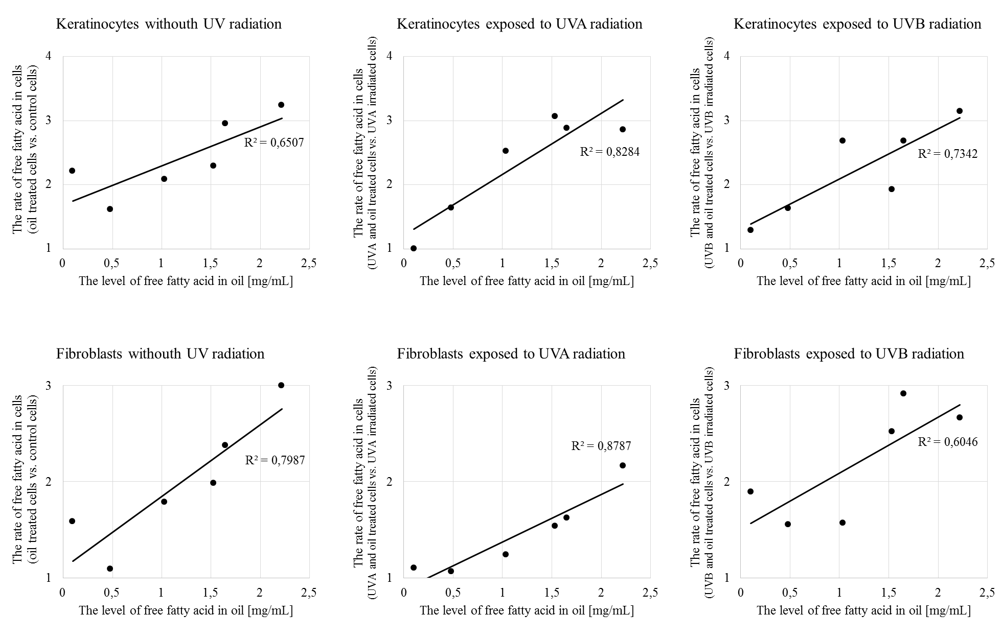

Figure S2. The The electrophorogram images of Western blot analyses of phospho-Nrf2 (pSer40) in keratinocytes and fibroblasts after exposure to UVA [30 J/cm² and 20 J/cm²] and UVB radiation [60 mJ/cm² and 200 mJ/cm², respectively] and sea buckthorn seeds oil [500 ng/mL] treatment.

