Supplementary Materials

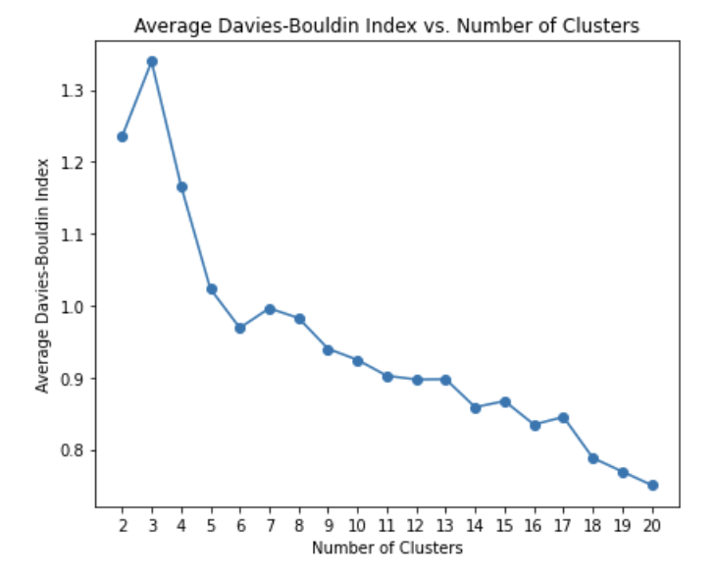
Supplementary Figure 1. Davies-Bouldin Index for different cluster splits. The Davies-Bouldin index was used to determine the optimal number of k-modes clusters. This was chosen as the first ‘dip’ of the lowest N.

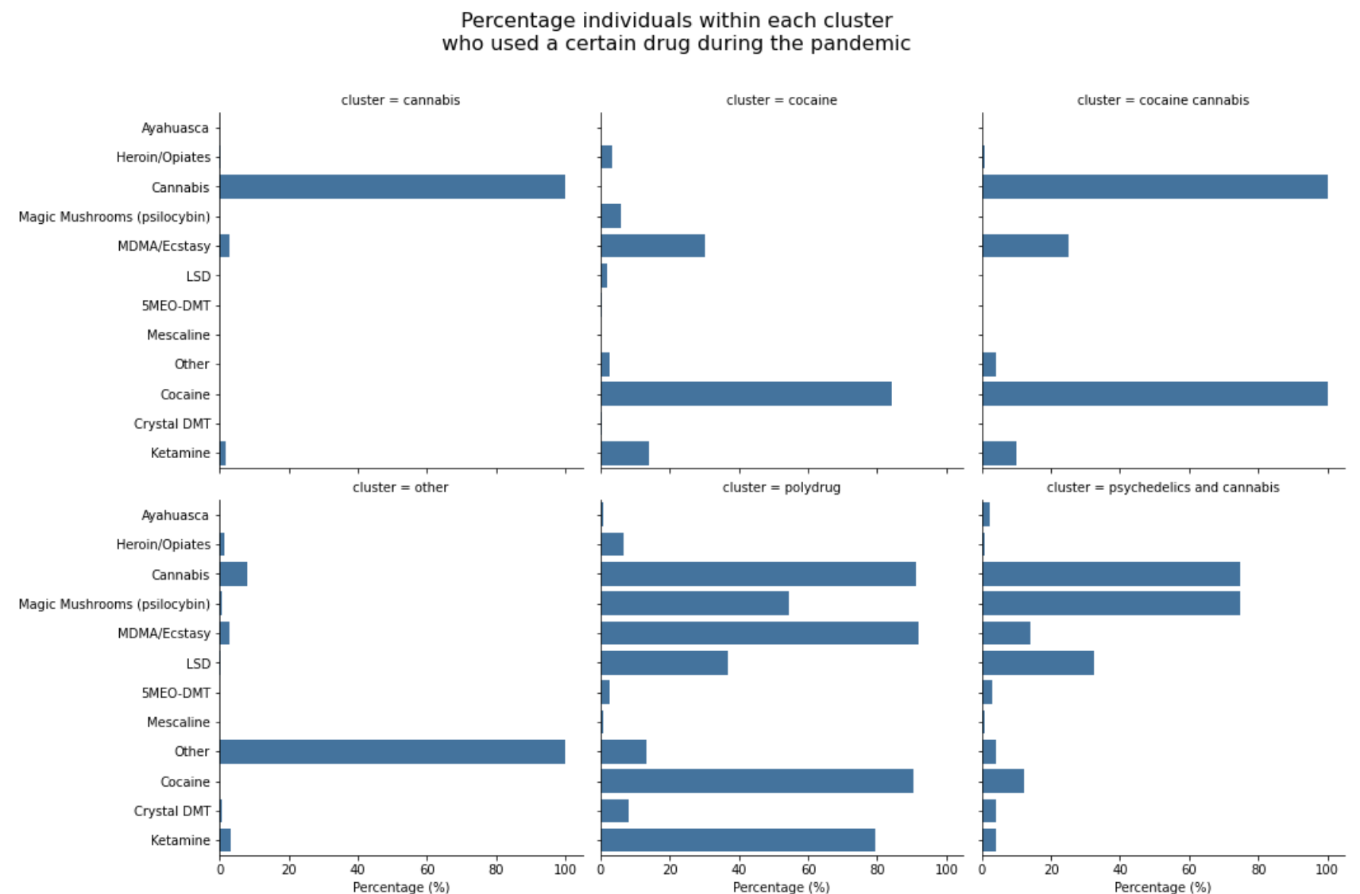
Supplementary Figure S2. Data-driven clusters of drug use choices during the pandemic. Percentages of individuals having consumed any of the drugs surveyed about within each cluster are represented.

cluster | cannabis | cocaine | cocaine and cannabis | drug naive | historic user | polydrug | psychedelics and cannabis | stopped
decade_10.0s | 6.560 | 2.610 | 5.260 | 2.750 | 0.380 | 11.850 | 7.020 | 3.530
decade_20.0s | 21.940 | 34.310 | 31.100 | 10.340 | 9.010 | 49.630 | 36.400 | 22.820
decade_30.0s | 23.880 | 30.720 | 24.880 | 13.070 | 19.300 | 25.190 | 21.490 | 21.530
decade_40.0s | 17.930 | 21.570 | 26.320 | 14.900 | 24.100 | 9.630 | 18.420 | 20.820
decade_50.0s | 16.990 | 8.820 | 10.050 | 24.740 | 25.000 | 3.700 | 10.530 | 17.290
decade_60.0s | 10.300 | 1.960 | 2.390 | 23.800 | 17.960 | NaN | 6.140 | 11.760
decade_70.0s | 2.340 | NaN | NaN | 9.320 | 4.120 | NaN | NaN | 2.240
decade_>80s | 0.070 | NaN | NaN | 1.090 | 0.120 | NaN | NaN | NaN
Sex_Female | 34.390 | 30.390 | 23.330 | 47.070 | 35.990 | 22.060 | 32.460 | 32.940
Sex_Male | 64.420 | 68.950 | 75.240 | 52.290 | 63.560 | 77.210 | 67.110 | 66.590
Sex_Other | 1.190 | 0.650 | 1.430 | 0.640 | 0.450 | 0.740 | 0.440 | 0.470
Education_Elementary_or_less | 2.010 | 1.310 | 4.310 | 1.700 | 1.400 | 0.740 | 0.880 | 1.290
Education_High_school_diploma | 34.920 | 30.720 | 32.540 | 31.930 | 28.480 | 23.700 | 37.280 | 33.410
Education_PhD | 4.480 | 0.980 | 1.910 | 6.030 | 5.900 | 4.440 | 4.390 | 6.120
Education_University_degree | 58.600 | 66.990 | 61.240 | 60.340 | 64.220 | 71.110 | 57.460 | 59.180
Ethnicity_American_Hispanic | 3.700 | 2.940 | 2.860 | 2.720 | 2.580 | 2.210 | 2.630 | 3.270
Ethnicity_East_Asian | 2.640 | 5.560 | 1.430 | 2.710 | 3.080 | 5.150 | 2.630 | 3.500
Ethnicity_Indian_South_Asian_South_East_Asian | 2.310 | 1.310 | 2.380 | 2.600 | 1.100 | 0.740 | 2.190 | 1.750
Ethnicity_Mixed | 4.100 | 3.920 | 4.760 | 1.890 | 1.780 | 6.620 | 4.390 | 3.620
Ethnicity_Other | 1.390 | NaN | 0.480 | 0.760 | 0.770 | NaN | 0.440 | 1.280
Ethnicity_Unknown | 0.460 | 0.980 | NaN | 0.270 | 0.380 | NaN | 0.440 | 0.350
Ethnicity_white | 85.400 | 85.290 | 88.100 | 89.040 | 90.310 | 85.290 | 87.280 | 86.230
Occupation_Disabled_Sheltered_employment | 1.450 | 1.310 | 0.950 | 0.800 | 1.390 | 0.740 | 2.190 | 0.700
Occupation_Homemaker | 2.240 | 0.330 | 0.950 | 2.550 | 2.110 | 0.740 | 0.440 | 1.400
Occupation_Looking_for_work | 4.750 | 5.230 | 6.670 | 2.390 | 2.950 | 2.940 | 7.020 | 4.320
Occupation_Retired | 8.780 | 0.980 | 1.900 | 28.770 | 17.320 | 2.210 | 3.510 | 10.970
Occupation_Student | 13.730 | 10.780 | 12.860 | 6.090 | 3.330 | 30.150 | 21.050 | 10.850
Occupation_Unknown | 1.780 | NaN | 2.380 | 1.480 | 0.470 | 0.740 | 0.440 | 1.280
Occupation_Worker | 67.260 | 81.370 | 74.290 | 57.920 | 72.430 | 62.500 | 65.350 | 70.480
Residence_Abroad | 13.730 | 4.580 | 3.330 | 5.450 | 6.610 | 6.620 | 16.230 | 5.950
Residence_United Kingdom | 86.270 | 95.420 | 96.670 | 94.550 | 93.390 | 93.380 | 83.770 | 94.050
Meditation_Almost never | 33.140 | 31.050 | 30.950 | 26.600 | 29.440 | 38.970 | 35.090 | 30.110
Meditation_Daily | 2.970 | 1.630 | 2.380 | 3.870 | 3.610 | 5.150 | 7.020 | 2.800
Meditation_Never | 48.120 | 62.090 | 59.050 | 57.000 | 54.790 | 43.380 | 34.210 | 52.390
Meditation_Once or twice a week | 11.620 | 3.270 | 6.190 | 9.220 | 9.180 | 9.560 | 14.910 | 10.740
Meditation_Several times a week | 4.160 | 1.960 | 1.430 | 3.310 | 2.980 | 2.940 | 8.770 | 3.970
Reading_Almost never | 30.890 | 35.950 | 33.330 | 22.920 | 24.560 | 32.350 | 28.070 | 25.200
Reading_Daily | 21.850 | 17.650 | 13.810 | 33.350 | 31.250 | 16.180 | 21.930 | 23.100
Reading_Never | 6.670 | 8.500 | 9.050 | 4.700 | 4.510 | 12.500 | 2.630 | 6.070
Reading_Once or twice a week | 25.350 | 26.140 | 29.050 | 22.950 | 23.560 | 20.590 | 27.190 | 25.550
Reading_Several times a week | 15.250 | 11.760 | 14.760 | 16.080 | 16.120 | 18.380 | 20.180 | 20.070
Exercise_Almost never | 21.190 | 20.260 | 19.050 | 17.200 | 19.360 | 18.380 | 13.600 | 21.820
Exercise_Daily | 16.830 | 13.400 | 12.380 | 19.750 | 17.970 | 13.240 | 9.210 | 14.940
Exercise_Never | 3.760 | 2.940 | 4.290 | 2.710 | 3.150 | 5.880 | 3.070 | 3.150
Exercise_Once or twice a week | 29.310 | 31.700 | 29.520 | 30.850 | 30.030 | 33.090 | 39.910 | 32.440
Exercise_Several times a week | 28.910 | 31.700 | 34.760 | 29.490 | 29.490 | 29.410 | 34.210 | 27.650
Supplementary Table 1. Sociodemographic and lifestyle characteristics across timepoints. Percentage of individuals within each cluster situated in each sociodemographic category are represented.

timepoint | cluster | N
december2020 | drug naive | 7175
 | historic user | 1559
 | cannabis | 504
 | stopped | 322
 | cocaine | 90
 | Psychedelics and cannabis | 70
 | Cocaine and cannabis | 64
 | polydrug | 33
january2022 | drug naive | 3573
 | historic user | 2623
 | cannabis | 619
 | stopped | 317
 | cocaine | 157
 | Psychedelics and cannabis | 107
 | Cocaine and cannabis | 99
 | polydrug | 73
june2021 | drug naive | 4843
 | historic user | 1556
 | cannabis | 392
 | stopped | 218
 | cocaine | 59
 | Psychedelics and cannabis | 51
 | Cocaine and cannabis | 47
 | polydrug | 30
Supplementary table 2. Number of individuals with complete datasets from pre-pandemic to follow ups.

Cluster | Change | Count
Cannabis | No change | 888
 | I am using less | 329
 | I am using more | 298
Cocaine | I am using less | 142
 | No change | 129
 | I am using more | 35
Cocaine and Cannabis | No change | 96
 | I am using less | 65
 | I am using more | 49
Polydrug | No change | 52
 | I am using more | 48
 | I am using less | 36
Psychedelics and Cannabis | No change | 131
 | I am using less | 51
 | I am using more | 46
Supplementary Table 3. Number of individuals within each cluster and their self-reported changes in drug use since baseline. Individuals were grouped based on their cluster, follow-up timepoint and self reported change.

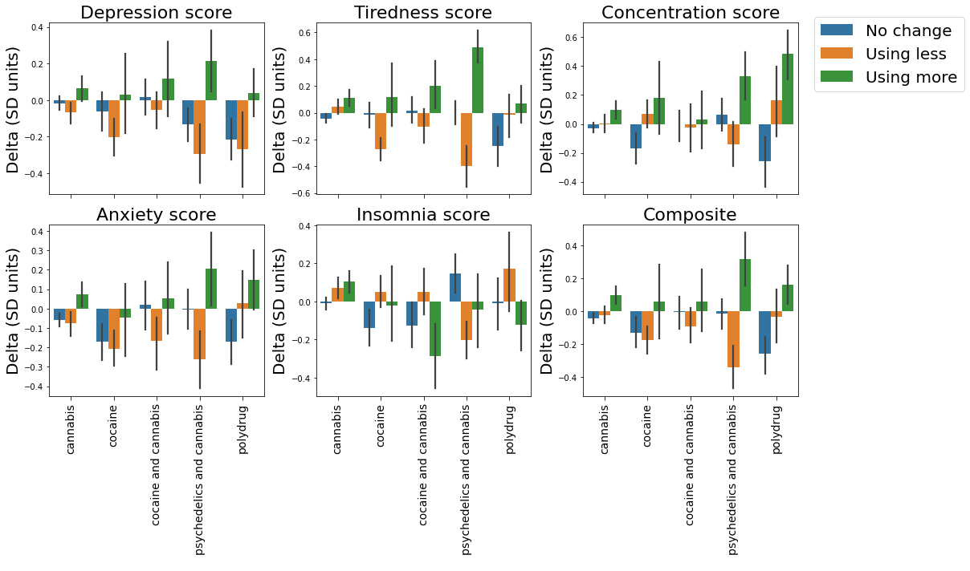
Supplementary Figure S4. Changes in drug use deltas per drug cluster. Changes in mental health are plotted across all timepoints for different clusters. Error bars are the standard error of the mean.

Mixed effects models output
Available as SupplementaryFile1.txt file

Supplementary ANOVA analysis
Available as SupplementaryFile2.txt file

