Table S2. Lipids for stabilization of CB₂ in micelles
Lipid | Structure | Reported phase transition temperature, °C¹
POPC | 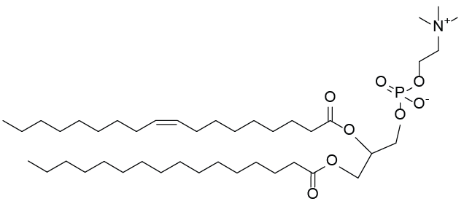 | -2
DMPC | 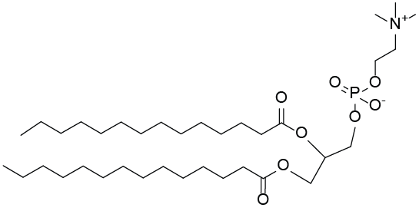 | 23
SOPC | 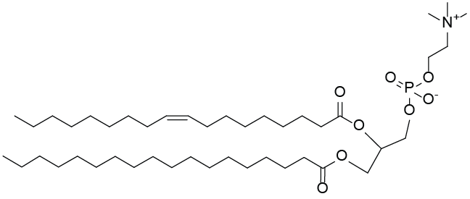 | 6
POPS | 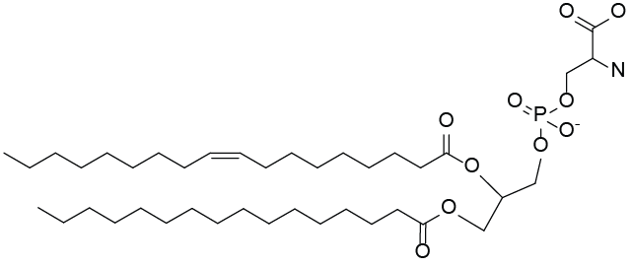 | 14
DOPS | 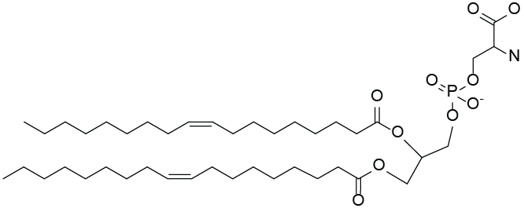 | 11
POPG | 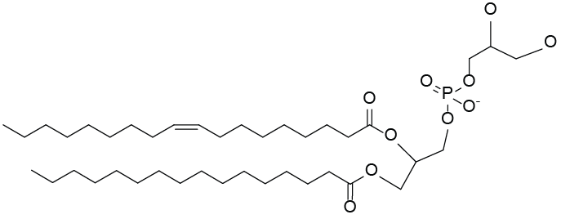 | -2
DOPE | 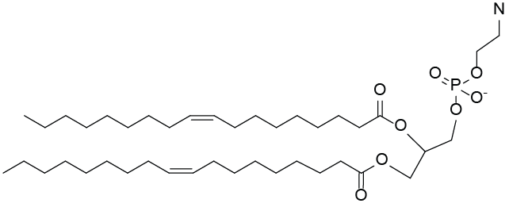 | -16
Cholesterol hemisuccinate  (CHS) | 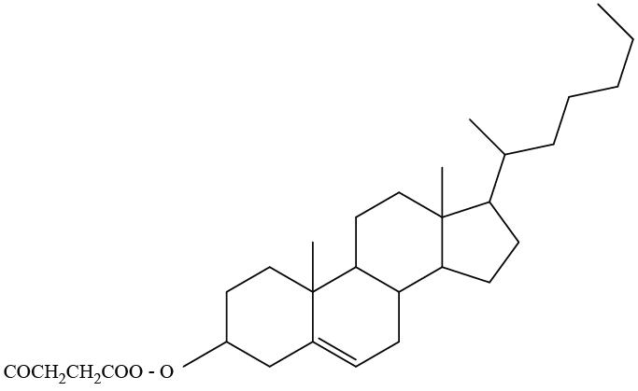 | nd
E. coli Cardiolipin  (Predominant species) | 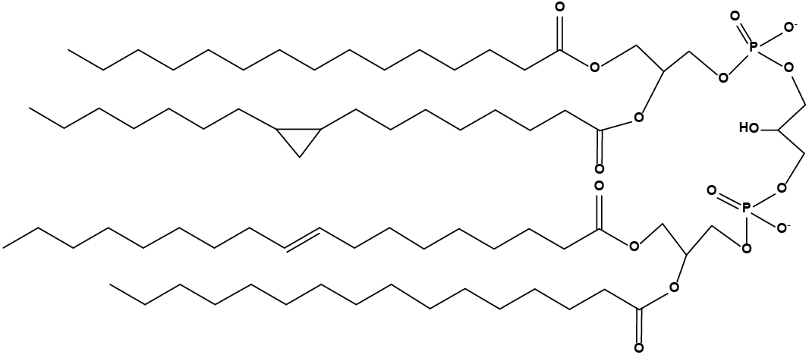 | nd
¹ (Avanti polar lipids)

