Supplementary Figure 2. Principle components of merged CNICS participants with 1KGP eigenvalues for overlapping SNPs.
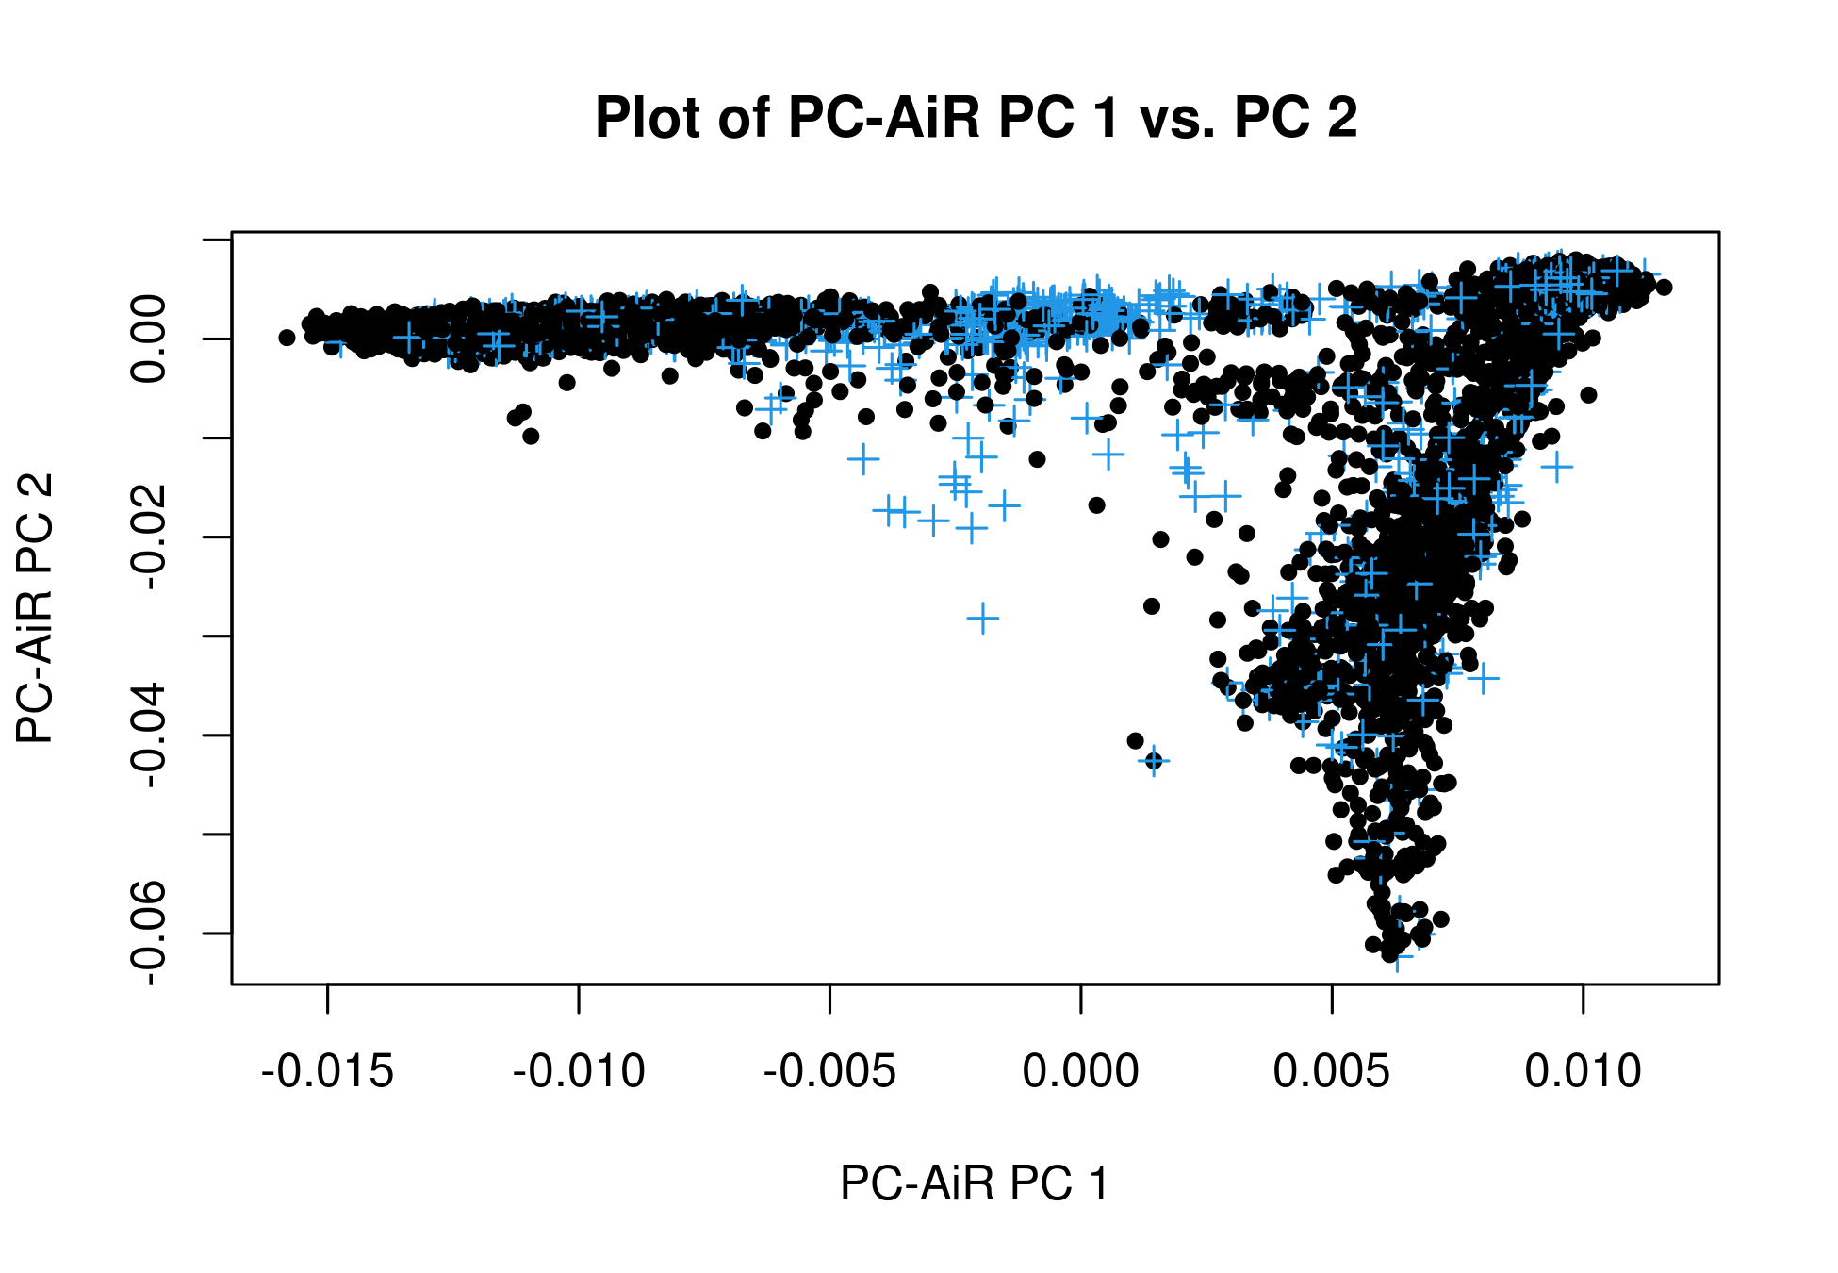
CNICS = Center for AIDS Research (CFAR) Network of Integrated Clinical Systems
1KGP = 1000 Genomes Project (reference population indicated by blue +)
SNP = single nucleotide polymorphism

