Supplementary Material
Table S1 Summary of differential metabolites
NO. | Name | Formula | RT[min] | m/z | FC |  | VIP
 |  |  |  |  | Model/NC | KN/Model | VIP
1 | 5-Hydroxydihydro-2,3-furandione | C₄H₄O₄ | 0.95 | 175.025 | 0.03 | 6.60 | 1.54
2 | Vitamin C | C₆H₈O₆ | 0.95 | 175.025 | 0.03 | 6.60 | 1.54
3 | 7-ketodeoxycholic acid | C₂₄H₃₈O₅ | 5.89 | 405.264 | 0.08 | 1.36 | 1.15
4 | ethyl 3-cyano-2-hydroxy-6-phenylisonicotinate | C₁₅H₁₂N₂O₃ | 1.55 | 267.073 | 0.11 | 1.62 | 1.56
5 | Purinol | C₅H₄N₄O | 1.25 | 135.032 | 0.14 | 1.72 | 1.60
6 | L-Glutathione (reduced) | C₁₀H₁₇N₃O₆S | 1.25 | 308.091 | 0.17 | 1.22 | 1.35
7 | 1-[(8Z,11Z,14Z)-icosatrienoyl]-sn-glycero-3-phosphocholine | C₂₈H₅₂NO₇P | 8.29 | 546.355 | 0.18 | 1.71 | 1.42
8 | Hypoxanthine | C₅H₄N₄O | 0.96 | 137.046 | 0.19 | 1.60 | 1.70
9 | 1-[(11Z,14Z)]-icosadienoyl-sn-glycero-3-phosphocholine | C₂₈H₅₄NO₇P | 8.97 | 548.370 | 0.22 | 1.49 | 1.24
10 | N-DesmethylZolmitriptan | C₁₅H₁₉N₃O₂ | 5.68 | 274.156 | 0.23 | 1.26 | 1.30
11 | Allopurinol | C₅H₄N₄O | 1.27 | 137.046 | 0.27 | 1.61 | 1.57
12 | 1-Linoleoyl glycerol | C₂₁H₃₈O₄ | 10.50 | 355.284 | 0.29 | 1.55 | 1.37
13 | Palmitamide | C₁₆H₃₃NO | 0.30 | 256.263 | 0.32 | 1.87 | 1.36
14 | Levulinic acid | C₅H₈O₃ | 0.28 | 117.054 | 0.33 | 1.54 | 1.21
15 | 1-[(8Z,11Z,14Z,17Z)-icosatetraenoyl]-sn-glycero-3-phosphocholine | C₂₈H₅₀NO₇P | 7.71 | 544.339 | 0.33 | 1.36 | 1.46
16 | 2-oleoyl-sn-glycero-3-phosphocholine | C₂₆H₅₂NO₇P | 8.63 | 522.354 | 0.33 | 1.25 | 1.35
17 | -20-hydroxy-5,8,11,14-Eicosatetraenoic acid | C₂₀H₃₂O₃ | 8.43 | 343.224 | 0.36 | 1.21 | 1.39
18 | Geranylacetone | C₁₃H₂₂O | 9.00 | 177.164 | 0.36 | 1.68 | 1.42
19 | 1-arachidonoyl-sn-glycero-3-phosphocholine | C₂₈H₅₀NO₇P | 7.87 | 544.339 | 0.38 | 1.57 | 1.36
20 | 2-Propionylthiazole | C₆H₇NOS | 1.36 | 142.032 | 0.38 | 1.46 | 1.58
21 | Platelet-activating factor | C₂₆H₅₄NO₇P | 9.38 | 524.370 | 0.39 | 1.30 | 1.49
22 | LysoPC(22:4(7Z,10Z,13Z,16Z)) | C₃₀H₅₄NO₇P | 8.75 | 572.371 | 0.41 | 1.21 | 1.20
23 | 1-Oleoyl-rac-glycerol | C₂₁H₄₀O₄ | 8.51 | 339.289 | 0.46 | 1.25 | 1.14
24 | 1-Oleoyl-2-hydroxy-sn-glycero-3-PE | C₂₃H₄₆NO₇P | 8.52 | 480.308 | 0.46 | 1.34 | 1.28
25 | 2-[(11Z,14Z)-icosadienoyl]-sn-glycero-3-phosphoethanolamine | C₂₅H₄₈NO₇P | 7.66 | 504.308 | 0.47 | 2.23 | 1.20
26 | 4-Undecylbenzenesulfonic acid | C₁₇H₂₈O₃S | 9.07 | 311.168 | 0.49 | 1.57 | 1.08
27 | 2-linoleoyl-sn-glycero-3-phosphoethanolamine | C₂₃H₄₄NO₇P | 7.78 | 476.277 | 0.51 | 1.57 | 1.01
28 | L-alpha-Glycerylphosphorylcholine | C₈H₂₀NO₆P | 0.87 | 258.110 | 0.52 | 1.25 | 1.01
29 | 6-Methylhept-5-en-2-one | C₈H₁₄O | 4.43 | 127.112 | 0.78 | 1.29 | 1.49
30 | 4-(2-Carboxy-1-azetidinyl)-N-(3-carboxy-3-hydroxypropyl)threonine | C₁₂H₂₀N₂O₈ | 4.40 | 321.131 | 1.69 | 1.23 | 1.11
31 | 1-alpha-linolenoyl-2-[(8Z,11Z,14Z)-icosatrienoyl]-sn-glycerol | C₄₁H₆₈O₅ | 13.77 | 641.511 | 1.72 | 1.65 | 1.20
32 | 2-Aminoisobutyric Acid | C₄H₉NO₂ | 0.88 | 102.056 | 1.85 | 0.82 | 1.38
33 | A-12(13)-EpODE | C₁₈H₃₀O₃ | 8.73 | 295.227 | 2.02 | 0.64 | 1.32
34 | N1,N1-dipropyl-4-(3-azabicyclo[3.2.2]non-3-ylcarbonyl)benzene-1-sulfonamide | C₂₁H₃₂N₂O₃S | 4.68 | 393.224 | 2.03 | 0.80 | 1.38
35 | D-Glucopyranuronic acid | C₆H₁₀O₇ | 0.89 | 193.035 | 2.06 | 1.28 | 1.15
36 | O-ureido-D-serine | C₄H₉N₃O₄ | 17.14 | 82.537 | 2.15 | 0.78 | 1.12
37 | 9,10-Dihydroxy-11-(3-pentyl-2-oxiranyl) undecanoic acid | C₁₈H₃₄O₅ | 5.96 | 329.233 | 2.17 | 0.75 | 1.45
38 | 5-AVA | C₅H₁₁NO₂ | 1.39 | 118.086 | 2.23 | 0.83 | 1.49
39 | leucoline | C₉H₇N | 3.62 | 130.065 | 2.33 | 0.72 | 1.43
40 | Dihomo-gamma-linolenic acid | C₂₀H₃₄O₂ | 12.11 | 307.263 | 2.36 | 0.69 | 1.30
41 | Adrenic acid | C₂₂H₃₆O₂ | 12.24 | 333.278 | 2.40 | 0.76 | 1.48
42 | aminoproline | C₅H₁₀N₂O₂ | 0.75 | 131.081 | 2.56 | 0.80 | 1.35
43 | Docosatrienoic Acid | C₂₂H₃₈O₂ | 13.21 | 333.279 | 2.63 | 0.70 | 1.04
44 | p-Xylene | C₈H₁₀ | 0.57 | 107.085 | 2.68 | 0.45 | 1.01
45 | L-Arginine | C₆H₁₄N₄O₂ | 0.84 | 175.119 | 2.89 | 0.78 | 1.60
46 | 4-[(Z)-2-Aminovinyl]phenol | C₈H₉NO | 0.95 | 136.075 | 3.04 | 0.73 | 1.32
47 | 3-Indoleacrylic acid | C₁₁H₉NO₂ | 3.63 | 188.070 | 3.21 | 0.78 | 1.48
48 | Sphingosine | C₁₈H₃₇NO₂ | 6.88 | 282.279 | 3.28 | 0.75 | 1.59
49 | 4-Indolecarbaldehyde | C₉H₇NO | 3.62 | 146.060 | 3.30 | 0.78 | 1.47
50 | Guaiacol | C₇H₈O₂ | 2.49 | 188.068 | 3.34 | 0.52 | 1.10
51 | 5-OxoETE | C₂₀H₃₀O₃ | 8.90 | 317.212 | 4.23 | 0.79 | 1.08
52 | 1-Phenyl-1,3-octadecanedione | C₂₄H₃₈O₂ | 12.72 | 359.294 | 4.35 | 0.76 | 1.63
53 | 2-Methyl-4-quinolinol | C10H9NO | 3.62 | 160.075 | 4.79 | 0.57 | 1.06
54 | L-Valine | C₅H₁₁NO₂ | 0.98 | 116.072 | 5.26 | 0.77 | 1.38
55 | 13,14-dihydro-19(R)-hydroxy Prostaglandin E1 | C₂₀H₃₆O₆ | 5.91 | 353.233 | 11.24 | 0.56 | 1.04
56 | Methyl 14-acetoxy-5-hydroxy-5,9-dimethyltetracyclo[11.2.1.0~1,10~.0~4,9~]hexadecane-14-carboxylate | C₂₂H₃₄O₅ | 5.97 | 377.232 | 12.29 | 0.71 | 1.10
57 | Uric acid | C₅H₄N₄O₃ | 1.24 | 167.021 | 12.49 | 0.81 | 1.60
58 | ala-arg | C₉H₁₉N₅O₃ | 0.78 | 309.165 | 14.28 | 0.61 | 1.19

Table S2 Differentially expressed proteins
Gene name | Accession | Fold Change |  | Gene name | Accession | Fold Change
Gene name | Accession | Model/NC | KN/Model | Gene name | Accession | Model/NC | KN/Model
Dpep1 | P31430 | 0.62 | 1.34 | Mesd | Q5U2R7 | 1.44 | 0.53
Cfl1 | P45592 | 2.01 | 0.62 | Tax1bp3 | A0A1W2Q5Z6 | 2.23 | 0.63
Pdia5 | Q5I0H9 | 2.72 | 0.14 | H920_07420 | A0A091DGJ8 | 1.75 | 0.54
Ppic | F7FHM1 | 5.44 | 0.33 | Rpl35a | A0A8I6GLI9 | 1.55 | 0.52
Vim | P31000 | 2.04 | 0.38 | Nme1 | Q05982 | 1.60 | 0.69
Snrpd1 | A0A8C6S632 | 1.52 | 0.70 | Col3a1 | P13941 | 1.59 | 0.61
Vcan | A0A0G2K944 | 2.01 | 0.66 | LOC105995859 | A0A1S3G8N9 | 1.58 | 0.67
Tnc | B2LYI9 | 3.91 | 0.42 | Snf8 | A0A1S3GZE8 | 1.94 | 0.38
Rps8 | P62243 | 1.50 | 0.76 | GW7_00978 | G5AU91 | 4.36 | 0.30
Rrbp1 | F1M853 | 1.36 | 0.69 | Pdia6 | A0A0G2JSZ5 | 1.47 | 0.74
Nit2 | A0A8I5ZM02 | 0.50 | 1.78 | Gpx1 | P04041 | 1.94 | 0.55
Rps27a | P62982 | 1.35 | 0.74 | P4hb | P04785 | 1.93 | 0.37
GW7_12661 | G5BEU8 | 0.21 | 1.98 | GW7_05563 | G5AZZ9 | 0.52 | 1.43
Retnlb | Q6DV77 | 0.25 | 1.65 | Spint1 | Q4V8Q2 | 0.54 | 1.66
Aldh9a1 | Q9JLJ3 | 0.27 | 2.91 | Cd9 | A0A8I5ZZU3 | 0.55 | 1.46
Minpp1 | G3V7H2 | 0.30 | 3.45 | Gnao1 | A0A8I5ZT81 | 0.56 | 2.39
Stat5a | Q62771 | 0.33 | 1.48 | Nt5e | A0A8I6AV15 | 0.63 | 1.26
Exoc5 | P97878 | 0.34 | 1.99 | Nid1 | F1LM84 | 0.75 | 1.20
H920_13578 | A0A091D3E2 | 0.35 | 3.43 | Vkorc1 | A0A346T6Q2 | 1.24 | 0.72
Top2a | A0A0G2JUF8 | 0.45 | 1.29 | H920_15478 | A0A091CZ26 | 1.36 | 0.80
NBR_LOCUS16951 | A0A0N4YJ28 | 0.46 | 1.76 | Acyp1 | D4A6X4 | 1.39 | 0.77
Des | Q6P725 | 0.47 | 1.22 | Map1lc3b2 | A0A0G2K9Q7 | 1.43 | 0.74
Pla2g4a | A0A0G2KAA9 | 0.48 | 1.40 | Stx7 | O70257 | 1.43 | 0.66
Nme2 | P19804 | 1.49 | 0.78 | Rpl24 | A0A8C6QV89 | 1.76 | 0.75
Ppib | P24368 | 1.49 | 0.72 | Osbpl10 | A0A8C6QXF3 | 2.05 | 0.64
Srsf2 | Q6PDU1 | 1.52 | 0.68 | Serpinc1 | Q5M7T5 | 2.11 | 0.49
Ranbp1 | D4A2G9 | 1.59 | 0.77 | Rcn1 | D3ZUB0 | 2.15 | 0.80
Erp29 | P52555 | 1.63 | 0.70 | ENSRNOG00000064589 | A0A8I6A4U0 | 2.19 | 0.70
Anxa2 | Q07936 | 1.68 | 0.71 | Fam114a1 | A0A8I6GGB2 | 2.23 | 0.70
LOC120098629 | A0A8I5ZTF4 | 1.75 | 0.68 | Rbm25 | A0A8I6GMR5 | 2.31 | 0.81
Rpl32 | P62912 | 1.75 | 0.72 | Rps29 | P62275 | 2.32 | 0.64
Pabpn1 | A0A1S3FWA9 | 1.75 | 0.48 | Lamtor4 | A0A8I6A858 | 2.35 | 0.68
ENSRNOG00000064207 | A0A8I6A583 | 2.39 | 0.73 | Lrrc25 | A0A8I5ZL91 | 3.03 | 0.40
Serpinh1 | Q5RJR9 | 2.50 | 0.48 | Mt1 | P02803 | 3.84 | 1.38
LOC681544 | A0A0G2K9Y5 | 2.50 | 0.48 | Serpina4 | A0A8I5ZZZ2 | 4.38 | 0.80
Lamp2 | P17046 | 2.52 | 0.61 | Myh10 | A0A8I6A5G4 | 4.45 | 0.61
GW7_15376 | G5BVX3 | 2.54 | 2.73 | Wdr61 | A0A8C6RC95 | 7.90 | 0.53
Ctsa | A0A8I6ARV9 | 2.66 | 0.71

Quality control standard of KN Decoction
HPLC
The chromatography procedure was performed using a Agilent high-performance liquid chromatography system. Experimental data were acquired and interpreted exploiting software. The stationary phase was represented by a reverse-phase column (Welch Ultimate XB-C18 column; 250 mm × 4.6 mm, Shanghai, China), while the mobile phase was Acetonitrile as solvent A and Acetonitrile water +0.2% HCOOH as solvent B in 90 min of analysis in total. And the detection wavelength was 254nm.As shown in Table 1, the elution gradient and its timepoints are reported.
T (min) | Solvent A(%) | Solvent B(%)
0-13 | 5-10 | 95-90
13-40 | 10-20 | 90-80
40-60 | 20-50 | 80-50
60-84 | 50-80 | 50-20
84-90 | 80 | 20
High-performance liquid chromatography fingerprints and the nine main compounds in the KN decoction
All results indicated that the HPLC analysis method was valid and satisfactory. The HPLC profiles of 15 batches of the KN decoction water extract are shown in Figure S1A. Fifteen coexisting peaks were detected in all analyzed samples; these were labeled 1–19 according to the standard fingerprint of the KN decoction of different grades (Figure S1B ). Indices of similarity among the samples of different grades were in the range of 0.924–0.996 (Table S3). These high degrees of similarity indicated that the compounds found in different grades of the KN decoction were similar. Seven reference compounds were quantitatively analyzed: Chlorogenic acid、Aesculetin、Loganin、Quercetin、Aloe emodin、Rhein acid、Chrysophanol. （Table S4、S5）
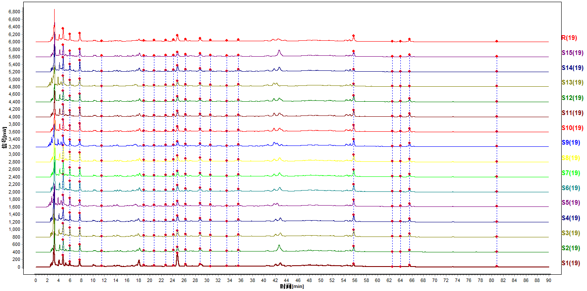（A）
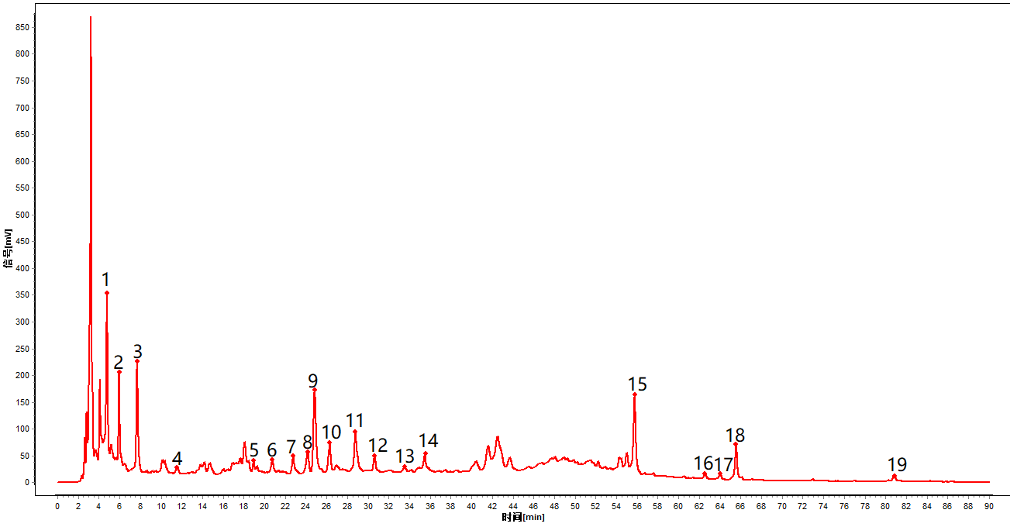（B）
Figure S1 HPLC fingerprints of samples.((A)Fingerprints of different grades of KN decoction;(B)Standard fingerprints of different grades of KN decoction. .1.unknown;2.unknown;3.unknown;4.unknown;5.unknown;6.unknown;7. Chlorogenic acid;8.unknown;9. Aesculetin;10.unknown;11. Loganin;12.unknown;13.unknown;14.unknown;15. Quercetin;16.unknown;17. Aloe emodin;18. Rhein acid;19.Chrysophanol)
Table S3 Similarity(Reference to Sample Ten)
Sample number | Similarity(  Reference spectrum) | Similarity(  Contrast spectrum)
1 | 0.904 | 0.924
2 | 0.995 | 0.996
3 | 0.987 | 0.992
4 | 0.986 | 0.992
5 | 0.985 | 0.991
6 | 0.991 | 0.996
7 | 0.993 | 0.997
8 | 0.993 | 0.996
9 | 0.976 | 0.978
10 | 1.000 | 0.993
11 | 1.000 | 0.993
12 | 0.998 | 0.994
13 | 0.920 | 0.951
14 | 0.943 | 0.972
15 | 0.996 | 0.996
Table S4 Linear relationships of various constituents
Ingredient | Mathematical equation | Correlation coefficient | Realm（μg/ml）
Chlorogenic acid | Y = 7.2249X + 75.729 | 0.9995 | 21.68~346.92
Aesculetin | Y = 12.064X +68.562 | 0.9999 | 41.65~666.40
Loganin | Y = 7.9549X+17.588 | 1.0000 | 20.34~325.36
Quercetin | Y = 39.071X+ 15.5 | 0.9997 | 9.98~159.74
Aloe emodin | Y = 32.37X+7.3042 | 0.9998 | 1.84~29.40
Rhein acid | Y = 34.608X – 33.704 | 0.9996 | 5.57~89.18
Chrysophanol | Y = 25.184X+110.26 | 0.9998 | 2.94~47.04

Table S5 Reasults of content determination of various constituents
Batch | Chlorogenic acid（%） | Aesculetin (%) | Loganin（%） | Quercetin（%） | Aloe emodin（%） | Rhein acid（%） | Chrysophanol（%）
1 | 0.0132 | 0.256 | 0.125 | 0.0181 | 0.00305 | 0.0171 | 0.00409
2 | 0.0119 | 0.107 | 0.137 | 0.0537 | 0.00495 | 0.0261 | 0.00425
3 | 0.0150 | 0.106 | 0.135 | 0.0536 | 0.00515 | 0.0257 | 0.00270
4 | 0.0135 | 0.108 | 0.123 | 0.0495 | 0.00529 | 0.0254 | 0.00298
5 | 0.0154 | 0.117 | 0.159 | 0.0581 | 0.00549 | 0.0245 | 0.00312
6 | 0.0136 | 0.106 | 0.145 | 0.0544 | 0.00525 | 0.0234 | 0.00460
7 | 0.0145 | 0.112 | 0.150 | 0.0585 | 0.00548 | 0.0242 | 0.00301
8 | 0.0090 | 0.104 | 0.096 | 0.0486 | 0.00486 | 0.0293 | 0.00292
9 | 0.0095 | 0.099 | 0.110 | 0.0477 | 0.00529 | 0.0272 | 0.00286
10 | 0.0100 | 0.100 | 0.110 | 0.0491 | 0.00560 | 0.0276 | 0.00289
11 | 0.0094 | 0.093 | 0.103 | 0.0459 | 0.00494 | 0.0257 | 0.00288
12 | 0.0106 | 0.108 | 0.106 | 0.0157 | 0.00159 | 0.0042 | 0.00285
13 | 0.0137 | 0.110 | 0.121 | 0.0152 | 0.00295 | 0.0044 | 0.00280
14 | 0.0119 | 0.088 | 0.126 | 0.0414 | 0.00167 | 0.0160 | 0.00362
15 | 0.0122 | 0.088 | 0.128 | 0.0403 | 0.00173 | 0.0162 | 0.00369
Min | 0.0090 | 0.088 | 0.096 | 0.0433 | 0.00167 | 0.0044 | 0.00270
Max | 0.0154 | 0.256 | 0.159 | 0.0585 | 0.00560 | 0.0293 | 0.00460
Average | 0.0122 | 0.114 | 0.125 | 0.0433 | 0.00422 | 0.0211 | 0.00328

