Supplemental Graphs
Supplemental Figure 1.
mCEQ Subscales
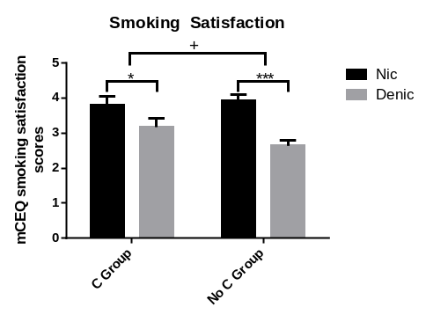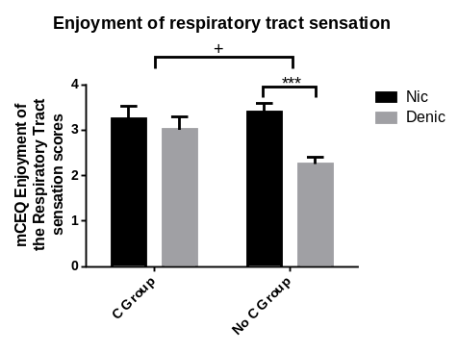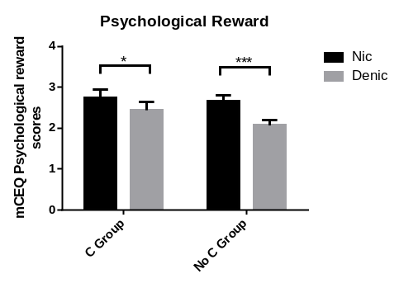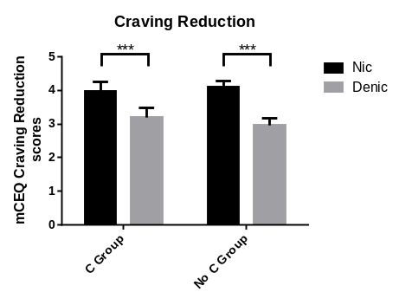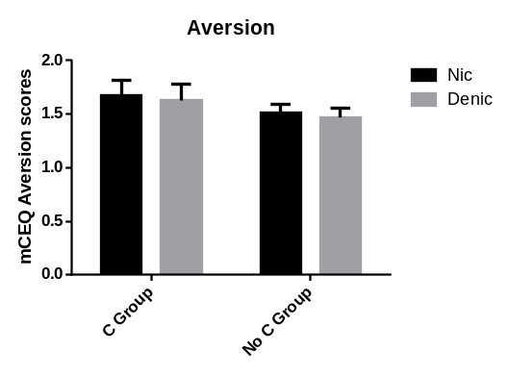
Legends: mCEQ scores of individual subscales. There were genotype × cigarette type interactions in both the ‘smoking satisfaction’ (F (1,100) = 3.981, p = 0.049, η²_{p} = 0.038) and ‘enjoyment of the respiratory tract sensation’ (F (1,100) = 6.893, p = 0.010, η²_{p} = 0.064). In both subscales, the Nic-Denic mean difference was smaller in the C group compared to the No C group. There was a main effect of cigarette type in all subscales, where Nic scores were significantly greater than Denic scores, except for Aversion. + = significant 2-way interaction. * = p < 0.05. *** = p < 0.001

Supplemental Figure 2.
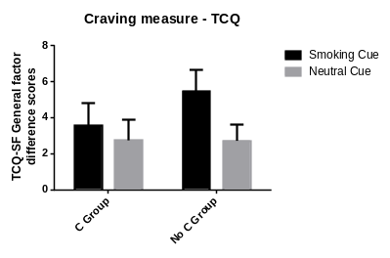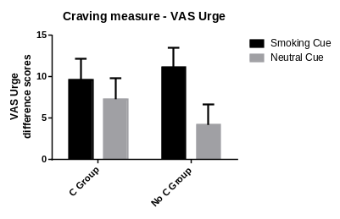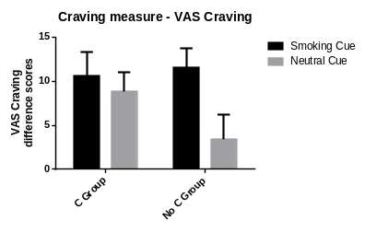
Legend: There were no genotype × cigarette type interaction in any of the craving measures. There was also no main effect of cue type in any measure.
Supplemental Figure 3.
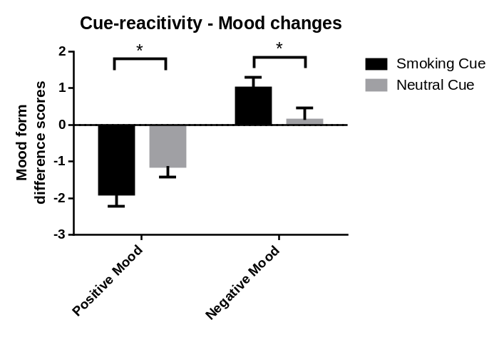
Legend: There were main effects of cue type in both positive mood (F (1,99) = 3.983, p = 0.049, η²_{p} = 0.039) and negative mood (F (1,99) = 7.086, p = 0.009, η²_{p} = 0.067). The smoking cue elicited significantly greater decreases in positive mood and significantly greater increases in negative mood compared to the neutral cue.
Supplemental Figure 4.
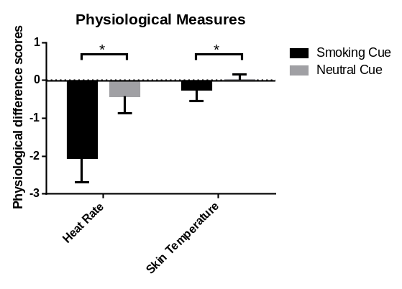
Legend: There were main effects of cue type in both heart rate (F (1,57) = 4.609, p = 0.036, η²_{p} = 0.075) and skin temperature (F (1,72) = 5.205, p = 0.025, η²_{p} = 0.067). The smoking cue elicited significantly greater decreases in heart rate and skin temperature compared to the neutral cue.
Supplemental Graphs- Race analysis
Forced Choice
All (Race collapsed) | White | Black
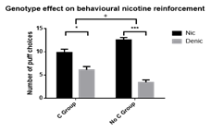 | 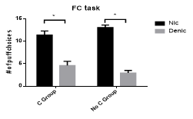 | 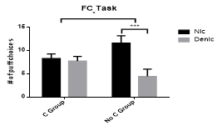
Supp. Fig. 5 | Supp. Fig. 6 | Supp. Fig. 7

mCEQ Composite score
All (Race collapsed) | White | Black
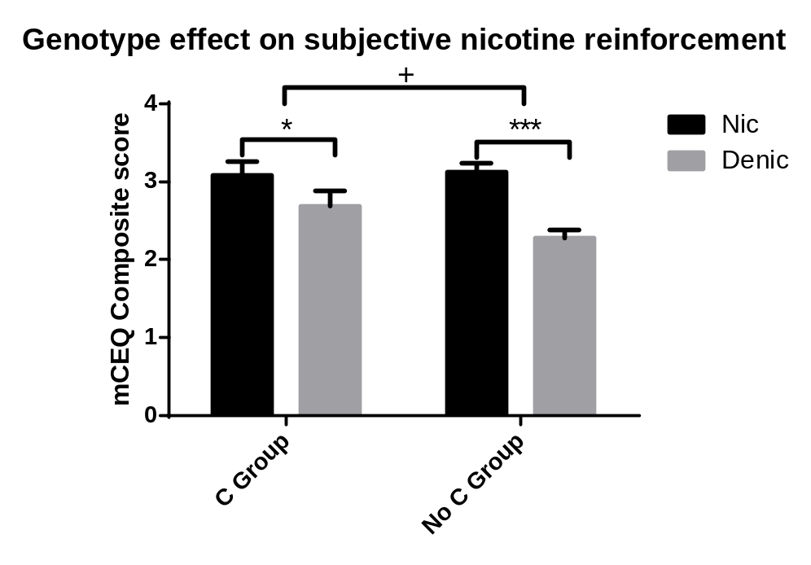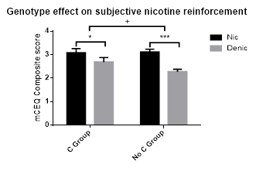 | 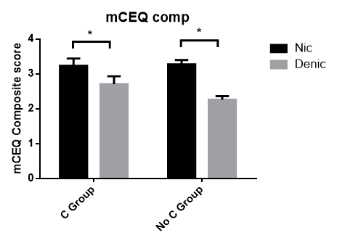 | 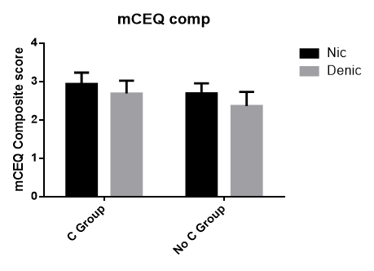
Supp. Fig. 8 | Supp. Fig. 9 | Supp. Fig. 10

mCEQ Subscales
All (Race collapsed) | White |  | Black
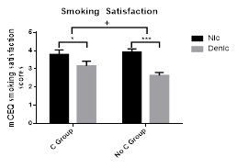 | 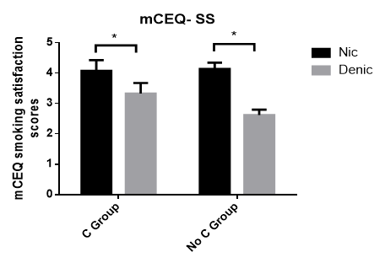 |  | 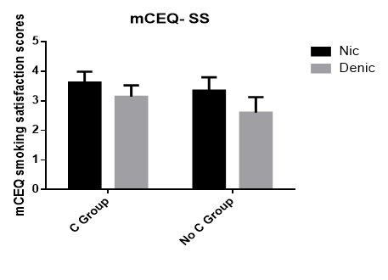
Supp. Fig. 11 | Supp. Fig. 12 |  | Supp. Fig. 13
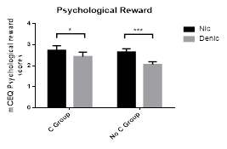 | 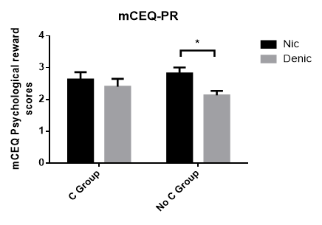 |  | 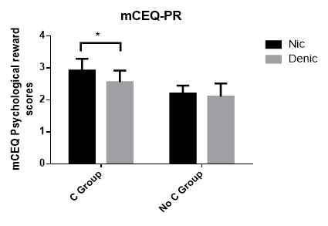
Supp. Fig. 14 | Supp. Fig. 15 |  | Supp. Fig. 16
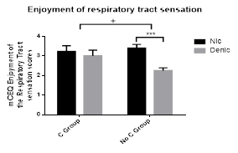 | 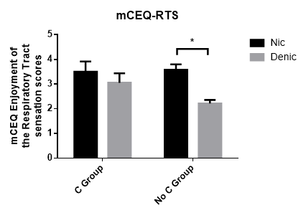 |  | 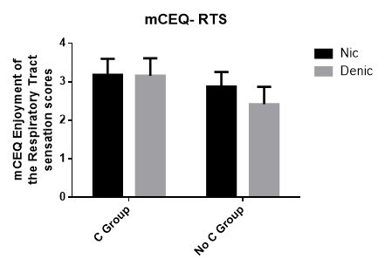
Supp. Fig. 17 | Supp. Fig. 18 |  | Supp. Fig. 19
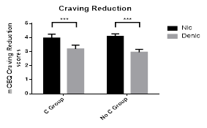 | 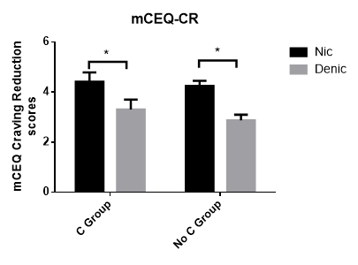 |  | 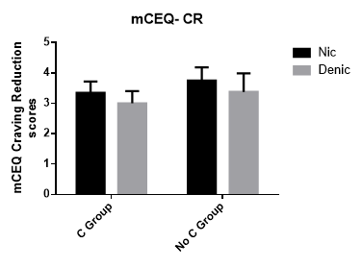
Supp. Fig. 20 | Supp. Fig. 21 |  | Supp. Fig. 22
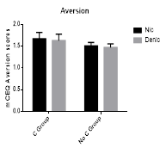 | 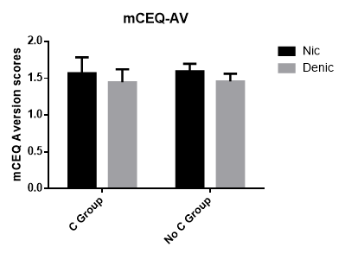 |  | 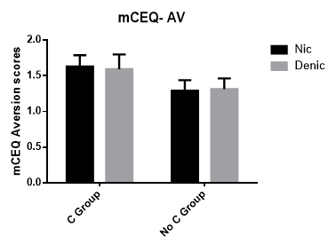
Supp. Fig. 23 | Supp. Fig. 24 |  | Supp. Fig. 25
Cue-reactivity (Craving)
All (Race collapsed) |  | White |  | Black
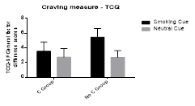 |  | 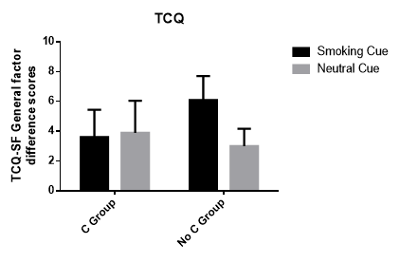 |  | 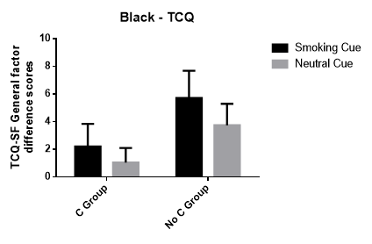
Supp. Fig. 26 |  | Supp. Fig. 27 |  | Supp. Fig. 28
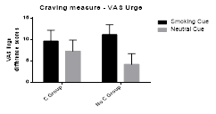 |  | 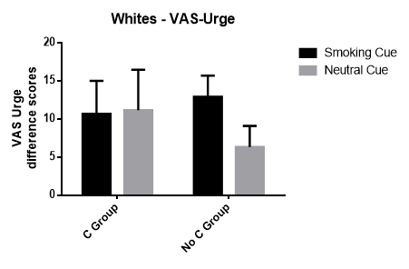 |  | 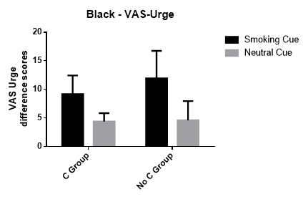
Supp. Fig. 29 |  | Supp. Fig. 30 |  | Supp. 31
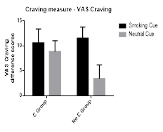 |  | 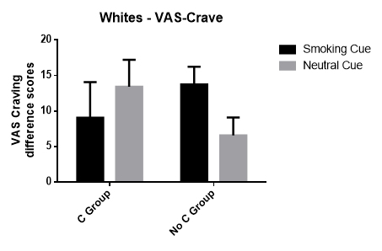 |  | 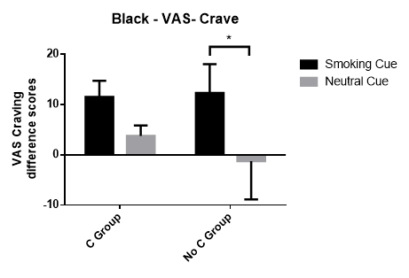
Supp. Fig. 32 |  | Supp. Fig. 33 |  | Supp. Fig. 34

