New Phytologist Supporting Information

Article title: Unique bibenzyl cannabinoids in the liverwort Radula marginata: parallels with Cannabis chemistry
Authors: Christelle M. Andre, Catherine E. Sansom, Blue J. Plunkett, Cyril Hamiaux, Lenhy Massey, Andrew Chan, Manu Caddie, Richard V. Espley, Nigel B. Perry
Article acceptance date: 28 November 2024
The following Supporting Information is available for this article:

Detailed chemistry methods
Method S1. Description of all analytical methods used to analyze Radula marginata bibenzyl cannabinoid compounds.

NMR spectra, at 25 °C, were recorded at 600 MHz for ¹H and 150 MHz for ¹³C on a Jeol 600 MHz NMR spectrometer. Chemical shifts are given in ppm on the δ scale referenced to the solvent peak CHCl₃ at 7.25 and CDCl₃ at 77.0. Optical rotations were recorded at 22-23 °C on an Autopol IV polarimeter using 0.9 ml cells.
Analytical HPLC (used to monitor preparative HPLC fractions) used an Agilent HP1260, controlled with Agilent OpenLab software, on a C18 column (Phenomenex Luna C18(2) 150 × 3 mm) with a 2 × 4 mm C18 guard column at 25 °C. Peaks were detected at 210, 228, 254, 300, 350, 400, 450 and 500 nm. The mobile phase was A, acetonitrile (MeCN) and B water with 0.1% (v/v) formic acid in both: A t₀=10%, t_{12.5}=100%, t₁₅=100%, t₁₆=10%, t₂₀=10%. The flow rate was 0.5 mL min⁻¹, with an injection volume of 5 μL.
Preparative HPLC (used to purify isolated compounds) used the same instrument and software as the HPLC, on a C18 column (Phenomenex Luna C18(2) 250 × 10 mm) with a 10 × 4 mm C18 guard column, at 25 °C. Peaks were detected at 210, 228 and 254 nm, and fractions were collected based on signals at 228 nm. The mobile phase was isocratic 75 or 80% MeCN in water, both with 0.1% formic acid. The flow rate was 5.0 mL min⁻¹, with injection volumes of 10-50 μL of mixtures 50-100 mg mL⁻¹.
LC-MS (used for HR-MS of isolated compounds) analysis used a Thermo Scientific™ Vanquish™ UHPLC system with a Q Exactive™ Plus Orbitrap version Orbitrap MS 2.11 build 3007 controlled using Chromeleon™ Thermo Scientific SII for Xcalibur with base software Foundation 3.1 SP6, Xcalibur 4.2 SPI Thermo Scientific™ . Separations were carried out using a Hypersil GOLD™ aQ C18 column (1.9µm, 100mm × 2.1mm), at 40 °C. The mobile phase was A, MeCN and B, water, both with 0.1% formic acid: A t₀=0%, t₁=0%, t₂=20%, t₈=40%, t₁₀=98%, t₁₃=98%, t₁₄=0%, t₁₇=0%. The flow rate was 0.3 mL min⁻¹, with injection volumes of 2 μL. The eluent was scanned from 0.5-13.5 min by heated electrospray ionisation (HESI) at 350 °C in the negative and positive mode with capillary temperature of 320 °C.
GC-MS (used to analyse samples and compounds) analysis used an Agilent 7890A gas chromatograph with a CTC Analytics PAL system autosampler and an Agilent 5975C inert XL MSD with triple axis detector (under the control of Enhanced ChemStation software). The injector (260 °C) was split 5:1 for 1 µl liquid injections, made onto a 30 m Agilent HP5-ms column with 0.25 mm ID and 0.25 µm film. The carrier gas was H₂ at 1.7 ml min⁻¹. The oven was heated from 50 °C to 320 °C at 5 °C min⁻¹. Detection was by flame ionization detector (FID) at 300 °C and by mass spectrometry (70 eV electron impact, +ve ion mode) over the range m/z 35-650 Da. The MS transfer line was at 300 °C, the source at 230 °C and the MS quad at 150 °C. Retention indices were measured against a series of n-alkanes. Identified bibenzyls were quantified using the response of benzyl alcohol standard.

Method S2. Chemical properties of bibenzyl cannabinoid compounds under investigation.

Perrottetinene, PET, 1 [Registry Number (RN) 160041-34-9]: pale yellow gum; [α]_{D} -77 (CHCl₃, c 0.70); ¹H and ¹³C NMR match (Toyota et al., 1994); LC-MS RT 10.67 min; HRMS m/z 347.2010 ([M-H]⁻, C₂₄H₂₇O₂ requires 347.2011), 349.2158 ([M+H]⁺, C₂₄H₂₉O₂ requires 349.2168).

Perrottetinenic acid, PETA, 2 [RN 481710-99-0]: pale yellow gum; [α]_{D} -139 (CHCl₃, c 0.44); ¹H and ¹³C NMR (Table 2) match(Toyota et al., 2002); LC-MS RT 10.82 min; HRMS m/z 391.1913 ([M-H]⁻, C₂₅H₂₇O₄ requires 391.1909) 393.2062 ([M+H]⁺, C₂₅H₂₉O₄ requires 393.2065).

Perrottetinene diol, PTD, 5 [RN 120467-09-7]: pale yellow gum [α]_{D} +39 (CHCl₃, c 0.56); ¹H and ¹³C NMR Table S2, Fig. S2; LC-MS RT 10.87 min; HRMS m/z 349.2164 ([M+H]⁺, C₂₄H₂₉O₂ requires 349.2168).

Perrottetinene diol acid, PTDA, 6 [RN 2662490-16-7]: pale yellow gum, [α]_{D} -11 (CHCl₃, c 0.65); ¹H and ¹³C NMR Table 2, Fig. S3; LC-MS RT 11.31 min HRMS m/z 391.1916 ([M-H]⁻, C₂₅H2₇O₄ requires 391.1909).

Bibenzyl-4-gerolic acid, BB4GA, 9 [RN 73436-04-1]: pale yellow gum, ¹H and ¹³C NMR match (Dat et al., 2008); LC-MS RT 10.95 min; HRMS 395.2204 ([M-H]⁻, C₂₅H₃₁O₄ requires 395.2222).

Bibenzyl-4-geranyl, BB4G, 10 [RN 70056-34-7/73436-03-0]: pale yellow gum, ¹H and ¹³C NMR match (Crombie et al., 1988).

Bibenzyl-2-geranyl, BB2G, 13 [RN 120467-08-5]: pale yellow gum, ¹H and ¹³C NMR match (Crombie et al., 1988).

Bibenzyl-2-prenyl, BB2P, 14 [RN 133462-42-7]: pale yellow gum, ¹H and ¹³C NMR match (Asakawa et al., 1991); LC-MS RT 10.59 min HRMS m/z 281.1550 ([M-H]⁻, C₁₉H₂₁O₂ requires 281.1541).

Supplementary notes
Note S1. Description in English and Te Reo Māori of the Biocultural (BC) notice attached to the Radula marginata samples.
The BC (Biocultural) Notice (https://localcontexts.org/notice/bc-notice/) is a visible notification that there are accompanying cultural rights and responsibilities that need further attention for any future sharing and use of this material or data (Kukutai, 2024). The BC Notice recognizes the rights of Indigenous peoples to permission the use of information, collections, data and digital sequence information (DSI) generated from the biodiversity or genetic resources associated with traditional lands, waters, and territories. The BC Notice may indicate that BC Labels are in development and their implementation is being negotiated.

BC notice in te reo māori

ko tā te pānui whakamārama bc (https://localcontexts.org/notice/bc-notice/), he āta whakaatu, tērā ētahi tikanga ā-iwi me ōna haepapa ki runga i te whakamahinga, i te horapatanga hoki o tēnei taonga me ōna raraunga rānei. whakamanahia ai ki tēnei pānui whakamārama bc, ko te mana tuku iho o ngā iwi taketake ki roto i ngā kohinga mātauranga pūtaiao, me ngā raraunga hangarau mō runga i ngā hapori, ngā tāngata, me te rerenga rauropi e noho pū ana i ngā whenua, i ngā wai me ngā rohe o ngā iwi taketake. kei roto hoki pea i tēnei pānui bc, ko te kōrero e mea ana, tērā ngā tohu bc (rerenga rauropi) e waihangatia ana, ā, kei te whiriwhirihia tonutia tōna whakatinanatanga. mō ētahi atu kōrero mō ngā pānui whakamārama bc, pāwhiritia i konei.

Supplementary tables

Table S1. Radula marginata samples collected from sites S1, S2 and S3.
Code | Colony | Date
TB1 7-21 | S1 bulk 1 | July 2021
TB2 7-21 | S1 bulk 2 | July 2021
TB3 7-21 | S1 bulk 3 | July 2021
T1 2-21 | S1 T1 | February 2021
T1 4-22 | S1 T1 | April 2022
T1 12-22 | S1 T1 | December 2022
T2 2-21 | S1 T2 | February 2021
T2 7-21 | S1 T2 | July 2021
T2 21-21 | S1 T2 | December 2021
T2 7-22 | S1 T2 | July 2022
T3 2-21 | S1 T3 | February 2021
T3 7-21 | S1 T3 | July 2021
T3 12-21 | S1 T3 | December 2021
T3 4-22 | S1 T3 | April 2022
T3 7-22 | S1 T3 | July 2022
T3 12-22 | S1 T3 | December 2022
T4 7-21 | S1 T4 | July 2021
T4 4-22 | S1 T4 | April 2022
T4 7-22 | S1 T4 | July 2022
T4 12-22 | S1 T4 | December 2022
T5 7-21 | S1 T5 | July 2021
T5 12-21 | S1 T5 | December 2021
T5 4-22 | S1 T5 | April 2022
T5 12-22 | S1 T5 | December 2022
T5.1 7-22 | S1 T5 rep 1 | July 2022
T5.2 7-22 | S1 T5 rep 2 | July 2022
T6 12-21 | S1 T6 | December 2021
T7 7-22 | S1 T7 | July 2022
T96 7-22 | S1 T96 | July 2022
M1 2-21 | S2 M1 | February 2021
M1 7-21 | S2 M1 | July 2021
M1 12-21 | S2 M1 | December 2021
M1 4-22 | S2 M1 | April 2022
M1 7-22 | S2 M1 | July 2022
M2 2-21 | S2 M2 | February 2021
M2 7-21 | S2 M2 | July 2021
M2 12-21 | S2 M2 | December 2021
M2 4-22 | S2 M2 | April 2022
M2 7-22 | S2 M2 | July 2022
M3 2-21 | S2 M3 | February 2021
M3 7-21 | S2 M3 | July 2021
M3 12-21 | S2 M3 | December 2021
M3 4-22 | S2 M3 | April 2022
M4 2-21 | S2 M4 | February 2021
M4 7-21 | S2 M4 | July 2021
M4 12-21 | S2 M4 | December 2021
M4 4-22 | S2 M4 | April 2022
M4 7-22 | S2 M4 | July 2022
M4 12-22 | S2 M4 | December 2022
M5 2-21 | S2 M5 | February 2021
M5 7-21 | S2 M5 | July 2021
M5 12-21 | S2 M5 | December 2021
M5 4-22 | S2 M5 | April 2022
M5 7-22 | S2 M5 | July 2022
M5 12-22 | S2 M5 | December 2022
M6 7-21 | S2 M6 | July 2021
M6 12-21 | S2 M6 | December 2021
M6 4-22 | S2 M6 | April 2022
M6 7-22 | S2 M6 | July 2022
M6 12-22 | S2 M6 | December 2022
M7 7-21 | S2 M7 | July 2021
M7.1 7-22 | S2 M7 rep 1 | July 2022
M7.2 7-22 | S2 M7 rep 2 | July 2022
M7.3 7-22 | S2 M7 rep 3 | July 2022
M7.4 7-22 | S2 M7 rep 4 | July 2022
M7.5 7-22 | S2 M7 rep 5 | July 2022
M7.6 7-22 | S2 M7 rep 6 | July 2022
M7.7 7-22 | S2 M7 rep 7 | July 2022
W1 2-21 | S3 1 | February 2021
W1 7-21 | S3 1 | July 2021
W2 2-21 | S3 2 | February 2021
W2.1 7-21 | S3 2.1 | July 2021
W2.2 7-21 | S3 2.2 | July 2021
W2.3 7-21 | S3 2.3 | July 2021
W2.1 4-22 | S3 W2.1 | April 2022
W2.2 4-22 | S3 W2.2 | April 2022
W2.3 4-22 | S3 W2.3 | April 2022
W2.4 4-22 | S3 W2.4 | April 2022

Table S2. ¹³C and ¹H NMR (CDCl₃) spectral data for perrottetinene diol 5 from Radula marginata (150/600 MHz) (Fig. S2) and synthetic (Crombie et al., 1988). HSQC coupling showed protons H-3 and H-4 were opposite in the isolated compound compared to the published synthetic compound data (Crombie et al., 1988).
Number | ¹³C |  | ¹H
Number | Synthetic | R. marginata | Synthetic | R. marginata
1 | 139.9 | 140.2 | - | -
2 | 124.2 | 124.0 | 5.57, s | 5.56, s
3 | 46.3 | 46.2 | 3.87, d, 10.2 | 2.39, td, 10, 4
4 | 37.1 | 37.3 | 2.41, dt, 4.4, 10.5 | 3.83, br d, 10.4
5 | 28.4 | 28.4 | 1.25, m | 1.85 m
6 | 30.5 | 30.4 | 1.7-1.9, m | 2.23, br t 15 + 2.09, br d, 14
7 | 20.3 | 23.7 | 1.80, s | 1.78, br s
8 | 149.0 | 149.3 | - | -
9 | 110.9 | 110.9 | 4.67, t, 1.7 + 4.56, s | 4.66 s + 4.55 s
10 | 23.6 | 20.5 | 1.66, s | 1.65, s
1’ | 114.3 | 114.3 | - | -
2’+6’ | 154-156 br | 156.3 br, 154.9 br | - | -
3’+5’ | 108-110 br | 109.8 br, 108.0 br | 6.15, br s | 6.30 br s + 6.15, v br s
4’ | 141.8 | 141.8 | - | -
1” | 37.4 | 37.4 | 2.85, m | 2.86, m
2” | 37.5 | 37.5 | 2.75, m | 2.74, m
3'' | 141.8 | 141.8 | - | -
4''+8'' | 128.3 | 128.3 | 7.30-7.14, m | 7.14, br d, 8
5''+7'' | 128.4 | 128.5 | 7.30-7.14, m | 7.25, br t, 6
6'' | 125.9 | 125.9 | 7.30-7.14, m | 7.17, m
2’OH+6’OH | - | - | 6.00, br s + 4.75, br s | 5.98, v br s + hidden

Table S3. Optical rotations of Radula cannabinoids (CHCl₃, 22-23 °C)
Compound | Source | Reference | c (% w/v) | Wavelength (nm) | Specific rotation
PET 1 | R. perrottetii | (Toyota et al., 1994) | 0.4 | 589 (Na D line) | -121.3
PET 1 | Synthetic | (Song et al., 2008) | 0.30 | 589 | -118.2
PET 1 | Synthetic | () | 0.2 | 589 | -109.0
PET 1 | R. marginata | This work | 0.02 | 365 | -166.7
PET 1 | R. marginata | This work | 0.02 | 405 | -328.3
PET 1 | R. marginata | This work | 0.02 | 436 | -333.3
PET 1 | R. marginata | This work | 0.02 | 546 | -101.0
PET 1 | R. marginata | This work | 0.44 | 589 | -77.5
PET 1 | R. marginata | This work | 0.48 | 589 | -69.2
PET 1 | R. marginata | This work | 0.02 | 589 | -79.0
PET 1 | R. marginata | This work | 0.02 | 589 | -70.7
PET 1 | R. marginata | This work | 0.02 | 633 | -60.6
PETA 2 | R. marginata | (Toyota et al., 2002) | 0.35 | 589 | -165.8
PETA 2 | R. marginata | This work | 0.02 | 365 | -395.0
PETA 2 | R. marginata | This work | 0.02 | 405 | -240.0
PETA 2 | R. marginata | This work | 0.02 | 436 | -185.0
PETA 2 | R. marginata | This work | 0.02 | 546 | -95.0
PETA 2 | R. marginata | This work | 0.65 | 589 | -139.0
PETA 2 | R. marginata | This work | 0.02 | 589 | -88.0
PETA 2 | R. marginata | This work | 0.02 | 589 | -80.0
PETA 2 | R. marginata | This work | 0.02 | 633 | -60.0
PTD 5 | R. marginata | This work | 0.02 | 365 | +153.8
PTD 5 | R. marginata | This work | 0.02 | 405 | +94.3
PTD 5 | R. marginata | This work | 0.02 | 436 | +74.4
PTD 5 | R. marginata | This work | 0.02 | 546 | +34.7
PTD 5 | R. marginata | This work | 0.56 | 589 | +39.5
PTD 5 | R. marginata | This work | 0.02 | 589 | +17.0
PTD 5 | R. marginata | This work | 0.02 | 589 | +19.9
PTD 5 | R. marginata | This work | 0.02 | 633 | +24.8
PTDA 6 | R. marginata | This work | 0.02 | 365 | -168.7
PTDA 6 | R. marginata | This work | 0.02 | 405 | -59.5
PTDA 6 | R. marginata | This work | 0.02 | 436 | -39.7
PTDA 6 | R. marginata | This work | 0.02 | 546 | -14.9
PTDA 6 | R. marginata | This work | 0.70 | 589 | -11.2
PTDA 6 | R. marginata | This work | 0.36 | 589 | -39.1
PTDA 6 | R. marginata | This work | 0.02 | 589 | -20.0
PTDA 6 | R. marginata | This work | 0.02 | 589 | -14.9
PTDA 6 | R. marginata | This work | 0.19 | 589 | -11.0
PTDA 6 | R. marginata | This work | 0.02 | 633 | -5.0

Table S4. GC-MS analyses of Radula marginata samples from the S1, S2, and S3 sites (mg g⁻¹ dry weight calculated using the internal standard response).
Code | BB2P | PTD | PET | BB4G | BB2G | PTDA | PETA | BB4GA
TB1 7-21 | 17.70 | 4.03 | 0.42 | 3.73 | 12.93 | <0.01 | 0.88 | <0.01
TB2 7-21 | 12.41 | 2.08 | 0.52 | 3.98 | 9.38 | <0.01 | 0.66 | <0.01
TB3 7-21 | 14.99 | 1.04 | 0.48 | 7.03 | 8.51 | <0.01 | 0.51 | <0.01
T1 2-21 | 22.31 | 4.49 | <0.01 | <0.01 | 9.62 | <0.01 | 0.84 | <0.01
T1 4-22 | 16.48 | 4.36 | <0.01 | <0.01 | 8.61 | 0.44 | 0.37 | <0.01
T1 12-22 | 8.04 | 1.88 | <0.01 | 3.52 | 3.52 | 1.98 | <0.01 | <0.01
T2 2-21 | 13.64 | 1.27 | <0.01 | 2.54 | 9.76 | <0.01 | 0.56 | <0.01
T2 7-21 | 13.81 | 4.57 | 0.49 | 0.17 | 12.58 | 0.16 | 1.20 | <0.01
T2 21-21 | 40.41 | 9.63 | <0.01 | 0.44 | 29.17 | 13.42 | 0.80 | <0.01
T2 7-22 | 19.27 | 4.63 | 0.27 | 0.91 | 10.98 | <0.01 | 1.03 | <0.01
T3 2-21 | 10.36 | 3.29 | <0.01 | 1.58 | 6.63 | <0.01 | 0.55 | <0.01
T3 7-21 | 11.43 | 3.88 | 0.56 | <0.01 | 9.35 | <0.01 | 0.63 | <0.01
T3 12-21 | 43.00 | 7.49 | <0.01 | <0.01 | 24.50 | 16.91 | <0.01 | <0.01
T3 4-22 | 13.65 | 3.72 | <0.01 | 0.24 | 8.78 | <0.01 | <0.01 | <0.01
T3 7-22 | 20.75 | 4.65 | 0.27 | <0.01 | 11.11 | 1.00 | 2.09 | <0.01
T3 12-22 | 5.73 | 1.71 | <0.01 | 3.13 | 3.13 | 2.19 | <0.01 | <0.01
T4 7-21 | 13.02 | 0.54 | 0.36 | 7.31 | 5.89 | <0.01 | 0.26 | <0.01
T4 4-22 | 14.77 | 2.03 | <0.01 | 4.57 | 7.32 | <0.01 | <0.01 | <0.01
T4 7-22 | 20.60 | 4.72 | 0.33 | <0.01 | 14.72 | <0.01 | 1.15 | <0.01
T4 12-22 | 4.14 | 0.36 | 0.40 | 1.13 | 1.58 | 0.36 | <0.01 | 0.83
T5 7-21 | 14.67 | 1.99 | 0.50 | 6.17 | 8.06 | <0.01 | 0.60 | <0.01
T5 12-21 | 34.05 | 3.39 | <0.01 | 7.85 | 18.28 | 3.92 | <0.01 | 3.98
T5 4-22 | 9.83 | 2.15 | <0.01 | 1.92 | 5.73 | <0.01 | 0.39 | <0.01
T5 12-22 | 6.32 | <0.01 | 2.22 | 2.57 | 1.85 | <0.01 | <0.01 | 1.43
T5.1 7-22 | 19.91 | 2.15 | <0.01 | 4.93 | 9.82 | <0.01 | 0.65 | <0.01
T5.2 7-22 | 20.47 | <0.01 | <0.01 | 8.12 | 8.32 | <0.01 | <0.01 | <0.01
T6 12-21 | 28.92 | <0.01 | <0.01 | 11.51 | 12.61 | <0.01 | <0.01 | 6.91
T7 7-22 | 7.64 | 0.80 | <0.01 | 1.91 | 5.78 | 1.35 | 0.28 | 3.13
T96 7-22 | 29.02 | 5.58 | 0.24 | <0.01 | 18.73 | <0.01 | 1.86 | <0.01
W1 2-21 | 13.32 | 3.71 | 0.32 | 0.38 | 9.17 | <0.01 | 1.04 | <0.01
W1 7-21 | 32.07 | 4.14 | 2.71 | 0.60 | 12.50 | <0.01 | 1.19 | <0.01
W2 2-21 | 15.04 | <0.01 | 6.40 | 0.26 | 8.11 | <0.01 | 0.22 | <0.01
W2.1 7-21 | 23.23 | 5.89 | 0.73 | <0.01 | 14.84 | <0.01 | 1.04 | <0.01
W2.2 7-21 | 24.37 | 4.36 | 1.19 | 0.10 | 18.68 | <0.01 | 1.08 | <0.01
W2.3 7-21 | 26.36 | <0.01 | 9.71 | 0.19 | 15.95 | <0.01 | 0.39 | <0.01
W2.1 4-22 | 35.80 | 3.54 | 4.00 | <0.01 | 12.98 | <0.01 | <0.01 | <0.01
W2.2 4-22 | 18.84 | 6.47 | <0.01 | <0.01 | 9.40 | 0.20 | 0.57 | 0.31
W2.3 4-22 | 18.34 | 3.91 | 4.02 | <0.01 | 11.30 | <0.01 | 0.52 | <0.01
W2.4 4-22 | 25.45 | 5.04 | 0.20 | <0.01 | 13.29 | <0.01 | 0.91 | <0.01
M1 2-21 | 28.14 | 0.69 | 3.08 | <0.01 | 10.97 | <0.01 | 0.46 | <0.01
M1 7-21 | 12.87 | <0.01 | 2.85 | 4.21 | 6.24 | <0.01 | 0.23 | <0.01
M1 12-21 | 76.93 | <0.01 | 9.05 | <0.01 | 33.03 | <0.01 | 7.12 | <0.01
M1 4-22 | 25.25 | 0.80 | 7.65 | 0.35 | 13.40 | 0.24 | 0.38 | <0.01
M1 7-22 | 34.18 | 0.77 | 6.23 | 0.43 | 17.10 | <0.01 | 0.69 | <0.01
M2 2-21 | 22.52 | 3.44 | 0.40 | <0.01 | 9.82 | <0.01 | 0.69 | <0.01
M2 7-21 | 21.96 | 1.32 | 5.24 | 0.12 | 11.84 | <0.01 | 0.39 | <0.01
M2 12-21 | 45.06 | 3.04 | 6.60 | 1.43 | 21.98 | 3.01 | 1.89 | <0.01
M2 4-22 | 11.81 | 0.70 | 0.28 | 6.28 | 5.23 | <0.01 | 0.26 | 0.18
M2 7-22 | 20.46 | 0.80 | 2.83 | 2.16 | 9.22 | 0.21 | 0.46 | 0.21
M3 2-21 | 36.34 | 2.60 | 0.75 | <0.01 | 11.18 | 1.81 | 0.52 | <0.01
M3 7-21 | 23.88 | 3.00 | 1.38 | 2.72 | 10.26 | <0.01 | 0.77 | <0.01
M3 12-21 | 57.63 | 0.90 | 5.39 | 2.27 | 23.49 | 3.07 | 5.26 | 3.04
M3 4-22 | 23.73 | 0.58 | 5.63 | <0.01 | 13.84 | <0.01 | 1.56 | <0.01
M4 2-21 | 27.80 | <0.01 | 5.19 | 4.67 | 17.54 | <0.01 | 0.51 | <0.01
M4 7-21 | 13.67 | 1.09 | 4.06 | 0.18 | 7.51 | <0.01 | 0.28 | <0.01
M4 12-21 | 56.17 | 2.63 | 1.18 | 3.63 | 19.95 | 3.88 | 1.39 | 3.18
M4 4-22 | 18.74 | 0.13 | 3.77 | 2.90 | 8.98 | <0.01 | <0.01 | <0.01
M4 7-22 | 14.80 | 1.41 | 0.95 | 2.00 | 7.64 | 0.45 | 0.57 | 0.45
M4 12-22 | 4.35 | 0.77 | 0.41 | 2.15 | 2.15 | 0.70 | <0.01 | <0.01
M5 2-21 | 16.94 | <0.01 | 4.69 | 0.12 | 9.71 | <0.01 | 0.22 | <0.01
M5 7-21 | 16.64 | 4.86 | 0.71 | 0.11 | 6.57 | <0.01 | 0.64 | <0.01
M5 12-21 | 40.38 | 2.75 | 1.95 | 6.72 | 15.37 | 3.31 | 1.09 | 4.26
M5 4-22 | 19.55 | 0.52 | 4.32 | 1.22 | 9.86 | <0.01 | <0.01 | <0.01
M5 7-22 | 17.43 | 1.08 | 0.76 | 5.43 | 6.71 | <0.01 | 0.44 | <0.01
M5 12-22 | 6.66 | <0.01 | 1.78 | 2.97 | 2.97 | <0.01 | 0.41 | <0.01
M6 7-21 | 15.14 | 0.30 | 3.97 | 2.98 | 7.73 | <0.01 | 0.42 | <0.01
M6 12-21 | 44.52 | 1.42 | 10.81 | 0.79 | 29.80 | <0.01 | 3.35 | <0.01
M6 4-22 | 14.33 | 0.55 | 4.99 | <0.01 | 9.41 | <0.01 | <0.01 | <0.01
M6 7-22 | 19.59 | <0.01 | 5.47 | <0.01 | 9.84 | <0.01 | 0.32 | 0.28
M6 12-22 | 4.87 | 0.55 | 0.93 | 2.48 | 2.48 | 0.55 | <0.01 | <0.01
M7 7-21 | 23.92 | 7.00 | 0.88 | <0.01 | 10.57 | <0.01 | 0.86 | <0.01
M7.1 7-22 | 22.63 | 1.54 | 5.30 | <0.01 | 14.54 | <0.01 | 0.61 | 0.18
M7.2 7-22 | 34.68 | 0.35 | 7.68 | 1.23 | 17.75 | <0.01 | 0.62 | <0.01
M7.3 7-22 | 21.35 | 1.26 | 6.45 | <0.01 | 14.62 | <0.01 | 0.68 | <0.01
M7.4 7-22 | 33.43 | <0.01 | 7.78 | <0.01 | 16.86 | <0.01 | 0.54 | <0.01
M7.5 7-22 | 29.28 | <0.01 | 3.83 | 3.95 | 10.69 | <0.01 | 0.33 | 0.16
M7.6 7-22 | 25.05 | 1.57 | 5.57 | <0.01 | 12.16 | <0.01 | 0.56 | <0.01
M7.7 7-22 | 33.51 | <0.01 | 8.56 | <0.01 | 14.90 | <0.01 | 0.41 | <0.01
W1 2-21 | 13.32 | 3.71 | 0.32 | 0.38 | 9.17 | <0.01 | 1.04 | <0.01
W1 7-21 | 32.07 | 4.14 | 2.71 | 0.60 | 12.50 | <0.01 | 1.19 | <0.01
W2 2-21 | 15.04 | <0.01 | 6.40 | 0.26 | 8.11 | <0.01 | 0.22 | <0.01
W2.1 7-21 | 23.23 | 5.89 | 0.73 | <0.01 | 14.84 | <0.01 | 1.04 | <0.01
W2.2 7-21 | 24.37 | 4.36 | 1.19 | 0.10 | 18.68 | <0.01 | 1.08 | <0.01
W2.3 7-21 | 26.36 | <0.01 | 9.71 | 0.19 | 15.95 | <0.01 | 0.39 | <0.01
W2.1 4-22 | 35.80 | 3.54 | 4.00 | <0.01 | 12.98 | <0.01 | <0.01 | <0.01
W2.2 4-22 | 18.84 | 6.47 | <0.01 | <0.01 | 9.40 | 0.20 | 0.57 | 0.31
W2.3 4-22 | 18.34 | 3.91 | 4.02 | <0.01 | 11.30 | <0.01 | 0.52 | <0.01
W2.4 4-22 | 25.45 | 5.04 | 0.20 | <0.01 | 13.29 | <0.01 | 0.91 | <0.01

Table S5. Results from the multivariate data analysis on the 8 bibenzyl cannabinoid concentrations in 75 Radula marginata collections. Loading values for the various principal components are presented.
 | PC 1 | PC 2 | PC 3 | PC 4 | PC 5 | PC 6 | PC 7 | PC 8
PET | 0.53718 | 0.47514 | 0.1211 | 0.00457 | 0.19665 | -0.43169 | 0.068716 | 0.19744
BB2P | 0.45364 | -0.50633 | 0.15352 | -0.2346 | 0.44085 | 0.42605 | -0.03364 | 0.15232
BB2G | 0.45021 | -0.60018 | 0.10534 | -0.17928 | 0.23592 | -0.03278 | -0.50399 | 0.092952
PETA | 0.38872 | -0.46259 | 0.096093 | 0.027451 | -0.14372 | -0.93173 | 0.83516 | -0.26631
PTD | -0.1418 | -0.51634 | 0.64728 | 0.67932 | -0.25874 | -0.02639 | -0.05813 | -0.10406
BB4GA | -0.18465 | 0.051901 | 0.34997 | -0.70446 | 0.64316 | -0.1901 | 0.075264 | -0.67865
PTDA | -0.26301 | -0.2304 | 0.66317 | -0.70297 | 0.071245 | -0.16275 | 0.083717 | 0.54674
BB4G | -0.37014 | 0.07881 | -0.30084 | 0.12057 | 0.68936 | -0.90214 | 0.24781 | 0.29654

Table S6: Mean Climatic data recorded in the nearest meteorological station (Hamilton- Ruakura, New Zealand) during R. marginata collections (National Institute of Water and Atmospheric Research (NIWA), https://cliflo.niwa.co.nz/, data retrieved in February 2024)
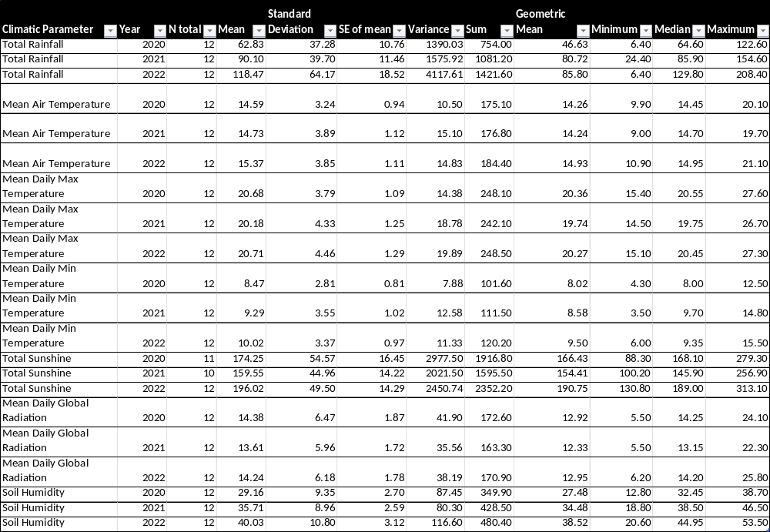.
Table S7. GC-MS analyses of Radula marginata samples from the growth experiment (data are expressed in mg g⁻¹ dry weight calculated using the internal standard response). Growth experiment on Radula marginata collected from S1 and S2 was performed in controlled indoor conditions under two different light and nutrient regimes: full spectrum (FR-) or full spectrum complemented with far-red light (FR+) and sprayed with water or with water supplemented with nutrient solution.
Origin | Stage | Light treatment | Nutrient treatment | BB2P | PTD | PET | BB4G | BB2G | PTDA | PETA | BB4GA
Site 1 | 4m | FR- | Supplemented | 10.98 | 2.32 | < 0.01 | 2.08 | 7.27 | < 0.01 | 0.60 | < 0.01
Site 1 | 4m | FR- | Supplemented | 25.38 | 0.26 | < 0.01 | 6.45 | 8.71 | < 0.01 | 0.47 | 0.90
Site 1 | 4m | FR- | Supplemented | 22.80 | 4.97 | < 0.01 | < 0.01 | 11.27 | < 0.01 | 0.86 | < 0.01
Site 1 | 12m | FR- | Supplemented | 34.05 | 0.74 | 9.11 | < 0.01 | 16.66 | < 0.01 | 3.25 | < 0.01
Site 1 | 12m | FR- | Supplemented | 51.00 | 2.08 | < 0.01 | 10.20 | 21.24 | 4.59 | < 0.01 | 13.55
Site 1 | 12m | FR- | Supplemented | 50.20 | 2.88 | < 0.01 | 10.90 | 22.24 | 5.19 | < 0.01 | 11.05
Site 1 | 4m | FR- | Water | 21.43 | < 0.01 | < 0.01 | 7.65 | 6.67 | < 0.01 | 0.30 | < 0.01
Site 1 | 4m | FR- | Water | 21.45 | 3.89 | < 0.01 | < 0.01 | 10.00 | < 0.01 | 0.83 | < 0.01
Site 1 | 4m | FR- | Water | 22.36 | < 0.01 | < 0.01 | 7.03 | 10.91 | < 0.01 | < 0.01 | 2.60
Site 1 | 12m | FR- | Water | 37.61 | 0.22 | < 0.01 | 14.14 | 21.37 | < 0.01 | < 0.01 | 19.06
Site 1 | 12m | FR- | Water | 35.47 | 0.19 | < 0.01 | 9.12 | 12.31 | < 0.01 | < 0.01 | 9.29
Site 1 | 12m | FR- | Water | 38.38 | 0.17 | < 0.01 | 9.39 | 14.84 | < 0.01 | < 0.01 | 14.00
Site 1 | 4m | FR+ | Supplemented | 8.77 | 3.19 | < 0.01 | < 0.01 | 6.05 | 0.25 | 0.27 | < 0.01
Site 1 | 4m | FR+ | Supplemented | 15.79 | 3.82 | 0.11 | 0.08 | 8.32 | 1.88 | 0.38 | < 0.01
Site 1 | 4m | FR+ | Supplemented | 18.55 | 0.22 | < 0.01 | 9.04 | 5.40 | < 0.01 | < 0.01 | < 0.01
Site 1 | 12m | FR+ | Supplemented | 16.47 | 4.55 | < 0.01 | < 0.01 | 9.34 | 2.20 | < 0.01 | < 0.01
Site 1 | 12m | FR+ | Supplemented | 8.30 | < 0.01 | < 0.01 | 1.83 | 3.21 | < 0.01 | < 0.01 | < 0.01
Site 1 | 12m | FR+ | Supplemented | 19.76 | 7.10 | < 0.01 | < 0.01 | 13.73 | 1.95 | < 0.01 | < 0.01
Site 1 | 4m | FR+ | Water | 23.07 | 3.41 | < 0.01 | < 0.01 | 10.93 | 2.24 | 0.84 | < 0.01
Site 1 | 4m | FR+ | Water | 21.44 | 0.30 | < 0.01 | 6.02 | 8.84 | 0.33 | 0.25 | 3.82
Site 1 | 4m | FR+ | Water | 23.05 | 3.31 | < 0.01 | 1.90 | 9.63 | < 0.01 | 0.61 | < 0.01
Site 1 | 12m | FR+ | Water | 16.16 | 3.71 | < 0.01 | < 0.01 | 9.05 | 2.23 | < 0.01 | < 0.01
Site 1 | 12m | FR+ | Water | 18.17 | 5.97 | < 0.01 | < 0.01 | 11.45 | 3.93 | < 0.01 | < 0.01
Site 1 | 12m | FR+ | Water | 22.43 | 2.00 | < 0.01 | < 0.01 | 13.02 | 10.38 | < 0.01 | < 0.01
Site 1 | 0m | Wild |  | 22.31 | 4.49 | < 0.01 | < 0.01 | 9.62 | < 0.01 | 0.84 | < 0.01
Site 1 | 0m | Wild |  | 13.64 | 1.27 | < 0.01 | 2.54 | 9.76 | < 0.01 | 0.56 | < 0.01
Site 1 | 0m | Wild |  | 10.36 | 3.29 | < 0.01 | 1.58 | 6.63 | < 0.01 | 0.55 | < 0.01
Site 2 | 4m | FR- | Supplemented | 17.68 | <0.01 | 5.63 | 0.20 | 8.22 | <0.01 | 0.21 | <0.01
Site 2 | 4m | FR- | Supplemented | 27.11 | <0.01 | 7.18 | <0.01 | 12.68 | <0.01 | <0.01 | <0.01
Site 2 | 4m | FR- | Supplemented | 18.72 | 2.99 | 2.03 | <0.01 | 10.90 | 2.26 | 0.40 | <0.01
Site 2 | 12m | FR- | Supplemented | 71.50 | <0.01 | 15.31 | <0.01 | 33.43 | <0.01 | <0.01 | <0.01
Site 2 | 12m | FR- | Supplemented | 59.30 | <0.01 | 16.44 | <0.01 | 26.73 | <0.01 | 4.34 | <0.01
Site 2 | 12m | FR- | Supplemented | 49.68 | <0.01 | 9.87 | <0.01 | 20.02 | <0.01 | 1.73 | <0.01
Site 2 | 4m | FR- | Water | 31.14 | <0.01 | 8.56 | 0.78 | 13.18 | <0.01 | 0.25 | <0.01
Site 2 | 4m | FR- | Water | 25.87 | 2.95 | 1.82 | 0.43 | 9.66 | <0.01 | 0.55 | <0.01
Site 2 | 4m | FR- | Water | 22.81 | <0.01 | 3.85 | 0.61 | 10.92 | <0.01 | 0.27 | <0.01
Site 2 | 12m | FR- | Water | 40.54 | 0.80 | 2.89 | 4.74 | 17.43 | 1.98 | 3.46 | 7.97
Site 2 | 12m | FR- | Water | 62.77 | 0.50 | 10.07 | 2.56 | 24.95 | <0.01 | 7.09 | <0.01
Site 2 | 12m | FR- | Water | 62.97 | 3.08 | 7.15 | 1.41 | 24.41 | 4.64 | 5.68 | <0.01
Site 2 | 4m | FR+ | Supplemented | 32.23 | 2.68 | 0.00 | 2.62 | 9.97 | <0.01 | 0.45 | <0.01
Site 2 | 4m | FR+ | Supplemented | 22.37 | <0.01 | 5.13 | 0.00 | 8.97 | <0.01 | 0.15 | <0.01
Site 2 | 4m | FR+ | Supplemented | 17.74 | <0.01 | 4.28 | 0.00 | 7.70 | <0.01 | 0.11 | <0.01
Site 2 | 12m | FR+ | Supplemented | 27.37 | 0.14 | 1.51 | 6.33 | 8.94 | <0.01 | <0.01 | <0.01
Site 2 | 12m | FR+ | Supplemented | 14.53 | 1.50 | <0.01 | 3.54 | 6.37 | <0.01 | <0.01 | <0.01
Site 2 | 12m | FR+ | Supplemented | 25.14 | 0.77 | <0.01 | 4.56 | 11.18 | 1.03 | <0.01 | 7.52
Site 2 | 4m | FR+ | Water | 25.97 | <0.01 | 0.72 | 2.57 | 12.64 | <0.01 | 0.34 | 0.35
Site 2 | 4m | FR+ | Water | 28.93 | 2.74 | 3.71 | 0.13 | 17.39 | <0.01 | 0.80 | <0.01
Site 2 | 4m | FR+ | Water | 32.47 | <0.01 | 7.27 | 0.35 | 19.56 | <0.01 | 2.00 | <0.01
Site 2 | 12m | FR+ | Water | 47.15 | 0.38 | 8.64 | 0.00 | 21.91 | <0.01 | 5.58 | <0.01
Site 2 | 12m | FR+ | Water | 49.45 | <0.01 | 6.69 | 0.00 | 17.92 | <0.01 | 3.81 | <0.01
Site 2 | 12m | FR+ | Water | 71.01 | 0.94 | 6.71 | 1.24 | 25.23 | 1.59 | 4.50 | <0.01
Site 2 | 0m | Wild |  | 28.14 | 0.69 | 3.08 | 0.00 | 10.97 | <0.01 | 0.46 | <0.01
Site 2 | 0m | Wild |  | 22.52 | 3.44 | 0.40 | 0.00 | 9.82 | <0.01 | 0.69 | <0.01
Site 2 | 0m | Wild |  | 36.34 | 2.60 | 0.75 | 0.00 | 11.18 | 1.81 | 0.52 | <0.01
Site 2 | 0m | Wild |  | 27.80 | < 0.01 | 5.19 | 4.67 | 17.54 | <0.01 | 0.51 | <0.01
Site 2 | 0m | Wild |  | 16.94 | < 0.01 | 4.69 | 0.12 | 9.71 | <0.01 | 0.22 | <0.01

Table S8. GC-MS analyses of Radula marginata samples from the in vitro samples compared with subsamples of their wild colony of origin (data are expressed in mg g⁻¹ dry weight calculated using the internal standard response).
Sample | Origin | BB2P | PTD | PET | BB4G | BB2G | PTDA | PETA | BB4GA
In vitro | Line 1 | 88.63 | <0.01 | 4.65 | 1.95 | 7.78 | <0.01 | 3.48 | 2.70
In vitro | Line 2 | 94.53 | <0.01 | 2.09 | 1.29 | 8.93 | <0.01 | 6.60 | 4.75
In vitro | Line 3 | 67.26 | <0.01 | 3.35 | 1.72 | 7.72 | <0.01 | 2.52 | 2.05
Wild | Site 2 | 28.14 | 0.69 | 3.08 | <0.01 | 10.97 | <0.01 | 0.46 | <0.01
Wild | Site 2 | 22.52 | 3.44 | 0.40 | <0.01 | 9.82 | <0.01 | 0.69 | <0.01
Wild | Site 2 | 36.34 | 2.60 | 0.75 | <0.01 | 11.18 | 1.81 | 0.52 | <0.01
Wild | Site 2 | 27.80 | 0.52 | 5.19 | 4.67 | 17.54 | <0.01 | 0.51 | <0.01
Wild | Site 2 | 16.94 | 0.64 | 4.69 | 0.12 | 9.71 | <0.01 | 0.22 | <0.01
Supplementary figures

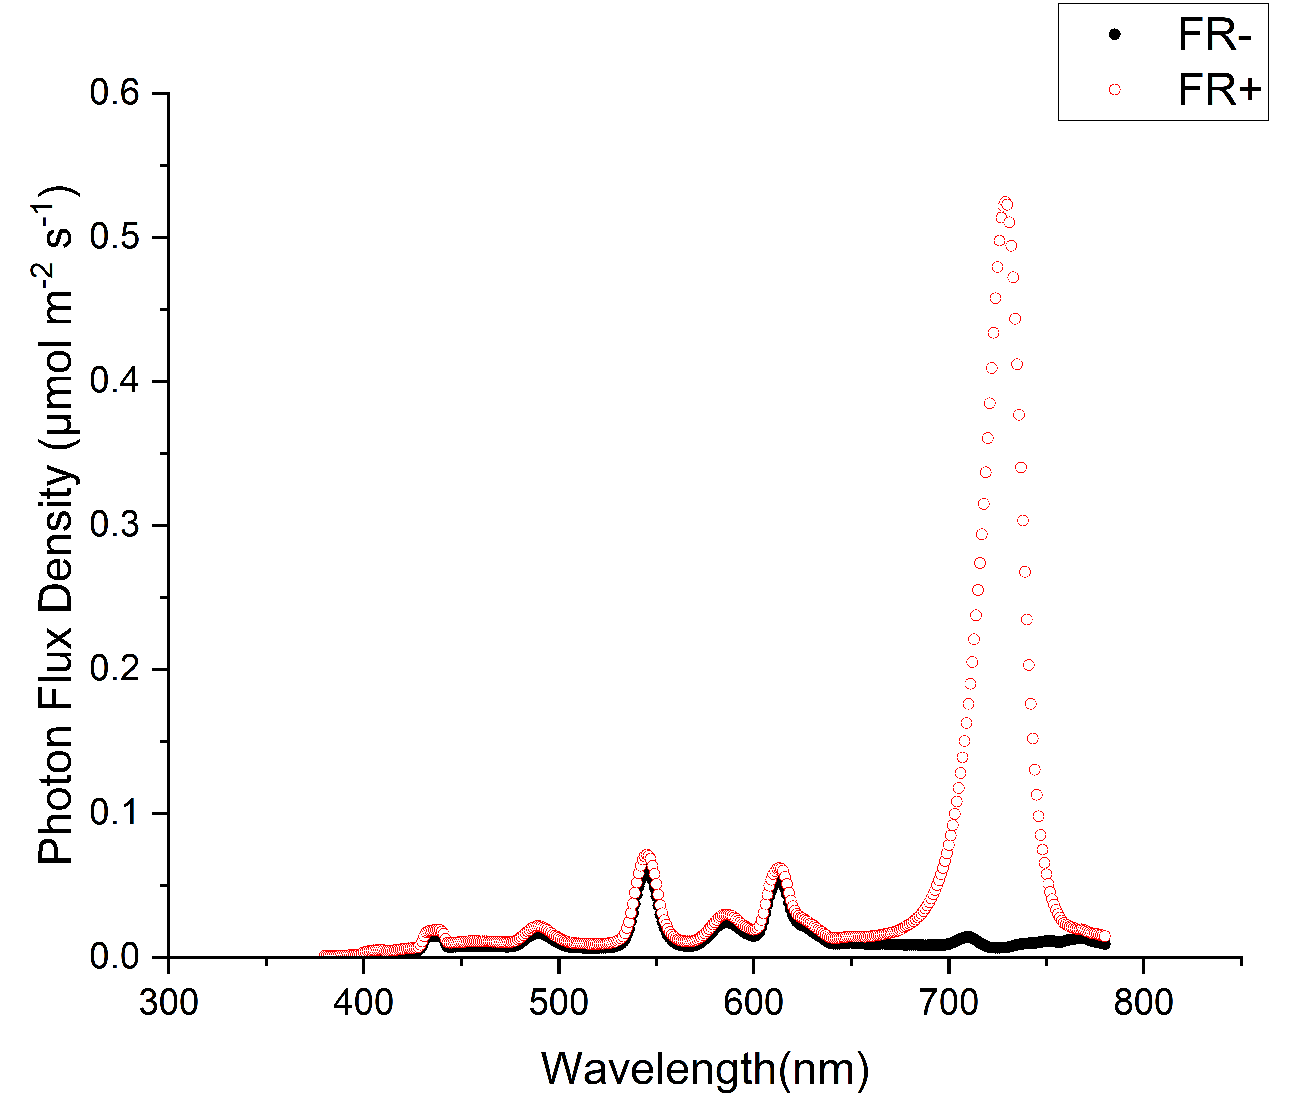
Fig. S1: Light spectrum in the two different growing cabinets equipped with artificial lightning supplemented with far red light (FR+; red dots) or not (FR-; black dots).
A
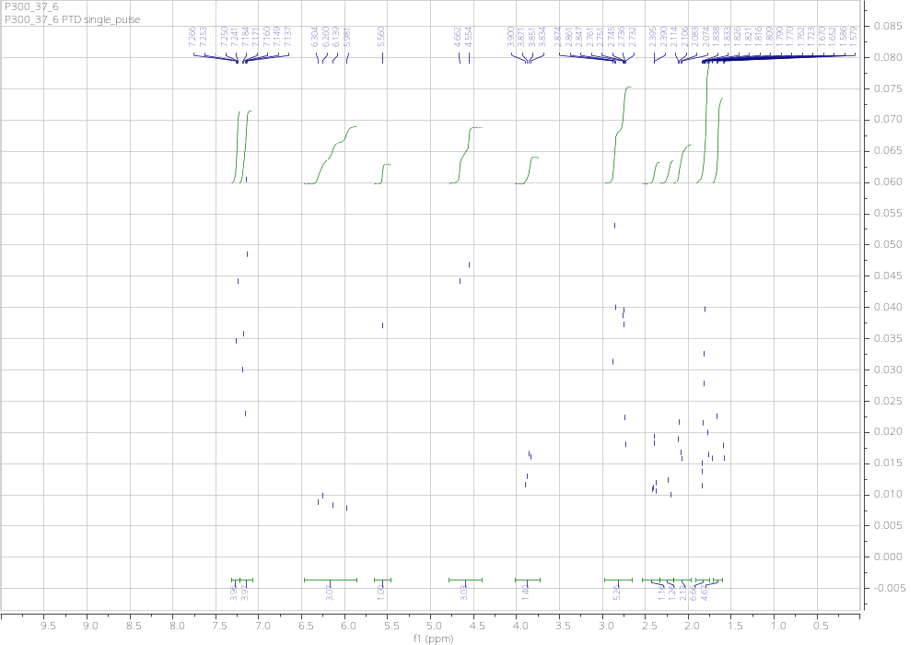
B
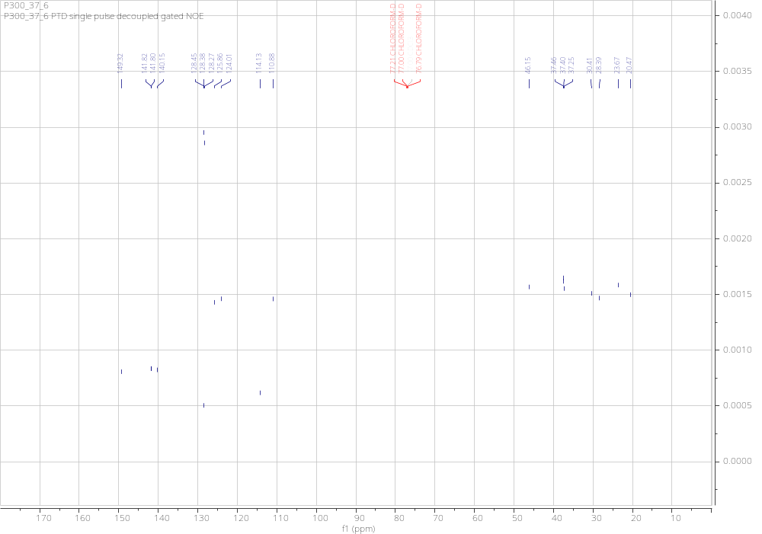
Fig. S2. ¹H NMR (A) and ¹³C (B) NMR spectrum of PTD 5 in CDCl₃, recorded at 600 MHz and 150 MHz, respectively.
A
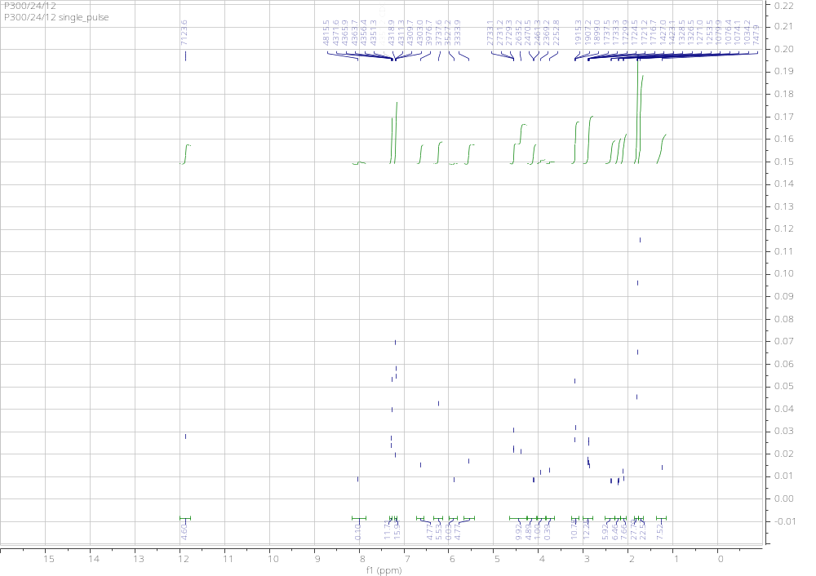
B
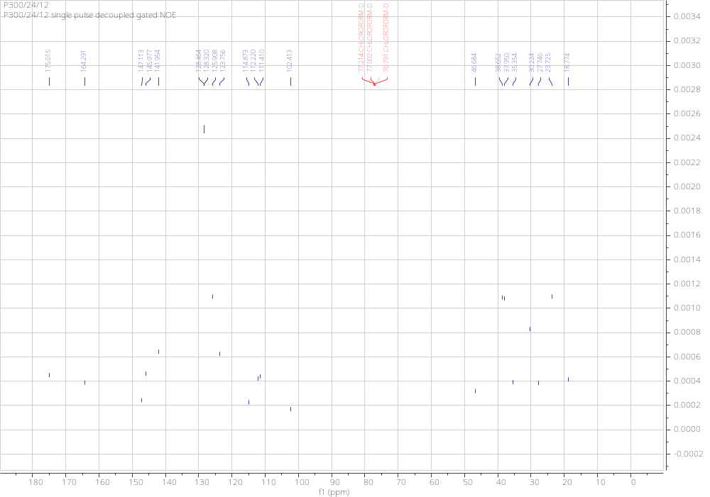
Fig. S3. ¹H NMR (A) and ¹³C (B) NMR spectrum of PTDA 6 in CDCl₃ recorded at 600 MHz and 150 MHz, respectively.

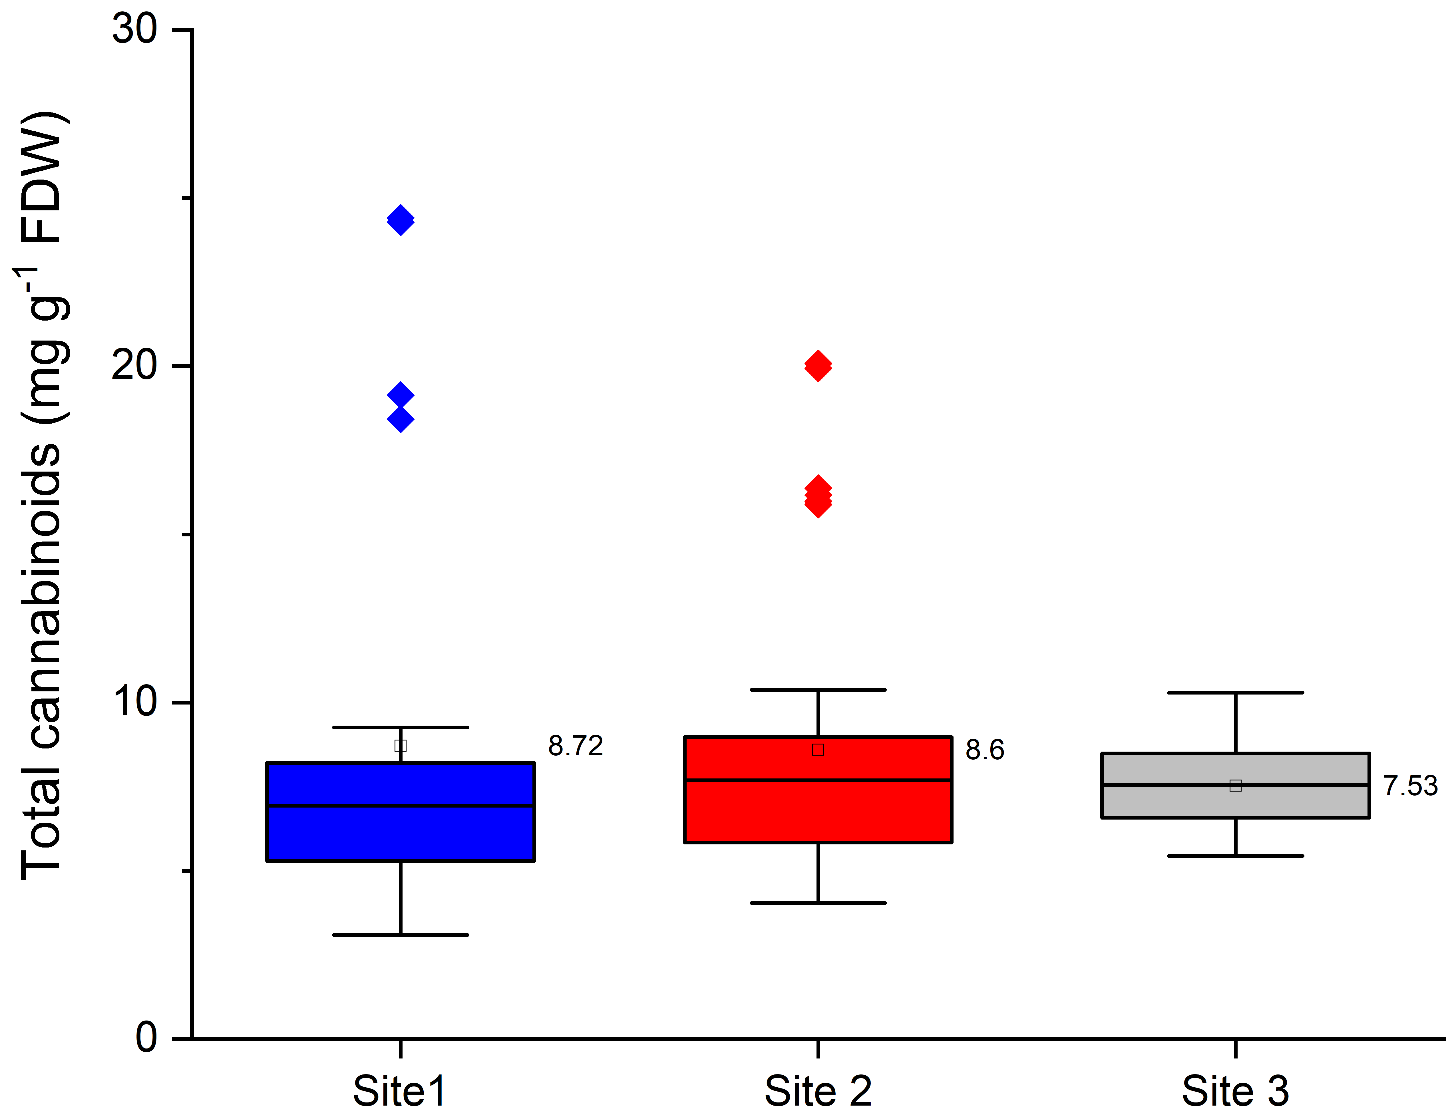
Fig. S4: Total bibenzyl cannabinoid concentrations averaged per site. Box plot includes the mean value (empty square). Data are expressed in mg g ⁻¹ freeze-dried weight.
(a) (b)
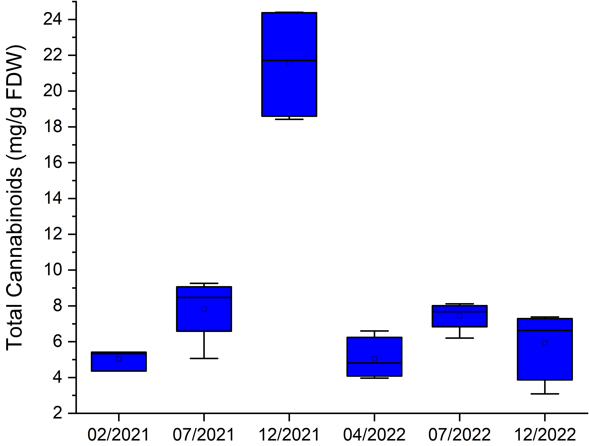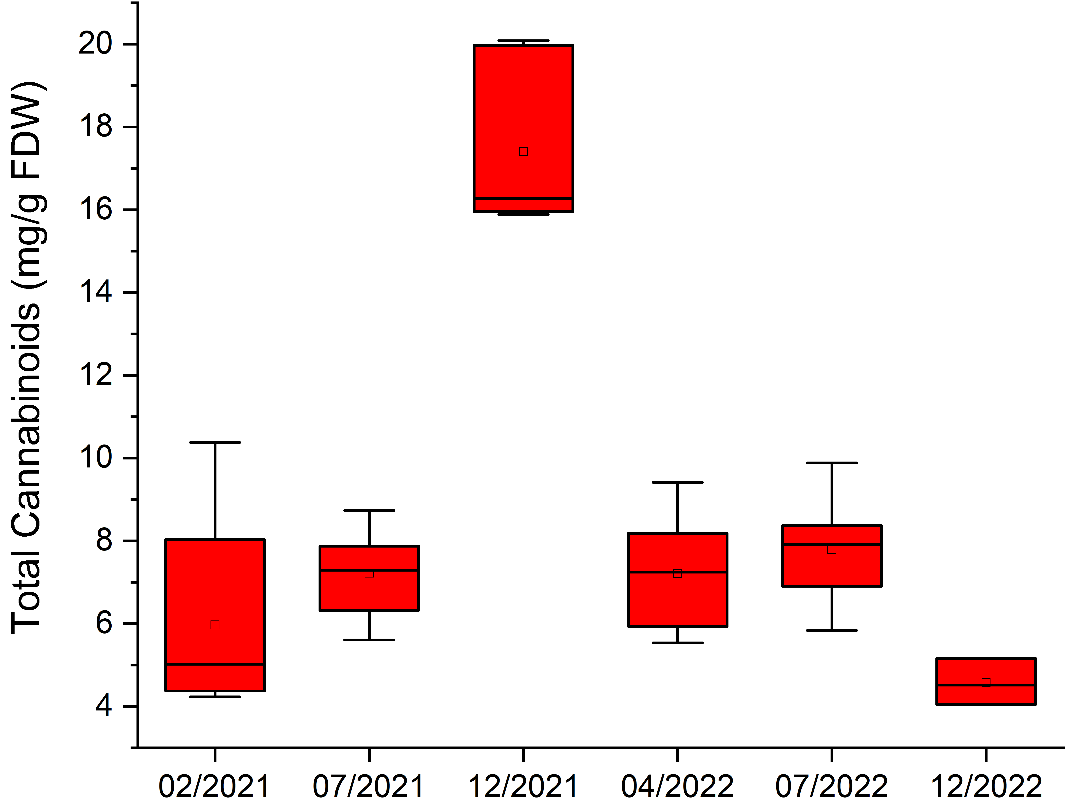
Fig. S5: Total bibenzyl cannabinoid concentrations averaged per date of sampling for S1 (a) and S2 (b). Box plot includes the mean value (empty square). Data are expressed in mg g ⁻¹ freeze-dried weight.
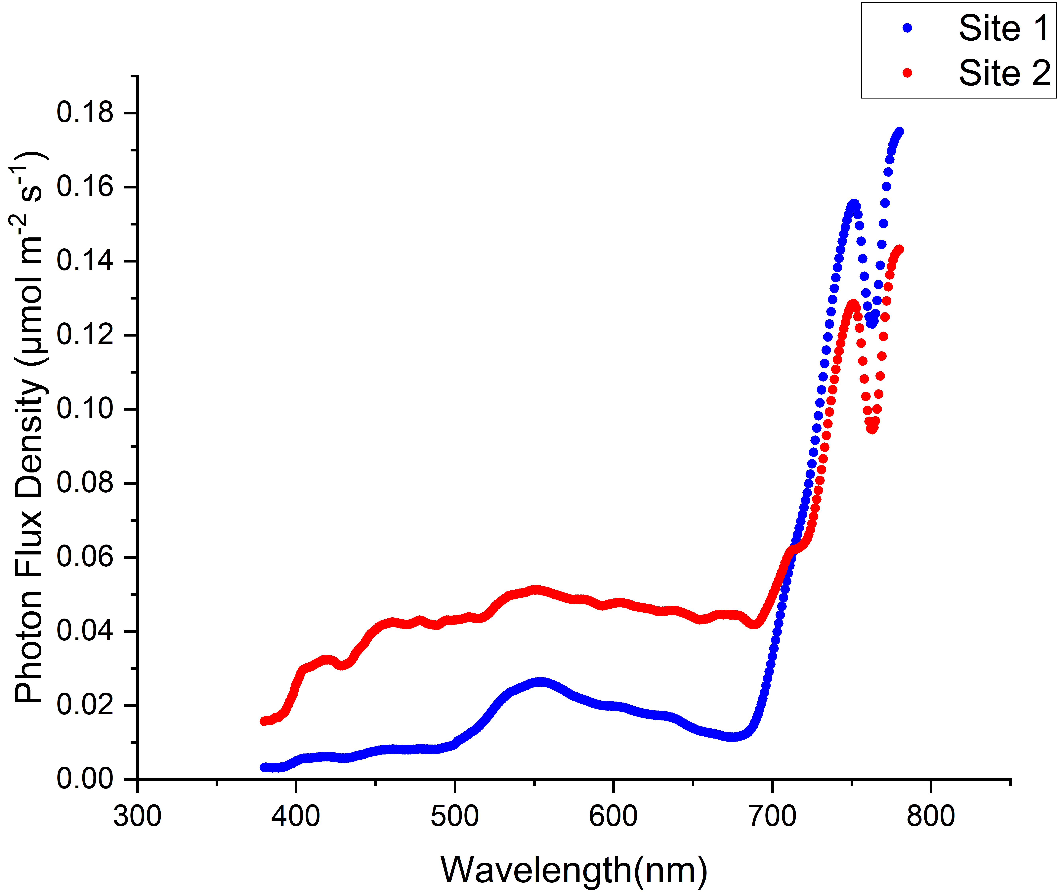
Fig. S6: Light spectrum recorded in December 2022 at Radula marginata growing sites S1 and S2. Significant difference between S1 and S2 in terms of intensity of far-red light compared to the rest of the light spectrum can be observed, with specifically a ratio of Photon Flux Density (PFD) (far red; 700-780 nm)/ PFD (380-700 nm) of 0.61 ± 0.06 and 0.41 ± 0.03 for S1 and S2, respectively (P < 0.01).

Fig. S7: Climatic data recorded in the nearest meteorological station (Hamilton- Ruakura, New Zealand) during Radula marginata collections (National Institute of Water and Atmospheric Research (NIWA), https://cliflo.niwa.co.nz/, data retrieved in February 2024).

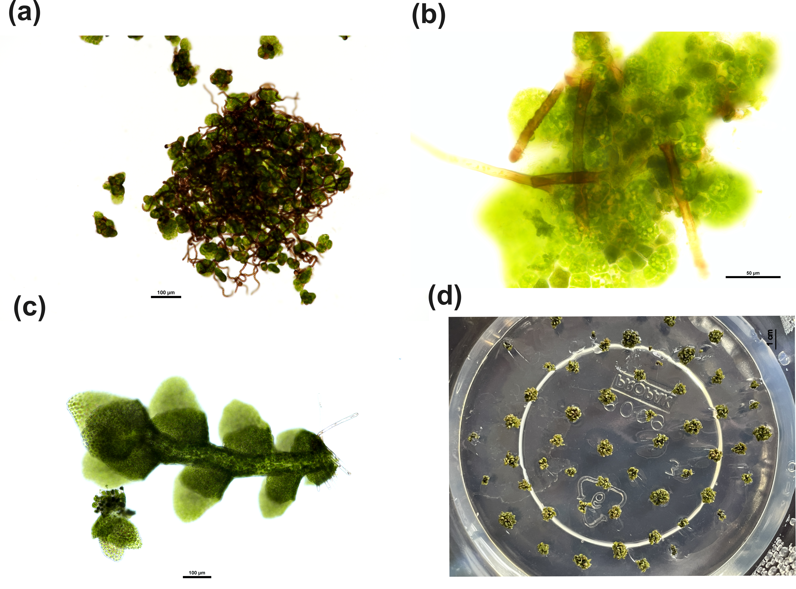

Fig. S8: Different stages of Radula marginata grown in in vitro tissue culture under artificial lighting. (a) Growing spores with remaining elaters from capsule. Scale bar = 100 µm (b) Protonema with developing rhizoids. Scale bar = 50 µm (c) Leaf and stem development along with oil bodies. Scale bar = 100 µm (d) Ball-like growth of adult plants. Scale bars = 100 µm for a and c; 50 µm for b; and 1 cm for d.

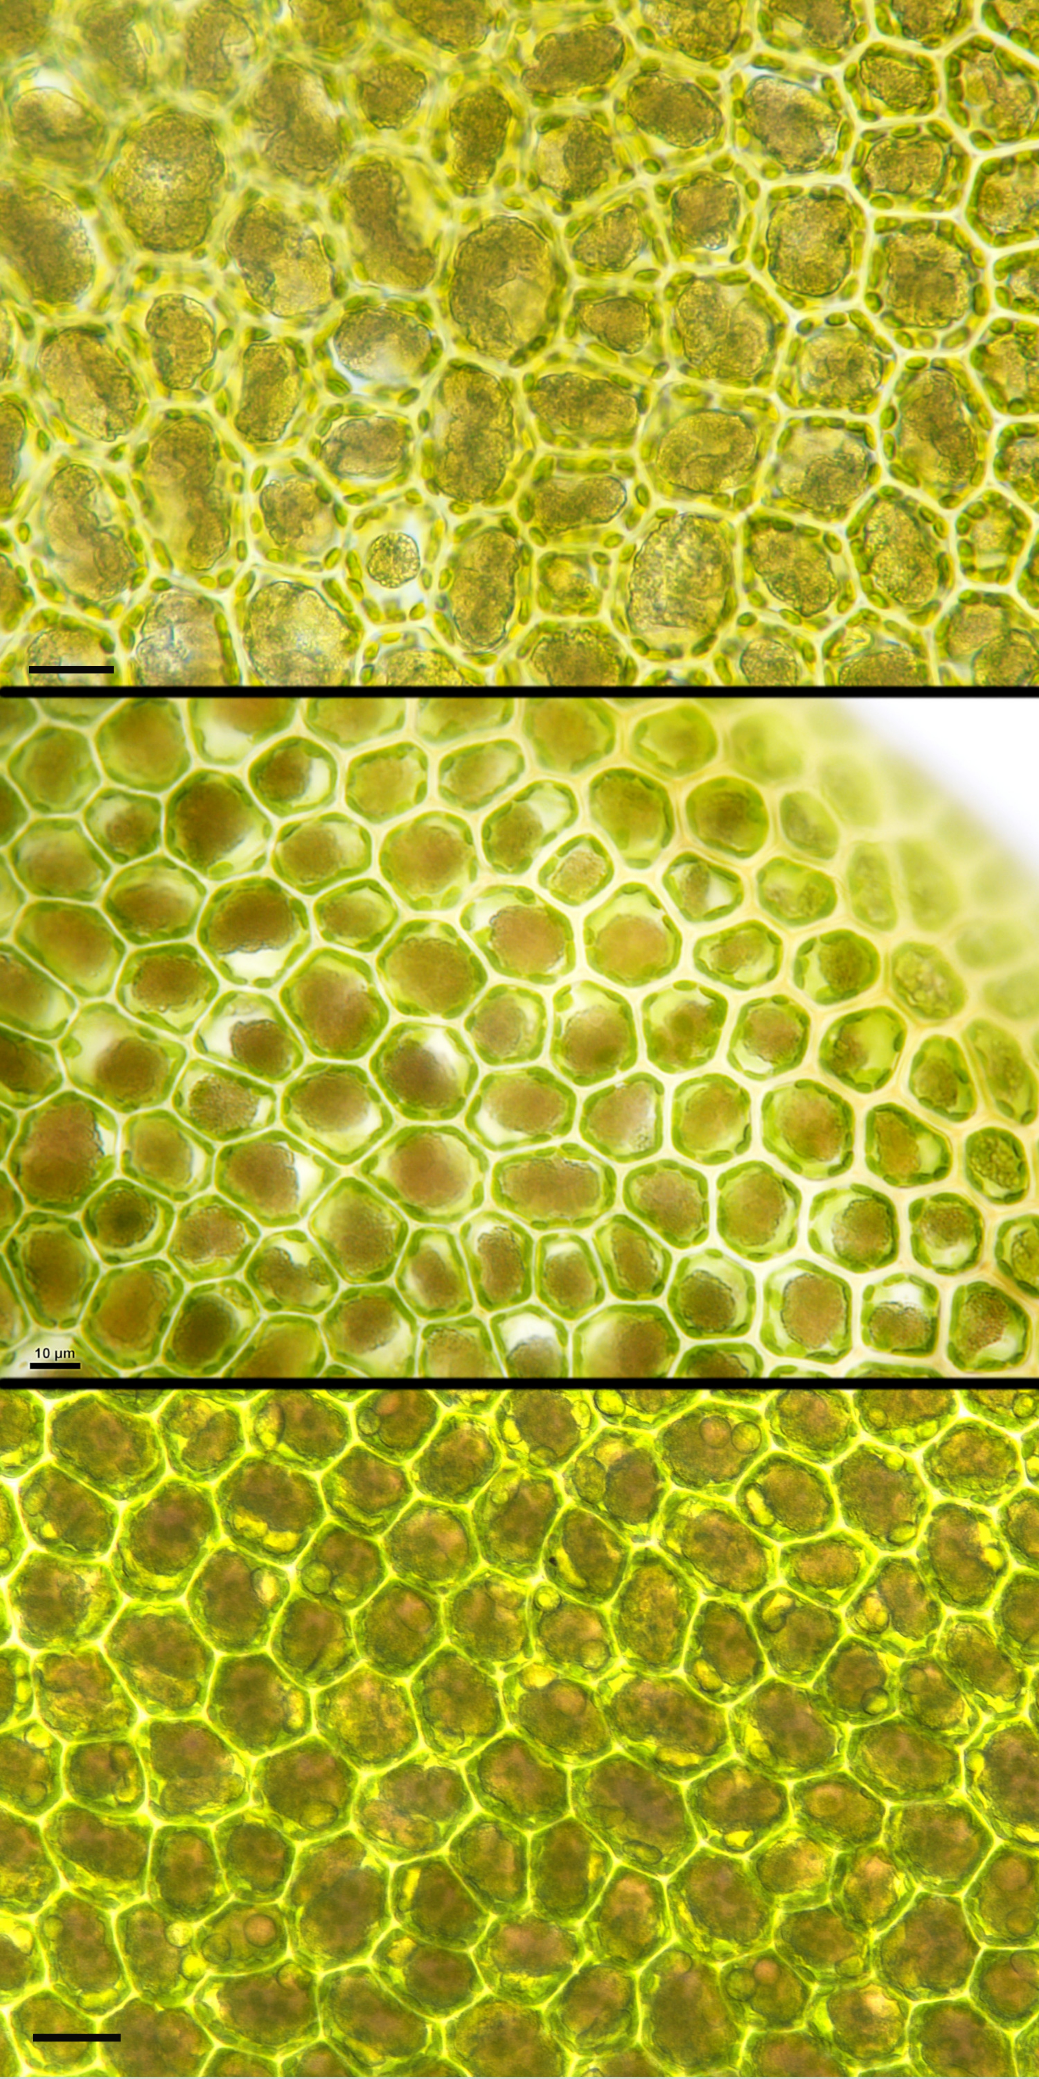

Fig. S9: Direct comparison of Radulamarginata oil bodies grown in wild environment (top) as well as in controlled indoor conditions (middle) and in in vitro tissue culture under artificial lighting (bottom). Scale bars = 10 µm.

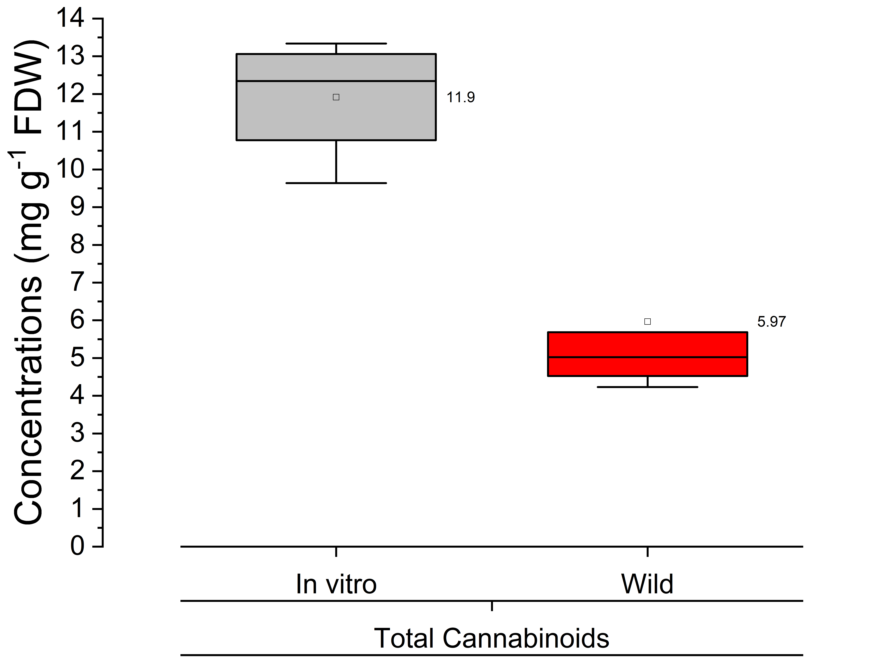

Fig. S10: Total bibenzyl cannabinoid concentrations of Radula marginata in tissue culture vs. in the wild.

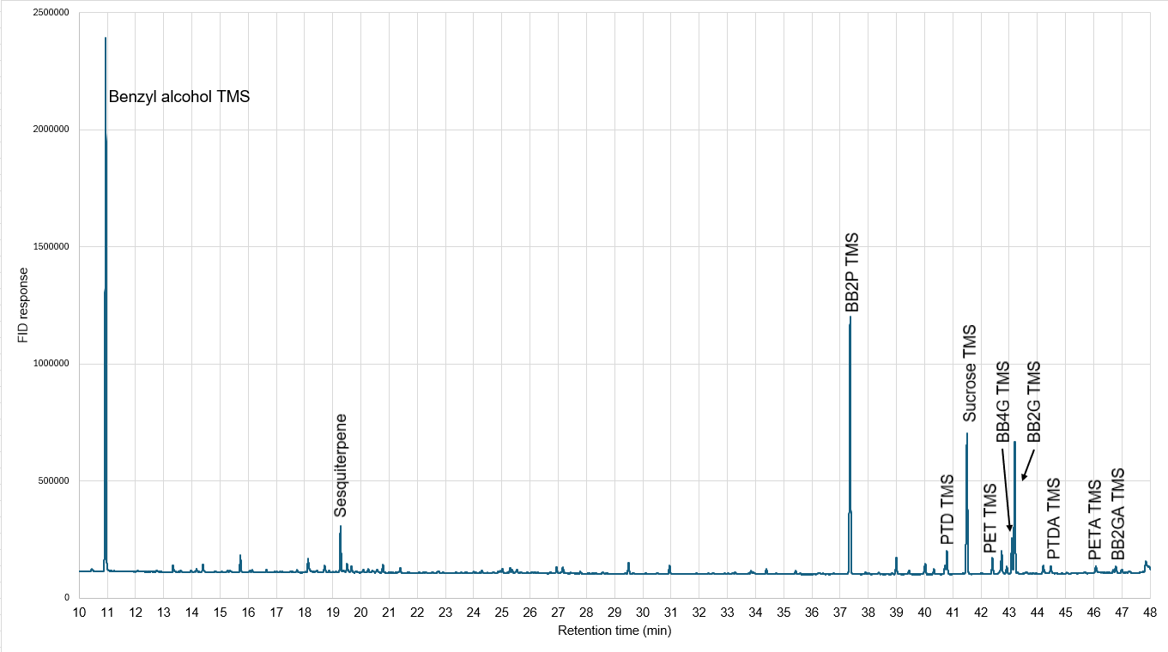
Fig. S11: Example GC-FID chromatogram of a derivatized Radula marginata extract containing benzyl alcohol as internal standard.

Supplementary references
Asakawa Y, Hashimoto T, Takikawa K, Tori M, Ogawa S. 1991. Prenyl bibenzyls from the liverworts Radula perrottetii and Radula complanata. Phytochemistry 30: 235-251.
Chicca A, Schafroth MA, Reynoso-Moreno I, Erni R, Petrucci V, Carreira EM, Gertsch J. 2018. Uncovering the psychoactivity of a cannabinoid from liverworts associated with a legal high. Science Advances 4: eaat2166.
Crombie LW, Crombie WML, Firth DF. 1988. Synthesis of bibenzyl cannabinoids. Hybrids of two biogenetic series found in Cannabis sativa. Journal of the Chemical Society, Perkin Transactions 1: 1263-1270.
Dat NT, Lee J-H, Lee K, Hong Y-S, Kim YH, Lee JJ. 2008. Phenolic Constituents of Amorpha fruticosa That Inhibit NF-κB Activation and Related Gene Expression. Journal of Natural Products 71: 1696-1700.
Kukutai T. 2024. How Indigenous communities in New Zealand are protecting their data. Science 384: eado9298.
Song Y, Hwang S, Gong P, Kim D, Kim S. 2008. Stereoselective Total Synthesis of (-)-Perrottetinene and Assignment of Its Absolute Configuration. Organic Letters 10: 269-271.
Toyota M, Kinugawa T, Asakawa Y. 1994. Bibenzyl cannabinoid and bisbibenzyl derivative from the liverwort Radula perrottetii. Phytochemistry 37: 859-862.
Toyota M, Shimamura T, Ishii H, Renner M, Braggins J, Asakawa Y. 2002. New bibenzyl cannabinoid from the New Zealand liverwort Radula marginata. Chemical and Pharmaceutical Bulletin 50: 1390-1392.

