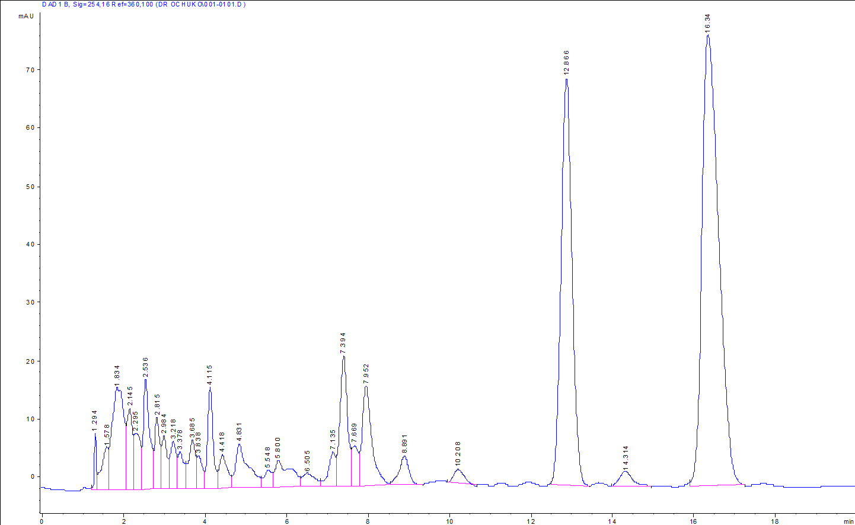
Fig. S1A: HPLC fingerprint of hexane extract of C. sativa

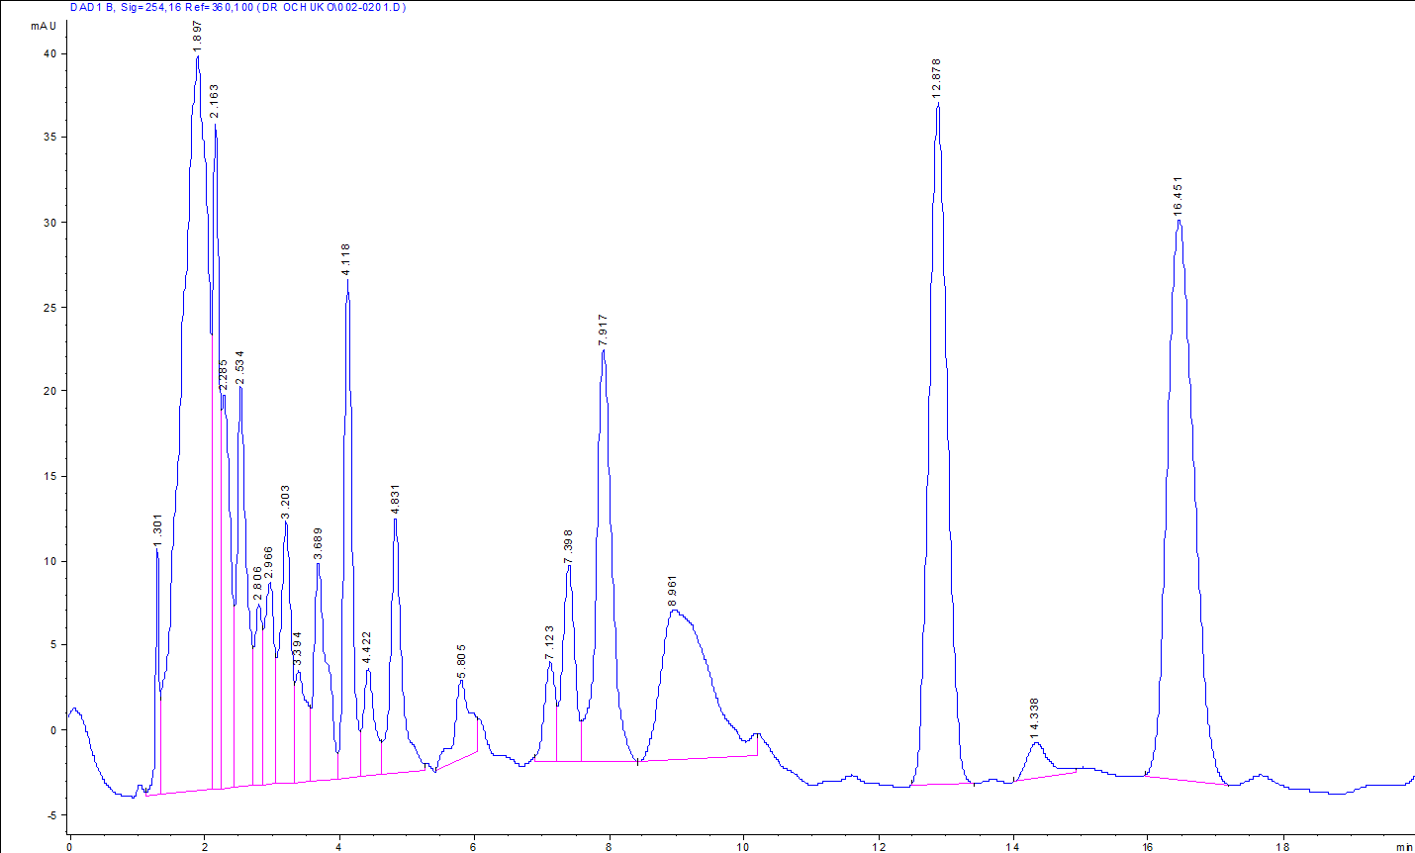
Fig. S1B: HPLC fingerprint of DCM extract of C. sativa

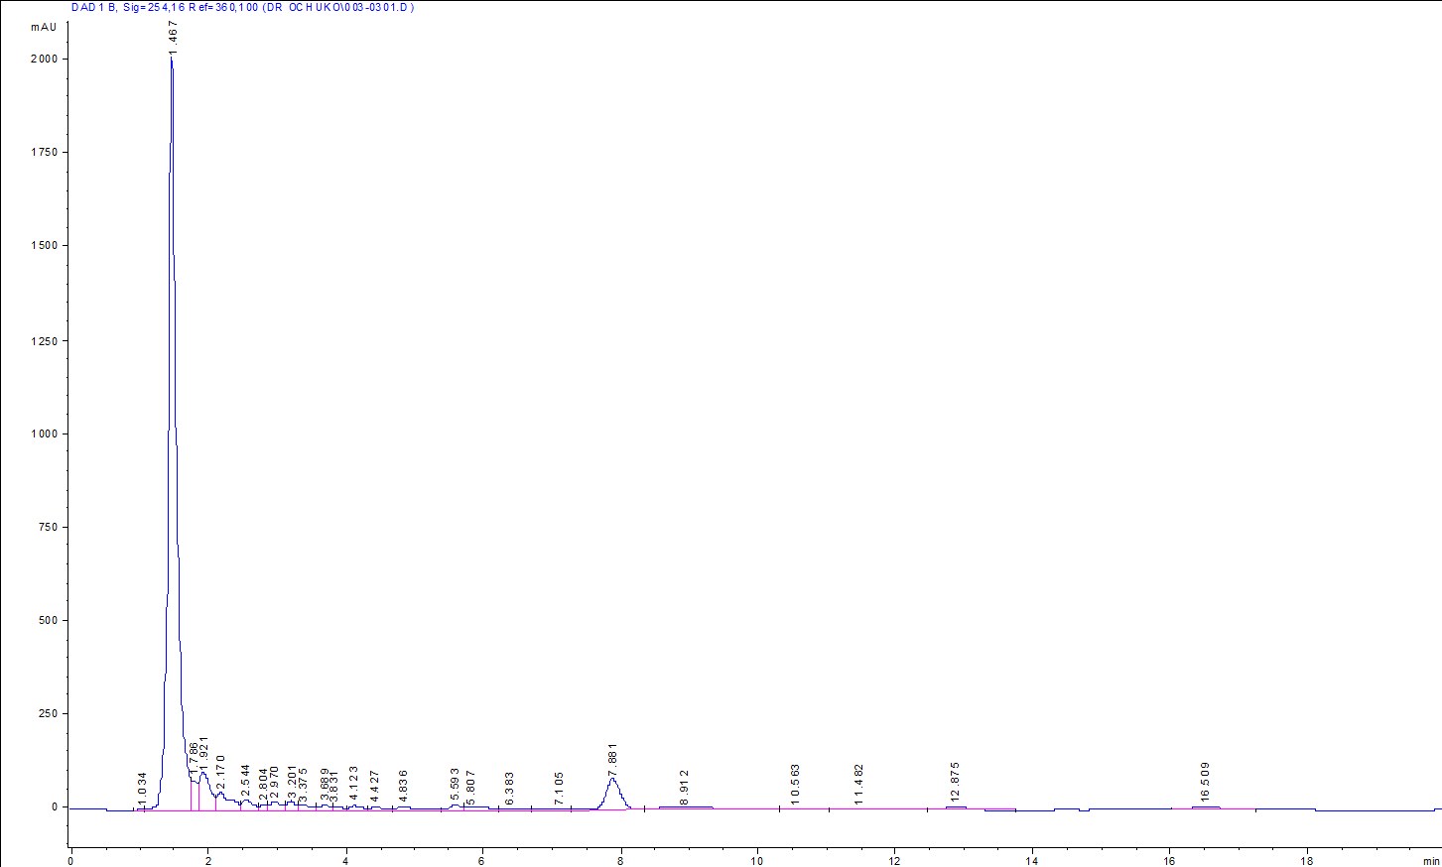
Fig. S1C: HPLC fingerprint of ethanol extract of C. sativa

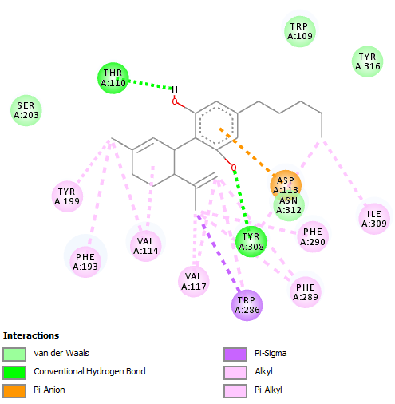

Fig. S2: 3D structure of (A) cannabidiol in complex with cannabinoid receptor. (B) 2-D representations displaying the interactions with amino acid residues.

