Supplementary Figure 1

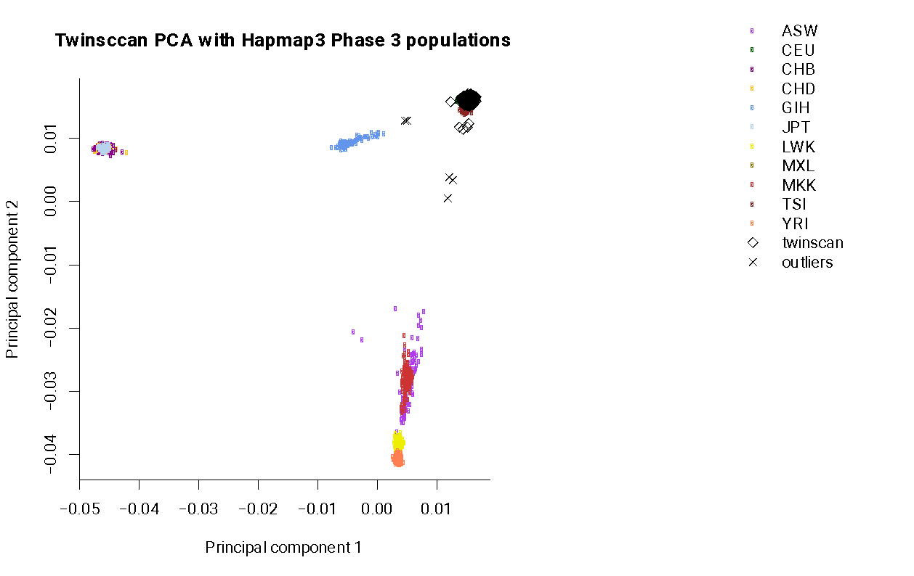
The first and second principal component of TwinssCan data (with identified ethnic outliers) along with hapmap3 population

Supplementary Tables

Table-1. 20 Complex-LD regions and long-range LD regions excluded from PRS analysis.
Chromosome | Base pair position (start point to end point)
1 | 48000000-52000000
2 | 86000000-100500000
2 | 183000000-190000000
3 | 47500000-50000000
3 | 83500000-87000000
5 | 44500000-50500000
5 | 129000000-132000000
6 | 25500000-33500000
6 | 57000000-64000000
6 | 140000000-142500000
7 | 55000000-66000000
8 | 8000000-12000000
8 | 43000000-50000000
8 | 112000000-115000000
10 | 37000000-43000000
11 | 87500000-90500000
12 | 33000000-40000000
20 | 32000000-34500000
8 | 8135000-12000000
17 | 40900000-45000000

Table-2. The number of alleles used for PRS calculation for the TwinssCan data at different P-value thresholds using the different cohorts
Level | P-value threshold | Number of SNPs
1 | 5x10⁻⁸ | 168
2 | 5x10⁻⁷ | 302
3 | 5x10⁻⁶ | 567
4 | 5x10⁻⁵ | 1236
5 | 5x10⁻⁴ | 2900
6 | 5x10⁻³ | 8144
7 | 0.05 | 26635
8 | 0.1 | 38852
9 | 0.2 | 56596
10 | 0.3 | 70225
11 | 0.4 | 81110
12 | 0.5 | 89965
13 | 1 | 113020

Table-3. Associations between psychosis-associated risk factors and autistic traits with CAPE positive subscores
 | B (95% CI) | p
Autistic traits | 0.10 (0.08 - 0.12) | <0.001
PRS-SZ | 0.01 (-0.01- 0.03) | 0.28
Winter birth | 0.01 (-0.19 - 0.20) | 0.28
Hearing impairment | 0.03 (-0.02- 0.07) | 0.96
Emotional abuse | 0.16 (0.12 - 0.20) | <0.001
Physical abuse | 0.25 (0.16 - 0.34) | <0.001
Sexual abuse | 0.23 (0.06 - 0.13) | <0.001
Emotional neglect | 0.06 (0.06 - 0.13) | 0.004
Physical neglect | 0.12 (0.06 - 0.13) | <0.001
Bullying | 0.10 (0.06 - 0.14) | <0.001
Obstetric complications | 0.03 (-0.02 - 0.08) | 0.25
Negative life events | 0.07 (0.05 - 0.08) | <0.001
Cannabis use | -0.05 (-0.14 - 0.04) | 0.27
Age and gender were covariates. Statistical significance is p<0.004 after Bonferroni correction. CAPE: The Community Assessment of Psychic Experiences,PRS-SZ: schizophrenia polygenic risk score, B: unstandardized regression coefficient, CI: confidence interval

Table-4. Associations between psychosis-associated risk factors and autistic traits with CAPE negative subscores
 | B (95% CI) | p
Autistic traits | 0.16 (0.14 - 0.18) | <0.001
PRS-SZ | 0.00 (-0.03- 0.03) | 0.99
Winter birth | 0.03 (-0.02- 0.07) | 0.28
Hearing impairment | 0.16 (-0.09 - 0.40) | 0.21
Emotional abuse | 0.18(0.13 - 0.23) | <0.001
Physical abuse | 0.19(0.08 - 0.31) | 0.001
Sexual abuse | 0.16(0.07 - 0.26) | <0.001
Emotional neglect | 0.10(0.05 - 0.14) | <0.001
Physical neglect | 0.12 (0.05 - 0.18) | <0.001
Bullying | 0.09 (0.04 - 0.14) | <0.001
Obstetric complications | -0.002 (-0.06- 0.06) | 0.94
Negative life events | 0.07 (0.04 - 0.09) | <0.001
Cannabis use | 0.03 (-0.08- 0.15) | 0.59
Age and gender were covariates. Statistical significance is p<0.004 after Bonferroni correction. , CAPE: The Community Assessment of Psychic Experiences, PRS-SZ: schizophrenia polygenic risk score, B: unstandardized regression coefficient, CI: confidence interval

Table-5. Associations between psychosis-associated risk factors and autistic traits with CAPE depressive subscores
 | B (95% CI) | p
Autistic traits | 0.11 (0.09 - 0.14) | <0.001
PRS-SZ | 0.02 (0.00- 0.05) | 0.07
Winter birth | 0.03 (-0.02- 0.09) | 0.25
Hearing impairment | 0.15 (-0.11 - 0.41) | 0.25
Emotional abuse | 0.23 (0.18 - 0.28) | <0.001
Physical abuse | 0.24 (0.12 - 0.36) | <0.001
Sexual abuse | 0.26 (0.17 - 0.36) | <0.001
Emotional neglect | 0.11 (0.06 - 0.16) | <0.001
Physical neglect | 0.10 (0.03 - 0.17) | 0.004
Bullying | 0.10 (0.05 - 0.15) | <0.001
Obstetric complications | 0.01 (-0.05- 0.07) | 0.76
Negative life events | 0.10 (0.07 - 0.12) | <0.001
Cannabis use | 0.09 (-0.03- 0.21) | 0.15
Age and gender were covariates. Statistical significance is p<0.004 after Bonferroni correction. , CAPE: The Community Assessment of Psychic Experiences,PRS-SZ: schizophrenia polygenic risk score, B: unstandardized regression coefficient, CI: confidence interval

Table-6. Marginal effects for the relationship between ATs and PEs by presence of CT Subtypes

Childhood Trauma  (1 = Present, 0 = Absent) |  |  | dy/dx (95% CI) | P value
Emotional abuse | 1 | 0.16 (0.13 – 0.18) |  | <0.001
Emotional abuse | 0 | 0.08 (0.06 – 0.10) |  | <0.001
Physical abuse | 1 | 0.22 (0.15 – 0.28) |  | <0.001
Physical abuse | 0 | 0.11 (0.09 – 0.12) |  | <0.001
Sexual abuse | 1 | 0.20 (0.14 – 0.25) |  | <0.001
Sexual abuse | 0 | 0.10 (0.09 – 0.12) |  | <0.001
Emotional neglect | 1 | 0.14 (0.11 – 0.16) |  | <0.001
Emotional neglect | 0 | 0.09 (0.07 – 0.12) |  | <0.001
Physical neglect | 1 | 0.17 (0.13 – 0.20) |  | <0.001
Physical neglect | 0 | 0.10 (0.08 – 0.12) |  | <0.001
Marginal effects analysis was performed to estimate the differential influences of the ATs at different levels of CT subtypes. ATs: autistic traits, PEs: psychotic experiences, CT: childhood trauma.

Table-7.Interaction effects of psychosis-associated risk factors and ATs on CAPE positive subscores
 | B (95% CI) | p
PRS-SZ | -0.01 (-0.02- 0.01) | 0.25
Winter birth | 0.03 (0.00- 0.07) | 0.08
Hearing impairment | -0.10 (-0.38- 0.18) | 0.48
Emotional abuse | 0.12 (0.08 - 0.15) | <0.001
Physical abuse | 0.15 (0.07 - 0.22) | <0.001
Sexual abuse | 0.10 (0.03 - 0.16) | 0.003
Emotional neglect | 0.05 (0.02 - 0.09) | 0.005
Physical neglect | 0.07 (0.03 - 0.11) | 0.002
Bullying | 0.02 (-0.02 - 0.06) | 0.27
Obstetric complications | 0.01 (-0.04 - 0.05) | 0.79
Negative life events | 0.01 (-0.004 - 0.02) | 0.17
Cannabis use | -0.06 (-0.14 - 0.03) | 0.20
Age and gender were covariates. Statistical significance is p<0.004 after Bonferroni correction. ATs: autistic traitsCAPE: The Community Assessment of Psychic Experiences PRS-SZ: schizophrenia polygenic risk score, B: unstandardized regression coefficient, CI: confidence interval

Table-8.Interaction effects of psychosis-associated risk factors and ATs on CAPE negative subscores
 | B (95% CI) | p
PRS-SZ | -0.01 (-0.03 - 0.01) | 0.39
Winter birth | 0.02 (-0.02 - 0.07) | 0.35
Hearing impairment | 0.21 (-0.11 - 0.54) | 0.20
Emotional abuse | 0.09 (0.04 - 0.13) | <0.001
Physical abuse | 0.08 (-0.01 - 0.17) | 0.08
Sexual abuse | 0.10 (0.02 - 0.18) | 0.01
Emotional neglect | 0.03 (-0.01 - 0.07) | 0.15
Physical neglect | 0.06 (0.01 - 0.11) | 0.03
Bullying | 0.03 (-0.02 - 0.07) | 0.21
Obstetric complications | -0.02 (-0.07 - 0.04) | 0.45
Negative life events | 0.02 (0.003 - 0.04) | 0.02
Cannabis use | -0.03 (-0.13 - 0.08) | 0.60
Age and gender were covariates. Statistical significance is p<0.004 after Bonferroni correction.ATs: autistic traits CAPE: The Community Assessment of Psychic ExperiencesPRS-SZ: schizophrenia polygenic risk score, B: unstandardized regression coefficient, CI: confidence interval

Table-9.Interaction effects of psychosis-associated risk factors and ATs on CAPE depressive subscores
 | B (95% CI) | p
PRS-SZ | -0.01 (-0.03 - 0.01) | 0.37
Winter birth | 0.04 (-0.01 - 0.09) | 0.09
Hearing impairment | 0.21 (-0.15 - 0.58) | 0.26
Emotional abuse | 0.09 (0.04- 0.14) | <0.001
Physical abuse | 0.11 (0.01- 0.21) | 0.04
Sexual abuse | 0.05 (-0.03 - 0.14) | 0.22
Emotional neglect | 0.05 (0.01 - 0.10) | 0.02
Physical neglect | 0.08 (0.02 - 0.13) | 0.009
Bullying | 0.01 (-0.04 - 0.06) | 0.58
Obstetric complications | 0.02 (-0.04 - 0.07) | 0.56
Negative life events | 0.01 (-0.004 - 0.03) | 0.12
Cannabis use | -0.05 (-0.17 - 0.06) | 0.38
Age and gender were covariates. Statistical significance is p<0.004 after Bonferroni correction. ATs: autistic traits CAPE: The Community Assessment of Psychic ExperiencesPRS-SZ: schizophrenia polygenic risk score, B: unstandardized regression coefficient, CI: confidence interval

