Supplementary Material
Supplementary Figure 1. Mice in the AMI group exhibit alterations in the gut microbiota.
(A-B) Circos plots show the relationships between samples and gut microbiota at the phylum and species levels. (C-D) Clustering heatmaps show gut microbiota abundance at the phylum and species levels. (E) Principal Component Analysis (PCA); (F) Non-metric Multidimensional Scaling (NMDS); (G-H) UPGMA clustering trees at the phylum and species levels.
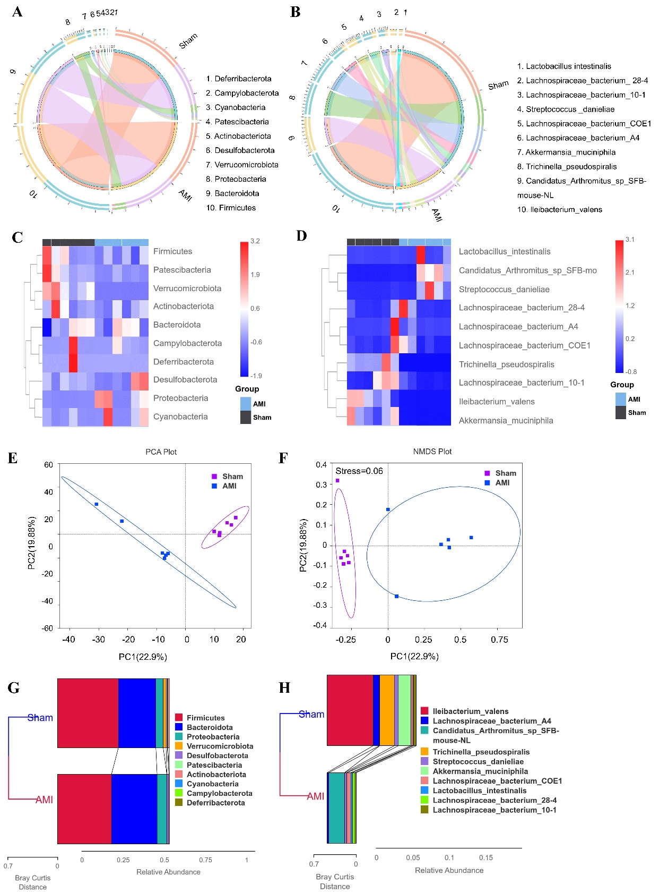
Supplementary Figure S2. Intergroup differences in the gut microbiota community structure
Simper analysis (A) at phylum level; (B) at species level. Differential gut bacterial taxa (C) at phylum level; (D) at genus level; (E) at species level.

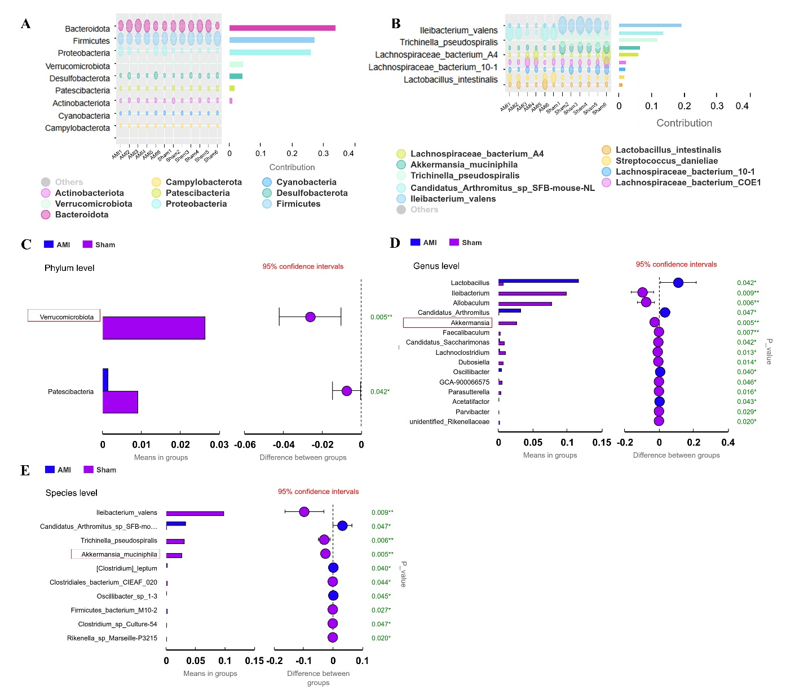

Supplementary Figure S3. Metagenome sequencing-based analysis of intergroup differences in the gut microbiota at the genus level
(A) Ligilactobacillus; (B) Delftia; (C) Ileibacterium; (D) Allobaculum; (E) Dubosiella; (F) Akkermansia; (G) Lachnoclostridium; (H) Candidatus_Saccharimonas.
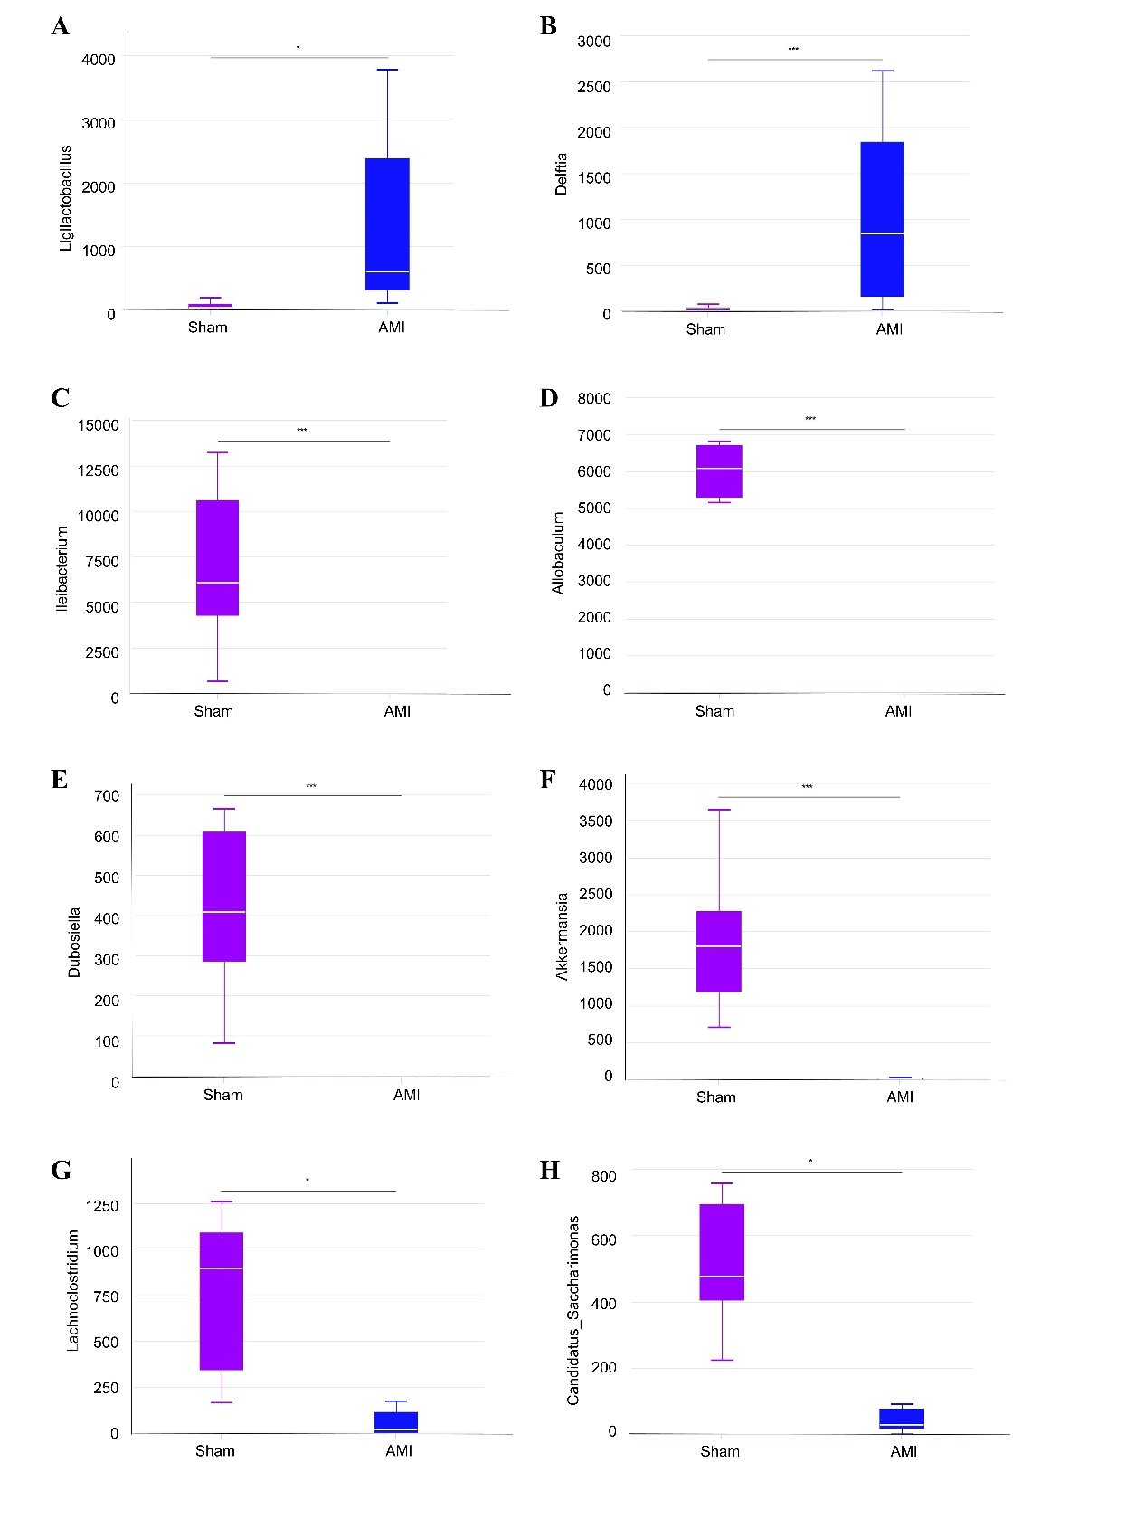
Supplementary Figure S4. Quantitative differential analysis and pathway annotation of metabolomics from gutintestinal contents
(A) Chord diagram of differential metabolites; (B) Pearson correlation between differential metabolites; (C) HMDB classification annotation map; (D) LIPID MAPS classification annotation map.
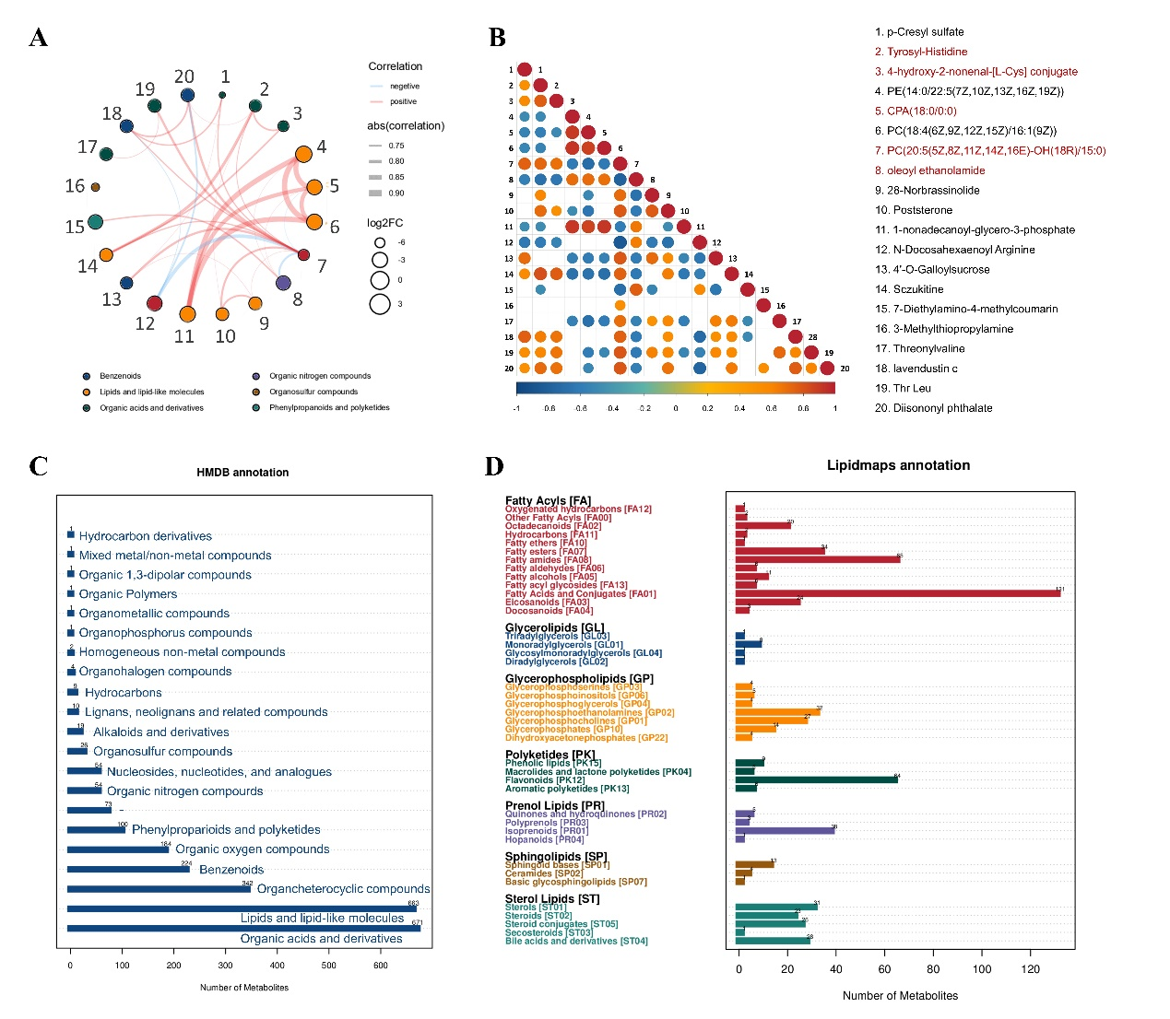

Supplementary Figure S5. Heatmap for correlation analysis between DEGs and differential metabolites
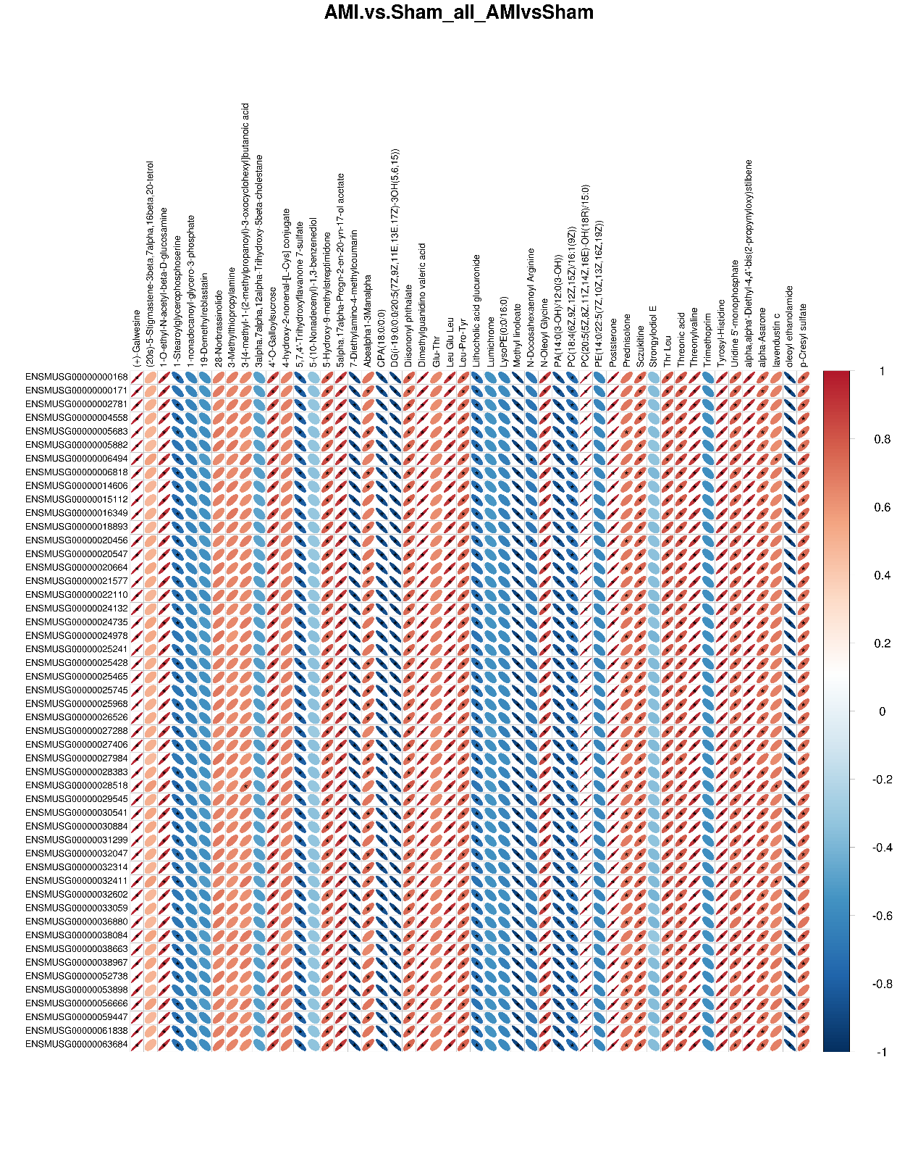

Supplementary Figure S6. Integrated visualization of the global metabolic pathway network
