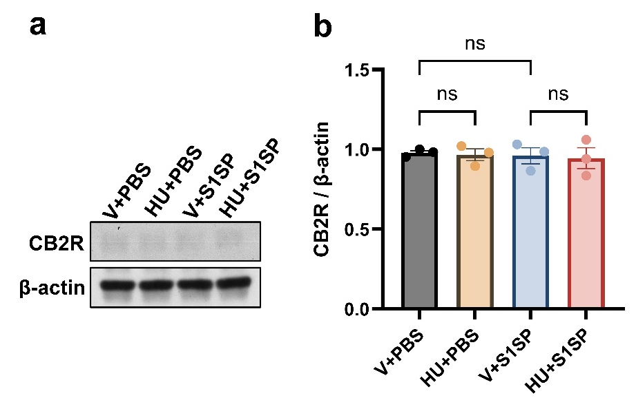

Supplementary Fig. 1. K18 hACE2 mice were exposed to PBS (control) or S1SP (0.5 mg/kg) and treated with vehicle or HU308. CB2R expression in alveolar epithelial cells was assessed at 48h following S1SP exposure. The representative immunoblots images are shown in panel (a), and densitometry data are presented in panels (b). n=3. Data are presented as mean ±SEM. V: vehicle, HU: HU308. ns: non-significant.
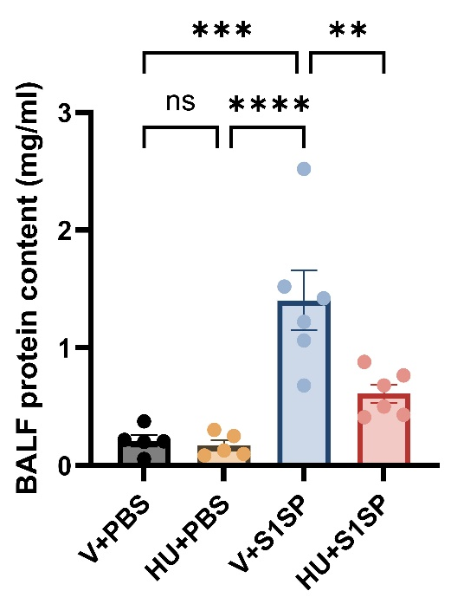

Supplementary Fig. 2. HU308 treatment alleviates S1SP-induced lung injury and inflammation. K18 hACE2 mice were exposed to PBS (control) or S1SP (0.5 mg/kg) and treated with vehicle or HU308. The total protein content in BALF was determined at 48h post-S1SP exposure. n=5-6, **p<0.01, ***p<0.001, ****p<0.0001. Data are presented as mean ±SEM. V: vehicle, HU: HU308.

