PHQ-4: Anxiety Subscale Score >= 3
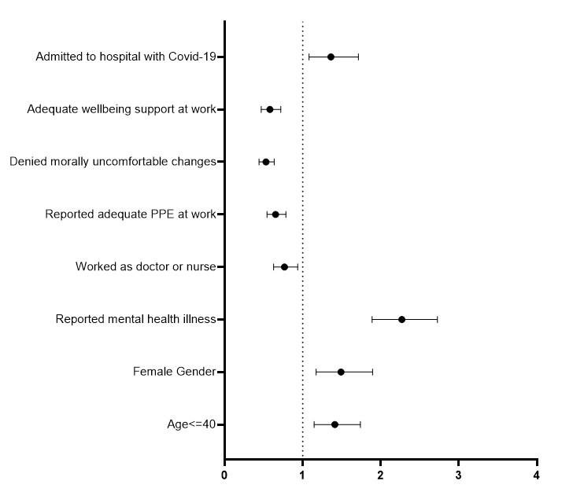
Odds Ratio (95% CI)

Admitted to hospital with Covid-19 | 1·4 (1·1-1·7); p=0·009
Wellbeing support available at work | 0·6 (0·5-0·7); p<0·001
Denied morally uncomfortable changes | 0·5 (0·4 – 0·6); p<0·001
Reported adequate PPE at work | 0·7 (0·5 – 0·8); p<0·001
Worked as a doctor or nurse | 0·8 (0·6-0·9); p=0·009
A history of mental health conditions | 2·3 (1·9 – 2·7); p<0·001
Female gender | 1·5 (1·2 – 1·9); p=0·001
Age <= 40 | 1·4 (1·1 – 1·7); p=0·001

Odds Ratio (95% CI)

Supplementary Figure 2: Factors associated with clinically significant anxiety symptoms in adjusted analysis

