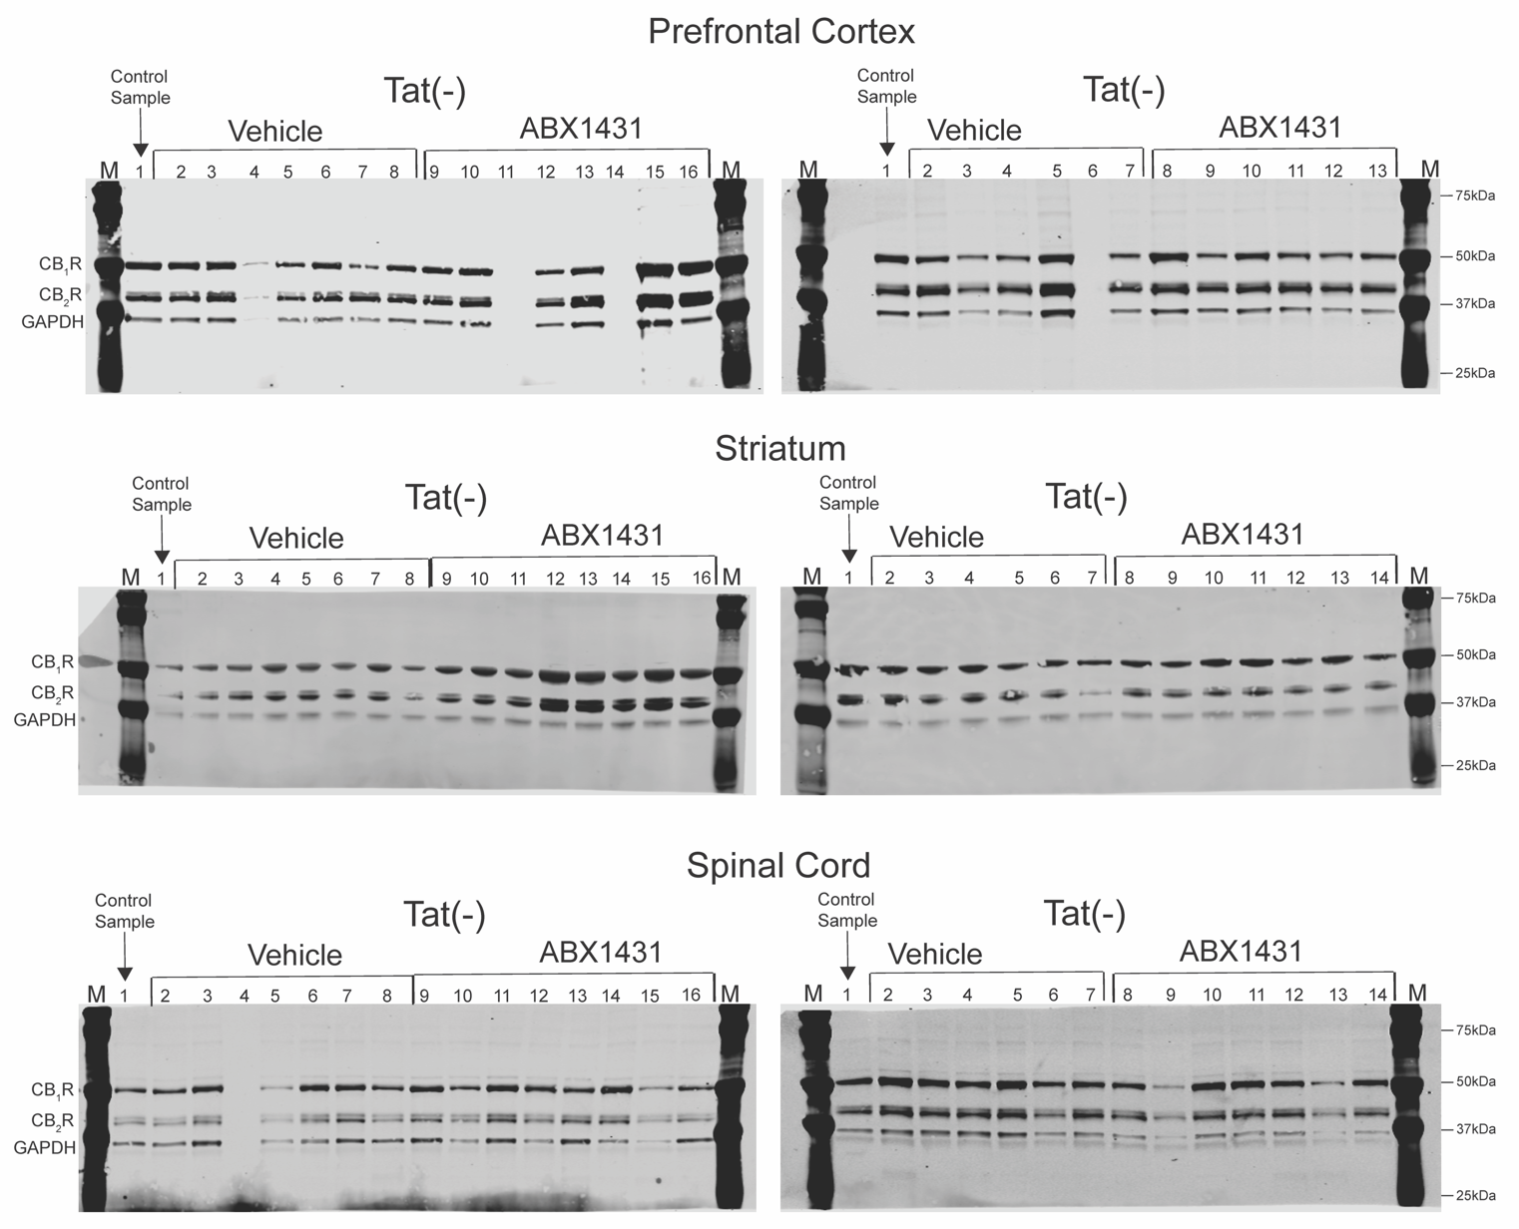Supplemental Figure S1: Western Blot – Raw Images
A.
B.
C.

Figure S1. Original and unedited blots of CB₁R and CB₂R expression levels in the prefrontal cortex (A), striatum (B), and spinal cord (C). Images show original CB₁R, CB₂R, and GAPDH Western blot gels for and male Tat transgenic mice used for Figure 5. For all Western blot gels lane 1 is a control sample represented on all blots. Male Tat(-) mice treated with vehicle (n = 7) are represented by lanes 2-8 and Tat(+) mice treated with vehicle (n = 6) are represented by lanes 2-7. Male Tat(-) mice treated with acute ABX1431 (n = 8) are represented by lanes 9-16 and male Tat(+) mice treated with acute ABX1431 (n = 7) are represented by lanes 8-14. Two samples for vehicle treated PFC Tat(-), one sample for vehicle treated PFC Tat(+), and one sample for vehicle treated SC Tat(-) were ost during snap freezing process. (M: molecular weights of marker protein (kDa).

