Supplementary Figure 1. Frequencies of responses for full scale for discrimination in healthcare settings question within Psychosocial Leave-Behind Questionnaire, Health and Retirement Study 2008-2020. (N=13,422)

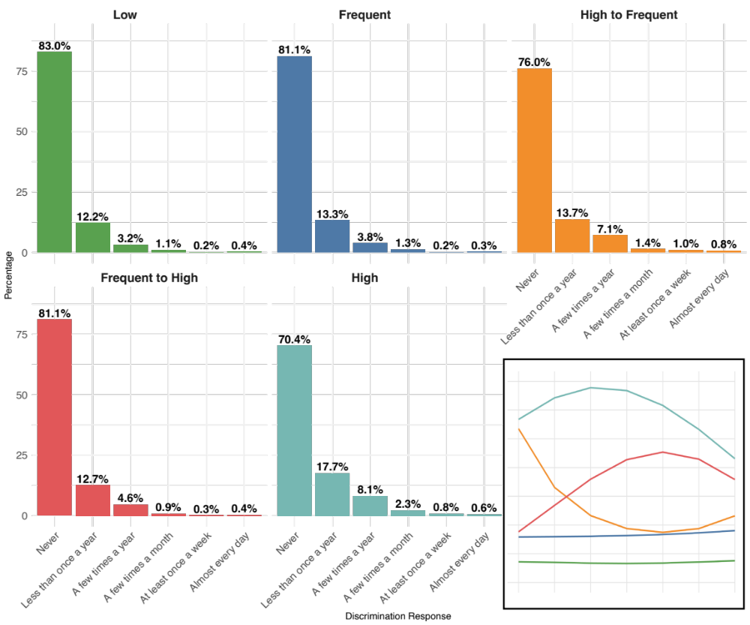
Note: Survey question for full Everyday Discrimination Scale is: (In your day-to-day life how often have any of the following things happened to you?). Item Q29f of the scale is “You receive poorer service or treatment than other people from doctors or hospitals. “

Supplementary Table 1. Parameter Estimates from the Zero-Inflated Poisson Group Based Trajectory Model Characterizing the Trajectory of Doctor Visits Over Time for Middle Aged and Older Adults. (N=13,422)
Group | Parameter | Estimate | Standard Error | T Score | P Value
Low | Parameter for Polynomial (Count)
 | Intercept | 1.332 | 0.008 | 165.424 | <0.001
 | Linear | 0.031 | 0.006 | 5.005 | <0.001
 | Quadratic | 0.015 | 0.006 | 2.493 | 0.0127
 | Parameter for Polynomial (Zero-Inflation)
 | Alpha0 | -2.062 | 0.042 | -49.61 | <0.001
 | Alpha1 | 0.262 | 0.050 | 5.295 | <0.001
 | Alpha2 | -0.596 | 0.052 | -11.422 | <0.001
Frequent | Parameter for Polynomial (Count)
 | Intercept | 2.135 | 0.007 | 317.055 | <0.001
 | Linear | 0.049 | 0.004 | 11.010 | <0.001
 | Quadratic | 0.007 | 0.005 | 1.422 | 0.1551
 | Parameter for Polynomial (Zero-Inflation)
 | Alpha0 | -3.274 | 0.072 | -45.282 | <0.001
 | Alpha1 | 0.361 | 0.071 | 5.069 | <0.001
 | Alpha2 | -0.404 | 0.077 | -5.235 | <0.001
High to Frequent | Parameter for Polynomial (Count)
 | Intercept | 2.298 | 0.015 | 153.664 | <0.001
 | Linear | -0.270 | 0.009 | -30.835 | <0.001
 | Quadratic | 0.266 | 0.011 | 25.1 | <0.001
 | Parameter for Polynomial (Zero-Inflation)
 | Alpha0 | -2.794 | 0.010 | -27.965 | <0.001
 | Alpha1 | 0.331 | 0.102 | 3.249 | 0.0012
 | Alpha2 | -0.394 | 0.112 | -3.515 | 0.0004
Frequent to High | Parameter for Polynomial (Count)
 | Intercept | 3.112 | 0.007 | 418.683 | <0.001
 | Linear | 0.238 | 0.007 | 34.016 | <0.001
 | Quadratic | -0.252 | 0.006 | -41.959 | <0.001
 | Parameter for Polynomial (Zero-Inflation)
 | Alpha0 | -2.966 | 0.01 | -29.764 | <0.001
 | Alpha1 | 0.136 | 0.117 | 1.168 | 0.2428
 | Alpha2 | -0.598 | 0.122 | -4.922 | <0.001
High | Parameter for Polynomial (Count)
 | Intercept | 3.530 | 0.007 | 506.656 | <0.001
 | Linear | -0.089 | 0.008 | -11.141 | <0.001
 | Quadratic | -0.139 | 0.007 | -19.524 | <0.001
 | Parameter for Polynomial (Zero-Inflation)
 | Alpha0 | -3.837 | 0.230 | -16.703 | <0.001
 | Alpha1 | 0.332 | 0.247 | 1.341 | 0.1799
 | Alpha2 | -0.449 | 0.253 | -1.775 | 0.0759
Note: Average Posterior Probability for each group are as follows. Low (0.940), Frequent (0.897), High-to-Frequent (0.897), Frequent-to-High (0.926), High (0.970)

Supplementary Table 2. Multinomial Estimates of Association between Discrimination in Healthcare Settings and Trajectory Group Membership with varying Comparator Groups based on the Similar Number of Doctor Visits, Health and Retirement Study (N=13,422)
Base Group | Frequent |  |  |  |  |  | High
Comparator Group | High-to-Frequent |  |  | Frequent-to-High |  |  | High-to-Frequent |  |  | Frequent-to-High
 | RRR | 95% CI | P-Value | RRR | 95% CI | P-Value | RRR | 95% CI | P-Value | RRR | 95% CI | P-Value
Unadjusted Model
Discrimination in Healthcare | 1.36 | (1.18-1.57) | <0.001 | 1.00 | (0.87-1.15) | 0.975 | 0.75 | (0.62-0.91) | 0.004 | 0.55 | (0.46-0.67) | <0.001
Adjusted Model
Discrimination in Healthcare | 1.24 | (1.07-1.44) | 0.004 | 0.935 | (0.81-1.08) | 0.359 | 0.85 | (0.70-1.04) | 0.106 | 0.64 | (0.52-0.78) | <0.001
Age | 1.00 | (0.99-1.01) | 0.368 | 1.00 | (0.99-1.01) | 0.756 | 1.01 | (1.00-1.03) | 0.054 | 1.02 | (1.01-1.03) | 0.004
Male | 1.03 | (0.90-1.18) | 0.706 | 1.07 | (0.94-1.20) | 0.311 | 1.10 | (0.90-1.33) | 0.349 | 1.14 | (0.94-1.37) | 0.175
Non-Hispanic Black | 0.97 | (0.82-1.15) | 0.756 | 0.85 | (0.73-1.00) | 0.048 | 1.26 | (0.99-1.61) | 0.058 | 1.11 | (0.87-1.40) | 0.405
Hispanic | 1.30 | (1.02-1.67) | 0.037 | 1.07 | (0.85-1.36) | 0.569 | 1.85 | (1.24-2.75) | 0.003 | 1.52 | (1.02-2.25) | 0.038
Married | 1.01 | (0.98-1.03) | 0.493 | 1.01 | (0.99-1.04) | 0.302 | 0.98 | (0.94-1.01) | 0.190 | 0.98 | (0.95-1.01) | 0.250
Education | 0.98 | (0.96-0.99) | 0.007 | 0.98 | (0.96-0.99) | 0.004 | 0.99 | (0.97-1.02) | 0.591 | 0.99 | (0.97-1.02) | 0.589
Wealth | 1.13 | (0.98-1.29) | 0.091 | 1.11 | (0.98-1.26) | 0.099 | 1.06 | (0.87-1.28) | 0.596 | 1.04 | (0.86-1.26) | 0.683
Uninsured | 1.15 | (0.95-1.40) | 0.162 | 1.26 | (1.06-1.51) | 0.009 | 0.96 | (0.73-1.25) | 0.740 | 1.05 | (0.81-1.36) | 0.707
Smoking Status
Former Smoker | 1.41 | (1.19-1.66) | <0.001 | 1.24 | (1.07-1.43) | 0.005 | 0.83 | (0.64-1.07) | 0.147 | 0.73 | (0.57-0.93) | 0.011
Current Smoker | 1.13 | (0.91-1.40) | 0.272 | 1.14 | (0.95-1.36) | 0.174 | 0.78 | (0.56-1.08) | 0.133 | 0.79 | (0.58-1.07) | 0.124
Drinking Status
No Consumption  (0 drinks) | 1.49 | (1.31-1.71) | <0.001 | 1.16 | (1.03-1.31) | 0.016 | 1.01 | (0.83-1.23) | 0.943 | 0.78 | (0.65-0.95) | 0.011
Heavy Consumption (3+ drinks) | 0.83 | (0.73-0.95) | 0.007 | 0.90 | (0.79-1.02) | 0.086 | 0.84 | (0.69-1.01) | 0.064 | 0.90 | (0.75-1.09) | 0.273
Physically Inactive | 0.58 | (0.42-0.79) | 0.001 | 0.88 | (0.69-1.13) | 0.324 | 1.00 | (0.63-1.59) | 0.992 | 1.53 | (1.00-2.33) | 0.050
Activities of Daily Living | 0.98 | (0.97-0.99) | 0.002 | 1.00 | (0.99-1.00) | 0.309 | 0.99 | (0.97-1.00) | 0.032 | 1.00 | (0.98-1.01) | 0.590
BMI | 1.20 | (1.12-1.28) | <0.001 | 1.11 | (1.04-1.19) | 0.002 | 0.92 | (0.86-0.99) | 0.024 | 0.85 | (0.79-0.92) | <0.001
Hypertension | 1.15 | (1.00-1.33) | 0.046 | 1.05 | (0.92-1.18) | 0.486 | 1.12 | (0.92-1.37) | 0.264 | 1.02 | (0.84-1.23) | 0.865
Heart Problem | 1.46 | (1.26-1.69) | <0.001 | 1.21 | (1.05-1.39) | 0.008 | 0.80 | (0.66-0.98) | 0.027 | 0.66 | (0.55-0.80) | <0.001
Stroke | 1.27 | (1.01-1.59) | 0.042 | 1.12 | (0.89-1.40) | 0.326 | 0.79 | (0.60-1.04) | 0.096 | 0.70 | (0.52-0.92) | 0.011
Diabetes | 1.14 | (0.98-1.32) | 0.089 | 1.17 | (1.02-1.34) | 0.026 | 0.85 | (0.69-1.04) | 0.111 | 0.87 | (0.72-1.06) | 0.168
Cancer | 1.71 | (1.44-2.02) | <0.001 | 1.23 | (1.05-1.45) | 0.012 | 0.97 | (0.77-1.21) | 0.770 | 0.70 | (0.56-0.87) | 0.002
Arthritis | 1.32 | (1.15-1.51) | <0.001 | 1.29 | (1.14-1.45) | <0.001 | 0.72 | (0.58-0.89) | 0.002 | 0.70 | (0.58-0.86) | 0.001
Psychiatric Condition | 1.15 | (0.98-1.34) | 0.087 | 1.31 | (1.14-1.51) | <0.001 | 0.61 | (0.50-0.75) | <0.001 | 0.70 | (0.57-0.85) | <0.001

