SUPPLEMENTAL MATERIALS AND METHODS

Effects of chronic exposure to low doses of
Δ⁹- tetrahydrocannabinol in adolescence and adulthood on serotonin/norepinephrine neurotransmission and emotional behaviors.

Danilo De Gregorio^{1,§} , Joshua Dean Conway^{2,§}, Martha-Lopez Canul¹, Luca Posa¹ , Francis Rodriguez Bambico^{2,3,#}, Gabriella Gobbi^{1,#z}
¹Neurobiological Psychiatry Unit, Department of Psychiatry, McGill University, Montreal, QC, Canada
²Department of Psychology, Memorial University of Newfoundland, St. John’s NL, Canada;
³Behavioral Neurobiology Laboratory, Center for Addiction and Mental Health, Toronto, ON, Canada;

Detailed Supplemental Methods and Materials

Elevated plus maze test (EPMT)
The EPMT was ran in a black-painted wooden maze with two open arms (50 × 10 cm) and two walled arms (50 × 10 × 40 cm). The four arms created a cross shape, with arms of the same type (open or closed) across from each other. The maze was raised 80-cm aboveground and had a 10 × 10 cm central area forming the intersection of the four arms. Each trial began with an animal being placed in the central area facing one of the open arms and was terminated 5 minutes later. Percentage duration of the time spent in the open arms, closed arm and central area visits, as well as the percentage of entries in the open arms, number of head dips (leaning over the open arms or beyond the borders of the open arms), were recorded and analyzed. Anxiolytic drugs and anxiety-reducing manipulations were found to significantly increase open arm visits and head dips, while anxiogenic drugs and manipulations increase closed arm visits while decreasing head dips (Cole and Rodgers, 1995; Rodgers and Johnson, 1995; Wolf, 2007).

Open field test (OFT)
Animals were placed in the center of a black open field apparatus according to our previous protocol. Anxious behavior was assessed by measuring both thigmotactic (“wall-following”) (defined by the frequency of central zone (70 × 70 cm) visits). Anxiogenics have been shown to decrease thigmotaxis behavior, while anxiolytics increase thigmotaxis. Locomotor activity was also assessed (total distance travelled; modified after (Choleris et al., 2001)).

Novelty-suppressed feeding test (NSFT)
The NSFT was used to measure anxiety-induced hyponeophagia, the increased latency to feed on/ approach food when exposed to an anxiety-inducing novel environment. The procedure was modified after (Bodnoff et al., 1988). Following 48-hrs of food deprivation each animal was placed at one corner of an open arena (80 × 80 × 30 cm). The center of the arena contained 12 laboratory chow pellets, and the latency to initiate feeding(s) was noted. The testing apparatus was composed of a black wooden flooring and walls covered with blue textile. To quantify latency to approach the food we also analyzed time spent within 7-cm perimeters (circumference) of the pellets during offline analyses (using the behavioural tracking system video files, actual circumference ≈ 45 cm). Each trial lasted for 600 s. After the assessment in the novel environment, feeding latency was observed in the home cage environment containing 12 pellets spread on the floor; the post-re-testing session was terminated immediately after the rats initiated feeding. The latency to feed in the arena or home cage was the time between the rats entered in the cage and the first approach to food. Anxiogenics and anxiolytics increase and decrease, respectively, approach and feeding latency. These effects are observed in the novel environment and not in the familiar home cage environment (Bodnoff et al., 1988; Gross et al., 2002).

Forced swim test (FST)
The FST measured the movement and behaviour of animals in an inescapable container of water. It was carried out in two sessions, a pretest swim session followed by a test swim session 24 hours later. Time spent active (swimming and climbing) and passive (immobility) was analyzed, with increased immobility taken to indicate learned behavioural despair (Porsolt et al., 1977). The container used was a clear Plexiglas cylinder with a height of 50 cm and a diameter of 20 cm. The cylinders were filled with water (with temperatures between 25–27 °C) to about 30 cm from the base. During the pretest swim, each animal was gently immersed in the pool hind limbs first and allowed to swim for 15 minutes. Following the pretest, animals were rescued using a plastic grid, dried with a towel, and caged near a heat source (lamp) to re-stabilize the animals body temperature. The test swim was conducted the following day and consisted of the same procedure, except that the animals remained in the table for just 5 minutes. The FST is a highly reliable procedure used to screen for antidepressant properties of drugs, with a decrease in immobility following antidepressant treatment being an indicator for the future success of the antidepressant. It is also used to assess pro-depressant liabilities triggered by predisposing manipulations prior to the test, e.g., chronic stress (Bielajew et al., 2003) and drug withdrawal (Cryan et al., 2003) which produce marked increases in immobility, as well as a faster onset of the first sustained immobility episode (time at which a clearly visible stationary posture was assumed and maintained for > 2 s and characterized by a total absence of forelimb movements (Pliakas et al., 2001).

Sucrose preference test (SPT)
The SPT is an anhedonia measure (i.e. a blunting of sensitivity to rewarding stimuli), which is a common feature of depression symptomatology. First, rats were exposed to a 2% (wt./vol.) sucrose solution for 1-hr a day on 3 consecutive days. Afterwards, their food intake was restricted to 30 g per animal. On the fourth day, they underwent a 1-hour trial where they were exposed to (and freely allowed to choose between), one containing the sucrose solution and the other tap water. After the first half of the test, the position of the bottles on the cage top cover was switched to control for any potential side-preference. Sucrose preference was quantified as the ratio of sucrose intake to total fluid intake × 100. Absolute sucrose represented the consumption of 2% of sucrose solution . The relative sucrose intake relative sucrose intake was quantified as the ratio of sucrose intake to the body weight of each animal and itruled out the THC effects on overfeeding and weight gain weight.

In vivo electrophysiological recordings of monoaminergic neurons
Three days following the last behavioral test, in vivo single-unit extracellular recordings of DR 5-HT and LC NE neurons were performed according our protocols. An additional group of animals which had not undergone behavioral testing was also used throughout these experiments as a control. All recordings took place immediately following drug treatment and washout. Rats were randomly assigned to one of two groups, one exclusively for 5-HT recordings and another exclusively for NE recordings, alternately conducted for 12 days. First, rats were anesthetized with chloral hydrate (400 mg./kg, i.p.) and mounted in a stereotaxic frame (David Kopf Instruments, Tujunga, CA) with the skull positioned horizontally (incisor bar at − 3.3 mm). Recordings were carried out using single-barreled glass micropipettes pulled from a 2-mm capillary glass (R&D Scientific Glass, Spencerville, MD) on a Narashige (Tokyo, Japan) PE-2 pipette puller. The micropipettes were preloaded with fiberglass strands to promote capillary filling with 2% Pontamine Sky Blue solution in 2 M NaCl and their tips were broken down to diameters of 1 to 3 μm. The impedance of the micropipettes ranged from 1.5 to 3.5 MΩ. Using a hydraulic micropositioner (model 650; David Kopf Instruments, Tujunga, CA), the electrode was advanced into the DR or LC at approximately 0.15 mm/min to minimize any chance of bypassing slow-spiking neurons during the descent. Three to five electrode descents were achieved. Single-unit activity was recorded as large-amplitude action potentials captured by a software window discriminator, amplified by an AC Differential MDA-3 amplifier (BAK Electronics, Inc., FL), postamplified and band-pass filtered by a Realistic 10 band frequency equalizer, digitized by a CED 1401 interface system (Cambridge Electronic Design, Cambridge, United Kingdom), processed online, and analyzed off-line using Spike2 software version 5.20 for Windows PC (Microsoft, Seattle, WA). The spontaneous single-spike activity of each neuron was recorded for at least 2 minutes, with the first 30 s immediately after detecting the neuron being eliminated from analysis to decrease mechanical artifacts due to electrode displacement. The regularity of neural firing activity was represented using interstimulus interval histograms. Burst firing activity was analyzed offline using a script designed for Spike 2 (Cambridge Electronic Design, Cambridge, UK). These analyses generated the mean ratio of the number of spikes within bursts to the sum total of recorded spikes (%). At the end of each recording session, the recording site was marked by iontophoretic ejection (1–10 mA, negative current for 10 min) of Pontamine Sky Blue for later histological verification of recording sites.

Spontaneous 5-HT single-spike and burst firing activity
The DR is the main source of 5-HT innervation in the brain. To record from single-unit 5-HT neurons in the DR, a burr hole was drilled on the cranial midline from 0.5 to 1.5 mm anterior to interaural zero, corresponding to the entire rostrocaudal medial extent of the DR presumed richest in 5-HT neurons (Paxinos and Watson, 2007). The first putative 5-HT neurons were encountered immediately below the ventral border of the Sylvian aqueduct, and 5-HT neuron-containing coordinates stretch from 5.0 to 6.5 mm ventral to the dura mater. Under physiological conditions, spontaneously active 5-HT neurons exhibit characteristic electrophysiological properties distinguishable from non-5-HT neurons. These 5-HT neurons exhibit a slow (0.1–4 Hz) and a prominently regular firing rate (coefficient of variation (COV), ranges from 0.12 to 0.87), a broad biphasic (positive–negative) or triphasic waveforms (0.8–3.5 ms; 1.4 ms first positive and negative deflections) (Baraban and Aghajanian, 1980; Allers and Sharp, 2003). Typical action potential waveforms obtained from presumed 5-HT neurons are shown in Fig. 4A. 5-HT burst firing activity was analyzed based on our criteria (Gobbi and Blier, 2005), such that a train of at least two spikes with an onset defined by a maximum initial interspike interval of 20 ms within a regular low-frequency firing pattern was categorized as a burst. The longest interspike interval allowed within a burst was 40 ms.

Spontaneous NE single-spike and burst firing activity
The LC is the main source of NE innervation in the brain. To record from single-unit NE neurons in the LC, the burr hole was drilled 0.7 mm posterior to the interaural line and 1.1 to 1.4 mm lateral to midline, corresponding to the extent of each of the bilaterally localized LC on either side of the midline. Spontaneously active putative NE neurons were identified using the following criteria: regular firing rate (1–5 Hz) and biphasic (positive–negative) or triphasic waveforms of long duration (0.8–1.2 ms) exhibiting a characteristic burst discharge in response to a nociceptive pinch of the contralateral hind paw (Szabo et al., 2004). Burst firing activity was analyzed based on the criteria of (Grace and Bunney, 1984), such that the onset was defined as the occurrence of two spikes with an inter-stimulus interval ≤ 80 ms and its termination by the next interval ≥ 160 ms.

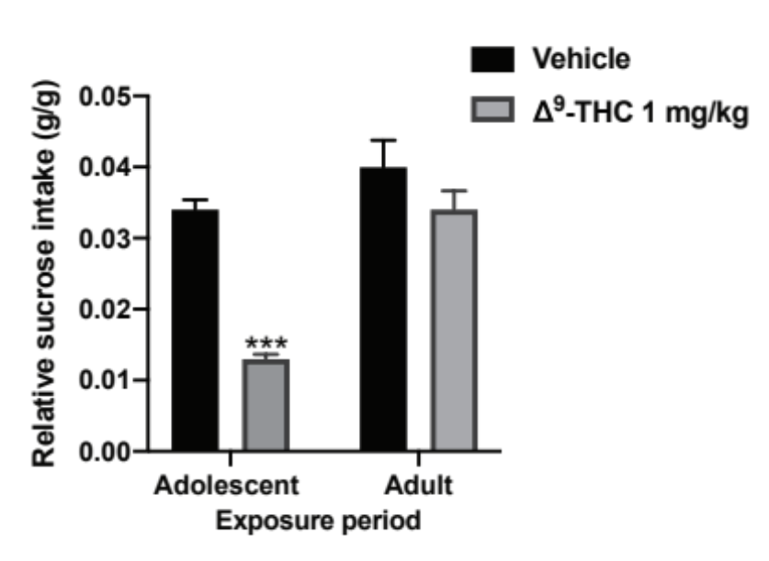
Supplemental Figure 1

Fig. Sup.1. Relative sucrose intake was assessed . THC markedly decreased the relative sucrose intake after adolescent but not adult exposure. Two-way ANOVA following Tukeys’ post Hoc comparison were employed. *** P< 0.001. Each bar or circle represent mean ± SEM. N=7-10 rats per group.

Supplemental References

Allers K, Sharp T (2003) Neurochemical and anatomical identification of fast-and slow-firing neurones in the rat dorsal raphe nucleus using juxtacellular labelling methods in vivo. Neuroscience 122:193-204.

Baraban JM, Aghajanian G (1980) Suppression of firing activity of 5-HT neurons in the dorsal raphe by alpha-adrenoceptor antagonists. Neuropharmacology 19:355-363.

Bielajew C, Konkle A, Kentner A, Baker S, Stewart A, Hutchins A, Santa-Maria Barbagallo L, Fouriezos G (2003) Strain and gender specific effects in the forced swim test: effects of previous stress exposure. Stress 6:269-280.

Bodnoff SR, Suranyi-Cadotte B, Aitken DH, Quirion R, Meaney MJ (1988) The effects of chronic antidepressant treatment in an animal model of anxiety. Psychopharmacology 95:298-302.

Choleris E, Thomas A, Kavaliers M, Prato F (2001) A detailed ethological analysis of the mouse open field test: effects of diazepam, chlordiazepoxide and an extremely low frequency pulsed magnetic field. Neurosci Biobehav Rev 25:235-260.

Cole J, Rodgers R (1995) Ethological comparison of the effects of diazepam and acute/chronic imipramine on the behaviour of mice in the elevated plus-maze. Pharmacol Biochem Behav 52:473-478.

Cryan JF, Hoyer D, Markou A (2003) Withdrawal from chronic amphetamine induces depressive-like behavioral effects in rodents. Biol Psychiatry 54:49-58.

Grace AA, Bunney BS (1984) The control of firing pattern in nigral dopamine neurons: burst firing. J Neurosci 4:2877-2890.

Gross C, Zhuang X, Stark K, Ramboz S, Oosting R, Kirby L, Santarelli L, Beck S, Hen R (2002) Serotonin 1A receptor acts during development to establish normal anxiety-like behaviour in the adult. Nature 416:396.

Paxinos G, Watson C (2007) The rat brain in stereotaxic coordinates. Academic. San Diego.
Pliakas AM, Carlson RR, Neve RL, Konradi C, Nestler EJ, Carlezon WA (2001) Altered responsiveness to cocaine and increased immobility in the forced swim test associated with elevated cAMP response element-binding protein expression in nucleus accumbens. J Neurosci 21:7397-7403.

Porsolt RD, Le Pichon M, Jalfre M (1977) Depression: a new animal model sensitive to antidepressant treatments. Nature 266:730.

Rodgers R, Johnson N (1995) Factor analysis of spatiotemporal and ethological measures in the murine elevated plus-maze test of anxiety. Pharmacol Biochem Behav 52:297-303.

Szabo ST, Gold MS, Goldberger BA, Blier P (2004) Effects of sustained gamma-hydroxybutyrate treatments on spontaneous and evoked firing activity of locus coeruleus norepinephrine neurons. Biol Psychiatry 55:934-939.

Wolf А (2007) The use of the elevated plus maze as an assay of anxiety–related behavior in rodents/AA Wolf, CА Frye. Nat Protoc 2:322-328.

