Appendix Table A.1. Predictor variables included in the primary analysis

Predictors
Sociodemographic characteristics
Age; Sexual identity; Race & ethnicity; BMI, Parent educational attainment, Household dwelling type, School performance (grades)
Past 30-day substance use behaviors
combustible tobacco use; non-combustible tobacco use; marijuana smoking; marijuana vaping; marijuana or THC edibles, foods, or drinks use; any CBD or hemp product use; alcohol use
E-cigarette susceptibility and belief measures
Use in the next year: Any electronic cigarette; Curious: Any electronic cigarette; Approval: Vaping nicotine or using e-cigarettes; More socially acceptable than smoking cigarettes; Provide a good nicotine buzz; Can be used without other people knowing; Less harmful than cigarettes; Easier to hide or conceal than smoking cigarettes; Come in appealing flavors; Help people quit smoking cigarettes; Can be used in places where smoking isn’t allowed; Number of friends who use e-cigarettes; Friend offered: Any electronic cigarette
Exposure to e-cigarette promotion
See posts that promote the use of e-cigarettes and nicotine vaping products; See posts that discourage the use of e-cigarettes and nicotine vaping products; TV/Movie Ads: Vaping
Phone use behaviors
Number of hours you spend on your phone each day on school days; Number of hours you spend on your phone each day on non-school days; Phone behavior: Parents put limits on your screen time; Phone behavior: Parents put limits for when your apps shut down; App used most often
Biggest issues that teens face
Mental Health; Academic stress/time management; Financial stress/poverty; Drugs/substance use; Family relationships; Peer relationships; Plans after high school; Social justice issues; Social media
Perceived neighborhood disorder
Physical disorder; Social disorder
Impulse behavior scale (UPPS-P)
Sensation seeking, Premeditation
Multidimensional Facebook intensity scale
Persistence, Boredom, Over use, Self-expression
Everyday Discrimination Scale
Parent-adolescent communication scale
Self-reported psychiatric symptoms
General anxiety disorder, Major depressive disorder, Obsessive compulsive disorder, Jenkins Sleep Scale
Physical and mental health diagnoses made by a health professional
Attention Deficit Disorder (ADHD), Asthma, Diabetes, Cancer, Digestive or gut issues, Depression, Anxiety, Post Traumatic Stress Disorder (PTSD), Autism Spectrum Disorder (ASD)

Appendix Table A.2. Hyperparameter search space and trained values

 | Hyperparameter | Search space | Trained value
Combined | col_sample_rate | c(0.05, 0.3, 1.00) | 0.05
Combined | learn_rate | c(0.001, 0.01, 0.1) | 0.01
Combined | max_depth | seq(1, 10, by=1) | 1
Combined | ntrees | c(100, 500, 1000) | 500
Combined | sample_rate | c(0.05, 0.3, 1.00) | 0.3
Female only | col_sample_rate | - | 0.05
Female only | learn_rate | - | 0.01
Female only | max_depth | - | 2
Female only | ntrees | - | 1000
Female only | sample_rate | - | 0.05
Male only | col_sample_rate | - | 0.3
Male only | learn_rate | - | 0.001
Male only | max_depth | - | 9
Male only | ntrees | - | 500
Male only | sample_rate | - | 0.3
Note. For each model, the area under the receiver operating characteristic curve was used as the optimization metric during tuning and testing. The search space for female-only and male-only models is identical to that of the combined model.

Appendix Table A.3. Results from binary logistic regression models

Variable | OR | 95% CI
P30D cannabis vaping, yes | 90.97 | 46.77, 183.19
P30D CBD/hemp use, yes | 58.53 | 27.76, 127.65
P30D cannabis smoking, yes | 52.45 | 26.84, 104.28
Number of friends using e-cigarettes | 2.43 | 2.12, 2.80
P30D alcohol use, yes | 23.04 | 12.61, 41.68
Susceptibility: E-cigarette use next year | 5.05 | 3.78, 6.80
P30D combustible tobacco use, yes | 62.79 | 21.58, 207.23
E-cigarette belief: nicotine buzz | 4.06 | 3.01, 5.56
Approval of using e-cigarettes | 2.88 | 2.23, 3.78
Susceptibility: Friend’s e-cigarette offer | 4.16 | 3.16, 5.50
Note. Separate models were estimated for each predictor to avoid instability in estimates due to multicollinearity. OR = odds ratio, CI = confidence interval, P30D = past 30-day, CBD = cannabidiol.

Appendix Figure A.1. Prediction model performance in combined-sex analysis

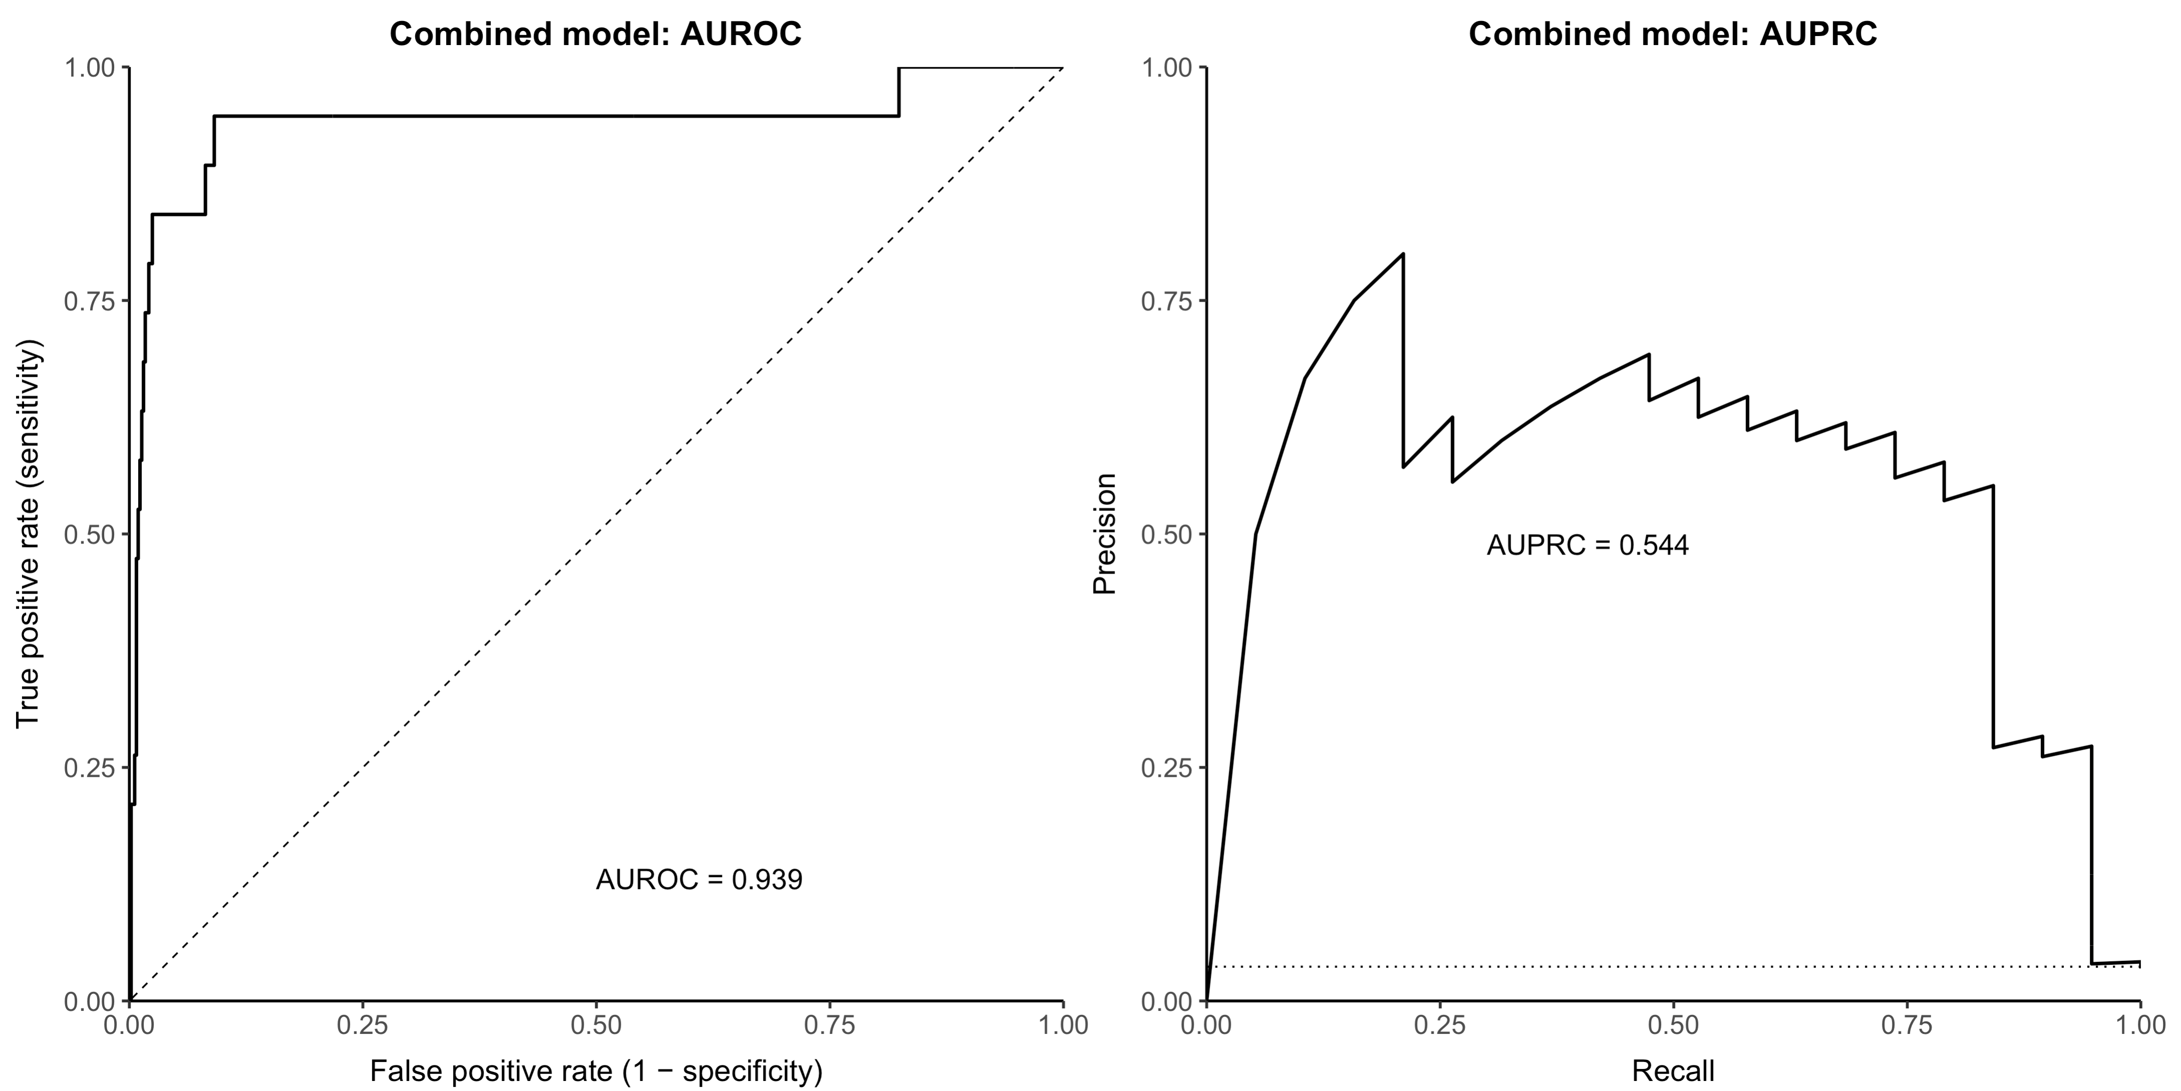

Note. AUROC = Area under the receiver operating characteristic curve, AUPRC = area under the precision-recall curve.

