Exploring consumer preferences for cannabis vaping products to support public health policy: A discrete choice experiment

Appendix 1 – Study Protocol

Jennifer R. Donnanª, Karissa Johnstonª, Michael Coombsª, Maisam Najafizada^{b}, Lisa Bishopª

ª School of Pharmacy, Memorial University, St. John’s, Newfoundland and Labrador, Canada.
^{b} Faculty of Medicine, Memorial University, St. John’s, Newfoundland and Labrador, Canada.
Email Adresses:
Jennifer R. Donnan, Jennifer.donnan@mun.ca; ORCID: 0000-0002-2908-0804
Karissa Johnston, kjohnston@broadstreetheor.com; ORCID 0000-0003-4570-9972
Michael Coombs, mdcoombs@mun.ca
Maisam Najafizada, maisam.najafizada@mun.med.ca; ORCID 0000-0001-9195-5379
Lisa Bishop, ldbishop@mun.ca, ORCID 0000-0002-4979-4222
Declarations
Funding: The authors received financial support to conduct the research from the Canadian Institutes of Health Research (Grant No. 201910CPV - 429120) and the Canadian Centre of Substance Use and Addiction inclusive of this research.
Conflict of interest: The authors declared no potential financial or personal conflicts of interest with respect to the research, authorship, and/or publication of this article.

Relative preferences for attributes of cannabis product purchases:
A protocol for a discrete choice experiment
With the passage of The Cannabis Act, recreational use of cannabis has been legal in Canada since October 2018 and edible cannabis since October 2019 (Cannabis Act, 2018). The goal of the Act was to protect public health and safety by allowing adults access to legal cannabis; keep cannabis out of the hands of youth; and keep profits out of the pockets of criminals ^{2,3}. It is estimated, however, that about 60-70% of all cannabis purchased is still through black market retailers ^{4,5}. Although there has been speculation in the media around the reasons for the slow uptake in purchasing from legal sources, there has been little research done in this area ^{6–9}.
Media sources have suggested that price, limited supply and insufficient retail outlets are the main factors at play, among other reasons (including poor cannabis quality and inconvenient packaging) ^{6–9}. At almost two years post-legalization, the legal supply chain has become well-established and more retail storefronts have opened. However, little is still known about the impacts of the legal cannabis market on product buying preferences.
Our own systematic review¹⁰ of the literature into attributes of cannabis purchase choice identified a lack of rigorous evidence in this area, with the exception of research on the impact of cannabis prices. Studies that examine other attributes still focus on the dried flower product type as this is the most common method of consumption, with 84% of users in the 2019 Canadian Cannabis Survey having reported using it in this way ¹¹. There is far less data on purchasing preferences for oils or vaping liquids. Edible, topical, and certain other products were not available legally until October 2019, and our understanding of how and why people purchase these products is even more limited. Very few of these studies were conducted in the context of Canada post-legalization.

This protocol outlines the design of a discrete choice experiment (DCE) to explore preferences for attributes for dried flower, edibles, vaping liquids, and the customer experience. A DCE is a choice modelling technique is based on multi-attribute utility theory. This theory states that when people make choices, they do so by making trade-offs of the various attributes that are important for making that choice (e.g., cost, quality, accessibility) ¹². A DCE presents respondents with a series of hypothetical choice tasks. Analysis of the participant selections allows us to calculate the weight, or relative importance, of each attribute in that choice. In turn we can also calculate how much of one attribute people are willing to trade off for another ¹³.
A thorough knowledge of what drives consumer preferences for cannabis and understanding how people make trade-offs is an important step towards refining cannabis policy in Canada. Policies need to be designed so that cannabis is produced and sold in a way that meets the needs of Canadian consumers while protecting their health and safety, thus realizing the ultimate goals of the Cannabis Act ².

Study Design

This DCE was designed following the general framework for good research practices as outlined by the International Society for Pharmacoeconomics and Outcomes Research.¹³ The survey included four unique choice based conjoint (CBC) questions focusing on three product types (dried flower, vaping liquid and edibles), and the retail location. Additional questions included demographic and cannabis use history questions. Consultations with cannabis industry stakeholders (retailer, producer, regulator and consumer) were conducted to ensure we were capturing the most relevant attributes. The survey was then pilot tested with members of our advisory panels for comprehension, technical ease, and length.

Choice Based Conjoint Questions

Data from earlier phases of this research^{10,14} were used to select the attributes and levels used in each of the choice-based conjoint (CBC) questions (Tables 1-4). Within the choice task for dried flower cannabis, images of package types were also provided to help respondents understand what was meant by package descriptors (Figure 1). As advised by best practices¹³, CBC questions were limited to between 6-8 attributes in order to prevent responder burden. Respondents may neglect to consider certain attributes when tasked with decisions involving larger numbers of factors. With this in mind, attributes for each CBC question were narrowed down to include those most significant to Canadian cannabis policy. For example, qualitative research identified cannabis strain or terpene profiles as important to consumers when choosing dried flower products.¹⁴ However, both licensed and unlicensed markets offer comparable selection in terms of varieties of cannabis strains and terpenes, as there are no regulations restricting the sales of certain strains or terpenes. As such, these attributes were not included in the CBC question design.
One-on-one consultations were conducted with cannabis industry stakeholders prior to piloting the survey in order to ensure that each question was both relevant and feasible. Industry stakeholders included a retailer, a producer and a regulator.

Table 1. Attributes and Levels for 3.5 grams of Dried Flower
Attribute | Levels
Price | $20, $30, $40, $50
Packaging | Plastic jar  Mylar bag  Tin  Pre-Roll  Glass
Moisture | Low: Cannabis is dry and crumbles when broken up  Medium: Cannabis breaks up easily but does not crumble
Potency | 10 – 14.9% THC  15 – 19.9% THC  20 – 24.9% THC  25%+ THC
Product Recommendation | Recommended by person selling it  Recommended by Family or Friend  Recommended in online reviews  Self-selected without input from others
Package Information | No info on the package  Basic: Producer, Amount of THC/CBD, not strain specific  Detailed: Producer, Amount of THC/CBD, Strain, harvest/package dates, Growth and Supply Chain Info
Regulated by Health Canada | Yes  No  Unknown

Figure 1. Images of Package Types Presented in Survey
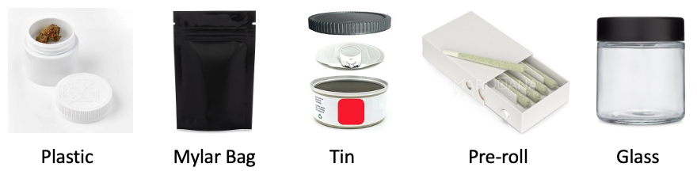

Table 2. Attributes and Levels for a Package of Edible Cannabis
Attribute | Levels
Type of Edible | A Candy (e.g. chocolate bar, gummy, mint)  A Baked Product (e.g. brownie, cookie, granola bar)  A Savory Product (e.g. pretzels, trail mix)
Price for Package | $5, $10, $15
Amount of TCH per Package | 5 mg  10 mg  50 mg  100 mg
Cannabis Taste | Strong cannabis taste  Mild cannabis taste  No cannabis taste
Package Information | No info on the package  Basic: Producer, Amount of THC and/or CBD in milligrams, nutritional information  Detailed: Producer, Amount of THC and/or CBD in milligrams, nutritional information, strain, terpenes, growth and supply Chain Info
Consistency of THC across servings | Unknown  Exactly the same
Product Recommendation | Recommended by person selling  Recommended by Family or Friend  Recommended in online reviews  Self-selected without input from others
Regulated by Health Canada | Yes  No  Unknown

Table 3. Attributes and Levels for Vaping Liquid or Cartridge
Attribute | Levels
Type of Device | Pre-filled Cartridge  Disposable pen
Price | $30, $40, $50, $60
Amount of TCH | 70%  80%  90%
Contents | Full spectrum with cannabis taste and terpenes  Distillate with no cannabis taste or terpenes  Distillate with non-cannabis flavors (e.g. fruit)
Product Recommendation | Recommended by person selling it  Recommended by Family or Friend  Recommended in online reviews  Self-selected without input from others
Regulated by Health Canada | Yes  No  Unknown

Table 4. Customer Experience
Attribute | Levels
Prices | Product discounts available  Products offered at regular prices
Product Information Available | -Only what is on the package  -Some additional information about the product  -Extensive information in each product such as terpene levels, grower and supply chain information
Customer Service | -I can get all of my questions answered and can receive help selecting my products  -No one is available to answer questions of help select a product
Proximity | Within walking distance  Store within a 15 minute drive  Store within a 30 minute drive  Online purchase with home delivery
Product Variety | Limited product selection  Wide product selection
Store is provincially regulated | Yes  No  Unknown

Each CBC question was prefaced by a vignette to frame the choice the participant was asked to make. Sample choice tasks with vignettes can be found in Figures 2-5.

Figure 2. Dried Flower Sample Choice Task
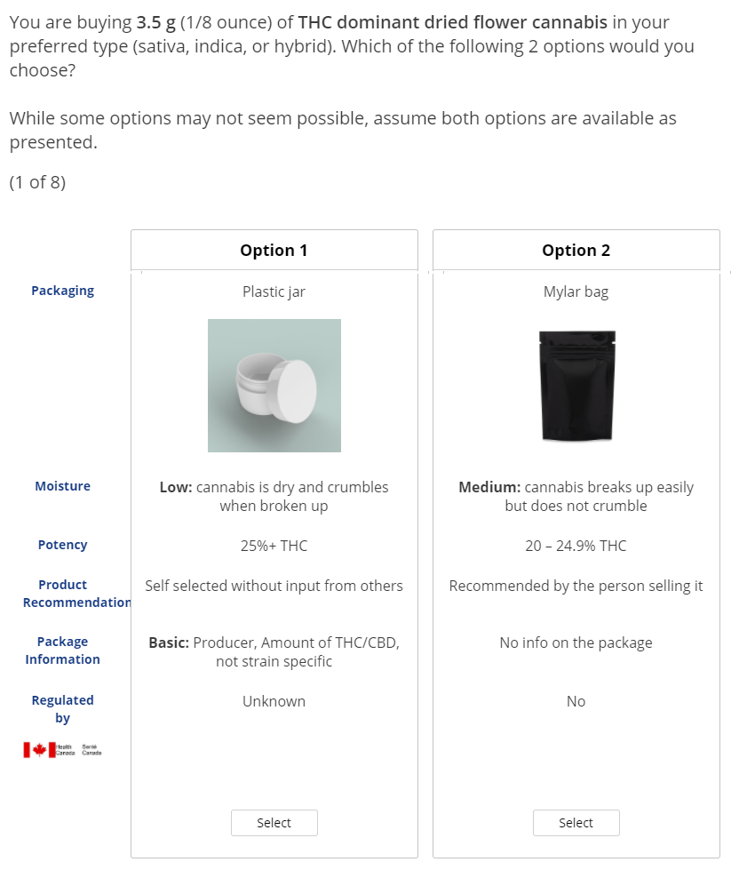

Figure 3. Edible Cannabis Sample Choice Task
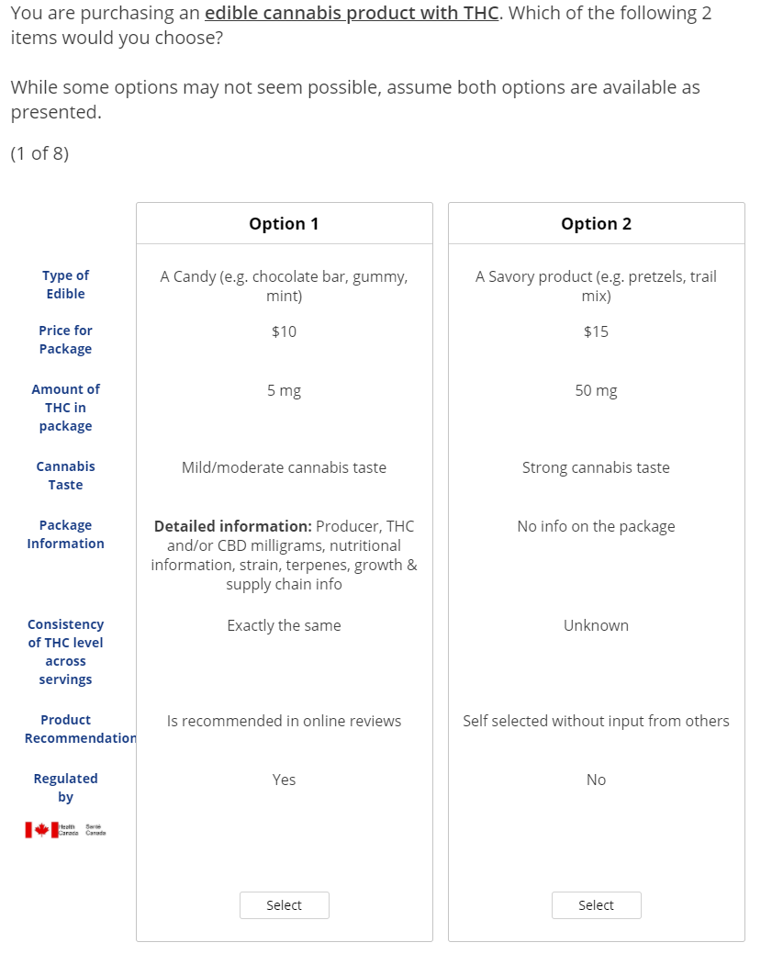

Figure 4. Vape Product Sample Choice Task
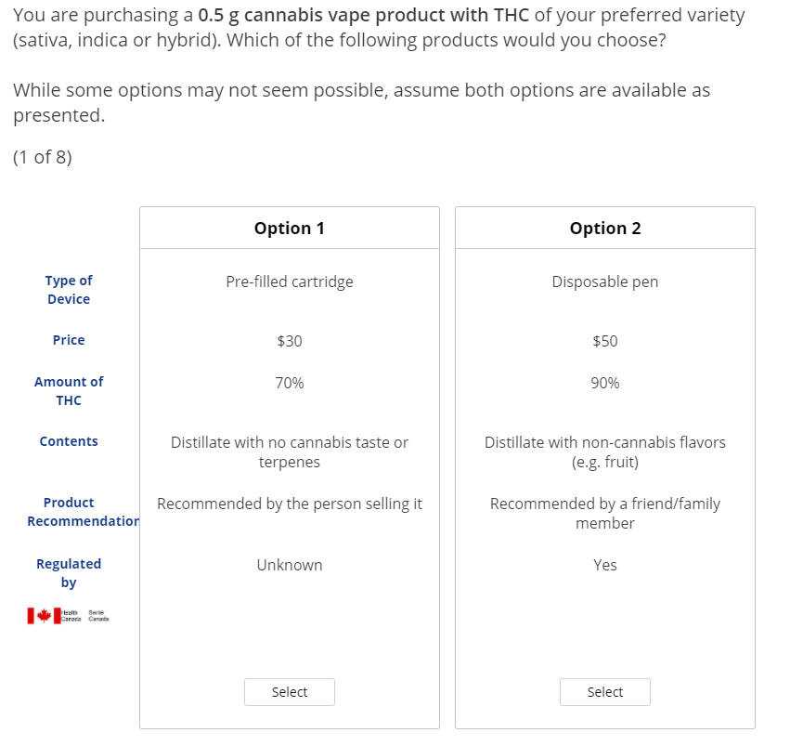

Figure 5. Customer Experience Sample Choice Task
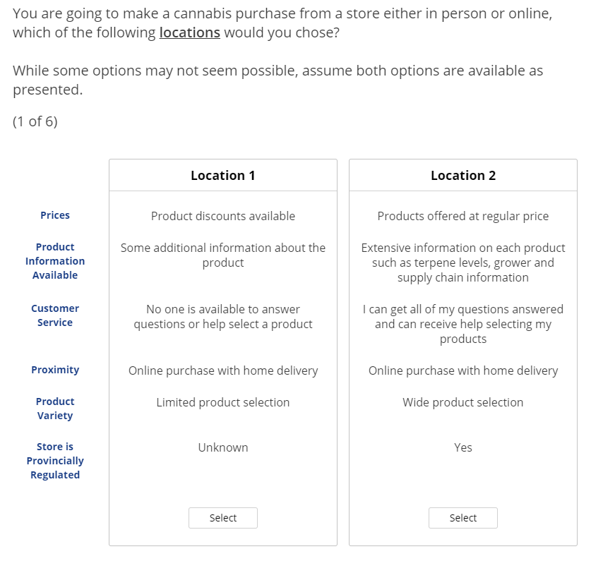

Experimental Design

Each CBC question consisted of two unlabelled alternatives, allowing each combination of attribute levels to only be described using arbitrary titles (e.g. Option A).¹⁵ Respondents were prompted to choose one of the options as they were not offered the choice to select “neither”.

A D-efficient fractional factorial design was adopted to allow for the widest range of choice sets, as full factorial designs were not feasible. Number of choice tasks for each CBC was determined by assessing the standard error and ensuring it was below the 0.05 threshold. As a result, eight choice tasks were included for dried flower, vapes and edibles and six choice tasks for retailer. For each CBC question, a total of 300 versions was generated using the Sawtooth software (Orem, UT; Version 9).¹⁶ Participants were randomized to one of the 300 versions.

Study Sample and Elicitation Method

To be eligible to participate, respondents had to live in Canada, be at least 19 years of age, and have purchased cannabis within the last 12 months. All eligible participants were given the DCE question that focused on retailer attributes. Participants were given the DCE questions on dried flower, vape and edible cannabis only if they purchased that specific product type within the last 12 months. As a result, not everyone would complete all DCE questions. However, we decerned that completing all four DCE questions for those who did qualify for all four would be too burdensome. To account for this burden, we had those participants complete only two of the three product DCE questions. The specific questions they were given was based on which questions had lower numbers of responses.

An online research company (Angus Reid) used email solicitation to recruit a representative sample. Only data from respondents who completed the full survey were included in the analysis.

Rules of thumb are often used to estimate appropriate sample size DCEs^{17–19}. For example, one such rule of thumb is including a minimum of 10 observations for each independent variable ²⁰. With four CBC questions we had to ensure a sufficient sample for the CBC with the most parameters. The dried flower CBC included 22 parameters from the included attributes (one for cost, and one for each of the levels of the other attributes) plus three stratification variables, for a total of 25 parameters and minimum sample of 250. We wanted to be able also run subgroup analysis based on geographic regions or cannabis retail model (public, private or hybrid). To be able to run sub-group analyses by cannabis retail model (private, public, hybrid), we aimed for 200 respondents from each of British Columbia, Alberta, Ontario and Quebec, 175 from Newfoundland and Labrador, 300 for Nova Scotia, New Brunswick, and Prince Edward Island combined, and 300 from Manitoba and Saskatchewan combined. While 200 from each province was initially planned, due to limited sample in some regions these strategic sample groupings were used. Sample from the territories was limited to 10 and only able to be included in analyses of the whole sample.

Statistical analysis

Descriptive statistics were used to examine sample characteristics. CBC data analysis was conducted using Sawtooth (Lighthouse Studio) software and consisted of a counts analysis and two regression models, a multinomial logit (MNL) model and a latent class model. The counts analysis determined the proportion of times that a specific attribute level was selected by survey respondents, in order to establish if that attribute level was dominant over the others. Chi-squared tests were used to assess if the selection rates of different levels within an attribute were significantly different from one another. Chi-squared tests were also used to calculate and test two-way interaction effects.

The base analysis was conducted using the MNL model to calculate average preferences across the sample. The data for each attribute were effects coded with the exception of cost, where continuous coding was used so that interpretable willingness to pay (WTP) values could be calculated. Potency for dried flower and vapes were also presented on a linear scale; however, the attribute was effects coded to allow for relaxation of the linearity assumption and to test for non-linearity. Odds ratios were calculated with the least favourable level from each attribute serving as a reference point. WTP values were determined by estimating the marginal rate of substitution by taking the ratio of two coefficients, using the linear cost estimate for the comparison attribute.

Finally, a latent class model was used to explore potential sub-groups of preferences within the sample population. The model was set to estimate between two and five groups, with a maximum number of iterations set to 100 and a convergence limit for log likelihood set at 0.01. The number of segments with the best fit was determined by selecting the solution with the lowest CAIC (Consistent Akaike Information Criterion) and BIC (Bayesian Information Criterion) values. Differences in participant characteristics between groups were identified using segment membership probabilities estimated by Sawtooth. Chi-squared tests were used to assess the significance of differences in participant characteristics between groups. Ternary diagrams were employed to illustrate class enrollment probabilities using the ggtern (v3.3.5)²¹ and ggplot2 (v3.3.5)²² packages in R (v4.0.3)²³. Ternary diagrams are used to represent three-dimensional coordinate systems within a two-dimensional space.

Limitations and mitigations strategies
Ordering effect, hypothetical bias and framing effect are inherent limitation for DCE methodology ¹³. Strategies to mitigate against these were:
- Ordering Effect: is the potential for choice task order to influence choice outcomes. For example, paying less attention to later choice tasks. Different versions of the survey were generated and choice tasks were randomly varied across all versions to minimize the ordering effect.
- Hypothetical bias: is bias may be introduced due to the fact that participants are making hypothetical choices based on scenarios rather than real choices. In this survey we only surveyed individuals with experience purchasing cannabis and presented them with realistic scenarios and used attributes that would be familiar to any cannabis consumer thereby minimizing hypothetical bias. Additionally, when setting up the choice tasks, some variables were held constant to help form realistic alternatives, for example cannabis strain (i.e. sativa, indica) and product quantity.
- Framing effect: refers to the impact that scenario and attribute descriptions may have on choice. Specifically, if positive or negative framing us used. We minimized this by providing additional information and visual aid for the attribute describing packaging, attribute descriptors and levels were also simplified and did not contain any complex concepts or positive of negative connotations.

References
1. Government Bill (House of Commons) C-45 (42-1) - Royal Assent - Cannabis Act - Parliament of Canada [Internet]. [cited 2019 Sep 20]. Available from: https://www.parl.ca/DocumentViewer/en/42-1/bill/C-45/royal-assent
2. Government of Canada D of J. Cannabis Legalization and Regulation [Internet]. 2018 [cited 2020 Aug 24]. Available from: https://www.justice.gc.ca/eng/cj-jp/cannabis/
3. Cannabis (Canadian Drug Summary) | Canadian Centre on Substance Use and Addiction [Internet]. [cited 2020 Aug 24]. Available from: https://www.ccsa.ca/cannabis-canadian-drug-summary
4. Statistics Canada. StatsCannabis data availability: Crowdsourced cannabis prices, fourth quarter 2019 [Internet]. 2020 [cited 2022 Aug 17]. Available from: https://www150.statcan.gc.ca/n1/daily-quotidien/200123/dq200123c-eng.htm
5. George-Cosh D. Pot sector’s “teething pains” to lower sales by 30%: Scotia - Article [Internet]. BNN. 2019 [cited 2020 Aug 24]. Available from: https://www.bnnbloomberg.ca/canadian-pot-sector-s-teething-pains-to-lower-sales-by-30-scotiabank-1.1210088
6. Esfandiari S. One year after Canada legalized weed, figures suggest a large number of Canadians still buy their cannabis on the black market [Internet]. Business Insider. [cited 2020 Aug 24]. Available from: https://www.businessinsider.com/canada-weed-black-market-boom-despite-legalization-2019-10
7. Turvill W. “The legal stuff is garbage”: why Canada’s cannabis black market keeps thriving. The Guardian [Internet]. 2020 Mar 18 [cited 2020 Apr 15]; Available from: https://www.theguardian.com/society/2020/mar/18/cannabis-canada-legal-recreational-business
8. Power M. Stoners cheered when Canada legalised cannabis. How did it go so wrong? The Observer [Internet]. 2020 Apr 5 [cited 2020 Aug 24]; Available from: https://www.theguardian.com/society/2020/apr/05/stoners-cheered-when-canada-legalised-cannabis-how-did-it-all-go-wrong
9. Levinson-King R. Why Canada’s cannabis bubble burst. BBC News [Internet]. 2019 Dec 29 [cited 2020 Aug 24]; Available from: https://www.bbc.com/news/world-us-canada-50664578
10. Donnan J, Shogan O, Bishop L, Swab M, Najafizada M. Characteristics that influence purchase choice for cannabis products: a systematic review. J Cannabis Res. 2022 Feb 1;4(1):9.
11. Canada H. Canadian Cannabis Survey 2019 - Summary [Internet]. aem. 2019 [cited 2020 Aug 24]. Available from: https://www.canada.ca/en/health-canada/services/publications/drugs-health-products/canadian-cannabis-survey-2019-summary.html
12. Torrance GW, Boyle MH, Horwood SP. Application of Multi-Attribute Utility Theory to Measure Social Preferences for Health States. Oper Res. 1982 Dec 1;30(6):1043–69.
13. Janssen EM, Hauber AB, Bridges JFP. Conducting a Discrete-Choice Experiment Study Following Recommendations for Good Research Practices: An Application for Eliciting Patient Preferences for Diabetes Treatments. Value Health. 2018 Jan 1;21(1):59–68.
14. Donnan J, Shogan O, Bishop L, Najafizada M. Drivers of purchase decisions for cannabis products among consumers in a legalized market: a qualitative study. BMC Public Health. 2022 Feb 21;22(1):368.
15. de Bekker-Grob EW. Discrete Choice Experiments in Health Care [Internet]. Erasmus Universiteit Rotterdam; 2009. Available from: http://www.sandy-campbell.com/sc/KTC_Module_3_files/KTC%20Module%203%20%E2%80%93%20de%20Bekker%E2%80%93Grob%202009.pdf
16. Kessels R, Jones B, Goos P, Vandebroek M. The usefulness of Bayesian optimal designs for discrete choice experiments. Appl Stoch Models Bus Ind. 2011 May 1;27(3):173–88.
17. Orme B. Sample size issues for conjoint analysis studies. Sequim: Sawtooth Software; 1998.
18. Johnson R, Orme B. Getting the most from CBC. Sequim: Sawtooth Software Research Paper Series,. Sawtooth Software; 2003.
19. Pearmain D, Swanson J, Kroes E, Bradley M. Stated preference techniques: a guide to practice. 2nd ed. . 1991. Steer Davies Gleave and Hague Consulting Group; 1991.
20. Lynd LD, Traboulsee A, Marra CA, Mittmann N, Evans C, Li KH, et al. Quantitative analysis of multiple sclerosis patients’ preferences for drug treatment: a best–worst scaling study. Ther Adv Neurol Disord. 2016 Jul;9(4):287–96.
21. Hamilton NE, Ferry M. ggtern: Ternary Diagrams Using ggplot2. J Stat Softw. 2018 Dec 20;87:1–17.
22. Wickham H. ggplot2: Create Elegant Data Visualisations Using the Grammar of Graphics [Internet]. New York; 2016 [cited 2022 Apr 5]. Available from: https://ggplot2.tidyverse.org/
23. R Core Team. R: A language and environment for statistical computing. [Internet]. Vienna, Austria: R Foundation for Statistical Computing; 2021. Available from: https://www.R-project.org/.

