Evaluation of a Risk-Stratified National Breast Screening Programme in the United Kingdom: An updated cost-effectiveness analysis
Supplementary Materials

Supplementary Materials 1: Distributions used in the probablistic analysis
Table S1.1: Input parameters with sampling distributions and hyperparameters used in PSA
Parameter | Distribution | Hyperparameter 1 | Hyperparameter 2 | Updated or added since Gray model?
Mammographic Sensitvity |  | Mean | Standard deviation
Beta 1 | Normal | 1.47 | 0.1 | No
Beta 2 | Normal | 6.51 | 0.5 | No
VDG modifiers |  | $$α$$ | $$β$$
VDG 1 | Beta | 96 | 16 | Yes
VDG 2 | Beta | 298 | 86 | Yes
VDG 3 | Beta | 212 | 93 | Yes
VDG 4 | Beta | 61 | 39 | Yes
Growth rate distribution |  | Mean | Standard deviation
$$α_{1}$$ | Normal | 1.07 | 0.09 | No
$$α_{2}$$ | Normal | 1.31 | 0.11 | No
Survival post-BC |  | Mean | Correlated draws
$γ$ stage I | Multivariate normal (MVN) | -5.46 | See Table 5 | Yes
$γ$ stage II | MVN | -3.82 | See Table 5 | Yes
$γ$ stage III | MVN | -2.72 | See Table 5 | Yes
Survival metastatic BC |  | Mean | Correlated draws
$γ$ stage IV, age <55 | MVN | -1.79 | See Table 6 | Yes
$γ$ stage IV, age 55-74 | MVN | -1.39 | See Table 6 | Yes
$γ$ stage IV, age >74 | MVN | -1.01 | See Table 6 | Yes
Utility weights
Early | 1-exp(MVN) | -1.71 | See Table 7 | Yes
Advanced cancer | 1-exp(MVN) | -1.39 | See Table 7 | Yes
Costs |  | Mean | Standard Deviation
Risk stratification | Log normal | 2.13 | 0.06 | Yes
Cost multiplier (independently drawn and applied for each other cost item) | Normal | 0 | 0.102 | Yes

Table S1.2: Covariance matrix for survival post-BC
0.08878
0.01819 | 0.00373
0.01866 | 0.00384 | 0.00395

Table S1.3: Covariance matrix for metastatic survival
0.01157
0.00884 | 0.00705
0.00804 | 0.00613 | 0.00560

Table S1.4: Covariance matrix for utility values
0.00309
0.00446 | 0.00643

Supplementary materials 2: Cost-effectiveness of risk-stratified breast cancer screening with feasible numbers of scans.

Figure S2.1: Cost-effectiveness threshold with resource intense strategies removed
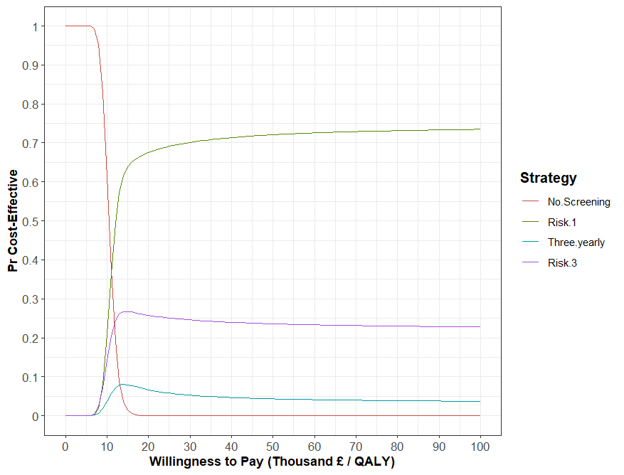

Supplementary materials 3: The impact of changes in parameter values on the most cost-effective strategy.

Figure S3.1: The impact of changes in parameter values on the most cost-effective strategy at a threshold of £30,000 per QALY
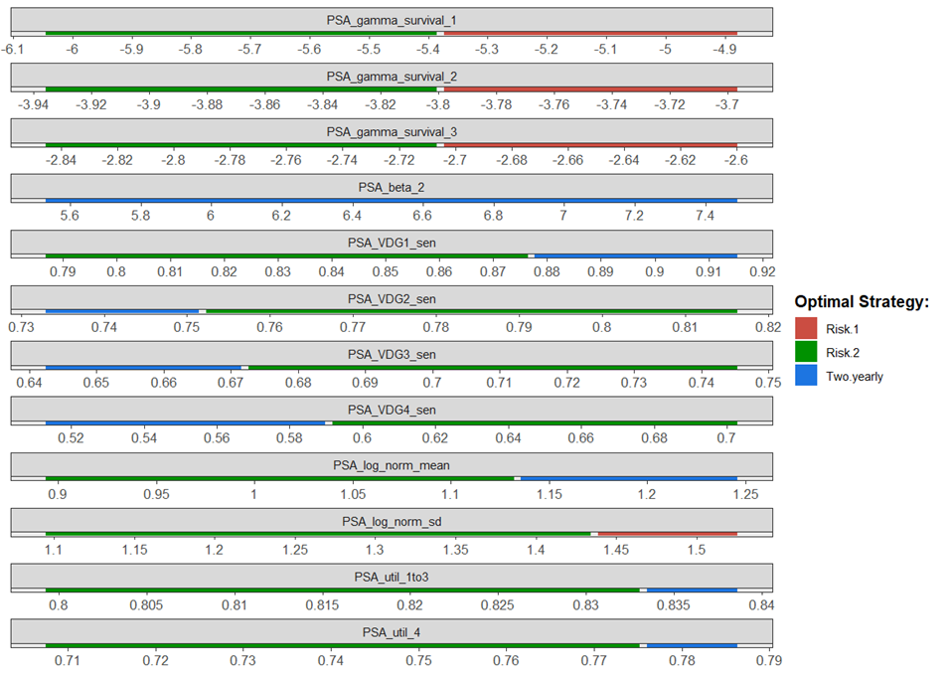
1 PSA_gamma_survival_X=exponential survival curve parameter for stage X, PSA_beta_2=beta parameter for screening sensitivity logistic function, PSA_VDGX_sen=sensitivity of screening for volpara breast density group X, PSA_log_norm_mean=mean of log normal distribution for tumour growth rates, PSA_log_norm_sd=standard deviation of log normal distribution for tumour growth rates, PSA_util_1to3=utility values for tumours of stage I to III, PSA_util_4=utility value for tumour of stage IV

At thresholds of £30,000 per QALY the risk-2 strategy was typically the most cost-effective except at low cancer survival rates where risk-1 was more cost-effective. Two-yearly screening was also more cost-effective than the risk-2 strategy when the sensitivity of screening was very high for VDG1 or very low for VDG2-4. 2-yearly screening was also the most-effective strategy when the mean tumour growth rate and utility values for stages I-III or IV was high. Changes in costs had no impact on the most cost-effective strategy.

Figure S3.2: The impact of changes in parameter values on the most cost-effective strategy at a threshold of £20,000 per QALY
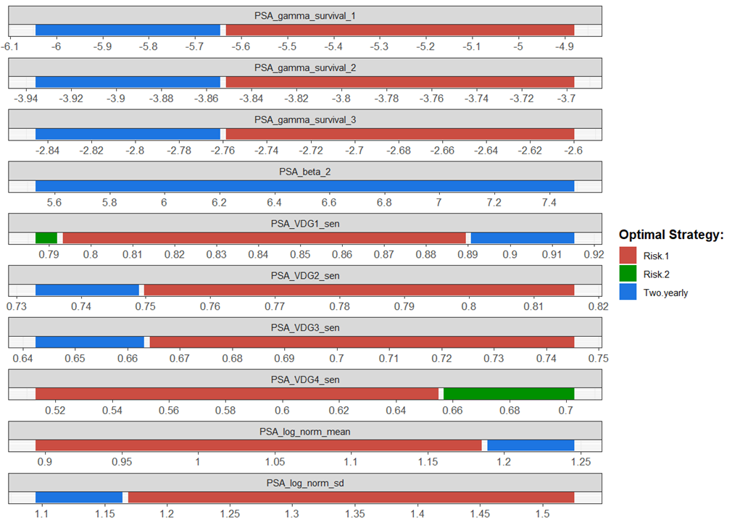
1 PSA_gamma_survival_X=exponential survival curve parameter for stage X, PSA_beta_2=beta parameter for screening sensitivity logistic function, PSA_VDGX_sen=sensitivity of screening for volpara breast density group X, PSA_log_norm_mean=mean of log normal distribution for tumour growth rates, PSA_log_norm_sd=standard deviation of log normal distribution for tumour growth rates, PSA_util_1to3=utility values for tumours of stage I to III, PSA_util_4=utility value for tumour of stage IV
At a threshold of £20,000 per QALY the risk-1 strategy was typically the most cost-effective. However, two-yearly screening was the most cost-effective strategy when survival rates were high or the mean tumour growth rate was high. The impact of variation in the sensitivity by VDG group was very mixed. Changes in utility values and cost had no impact on the results.

Supplementary materials 4: Results when using a discount rate of 1.5%
Table S4.1 shows the estimated costs, QALYs, and cost-effectiveness of the six strategies when the discount rate is reduced to 1.5% for both health outcomes and costs. Figure S3.1 shows the cost-effectiveness acceptability curve for this analysis.

Table S4.1: Costs, Outcomes, and Cost-effectiveness of Six Breast Cancer Screening Strategies
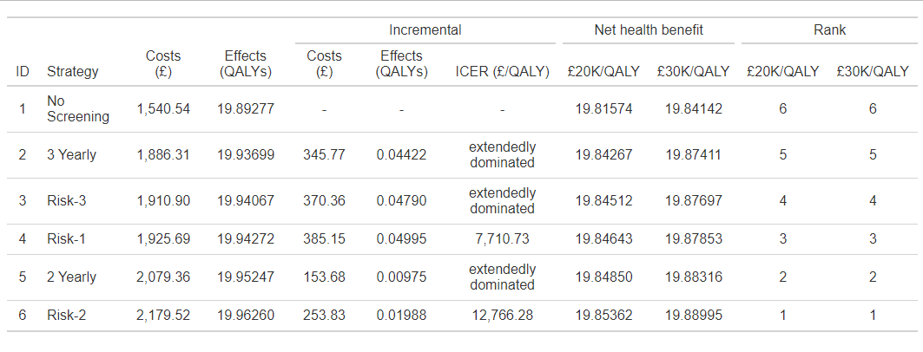

Figure S4.1: Cost-effectiveness Plane When Using a Discount Rate of 1.5%
