Title Page
Title of the article
CB2 regulates oxidative stress and osteoclastogenesis through NOX1-depedent signaling pathway in titanium particle-induced osteolysis
Running Title: CB2 regulates osteolysis via NOX1 pathway

The name(s) of the author(s)
Huaqiang Tao, MS ^{1, a}; Xueyan Li, MS ^{2, a}; Miao Chu, MS ^{1, a}; Qiufei Wang, MS ³; Ping Li, MS ⁴; Qibin Han, MS ⁵; Kai Chen, MS ¹; Pengfei Zhu, MS ¹; Yuefeng Hao, PhD ⁵; Xing Yang, PhD ^{5, *}; Dechun Geng, PhD ^{1, *}; Ye Gu, PhD ^{3, *}.

Name and address of the institution
¹ Department of Orthopedics, The First Affiliated Hospital of Soochow University, No. 188 Shizi Street, Suzhou, Jiangsu, China.
² Anesthesiology department, Suzhou Municipal Hospital, Nanjing Medical University Affiliated Suzhou Hospital, 242, Guangji Road, Suzhou, Jiangsu, China.
³ Department of Orthopedics, Changshu Hospital Affiliated to Soochow University, First People’s Hospital of Changshu City, the First Affiliated Hospital of Soochow University, Suzhou, Jiangsu, China.
⁴ Department of Central Laboratory, Nanjing Medical University Affiliated Suzhou Hospital, Gusu School, Suzhou, Jiangsu, China.
⁵ Orthopedics and Sports Medicine Center, Suzhou Municipal Hospital, Nanjing Medical University Affiliated Suzhou Hospital, 242, Guangji Road, Suzhou, Jiangsu, China.

ª Contribute equally to this work
* Correspondence and requests for materials should be addressed to
Xing Yang Email: xingyangsz@126.com;
Dechun Geng Email: szgengdc@suda.edu.cn;
Ye Gu Email: edwingguye@126.com.

Supplementary materials.

Table S1. Primers used in RT-PCR.
Gene | Primer Sequence (F) | Primer Sequence (R)
CTSK  MMP9  NFATc1  Atp6v0d2  DC-STAMP  NOX1  NOX2  Nrf2  NQO1  HO-1  SOD2 | CTTCCAATACGTGCAGCAGA  CGTGTCTGGAGATTCGACTTGA  GAGAATCGAGATCACCTCCTAC  GACCCTGTGGCACTTTTTGT  AAAACCCTTGGGCTGTTCTT  GCACAGCTTCCACACTTTC  TGGCGATCTCAGCAAAAGGT  TCTTCACTGCCCCTCATC  TTTTCCCCAGCTTGTCTG  GCAACAAGCAGAACCCA  ATGCCCAAACCTATCGTG | TCTTCAGGGCTTTCTCGTTC  TTGGAAACTCACACGCCAGA  TTGCAGCTAGGAAGTACGTCTT  GTGTTTGAGCTTGGGGAGAA  AATCATGGACGACTCCTTGG  CTCTCAGGTCGGCCAAG  TTCAGCCCCAACCAGGAAAC  CTCCTGCCAAACTTGCTC  TCCTTTTCCCATCCTCGT  GTGAGGCCCATACCAGAA  GACCCAATGAGCCAAAGA
GAPDH | GGTTGTCTCCTGCGACTTCA | TGGTCCAGGGTTTCTTACTCC

Table S2. The sequence of CB2 transfection reagent.
Gene | sense | antisense
NC  Cnr2-369  Cnr2-457  Cnr2-689 | UUCUCCGAACGUGUCACGUTT  GAGUACAUGAUCCUGAGCATT  CCGUGCUCUAUAUUAUCCUTT  CCGCUACCUAUGUCUGUGUTT | ACGUGACACGUUCGGAGAATT  UGCUCAGGAUCAUGUACUCTT  AGGAUAAUAUAGAGCACGGTT  ACACAGACAUAGGUAGCGGTT

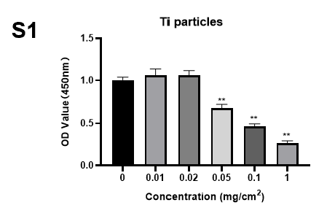
Fig. S1 Cell viability was assessed using a CCK-8 kit after incubation for 24 hours with varying concentrations of Ti particles. Statistical significance was determined by a one-way ANOVA with Tukey’s multiple-comparison test. **P < 0.01, compared with the 0 mg/cm² group.

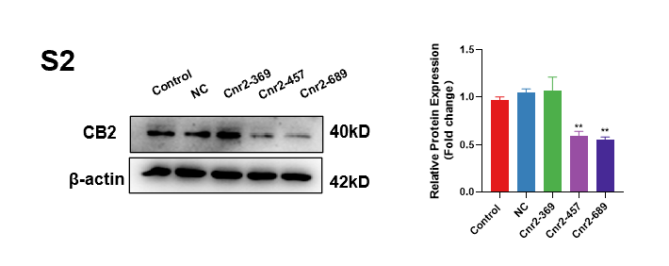
Fig. S2 Western blot revealed that validation of the effect of several CB2 siRNAs to inhibit CB2 expression. Statistical significance was determined by a one-way ANOVA with Tukey’s multiple-comparison test. n=3, **P<0.01.

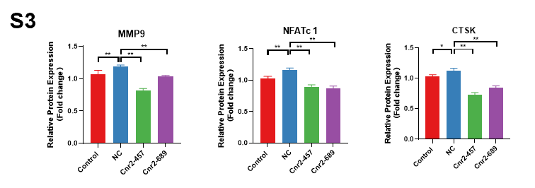
Fig. S3 Quantitative analysis of MMP9, NFATc 1 and CTSK were detected by western blot after the intervention of CB2 blockade. Statistical significance was determined by a one-way ANOVA with Tukey’s multiple-comparison test. n=3, *P<0.05, **P<0.01.

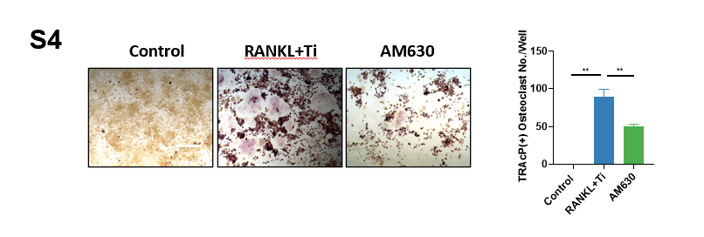
Fig. S4 TRAcP staining and quantitative analysis revealed that AM630 inhibited the number of positive osteoclasts and the percentage of osteoclasts in the area, the scale =100 μm. Statistical significance was determined by a one-way ANOVA with Tukey’s multiple-comparison test. n=3, *P<0.05, **P<0.01.

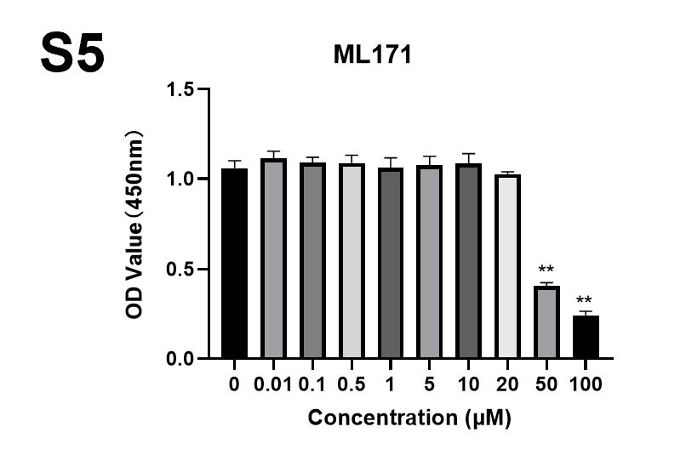
Fig. S5 Cell viability after incubation for 24 hours with different concentrations of ML171 was assessed using a CCK-8 kit. Statistical significance was determined by a one-way ANOVA with Tukey’s multiple-comparison test. n=5. **P < 0.01, compared with the 0 μM group.

