Supplementary information

Untargeted LC-HRMS-based metabolomics to identify novel biomarkers of metastatic colorectal cancer

Ariadna Martín-Blázquez^{1,+}, Caridad Díaz^{1,+}, Encarnación González-Flores², Daniel Franco-Rivas¹, Cristina Jiménez-Luna³, Consolación Melguizo^{3,4,5}, José Prados^{3,4,5,*}, Olga Genilloud¹, Francisca Vicente¹, Octavio Caba^{3,4,5,++} & José Pérez del Palacio^{1,++}

¹ Fundación MEDINA, Centro de Excelencia en Investigación de Medicamentos Innovadores en Andalucía, Granada, Spain
² Service of Medical Oncology, University Hospital Virgen de las Nieves of Granada, Granada, Spain
³ Institute of Biopathology and Regenerative Medicine (IBIMER), Center of Biomedical Research (CIBM), University of Granada, Granada, Spain
⁴ Biosanitary Institute of Granada (ibs. GRANADA), SAS-Universidad de Granada, Granada, Spain
⁵ Department of Anatomy and Embryology, University of Granada, Granada, Spain

*Corresponding author: Jose Prados, jcprados@ugr.es

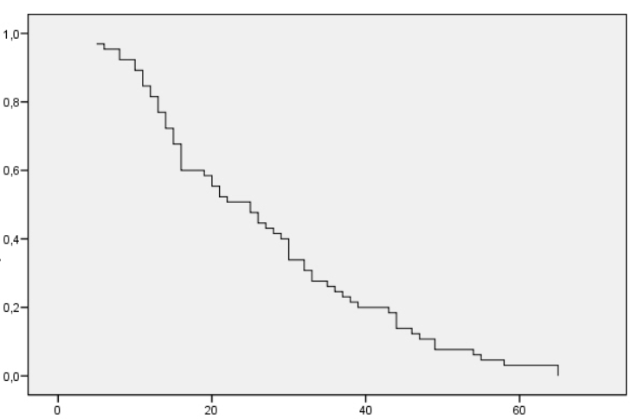
Overall survival
probability
Time (months)

Figure S1. Kaplan-Meier survival curve for all metastatic CRC patients in the cohort (n=65).

