Supplementary Material

A novel class of plant type III polyketide synthase involved in orsellinic acid biosynthesis from Rhododendron dauricum

Futoshi Taura*, Miu Iijima, Eriko Yamanaka, Hironobu Takahashi, Hiromichi Kenmoku, Haruna Saeki, Satoshi Morimoto, Yoshinori Asakawa, Fumiya Kurosaki, Hiroyuki Morita*

* Correspondence:
Futoshi Taura
Graduate School of Medicine and Pharmaceutical Sciences for Research, University of Toyama, 2630 Sugitani, Toyama, 930-0194, Japan. Email taura@pha.u-toyama.ac.jp
Hiroyuki Morita
Institute of Natural Medicine, University of Toyama, 2630 Sugitani, Toyama, 930-0194, Japan. Email morita@inm.u-toyama.ac.jp

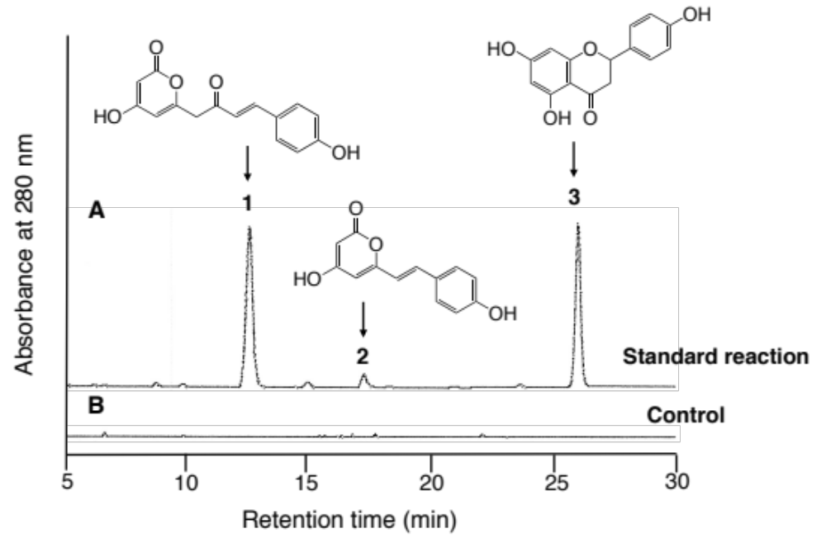

Supplementary Figure 1. HPLC elution profile of the products synthesized by the recombinant R. dauricum CHS, from p-coumaroyl-CoA and malonyl-CoA. (A) The standard reaction using 20 μg of CHS. The reaction products are coumaroyl triacetic acid lactone (1), bis-noryangonin (2), and naringenin (3). (B) Control reaction with heat-denatured CHS.

Supplementary Table 1. Primers and PCR conditions used in this study.
Purposes | Primers | Sequences | PCR conditions
Degenerate PCR | PKS_Fw ª  PKS_Rv ª | TAYCCIGAYTWYTAYTT  CCCCAYTCYTYDATIGC | 30 cycles of (94 ˚C 1 min, 50˚C 1 min, 72 ˚C 1 min)
ORS 3’RACE  ORS first 5’RACE  ORS nested 5’RACE  CHS 3’RACE  CHS first 5’RACE  CHS nested 5’RACE | ORS_3R  ORS_5R1  ORS_5R2  CHS_3R  CHS_5R1  CHS_5R | TGAATCATGGTGGGGAGAAG  (AP for the counter primer)  GTCCAGAACATCAAGAGATG  (dT₁₇AP for the counter primer)  TCGTTCACGTGCATGTACCT  (AP for the counter primer)  GTGGAAGTTCCCAAATTGGG  (AP for the counter primer)  AACTTCTCTTTGAGCTCTGC  (dT₁₇AP for the counter primer)  CCCAGTTTAGGGACCTCAAC  (AP for the counter primer) | 30 cycles of (94 ˚C 1 min, 60˚C 1 min, 72 ˚C 1 min)  5 cycles of (94 ˚C 1 min, 50 ˚C 1 min, 72 ˚C 1 min); 30 cycles of (94 ˚C 1 min, 60 ˚C 1 min, 72 ˚C 1 min)  30 cycles of (94 ˚C 1 min, 60 ˚C 1 min, 72 ˚C 1 min)  ditto  5 cycles of (94 ˚C 1 min, 50 ˚C 1 min, 72 ˚C 1 min);  30 cycles of (94 ˚C 1 min, 60 ˚C 1 min, 72 ˚C 1 min)  30 cycles of (94 ˚C 1 min, 60 ˚C 1 min, 72 ˚C 1 min)
ORS full length PCR | ORS_Fw | CGGGATCCATGGCTTTGGTGAACCACA ^{b} | 30 cycles of (98˚C 10 sec, 60˚C 5 sec, 72˚C 1 min)
 | ORS_Rv | CCGGTCGACCTATTTAAGTTTGGCCGTAGG ^{c}
CHS full length PCR | CHS_Fw | CGGGATCCATGGTCACCGTCGAGGATGT ^{b} | ditto
ORS yeast expression  ORS RT-PCR  CHS RT-PCR  18S rRNA RT-PCR | CHS_Rv  ORS_Fw2  ORS_Rv2  18S_Fw  18S_Rv | CCGGTCGACTCAAGTGCACAAACTGTGCA ^{c}  CGGAATTCAAAACAATGGCTTTGGTGAACCACA ^{d}  CCGGTCGACTTTAAGTTTGGCCGTAGG ^{c}  ORS_3R and ORS_Rv  CHS_3R and CHS_Rv  TTCTTGGATTTATGAAAGAC  AAGACCAACAATTGCAATGA | ditto  30 cycles of (94 ˚C 1 min, 60 ˚C 1 min, 72 ˚C 1 min)  ditto  25 cycles of (94 ˚C 1 min, 60 ˚C 1 min, 72 ˚C 1 min)
First 5’RACE | dT₁₇AP | GACTCGTCTAGAGGATCCCG(T)₁₇
Nested 5’RACE | AP | GACTCGTCTAGAGGATCCCG
ª PKS_Fw and PKS_Rv were designed from the conserved peptide sequences YPD(Y/F)YF and AIKEWG, respectively. ^{b} BamHI, ^{c} SalI, and ^{d} EcoRI sites are underlined. The partial Kozak sequence in ORS_Fw2 is double-underlined.

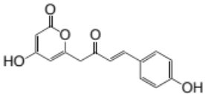
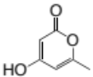
Supplementary Table 2. LC-ESI-MS analyses of the reaction products synthesized by R. dauricum CHS from acetyl-CoA or p-coumaroyl-CoA.
Starter-CoA  products | Product structures | Rt  (min) | Gradient ª | HR-ESI-MS  (m/z) | MS/MS ^{b}  (m/z) | λ_{max}  (nm)
Acetyl-CoA  triacetic acid lactone  (4-hydroxy-6-methyl-2-pyrone)  p-Coumaroyl-CoA  - 1) coumaroyl triacetic acid lactone  - 2) bis-noryangonin  - 3) naringenin |  | 15.8  12.8  17.4  26.8 | A  B  B  B | 125.02413 [M-H]⁻  (calc. for C₆H₅O₃⁻, 125.02387)  271.06046 [M-H]⁻  (calc. for C₁₅H₁₁O₅⁻, 271.06065)  229.05000 [M-H]⁻  (calc. for C₁₃H₉O₄⁻, 229.05009)  271.06054 [M-H]⁻  (calc. for C₁₅H₁₁O₅⁻, 271.06065) | 81.1 [M-H-CO₂]⁻  125.1 [C₆H₅O₃]⁻  227.1 [M-H-CO₂]⁻  185.1 [M-H-CO₂]⁻  ND | 283  333  363  289
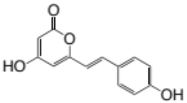
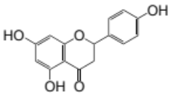
ª Solvent systems A and B are described in Materials and Methods. ^{b} Precursor ions are the [M-H]⁻ ions in HR-ESI-MS. Note that the [C₆H₅O₃]⁻ ion corresponds to an α-pyrone core structure, and [M-H-CO₂]⁻ ions are generated from the decarboxylation of α-pyrone compounds. ND, not determined.

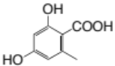
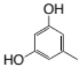
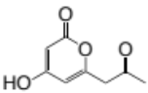
Supplementary Table 3. LC-ESI-MS analyses of the reaction products synthesized by ORS from different starter substrates.
Starter-CoA  products | Product structures | Rt  (min) | Gradient ª | HR-ESI-MS  (m/z) | MS/MS ^{b}  (m/z) | λ_{max}  (nm)
Acetyl-CoA  - 1) tetraacetic acid lactone  - (6-acetonyl-4-hydroxy-2-pyrone)  - 2) triacetic acid lactone  - (4-hydroxy-6-methyl-2-pyrone)  - 3) orcinol  - 4) orsellinic acid  - 5) phloroacetophenone  Butyryl-CoA  4-hydroxy-6-propyl-2-pyrone  Hexanoyl-CoA  4-hydroxy-6-pentyl-2-pyrone |  | 12.6  15.8  23.2  27.9  30.2  12.3  28.3 | A  A  A  A  A  B  B | 167.03474 [M-H]⁻ (calc. for C₈H₇O₄⁻, 167.03444)  125.02420 [M-H]⁻  (calc. for C₆H₅O₃⁻, 125.02387)  123.04490 [M-H]⁻  (calc. for C₇H₇O₂⁻, 123.04461)  167.03400 [M-H]⁻  (calc. for C₈H₇O₄⁻, 167.03444)  167.03441 [M-H]⁻  (calc. for C₈H₇O₄⁻, 167.03444)  153.05544 [M-H]⁻  (calc. for C₈H₉O₃⁻, 153.05517)  181.08647 [M-H]⁻ | 125.1 [C₆H₅O₃]⁻  123.1 [M-H-CO₂]⁻  81.1 [M-H-CO₂]⁻  ND  123.0 [M-H-CO₂]⁻  ND  109.1 [M-H-CO₂]⁻  137.1 [M-H-CO₂]⁻ | 283  284  271  261, 297  285  285  285
 |  |  |  | (calc. for C₁₀H₁₃O₃⁻, 181.08647)
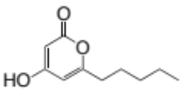
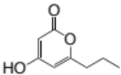
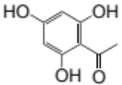
ª Solvent systems A and B are described in Materials and Methods. ^{b} Precursor ions are the [M-H]⁻ ions in HR-ESI-MS. Note that the [C₆H₅O₃]⁻ ion corresponds to an α-pyrone core structure, and [M-H-CO₂]⁻ ions are generated from the decarboxylation of α-pyrone and resorcylic acid compounds. ND, not determined.

