Figure S1. Directed Acyclic Graph representing hypothesized relationships between ADHD and Risky Sexual Behaviours (RSB).
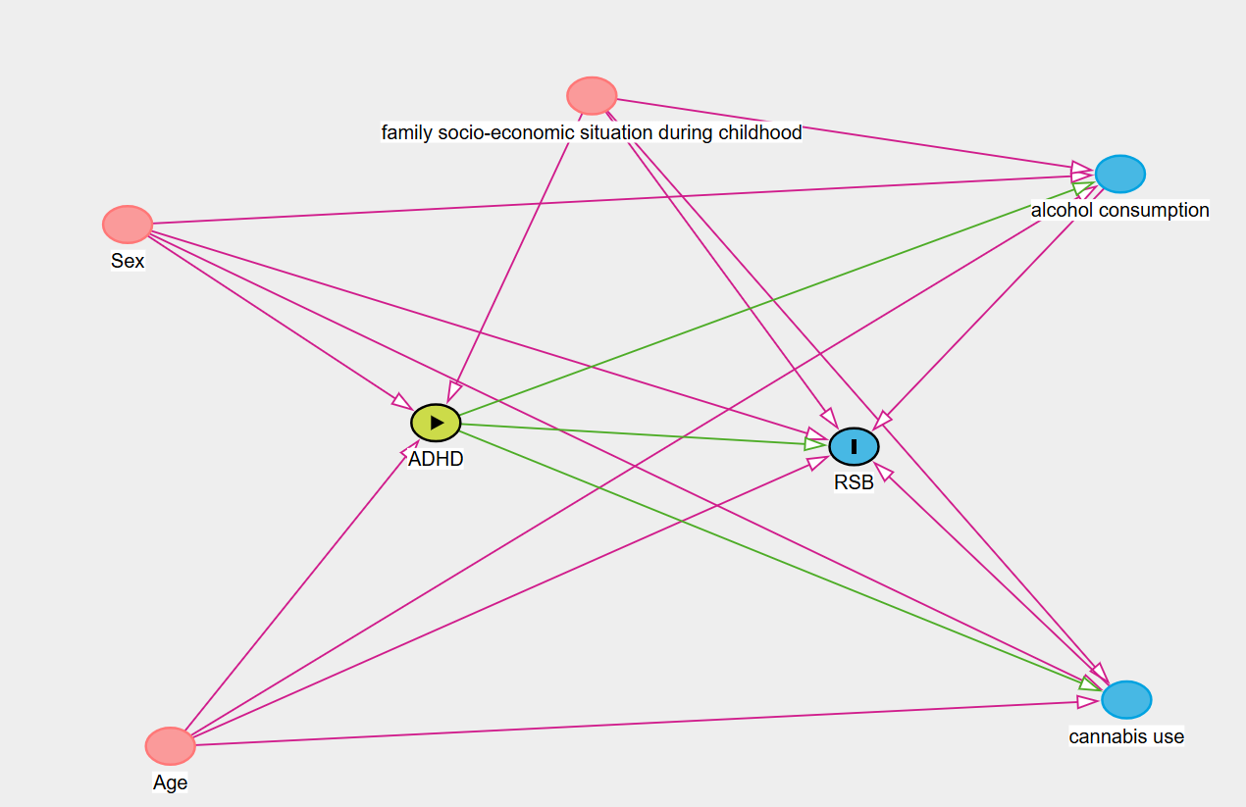
Note: This DAG illustrates the assumed causal relationships between ADHD (exposure) and Risky Sexual Behaviour (RSB, outcome).
The minimal sufficient adjustment set to estimate the total effect of ADHD on RSB includes Age, Sex, and Family socio-economic situation during childhood.

Figure S2. Flowchart of the Study Population Selection: the i-Share study
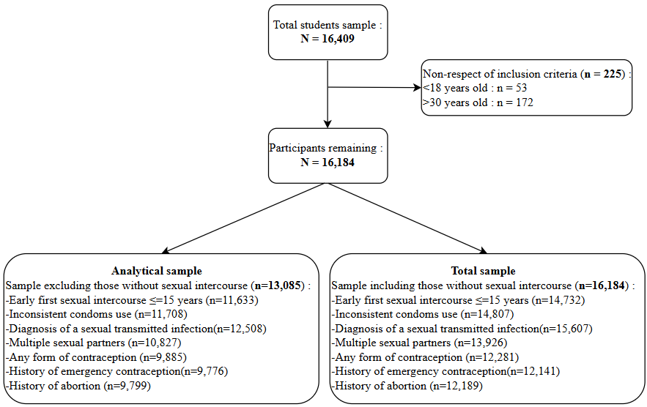

Table S1. Characteristics of the study population (including those without sexual intercourse): the i-Share study
 |  | Total sample  (N=16,184) | ADHD Symptoms:  Low level  (n=15,328) | ADHD Symptoms:  High level  (n=856) | p-value
 |  | n (%) or mean (SD) | n (%) or mean (SD) | n (%) or mean (SD)
 | Sex |  |  |  | 0.282
 | Men | 3,893 (24.1%) | 3,674 (24.0%) | 219 (25.6%)
 | Women | 12,291 (75.9%) | 11,654 (76.0%) | 637 (74.4%)
 | Age* | 20.38 (2.31) | 20.38 (2.31) | 20.33 (2.30) | 0.464
 | SES |  |  |  | <0.001
 | Low | 1,506 (9.3%) | 1,386 (9.0%) | 120 (14.0%)
 | Moderate to high | 14,675 (90.7%) | 13,939 (91.0%) | 736 (86.0%)
 | Study level |  |  |  | 0.291
 | First year | 6,112 (37.9%) | 5,778 (37.8%) | 334 (39.1%)
 | Second year | 3,162 (19.6%) | 2,977 (19.5%) | 185 (21.7%)
 | Third year | 2,479 (15.4%) | 2,359 (15.4%) | 120 (14.1%)
 | Four or more | 2,546 (15.8%) | 2,416 (15.8%) | 130 (15.2%)
 | Other | 1,824 (11.3%) | 1,739 (11.4%) | 85 (10.0%)
 | Alcohol use |  |  |  | 0.236
 | < 1/ week | 7,389 (45.7%) | 7,015 (45.8%) | 374 (43.7%)
 | ≥ 1/ week | 8,795 (54.3%) | 8,313 (54.2%) | 482 (56.3%)
 | Cannabis use |  |  |  | <0.001
 | No | 10 367 (65,2%) | 9 917 (65,9%) | 450 (53,5%)
 | ≤once/month | 4 052 (25,5%) | 3 807 (25,3%) | 245 (29,1%)
 | > once/month | 1 481 (9,3%) | 1 335 (8,9%) | 146 (17,4%)
 | Risk Sexual Behaviours
 | Inconsistent condoms use (last 12 months) |  |  |  | <0.001
 | No | 11,886 (80.3%) | 11,304 (80.6%) | 582 (74.5%)
 | Yes | 2,921 (19.7%) | 2,722 (19.4%) | 199 (25.5%)
 | Diagnosis of sexually transmitted infection (last 12 months) |  |  |  | 0.004
 | No | 15,077 (96.6%) | 14,284 (96.7%) | 793 (94.6%)
 | Yes | 530 (3.4%) | 487 (3.3%) | 43 (5.1%)
 | Number of sexual partners (last 12 months) | 1.61 (2.88) | 1.59 (2.69) | 2.07 (5.24) | 0.002
 | Any form of contraception (current) |  |  |  | <0.001
 | No | 4,026 (32.8%) | 3,753 (32.2%) | 273 (42.9%)
 | Yes | 8,255 (67.2%) | 7,891 (67.8%) | 364 (57.1%)
 | History of emergency contraception (ever) |  |  |  | 0.040
 | No | 7,550 (62.2%) | 7,182 (62.4%) | 368 (58.3%)
 | Yes | 4,591 (37.8%) | 4,328 (37.6%) | 263 (41.7%)
 | History of abortion (ever) |  |  |  | 0.003
 | No | 11,798 (96.8%) | 11,196 (96.9%) | 602 (94.8%)
 | Yes | 391 (3.2%) | 358 (3.1%) | 33 (5.2%)
* Age is shown as the mean (SD = standard deviation).
p-values from Chi2 tests (all variables except for age and multiple sexual partners), Mann-Whitney test (for age) and Wilcoxon test (for multiple sexual partners).
Abbreviations: ADHD = Attention Deficit Hyperactivity Disorder, SES = Socio Economic Status.

Table S2. Multivariable associations between ADHD symptoms and Risky Sexual Behaviours (including those without sexual intercourse): the i-Share study
 | Early first sexual intercourse  (≤ 15 years)  N = 14,732 | Inconsistent condom use  (last 12 months)  N = 14,807 | Diagnosis of a sexually transmitted infection  (last 12 months)  N = 15,607 | Multiple sexual partners  (last 12 months)  N = 13,926 | Any form of contraception*  (current)  N = 12,281 | History of emergency contraception* (ever)  N = 12,141 | History of abortion*  (ever)  N = 12,189
 | OR (95% CI) | OR (95% CI) | OR (95% CI) | IRR (95% CI) | OR (95% CI) | OR (95% CI) | OR (95% CI)
ADHD unadjusted | 1.27(1.07 – 1.51) | 1.42(1.20 – 1.68) | 1.59(1.15 – 2.19) | 1.31(1.24 – 1.37) | 0.63(0.54 – 0.75) | 1.19(1.01 – 1.40) | 1.71(1.19 – 2.47)
ADHD and gender, age, SES | 1.25(1.06 – 1.48) | 1.42(1.20 – 1.68) | 1.61(1.16 – 2.22) | 1.30(1.24 – 1.37) | 0.64(0.54 – 0.75) | 1.20(1.02 – 1.42) | 1.77(1.22 – 2.58)
ADHD and gender, age, SES, alcohol, cannabis | - | 1.26(1.06 – 1.50) | 1.49(1.08 – 2.06) | 1.21(1.14 – 1.27) | 0.61(0.52 – 0.73) | - | -
* Female sample
Early first sexual intercourse is not adjusted for age.
Sensitivity analysis (including participants without sexual intercourse).
Abbreviations: ADHD = Attention Deficit Hyperactivity Disorder, SES = Socio Economic Status, OR: odds ratio, IRR: Incidence Rate Ratio, CI: confidence interval.
Table S3. Multivariable associations between ADHD symptoms and Risky Sexual Behaviours, treating ADHD symptoms as a standardized continuous variable: the i-Share study
 | Early first sexual intercourse  (≤ 15 years)  N = 11,633 | Inconsistent condom use  (last 12 months)  N = 11,708 | Diagnosis of a sexually transmitted infection  (last 12 months)  N = 12,508 | Multiple sexual partners  (last 12 months)  N = 10,827 | Any form of contraception*  (current)  N = 9,885 | History of emergency contraception* (ever)  N = 9,776 | History of abortion*  (ever)  N = 9,799
 | OR (95% CI) | OR (95% CI) | OR (95% CI) | IRR (95% CI) | OR (95% CI) | OR (95% CI) | OR (95% CI)
ADHD unadjusted | 1.07 (1.02– 1.11) | 1.22 (1.17 – 1.27) | 1.12 (1.03 – 1.23) | 1.10 (1.09 – 1.12) | 0.80 (0.76 – 0.84) | 1.13 (1.08 – 1.17) | 1.20 (1.09 – 1.33)
ADHD and gender, age, SES | 1.06 (1.02 – 1.10) | 1.22 (1.16 – 1.27) | 1.13 (1.04 – 1.23) | 1.10 (1.08 – 1.11) | 0.80 (0.76 – 0.84) | 1.14 (1.09 – 1.18) | 1.21 (1.10 – 1.34)
ADHD and gender, age, SES, alcohol, cannabis | - | 1.13 (1.08 – 1.18) | 1.12 (1.01 – 1.23) | 1.06 (1.04 – 1.07) | 0.80 (0.76 – 0.84) | - | -
* Female sample
Early first sexual intercourse is not adjusted for age.
Abbreviations: ADHD = Attention Deficit Hyperactivity Disorder, SES = Socio Economic Status, OR: odds ratio, IRR: Incidence Rate Ratio, CI: confidence interval.

