Changes in disability status and oral healthcare unaffordability among working age Australians
Supplementary material
eFigure S1. Observed and shifted disability trajectories in a random sample of participants, under the natural course and the 50% and 25% odds-reduction (IPSI) policies.
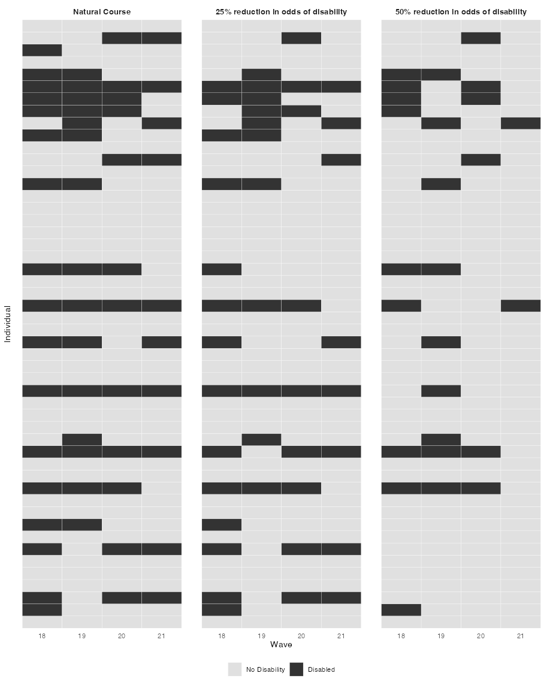
Note: IPSI indicates incremental propensity score intervention. Dark tiles indicate disability; light tiles indicate no disability.

eTable S1. Flow of participant numbers after each follow-up wave in the main wave 18 to 22 analysis.
Wave | Retained, n | Retained, % | Censored since previous wave, n | Censored since previous wave, %
18 | 9,635 | 100.0 | - | -
19 | 9,570 | 99.3 | 65 | 0.7
20 | 9,519 | 98.8 | 51 | 0.5
21 | 9,479 | 98.4 | 40 | 0.4
22 | 9,426 | 97.8 | 53 | 0.6
Note. n indicates number of participants. Wave 18 is the baseline wave; not applicable indicates no previous wave for calculating censoring or loss to follow-up.

eFigure S2. Distribution of missingness across study variables by covariate and wave before multiple imputation.
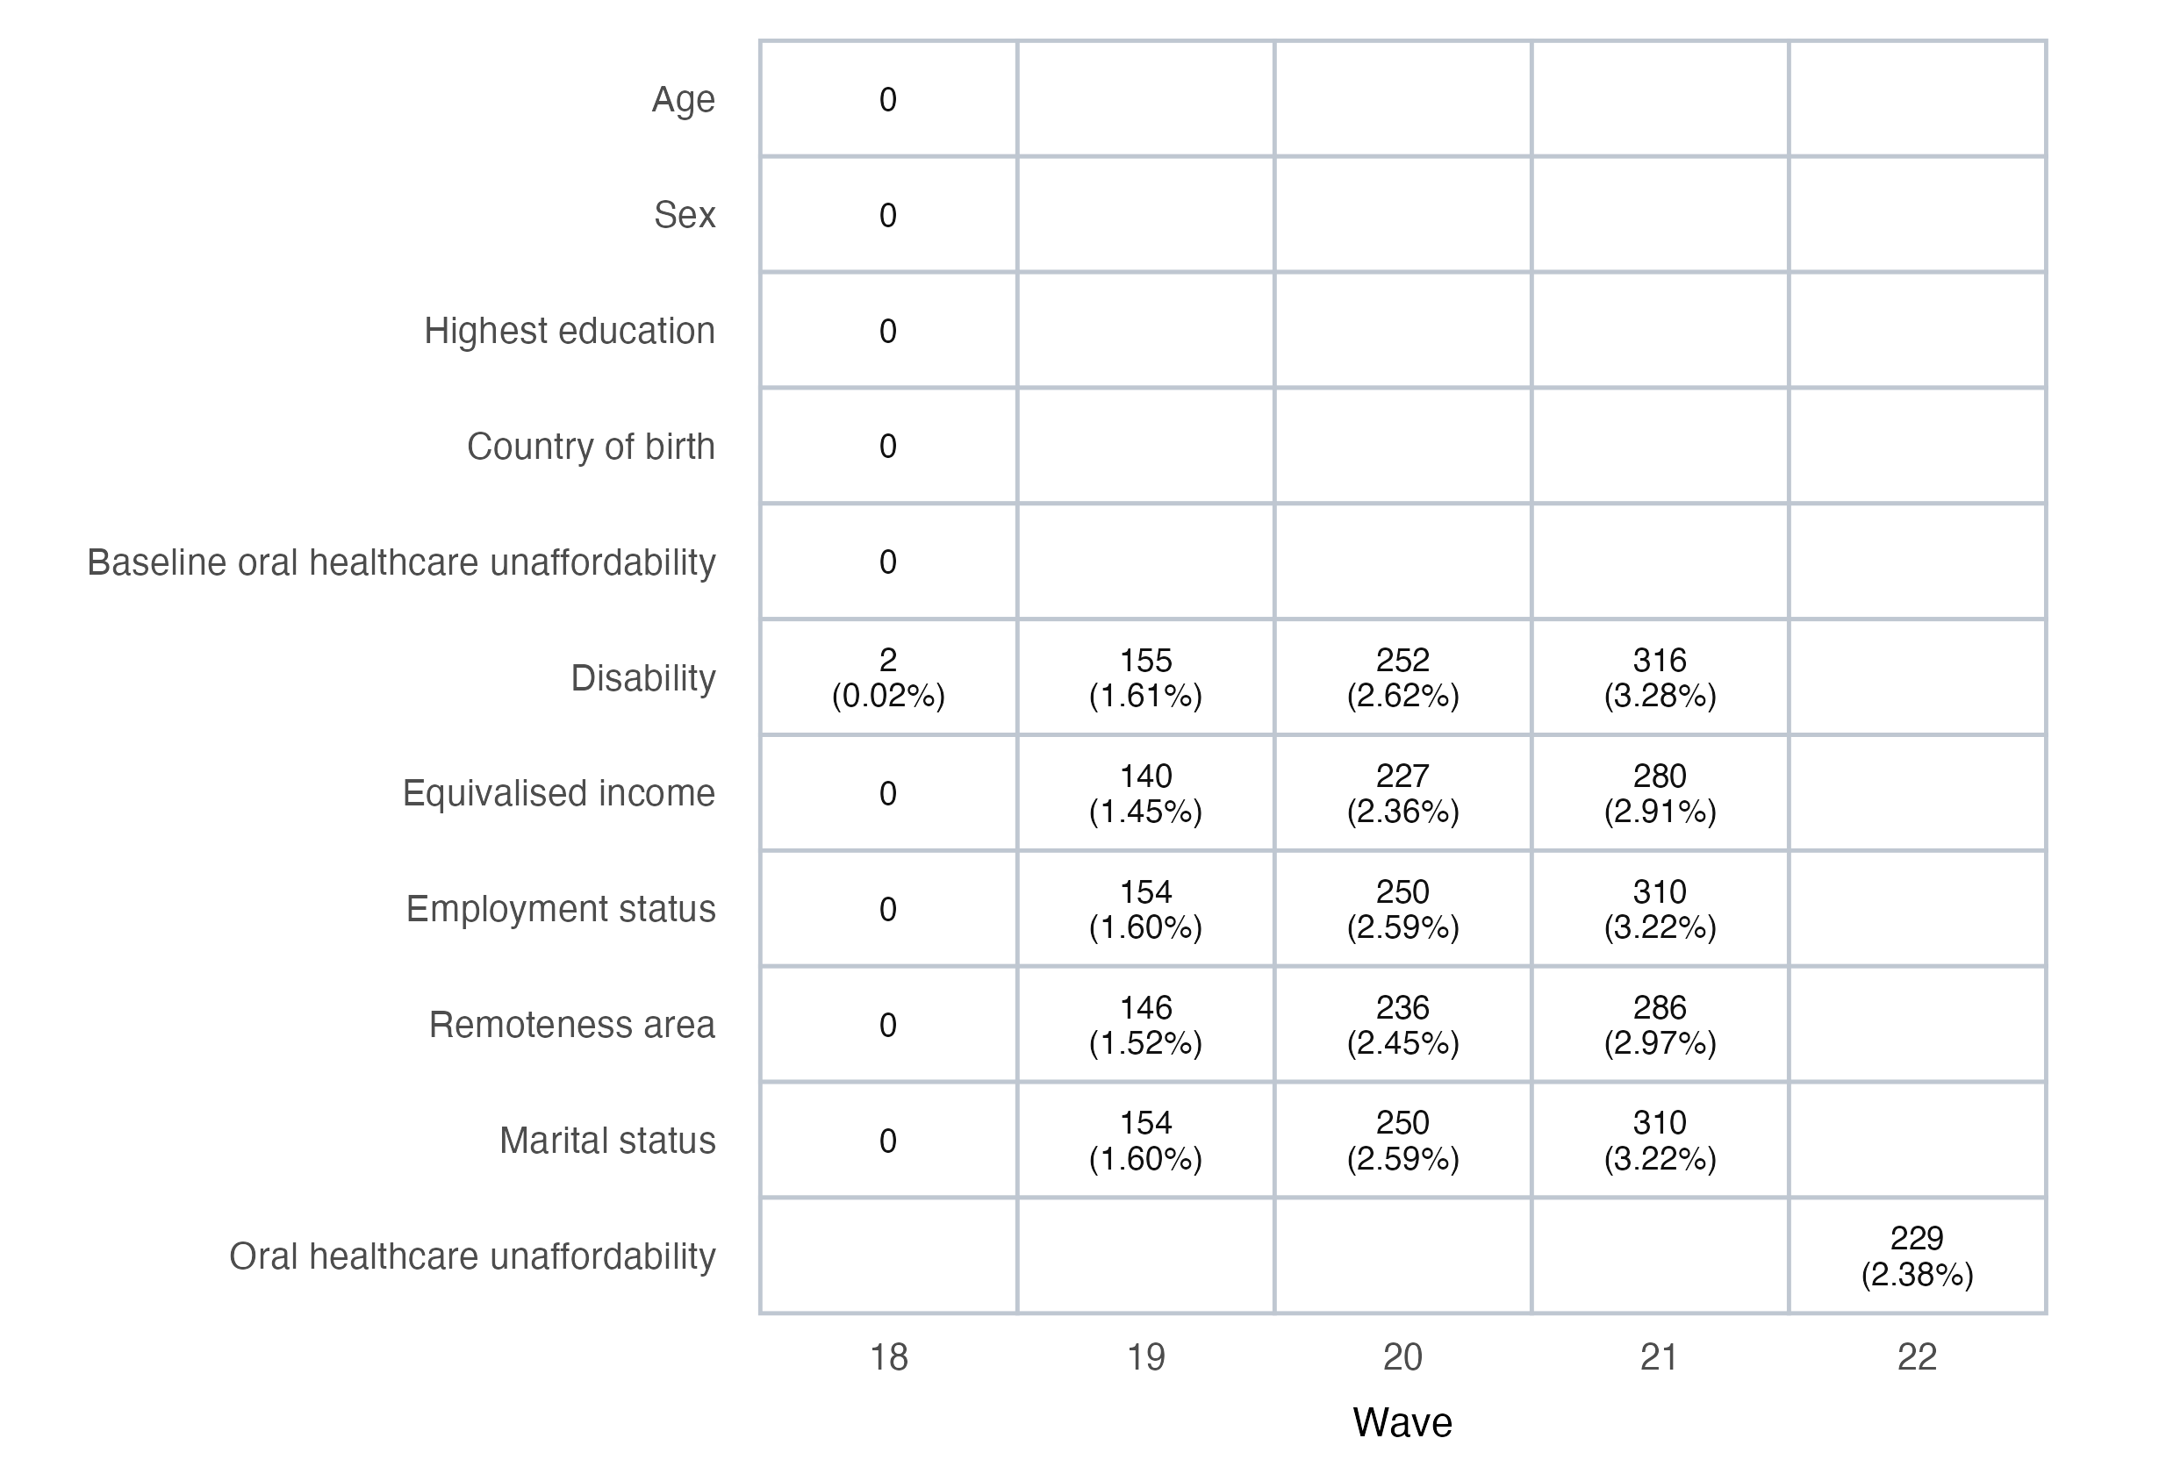
Note: Values are number missing and percentage missing among main analytic participants before imputation; blank cells indicate variables not included at that wave.

eTable S2. Results of the incidence cohort analysis restricted to participants without baseline oral healthcare unaffordability.
Intervention scenario | RR (95% CI) | RD (95% CI)
Sustained disability at every exposure wave | 1.43 (0.89, 2.30) | 0.014 (-0.009, 0.037)
No disability at any exposure wave | 0.52 (0.40, 0.67) | -0.016 (-0.021, -0.011)
50% reduction in odds of disability (IPSI) | 0.71 (0.63, 0.81) | -0.009 (-0.013, -0.006)
25% reduction in odds of disability (IPSI) | 0.85 (0.79, 0.91) | -0.005 (-0.007, -0.003)
Note: CI indicates confidence interval; IPSI, incremental propensity score intervention; RD, risk difference; RR, risk ratio. Estimates are contrasts with the natural course. The incidence cohort excludes participants who reported oral healthcare unaffordability at baseline.

eTable S3. Results of the pre-pandemic waves 14 to 18 analysis.
Intervention scenario | RR (95% CI) | RD (95% CI)
Sustained disability at every exposure wave | 1.98 (1.51, 2.60) | 0.058 (0.025, 0.092)
No disability at any exposure wave | 0.70 (0.60, 0.82) | -0.018 (-0.025, -0.011)
50% reduction in odds of disability (IPSI) | 0.78 (0.72, 0.85) | -0.013 (-0.017, -0.009)
25% reduction in odds of disability (IPSI) | 0.86 (0.82, 0.91) | -0.008 (-0.011, -0.005)
Note: CI indicates confidence interval; IPSI, incremental propensity score intervention; RD, risk difference; RR, risk ratio. Estimates are contrasts with the natural course. The pre-pandemic analysis uses waves 14 to 18.

