Supporting Information
In this additional section, we highlight some of the descriptive information and statistics supporting our proposed analysis.

S1: Key eligibility criteria for ADNI participants
Enrolled participants for the study were between 55-90 (inclusive) years of age, had a study partner, were able to provide an independent evaluation of functioning and were able to speak either English or Spanish. All participants were willing and able to undergo all test procedures including neuroimaging and agreed to longitudinal follow up. Normal, MCI and mild AD participants had MMSE scores between 24-30 (inclusive), 24-30 (inclusive) and 20-26 (inclusive) respectively and a CDR total scores of 0, 0.5 and 1.0 respectively. Refer [20] for further details on protocols and criteria for the participants.

S2 Table: Description of ADNI clinical features used in analysis
Clinical test | Sub Test name | Features | Description
Montreal Cognitive Assessment
Moca (856, 42) - ['bl', 'm06', m12'] | ALTERNATING TRAIL MAKING | TRAILS
 | VISUOCONSTRUCTIONAL SKILLS | CUBE | Copy Cube
 |  | CLOCKCON | Draw Clock - Contour
 |  | CLOCKNO | Draw Clock - Number
 |  | CLOCKHAN | Draw Clock - Hands
 | NAMING | LION | Lion
 |  | RHINO | Rhinoceros
 |  | CAMEL | Camel
 | MEMORY | IMMT2W1 | Immediate (#2): Daisy
 |  | IMMT2W2 | Immediate (#2): Red
 |  | IMMT2W3 | Immediate (#2): Velvet
 |  | IMMT2W4 | Immediate (#2): Church
 |  | IMMT2W5 | Immediate (#1): Daisy
 |  | IMMT1W1 | Immediate (#1): Red
 |  | IMMT1W2 | Immediate (#2): Face
 |  | IMMT1W3 | Immediate (#1): Velvet
 |  | IMMT1W4 | Immediate (#1): Church
 |  | IMMT1W5 | Immediate (#1): Face
 | SENTENCE REPETITION | REPEAT1 | Repeat Sentence: I only know that John is the one to help today.
 |  | REPEAT2 | Repeat Sentence: The cat always hid under the couch when dogs were in the room.
 | VERBAL FLUENCY | FFLUENCY | Letter Fluency - F: Total number of correct words
 | ABSTRACTION | ABSTRAN | Abstraction: train-bicycle
 |  | ABSMEAS | Abstraction: watch-ruler
 | DELAYED RECALL | DELW1 | Delayed: Face
 |  | DELW2 | Delayed: Velvet
 |  | DELW3 | Delayed: Church
 |  | DELW4 | Delayed: Daisy
 |  | DELW5 | Delayed: Red
 | ORIENTATION | DATE | -
 |  | MONTH | -
 |  | YEAR | -
 |  | DAY | -
 |  | PLACE | -
 |  | CITY | -
 | ATTENTION | DIGFOR | Digits Forward
 |  | DIGBACK | Digits Backward
 |  | LETTERS | List of Letters/Tapping: # Errors
 |  | SERIAL1 | 1st Subtraction
 |  | SERIAL2 | 2nd Subtraction
 |  | SERIAL3 | 3rd Subtraction
 |  | SERIAL4 | 4thSubtraction
 |  | SERIAL5 | 5th Subtraction
Clinical Dementia Rating
CDR (1461, 6) - ['bl', 'm06', 'm12'] | CDR RATER to compute the Global CDR Score availabe at http://www.biostat.wustl.edu/adrc/ | CDMEMORY | Memory Score
 |  | CDORIENT | Orientation Score
 |  | CDJUDGE | Judgment and Problem Solving Score
 |  | CDCOMMUN | Community Affairs Score
 |  | CDHOME | Home and Hobbies Score
 |  | CDCARE | Personal Care Score
Neuropsychiatric Inventory Questionnaire | NPI Score = Frequency x Severity
NPIQ (778, 24) - ['bl', 'm06', 'm12'] | Delusions | NPIA | Does {P} believe that others are stealing from him/her, or planning to harm him/her in some way?
 |  | NPIASEV | Severity Ratings for Delusions
 | Hallucinations | NPIB | Does {P} act as if he/she hears voices? Does he/she talk to people who are not there?
 |  | NPIBSEV | Severity Ratings for Hallucinations
 | Agitation/Aggression | NPIC | Is {P} stubborn and resistive to help from others?
 |  | NPICSEV | Severity Ratings for. Agitation/Aggression
 | Depression/Dysphoria | NPID | Does {P} act as if he/she is sad or in low spirits? Does he/she cry?
 |  | NPIDSEV | Severity Ratings for Depression/Dysphoria
 | Anxiety | NPIE | Does {P} become upset when separated from you? Does he/she have any other signs of nervousness, such as shortness of breath, sighing, being unable to relax, or feeling excessively tense?
 |  | NPIESEV | Severity Ratings for Anxiety
 | Elation/Euphoria | NPIF | Does {P} appear to feel too good or act excessively happy?
 |  | NPIFSEV | Severity Ratings for Elation/Euphoria
 | Apathy/Indifference | NPIG | Does {P} seem less interested in his/her usual activities and in the activities and plans of others?
 |  | NPIGSEV | Severity Ratings for Apathy/Indifference
 | Disinhibition | NPIH | Does {P} seem to act impulsively? For example, does {P} talk to strangers as if he/she knows them, or does {P} say things that may hurt people's feelings?
 |  | NPIHSEV | Severity Ratings for Disinhibition
 | Irritability/Lability | NPII | Is {P} impatient or cranky? Does he/she have difficulty coping with delays or waiting for planned activities?
 |  | NPIISEV | Severity Ratings for Irritability/Lability
 | Aberrant Motor Behavior | NPIJ | Does {P} engage in repetitive activities, such as pacing around the house, handling buttons, wrapping strings, or doing other things repeatedly?
 |  | NPIJSEV | Severity Ratings for Aberrant Motor Behavior
 | Sleep | NPIK | Does {P} awaken you during the night, rise too early in the morning, or take excessive naps during the day?
 |  | NPIKSEV | Severity Ratings for Sleep
 | Appetite | NPIL | Has {P} lost or gained weight, or had a change in the food he/she likes?
 |  | NPILSEV | Severity Ratings for Appetite
Neuropsychological Battery
NEUROBAT - (1456, 43) | CLOCK - (1637, 1) - ['bl', 'm06', 'm12'] | CLOCKCIRC | 1. Approximately circular face
 |  | CLOCKSYM | 2. Symmetry of number placement
 |  | CLOCKNUM | 3. Correctness of numbers
 |  | CLOCKHAND | 4. Presence of the two hands
 |  | CLOCKTIME | 5. Presence of the two hands, set to ten after eleven
 | We consider only the Total Score | CLOCKSCOR | Total Score
 | COPY - (1637, 1) - ['bl', 'm06', 'm12'] | COPYCIRC | 1. Approximately circular face
 |  | COPYSYM | 2. Symmetry of number placement
 |  | COPYNUM | 3. Correctness of numbers
 |  | COPYHAND | 4. Presence of the two hands
 |  | COPYTIME | 5. Presence of the two hands, set to ten after eleven
 | We consider only the Total Score | COPYSCOR | Total Score
 | STORY - (1476, 1) - ['m12'] | LIMMTOTAL | Total Number of Story Units Recalled
 | Category fluency - Animal examples - (1636, 6) - ['bl', 'm06', 'm12'] | CATANIMSC | Category Fluency (Animals) - Total Correct
 |  | CATANPERS | Category Fluency (Animals) - Perseverations
 |  | CATANINTR | Category Fluency (Animals) - Intrusions
 |  | CATVEGESC | Category Fluency (Vegetables) - Total Correct
 |  | CATVGPERS | Category Fluency (Vegetables) - Perseverations
 |  | CATVGINTR | Category Fluency (Vegetables) - Intrusions
 | Trail Making - (1614, 6) - ['bl', 'm06', 'm12'] | TRAASCOR | Part B - Time to complete
 |  | TRAAERRCOM | Errors of Commission
 |  | TRAAERROM | Errors of Omission
 |  | TRABSCOR | Part A - Time to Complete
 |  | TRABERRCOM | Errors of Commission
 |  | TRABERROM | Errors of Omission
 | AV - (1637, 18) - ['bl', 'm06', 'm12'] | AVDEL30MIN | 30 Minute Delay Total
 |  | AVDELERR1 | Total Intrusions
 |  | AVDELERR2 | Total Intrusions
 |  | AVDELTOT | Recognition Score
 |  | AVERR1 | Total Intrusions
 |  | AVERR2 | Total Intrusions
 |  | AVERR3 | Total Intrusions
 |  | AVERR4 | Total Intrusions
 |  | AVERR5 | Total Intrusions
 |  | AVERR6 | Total Intrusions
 |  | AVERRB | Total Intrusions
 |  | AVTOT1 | Trial 1 Total
 |  | AVTOT2 | Trial 2 Total
 |  | AVTOT3 | Trial 3 Total
 |  | AVTOT4 | Trial 4 Total
 |  | AVTOT5 | Trial 5 Total
 |  | AVTOT6 | Trial 6 Total
 |  | AVTOTB | List B Total
 | Digit score - (785, 1) - ['bl', 'm06', 'm12'] | DIGITSCOR | Total Correct
 | Logical memeory test - (1474, 2) - ['m12'] | LDELTOTAL | Total Number of Story Units Recalled
 |  | LDELCUE | Reminder given?
 | Boston naming test - (1631, 5) - ['bl', 'm06', 'm12'] | BNTSPONT | 1. Total correct without a cue
 |  | BNTSTIM | 2. Total semantic cues given
 |  | BNTCSTIM | 3. Total correct with a semantic cue
 |  | BNTPHON | 4. Total phonemic cues given
 |  | BNTCPHON | 5. Number of correct responses following a phonemic cue
Mini Mental State Exam
MMSE - (1451, 31) - ['m06', 'm12'] |  | MMSCORE | MMSE TOTAL SCORE
 |  | MMDATE | 1. What is today's date?
 |  | MMYEAR | 2. What is the year?
 |  | MMMONTH | 3. What is the month?
 |  | MMDAY | 4. What day of the week is today?
 |  | MMSEASON | 5. What season is it?
 |  | MMHOSPIT | 6. What is the name of this hospital (clinic, place)?
 |  | MMFLOOR | 7. What floor are we on?
 |  | MMCITY | 8. What town or city are we in?
 |  | MMAREA | 9. What county (district, borough, area) are we in?
 |  | MMSTATE | 10. What state are we in?
 |  | MMBALL | 11. Ball
 |  | MMFLAG | 12. Flag
 |  | MMTREE | 13. Tree
 |  | MMD | 14. D
 |  | MML | 15. L
 |  | MMR | 16. R
 |  | MMO | 17. O
 |  | MMW | 18. W
 |  | MMBALLDL | 19. Ball
 |  | MMFLAGDL | 20. Flag
 |  | MMTREEDL | 21. Tree
 |  | MMWATCH | 22. Show the participant a wrist watch and ask "What is this?"
 |  | MMPENCIL | 23. Repeat for pencil.
 |  | MMREPEAT | 24. Say, "Repeat after me: no ifs, ands, or buts."
 |  | MMHAND | 25. Takes paper in right hand.
 |  | MMFOLD | 26. Folds paper in half.
 |  | MMONFLR | 27. Puts paper on floor.
 |  | MMREAD | 28. Present the piece of paper which reads, "CLOSE YOUR EYES," and say: "Read this and do what it says."
 |  | MMWRITE | 29. Give the participant a blank piece of paper and say: "Write a sentence."
 |  | MMDRAW | 30. Present the participant with the Construction Stimulus page. Say, "Copy this design."
Geriatric depression scale
GDSCALE - (723, 1) - ['m06', 'm12'] |  | GDSATIS | 1. Are you basically satisfied with your life?
 |  | GDDROP | 2. Have you dropped many of your activities and interests?
 |  | GDEMPTY | 3. Do you feel that your life is empty?
 |  | GDBORED | 4. Do you often get bored?
 |  | GDSPIRIT | 5. Are you in good spirits most of the time?
 |  | GDAFRAID | 6. Are you afraid that something bad is going to happen to you?
 |  | GDHAPPY | 7. Do you feel happy most of the time?
 |  | GDHELP | 8. Do you often feel helpless?
 |  | GDHOME | 9. Do you prefer to stay at home, rather than going out and doing new things?
 |  | GDMEMORY | 10. Do you feel you have more problems with memory than most?
 |  | GDALIVE | 11. Do you think its wonderful to be alive now?
 |  | GDWORTH | 12. Do you feel pretty worthless the way you are now?
 |  | GDENERGY | 13. Do you feel full of energy?
 |  | GDHOPE | 14. Do you feel that your situation is hopeless?
 |  | GDBETTER | 15. Do you think that most people are better off than you are?
 | We consider only the Total Score | GDTOTAL | Total Score
 |  | ADNI_EF | Executive function summary score
Baseline symptoms
BLSCHECK - (821, 27) - ['bl'] |  | BCNAUSEA | 1. Nausea
 |  | BCVOMIT | 2. Vomiting
 |  | BCDIARRH | 3. Diarrhea
 |  | BCCONSTP | 4. Constipation
 |  | BCABDOMN | 5. Abdominal discomfort
 |  | BCSWEATN | 6. Sweating
 |  | BCDIZZY | 7. Dizziness
 |  | BCENERGY | 8. Low energy
 |  | BCDROWSY | 9. Drowsiness
 |  | BCVISION | 10. Blurred vision
 |  | BCHDACHE | 11. Headache
 |  | BCDRYMTH | 12. Dry mouth
 |  | BCBREATH | 13. Shortness of breath
 |  | BCCOUGH | 14. Coughing
 |  | BCPALPIT | 15. Palpitations
 |  | BCCHEST | 16. Chest pain
 |  | BCURNDIS | 17. Urinary discomfort (e.g., burning)
 |  | BCURNFRQ | 18. Urinary frequency
 |  | BCANKLE | 19. Ankle swelling
 |  | BCMUSCLE | 20. Musculoskeletal pain
 |  | BCRASH | 21. Rash
 |  | BCINSOMN | 22. Insomnia
 |  | BCDPMOOD | 23. Depressed mood
 |  | BCCRYING | 24. Crying
 |  | BCELMOOD | 25. Elevated mood
 |  | BCWANDER | 26. Wandering
 |  | BCFALL | 27. Fall
Neuropsychiatric Inventory
NPI - (627, 12) - ['bl', 'm12'] |  | NPIATOT | A. Delusions: Item score
 |  | NPIBTOT | B. Hallucinations: Item score
 |  | NPICTOT | C. Agitation/Aggression: Item score
 |  | NPIDTOT | D. Depression/Dysphoria: Item score
 |  | NPIETOT | E. Anxiety: Item score
 |  | NPIFTOT | F. Elation/Euphoria: Item score
 |  | NPIGTOT | G. Apathy/Indifference: Item score
 |  | NPIHTOT | H. Disinhibition: Item score
 |  | NPIITOT | I. Irritability/Lability: Item score
 |  | NPIJTOT | J. Aberrant Motor Behavior: Item score
 |  | NPIKTOT | K. Sleep: Item score
 |  | NPILTOT | L. Appetite and eating disorders: Item score
Everyday cognition - study partner
ECOGSP - (842, 39) - ['bl', 'm06', 'm12'] |  | MEMORY1 | 1. Remembering a few shopping items without a list.
 |  | MEMORY2 | 2. Remembering things that happened recently (such as recent outings, events in the news).
 |  | MEMORY3 | 3. Recalling conversations a few days later.
 |  | MEMORY4 | 4. Remembering where he/she has placed objects.
 |  | MEMORY5 | 5. Repeating stories and/or questions.
 |  | MEMORY6 | 6. Remembering the current date or day of the week.
 |  | MEMORY7 | 7. Remembering he/she has already told someone something.
 |  | MEMORY8 | 8. Remembering appointments, meetings, or engagements.
 |  | LANG1 | 1. Forgetting the names of objects.
 |  | LANG2 | 2. Verbally giving instructions to others.
 |  | LANG3 | 3. Finding the right words to use in conversations.
 |  | LANG4 | 4. Communicating thoughts in a conversation.
 |  | LANG5 | 5. Following a story in a book or on TV.
 |  | LANG6 | 6. Understanding the point of what other people are trying to say.
 |  | LANG7 | 7. Remembering the meaning of common words.
 |  | LANG8 | 8. Describing a program he/she has watched on TV.
 |  | LANG9 | 9. Understanding spoken directions or instructions.
 |  | VISSPAT1 | 1. Following a map to find a new location.
 |  | VISSPAT2 | 2. Reading a map and helping with directions when someone else is driving.
 |  | VISSPAT3 | 3. Finding one's car in a parking lot.
 |  | VISSPAT4 | 4. Finding my way back to a meeting spot in the mall or other location.
 |  | VISSPAT6 | 5. Finding his/her way around a familiar neighborhood.
 |  | VISSPAT7 | 6. Finding his/her way around a familiar store.
 |  | VISSPAT8 | 7. Finding his/her way around a house visited many times.
 |  | PLAN1 | 1. Planning a sequence of stops on a shopping trip.
 |  | PLAN2 | 2. The ability to anticipate weather changes and plan accordingly (i.e., bring a coat or umbrella)
 |  | PLAN3 | 3. Developing a schedule in advance of anticipated events.
 |  | PLAN4 | 4. Thinking things through before acting.
 |  | PLAN5 | 5. Thinking ahead.
 |  | ORGAN1 | 1. Keeping living and work space organized.
 |  | ORGAN2 | 2. Balancing the checkbook without error.
 |  | ORGAN3 | 3. Keeping financial records organized.
 |  | ORGAN4 | 4. Prioritizing tasks by importance.
 |  | ORGAN5 | 5. Keeping mail and papers organized.
 |  | ORGAN6 | 6. Using an organized strategy to manage a medication schedule involving multiple medications.
 |  | DIVATT1 | 1. The ability to do two things at once.
 |  | DIVATT2 | 2. Returning to a task after being interrupted.
 |  | DIVATT3 | 3. The ability to concentrate on a task without being distracted by external things in the environment.
 |  | DIVATT4 | 4. Cooking or working and talking at the same time.
Everyday cognition - participant
ECOGPT - (838, 39) - ['bl', 'm06', 'm12'] |  | MEMORY1 | 1. Remembering a few shopping items without a list.
 |  | MEMORY2 | 2. Remembering things that happened recently (such as recent outings, events in the news).
 |  | MEMORY3 | 3. Recalling conversations a few days later.
 |  | MEMORY4 | 4. Remembering where I have placed objects.
 |  | MEMORY5 | 5. Repeating stories and/or questions.
 |  | MEMORY6 | 6. Remembering the current date or day of the week.
 |  | MEMORY7 | 7. Remembering I have already told someone something.
 |  | MEMORY8 | 8. Remembering appointments, meetings, or engagements.
 |  | LANG1 | 1. Forgetting the names of objects.
 |  | LANG2 | 2. Verbally giving instructions to others.
 |  | LANG3 | 3. Finding the right words to use in conversations.
 |  | LANG4 | 4. Communicating thoughts in a conversation.
 |  | LANG5 | 5. Following a story in a book or on TV.
 |  | LANG6 | 6. Understanding the point of what other people are trying to say.
 |  | LANG7 | 7. Remembering the meaning of common words.
 |  | LANG8 | 8. Describing a program I have watched on TV.
 |  | LANG9 | 9. Understanding spoken directions or instructions.
 |  | VISSPAT1 | 1. Following a map to find a new location.
 |  | VISSPAT2 | 2. Reading a map and helping with directions when someone else is driving.
 |  | VISSPAT3 | 3. Finding my car in a parking lot.
 |  | VISSPAT4 | 4. Finding my way back to a meeting spot in the mall or other location.
 |  | VISSPAT6 | 5. Finding my way around a familiar neighborhood.
 |  | VISSPAT7 | 6. Finding my way around a familiar store.
 |  | VISSPAT8 | 7. Finding my way around a house visited many times.
 |  | PLAN1 | 1. Planning a sequence of stops on a shopping trip.
 |  | PLAN2 | 2. The ability to anticipate weather changes and plan accordingly (i.e., bring a coat or umbrella)
 |  | PLAN3 | 3. Developing a schedule in advance of anticipated events.
 |  | PLAN4 | 4. Thinking things through before acting.
 |  | PLAN5 | 5. Thinking ahead.
 |  | ORGAN1 | 1. Keeping living and work space organized.
 |  | ORGAN2 | 2. Balancing the checkbook without error.
 |  | ORGAN3 | 3. Keeping financial records organized.
 |  | ORGAN4 | 4. Prioritizing tasks by importance.
 |  | ORGAN5 | 5. Keeping mail and papers organized.
 |  | ORGAN6 | 6. Using an organized strategy to manage a medication schedule involving multiple medications.
 |  | DIVATT1 | 1. The ability to do two things at once.
 |  | DIVATT2 | 2. Returning to a task after being interrupted.
 |  | DIVATT3 | 3. The ability to concentrate on a task without being distracted by external things in the environment.
 |  | DIVATT4 | 4. Cooking or working and talking at the same time.
Functional Assessment Questionnaire
FAQTOTAL - (1637, 1) - ['bl', 'm06', 'm12'] |  | FAQFINAN | 1. Writing checks, paying bills, or balancing checkbook.
 |  | FAQFORM | 2. Assembling tax records, business affairs, or other papers.
 |  | FAQSHOP | 3. Shopping alone for clothes, household necessities, or groceries.
 |  | FAQGAME | 4. Playing a game of skill such as bridge or chess, working on a hobby.
 |  | FAQBEVG | 5. Heating water, making a cup of coffee, turing off the stove.
 |  | FAQMEAL | 6. Preparing a balanced meal.
 |  | FAQEVENT | 7. Keeping track of current events.
 |  | FAQTV | 8. Paying attention to and understanding a TV program, book, or magazine.
 |  | FAQREM | 9. Remembering appointments, family occasions, holidays, medications.
 |  | FAQTRAVL | 10. Traveling out of the neighborhood, driving, or arranging to take public transportation.
 | We only use the total score | FAQTOTAL | Total Score

S3 Figure: Number of observations available for each feature before and after data imputation
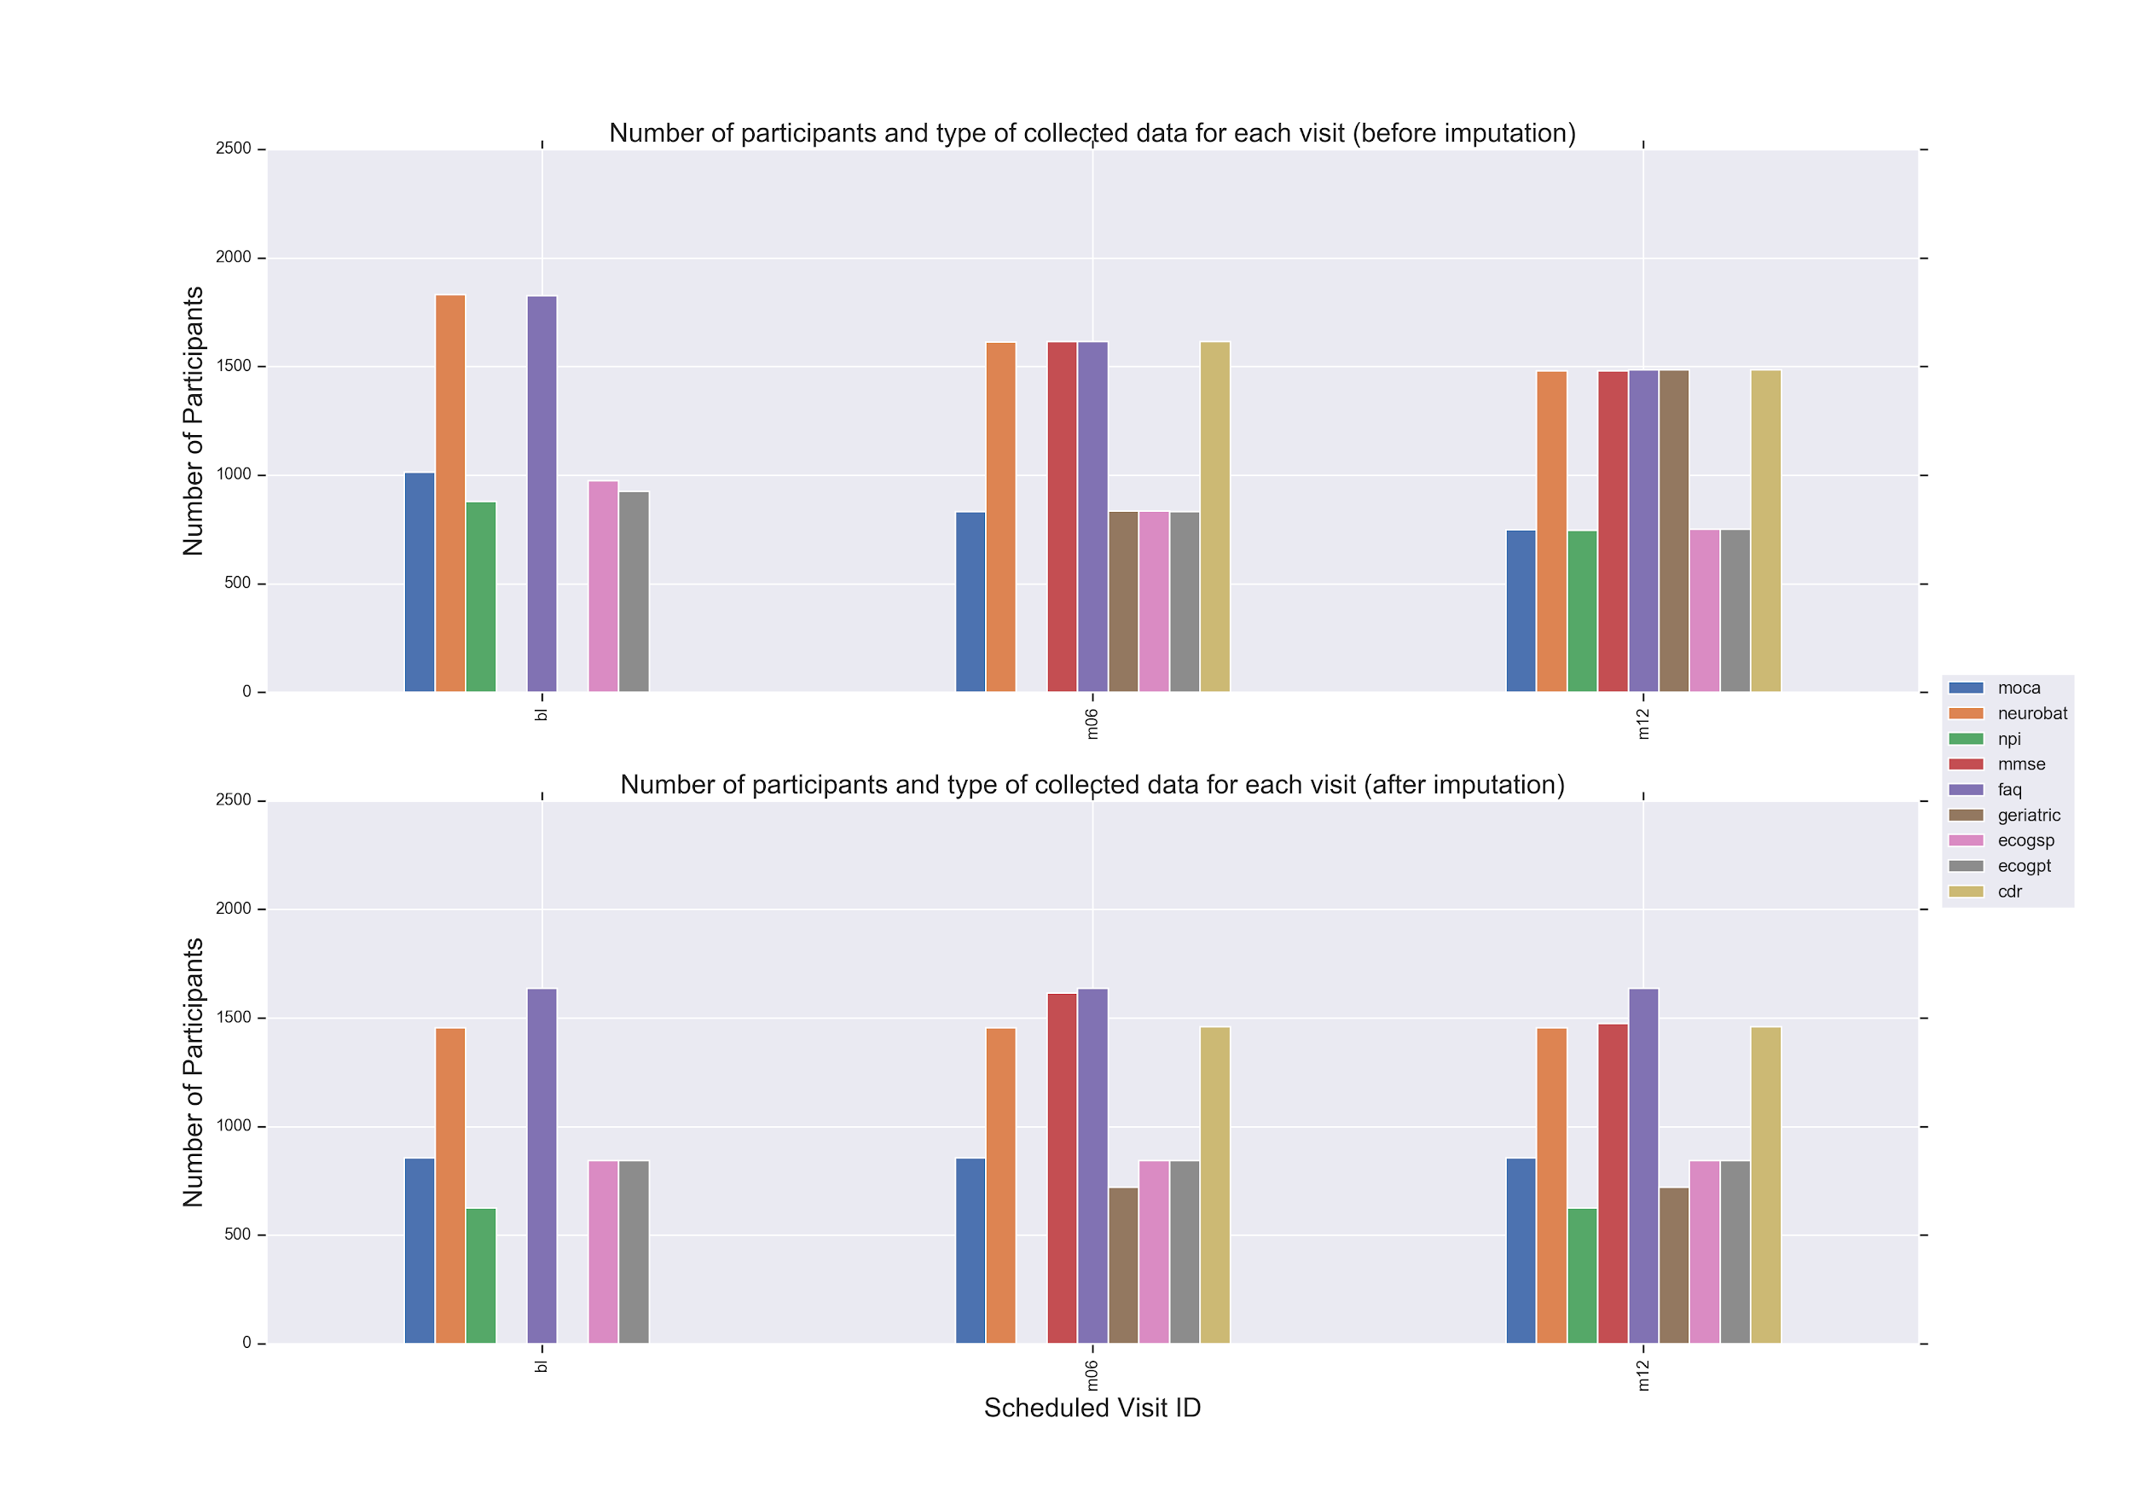

S4 Table: Axis labels for features using 2D non-negative matrix factorization and Gaussian mixture model

Feature Name | Axis Label | Description | Dataset
CATANINTR | 2 | Category Fluency (Animals) - Intrusions | NEUROBAT - m12
TRAAERROM | 2 | Errors of Omission | NEUROBAT - bl
NPIFTOT | 2 | Elation/Euphoria: Item score | NPIALL - m12
TRAAERROM | 2 | Errors of Omission | NEUROBAT - m06
NPIBTOT | 2 | Hallucinations: Item score | NPIALL - m12
NPIBTOT | 2 | Hallucinations: Item score | NPIALL - bl
NPIFTOT | 2 | Elation/Euphoria: Item score | NPIALL - bl
TRAAERROM | 2 | Errors of Omission | NEUROBAT - m12
CATANINTR | 2 | Category Fluency (Animals) - Intrusions | NEUROBAT - bl
NPIATOT | 2 | Delusions: Item score | NPIALL - bl
CATANINTR | 2 | Category Fluency (Animals) - Intrusions | NEUROBAT - m06
TRAAERRCOM | 2 | Errors of Omission | NEUROBAT - m12
NPIATOT | 2 | Delusions: Item score | NPIALL - m12
NPIHTOT | 2 | Disinhibition: Item score | NPIALL - m12
NPIHTOT | 2 | Disinhibition: Item score | NPIALL - bl
AVERR3 | 2 | Total Intrusions (Drum, Curtain, Bell, Coffee, etc.), Trial 3 | NEUROBAT - bl
NPIJTOT | 2 | Aberrant Motor Behavior: Item score | NPIALL - bl
BNTCSTIM | 2 | Total correct with a semantic cue | NEUROBAT - m12
TRAAERRCOM | 2 | Errors of Omission | NEUROBAT - m06
NPIJTOT | 2 | Aberrant Motor Behavior: Item score | NPIALL - m12
BNTCSTIM | 2 | Total correct with a semantic cue | NEUROBAT - m06
AVERR1 | 2 | Total Intrusions (Drum, Curtain, Bell, Coffee, etc.), Trial 1 | NEUROBAT - m12
AVERR5 | 2 | Total Intrusions (Drum, Curtain, Bell, Coffee, etc.), Trial 5 | NEUROBAT - m12
AVERR3 | 2 | Total Intrusions (Drum, Curtain, Bell, Coffee, etc.), Trial 3 | NEUROBAT - m12
AVERR4 | 2 | Total Intrusions (Drum, Curtain, Bell, Coffee, etc.), Trial 4 | NEUROBAT - m12
NPILTOT | 2 | Appetite and eating disorders: Item score | NPIALL - m12
AVERR4 | 2 | Total Intrusions (Drum, Curtain, Bell, Coffee, etc.), Trial 1 | NEUROBAT - m06
AVERR2 | 2 | Total Intrusions (Drum, Curtain, Bell, Coffee, etc.), Trial 2 | NEUROBAT - m12
TRABERROM | 2 | Errors of Omission | NEUROBAT - m12
NPIKTOT | 2 | Sleep: Item score | NPIALL - m12
BNTCSTIM | 2 | Total correct with a semantic cue | NEUROBAT - bl
TRAAERRCOM | 2 | Errors of Commission | NEUROBAT - bl
AVERR2 | 2 | Total Intrusions (Drum, Curtain, Bell, Coffee, etc.), Trial 2 | NEUROBAT - m06
AVERR4 | 2 | Total Intrusions (Drum, Curtain, Bell, Coffee, etc.), Trial 4 | NEUROBAT - bl
AVERR6 | 2 | Total Intrusions (Drum, Curtain, Bell, Coffee, etc.), Trial 6 | NEUROBAT - m12
NPIKTOT | 2 | Sleep: Item score | NPIALL - bl
NPIETOT | 2 | Anxiety: Item score | NPIALL - m12
AVERR5 | 2 | Total Intrusions (Drum, Curtain, Bell, Coffee, etc.), Trial 5 | NEUROBAT - bl
AVERR1 | 2 | Total Intrusions (Drum, Curtain, Bell, Coffee, etc.), Trial 1 | NEUROBAT - bl
NPICTOT | 2 | Agitation/Aggression: Item score | NEUROBAT -m06
NPIETOT | 2 | Anxiety: Item score | NPIALL - bl
TRABERROM | 2 | Errors of Omission | NEUROBAT -m06
AVERR2 | 2 | Total Intrusions (Drum, Curtain, Bell, Coffee, etc.), Trial 2 | NEUROBAT -bl
AVERR5 | 2 | Total Intrusions (Drum, Curtain, Bell, Coffee, etc.), Trial 5 | NEUROBAT -m06
NPIDTOT | 2 | Depression/Dysphoria: Item score | NPIALL - bl
AVERR1 | 2 | Total Intrusions (Drum, Curtain, Bell, Coffee, etc.), Trial 1 | NEUROBAT -m06
AVERR3 | 2 | Total Intrusions (Drum, Curtain, Bell, Coffee, etc.), Trial 3 | NEUROBAT -m06
NPICTOT | 2 | Agitation/Aggression: Item score | NPIALL - m12
NPIITOT | 2 | Irritability/Lability: Item score | NPIALL - m12
NPILTOT | 2 | Appetite and eating disorders: Item score | NPIALL - m12
AVERR6 | 2 | Total Intrusions | NEUROBAT -m06
NPIITOT | 2 | Irritability/Lability: Item score | NPIALL - bl
BNTCPHON | 2 | Number of correct responses following a phonemic cue | NEUROBAT - bl
BNTCPHON | 2 | Number of correct responses following a phonemic cue | NEUROBAT -m06
AVERR6 | 2 | Total Intrusions (Drum, Curtain, Bell, Coffee, etc.), Trial 6 | NEUROBAT - bl
BNTCPHON | 2 | Number of correct responses following a phonemic cue | NEUROBAT -m12
CATANPERS | 2 | Category Fluency (Animals) - Perseverations | NEUROBAT -m06
TRABERRCOM | 2 | Errors of Commission | NEUROBAT -m12
TRABERROM | 2 | Errors of Omission | NEUROBAT -m12
NPIDTOT | 2 | Depression/Dysphoria: Item score | NPIALL - m12
AVERRB | 2 | Total Intrusions | NEUROBAT - bl
NPIGTOT | 2 | Apathy/Indifference: Item score | NPIALL - m12
NPIGTOT | 2 | Apathy/Indifference: Item score | NPIALL - bl
CATANPERS | 2 | Category Fluency (Animals) - Perseverations | NEUROBAT - bl
BNTSTIM | 2 | Total semantic cues given | NEUROBAT - m12
GDTOTAL | 2 | Total Depression Score | GDSCALE - m06
GDTOTAL | 2 | Total Depression Score | GDSCALE - m12
BNTSTIM | 2 | Total semantic cues given | NEUROBAT - m06
CATANPERS | 2 | Category Fluency (Animals) - Perseverations | NEUROBAT - m12
BNTSTIM | 2 | Total semantic cues given | NEUROBAT - bl
AVERRB | 2 | Total Intrusions | NEUROBAT - m06
TRABERRCOM | 2 | Errors of Commission | NEUROBAT - bl
AVDELERR2 | 2 | Total Intrusions (Drum, Curtain, Bell, Coffee, etc.), Trial 2 | NEUROBAT - bl
AVERRB | 2 | Total Intrusions | NEUROBAT - m12
vis | 2 | Following a map to find a new location, Reading a map and helping with directions when someone else is driving., Finding one's car in a parking lot.  , Finding my way back to a meeting spot in the mall or other location., etc. | ECOGPT - m06
vis | 2 | Following a map to find a new location, Reading a map and helping with directions when someone else is driving., Finding one's car in a parking lot.  , Finding my way back to a meeting spot in the mall or other location., etc. | ECOGPT - bl
TRABERRCOM | 2 | Errors of Commission | NEUROBAT - m06
AVDELERR2 | 2 | Total Intrusions (Drum, Curtain, Bell, Coffee, etc.), Trial 2 | NEUROBAT - m06
plan | 2 | Planning a sequence of stops on a shopping trip, The ability to anticipate weather changes and plan accordingly (i.e., bring a coat or umbrella), Developing a schedule in advance of anticipated events, etc. | ECOGPT - bl
AVDELERR2 | 2 | Total Intrusions (Drum, Curtain, Bell, Coffee, etc.), Trial 2 | NEUROBAT - m12
org | 2 | Keeping living and work space organized, Balancing the checkbook without error.  , Keeping financial records organized., Prioritizing tasks by importance.  , etc. | ECOGPT - bl
BNTPHON | 2 | Total phonemic cues given | NEUROBAT - bl
org | 2 | Keeping living and work space organized, Balancing the checkbook without error.  , Keeping financial records organized., Prioritizing tasks by importance.  , etc. | ECOGPT - m06
TRAASCOR | 2 | Part B - Time to complete | NEUROBAT - bl
BNTPHON | 2 | Total phonemic cues given | NEUROBAT - m06
TRAASCOR | 2 | Part B - Time to complete | NEUROBAT - m06
BNTPHON | 2 | Total phonemic cues given | NEUROBAT - m12
FAQ | 2 | FAQ Total Score | FAQ - bl
lang | 2 | Forgetting the names of objects, Verbally giving instructions to others, Finding the right words to use in conversations, Communicating thoughts in a conversation, Following a story in a book or on TV. etc. | ECOGPT - m06
lang | 2 | Forgetting the names of objects, Verbally giving instructions to others, Finding the right words to use in conversations, Communicating thoughts in a conversation, Following a story in a book or on TV. etc. | ECOGPT - bl
TRAASCOR | 2 | Part B - Time to complete | NEUROBAT - m12
division | 2 | The ability to do two things at once, Returning to a task after being interrupted, the ability to concentrate on a task without being distracted by external things in the environment, etc. | ECOGPT - bl
CDCARE | 2 | Personal Care Score | CDR - m06
FAQ | 2 | Total Score | FAQ - m06
CDHOME | 2 | Home and Hobbies Score | CDR - m06
CDCARE | 2 | Personal Care Score | CDR - m12
FAQ | 2 | FAQ Total Score | FAQ - m12
CDHOME | 2 | Home and Hobbies Score | CDR - m12
memory | 2 | Remembering a few shopping items without a list. | ECOGPT - m12
memory | 2 | Remembering a few shopping items without a list. | ECOGPT - m06
memory | 2 | Remembering a few shopping items without a list. | ECOGPT - bl
CDCOMMUN | 2 | Community Affairs Score | CDR - m06
CDORIENT | 2 | Orientation Score | CDR - m06
CDJUDGE | 2 | Judgment and Problem Solving Score | CDR - m06
CDCOMMUN | 2 | Community Affairs Score | CDR - m12
TRABSCOR | 2 | Part A - Time to Complete | NEUROBAT - bl
CDORIENT | 2 | Orientation Score | CDR - m12
CDJUDGE | 2 | Judgment and Problem Solving Score | CDR - m12
CDMEMORY | 2 | Memory Score | CDR - m06
TRABSCOR | 2 | Part A - Time to Complete | NEUROBAT - m06
CDMEMORY | 2 | Memory Score | CDR - m12
TRABSCOR | 2 | Part A - Time to Complete | NEUROBAT - m12
AVDEL30MIN | 1 | 30 Minute Delay Total | NEUROBAT - bl
AVDEL30MIN | 1 | 30 Minute Delay Total | NEUROBAT - m12
AVDEL30MIN | 1 | 30 Minute Delay Total | NEUROBAT - m06
LDELTOTAL | 1 | Total Number of Story Units Recalled | NEUROBAT - m12
AVTOT6 | 1 | Total Intrusions (Drum, Curtain, Bell, Coffee, etc.) Trial 6 Total | NEUROBAT - m06
AVTOT6 | 1 | Total Intrusions (Drum, Curtain, Bell, Coffee, etc.) Trial 6 Total | NEUROBAT - m06
AVTOT6 | 1 | Total Intrusions (Drum, Curtain, Bell, Coffee, etc.) Trial 6 Total | NEUROBAT - bl
AVDELERR1 | 1 | Total Intrusions (Drum, Curtain, Bell, Coffee, etc.) | NEUROBAT - m12
LIMMTOTAL | 1 | Total Number of Story Units Recalled | NEUROBAT - m12
AVTOT3 | 1 | Total Intrusions (Drum, Curtain, Bell, Coffee, etc.) Trial 3 Total | NEUROBAT - bl
AVTOT5 | 1 | Total Intrusions (Drum, Curtain, Bell, Coffee, etc.) Trial 5 Total | NEUROBAT - m12
AVDELERR1 | 1 | Total Intrusions (Drum, Curtain, Bell, Coffee, etc.), Trial 1 | NEUROBAT - m06
AVTOT4 | 1 | Total Intrusions (Drum, Curtain, Bell, Coffee, etc.)Trial 4 Total | NEUROBAT - bl
AVTOTB | 1 | List B Total | NEUROBAT - m12
AVTOT5 | 1 | Total Intrusions (Drum, Curtain, Bell, Coffee, etc.) Trial 5 Total | NEUROBAT - bl
AVTOT4 | 1 | Total Intrusions (Drum, Curtain, Bell, Coffee, etc.) Trial 4 Total | NEUROBAT - m06
AVDELERR1 | 1 | Total Intrusions (Drum, Curtain, Bell, Coffee, etc.), Trial 1 | NEUROBAT - bl
AVTOTB | 1 | Total Intrusions (Drum, Curtain, Bell, Coffee, etc.) List B Total | NEUROBAT - bl
AVTOT1 | 1 | Trial 1 Total (Time to complete) | NEUROBAT - m12
AVTOT3 | 1 | Total Intrusions (Drum, Curtain, Bell, Coffee, etc.)Trial 3 Total | NEUROBAT - m12
AVTOT2 | 1 | Total Intrusions (Drum, Curtain, Bell, Coffee, etc.) Trial 2 Total | NEUROBAT - m12
AVTOT4 | 1 | Total Intrusions (Drum, Curtain, Bell, Coffee, etc.) Trial 4 Total | NEUROBAT - m12
AVTOT5 | 1 | Total Intrusions (Drum, Curtain, Bell, Coffee, etc.) Trial 5 Total | NEUROBAT - m06
AVTOT1 | 1 | Total Intrusions (Drum, Curtain, Bell, Coffee, etc.) Trial 1 Total | NEUROBAT - m06
AVTOT3 | 1 | Total Intrusions (Drum, Curtain, Bell, Coffee, etc.) Trial 3 Total | NEUROBAT - m06
AVTOTB | 1 | Total Intrusions (Drum, Curtain, Bell, Coffee, etc.) List B Total | NEUROBAT - m06
AVTOT2 | 1 | Total Intrusions (Drum, Curtain, Bell, Coffee, etc.) Trial 2 Total | NEUROBAT - m06
AVTOT2 | 1 | Total Intrusions (Drum, Curtain, Bell, Coffee, etc.) Trial 2 Total | NEUROBAT - bl
CATANIMSC | 1 | Category Fluency (Animals) - Total Correct | NEUROBAT - bl
AVTOT1 | 1 | Total Intrusions (Drum, Curtain, Bell, Coffee, etc.) Trial 1 Total | NEUROBAT - m12
CATANIMSC | 1 | Category Fluency (Animals) - Total Correct | NEUROBAT - m12
CATANIMSC | 1 | Category Fluency (Animals) - Total Correct | NEUROBAT - m06
attention | 1 | Attention to digits and letters | MOCA - m06
attention | 1 | Attention to digits and letters | MOCA - bl
AVDELTOT | 1 | Recognition Score | NEUROBAT - m12
fluency | 1 | Letter Fluency - F: Total number of correct words | MOCA - m12
AVDELTOT | 1 | Recognition Score | NEUROBAT - m06
fluency | 1 | Letter Fluency - F: Total number of correct words | MOCA - m06
fluency | 1 | Letter Fluency - F: Total number of correct words | MOCA - bl
AVDELTOT | 1 | Recognition Score | NEUROBAT - bl
sen repetetion | 1 | Sentence Repetetion | MOCA - m12
visuosoconstructional | 1 | Visioconsytructional (Draw Cube , clock etc) | MOCA - m12
sen repetetion | 1 | Sentence Repetetion | MOCA - m06
delayed word recall | 1 | Delayed word recall | MOCA - m12
trail making | 1 | Alternating Trail Making | MOCA - bl
delayed word recall | 1 | Delayed word recall | MOCA - bl
trail making | 1 | Alternating Trail Making | MOCA - m12
delayed word recall | 1 | Delayed word recall | MOCA - m06
visuosoconstructional | 1 | Visioconsytructional (Draw Cube , clock etc) | MOCA - m06
mmse MMSCORE | 1 | MMSE TOTAL SCORE | MMSE - m06
CLOCKSCOR | 1 | Total clock score | MMSE - m06
sen repetetion | 1 | Sentence Repetetion | MOCA - bl
mmse MMSCORE | 1 | MMSE TOTAL SCORE | MOCA - m12
abstraction | 1 | Abstraction (train-bicycle, watch-ruler) | MOCA - m12
BNTSPONT | 1 | Total correct without a cue | NEUROBAT - bl
abstraction | 1 | Abstraction (train-bicycle, watch-ruler) | MOCA - bl
trail making | 1 | Alternating Trail Making | MOCA - m06
BNTSPONT | 1 | Total correct without a cue | NEUROBAT - m06
CLOCKSCOR | 1 | Total clock score | NEUROBAT - bl
BNTSPONT | 1 | Total correct without a cue | NEUROBAT - m12
visuosoconstructional | 1 | Visioconsytructional (Draw Cube , clock etc) | NEUROBAT - m12
abstraction | 1 | Abstraction (train-bicycle, watch-ruler) | MOCA - m06
orientation | 1 | Orientation (Date,Month, Year,Day,Place,city) | MOCA - m12
immediate recall | 1 | Immediate word recall | MOCA - m06
orientation | 1 | Orientation (Date,Month, Year,Day,Place,city) | MOCA - bl
orientation | 1 | Orientation (Date,Month, Year,Day,Place,city) | MOCA - m06
CLOCKSCOR | 1 | Total clock score | NEUROBAT - m06
immediate recall | 1 | Immediate word recall | MOCA - m12
immediate recall | 1 | Immediate word recall | MOCA - bl
naming | 1 | Naming (Lion, Rhino, camel) | MOCA - m12
COPYSCOR | 1 | Total copy score | NEUROBAT - m12
moca naming | 1 | Naming (Lion, Rhino, camel) | MOCA - m06
moca naming | 1 | Naming (Lion, Rhino, camel) | MOCA - m06
COPYSCOR | 1 | Total copying score | NEUROBAT - bl
COPYSCOR | 1 | Total copy score | NEUROBAT - m06

S5 Figure: Projection mapping for clinical features to new 2-dimensional AD progression space axis. Here, first axis corresponds to cognition related features and second axis corresponds to memory related features.
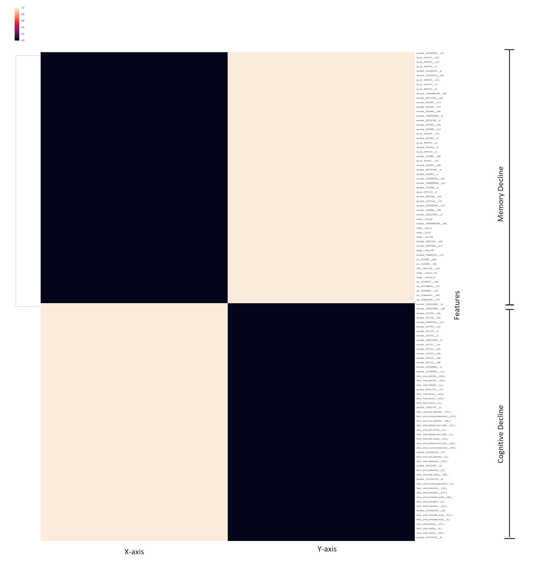

S6 Figure: Comparison of different algorithms for the prediction of progression after 24 months from the baseline. Five-fold cross-validation accuracy was used to evaluate each model. Random forest algorithm provides the highest accuracy.
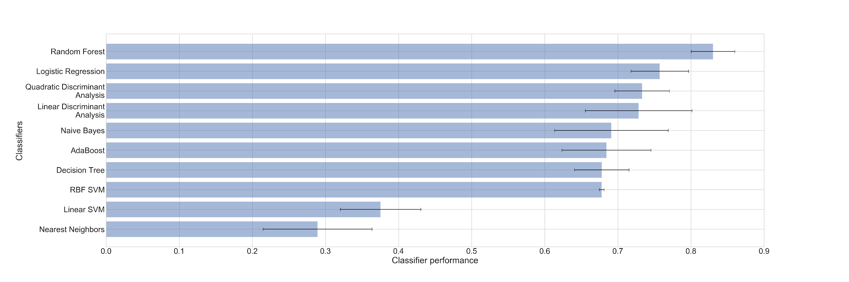
S7 Figure: Comparison of different algorithms for the prediction of progression after 48 months from the baseline. Five-fold cross-validation accuracy was used to evaluate each model. Random forest algorithm provides the highest accuracy.

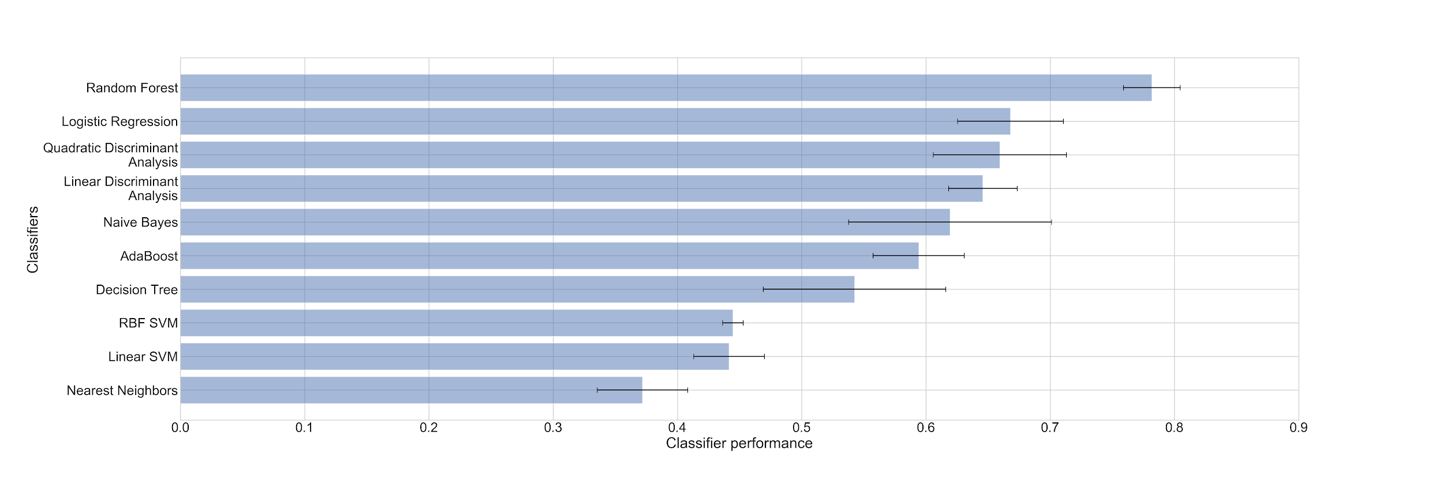
S8 Figure: Percent share of controls, MCI and dementia patients for different subtypes present after 48 months from baseline. The share of MCI patients is decreasing with increase in progression rate.
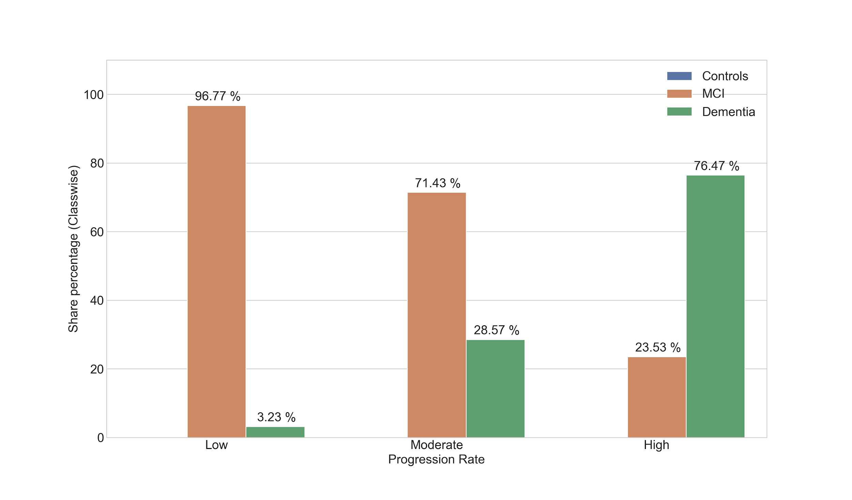
S9 Figure: Percent share of APOEε4 variants for different subtypes after 48 months from baseline. The share of 0 occurrences of APOEε4 variants is decreasing with increase in progression rate, whereas the share of other two 1 and 2 occurrences is increasing.
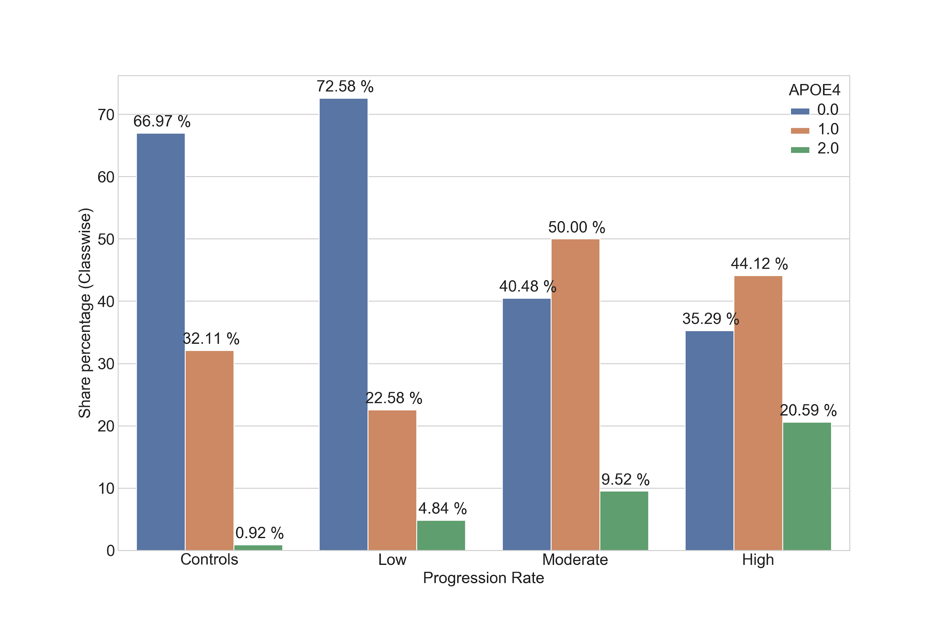

S10 Figure. The distribution of MMSE score for each AD subtype (subtypes at the 48th month) after 6 and 12 months from the baseline. MMSE score decreases with increase in the progression rate.
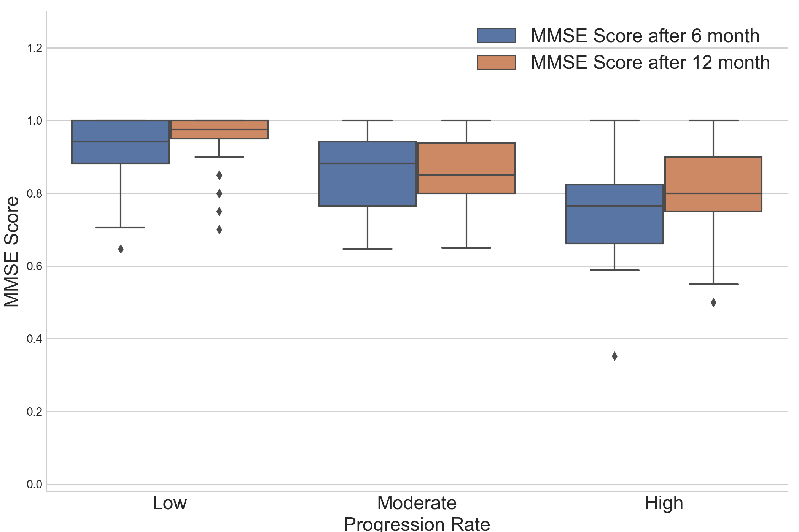

S11 Figure: The distribution of FAQ total score score for each AD subtype (subtypes at the 48th month) after 6 and 12 months from the baseline. FAQ total score increases with increase in the progression rate.

