Predictors of substance use during treatment for addiction: A network analysis of Ecological Momentary Assessment data

Fuschia SERRE ^{1,2,7*#}, Christophe GAULD ^{1,2,3,4#}, Laura LAMBERT ^{1,2}, Emmanuelle BAILLET ^{1,2}, Virginie BELTRAN ^{2,5}, Jean-Pierre DAULOUEDE ^{2,5}, Jean-Arthur MICOULAUD-FRANCHI ^{1,2,6}, Marc AURIACOMBE ^{1,2,7}

¹ University of Bordeaux, F-33076 Bordeaux, France
² CNRS, SANPSY, UMR 6033, F-33076 Bordeaux, France
³ Department of Child Psychiatry, Université de Lyon, 59 Bd Pinel, F-69000 Lyon, France.
⁴ Institut des Sciences Cognitives Marc Jeannerod, UMR 5229 CNRS & Université Claude Bernard Lyon 1, F-69000 Lyon, France
⁵ Centre de Soins et d'Accompagnement et de Prévention en Addictologie (CSAPA), BIZIA, Médecins du Monde, Centre Hospitalier de la côte Basque, F-64000 Bayonne, France.
⁶ University Sleep Clinic Unit, University Hospital of Bordeaux, Place Amélie Raba-Leon, F-33076 Bordeaux, France.
⁷ Pôle Interétablissement d’Addictologie, CH Ch. Perrens and CHU de Bordeaux, F-33076 Bordeaux, France

# These authors contributed equally.

*Corresponding author
Fuschia SERRE
e-mail: fuschia.serre@u-bordeaux.fr
Pôle Addictologie, CHCP, 121 rue de la Béchade, 33076 Bordeaux Cedex, France
Tel: +33 556 561 738
Fax: +33 556 561 727

Supporting information

METHODS
Participants recruitment – Samples description

Sample 1 (n = 163): Data were collected from 2009 to 2013 as part of a study to explore determinants of craving and substance use among a variety of addictions at Bordeaux, France (1, 2).
Sample 2 (n = 48): Data were collected from 2019 to 2022 as part of a study to explore the validity of the “Cues – Craving – Use” model of addiction across a variety of addictions (substances and behaviors) in regular users (recruited from harm reduction facilities) and patients attempting abstinence/reduction of use (recruited from outpatient addiction services in Bordeaux and Bayonne, France).
Only a minority (24%) of patients eligible for the study was included (Figure S1). However, no socio-demographic or clinical differences between eligible individuals not included and those included were observed (1), and the final sample was highly similar to the broader population of individuals that are in addiction treatment centers in France and Europe (3).
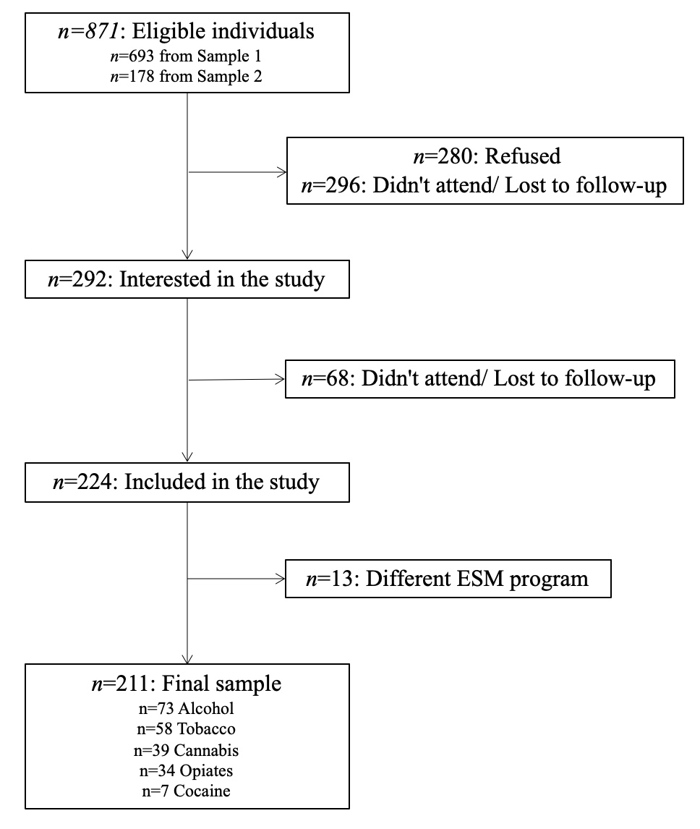
Figure S1. Flow chart of the inclusion process.
EMA program
Sample 1. Each Personal Digital Assistant (PDA PalmOne, Tungsten E2 model, with PMAT program specifically developed for the study by INCIA and SANPSY Lab, University of Bordeaux) was programmed to administer four electronic surveys per day, between 8:00 am and 11:00 pm. Signal times were fixed for each individual, but randomized across participants in the sample using 20 distinct signaling programs. The average time between signals was 4 h and 36 s (SD = 43 min, 35 s). There was no significant difference among the four substance groups concerning the time delay between signals, F(3, 153) = 2.312, p > .05.

Sample 2. Each smartphone (Motorola E4 Plus, E7 Plus, Xiaomi Redmi 7, or Redmi 8 with Android OS versions from 7.1.1 to 10, locked with CUSEMA app developed with Unity 2019.4.10F1 by SANPSY Lab, University of Bordeaux) was programmed to administer four electronic surveys per day, on an open time slot of 14 consecutive hours (no later than 4 am for the last assessment of the day). The signals were randomized over the period, but two consecutive signals were at least one hour apart. The average time between signals was 3h39 (SD = 1h, 6 min).
Neither of these two EMA applications or their codes are available in open access.

EMA measures
EMA items (Mood, Craving, Substance Use) were derived from previous studies (4), in order to maximize comparability, or developed specifically for the parent studies (Cues, Self-efficacy, Pharmacological treatment), according to a panel of clinical experts and researchers at SANPSY lab (1). EMA items were not submitted to psychometric validation (5).

Mood states recoding
Mood state measurement in Sample 1:
- Happy / sad: “Between sadness and joy, where do you stand right now?” (1 “Very sad” to 7 “In a very good mood, cheerful”)
Mood state measurement in Sample 2:
- Happy: “At this moment, how do you feel: happy, in a good mood?” (1 “Not at all” to 7 “Very good mood, happy”)
- Sad: “At this moment, how do you feel: sad?” (1 “Not sad at all” to 7 “Very sad”)
The Happy and Sad variables of Sample 2 were transformed to be on a single scale. For this, each subscale was transformed, and the maximum value between sad and happy defined which value was attributed on a 1 “Very sad “- 7 “Very happy” scale (or neutral value of 4 if equivalent).

The order of the questions was fixed. No design feature or item was added to address potential sources of bias (e.g., reactivity, vigilance) or participant burden. No additional tests were carried out to check whether all the items were relevant to the concept or the population of interest, or to test whether a concept was missing. Except the training session, no other method was used to check whether the questions and instructions were understood by the participants as intended. The latency between the time the questionnaire was prompted and the time it was completed, as well as the time taken to complete the questionnaire, were not examined. But the time needed to complete a questionnaire was estimated to 5 minutes, due to the presence of conditional questions (e.g., reasons for use, when substance use was reported).
All EMA items delivered during the study were in French.
- Craving : “Depuis le dernier questionnaire, avez-vous ressenti une envie de consommer (la substance primaire) ?” “(1 Aucune envie à 7 Envie extrême)”.
- Substance Use : “Depuis le dernier questionnaire, avez-vous consommé (la substance primaire) ?” “(0 Non / 1 Oui)”.
- Mood states :“Entre tristesse et joie où vous situez vous a cet instant ?” “(1 Très triste à 7 De très bonne humeur, joyeux)”
- Cues : “Depuis le dernier questionnaire, avez-vous vu ou été en contact avec une ou plusieurs des choses suivantes ? ”
- Self-efficacy : “A quel degré vous sentez-vous capable de ne pas consommer de (la substance primaire) ?” “(1 Pas capable de s’abstenir à 7 Totalement capable)”.
- Pharmacological treatment : “Depuis le dernier signal, avez-vous pris un médicament prescrit pour l'addiction ?” “(0 Non / 1 Oui)”.

EMA training
In order to improve participants understanding as well as the validity and reproducibility of our study, a training session was scheduled for each participant the day before the first day of the EMA study. During the training session, participants completed a 'test' questionnaire which included all possible EMA questions. An interviewer was present to explain how to use the EMA application, and to help them understand the questions if needed. If participants had great difficulty understanding or answering the questions, despite the explanations given by the interviewer, it was planned to exclude them. No participants were excluded for this reason in this study. On the evening of the first day of the EMA study, the interviewer called the participants to check that they had not encountered any difficulties in answering the questionnaires.

Statistical Analysis - Network
Subjects needed for the time-series analysis
Time-series network analyzes being based on within-person centering using sample means per person, it is recommended to include individuals with at least 20 measurements (6, 7) . Here, we collected 4 measures x 14 days by person (N = 56 measures by person), but, as previously explained, only data from days 2 to 13 of each participant were analyzed, resulting in 48 measures by person. The optimal balance between including participants with minimal missingness and retaining as many participants as possible was found to be at 10 completed assessments. This resulted in the inclusion of 211 participants, with on average 39,1 assessment completed (SD=7,9, Min=10, Max=48), corresponding to an average of 3.3 questionnaires completed per day.

Item selection
Regarding item selection on the simplified and complete network models (see 2.4.4), we used three methods to avoid irrelevant overlap. First, variables included in the models were selected on the basis of the theoretical and clinical judgments consistency. Secondly, according to Ebrahimi and colleagues (8), this theoretically grounded selection was followed by a data-driven approach, using the goldbricker algorithm to search for pairs of highly intercorrelated items (in addition to items displaying similar behavioral patterns with the other items in the network). Goldbricker algorithm compares dependent overlapping correlations (i.e., if the correlations are significantly different, then, the compared symptoms capture independent aspects of the response) (9). Given that less than 25% of correlations were significantly different, no reduction in the number of items was required.

Stationarity and processing of intra- and extra-diurnal effects on the time-series analysis
Time-series analysis assumes stationarity. Stationarity means that the means and variances-covariances of each subject were stable over time. Tested for each variable, the Augmented Dickey Fuller (ADF) test confirms or not that the time-series had a time-dependent structure, supporting or not its stationarity. A detrending is necessary if stationarity is not confirmed.
However, data processing was carried out mlVAR networks differentiating the day-to-day and within-day evolutions, to improve the interpretation of the network analysis. For that, weekday versus weekend (Saturday and Sunday) effects were removed from each variable by subtracting these effects from each observation. Moreover, all time-lagged analyses examined within-day (and not across-day) associations (dayvar), representing the lagged associations between symptoms from one measurement point, T0, to the next, T1, approximately four hours later, without considering the across-day time-lagged.

RESULTS
Missing data
Missing data were due to noncompliance from participants (n=1,868; 18%), and were higher in Sample 2 (22.7%) than in Sample 1 (17.2%) (Khi² test: χ²=35.91; p<.0001), for younger compared to older people (Logistic regression: coef=-0.03; χ²=156.55; p<.0001) and for men (19.3%) compared to women (17.0%) (Khi² test: χ²=7.78; p=0.005). Missing data increased over the course of the study (coef=0.045; SE=0.016; t-ratio=2.846; d.f.=208;p=0.005; adjusted on age and sex), see Table S1.

Table S1. Percentage of assessment completed according to day in study.
Day | 2 | 3 | 4 | 5 | 6 | 7 | 8 | 9 | 10 | 11 | 12 | 13
% completed | 88.0 | 84.8 | 86.1 | 82.0 | 81.8 | 83.2 | 81.2 | 79.0 | 79.3 | 79.4 | 77.3 | 76.7

The average response rate by groups were: 78% (n=1,464) for cannabis, 81% (n=2,845) for alcohol, 82% (n=1,340) for opiates, 85% (n=2,357) for tobacco and 76% (n=254) for cocaine (Fisher test: u=.0014; χ²=40.41; p<.0001).
Sensitivity analysis was conducted computing networks with multiple imputations (predictive mean matching algorithm) for missing data. No clinically significant differences appear in comparison to non-imputed networks (Figure S3).

Variability, Stationarity and time-dependent changes of EMA scores over the course of the study
Variability of EMA scores during the study was explored by intraclass correlation (ICC): 52.7% for craving (indicating that 47.3 % of variance accounted for within-person variability), 43.0% for mood, 56.2% for self-efficacy, and 53.3% for number of cues.
The ADF test confirmed that the time-series does not have a time-dependent structure, supporting its stationarity, for each variable. Thus, no detrend was necessary.
A decrease over the course of the study was observed for primary substance use (coef=-0.03; SE=0.01; t-ratio=-2.086; d.f.=208; p=0.038; adjusted on age and sex), craving (coef=-0.06; SE=0.02; t-ratio=-3.600; d.f.=208; p<.001; adjusted on age and sex), number of cues (coef=-0.06; SE=0.02; t-ratio=-3.126; d.f.=208; p=0.002; adjusted on age and sex) and an increase for self-efficacy (coef=0.03; SE=0.01; t-ratio=1.935; d.f.=208; p=0.054; adjusted on age and sex). No time-effect was observed for mood intensity (coef=-0.001; SE=0.01; t-ratio=-0.378; d.f.=208; p=0.706; adjusted on age and sex) and pharmacological treatment intake (coef=0.001; SE=0.01; t-ratio=0.155; d.f.=208; p=0.877; adjusted on age and sex).

Samples differences in EMA scores
No difference was observed between the two samples on craving intensity (coef=-0.007; SE=0.24; t-ratio=-0.029; d.f.=209;p=0.977), primary substance use (coef=0.001; SE=0.22; t-ratio=0.004; d.f.=209;p=0.997), number of cues (coef=0.042; SE=0.41; t-ratio=0.103; d.f.=209;p=0.918) and pharmacological treatment intake (coef=-0.095; SE=0.23; t-ratio=-0.397; d.f.=209;p=0.692). Sample 2 demonstrated higher levels of self-efficacy (coef=0.55; SE=0.23; t-ratio=2.341; d.f.=209;p=0.020), and of positive mood (coef=0.73; SE=0.18; t-ratio=3.979; d.f.=209;p<0.001).

Table S2. Correlation coefficients for Simplified network model
Contemporaneous Network
From / To | From / To | Correlation (r)
Craving | Use | 0.20
Cues | Craving | 0.18
Cues | Use | 0.34
Temporal Network
From (T0) | To (T1) | Correlation (r) | 95% CI
Use | Use | 0.09 | [0.070, 0.115]
Craving | Use | 0.11 | [0.088, 0.132]
Use | Craving | -0.02 | [-0.045, -0.001]
Cues | Use | -0.03 | [-0.048, -0.004]
Use | Cues | 0.01 | [-0.009, 0.035]
Craving | Craving | 0.20 | [0.176, 0.220]
Cues | Craving | -0.02 | [-0.045, -0.001]
Craving | Cues | 0.04 | [0.021, 0.065]
Cues | Cues | 0.09 | [0.065, 0.109]
Between-subject Network
From / To | From / To | Correlation (r)
Craving | Use | 0.57
Cues | Craving | 0.32
Cues | Use | 0.14

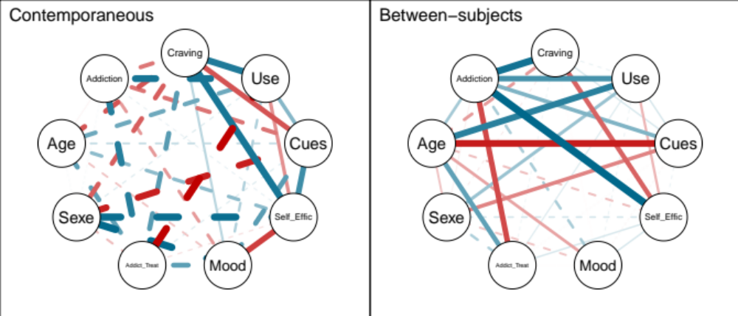
Figure S2. Sensitivity analysis of influence of Age, Sex and Substance type on Complete network model. Non-significant correlations are in dashes. Positive correlations are in blue, negative correlations are in red. The thickness of an edge represents the strength of connection, relative to the strongest edge coefficient. Temporal network was not estimated due to lack of sufficient statistical power.

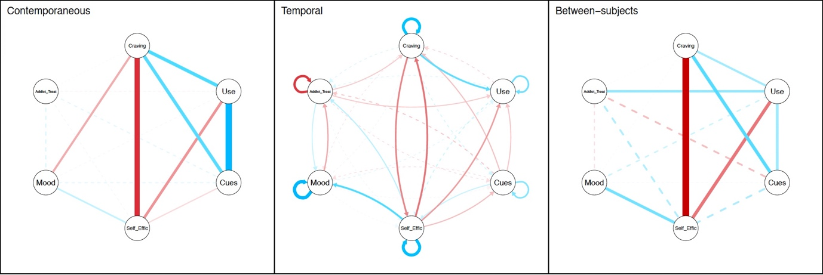
Figure S3. Sensitivity analysis computing networks with multiple imputations (predictive mean matching algorithm) for missing data. Non-significant correlations are in dashes. Positive correlations are in blue, negative correlations are in red. The thickness of an edge represents the strength of connection, relative to the strongest edge coefficient.

Table S3. Correlation coefficients for Complete network model
Contemporaneous Network
From (T0) | To (T0) | Correlation (r)
Craving | Use | 0.16
Self-efficacy | Use | -0.12
Cues | Use | 0.32
Mood | Craving | -0.09
Self-efficacy | Craving | -0.23
Cues | Craving | 0.16
Mood | Self-efficacy | 0.06
Cues | Self-efficacy | -0.04
Temporal Network
From (T0) | To (T1) | Correlation (r) | 95% CI
Use | Use | 0.09 | [0.065, 0.109]
Craving | Use | 0.10 | [0.073, 0.118]
Pharmacological Treatment | Use | -0.03 | [-0.057, -0.012]
Self-efficacy | Use | -0.07 | [-0.091, -0.046]
Cues | Use | -0.04 | [-0.062, -0.017]
Craving | Craving | 0.17 | [0.148, 0.192]
Pharmacological Treatment | Craving | -0.04 | [-0.058, -0.014]
Self-efficacy | Craving | -0.10 | [-0.120, -0.075]
Craving | Self-efficacy | -0.09 | [-0.107, -0.063]
Cues | Craving | -0.04 | [-0.065, -0.021]
Self-efficacy | Self-efficacy | 0.18 | [0.159, 0.203]
Self-efficacy | Pharmacological Treatment | 0.04 | [0.020, 0.065]
Self-efficacy | Mood | 0.10 | [0.080, 0.124]
Cues | Self-efficacy | 0.04 | [0.014, 0.058]
Self-efficacy | Cues | -0.04 | [-0.066, -0.022]
Mood | Mood | 0.20 | [0.180, 0.225]
Pharmacological Treatment | Mood | 0.03 | [0.012, 0.057]
Mood | Pharmacological Treatment | -0.06 | [-0.082, -0.038]
Pharmacological Treatment | Pharmacological Treatment | -0.14 | [-0.163, -0.119]
Cues | Cues | 0.08 | [0.055, 0.099]
Between-subject Network
From | To | Correlation (r)
Craving | Use | 0.19
Pharmacological Treatment | Use | 0.22
Self-efficacy | Use | -0.32
Cues | Use | 0.20
Self-efficacy | Craving | -0.68
Cues | Craving | 0.33
Mood | Self-efficacy | 0.28

REFERENCES

1. Serre F., Fatseas M., Debrabant R., Alexandre J. M., Auriacombe M., Swendsen J. Ecological momentary assessment in alcohol, tobacco, cannabis and opiate dependence: A comparison of feasibility and validity, Drug Alcohol Depend 2012: 126: 118-123.
2. Fatseas M., Serre F., Alexandre J. M., Debrabant R., Auriacombe M., Swendsen J. Craving and substance use among patients with alcohol, tobacco, cannabis or heroin addiction: a comparison of substance-specific and person-specific cues, Addiction 2015: 110: 1035-1042.
3. EMCDDA. European Drug Report 2023: Trends and Developments: European Monitoring Centre for Drugs and Drug Addiction; 2023.
4. Johnson E. I., Barrault M., Nadeau L., Swendsen J. Feasibility and validity of computerized ambulatory monitoring in drug-dependent women, Drug Alcohol Depend 2009: 99: 322-326.
5. Degroote L., DeSmet A., De Bourdeaudhuij I., Van Dyck D., Crombez G. Content validity and methodological considerations in ecological momentary assessment studies on physical activity and sedentary behaviour: a systematic review, Int J Behav Nutr Phys Act 2020: 17: 35.
6. Epskamp S. Psychometric network models from time-series and panel data, Psychometrika 2020: 85: 206-231.
7. Epskamp S., Waldorp L. J., Mottus R., Borsboom D. The Gaussian Graphical Model in Cross-Sectional and Time-Series Data, Multivariate Behav Res 2018: 53: 453-480.
8. Ebrahimi O. V., Burger J., Hoffart A., Johnson S. U. Within-and across-day patterns of interplay between depressive symptoms and related psychopathological processes: a dynamic network approach during the COVID-19 pandemic, BMC Med 2021: 19: 1-17.
9. Levinson C. A., Brosof L. C., Vanzhula I., Christian C., Jones P., Rodebaugh T. L. et al. Social anxiety and eating disorder comorbidity and underlying vulnerabilities: Using network analysis to conceptualize comorbidity, Int J Eat Disord 2018: 51: 693-709.

